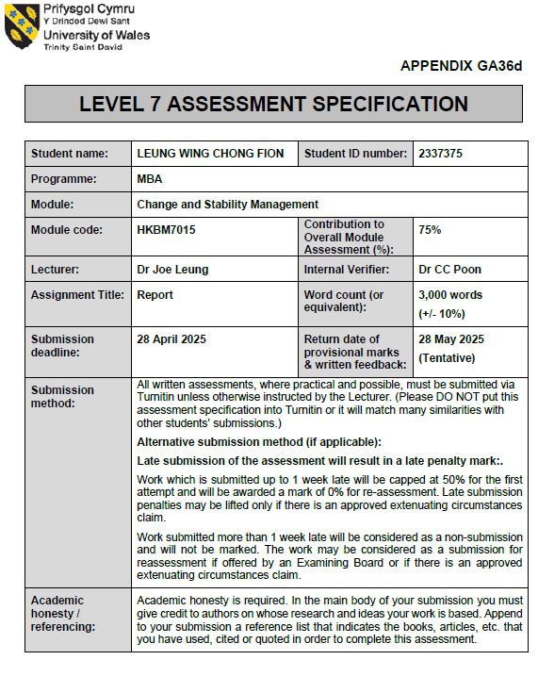



UWTSD MBA
HKBM7015 Change and Stability Management

An analytical Report for Café de Coral's Strategic Change Initiatives

Student Name | ： | LEUNG WING CHONG FION
Student ID Number | ： | 2337375
Date of Submission | ： | 28 April, 2024
Lecturer | ： | Dr Joe Leung

Executive Summary
This analytical report presents a compelling case for Café de Coral's strategic change initiatives as the company going through the significant drop in sales revenue from 2020 due to COVID-19, operating profit drop 98% and moves from an owner-managed model to a more professional and sustainable management style in 2024. Utilizing force field analysis, to identify both the driving forces—such as technological advancements and promising market opportunities in the ASEAN region—and the resisting forces, which include cost constraints and internal pushback.

Employing Lewin's 3-Step Change Model, the report lays out a methodical approach to implementing this transformation effectively. The unfreezing phase is crucial for raising awareness and developing a coalition to champion change. During the change phase, it's imperative to empower employees and achieve short-term wins that demonstrate the benefits of this new direction. Finally, the refreezing phase focuses on solidifying new practices within the organizational culture to ensure lasting impact.

Transformational leadership emerges as a vital element in facilitating this change. Leaders will need to inspire and engage employees, cultivating a culture of innovation and collaboration that alleviates resistance and drives organizational performance.

To ensure sustainable growth, it recommends that Café de Coral consider expanding into the ASEAN market. This venture would not only diversify revenue streams but also help counter competitive pressures. Additionally, enhancing operational productivity through process optimization and employee training will be key. By embracing transformational leadership and pursuing strategic market initiatives, Café de Coral can adeptly navigate the challenges of the fast-food industry and secure a successful, long-term position in the market.
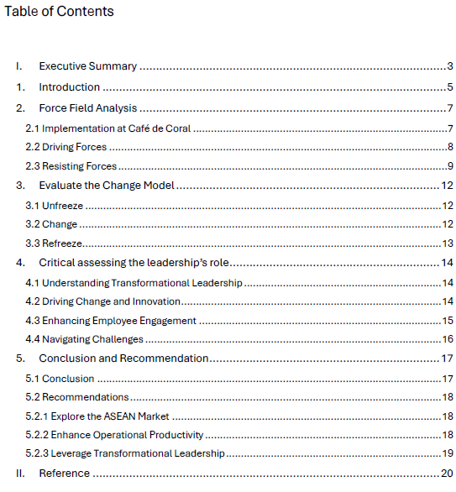

Introduction
Café de Coral stands as a leading quick-service restaurant chain, renowned for delivering affordable Chinese cuisine in Hong Kong and beyond. Since its establishment in 1968, the company has broadened its reach significantly, operating hundreds of outlets and catering to millions of customers each year (Café de Coral, 2024). However, despite its impressive achievements, Café de Coral faces several pressing challenges that could hinder its future growth and long-term sustainability.

In the critical analysis for changing factors of Café de Coral, one of the most pressing issues is the notable shift in consumer preferences towards healthier and more sustainable dining options after Covid-19 (HKSAR, 2023). Studies reveal that today's consumers increasingly prioritize health-conscious choices, compelling many fast-food chains to adapt their menus accordingly (Lewis, 2021). This evolving trend could pose a significant risk to Café de Coral, as its traditional offerings may not resonate with the growing number of health-focused diners.

The fast-food industry faces significant competition as Hong Kong's sluggish GDP growth makes consumers more price-conscious (Census and Statistics Department, 2025). With local and global brands vying for market share, Café de Coral must implement competitive pricing and innovative marketing strategies to stand out (Jones & Lee, 2022). Adapting to this landscape is crucial to avoid losing market share and facing tighter profit margins that could jeopardize the company’s financial stability.

Rising operational costs at Café de Coral, driven by increasing ingredient prices, labor expenses, and strict food safety regulations (Centre for Food Safety, n.d.), demand an urgent review of the operational efficiencies and cost management strategies. By enhancing unit productivity, it can ensure the long-term viability of the business.
The swift incorporation of technology into food service operations is now a necessity. The pandemic has fast-tracked the shift towards digital ordering and delivery systems, making it vital for Café de Coral to bolster its technological capabilities. By doing so, Café de Coral not only meets the evolving expectations of consumers but also significantly enhances overall service delivery (Garg, 2024).

This analytical report will analyze Lewin change management model (Kurt Lewin, 1947), and the Lewin’s leadership styles in Café de Coral change (Burn, J.M., 1978), highlighting the implications for the organization while offering strategic recommendations to navigate these obstacles effectively. By proactively addressing these critical factors, Café de Coral can position itself for sustained growth and resilience in an ever-changing market.

Force Field Analysis
Force Field Analysis, developed by Kurt Lewin, is a crucial management tool for assessing organizational change (Kurt Lewin, 1947). It provides valuable insights into a business's current state, such as Café de Coral's, by identifying growth drivers and potential obstacles. Using this analysis, it can effectively leverage supportive factors while addressing challenges, leading to informed decision-making and improved performance.

2.1 Implementation at Café de Coral
Café de Coral is a top fast-food chain in Hong Kong, known for its quick service and affordable meals. Understanding the driving and restraining forces affecting performance is essential for staying competitive. Figure 1 highlights key factors influencing Café de Coral's success and offers actionable strategies for enhancement, ensuring the company meets its strategic goals.
  - 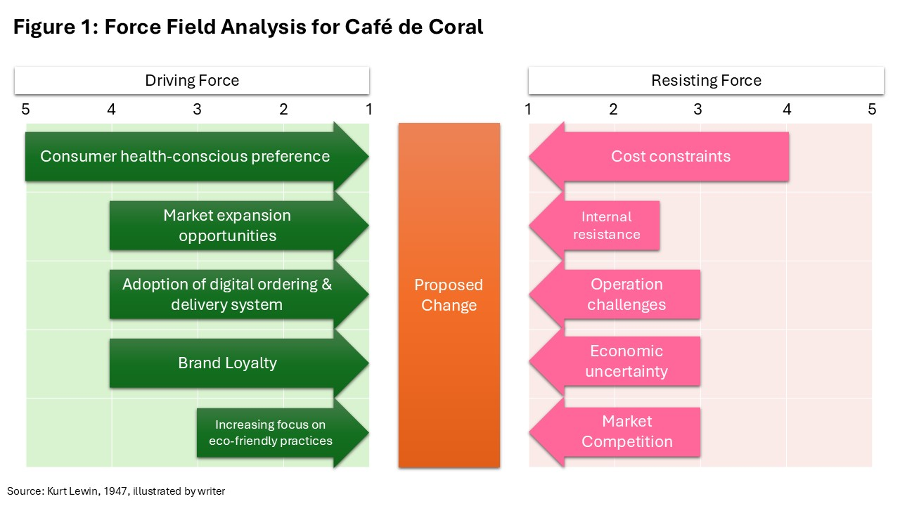

2.2 Driving Forces
Consumers are the driving force behind the food service industry, and their evolving preferences are the primary catalyst for change. In the wake of the COVID-19 pandemic, there has been a significant surge in demand for healthier and more sustainable food options. Today’s health-conscious consumers are actively seeking meals that not only nourish their bodies but also align with their values of sustainability and well-being. This shift presents a unique opportunity for Café de Coral to creatively reinvent and enhance its menu offerings. By embracing these trends, the restaurant can position itself as a leader in the industry, catering to the growing desire for nutritious, responsible dining experiences (HKET, 2023).

The proliferation of digital ordering and delivery platforms has significantly transformed the fast-food industry. For Café de Coral, the integration of technology is not merely an option, but a necessity for sustained growth. By adopting digital platforms, the company enhances the customer experience, enabling consumers to place orders conveniently from smartphones or computers. The transition not only improves customer satisfaction but also increases operational efficiency by minimizing wait times and reducing errors in order processing. By embracing these technological advancements, Café de Coral is well-positioned to meet the evolving expectations of its customer base, thereby serving as a critical driver for future growth (Ahuja et al., 2021).

Café de Coral has built a strong brand and a loyal customer base, which are crucial for increasing market share and launching new products. This loyalty encourages repeat visits and word-of-mouth recommendations, leading to boosted sales. By engaging customers and consistently delivering quality, Café de Coral can leverage this loyalty to enhance its competitive edge. With a solid brand presence, the company has significant opportunities for expansion in mainland China and the ASEAN market (imarc, 2024). The fast-food industry in China is growing, driven by a rising middle class and urbanization (Interesse, 2023). By tapping into these trends and offering tailored options, Café de Coral can establish a foothold in these regions, expanding its market reach and accelerating growth.

The sustainability movement has gained significant attention, as consumers increasingly prioritize environmental issues (Environmental, 2023). Café de Coral can enhance its brand image by adopting eco-friendly practices, like sourcing ingredients responsibly and reducing waste. Embracing sustainability will attract environmentally conscious customers, fostering loyalty and solidify Café de Coral's reputation as a responsible leader in the fast-food industry—essential for today's consumers.

The interconnected forces are designed to bolster Café de Coral's future growth and enhance business efficiency. With a total driving forces score of 21 out of 25, it can anticipate a positive and gradual shift in development.

2.3 Resisting Forces
Café de Coral faces several challenges that can impede its ability to adapt and innovate. Further understanding the forces resisting change is crucial for Café de Coral to navigate the strategic direction effectively. Key resisting forces include cost constraints, internal resistance, operational challenges, economic uncertainty, and market competition.

Café de Coral is facing a critical challenge with rising operational costs related to ingredients, labor, and regulatory compliance (Chain Daily, 2025). Fluctuating food prices and increasing labor costs have caused the cost of goods sold to rise from 86% to 91%, negatively impacting profitability. These financial pressures limit resources for innovation and expansion, hindering the company’s ability to invest in technologies that improve efficiency and customer experience. If not addressed, these rising costs could significantly stifle the company’s growth potential.

Figure 2 Café de Coral Revenue & Profit / Operation Unit
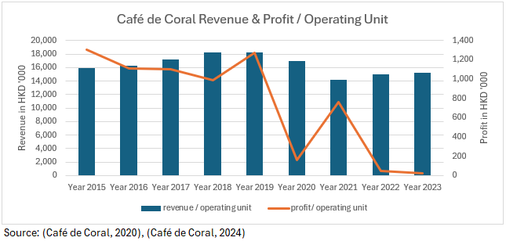

Café de Coral, like many corporations, faces internal resistance to change, which is a significant challenge (Drucker, 1954). Employees may feel anxious about new technologies and operational changes, fearing job loss or the need for retraining. This resistance often stems from a lack of understanding of the benefits of change or an unsupportive culture. To tackle this, Café de Coral should foster open communication and ensure employees feel valued and informed. Involving staff in the change process can help reduce resistance and promote a more adaptable organization. With internal resistance, operational challenges pose significant barriers to change for Café de Coral yet overcoming them is vital for future success. While implementing new systems can disrupt workflows and initially create inefficiencies, the long-term benefits are substantial.

The fast-food industry is vulnerable to economic fluctuations that can significantly affect businesses like Café de Coral. Economic uncertainty often leads consumers to cut back on discretionary spending, impacting sales. This caution may hold the organization back from pursuing new initiatives due to perceived risks. To address this, Café de Coral must remain agile and adapt its strategies to stay relevant and profitable.

Moreover, intense competition poses a significant challenge. With many local and international brands competing for consumer attention, the fast-food landscape is crowded. This pressure can shift focus from innovation to defensive strategies aimed at maintaining market share. To succeed, Café de Coral must differentiate itself through unique offerings, outstanding customer service, and effective marketing. By understanding and responding to competitive dynamics, the company can navigate these challenges and maintain its market position.

The Force Field Analysis for Café de Coral reveals a complex interplay of driving and restraining forces that the organization must navigate to achieve its strategic objectives. By leveraging its strengths and addressing the challenges, it proposes Café de Coral can enhance its competitive position with change in the fast-food industry.

Evaluate the Change Model
Café de Coral can successfully drive change by utilizing Lewin's 3-Step Change Management Model, which consists of unfreezing, changing, and refreezing (Kurt Lewin, 1947). This proven framework offers a clear and effective approach to managing organizational transformation, ensuring that changes are not only implemented but also sustained over time.

3.1 Unfreeze
To initiate meaningful change at Café de Coral, the first vital step is to foster awareness and readiness among the team. The management must effectively communicate the urgent need for transformation by emphasizing key market trends, such as the emergence of digital platforms and the growing expectation for sustainable practices. By doing so, it can help employees grasp the importance of this shift.

Moreover, it’s essential to cultivate a coalition of influential leaders and stakeholders within the organization who can champion this change. This dedicated group will play a crucial role in driving the initiative and ensuring widespread support. Clearly articulating the vision for change — focusing on objectives like enhancing customer experience and embracing sustainable practices — will unite the team’s efforts with the company’s overarching goals.

3.2 Change
To ensure the successful implementation of new strategies and practices within the organization, it must equip every employee with the necessary training and resources to embrace new technologies and processes. By empowering individuals at all levels, it creates an environment where everyone feels invested in the change initiative. Actively encouraging feedback and removing barriers will further enable Café de Coral’s staff to engage wholeheartedly in the transformation process.

Setting clear success milestones is vital for driving meaningful change and achieving short-term wins. To establish valuable pinpoints and celebrate early successes, such as the launch of digital ordering platform or the adoption of a sustainable sourcing program. Acknowledging these achievements not only builds momentum but also strengthens the collective belief in the effectiveness of the change effort.
Moreover, Café de Coral’s management team should focus on consolidating these gains by using the momentum from short-term victories to fuel ongoing progress. By analyzing the outcomes of the initial initiatives, it can identify opportunities to enhance and expand all staff’s efforts, leading to even greater improvements across the organization.

3.3 Refreeze
In the refreeze stage, it is crucial to embed and sustain changes that integrate seamlessly into the organization's culture, ensuring lasting success. This can be accomplished by incorporating new practices into training programs, performance evaluations, and company policies. Leadership teams must actively champion these new approaches, consistently promoting the values of innovation and sustainability to make them an integral part of Café de Coral's identity.

Moreover, it is vital for the leadership team to implement a robust monitoring and adjustment system. Continuous assessment of the changes' effectiveness allows for timely modifications as needed. Actively soliciting feedback from both employees and customers will not only identify areas for improvement but also strengthen the commitment to the changes made, driving the organization forward.

Critical assessing the leadership’s role
Transformational leadership is essential in steering the success and direction of organizations, particularly in the ever-evolving fast food industry. At Café de Coral, a leading fast-food chain in Asia, transformational leadership is a key driver of change, innovation, and heightened employee engagement (Bass, 1985). Especially considering the upcoming change from an owner-managed model to a more sustainable and professional management style in 2024 (news, 2024).

4.1 Understanding Transformational Leadership
Transformational leadership excels in inspiring and motivating followers to prioritize the success of the organization above their own individual interests. Leaders who adopt this style craft a compelling vision for the future, promote creativity and innovation, and nurture an inclusive organizational culture (Bass, 1985). This approach is crucial in the fast-food industry, where swift changes in consumer preferences and market dynamics call for leaders who can adapt and drive progress effectively.

4.2 Driving Change and Innovation
At Café de Coral, transformational leaders are essential in driving meaningful change and cultivating a culture of innovation. In an industry increasingly dependent on technology, leaders who advocate for digital transformation can motivate employees to embrace new tools and processes. For instance, the introduction of digital ordering systems and delivery platforms necessitates a shift in both mindset and operational practices. By articulating a compelling vision and showcasing the benefits of these changes, transformational leaders can ease this transition (Kotter, 1996).

As Café de Coral moves from an owner-managed model to a more sustainable and professional management approach in 2024, the opportunity for transformational leadership to excel is greater than ever. This transition calls for a thorough reevaluation of organizational structures and practices. Transformational leaders are uniquely positioned to guide this process by promoting a vision that prioritizes sustainability and professionalism. By nurturing an environment in which employees feel empowered to contribute to this new direction, leaders can establish a culture that not only embraces change but also drives continuous innovation.

4.3 Enhancing Employee Engagement
Employee engagement is a pivotal aspect where transformational leadership can profoundly influence Café de Coral. By prioritizing strong relationships with team members, transformational leaders cultivate a sense of belonging and commitment that is essential in the fast-food industry, where high turnover rates can severely affect organizational performance.

By providing genuine support, recognition, and opportunities for professional development, transformational leaders can significantly boost employee morale and retention. Engaged employees are not only more productive and deliver exceptional customer service, but they also enhance the organization’s culture (Bakker and Leiter, 2017). As Café de Coral embraces a more sustainable and professional management style, it is imperative for leaders to actively engage employees in this transition, ensuring they fully understand and rally behind the new vision.

4.4 Navigating Challenges
While transformational leadership offers numerous advantages, Café de Coral must navigate significant challenges that could limit its success. One major hurdle is employee resistance to change, especially in a traditional industry where established practices are entrenched. The transition from an owner-managed model to a more professional approach may evoke skepticism or reluctance among staff. To effectively address this resistance, transformational leaders should prioritize open communication and actively involve employees in the change process to foster a sense of ownership and collaboration.

Moreover, the fast-paced nature of the industry poses a risk of burnout for leaders, underscoring the importance of self-care and sustained engagement. Furthermore, transformational leadership demands ongoing development and adaptability. As market conditions and consumer preferences shift, it is essential for leaders to continually refine their strategies to remain relevant. This ongoing commitment to lifelong learning and professional growth is crucial not only for leaders but also for building resilient teams that can thrive in an evolving landscape (Northouse, 2018).

Conclusion and Recommendation
Café de Coral is poised to transition from an owner-managed model to a sustainable management structure in 2024. This shift is critical due to challenges like market competition, economic fluctuations, and changing consumer preferences. By applying a force field analysis and leveraging Lewin’s change model alongside transformational leadership, Café de Coral can successfully navigate this change and ensure long-term growth and success.

5.1 Conclusion
The force field analysis highlights the key driving and resisting forces impacting Café de Coral's change initiative. The company faces challenges like cost constraints, internal resistance, and operational hurdles, which can hinder new strategies and overall performance. However, there are opportunities through technological advancements, a strong brand presence, and market expansion in the ASEAN region. By adopting a professional management style, Café de Coral can leverage these driving forces while effectively addressing the resisting factors, setting the stage for successful transformation.

Utilizing Lewin’s 3-Step Change Model — Unfreeze, Change, and Refreeze — provides Café de Coral with an effective strategy for transformation. In the unfreezing phase, it’s essential to raise awareness of the need for change, build a coalition of supportive leaders, and communicate a clear vision for the future. During the change phase, empowering employees and celebrating short-term wins will generate confidence and momentum. The final refreezing phase will ensure that new practices are integrated into the company culture, promoting sustainability.

Transformational leadership will be essential throughout this process. Leaders must inspire and engage employees, fostering a culture of innovation. By involving staff in the change process, the leadership team can reduce resistance and enhance overall performance, positioning Café de Coral as an industry leader.

5.2 Recommendations

5.2.1 Explore the ASEAN Market
To stay competitive amid economic uncertainties, Café de Coral should expand into the ASEAN market, which offers significant growth potential due to its expanding middle class and demand for diverse dining options. Countries like Vietnam, Thailand, and Indonesia present opportunities to engage new customers and diversify revenue.

Building partnerships with local suppliers and customizing menu offerings to suit regional tastes will be crucial. Conducting market research to understand consumer behaviors and challenges will enhance the chances of successful entry. Additionally, targeted digital marketing will help raise brand awareness and attract customers in these new markets.

5.2.2 Enhance Operational Productivity
To achieve sustainable growth and profitability, Café de Coral must focus on improving operational productivity. Streamlining processes, adopting new technologies, and optimizing supply chain management are critical areas for enhancement. Implementing advanced inventory management systems and utilizing data analytics can help reduce waste and improve efficiency.

Investing in employee training and development is equally important. By equipping staff with the necessary skills to utilize new technologies and processes effectively, Café de Coral can enhance service delivery and operational efficiency. Engaging employees in continuous improvement initiatives can foster a culture of innovation, where team members actively contribute ideas for enhancing productivity.

5.2.3 Leverage Transformational Leadership
Café de Coral must prioritize the promotion of transformational leadership within its management team. By training leaders to inspire and motivate their teams, it can cultivate an environment that fosters creativity and collaboration. Implementing regular leadership development programs will equip the managers with the essential skills to effectively navigate their teams through the impending changes.

Additionally, by emphasizing communication and transparency, the leaders can establish trust with employees, making them feel valued and actively involved in the change process. This heightened engagement is critical for minimizing resistance and ensuring a seamless transition to the new management style. Embracing this approach will ultimately lead to a more dynamic and successful organization.

Reference

Ahuja, K., Chandra, V., Lord, V. and Peens, C. (2021). Ordering in: The rapid evolution of food delivery. [online] McKinsey & Company. Available at: https://www.mckinsey.com/industries/technology-media-and-telecommunications/our-insights/ordering-in-the-rapid-evolution-of-food-delivery.
Bakker, A.B. and Leiter, M.P. (2017). Work Engagement. Psychology Press.
Bass, B.M. (1985). Leadership and Performance beyond Expectations. New York: Free Press.
Burn, J.M. (1978). Leadership, New York: Harper and Row.
Café de Coral (2024). Spearheading with Unity. [online] Available at: https://www.hkexnews.hk/listedco/listconews/sehk/2024/0708/2024070800339.pdf.
Census and Statistics Department (2025). Web Table. [online] www.censtatd.gov.hk. Available at: https://www.censtatd.gov.hk/en/web_table.html?id=310-30001#.
Centre for Food Safety (n.d.). Food Legislation / Guidelines. [online] www.cfs.gov.hk. Available at: https://www.cfs.gov.hk/english/food_leg/food_leg.html.
Chain Daily (2025). Hong Kong consumer prices up 2% in January. [online] chinadailyhk. Available at: https://www.chinadailyhk.com/hk/article/605064 [Accessed 20 Apr. 2025].
Drucker, P. (1954). Practice Of Management. New York: Harper Business.
Environmental, M. (2023). Sustainability Strategies for Fast Food Chains. [online] Used Restaurant Cooking Oil Recycling Company - Mahoney Environmental. Available at: https://www.mahoneyes.com/blog/fast-food-chain-sustainability-strategies/.
Garg, A. (2024). Technological Innovations in the Food Service Industry. IGI Global.
HKET (2023). 疫下香港5大消費行為轉變 飲食習慣改變、化妝美容顯著增加 - 香港經濟日報 - 理財 - 個人增值. [online] 香港經濟日報HKET. Available at: https://wealth.hket.com/article/3525110/%E7%96%AB%E4%B8%8B%E9%A6%99%E6%B8%AF5%E5%A4%A7%E6%B6%88%E8%B2%BB%E8%A1%8C%E7%82%BA%E8%BD%89%E8%AE%8A%E3%80%80%E9%A3%B2%E9%A3%9F%E7%BF%92%E6%85%A3%E6%94%B9%E8%AE%8A%E3%80%81%E5%8C%96%E5%A6%9D%E7%BE%8E%E5%AE%B9%E9%A1%AF%E8%91%97%E5%A2%9E%E5%8A%A0.
HKSAR (2023). DH releases latest Health Behaviour Survey Report. [online] Info.gov.hk. Available at: https://www.info.gov.hk/gia/general/202501/23/P2025012300170.htm?fontSize=1.
imarc (2024). Southeast Asia Fast Food Market Size & Trends | 2032. [online] www.imarcgroup.com. Available at: https://www.imarcgroup.com/southeast-asia-fast-food-market.
Interesse, G. (2023). The Recipe to Win China’s Fast-Food Market. [online] China Briefing News. Available at: https://www.china-briefing.com/news/the-recipe-to-win-chinas-fast-food-market/.
Jones & Lee (2022). Competitive Strategies in the Fast Food Industry. Competitive Strategies in the Fast Food Industry.
Kotter, J.P. (1996). Leading change. Boston, Mass.: Harvard Business School Press.
Kurt Lewin (1947). Field Theory in Social Science, New York: Harper & Row.
Lewis, D. (2021). Fast Food Industry Trends, Stats, and Analysis for 2021. [online] SynergySuite. Available at: https://www.synergysuite.com/blog/fast-food-industry/.
news, R. (2024). Suite Talk: CEO Piony Leung on keys to Café de Coral’s transformation success. [online] Human Resources Online. Available at: https://www.humanresourcesonline.net/suite-talk-ceo-piony-leung-on-keys-to-cafe-de-coral-s-transformation-success.
Northouse, P.G. (2018). Leadership: Theory and Practice. 9th ed. Los Angeles: Sage Publications.

