University of Wales Trinity Saint David



Development and Evaluation of a Safe system of work for ice accretion testing in preparation for UKAS ISO 9001 Audit: Enhancing Icing test procedures and quality assurance

L6 OME Independent Project (ACCA6020)
Word Count: 1091

Albert Willett

2030850

06/2025

Contents

Contents 2
Abbreviations 3
Figures 3
Tables 3
1. Introduction 4
Why is testing munitions in Arctic environments important? 4
2. Background to the Proposed Research 5
3. Aims & Objectives 6
3.1 Aims and Objectives 6
3.2 Project justification 7
3.3 Defining success 7
4. What is Ice Accretion Testing? 8
4.1 What is Ice accretion testing? 8
4.2 Informing design decisions 8
4.3 Tests and test facilities alternatives 9
4.4 Risks, Limitations & Ethical Issues 10
6. Resources & Planning 11
6.1 Resources Required 11
6.1.1 Physical Resources 11
6.1.2 Human Resources 11
6.2 Gantt Chart 12
7. References 13
8. Appendix 15

Abbreviations
Abbreviation | Definition
AECTP | Allied Environmental Conditions and Test Publications
BS EN | British Standards European
ETC | Environmental Test Centre
FM | Field Manual
HSE | Health Safety Executive
JOTP | Joint Ordnance Test Publication
LTPA | Long Term Partnership Agreement
MIL STD | Military Standard
OME | Ordnance Munitions and Explosives
PPE | Personal Protective Equipment
RPE | Respiratory Protective Equipment
RTCA | Radio Technical Commission for Aeronautics
SME | Subject Matter Expert
SQEP | Suitably Qualified and Experienced Person
SSoW | Safe System of Work
STANAG | Standardization Agreement
UKAS | UK Accreditation service

Figures
Figure 1 US Army Paratrooper conducting joint field training exercise [3] 4
Figure 2 Hierarchy of Controls [4] 6
Figure 3 SSoW [5] 6
Figure 4 LEAN Principles [6] 7
Figure 5 Icing on deck of South Korean warship [8] 8
Figure 6 Air Canada GaN de-icer technology [9] 8

Tables
Table 1 UKAS accredited test facilities 9
Table 2 Risk Register 10
Table 3 physical resource 11
Table 4 Human resource 11
Table 5 Project plan and Gantt chart 12

1. Introduction

Why is testing munitions in Arctic environments important?
The importance for testing military forces and their equipment is highlighted from many historical and current conflicts in particular the current war in Ukraine and shown in Figure 1. [1] The learnings from these are captured in various documents like field manuals, JOTP and Defence standards. The quote “every mile is two in winter” by George Herbert is quoted in FM 9-207 to emphasise the difficulty of operating in such conditions. [2]
Ice is just one factor however it is responsible for affecting components such as: breach, firing mechanisms, solenoids, actuators, causing brittle fractures leading to water ingress resulting in wet propellant. [2]As a result of the failure modes attributed to icing these conditions are simulated in a controlled accelerated environment conditions prior to OME entering service. This testing is completed at facilities like ETC. [1]

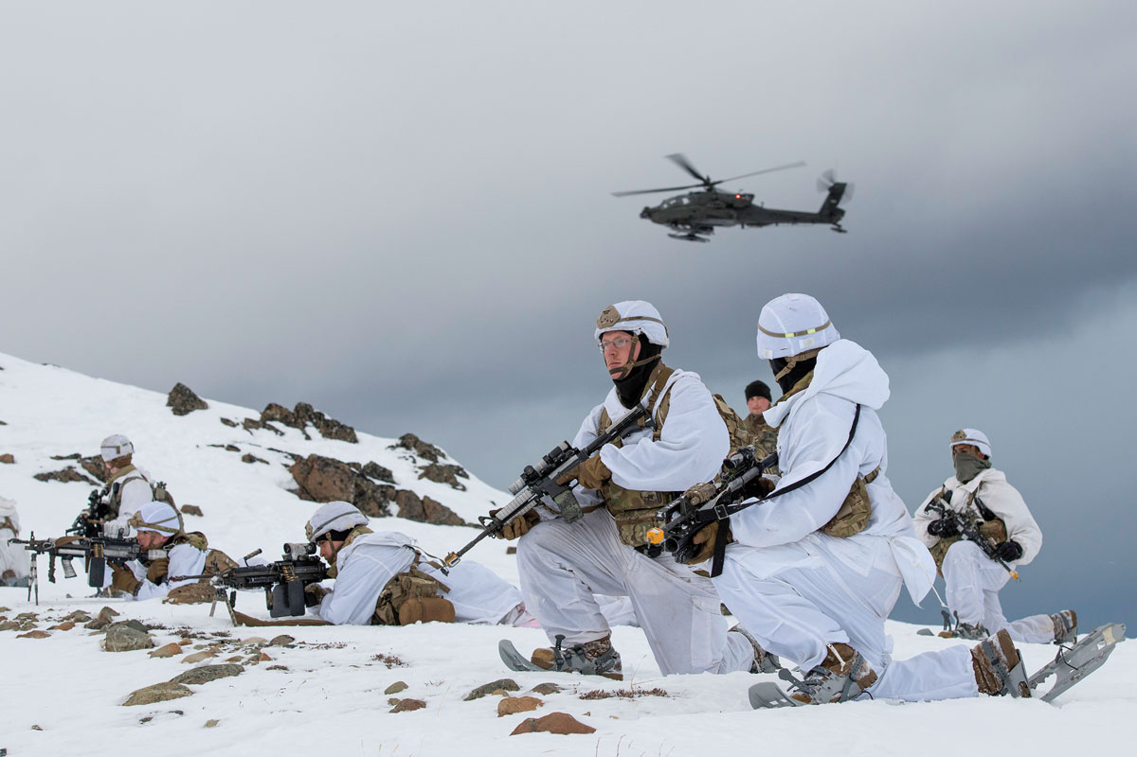
Figure 1 US Army Paratrooper conducting joint field training exercise [3]

2. Background to the Proposed Research
ETC is a unique environmental test facility with an explosive license to complete testing on Live munitions and explosives. The CL10 Ice test, a test that ETC is contracted to have the capability to deliver and is currently accredited to ISO 9001 via UKAS. This accreditation is maintained through audits demonstrating the quality management processes during testing. However, the current SSoW for using the Icing test equipment requires review and updating in line with latest HSE guidance and QinetiQ global instruction to ensure QinetiQ can maintain the capability contracted under the LTPA. Demand is low for this test facility, an analysis into the relevance of this testing and how it can be improved to appeal to our customer’s requirements will be completed.

3. Aims & Objectives

3.1 Aims and Objectives
- Develop a comprehensive risk assessment for the activity by (22/07/2025) identifying all major hazards including the eight already identified. Implement all further controls identified prior to training commencing on (14/08/2025) using the hierarchy of controls shown in figure 2. This will be completed in line with ISO 9001:2015 requirements for risk based thinking.
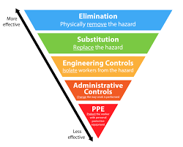
Figure 2 Hierarchy of Controls [4]
- Standardise work instructions for Test procedure allowing someone with limited knowledge of the test can complete test preparation and completion. To be completed by (22/07/2025) and suitable for both internal and external audits.


Figure 3 SSoW [5]

- Conduct a review and performance evaluation of the current Icing test methodology and the environment that QinetiQ operates in to identify three improvement opportunities.
- To making the test more efficient using principles in Figure 4
- To improve accuracy of the test
- To understand what customers require so that more bids can be secured for ETC.
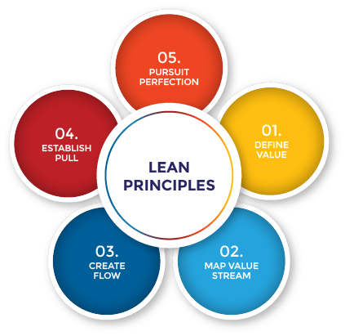
Figure 4 LEAN Principles [6]

3.2 Project justification

This project is to maintain capability at the Environmental Test Centre as part of the LTPA. Failure to do so results in large financial penalties for QinetiQ. Additionally, operational test equipment will allow QinetiQ to Bid for more work allowing increased revenue for the Company. The Analysis of the ice accretion test will provide QinetiQ with the ability to justify to the MOD if the capability can be removed or if it should be updated to fit the current test and evaluation environment.

3.3 Defining success

- Baseline success – Compliance and Continuity
The fundamental measure of success is ensuring that the UKAS deadline is met and ETC remains an accredited test facility for CL10 testing.
- Enhanced success – Facility improvement and risk reduction
This focuses on improvements to the facility and the test methodology. This aims to further reduce the risk of completing the activity and support long term compliance.
- Aspirational success- Business growth
Leveraging the improvements and analysis made to attract additional testing work and hence increase ETC’s revenue and market presence.

4. What is Ice Accretion Testing?

4.1 What is Ice accretion testing?
Ice accretion or Ice build-up testing is layering of ice onto a test item to simulate climatic conditions experienced by Submarines, Surface ships and/or land-based vehicles in climates M3, C0, C1, C2 and C4 as shown in Figure 5. The test item is held at sub-zero temperatures a water/salt solution is sprayed onto the item until a specified ice thickness is achieved. Once Ice Layer is stabilised performance tests can be completed. At ambient conditions the items will be inspected for damage. [7]
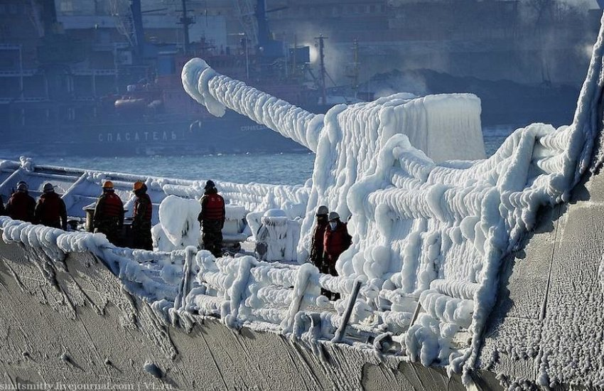
Figure 5 Icing on deck of South Korean warship [8]

4.2 Informing design decisions
Ice build-up can test factors include mechanical properties from loading mass on the test item; testing seals; testing solenoids, actuators; de-icing agents. This will be captured by post-test inspections and relayed back to the customer/s. [2]
The designers of the test items can use this information to change the materials used, strengthen areas of the design if a failure occurred and/or implement heating/de-icing measures in the system as shown in the figure 6 below. [7]

Figure 6 Air Canada GaN de-icer technology [9]

4.3 Tests and test facilities alternatives
The CL10 icing test is just one icing test out of many. Other Defence Standards 00-035 tests simulating similar Arctic conditions. Other standards also include tests: EUROCAE/ED – 14 and RTCA D0160, BS EN 60068, STANAG 4370 AECTP 300 and MIL STD 810 [7].
These standards differ by focusing on snowy, high altitude and Ice Impact test conditions. Throughout the analysis phase of the project these tests will be compared to the testing ETC is currently contracted to deliver and its relevance. Table 1 shows UKAS accredited test facilities and how unique ETC is with an Explosive Licence.
Table 1 UKAS accredited test facilities
Facility | Live or Inert
ETC QinetiQ | Live and Inert
TUV SUD [10] | Inert
Faraday test centre (Bae) [11] | Inert
MBDA Stevenage [12] | Inert

An alternative to the physical test and evaluation is using numerical modelling and artificial intelligence to simulate the effects. There is already research into this field and further investigations will be completed for this test. [13]

4.4 Risks, Limitations & Ethical Issues
Table 2 Risk Register
Issues | Solution
Physical Risks | Hazards arising from testing will be managed via comprehensive Risk Assessments and Method statements creating a complete SSoW
Technical risk – failure to achieve test levels | - SME input  - Variety of Test Equipment  - Water quality a large focus due to research into demineralised water not freezing at temperatures required. [14] [15]
Limitations  - MOD may not be willing to incorporate the findings from this project  - Budget | - Information gathered may not prompt immediate change due to resource and budget constraints however will remain pertinent for future contract negotiations
Ethical Issues | - Captured in Annex A with Draft Ethics Form.  - Focus groups and Interviews present minimal risk, classifying as a low risk activity.

6. Resources & Planning

6.1 Resources Required
A project plan has been created via stakeholder meetings. Attendees included those in Table 4. This plan has broken the overarching deliverable of meeting the UKAS audit deadline into smaller task with their own milestone. Physical and Human resource is captured in Tables 3 and 4.

6.1.1 Physical Resources
Table 3 physical resource
Name | Type of equipment
ETC Building 53 | Test cell /Building
Chamber AU | Climatic test chamber
Water spray bottle
Ice thickness gauges
PPE
RPE
Water to test specification
Stopwatch

6.1.2 Human Resources
Table 4 Human resource
Role | Requirement | Hours required(hrs)
Climatic technical specialist | SME knowledge in Test | 60
Operational safety manager | Provide guidance on SSoW | 5
Group lead | Provide sign off and accept risk | 5
Operations team lead | Provide working facilities | 5
Climatic Team lead | Approve resource | 5
Environmental test technicians | Assist with equipment preparation and set up | 40
Explosive safety manager | Provide guidance on Explosive safety | 5
Head of Energetic and environmental test | Provide sign off on SSoW due to medium risk | 2
Environmental test Engineer | Provide knowledge and assistance with equipment set up | 40
Mechanical engineering apprentice | Manage project, SSoW and coordinate all other resource for project | 180

6.2 Gantt Chart
The project plan captured in the Gantt chart has been developed through consultations with key stakeholders and analysis of activity duration, scope, resource and dependencies like equipment maintenance. Table 5 illustrates the waterfall project plan in Gantt format. The text highlighted pink shows activities on the critical path and delays to those activities will result in failure to meet the milestones.
Table 5 Project plan and Gantt chart
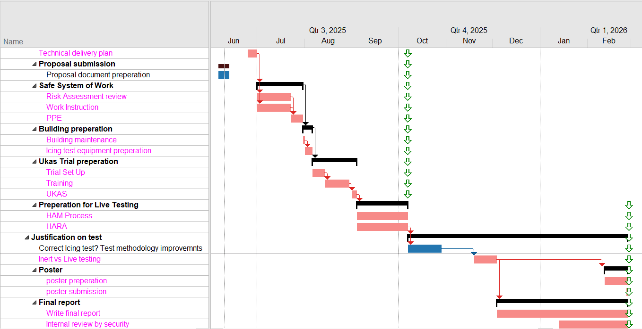

7.

References

[1] | D. U. A. Chief Warrant Officer 4 Michael Lima, “Army University Press,” September - October 2024. [Online]. Available: https://www.armyupress.army.mil/Portals/7/military-review/Archives/English/September-October-2024/Arctic-Munition-Operations/Arctic-Munition-Operations-UA.pdf. [Accessed 11 June 2025].
[2] | DEPARTMENT OF THE ARMY, “OPERATION AND MAINTENANCE OF ORDNANCE MATERIAL IN COLD WEATHER,” in Field Manual 9-207, Vols. FM 9-207, Washington DC, DEPARTMENT OF THE ARMY, 1998, pp. 1-85.
[3] | U. A. Lt. Col. Joshua P. Bost, “Army University Press,” January - February 2024. [Online]. Available: https://www.armyupress.army.mil/Portals/7/military-review/Archives/English/JF-24/Arctic/Assured-Mobility-in-the-Arctic-UA.pdf. [Accessed 12 June 2025].
[4] | Vector Solutions , Risk Assessment policy, Haywards Heath: Vector Solutions , 2024.
[5] | l. Bloom, “Dozuki,” Dozuki, 2025. [Online]. Available: https://www.dozuki.com/blog/benefits-of-implementing-proceduresvs-work-instructions-in-manufacturing. [Accessed 12 June 2025].
[6] | D. Do, “The Lean Way,” The Lean Way, 5 August 2017. [Online]. Available: https://theleanway.net/The-Five-Principles-of-Lean. [Accessed 12 June 2025].
[7] | Ministry of Defence , “UK Defence Standardization,” 14 December 2023. [Online]. Available: https://oauth2.defencegateway.mod.uk/Account/Login?ReturnUrl=%2Fsaml%2Fsso%2Flogin%3FrequestId%3D_DwWNW4KHI4MtuNL2eydz1NnNhfkGzeWhA. [Accessed 11 june 2025].
[8] | C. Dyrcz, “PHENOMENON OF ICING AND A REVIEW OF ICE ACCRETION NOMOGRAMS, MODELS AND CHARTS IN NAVIGATION,” Polish Naval Academy , Gdynia, 2019.
[9] | Military + Aerospace Electronics, “Military + Aerospace Electronics,” Endeavor Business Media, 6 December 2023. [Online]. Available: https://www.militaryaerospace.com/commercial-aerospace/article/14302320/air-canada-becomes-first-airline-to-install-gan-de-icing-technology-from-de-ice. [Accessed 12 June 2025].
[10] | TUV SUD, “TUV SUD,” TUV SUD, [Online]. Available: https://www.tuvsud.com/en-us/resource-centre/blogs/mobility-and-automotive/ice-freeze-and-rain-testing. [Accessed 11 June 2025].
[11] | BAE systems , “BAE SYSTEMS,” BAE Systems , [Online]. Available: https://www.baesystems.com/en-uk/uk-businesses/electronic-systems-uk/faraday-test-centre/environmental. [Accessed 11 June 2025].
[12] | UKAS, “UKAS,” 25 june 2024. [Online]. Available: https://www.ukas.com/download-schedule/0066/Testing/. [Accessed 11 June 2025].
[13] | T. I. Kazuma Nogi, “Numerical simulation of rime ice accretion on airfoil using rigid sphere model,” Computers and Fluids, vol. 275, no. 106244, 2024.
[14] | M. M. a. D. G. Xin Yang, “Sticking–Erosion Model for Ice Crystal Icing Using Particle Size Distribution,” Aeronautics, vol. 61, no. 11, pp. 4976 - 4989, 2023.
[15] | Q. W. D. H. Y. X. S. L. P. W. Yiheng Zhang, “Dynamic splitting tensile behaviours of distilled-water and river-water ice using a modified SHPB setup,” International Journal of Impact Engineering, vol. 145, no. 103686, pp. 734-743, 2020.

8. Appendix


