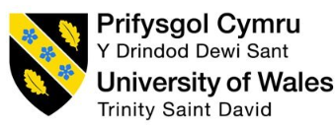

Task 3
REFLECTIVE REPORT

Student ID:2244970
Student Name: Manailescu Anca
Prof.: Sukhpreet Grewall

Table of Contents
Introduction 2
Stage 1: Description 2
Stage 2: Feelings 2
Stage 3: Evaluation 3
Stage 4: Analysis 4
Stage 5: Conclusion 4
Stage 6: Action Plan 5
References 7

Introduction
A reflective report is about expressing opinions and reflecting upon individual learnings on a specific subject. Through this reflective report, the academic skill development process by completing the learning module will be discussed. Academic skills are important because the skills are intertwined with academic performance (Ramzan et al. 2023). Gibb’s reflective cycle is a powerful tool that helps to create a structural approach for professional and personal growth (Hashim et al. 2023). I use this reflective cycle to reflect upon the development of my academic skills, namely academic writing skills, note-taking skills, and paraphrasing skills. The reflective report provides various opportunities that are crucial for future professional endeavours. My aim in this study is to demonstrate the significance of these skills in the improvement of my personal and professional performance.
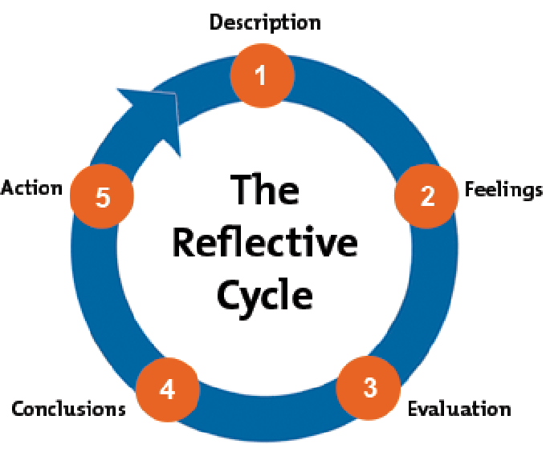
Figure 1: Gibb’s Reflective Cycle
(Source: Researchgate, 2020)

Stage 1: Description
This session provided the environment for me to enhance my academic writing skills as the in-class activities and exercises have contributed to my success. I especially admire the advice provided regarding essay structure, how to build clear and concise sentences as well and maintaining a flow of writing by covering all the task requirements. Proper review of my written works helps me identify my mistakes and grow a deep understanding about conventional academic writing to avoid repetition of the previous mistakes.
I can articulate a variety of effective note-taking strategies ranging from capturing key information during discussions to the incorporation of self-developed pictorial representations. These methods include such things as writing abbreviations and note cards, as well as outlining concepts or stories, taking into consideration the relevant details and the main ideas. The skill improved my ability to review the course content which positively impacted my comprehension as well as knowledge gathering from study materials.
Meanwhile, I have learnt how to improve my writing without plagiarizing. In the course, I have harnessed the paraphrasing skill of interpreting the true content of a source document correctly and paraphrasing it without losing its meaning while still preserving the core content. This is very helpful in terms of including supporting arguments as well as a paraphrasing of the sources read during writing for instance written assignments (Cheong et al. 2023).

Stage 2: Feelings
Assessing my acquired academic skills enriched me with the feeling of achievement and improves my confidence.
The experience of mastering academic writing skills has brought me satisfaction. I can effectively structure my thoughts, produce a coherent argument, and convey my concepts succinctly. The feedback I have received has been greatly valuable, it has assisted me to pinpoint the areas in which I can enhance my writing style to produce a better quality of work.
Moreover, I have gained new skills of note-taking that made a big difference in my ability to work with course materials and participate in class discussions actively. I sense greater preparedness and more confidence in my skills to pick and explain the main points.
Paraphrasing skill is one of the major aspects which has been noted as an important part of my learning journey. I am confident that I am well-versed in integrating academic sources into my paper, while at the same time, ensuring that I do not plagiarize or misrepresent the original ideas. This skill has given me a confidence boost in doing my research and creating a solid written piece.

Stage 3: Evaluation
Evaluation of learning progress, I can say with confidence that I have ensured good progress. This module has been the cornerstone of my knowledge base and has equipped me with the right tools to excel in all these areas.
I have made great progress in writing academic papers. My writings have become much clearer and better organized with time. I have learnt the process of writing organized paragraphs and crafting logical arguments with convincing evidence to support my ideas. The feedback from the professor helped to understand the lacking area in this skill (Olsen and Hunnes, 2024).
Regarding my improved note-taking skills, I have noticed an improvement in my speed and accuracy when recording important information in classes and seminars. My transition from listening to notes has improved my ability to distinguish between main ideas and supporting details. I can quickly and accurately remember the most important points. I have been able to effectively compare the course materials with my proper understanding. Listening skills also improve through these note-taking practices which majorly contributed to improved performance in examinations (Braganza, 2023).
However, Conclusively, my paraphrasing skills become more polished and consistent. In my capacity as a student, I have gained the confidence to provide a faithful interpretation of the original material in my own words, which at the same time maintains the integrity of the original ideas and protects from plagiarism. This has helped me improve my research skills which I apply to my academic work.

Stage 4: Analysis
In the analysis phase, I can clearly understand my academic improvement which help me for future growth. The enhancements in writing, note-taking, and paraphrasing skills have had a positive ripple effect on the overall field of learning (Linkedin, 2023).
Acquired advanced skills in academic writing have helped me to write better assignments and essays which is reflected from the improved scores and comments from the instructors. The capability to organize my ideas logically, form persuasive arguments and communicate ideas has been a great asset to me in terms of showing my understanding of the coursework and being involved in academic discussions.
Reinforced note-taking skills help to enhance my ability to absorb and retain information during lectures, and provide the necessary foundation for my participation in class discussion and group work. Through the ability to grasp main points quickly and precisely, I become able to take part in discussions more actively, ask informed questions and make conclusions based on data from various sources.
The refined paraphrasing skills have boosted my confidence when it comes to research and writing papers with the proper attribution of outside sources. I am now able to incorporate relevant evidence to back up my arguments without having to forget to acknowledge and represent the original ideas of the authors. This has broadened the authentic and intricate nature of my academic writing.

Stage 5: Conclusion
In the final analysis, the evolution of my academic skills in writing, note-taking, and paraphrasing has been a tremendously transformative experience in this class course. The variety of learning activities and the practice for skills application gave me a chance to considerably enhance my capabilities in these topics. My efficiency in performing in the current module has significantly been enhanced and will benefit me in the future both in my academic and professional life. The special part of learning and communication is a great source of academic success like essays, meetings and paraphrasing a fact completely. The module has given me a nourishing ambience to be challenged in interaction with my peers and to receive supportive feedback from the tutor.

Stage 6: Action Plan
Skill | Period | Planned Activities
Academic Writing | 6 Months | - Apply learned techniques for structuring and organizing written assignments  - Focus on crafting clear, concise sentences and constructing persuasive arguments  - Integrate relevant evidence to support claims  - Seek feedback from instructors and peers to identify areas for improvement
Note-Taking | 3 Months | - Experiment with different organizational methods and digital tools  - Practice identifying and recording key information during lectures and discussions  - Regularly review and refine notes to ensure they are comprehensive and easily accessible
Paraphrasing | 3 Months | - Diligently apply techniques learned for accurately conveying meaning from source material  - Carefully read and understand sources before paraphrasing  - Ensure proper citation of sources to maintain academic integrity
Supplementary Activities | 4 Months | - Seek out workshops or tutoring sessions to receive additional guidance and practice opportunities  - Actively engage with instructors and peers to get feedback and deepen understanding of these skills
(Source: Self-created)
Action plans are very useful for recovering the weak areas of individuals through setting objectives (Mindtools, 2024). The plan allows to identification of the priorities through a clear timetable of activities as well as tasks. The action plan helps to improve my academic performance through the improvement of my academic skills. I will try to apply structural and stylistic techniques to the purpose of academic writing.
I continuously experiment with new strategies to improve my note-taking skills. Exploration of digital note-taking tools as well as organizational methods is part of the experiment. In addition, I make a habit of reviewing as well as refining all notes regularly.
I diligently applied my paraphrasing skills in my academic writing as well as research-based work. Proper reading and understanding source material, identification of main ideas as well as conveying actual information become parts of daily routine. Active engagement with peers, taking feedback as well as proper discussions can improve paraphrasing skills. I can improve my areas of strength and remove my weaknesses with the proper implementation of the action plan. These competencies are not only going to help me in this module but also will be the constant forces that are going to lead me in my academic and professional career.

References
Braganza, A., 2023. Pencil or Pixel: Is the iPad and Apple Pencil a More Effective Aid for Memory Retention for Students in Grades 11 and 12 Than Using Paper and Pen for Handwritten Lecture Note-Taking?. https://www.researchgate.net/profile/Alexa-Braganza/publication/378127417_Pencil_or_Pixel_iPad_and_Apple_Pencil_Versus_Pen_and_Paper_Memory_Retention_in_Grades_11-12/links/65c8274e79007454976fb368/Pencil-or-Pixel-iPad-and-Apple-Pencil-Versus-Pen-and-Paper-Memory-Retention-in-Grades-11-12.pdf
Cheong, C.M., Luo, N., Zhu, X., Lu, Q. and Wei, W., 2023. Self-assessment complements peer assessment for undergraduate students in an academic writing task. Assessment & Evaluation in Higher Education, 48(1), pp.135-148. https://www.researchgate.net/profile/Wei-Wei-219/publication/360309851_Self-assessment_complements_peer_assessment_for_undergraduate_students_in_an_academic_writing_task/links/63be63b7097c7832caa74232/Self-assessment-complements-peer-assessment-for-undergraduate-students-in-an-academic-writing-task.pdf
Hashim, S.N.A., Yaacob, A., Suryani, I., Asraf, R.M., Bahador, Z. and Supian, N., 2023. Exploring the Use of Gibbs' Reflective Model in Enhancing In-Service ESL Teachers' Reflective Writing. Arab World English Journal, 14(2). https://www.researchgate.net/profile/Ina-Suryani/publication/371830975_Exploring_the_Use_of_Gibbs'_Reflective_Model_in_Enhancing_In-Service_ESL_Teachers'_Reflective_Writing/links/64d4ddd51290c33cce866847/Exploring-the-Use-of-Gibbs-Reflective-Model-in-Enhancing-In-Service-ESL-Teachers-Reflective-Writing.pdf
Linkedin, 2023, Knowledge, Available at: https://www.linkedin.com/pulse/power-note-taking-enhancing-your-knowledge-avil-beckford#:~:text=Summary,deep%20learning%20and%20critical%20thinking.
Mindtools, 2024, Action plan, Available at: https://www.mindtools.com/a1nq46m/action-planning
Olsen, T. and Hunnes, J., 2024. Improving students’ learning—the role of formative feedback: experiences from a crash course for business students in academic writing. Assessment & Evaluation in Higher Education, 49(2), pp.129-141. https://www.tandfonline.com/doi/pdf/10.1080/02602938.2023.2187744
Ramzan, M., Bibi, R. and Khunsa, N., 2023. Unraveling the Link between Social Media Usage and Academic Achievement among ESL Learners: A Quantitative Analysis. Global. Educational Studies Review, VIII, pp.407-421. https://www.humapub.com/admin/alljournals/gesr/papers/cBmpxMq8KB.pdf
Researchgate, 2020. Reflective cycle. Available at: https://www.researchgate.net/figure/Gibbs-Reflective-Cycle-Image-credit-Mind-Tools_fig8_342875663

