Student Number: 1706412
Module Number: EAEE4003/C
Word Count: 3,300

TRANSITION
IN THE EARLY YEARS

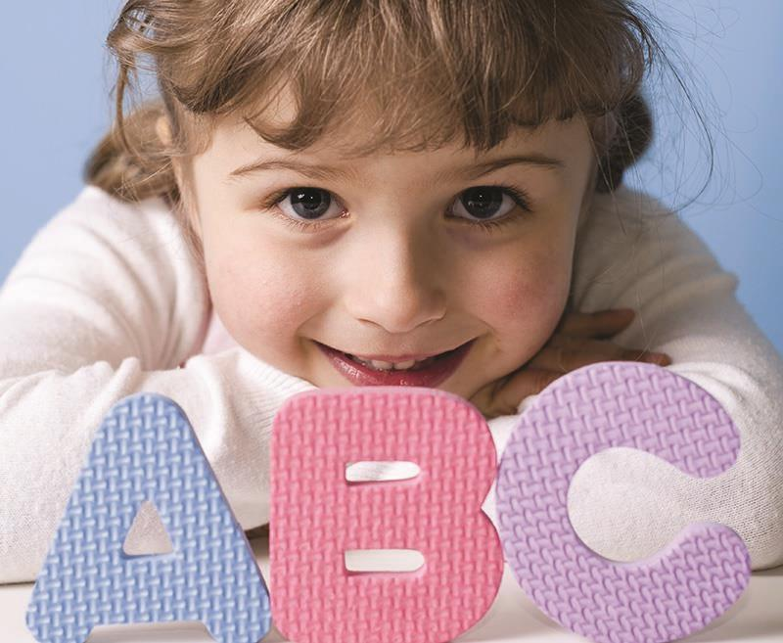



(Source: Early Years Matters, 2017)

(Source: Aubrey-Smith, 2016)
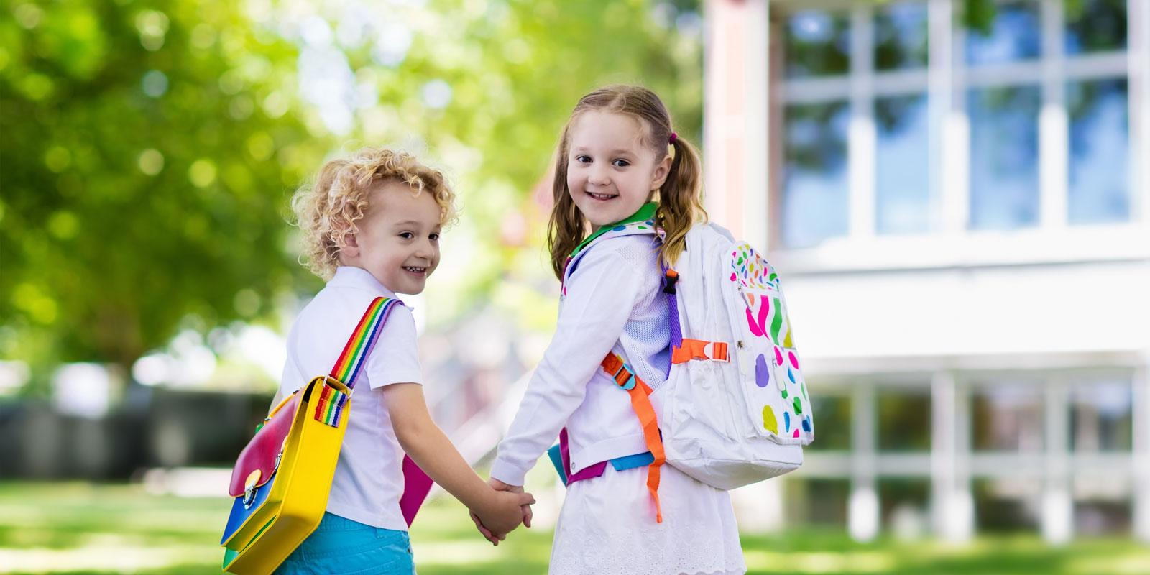
(Source: QA Nursery, 2017)
Contents
Section 1- Aims and the importance of transitions 4
Introduction
Aims
Why transition is important
Attachment Theory
Section 2- Communication and Partnerships 5
Why is it important?
Every Child Is Unique
Section 3- Transition Activities 6
Foundation Phase Network
Section 4- Play 4
Physical development
Emotional development
Social and cognitive development
Section 5- Conclusion 11

Section 1-Aims and importance of transitions
From a very young age, children are faced with changes in their everyday life. They learn to deal with them through watching adults resulting in them being able to face challenges. Before they reach the age of 6, children are faced with transitional changes such as being transferred into a school setting for the first time. Children deal with these situations in different ways. Some may take it in their stride whilst others may have long lasting effects. Confidence can be built up through gradual changes and through being supported by those around them (Kirklees, 2013).
Aims
This handbook is for anyone who works with children as it is not only the parents who are involved. Other adults involved with transitions include:
- Teachers
- Administration Staff
- Health visitors
- School Nurses
- Dinner Ladies
- Parents who volunteer/help
These people play an important role in helping a child through transition. This handbook is to give guidance to all involved in the early years sector found upon successful methods that support the children and their families during the process. This guidance helps with those transitioning from the Foundation Stage into Key Stage 1 (Allingham, 2012). It is important for the families and child’s needs to be considered through the transition stages and for it to be made a positive learning experience for the child rather than an obstruction to their education (Brooker, 2008).
(Source: Raunaquiah, 2013)
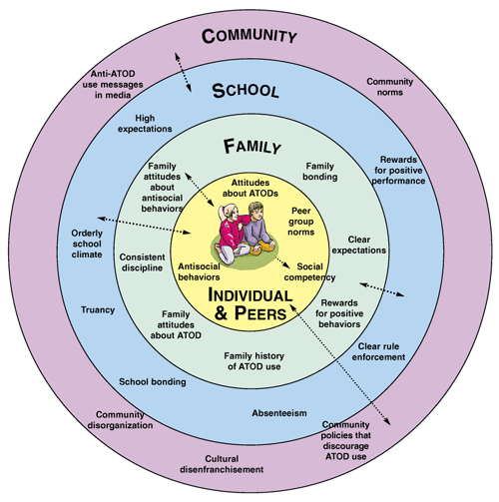
Why transition is important
Whilst there have been many attempts to explain and define the transition process, Bronfenbrenner’s theory helps describe how a child’s environment will influence their development throughout life. The settings the child experience such as their home or school, is described as a microsystem which is demonstrated in the diagram on the right. Each of the microsystems play a part in the child’s development. However, the argument that Bronfenbrenner puts forward is that the most significant influence on a child’s welfare is the links made between the microsystems, none as a mesosystem. This means that the more links there are, and the stronger they are, the better the child’s experiences and development will have.
It is a time that the child and parent or carers experience an emotional time through the transition phase. It is acknowledged as an expected time for the child to go through and is genuinely seen as a positive aspect of a child’s life as they move up through school. However, it is not a smooth transition for every child. Through supporting the child and parent or carer in transitioning to the new environment, it will help the child feel confident and supported in this new stage and process they will go through.
Attachment Theory
Bowlby’s attachment theory is a good way of explaining the importance of keeping the families or main carer involved in the transitioning stage. He believes that children are brought into the world already programmed to want an attachment with someone to survive. He explains that they tend to display behaviours such as crying to their main carer when left with a stranger for example. He argued that the bond between a mother and child is different from any other relationship. Bowlby believes that the need for a child and mother (in most cases) to stay in close contact with each other is inevitable.
He suggests that disruption between the strong bond between the two can have severe consequences with future social relationships (McLeod, 2007). If the attachment with the mother is none existent in the first two years of the child’s life, he believes it will lead to what he calls ‘maternal deprivation’. McLeod (2007) states that ‘Bowlby used the term maternal deprivation to refer to the separation or loss of the mother as well as failure to develop an attachment.’ Bowlby found that the lack of attachment could lead to absence of cognitive, social and emotional skills. He also explained how when starting the child in a school setting for example, the child may act out due to separation from the main career. This shows why it is important for the child to be gradually transitioned into the school environment as they may not have experienced being left without their main attachment figure.

Child needs to attach to one main attachment figure

Material Deprivation

Child needs to receive care from attachment figure for at least the first two years of life
If not met will lead to..

Delinquency

Reduced intelligence
Depression
Increased aggression
Section 2- Communication and Partnerships
Communication is the basis of a successful transition phase as it must be available during all stages of the transition. Maintaining good communication with the families is good to create partnerships. Partnerships between the families and key workers mean that the child’s wishes and interests are the focus always. The child and their families are the main individuals involved in the transition, so it is important they are a main part of the transition team which also consists of the key workers. It is crucial for the families to be involved with:
- Referral, evaluation and placement
- Placement options
- Transition preparation for the children
Why is it important?
It is important to have partnerships between the families and the educators. It is important for the professionals to have good listening skills and give information to families in a way that is easy for them to understand such as information about the transition process in school newsletters to avoid miscommunication. Family members should receive the vital information and support for them to be able to plan for their child’s transition (Jo-Anne and Jane, 2002).
Positive relationships are a key way for children to gain confidence and independence. By having a positive relationship with the key worker, the child will feel a strong sense of belonging which will help them settle in to the new environment. It allows the key worker to understand what the child’s needs, wishes and interests are as they will have that strong relationship with them. A positive and healthy environment can be developed for the child by the key works and families through having a strong partnership.
Every Child Is Unique
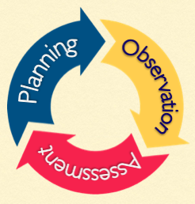
Every child is unique as they have their own individual needs, interests and capabilities. Practitioners should observe the children with their development through watching them play and their interaction with others. This will help them to identify the child’s social skills. Through observing a child, the key worker will be able to identify any additional support needed. They may also ask parents what they do at home to help know where the child is in their development. From this the key workers can assess ways to support the child with the areas that may need improvement. They can then plan and challenge the areas that the child need further support in by helping to develop those skills.
(Source: Brodie, 2015)

Section 3- Transition Activities
Transitional activities are very important for the families and the child when moving into year 1 as it is a big stage in their lives. They give them opportunities to find out information about the school and time to get to know the teachers they will be involved with. This helps the child feel settled and less nervous about attending the school. The families can have any questions answered about when the child is able to start. This shows the importance of families visiting the school and getting to know the teachers and it also means the teachers can find out information about the child that they are going to be looking after.
It is essential for both the families and school to confirm with each other about whether the child has a place in the setting. This is because it can be very upsetting for the child if they are visiting a school they will not be attending. There are many activities that can be done by both family and key workers to enable to the child to settle in to their new setting. This includes:
Allow the parent and child to attend together on the first day (Ofsted, 2014).

o
Visits to the school they will attend so they can become familiar with the environment
The pre-school key worker could create a booklet for the teachers of the new school about the things the child likes for example (Ofsted, 2014).

Read a book to them on the visit day that will be ready to them at the beginning of every term
Transitional Activities

Encourage parents to come in and discuss how the child is settling in so they can further assist the child if needed
Carry out home visits to meet the child in the comfortable environment so connections can be made
Provide the parents with clear information about whether the child is having halve days or full days when they first start and their role as a parent on the first few days
The key worker could take pictures of the child during the visit and create a picture board in the classroom for the child to look at when they start the school
The key worker of the new setting can ask the child’s reception practitioner what the child’s routines are

Foundation Phase Network
These transitional activities will have an affect on the child’s physical, emotional, social and cognitive development. Play develops not only social skills, but also intellectual skills as they are learning to be creative. Play shapes how children think of the world and interact with others.
According to the Foundation Phase Framework (2015), it is important for the key workers of the school to plan the curriculum around the child’s skills that they need to be able to develop and grow. A good thought out curriculum will give the child opportunities to be involved and build upon the skills and knowledge they already know. According to the Donaldson Report (2015), there are six areas of learning and experience that should be incorporated with the curriculum. This includes:
- Expressive Arts
- Health and well-being
- Humanities
- Language, Literacy and communication
- Mathematics and numeracy
- Science and technology
Section 4-Play
Importance of play on physical development
According to the Foundation Phase Network (2015), children’s physical development should always be promoted in an area of the curriculum. Here are some physical aspects that can be developed:
- Coordination
- Gross and fine motor skills
- Confidence
- Control of body movements
- Balance
- Sensory awareness
- Use of equipment and tools
Opportunities to engage in physical activities helps promote these abilities. Children should be given time to try out new things. This links with Montessori’s idea of children being provided with real tools that work. For example, a real knife instead of a plastic one. Her approach is not the normal route that the school education system takes. She works closely with children but allows them an environment that they can explore without the fear of doing something wrong through access to equipment and tools (MontessoriMom, 2016).
Moving into year 1 means the child is more likely going to be feeding themselves. Although this may get a bit messy, it gives the child a chance to develop their motor skills as they will be developing their eye coordination. Many children find drawing pictures and colouring fun, but it also allows them to develop their fine moto skills as they pick up the pen or pencil and push it down on the paper. By the time they move into year 1, children are normally given the chance to play outside during lunchtime or games time, so they can play different games that may involve a ball such as catching and throwing. Many also like to play skipping and tag games so this all contributes to their motor skills and coordination as well as building towers with blocks and putting a puzzle together.
Outdoor play involves football or making a daisy chain. They all help develop those physical skills that are essential. Outdoor play can be adapted to meet the child’s needs as some learn and develop better outside. Art can be a lesson that is taught outside as the children can use chalk or sticks to create a picture on the ground. This helps develop their independence and confidence. In year 1, the child should have gathered the concept of personal hygiene and safety such a washing their hands. This shows their understanding of their physical and personal hygiene. Rachel and Margaret McMillan both had influence on there being medical checks for children, so this also helps children gain an understanding of their bodies and the importance of being healthy. They should be aware of how exercise keeps you fit and healthy and the importance of safety when carrying or lifting equipment (Foundation Phase Framework, 2015). Play has proven to decrease stress levels and help with fatigue.
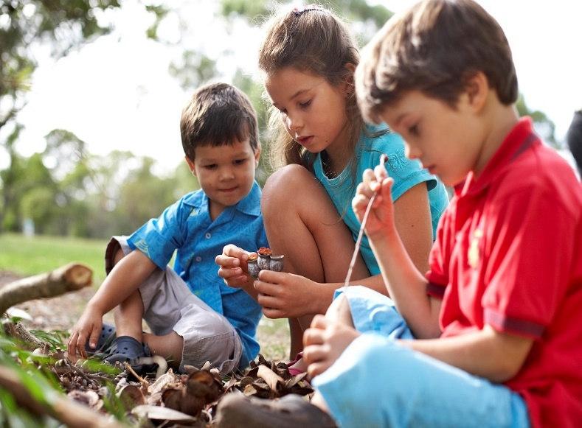

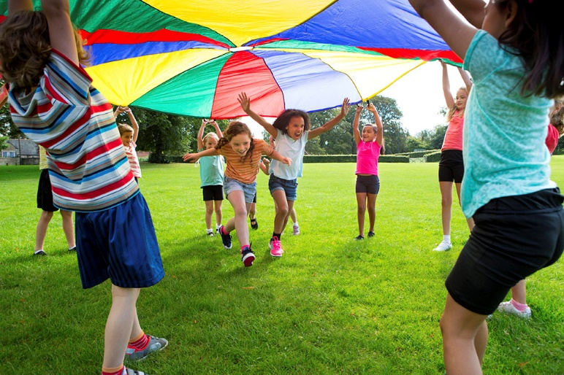
(Source: Brown, 2012)

(Source: Chelsea Kids, 2016)

Importance of play on emotional development
Every child will leave reception with a different maturity, experience and developments. It is important to consider the child’s emotional state when they move up into Year 1. Children are a lot more perceptive and can identify when someone is happy or sad. They also pick up when a teacher is genuine or not as they look out for fake smiles and eye rolls for example.
When a child is happy with their achievements, they will have a great deal of self-esteem and self-worth which is important for a child to feel when developing new skills and concepts. Children are often given goals to reach when doing work and a reward if they reach this goal. This gives the child a chance to motivate themselves to do the task to receive the reward. They must not be out of reach or too easy otherwise the child will give up. A previous experience may affect how a child reacts in certain situations for example they may feel uncomfortable and nervous interacting with children as they may have not experienced this but may feel comfortable talking to an adult. It could mean that they don’t develop from solitary play for a long time. This shows how home life can influence the child’s decisions. A child may not give their best in something if they have slow self-esteem, so it is important to support them by making them aware of their own personal achievements (Beckley, 2012).
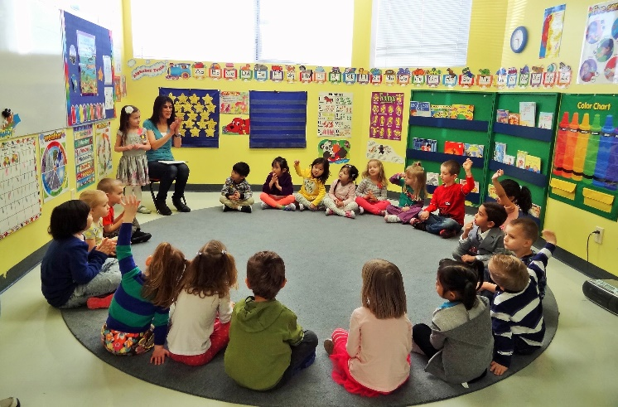
According to Beckley (2012), children experience a range of emotions when in an early year setting such as happiness and enthusiasm to anger and wanting to withdraw from the situation. These emotions can be recognised by the key worker and they can support and help the child in a way that best suites them. Children need to feel emotionally safe to progress and achieve. Circle time is a good way of finding out what the child enjoys and dislikes and what makes them happy and sad. This helps the child with their confidence as they are telling others their emotions. It also teaches children to have empathy with others as they listen to how others feel.
(Source: Unique Kids, no date)
Giving a child praise helps them feel motivated to carry on behaving or acting this way. Praise can be given for their academic achievements to give them confidence in their work. A child with a different culture to most of the children in the school, may feel unworthy and unable to settle so it is important the key workers identify this and find strategies to help them settle in.
In school, children should be given the opportunity to express their feelings and communicate them to others as well as being sensitive to other’s feelings. They should be able show curiosity to taking part in new experiences and enjoy them. Have the confidence to take risks and explore the indoor and outdoor environment. Froebel’s theory of play demonstrates this as he believes that play was a very important part of early years and children should be given the opportunity to freely play using their creativity as well as developing their motor skills. A child should be aware of when they have done something well or when it needs improving and use their feedback to do this (Foundation Phase Framework, 2015).
Importance of play on social and cognitive development
During a child’s social development, they will learn to be aware and respect individual’s needs and take responsibility for their own actions no matter the outcome. They should understand the rules that are set by the school and that they should be followed by everyone. However, this may not always be the case as some children may have different rules in their home life, so it may take them longer to understand and adjust the school’s rules on behaviour for example. A child should know what is fair, unfair and what needs to be compromised. They should build relationships with other children and have the confidence to play and work alongside others. This may not always be the case for some children as not all have the confidence to go and make friends so may exclude themselves. A child should be aware of other’s cultural backgrounds and that others may have different beliefs and teachings, so it is all about learning to respect others.
During play time, children often speak allowed to themselves showing their understanding of the world. According to Vygotsky, language help’s a child gain self-control over the own cognitive processes such as their memory. He also argued that development takes place socially first in a child’s life. This is because they watch their parents and other family members such as siblings and imitate their actions, behaviour and language. As the children imitate these, parents are normally the important person to help guide them in the right way. His theory on the ‘Zone of Proximal Development’ explains how having a relationship with someone who can aid them moves them into a new zone of development which he refers to as ‘scaffolding’ which helps the child to progress and move forward. This shows the influence that teachers have with children and how relationships between the two are important (Beckley, 2012).
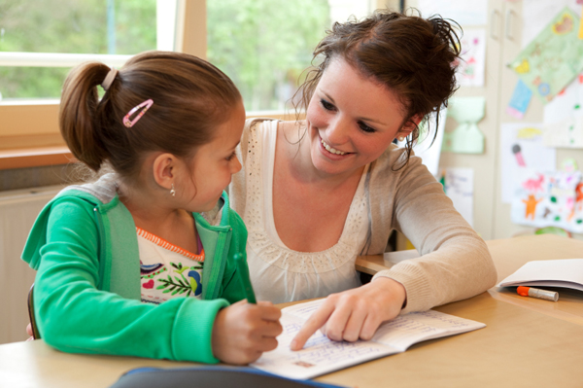
Play with other children allows them to begin to understand others and know that not everyone is the same. It allows them to form strong relationships in the future as they can deal with fall-outs and arguments but also understand when they are in the wrong and need to apologise. By forming friendships, a child will feel comfortable in the school and it will help boost their confidence and self-esteem. It also teaches them the importance of sharing and knowing when it is someone else’s turn to play or have a go on something.
(Source: She Knows, 2010)

Conclusion
This booklet gives an overview on why transitions are important for both parents and child and why communication and partnerships with key workers support the child’s progress with the transition. It explains what the consequences are on the child’s development if the needs and interests of the child are not met. It also highlights the importance of play in early years and why it affects their physical, emotional, social and cognitive development. All the needs of a child need to be considered so they can lead be supported in their holistic development, learning and well-being.

