07/11/2025
Sahyra Khan (2237641)
Module code: ACCA6026
Data Warehousing & Data Mining
Assignment Title: Data Warehousing
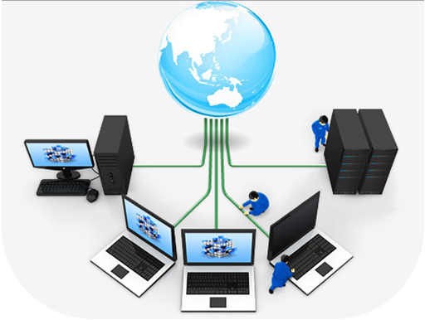

Contents
Contents 1
Executive Summary 2
1.0: Introduction 2
1.1: OLTP vs Data Warehouse 2
Contrast between OLTP and Data Warehouse 3
Benefits for Data Warehouse for Rags’n’Riches Ltd. 3
1.2: Data Warehouse Architecture and ETL 4
Using Internal and External Data Sources to Populate the Data Warehouse 5
1.3: Data Mart for Directors 6
1.4: Normalisation and Dimensional Modelling 9
Dimensional Transport Star Schema for Rags’n’Riches Ltd. 10
Task 2 11
2.0 Introduction 11
2.1: Source Systems 11
2.2: Star Schema Design 11
Star Schema for Rags n Riches Ltd. 13
2.3: Data Mart 13
There are three types of Data Marts: 14
Fact and Dimension Tables per Data Mart 15
Departments and Suitable Data Mart Types 16
2.4: ETL 17
2.5: Data Quality and Governance Issues 20
References 22

Executive Summary

Rags’n’Riches Ltd. is enhancing its strategic decision-making and operational efficiency through the implementation of a data warehouse system. This integrated platform will consolidate data from finance, logistics, inventory, and client operations, supported by a structured ETL process and star schema architecture. The development of department-specific data marts will enable precise analysis and performance monitoring, allowing directors to make informed, data-driven decisions. Overall, the system will strengthen organisational insight, cost management, and long-term competitiveness within the film and theatre industry.

1.0: Introduction

Rags’n’Riches Ltd., established in 1923, hires costumes and props to clients from theatre groups to major film studios. With six specialised warehouses across the UK, it is positioned to benefit from industry growth and tax incentives. However, current IT systems handle only daily operations. A centralised data warehouse would integrate data from all warehouses and systems, enabling management to analyse trends, track performance, and make informed decisions - improving efficiency, customer service, and profitability in a competitive market.

1.1: OLTP vs Data Warehouse
An OLTP (Online Transaction Processing) system is designed to manage the daily operations of a business [1]. For Rags’n’Riches Ltd., it manages daily operations, such as orders, inventory transfers, deliveries, returns, and invoicing. Its highly normalized database ensures fast, accurate transaction processing and prevents data duplication. This system keeps the company’s day-to-day rental activities efficient and reliable.
A data warehouse is designed for analysis and decision-making rather than transactions [2]. It brings together data from all warehouses, finance systems, transport records, and external sources such as supplier costs or industry trends. The data is stored in a dimensional format, making it easier to explore patterns and generate insights.

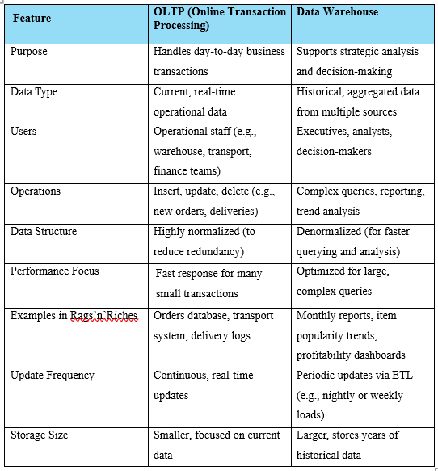
Contrast between OLTP and Data Warehouse
Figure 1 OLTP handles daily transactions efficiently, while a Data Warehouse focuses on analysing historical data for strategic decision-making.

Benefits for Data Warehouse for Rags’n’Riches Ltd.

OLTP (Online Transaction Processing) system manages daily operations like tracking costumes, deliveries, and invoices efficiently, it doesn’t provide management with deeper insights [3].

A data warehouse complements this by analysing rental profitability, seasonal demand, and delivery costs. It gives the CEO and board valuable decision-making insights, helping them cut costs, boost profits, anticipate demand, and plan strategically for sustainable growth in the competitive UK film and theatre market

1.2: Data Warehouse Architecture and ETL

A data warehouse acts as a central hub where information from across the company is collected, organised, and stored in one location [4]. Instead of working with scattered systems in each warehouse or department, all data is integrated so managers can access a unified view. While the OLTP system efficiently manages daily operations like processing orders and tracking deliveries, the data warehouse focuses on analysing broader trends, patterns, and business performance [5].

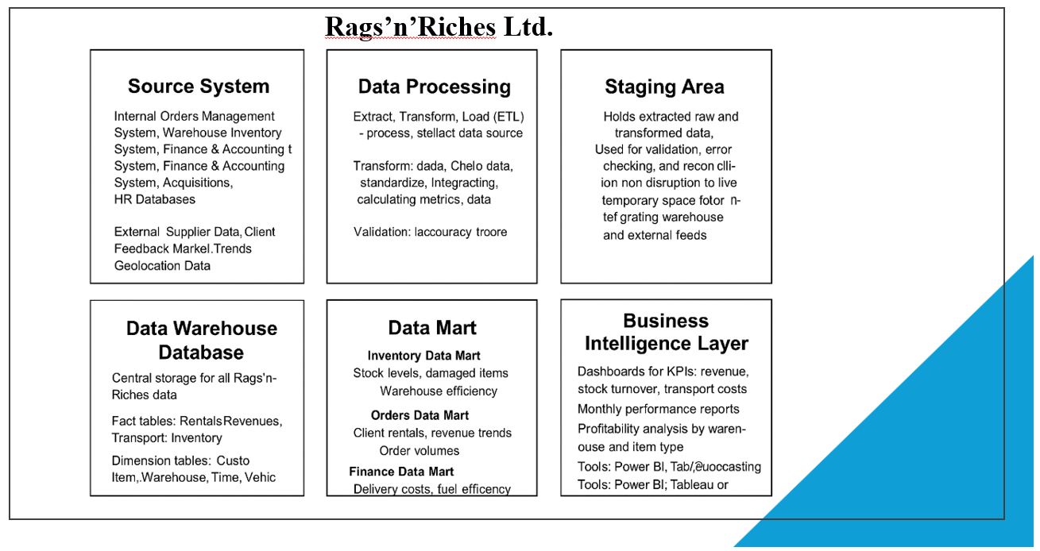
Below is an overview of the key components and layers within a conventional data warehouse architecture:
Figure 2 Main elements of the Warehouse Architecture
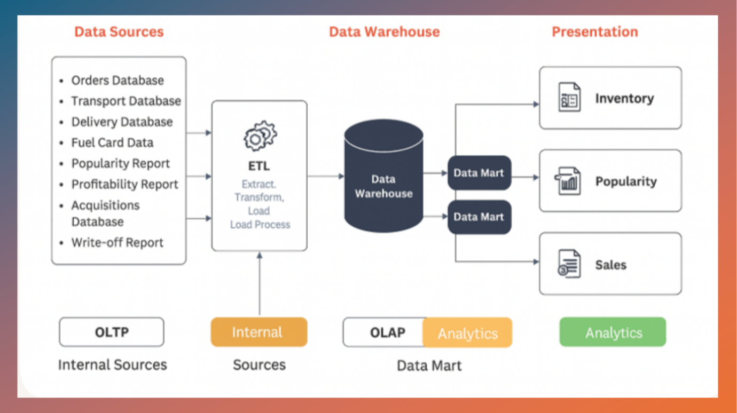
Rags’n’Riches Data Warehouse Architecture

Figure 3 Single-tier Data Warehouse Architecture for Rags’n’Riches Ltd.

Using Internal and External Data Sources to Populate the Data Warehouse

Internal Data Sources:
Internal systems provide essential operational data. The orders database records rental requests, pricing, discounts, and client details. The transport system captures delivery schedules, vehicle usage, and inter-warehouse stock transfers, while the delivery database logs confirmations, client signatures, and inventory checks. Inventory data, collected via staff tablets, includes item conditions, damages, and real-time locations. Additional internal sources such as acquisitions and write-off reports track new or retired items, while finance systems contribute invoices, payment histories, and revenue figures. Fuel card data, mileage logs, and staff activity records offer insights into operational efficiency [6].
External Data Sources:
External data includes client communications, supplier information, and industry reports. Rental confirmations, delivery requests, and emergency orders reveal customer preferences and demand trends. Government policies on film production tax incentives and seasonal demand for costumes and props also inform business planning and forecasting [7].
ETL Process:
The ETL (Extract, Transform, Load) process ensures that data from these varied sources is accurate, consistent, and ready for analysis [8]. Data is extracted from operational systems, transformed by cleansing errors, standardising formats, and integrating related datasets, and finally loaded into the central warehouse. This enables the creation of focused data marts for finance, logistics, and inventory management.
Assurance to the CEO:
The ETL process operates on copies of live data, avoiding interference with daily operations. Data extraction occurs automatically during off-peak hours, ensuring the warehouse remains current and reliable. This approach guarantees that management always has access to accurate, up-to-date information for strategic analysis and evidence-based decision-making.

1.3: Data Mart for Directors

A data mart is a focused, departmental subset of a larger data warehouse, designed to provide specific users or departments with targeted, relevant information for analysis and reporting [9]. Unlike the central warehouse, which holds organisation-wide data, a data mart simplifies access by filtering information according to the analytical needs of a particular business area. This structure improves performance, supports faster queries, and delivers actionable insights directly aligned with departmental objectives.
At Rags’n’Riches Ltd., three key managers - the Managing Director, Finance Director, and Sales and Marketing Director - each benefit from their own data marts tailored to their strategic and operational requirements (Figure 3).
The Managing Director’s Data Mart integrates data from all warehouses and departments, offering a company-wide perspective. It allows analysis of overall performance, including revenue growth, profitability, client retention, and warehouse utilisation. Key metrics might include total rental revenue, cost per delivery, stock availability rates, and overall customer satisfaction. This data mart enables the Managing Director to identify performance trends across all operations and make evidence-based decisions that support strategic planning and long-term growth.
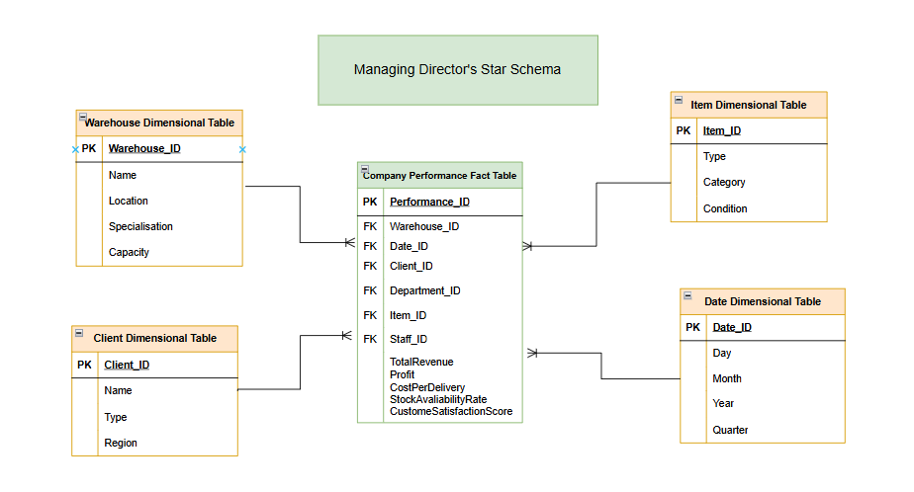
Figure 4 The Managing Director’s Data Mart provides a unified company-wide view, enabling strategic insights into performance, profitability, and operational efficiency.

The Finance Director’s Data Mart focuses on financial performance and cost management. Drawing data from finance, warehouse, and transport systems, it tracks income, expenses, and profitability across regions and departments. Metrics include total revenue, profit margins, outstanding payments, and expense ratios. This enables financial forecasting, cost control, and performance evaluation of business units. By linking rental income data with transport and maintenance costs, the Finance Director can assess profitability by warehouse or client type, ensuring accurate budgeting and resource allocation.
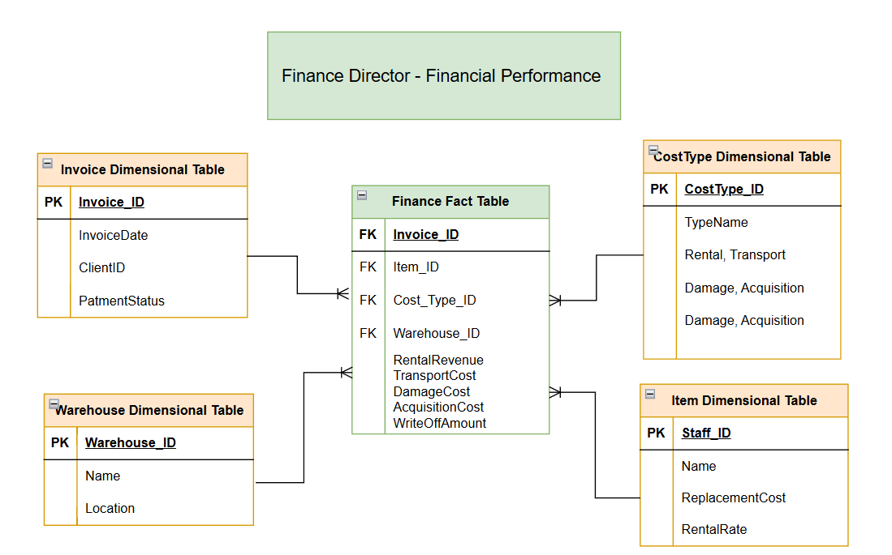
Figure 5 The Finance Director’s Data Mart delivers detailed financial insights, supporting profitability analysis, cost control, and strategic budgeting across all business areas.

The Sales and Marketing Director’s Data Mart provides insights into customer behaviour, item demand, and market performance. It analyses metrics such as rental frequency, item popularity, seasonal trends, and client segmentation. This helps in designing promotional strategies, managing client relationships, and identifying high-demand products. For example, identifying which costume categories are most rented during certain months allows more targeted marketing campaigns and stock management planning.
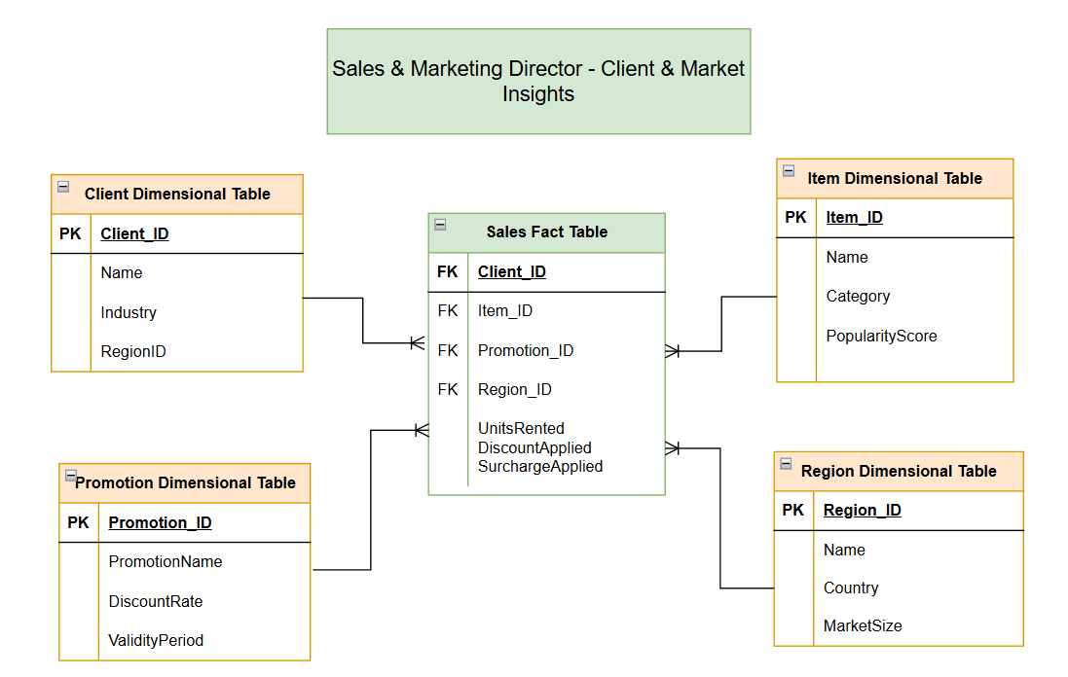
Figure 6 The Sales and Marketing Director’s Data Mart analyses customer trends and item demand to drive targeted promotions, improve client engagement, and boost sales performance.

Together, these data marts transform the company’s centralised data into clear, actionable intelligence. Each director gains a tailored view of their area of responsibility, improving efficiency, accuracy, and decision-making while aligning departmental goals with overall business strategy
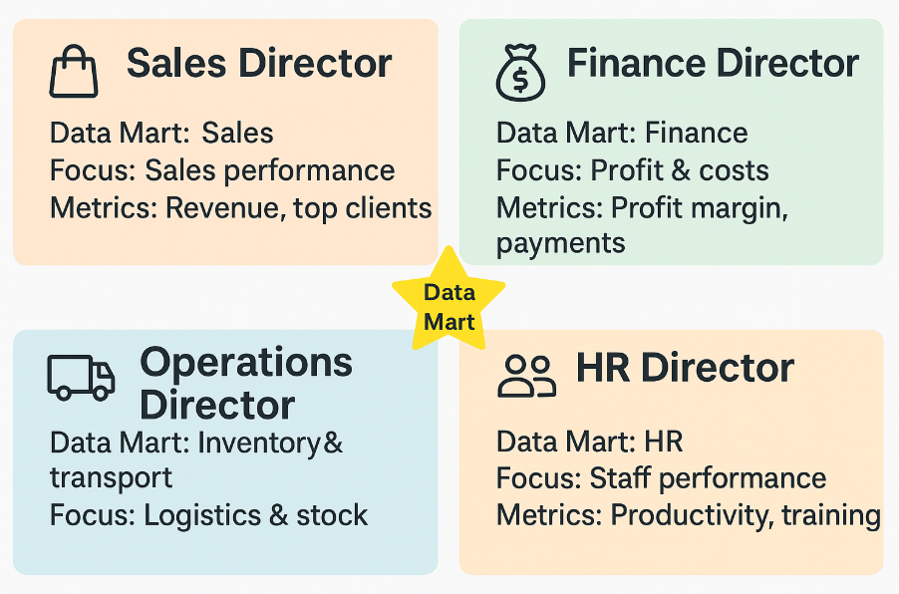

Figure 7 How each Director uses their Data Mart for targeted insights

1.4: Normalisation and Dimensional Modelling
In OLTP (Online Transaction Processing) systems, normalisation is used to organise data into related tables that minimise redundancy and maintain consistency [10]. Each piece of information is stored only once, with relationships maintained through primary and foreign keys. This structure supports rapid, reliable transaction processing. For example, in Rags’n’Riches Ltd., client details are stored in a single Client table, while rental orders link to it via Client_ID, ensuring accurate and efficient updates across multiple warehouses.
In contrast, a data warehouse uses dimensional modelling, designed to simplify analysis rather than daily transactions. Dimensional modelling organises data around measurable business processes, represented in fact tables, and descriptive business entities, represented in dimension tables. This design supports fast querying and trend analysis across large datasets.
A common approach is the star schema, where a central Fact Table (e.g., Rental Fact Table) contains numerical data such as Revenue, Rental_Days, and Cost. Surrounding Dimension Tables - such as Client, Item, Warehouse, and Date - provide descriptive context for analysis.
This structure enables managers to answer complex questions quickly, such as “Which warehouse generates the highest rental revenue?” or “What items are most in demand during specific seasons?”

Dimensional Transport Star Schema for Rags’n’Riches Ltd.
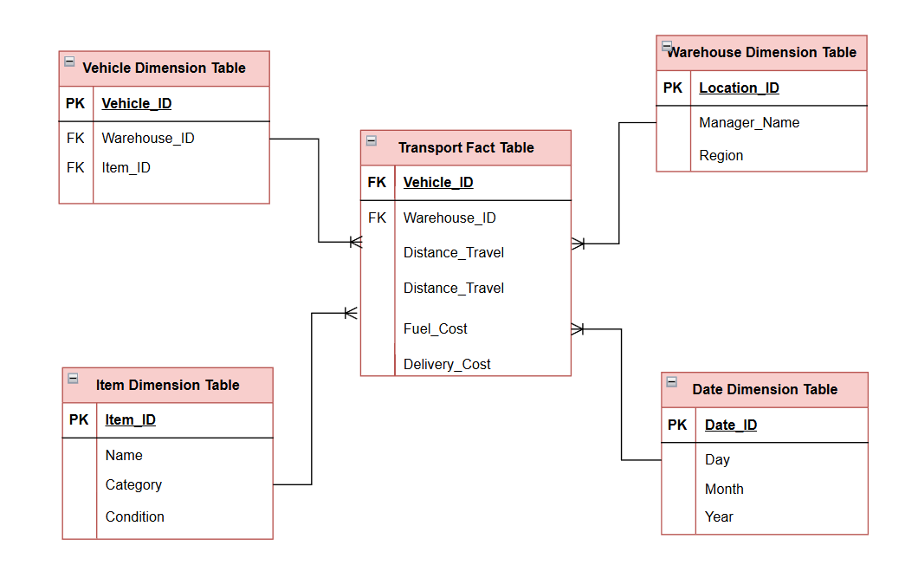
Figure 8 Star Schema for Dimensional Transport

Advantages
Dimensional modelling simplifies data access, enhances query speed, supports historical analysis, and provides a clear, business-friendly view of performance - essential for strategic decision-making at Rags’n’Riches Ltd.

Task 2

2.0 Introduction
Rags’n’Riches Ltd. relies on a combination of internal and external data sources to manage its multi-warehouse prop and costume rental operations. Data from orders, inventory, transport, finance, acquisitions, and client interactions is collected, cleaned, integrated, and stored in a central data warehouse. Using ETL processes, this data is transformed into department-specific data marts, supporting reporting, analysis, and KPI monitoring. Ensuring high data quality, validation, audit trails, and GDPR compliance is essential for accurate, reliable, and secure business intelligence.

2.1: Source Systems
Internal source systems are managed within the organisation and capture daily operations. At Rags’n’Riches Ltd., these include orders, inventory, staff, warehouse, transport, and finance systems, which track rentals, stock movements, invoices, and deliveries. External sources come from outside the company, such as client communications, fuel card data, and government tax incentive updates. Together, internal and external data feed into the warehouse through ETL processes, providing structured, reliable information. This integration enables accurate reporting, trend analysis, and informed decision-making across departments, ensuring timely, consistent data for business intelligence and performance monitoring [11].
2.2: Star Schema Design
Star schema is the name of a diagram where the fact table is in the middle, connected outwards to the dimensions like points on a star [12].
A star schema is a simple yet powerful data warehouse design where a central Fact Table stores measurable business data (e.g., revenue, rentals, costs) and connects to multiple Dimension Tables that describe business entities such as customers, items, warehouses, and time. The structure resembles a star - with the Fact Table at the centre and the Dimension Tables radiating outward - allowing for fast queries and clear, intuitive analysis [13].
Central Fact Tables
For Rags’n’Riches Ltd., the primary Fact Table is the Rental Fact Table, which captures the details of each rental transaction. It includes metrics such as rental revenue, rental days, discounts, surcharges, delivery cost, and total profit. Additional Fact Tables could include Stock Movement Facts (tracking inter-warehouse transfers and damages) and Financial Fact Tables (covering invoices and payments).
The key dimension tables at Rags’n’Riches Ltd. provide essential context for analysing operations.
The Customer Dimension records client details such as name, type, and region to identify demand patterns. The Item Dimension tracks item ID, description, category, and status, helping assess product popularity. The Warehouse Dimension defines each location’s specialisation and capacity for performance comparisons. The Time Dimension captures order, delivery, and return dates to support seasonal trend analysis. Finally, the Transport Dimension stores vehicle, driver, and distance data to evaluate logistics efficiency and delivery costs.

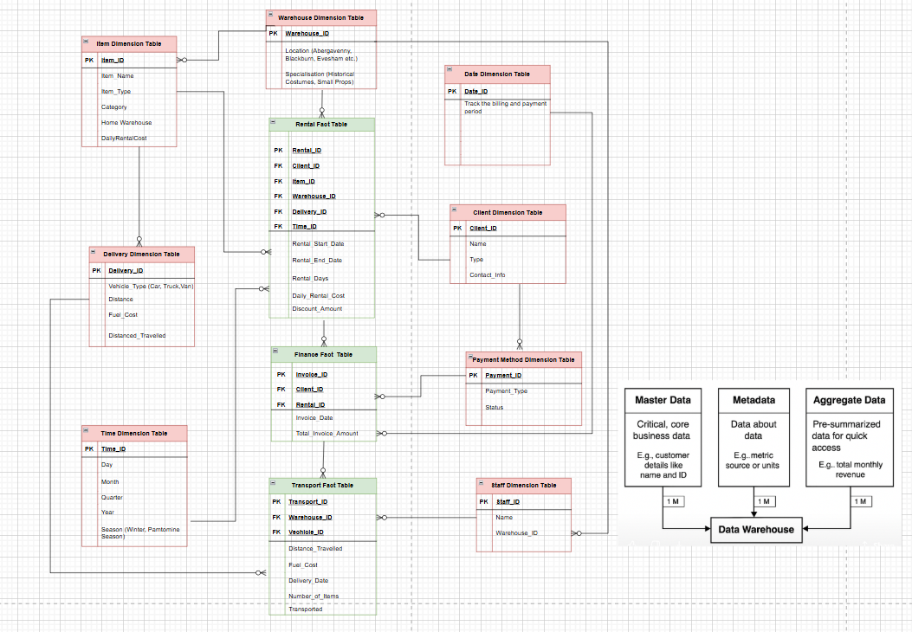
Star Schema for Rags n Riches Ltd.
Figure 9 Star Schema for Rag n Riches Ltd. with multiple factors and dimensional tables.

The star schema helps Rags’n’Riches monitor key business metrics like revenue, delivery efficiency, and customer retention by linking all operational data into one structured model. It provides fast, consistent analysis across departments, allowing managers to make informed decisions that improve performance and profitability.

2.3: Data Mart
A data mart is a smaller, department-focused section of a data warehouse designed for specific business areas such as sales, finance, or logistics. It provides easy access to relevant data for quick analysis and reporting [14].
Organisations use data marts to improve decision-making by allowing departments to access only the data they need, reducing complexity, processing time, and cost while ensuring greater efficiency and focus [15].

There are three types of Data Marts:

- Dependent Data Mart: Draws data from a central data warehouse ensuring consistency and integration.
- Independent Data Mart: Built directly from operational systems offering faster implementation but less integration.
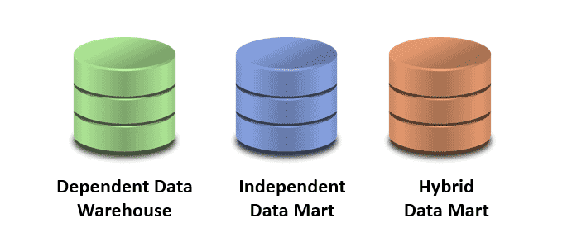
- Hybrid Data Mart: Combines both internal warehouse and external sources to provide more comprehensive analysis [16].

Figure 10 Three Types of Data Marts

At Rags’n’Riches Ltd., three main departments benefit from data marts. The Finance Department uses a dependent data mart to track income, expenses, and profits, drawing accurate data from the central warehouse.
The Logistics Department operates an independent data mart, using real-time vehicle and delivery data to monitor transport performance.
The Inventory Department uses a hybrid data mart, combining warehouse data with supplier updates to manage stock levels and item demand effectively.

Fact and Dimension Tables per Data Mart

Department | Fact Table | Dimension Tables
Finance | Finance Fact | Client, Warehouse, Date, Payment, Method, Item, Staff
Logistics | Transport Fact | Vehicle, Warehouse, Date, Item, Driver/Staff, Route/Location
Inventory | Rental Fact | Item, Warehouse, Time, Client, Transport, Finance/Payment, Staff

Each data mart links a central fact table -holding measurable data such as revenue, deliveries, or rentals - with dimension tables that provide descriptive context like client, item, or warehouse details.
Analytical Focus of Each Data Mart
The Finance, Logistics, and Inventory Data Marts at Rags’n’Riches Ltd. provide focused insights for departmental decision-making. The Finance Mart tracks revenue, profit, and client payments to evaluate performance and identify profitable areas. The Logistics Mart monitors delivery efficiency, fuel costs, and transport usage to optimise routes and reduce expenses. The Inventory Mart analyses rental rates, stock turnover, and write-offs to manage demand and reduce losses. Together, they enable data-driven decisions that enhance efficiency, profitability, and strategic planning [17].

Each star schema helps directors make better, faster decisions. The Finance Director gains clear insight into revenue and profit trends. The Logistics Director can track transport efficiency and reduce delivery costs. The Inventory Director monitors stock performance and item demand, ensuring better resource management and reduced losses.

Departments and Suitable Data Mart Types

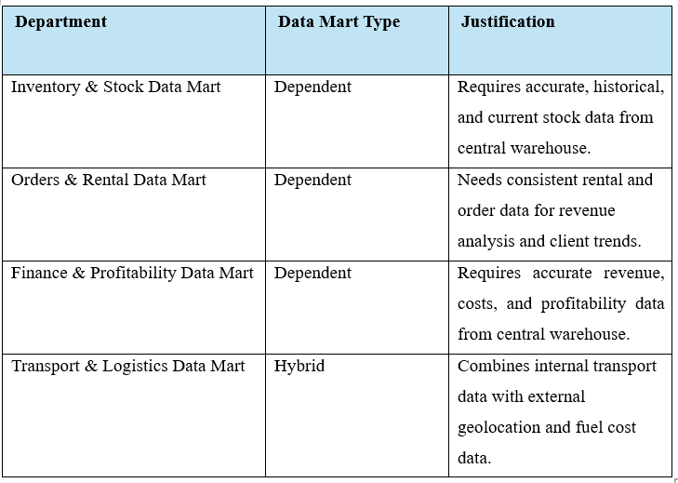

Rags’n’Riches Ltd. uses several data marts to support departmental analysis. The Inventory & Stock Data Mart tracks costume and prop availability across warehouses, analysing stock levels, rental activity, and maintenance costs. The Orders & Rentals Data Mart examines client rental patterns, popular items, and seasonal demand to support marketing and planning. The Finance & Profitability Data Mart compares revenue, costs, and profits to assess overall financial performance. Finally, the Transport & Logistics Data Mart analyses delivery efficiency, fuel usage, and route performance by integrating internal and external transport data.

2.4: ETL
An ETL Plan outlines how data is Extracted, Transformed, and Loaded into a data warehouse. It defines the sources of data, how it will be cleaned and formatted, and where it will be stored. The plan ensures data is accurate, consistent, and ready for analysis [18].

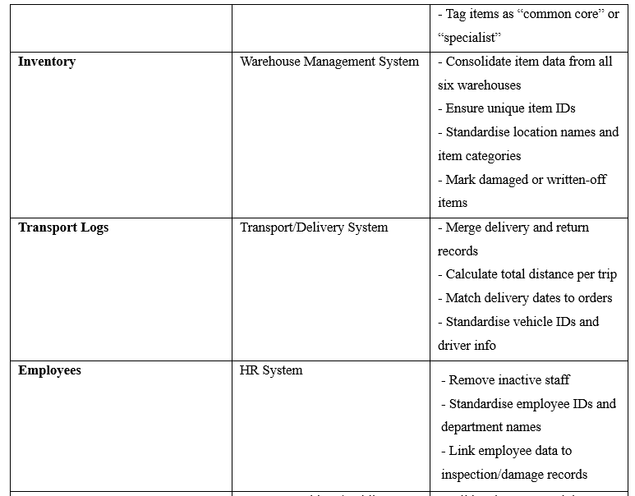
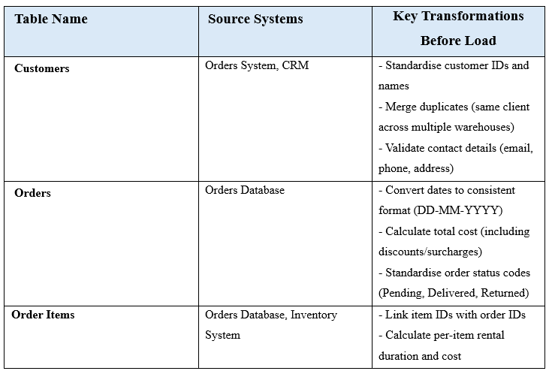
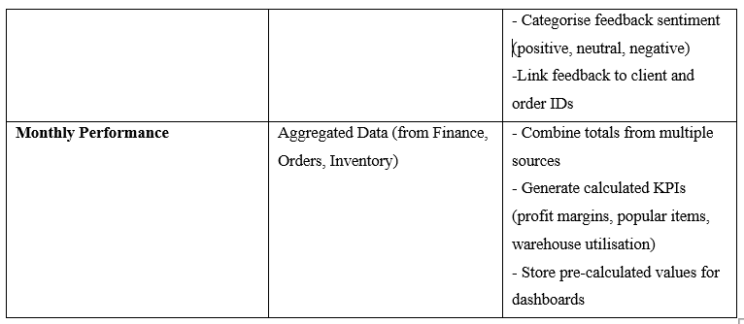
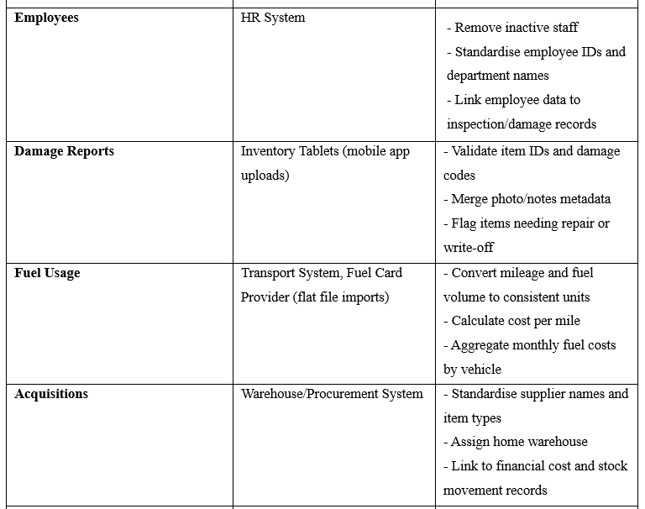

Simplified ETL Plan for Rags and Riches Ltd.

The data warehouse flow at Rags’n’Riches Ltd. moves data from internal systems like orders, finance, and transport, and external sources such as clients and suppliers, through an ETL process. Data is extracted, transformed (cleaned, standardised, integrated, and calculated), and then loaded into the central warehouse. From there, departmental data marts use the data for reporting and analysis.

Key transformations: cleaning errors, standardising formats, joining related data, and calculating metrics like rental cost and fuel usage [19].

2.5: Data Quality and Governance Issues
Data quality refers to the accuracy, completeness, consistency, and reliability of data, ensuring it is fit for decision-making and operational use. High-quality data supports accurate decisions, efficient operations, customer trust, and regulatory compliance, including GDPR. Key challenges include data entry errors, inconsistencies, duplicates, integration issues, and outdated information. Essential practices to maintain data quality are data validation to check correctness, audit trails to track changes, and GDPR compliance to securely manage personal and sensitive data [20].

Conclusion

Implementation of a data warehouse supported by a robust ETL plan and star schema will enable Rags’n’Riches Ltd. to integrate and analyse data efficiently across all departments. This structured approach ensures accurate, consistent, and timely insights, empowering management to make data-driven decisions that enhance performance and profitability. By consolidating information from finance, logistics, and inventory systems, the company can monitor key metrics such as revenue trends, delivery efficiency, and stock utilisation in real time.

The ETL process guarantees that all data entering the warehouse is cleansed, standardised, and up to date, providing a reliable single source of truth for decision-making. The star schema design simplifies complex data relationships, making analysis faster and more accessible for directors and managers. This improved visibility across business functions supports proactive planning, cost reduction, and operational optimisation.

Ultimately, this integrated system creates a foundation for strategic growth and future scalability, positioning Rags’n’Riches Ltd. to expand nationally and internationally. By leveraging high-quality data and analytics, the company can respond more effectively to market changes, strengthen client relationships, and maintain a competitive edge within the evolving film and theatre industry.

References
[1] M. Heller, “What is OLTP? The backbone of ecommerce,” InfoWorld.com, 2022.
[2] D. Goyal and linkedin.com, Carpenteria, CA. Introduction to Data Warehouses., (2023).
[3] T. Shioi, T. Kambayashi, S. Arakawa, R. Kurosawa, S. Hikida, and H. Yokota, “Read-safe snapshots: An abort/wait-free serializable read method for read-only transactions on mixed OLTP/OLAP workloads,” Information systems (Oxford), vol. 124, Art. no. 102385, 2024, doi: 10.1016/j.is.2024.102385.
[4] R. D. Thantilage, N.-A. Le-Khac, and M.-T. Kechadi, “Healthcare data security and privacy in Data Warehouse architectures,” Informatics in medicine unlocked, vol. 39, Art. no. 101270, 2023, doi: 10.1016/j.imu.2023.101270.
[5] M. G. Khan, N. U. Huda, and U. K. U. Zaman, “Smart Warehouse Management System: Architecture, Real-Time Implementation and Prototype Design,” Machines (Basel), vol. 10, no. 2, p. 150, 2022, doi: 10.3390/machines10020150.
[6] M. Frau and T. Keszey, “Seeding innovation: the role of internal and external digital data in agri-food product innovation,” British food journal (1966), vol. 126, no. 13, pp. 286–302, 2024, doi: 10.1108/BFJ-08-2023-0687.
[7] C. Buss, J. Mousavi, M. Tokarev, A. Termehchy, D. Maier, and S. Lee, “Effective Entity Augmentation by Querying External Data Sources,” Proceedings of the VLDB Endowment, vol. 16, no. 11, pp. 3404–3417, 2023, doi: 10.14778/3611479.3611535.
[8] S. Hira and P. S. Deshpande, “Automated heuristic based context dependent ETL process to generate multi‐dimensional model for tabular data,” Concurrency and computation, vol. 35, no. 2, 2023, doi: 10.1002/cpe.7459.
[9] N. Gupta and S. Jolly, “Enhancing Data Quality at ETL Stage of Data Warehousing,” International journal of data warehousing and mining, vol. 17, no. 1, pp. 74–91, 2021, doi: 10.4018/IJDWM.2021010105.
[10] R. Rehrmann, C. Binnig, A. Böhm, K. Kim, and W. Lehner, “Sharing opportunities for OLTP workloads in different isolation levels,” Proceedings of the VLDB Endowment, vol. 13, no. 10, pp. 1696–1708, 2020, doi: 10.14778/3401960.3401967.
[11] Murnawan and I. Rijayana, “Data Warehouse Design for Multi Finance Companies,” Turkish journal of computer and mathematics education, vol. 12, no. 8, pp. 726–741, 2021.
[12] M. Fischer et al., “BCNF - From Normalized- to Star-Schemas and Back Again,” in Companion of the 2023 International Conference on Management of Data, New York, NY, USA: ACM, 2023, pp. 103–106. doi: 10.1145/3555041.3589712.
[13] M. M. Amin, A. Sutrisman, and Y. Dwitayanti, “Development of Star-Schema Model for Lecturer Performance in Research Activities,” International journal of advanced computer science & applications, vol. 12, no. 9, 2021, doi: 10.14569/IJACSA.2021.0120909.

[14] “Designing data marts for data warehouses,” ACM transactions on software engineering and methodology, vol. 10, no. 4, pp. 452–483, 2001, doi: 10.1145/384189.384190.
[15] J. Ramos, B. Alturas, and S. Moro, “Business intelligence in a public institution - Evaluation of a financial data mart,” in 2017 12th Iberian Conference on Information Systems and Technologies (CISTI), AISTI, 2017, pp. 1–6. doi: 10.23919/CISTI.2017.7975672.
[16] “What is Data Mart? Various Types with Examples,” Simplilearn, Jun. 22, 2025. [Online]. Available: https://www.simplilearn.com/what-is-data-mart-article. [Accessed: Oct. 31, 2025].
[17] A. Sodero, “Data and Predictive Analytics Use for Logistics and Supply Chain Management,” Marquette University, White Paper, Jan. 6, 2019. [Online]. Available: https://epublications.marquette.edu/context/mgmt_fac/article/1336/viewcontent/barratt_13574.pdf. [Accessed: Oct. 31, 2025].
[18] B. Singhal and A. Aggarwal, “ETL, ELT and Reverse ETL: A business case Study,” in 2022 Second International Conference on Advanced Technologies in Intelligent Control, Environment, Computing & Communication Engineering (ICATIECE), IEEE, 2022, pp. 1–4. doi: 10.1109/ICATIECE56365.2022.10046997.
[19] O. Azeroual, G. Saake, and M. Abuosba, “ETL Best Practices for Data Quality Checks in RIS Databases,” Informatics (Basel), vol. 6, no. 1, p. 10, 2019, doi: 10.3390/informatics6010010.
[20] I. Leghemo, O. D. Segun-Falade, C. S. Odionu, and C. Azubuike, “Continuous Data Quality Improvement in Enterprise Data Governance: A Model for Best Practices and Implementation,” Journal of Engineering Research and Reports, vol. 27, no. 2, pp. 29–45, 2025, doi: 10.9734/jerr/2025/v27i21391.

