Effectiveness of the Current Structure of NHS Wales
Managing Organisations
Jayne Griffith-Parry
Sophie Miller
Table of Contents
Abstract 2
Introduction 2
Information/Statistics/Guides 2
Evaluation of Current Structure 4
Recommendations 5
Conclusion 5
References 6

Abstract

The National Health Service spans across the United Kingdom and aims to provide free healthcare for the public. NHS Wales is the Welsh section of the NHS that has undergone major structural changes over time. This report investigates the effectiveness of these new structural changes by considering the health boards involved. Recommendations for improvement are made based on these findings.

Introduction

As stated by NHS Wales (2006), “NHS Wales is the publicly funded National Health Service of Wales providing healthcare…”. It is a derivative of the National Health Service which is a government funded system that is in place to provide free healthcare to residents of the United Kingdom. Welsh Government (2020) lists some of the treatments that are included with NHS Wales, including drug misuse, smoking and social care. In addition to this, opportunities such as blood donation exist for the public to be able to contribute to the resources that are required. Upon reconsidering the structure of NHS Wales in 2009, multiple health boards were established that aim to implement a different approach to care than what was active before. A health board can be thought of as a system in an area of wales that is a concatenation of many different NHS services that work together to provide general care to the people in that area. There are seven health boards in wales which according to NHS Wales (2020) are Aneurin Bevan University, Betsi Cadwaladr University, Cardiff and Vale University, Cwm Taf Morgannwg University, Hywel Dda University, Powys Teaching and Swansea Bay University. Alongside the health boards, NHS Wales also utilises three NHS Trusts. An NHS Trust is an organisation that aims to provide certain services such as ambulances and hospital services. The Welsh Ambulance Service offers patient transport and emergency services. The Velindre NHS Trust offers national support services and specialist cancer care. Public Health Wales deals with topics such as carbon monoxide regulation and fall prevention, ensuring that the public is safe when they go about their everyday lives.

Information/Statistics/Guides

NHS Wales (2016) explains that the committees that the Aneurin Bevan University Health Board consists of are audit, quality and patient safety, information governance, charitable funds, public partnerships and wellbeing, remuneration and terms of service, finance and performance, planning and strategic change and an executive team. The 2018/19 annual report (2019) notes that a budget of £1.2 billion and that “The Health Board receives all of its operational funding from the Welsh Government”, NHS Wales (2019). 14000 Staff members are employed in order to provide health care for 21% of the Welsh population. The annual accounts document (2019) places a figure of £1,324,032 on expenditure and a net operating cost of £1,226,261. This is £26,261 larger than the budget that was given by the Welsh Government.

The Betsi Cadwaladr University Health Board (2020) notes that they have “a budget of £1.3 billion and a workforce of over 17,000 staff.” As written by NHS Wales (2019), the board “receives and NHS budget allocated by the Welsh Government.” This means that the £1.3 billion budget that was stated earlier is supplied entirely by the Welsh Government, as the charitable funds committee focuses on giving some of these funds to charities rather than acquiring more funds. This health board holds three main hospitals and other organisations such as clinics. Their committee structure is as follows:

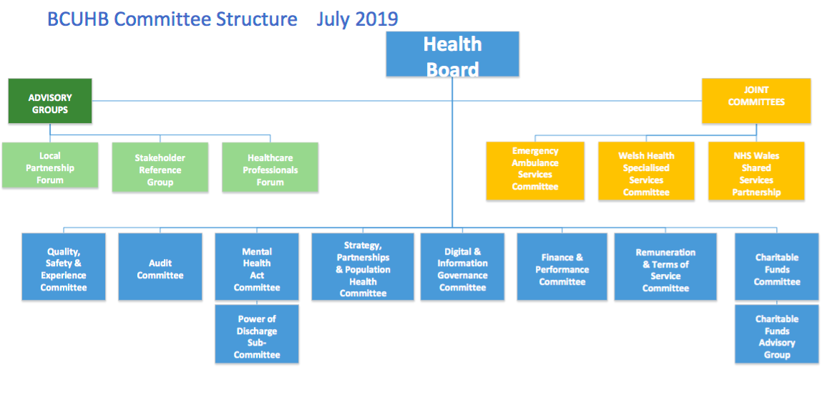
Figure 1 - Organisation of BCUHB Committees

Boasting a large workforce of 14,500 staff members and a budget of £1.4 billion per year, Cardiff and Vale University Health Board (2020) focuses on corporate services, acute and tertiary care, public health and primary, community and intermediate care. Each board has a management team that is directed by someone with detailed knowledge of the area such as a doctor. The team that belongs to each board consists of a board director, director of operations, director of nursing, head of finance and head of workforce. Some boards may have additional team members if they are required.

Cwm Taf Morgannwg University Health Board operates between Bridgend, Merthyr Tydfil and Rhondda. Almost 12,000 members of staff are employed to treat roughly 450,000 people, implies Cwm Taf Morgannwg (2020). The board itself consists of independent members, executive directors and associate members. The final operating costs according the board’s annual accounts document (2019) was £687,347 which is much less than other health boards. It is also documented that “The main source of funding for the Local Health Boards (LHB) are allocations from the Welsh Government within an approved cash limit.” If the main funding comes from the Welsh Government, then it can be assumed that other smaller amounts of funding is likely to come from charitable donations by the public or other private stakeholders.

Hywel Dda University Health Board (2013) elaborates on how changes to their funding is assigned by the Welsh Government, “subject to the Barnett formula which seeks to ensure that all increases are based on actual population.” This suggests that each health board receives funding based primarily on the population of the area that they cover, rather than the services that they offer. This health board consists of a business planning and performance, audit and risk assurance, charitable funds, finance, mental health legislation assurance, primary care applications, quality, safety and experience assurance committee and a university partnership board.

Committees, partnership boards and advisory groups are what defines the structure of the Powys Teaching Health Board (2020). The board must agree with all others on standing orders, which are specified means of conduct within the board and staff that work with them. The roles of the committees are to ensure that these standing orders are met, alongside other responsibilities such as risk assessments and producing plans for development of NHS Wales. Funding for Powys Teaching Health Board is provided by the Welsh Government. Financial information is included in the board’s annual report (2019) shows a net expenditure of £299,184 which is funded by the Welsh Government. According to the Barnett formula, this means the population that the Powys Teaching Health Board covers is 44% of the population that Cwm Taf Morgannwg University Health Board covers and 21% of the population that the Cardiff and Vale University Health Board covers.

Swansea Bay University Health Board (2020) manages three hospitals located in Singleton, Morriston and Neath Port Talbot. It covers a population of around 390,000 people and has a budget of around £1 billion. Funding for this health board is also provided by the Welsh Government. The board’s financial report (2019) shows that it exceeded its budget by £81,612 with regards to its revenue resource limit.

Evaluation of Current Structure

A study by Zairi, M and Jarrar, Y (2007) investigates the effectiveness of NHS trusts. 464 Trusts were used for this study, some of which were in Wales. This means this paper can be applied to NHS Wales because Trusts were introduced after its change in 2006. It is suggested that “the organisational and informal networks within a Trust will impact on the efficiency and effectiveness of this organisation.” One important aspect is to plan as far ahead as possible. This was more evident in some of the health boards as they had a three-year plan, however some health boards only had short-term plans and no specific dates stating when these plans should be complete. Performance was evaluated in the form of an annual report by every health board which made it clear which areas of the board were not performing as effectively. Most health boards were over their budget, meaning too many resources were used. This may mean that the plans from previous years were not evaluated well enough resulting in poor planning for the future. On the other hand, the demand for NHS services is increasing therefore boards must attempt to meet these needs based on extrapolated data for years to come; meaning the final result may not be what was expected.

Brexit is the subject of serious concern with regards to the NHS. It is feared that funding will not be distributed fairly, or it will become private and members of the public will be forced to pay for their healthcare. It is the responsibility of the health boards and trusts to ensure that NHS Wales is treated fairly. Due to a large majority of funding coming from the Welsh Government, the plans created by health boards may begin to deteriorate if funding is cut and trusts may not be willing to offer their services if health boards cannot afford them. This would result in a dramatic change to the structure of NHS Wales as health boards may become private and more money-oriented for the sake of maintaining their status of managing NHS Wales.

Cosh, A et al (2010) performed a study on the organisational structure of small to large UK businesses and how it affects performance. It is stated that “they identified an organic form of management system best suited to technically turbulent environments and for maximising commitment to organisational goals.” This means that a system where control is distributed was found to be more effective for achieving goals than a strict hierarchical system where communication is done up and down the hierarchy. NHS Wales matches the organic form of management system because it consists of health boards and trusts. The health boards are what control is distributed to because each area of wales is managed by a different one. This implies that commitment to goals set by the health boards will be maximised and so improvements to healthcare should be quicker and higher quality with the current structure of NHS Wales.

Recommendations

A significant improvement to NHS Wales would come from increasing the funding to certain health boards. This would allow projects to be fulfilled in shorter amounts of time and would reduce the need to compete with the increasing reliability on the NHS by the general public. Health boards such as Swansea Bay University were only 2.7% over their budget therefore better planning by the financial committee could have prevented this.

Another way to handle the increase in healthcare demand would be to increase the number of health boards belonging to NHS Wales. This would mean that more staff can be employed in certain areas under a new health board and more resources can be supplied such as hospitals and clinics.

More involvement with the staff that work in medical organisations would also be beneficial. It is not clear when investigating health boards how much they work with members of staff that are at the front end of the environments that the health boards manage. More communication would make it more obvious for committees to see what needs to improve and how they can implement those improvements.

Conclusion

Health Boards and Trusts make up the structure of NHS Wales. Seven different health boards are required to manage different areas of Wales. Every health board is managed by a committee, each of which has certain responsibilities such as managing public health or finances. The current structure of NHS Wales is adequate, however could be improved by increasing funding and better planning by health boards, especially with ongoing political situations. More health boards and better communication with staff employed by the NHS would refine the existing system.

References

- Aneurin Bevan Annual Accounts (2019). Annual reports, Annual accounts, Annual quality statements and Governance Statements Available at: http://www.wales.nhs.uk/sitesplus/866/page/62034 [Accessed 09th January 2020].

- Aneurin Bevan Annual Report (2019). Annual reports, Annual accounts, Annual quality statements and Governance Statements. Available at: http://www.wales.nhs.uk/sitesplus/866/page/62034 [Accessed 09th January 2020].

- Aneurin Bevan University Health Board (2020). Aneurin Bevan University Health Board’s Committee Structure. Available at:http://www.wales.nhs.uk/sitesplus/866/page/52736 [Accessed 09th January 2020].

- Aneurin Bevan University Health Board (2020). Freedom of information – Class 2: What we spend and how we spend it. Available at:http://www.wales.nhs.uk/sitesplus/866/page/59450#Funding [Accessed 09th January 2020].

- Betsi Cadwaladr University Health Board (2020). Individual Patient funding requests - IPFR. Available at:http://www.wales.nhs.uk/sitesplus/861/page/57859 [Accessed 10th January 2020].

- Betsi Cadwaladr University Health Board (2020). About the health board. Available at:https://bcuhb.nhs.wales/about-us/about-the-health-board/ [Accessed 09th January 2020].

- Betsi Calwaladr University Health Board (2020). Health Board Committees and Advisory Groups. Available at: http:/www.wales.nhs.uk/sitesplus/861/page/41978/ [Accessed 10th January 2020].

- Cardiff and Vale University Health Board (2020). Our Health Board. Available at:http://www.cardiffandvaleuhb.wales.nhs.uk/our-health-board-structure [Accessed 10th January 2020].
- Cwm Taf Morgannwg University Health Board (2019). Annual Accounts. Available at: https://cwmtafmorgannwg.wales/how-we-work/financial-information/annual-accounts/ [Accessed 10th January 2020].

- Cwm Taf Morgannwg University Health Board (2020). We are Cwm Taf Morgannwg. Available at:https://cwmtafmorgannwg.wales/we-are-cwm-taf-morgannwg/ [Accessed 10th January 2020].

- Hywel Dda University Health Board (2020). NHS Wales & Us. Available at:http://www.wales.nhs.uk/sitesplus/862/page/40322 [Accessed 10th January 2020].

- Mohamed Zairi & Yasar F.Jarrar. (2001). Measuring organizational effectiveness in the NHS: Management style and structure best practices. Total Quality Management. 12 (7), 882-889. [Accessed 10th January 2020].

- NHS Wales (2020). Local Health Boards. Available at:https://www.wales.nhs.uk/ourservices/directory/LocalHealthBoards [Accessed 09th January 2020].

- NHS Wales (2020). NHS Wales – About us. Available at:https://www.wales.nhs.uk/nhswalesaboutus [Accessed 09th January 2020].

- Powys Teaching Health Board (2019). 2018-2019 PTHB Annual Report EN. Available at: http://www.powysthb.wales.nhs.uk/document/348095 [Accessed 10th January 2020].

- Powys Teaching Health Board (2020). The Board’s committees, partnership boards and advisory groups. Available at:http://www.powysthb.wales.nhs.uk/sub-committees [Accessed 10th January 2020].

- Swansea Bay University Health Board (2019). Annual General Meeting 2019. Available at: https://sbuhb.nhs.wales/about-us1/key-documents-folder/board-papers/annual-general-meeting-2019/ [Accessed 10th January 2020].

- Swansea Bay University Health Board (2020). Swansea Bay UHB. Available at:https://sbuhb.nhs.wales/about-us1/swansea-bay-uhb/ [Accessed 10th January 2020].

- Welsh Government (2020). Health and social care. Available at:https://gov.wales/health-social-care [Accessed 09th January 2020].

- Xiaolan Fu. Andy Cosh. Alan Hughes. (2012). Organisation Structure and Innovation Performance in Different Environments. Small Business Economics. Volume 39, Issue 2. Page 301-317. Available at: https://link.springer.com/article/10.1007/s11187-010-9304-5 [Accessed 10th January 2020].

