[Date]
Problem analysis and solution development

Module code ACCA4019
Student name: Cesar Nicolas Vargas Rodriguez
Studet id: 2429944
Grup2.
Lecture name: Redhwan Al amri

Contents
Introduction 2
1. Problem Deconstruction 2
1.1 Overview of the Problem Scenario 2
1.2 Key Variables and System Components 3
1.3 Requirements and Constraints Using the MoSCoW Technique 3
1.4 Constraints and Assumptions 3
2. Proposed Solution and Explanation 4
2.1 Overview of the Proposed Approach 4
2.2 Logical Process and Flowchart Explanation 4
2.3 Pseudocode Representation 9
2.4 Addressing Fuel Efficiency and Time Constraints 10
2.5 Assumptions and Design Considerations 10
3. Reflection and Justification 11
3.1 Problem-Solving Techniques Applied 11
3.2 Justification of the Chosen Approach 11
3.3 Limitations and Assumptions 12
3.4 Reflection on Learning Outcomes 12
References 12

Introduction
This report analyses a real-world logistics problem faced by the online grocery delivery service GrocerQuick. The aim is to design a structured and logical solution for optimising delivery routes using abstract thinking and problem-solving techniques. The report first deconstructs the problem to identify key requirements, variables, and constraints. It then proposes a generic solution supported by a flowchart and pseudocode, before reflecting on the techniques used, their suitability, and the limitations of the proposed approach.

1. Problem Deconstruction

1.1 Overview of the Problem Scenario
GrocerQuick is an online grocery delivery service that is currently facing challenges in managing its delivery routes efficiently. As customer demand grows and delivery areas expand, the company experiences increased fuel consumption, longer delivery times, and difficulties in ensuring that all orders arrive within acceptable time windows. The core problem lies in coordinating multiple orders, delivery vehicles, and routes in a way that balances operational efficiency with customer satisfaction. This scenario represents a common logistics and optimisation challenge, where decisions must be made under time and resource constraints [1].
From an abstract perspective, the problem can be viewed as a route optimisation and resource allocation issue within a complex system, which is a common challenge in logistics operations. The delivery process involves multiple interdependent components, such as order locations, vehicle capacity, travel distances, and delivery deadlines. Inefficiencies in any of these components can negatively affect overall system performance. Therefore, the problem must be decomposed into smaller, manageable elements to enable a structured and logical solution.

1.2 Key Variables and System Components
Several key variables define the delivery optimisation problem and directly influence fuel consumption and delivery timeliness. Orders are characterised by delivery location and required delivery time. Delivery vehicles are constrained by capacity and route assignment. Distance and travel time determine fuel usage and delivery duration. Routes represent the sequence in which orders are delivered. Time constraints require all deliveries to be no more than 30 minutes late. These variables form an interdependent system in which inefficient allocation of orders can increase travel distance and lead to delayed deliveries [2].

1.3 Requirements and Constraints Using the MoSCoW Technique
To prioritise system requirements, the MoSCoW prioritisation technique is applied, as it provides a simple and effective way to categorise requirements based on their importance. This approach helps distinguish essential requirements from desirable but non-critical features, supporting structured decision-making [3].
Must Have: - All customer orders must be delivered. - No delivery should be more than 30 minutes late. - Delivery routes must minimise total travel distance to reduce fuel consumption.
Should Have: - Efficient grouping of nearby orders to improve route efficiency. - Balanced workload across delivery vehicles.
Could Have: - Real-time route adjustments based on traffic conditions. - Dynamic reassignment of orders if delays are detected.
Won’t Have: - Advanced predictive analytics or machine learning-based optimisation, as these exceed the scope of the current solution.
By applying MoSCoW, the problem scope is clearly defined, ensuring that critical operational goals are addressed first while acknowledging potential enhancements.

1.4 Constraints and Assumptions
Several constraints limit the solution space. These include fixed vehicle availability, limited delivery time windows, and the assumption that distance and estimated travel time can be reasonably approximated. Additionally, the solution assumes that order data is available before route planning begins. These constraints guide the design of a logical and generic solution that remains practical and realistic within the given scenario.

2. Proposed Solution and Explanation

2.1 Overview of the Proposed Approach
The proposed solution aims to optimise GrocerQuick’s delivery operations by applying abstract problem-solving and route optimisation principles in a clear and structured manner. Rather than focusing on a specific programming implementation, the approach is designed as a generic and logical process that can be adapted to different operational contexts. At its core, the solution seeks to efficiently allocate customer orders to delivery routes while minimising total travel distance and ensuring that all deliveries are completed within the maximum allowable delay of 30 minutes.
The problem is treated as a simplified form of the Vehicle Routing Problem (VRP), a well-established optimisation challenge in logistics and transportation systems [4]. By abstracting the real-world complexity into manageable logical steps, the solution balances efficiency, clarity, and feasibility. The approach prioritises grouping orders based on geographic proximity, assigning them to available vehicles, and continuously verifying time constraints throughout the delivery process.

2.2 Logical Process and Flowchart Explanation
The optimisation process begins by collecting all pending orders and estimating travel distances and times. Nearby orders are grouped and assigned to vehicles based on capacity, and initial routes are generated to minimise total travel distance. Delivery times are then checked against the 30-minute limit, and routes are adjusted as needed until all constraints are satisfied.

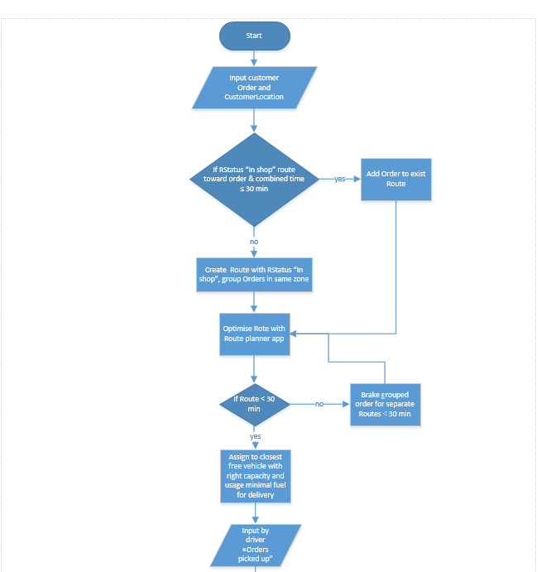
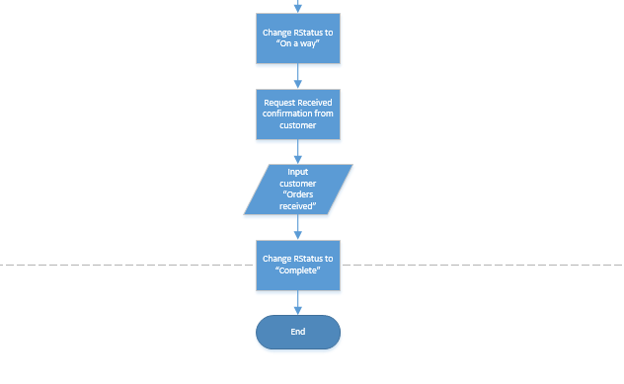

Variables:
Main variables
These can change during operation or differ for each order/route.
CustomerOrder (details of an individual order: items, quantity, time placed, etc.)
CustomerLocation (address or geographic coordinates of the customer)
RStatus (route status: “In shop”, “On a way”, “Complete” – value changes over time)
ExistingRoutes (set/list of currently active routes)
CombinedTime (updated travel + service time when adding a new order to an existing route)
Route (a specific planned sequence of stops for one vehicle)
OrdersInRoute (grouped orders assigned to a given route)
Zone (geographical area used to group orders; which zone an order belongs to can vary)
OptimisedRoute (resulting route after optimisation in the planner app)
RouteTime (calculated duration of a route, compared with the 30-minute limit)
GroupedOrders (set of orders grouped together before possibly being split)
SeparateRoutes (multiple routes created when grouped orders are split)
Vehicle (identifier of an individual vehicle, e.g., van1, scooter3)
VehicleCapacityUsed (current load of a vehicle on a route)
VehicleCapacityLimit (max capacity; treated as parameter per vehicle but differs by vehicle)
FuelUsage (estimated or actual fuel consumption of a route)
FreeVehicles (list/set of vehicles currently not assigned to any route)
DriverInputPickedUp (driver’s input event “Orders picked up” for a route)
CustomerConfirmationReceived (boolean/flag that customer confirmed receipt)
CustomerInputOrdersReceived (customer’s “Orders received” input recorded in the system)
TimeStamps (times when status changes occur: picked up, on the way, delivered)
DeliveryCost (optional variable derived from time, distance, fuel, etc., if your model includes cost)
Constants and fixed parameters
These do not change within a run of the model or are fixed business rules.
TimeLimit = 30 minutes (maximum allowed combined/route time)
RStatus values set: {“In shop”, “On a way”, “Complete”} as allowed states
ZoneDefinitions (fixed partitioning of the service area into zones)
VehicleTypes (e.g., car, bike, van categories defined in advance)
VehicleFuelType and efficiency parameters per vehicle (used for “minimal fuel” rule)
ShopLocation (origin depot location)
OptimisationObjective (business rule such as “minimise route time” and/or “minimise fuel”)
ServiceTimePerOrder (fixed default load/unload/hand-over time, if assumed constant)
WorkingTimeWindow (e.g., store operating hours or delivery window, if fixed in the model)
MaxOrdersPerRoute (if your business rule caps how many orders can be on one route)

2.3 Pseudocode Representation
BEGIN
INPUT OrderDetails, CustomerLocation

IF exist Route
WHERE Route.Status = &quot;in shop&quot;
AND Time with added Order to Route(Route, OrderDetails) &lt;= 30 minutes
THEN: Add Order to existing Route
ELSE: Create New Route, Route.Status &quot;in shop&quot;, Group orders in same zone
ENDIF

Add Order to existing Route
Calculate optimal Route with Planner App (Route)

Create New Route, Route.Status &quot;in shop&quot;, Group orders in same zone
Calculate optimal Route with Planner App (Route)

IF Route TotalTime &gt;= 30 minutes
THEN Find closest free Vehicle with Capacity&gt;Load,
AND Configure Vehicle with Minimal FuelUsage ,
AND Assign Route to Vehicle
ELSE Process Break GroupedOrders into separate Routes(&lt; 30 minutes)
Calculate optimal Route with Planner App (Route)
ENDIF

Find closest free Vehicle with Capacity&gt;Load,
AND Configure Vehicle with Minimal FuelUsage ,
AND Assign Route to Vehicle
Calculate optimal Route with Planner App (Route)
Assign Route to Vehicle

INPUT Driver &quot;Orders picked up&quot;
Change RStatus to &quot;On a way&quot;
Request delivery confirmation from customer

INPUTCustomer inputs &quot;Order received&quot;
Change RStatus to &quot;Complete&quot;

END

2.4 Addressing Fuel Efficiency and Time Constraints
Fuel efficiency is primarily addressed by minimising total travel distance through proximity-based order grouping and route optimisation. Shorter routes reduce fuel consumption and vehicle wear, contributing to both economic and environmental benefits. This aligns with established logistics optimisation practices, which emphasise distance minimisation as a key driver of operational efficiency [5].
Timely delivery is ensured through continuous monitoring of estimated delivery times. By integrating time checks early in the routing process, the solution reduces the risk of late deliveries. The iterative adjustment mechanism further strengthens reliability by allowing corrective action before routes are executed. Together, these strategies ensure that GrocerQuick can meet customer expectations while maintaining efficient delivery operations.

2.5 Assumptions and Design Considerations
Several assumptions underpin the proposed solution. It is assumed that travel time estimates are reasonably accurate and that traffic conditions remain relatively stable during route execution. Additionally, the solution assumes that all orders are known prior to route planning, enabling batch optimisation. While these assumptions simplify the problem, they allow for a clear and logical solution design suitable for the scope of this assessment.

3. Reflection and Justification

3.1 Problem-Solving Techniques Applied
The development of the proposed solution applied structured problem-solving techniques, including abstract thinking, problem decomposition, and systems thinking. Abstract thinking was used to reduce the complexity of real-world grocery delivery operations into a generic and logical model based on key elements such as orders, routes, vehicles, distance, and time constraints. This enabled the design of a solution that is adaptable and independent of specific implementation details.
Problem decomposition was essential for managing complexity by dividing the overall challenge into smaller components, such as order grouping, route planning, and time validation. Addressing these components individually simplified analysis while ensuring they collectively supported the system objective. This approach is consistent with established practices in computer science and logistics, where complex problems are solved through modularisation [6].
Systems thinking further informed the solution by highlighting the interdependencies between routing decisions, fuel consumption, delivery time, and customer satisfaction. Considering the delivery process as an interconnected system allowed trade-offs to be evaluated rather than optimising a single variable in isolation.

3.2 Justification of the Chosen Approach
The chosen approach is appropriate as it balances efficiency, feasibility, and clarity. Modelling the problem as a simplified Vehicle Routing Problem applies a well-established optimisation framework while remaining suitable for the scope of this assessment [7]. Proximity-based grouping and distance minimisation directly support fuel efficiency objectives.
Time constraint checks ensure delivery deadlines are met without compromising customer service, reflecting real-world logistics trade-offs between cost and service quality. The use of the MoSCoW technique further ensured that critical requirements were prioritised while avoiding unnecessary complexity.

3.3 Limitations and Assumptions
Despite its strengths, the proposed solution has several limitations. One key limitation is the reliance on estimated travel times, which may not accurately reflect real-time traffic conditions [8]. Unexpected delays such as road closures or peak traffic periods could affect delivery performance. Furthermore, the solution assumes that all orders are known prior to route planning, which may not be the case in highly dynamic delivery environments.
Another limitation is the absence of advanced optimisation techniques, such as real-time route recalculation or machine learning-based predictions. While these methods could further improve efficiency, they were intentionally excluded to maintain a clear and generic solution suitable for the assessment scope. These limitations highlight opportunities for future enhancement rather than weaknesses in the core logic.

3.4 Reflection on Learning Outcomes
This assessment demonstrates how abstract problem-solving techniques can be applied to real-world operational challenges. The process reinforced the importance of structured analysis, prioritisation, and logical design when addressing complex systems. By focusing on clarity and justification rather than technical implementation, the solution remains understandable, adaptable, and aligned with academic expectations.

References
[1] S. Chopra and P. Meindl, Supply Chain Management: Strategy, Planning, and Operation, 6th ed., Pearson, 2016.
[2] J. Banks, J. S. Carson, B. L. Nelson, and D. M. Nicol, Discrete-Event System Simulation, 5th ed., Pearson, 2010.
[3] K. Clegg and R. Barker, Case Method Fast-Track: A RAD Approach, Addison-Wesley, 1994.
[4] P. Toth and D. Vigo, Vehicle Routing: Problems, Methods, and Applications, 2nd ed., SIAM, 2014.
[5] G. Laporte, “The Vehicle Routing Problem: An overview of exact and approximate algorithms,” European Journal of Operational Research, vol. 59, no. 3, pp. 345–358, 1992.
[6] J. Sterman, Business Dynamics: Systems Thinking and Modeling for a Complex World, McGraw-Hill, 2000.
[7] P. Toth and D. Vigo, Vehicle Routing: Problems, Methods, and Applications, 2nd ed., SIAM, 2014.
[8] G. Ghiani, G. Laporte, and R. Musmanno, Introduction to Logistics Systems Planning and Control, Wiley, 2004.

