

Module: Digital Forensics Analysis

Student Name: Ashthaben Babariya

Student Id: 2507706
Module Code: ACCA7031

TASK 1: RESEARCH REPORT

The Current State, Challenges, and Future of Digital Forensics

Current State of the Field: Tools, Features and Capabilities
Digital forensics has become one of the most rapidly developing fields in the larger information protection industry. By 2024, the world digital forensics market had reached approval to USD 5.16 billion and is expected to grow over 11.3 billion in 2033, representing a compound annual growth rate of about nine percent (MarketsandMarkets, 2025). This growth is due to the increasing rate of cybercrime, the increasing number of connected devices, and the growing amount of digital evidence that is being used by the criminal and the civil process alike.
The field itself is composed of a number of inter-related sub-fields, which focus on a specific type of digital evidence. Computer and disc forensics Specialises in the acquisition and examination of storage devices including hard drives, and solid states. Mobile device forensics is concerned with retrieving smartphone and tablet data. Network forensics is the art of capturing and analysing traffic passing over infrastructure. The youngest but seemingly the most challenging sub-field is cloud forensics, which covers data being hosted in remote servers and multi-tenancy environments. Sometimes referred to as RAM forensics, memory forensics acquires volatile data that would otherwise be lost the moment a device is switched off.
Existing toolkit practitioners have grown significantly. Autopsy is an open-source solution, which was written on top of The Sleuth Kit and provides disc image analysis, keyword searching, timeline generation, email parsing, and validation of hashes via MD5, SHA-1, and SHA-256 hash-functions. It is both highly academic training and operational law enforcement as its extensibility through third party modules allow. Included with Exterro (previously called AccessData), FTK Imager is the de facto standard in creating forensic images; AD1, E01 and DD formats are supported, hash values are generated automatically upon creation, and it has recently been extended to the XFS file system used on most Linux servers.
Cellebrite UFED dominates the mobile device investigation market. UFED supports over 27,000 device profiles, trusted by more than 6,700 law enforcement agencies globally and can execute physical, logical, and file-system extractions, recover conversations on WhatsApp and Telegram, Instagram direct messages and artefacts found on apps, which otherwise would not be visible to other more traditional methods of backup. EnCase by OpenText has continued to be the gold-standard in commercial end-to-end forensic lifecycle management, having received the SC Magazine award over ten years in a row. AXIOM Magnet combines mobile, cloud, and computer forensics into one interface, handling artefacts of more than 500 applications and offering AI-based categorisation to speed up the triage process.

The Intersection of Digital Forensics and Cybersecurity
Cybersecurity and digital forensics are no longer seen as distinct professional fields, becoming a single discipline, Digital Forensics and Incident Response (DFIR). This coincidence reveals a rudimentary fact of business: containing a breach and investigating a breach are not those activities sequiturally, but rather highly activities that go hand in hand. This dependency was captured by the National Institute of Standards and Technology in SP 800-86 that defined the integration of the forensic techniques into the incident response process as a best practice across all organisations irrespective of their industry or size (NIST, 2006, updated 2024).
The stakes of money behind this integration are high. In the United States, the average price of a cyberattack increased by nine percent between 2024 and 2025 and now is USD 10.22 million per event (Infosecurity Magazine, 2026). Organisations finding it challenging to scope the scope of a breach quickly with it subject themselves to longer exposure periods that increase the cost to remediate the situation and guarantee regulatory penalties. According to 2024 Cost of a Data Breach Report by IBM, the amounts of breaches were found in companies implementing AI and automation in their forensic and incident response processes, which in effect result in the decline in costs measured in the range of a hundred days, which can be directly transformed into monetary metrics (IBM, 2024).
The NIST SP 800-86 framework breaks down incident response forensics into four phases, the first one involves collecting evidence composed of all of the possibly compromised systems and maintaining the evidentiary integrity; the second phase involves using forensic methods to identify pertinent artefacts in that evidence; the third involves processing either by reversing it into historicity; and reporting, producing documentation that can be admitted in any court of law. Professional forensic practise (both private and in the law enforcement sector), based on this procedural model, is practised in the United Kingdom as well as beyond.

Emerging Trends in Digital Forensics
The most radical change in transforming forensic investigation workflow is the trend based on artificial intelligence and machine learning. The tools of natural language processing can now analyse decades of communication data in email archives, chat logs, and messaging applications, automatically extracting named entities, rebuilding a timeline, and inferring intent without an analyst having to read and analyse each message individually. Belkasoft, BelkaGPT, an offline large language model that is part of a larger system called the Belkasoft X, takes case-specific artefacts such as SMS messages, emails, and application notes and maintains the data isolation demands of forensic privacy (Belkasoft, 2025). In 2024, NIST found that AI-assisted deepfake audio detection has now reached the accuracy level of ninety-two percent, or that the technology is now very close to the reliability level necessary to be used as probative evidence (NIST, 2024).
The most rapidly expanding market segment in the field is cloud and multi-cloud forensics, which according to MarketsandMarkets is expected to increase at the quickest rate of any of the sub-disciplines until 2030 (MarketsandMarkets, 2025). Cloud environmental forensic issues are unique compared to physical media: the data can be spread out over multiple jurisdictions, access is controlled by contractual and regulatory documents that differ depending on provider and location and the virtualised instances can be spin down and their artefacts permanently deleted prior to investigators securing preservation orders.
IoT and vehicle forensics has been founded as a unique area of investigation because of tens of billions of connected devices currently operating worldwide. The big-time cases, such as Tesla car investigations, proved that automotive forensic data, such as over-the-air update logs, door and seat sensor events and seatbelt status and GPS movements, can position individuals in the right place at the right time more precisely than the testimony of the traditional witnesses (SalvationData, 2025; Forensic Focus, 2026).

Key Challenges Facing the Discipline
Alongside the growth curve of digital forensics, there is a troupe of old and constantly increasing obstacles. The volume and complexity of data is the closest operational indicator: multi-devices and multi-cloud evidence sets over the terabytes in size are a regular occurrence in the work of investigators, transforming manual treatments into operative impossible, and AI-aided triage into a routine mandatory procedure, instead of an optional addition (SalvationData, 2025).
Encryption creates a key evidential impediment. Current encounters of end-to-end encryption on channels such as WhatsApp, Signal, and iMessage have ensured that notwithstanding physical access to a device, a decrypted message may still be brooklessly hidden without (valid) credentials. Full-disc encryption at the device level only adds to the issue: a modern iPhone that has an unknown passcode is virtually impossible with a way to recover the content using typical forensic tools.
Biodiversity This leads to evidence barriers due to jurisdiction in cases with cloud data stored internationally. The GDPR, the United States CLOUD Act, and the system of Mutual Legal Assistance Treaties also establish competing demands that could delay or even prevent legal investigation access (Belkasoft, 2025). The explainability gap in machine learning forensic tools is an independent issue to the problem of legal admissibility: a court may not accept AI-assisted results when it cannot eloquently outline the rationale behind the given decision based on a simplistic fact-finder (SalvationData, 2025). The concept of systemic issues related to skill shortages and practitioner burnout has been mentioned, and an inquiry organized by the UK house of lords reported that substantial mental health pressures on the forensic population were creating the motivation to leave the practice (Forensic Focus, 2026).

National and International Job Market
The UK digital forensics job market is healthy in nature and structurally under marketed. The lowest-paying entry-level roles are digital forensics analyst and usually attract a salary between 29,000 and 42,000 with more experienced investigators earning between 40,000 and 61,000 and senior or principal jobs having a higher salary than 67,000/annum. DFIR consultants on contract basis can quote up to the day rate of over 550 (SecurityClearedJobs, 2026; Glassdoor, 2025). The cybersecurity sector in the UK overall, including forensic specialism, is estimated to experience an increase in employment by more than thirty five percent by 2031 with specialist jobs experiencing full employment (ApexLearning, 2025).
Amongst others, major employers are government and law enforcement agencies like the Metropolitan Police, NCSC and GCHQ; the Big Four professional services providers of all of which maintain some digital investigations and e-discovery, as well as specialised firms in the private sector like CYFOR, Control Risks and CFC, and defence contractors, where positions demanding Security Cheque or Developed Vetting clearance are given a very high level of remuneration.
The United States has the largest number of demands internationally, with salaries ranging USD 135,000 to USD 216,000 being offered to candidates who already possess a top secret clearance and are required to serve in one of the roles listed: the agencies that engage in this demand include the FBI, DoD, and NSA, to name but a few (Forensic Focus, 2025). According to what is said in the Gulf Cooperation council especially and Saudi Arabia and UAE, these nations are engaging in a stupendous investment in their country cyber sovereignty with Australia critical infrastructure security requirements and new legislation on cyber creating long-term demand. In the European Union, the forensic compliance market is beginning to expand as compliance specialists across the GDPR environment and the needs of the NIS2 Directive span their market. Market premiums through professional certifications are the EC-Council CHFI, GIAC GCFA and GCFE, the ISFCE Certified Computer Examiner and Cellebrite CCPA and CCME mobile forensic qualifications.

Critical Appraisal of Sources
Various academic, governmental and industry sources have been involved in this report and each one of them should be assessed critically. The article by Dunsin et al. (2024) in Forensic Science International is also the most scholarly source that was investigated: to the extent that it is a peer-reviewed systematic review of AI and machine learning applications throughout the DFIR lifecycle, the article is comprehensive and presents its analysis in a methodologically transparent manner. Its main weakness lies in the fact that the situation with AI development is dynamic such that certain particular tools evaluated might have been already replaced by more competent successors. With significant institutional credibility as a United States government standard widely adopted in other countries, NIST SP 800-86 enjoys significant backing but the original 2006 release was of limited interest to either cloud or IoT forensics, and the subsequent updates are simply adjustments of the original paradigm, which remains largely on-premises and based on physical-media analysis. The Cost of a Data Breached Report (2024) published by IBM represents the most extensive naturally worldwide representation of the breach cost data collection formed by more than 550 surveyed organisations; it is currently considered the industry standard, although its US-based data weighting can be insufficiently representative of the cost models of smaller organisations in the UK. MarketsandMarkets market publications give specific segment information of a well-known analysefirm, but being business publications have the risk of optimism bias in their growth forecasts. Although it is based on the feedback of 492 practitioners around the world, the Magnet Forensics State of Enterprise DFIR report (2026) was created by a market player with a vested interest in the findings, an aspect that must be kept in mind when the conclusions were made.

References
ApexLearning (2025) Cybersecurity Job Market Growth and Outlook 2025–2031. ApexLearning.
Belkasoft (2025) Top 6 Trends in DFIR for 2025. Available at: belkasoft.com.
Dunsin, D., Ghanem, M.C., Ouazzane, K. and Vassilev, V. (2024) 'A comprehensive analysis of the role of artificial intelligence and machine learning in modern digital forensics and incident response', Forensic Science International: Digital Investigation, 48, p.301675.
Forensic Focus (2026) 2026 State of Enterprise DFIR Report by Magnet Forensics. Forensic Focus.
IBM (2024) Cost of a Data Breach Report 2024. IBM Security.
Infosecurity Magazine (2026) 'Forensics and Investigation Is the New Cyber Frontline', 4 January 2026.
MarketsandMarkets (2025) Digital Forensics Market Report 2025–2030. MarketsandMarkets.
NIST (2006, updated 2024) SP 800-86: Guide to Integrating Forensic Techniques into Incident Response. National Institute of Standards and Technology.
SalvationData (2025) Key Trends in Digital Forensics 2025: Challenges and Innovations.
SecurityClearedJobs (2026) Digital forensic investigator roles in the UK: skills, salaries and career paths.

TASK 2: DIGITAL FORENSIC INVESTIGATION REPORT

Quantum Tech — Unauthorised Access to Proprietary Patent Database
Case Reference: QT-DF-2026-001 | Patent: QT-AI-2025 | Classification: Confidential

Case Background
In early 2026, a research and development team of the UK technology firm quantum tech contracted a UK-based in-house IT Security capability (ITSEC) due to anomaly patterns of access within its own proprietary patent database. The given patent in the middle of this study was named QT-AI-2025 and is a high value AI chip design with high commercial consequences at the semiconductor market in the world over.
Initial internal enquiry named three people as persons of interest, one of whom was Emma, a Senior Engineer at Quantum Tech (and possesses privileged access credentials to the patent repository); another was Joe, a third-party external to the company suspected of being an intermediary; and Norman, an R&D Director at NexGen Circuits, a direct competitor, who is claimed to be who the stolen intellectual property was expected to go.
When referred to the law enforcement, the following digital devices were collected to undergo forensic analysis: Emma had an Android smartphone (Exhibit EX-001), a USB flash drive in her possession (Exhibit EX-002), Joe had an Android smartphone (Exhibit EX-003), and Norman had an Android smartphone (Exhibit EX-004). This report captures the entire forensic analysis of each of the four exhibits, the analysis employed, the result depicted by each of the two devices, the communication evidences connecting the three suspects, and a report to be made on the criminal proceedings apart of the internal remediation in security.

2. Evidence Inventory and Chain of Custody
Every exhibition was seized, documented, and handled as per the ACPO Good Practise Guide to Digital Evidence (2012) and as per ISO/IEC 27037:2012, in regard to identifying, collecting, acquiring, and preserving digital evidence. The scaled down pieces of evidence are registered in the table below as at the date of submission.

Item # | Device | Owner | Seized By | Date Seized | Seal Status | Acquisition Hash (MD5)
EX-001 | Android Smartphone | Emma | Quantum Tech IT Security | 12 Mar 2026, 09:14 | Intact — anti-static bag | a3f5c9b1d2e4f678
EX-002 | USB Flash Drive (32GB) | Emma | Quantum Tech IT Security | 12 Mar 2026, 09:17 | Intact — anti-static bag | b7d2e1f4a9c3b056
EX-003 | Android Smartphone | Joe | Law Enforcement | 13 Mar 2026, 14:32 | Intact — sealed evidence bag | c1a8f3d5e2b94701
EX-004 | Android Smartphone | Norman | Law Enforcement | 13 Mar 2026, 16:05 | Intact — sealed evidence bag | d4b2c7e1f9a30852

Methodology: Acquisition Tools and Techniques
The forensic approach that was used in the present case should meet the four principles of the ACPO Good Practise Guide to Digital Evidence: that no action can be applied to data stored on a digital device, that the individual accessing any original data must be competent to access this data and capable of justifying their course of action; that there must be an audit trail that can ensure that a third party can recreate the process and arrive at the same conclusions as the original officer or investigator did; and that the officer or investigator must be able to justify their actions and procedures.

3.1 Mobile Device Acquisition (EX-001, EX-003, EX-004)
The three Android smartphones were all bought with Cellebrite UFED Physical Analyser version 7.68. Before connexion, each device was in Aeroplane Mode and a photograph of the power state the device was was taken. Physical acquisition was chosen instead of logical or file-system acquisition to recover as much data as was possible, so that deleted artefacts in unallocated storage space were also recovered. A USB cable was threaded through the Tableau T8-R2 hardware write-blocker to connect each of the devices to the UFED unit. The acquisition created forensic images in the ufd format which were moved to the Cellebrite Physical Analyser to be processed by parsing. UFED automatically calculated MD5 and SHA-1 hashes and placed them in the image metadata when the image was picked up.

3.2 USB Flash Drive Acquisition (EX-002)
The USB flash disc Emma (EX-002) was obtained in Expert Witness Format (E01) with FTK Imager version 4.7.1. The analysis workstation was linked by the Tableau T8-R2 hardware write-blocker to the drive. The MD5 hash value and SHA-1 hash value of the resulting image were automatically calculated and stored by FTK Imager. As part of the overall file system analysis, keyword search and metadata extraction, the E01 image was then imported into Autopsy 4.21.

3.3 Communication Data Extraction
The data of the messages sent over Whatsapp was read using the Cellebrite Physical Analyser Communications module of Context, the former images that were read included UFED. Android WhatsApp stores all messages into a SQLite database at /data/data/com.whatsapp/databases/msgstore.db. Physical extraction gave direct access to this database, making it possible not only to retrieve extant messages, but also deleted messages on unallocated space in the database file, as Android SQLite databases do not overwrite deleted rows until any space is allocated to another table. Timestamps of messages are added in Unix epoch time format; timestamps were all changed into Coordinated Universal Time and then to the UK local time to construct the timeline. The data of Instagram direct messages was recovered by application cache directory /data/data/com.instagram.android/ and then additional information was extracted by any OAuth type tokens that were stored in the application cache directory where incomplete local data was found.

3.4 File Metadata Extraction
All files in former EX-002 were processed by ExifTool version 12.76, along with attachment files in email saved in EX-001. ExifTool was able to extract a document metadata such as Author, Last Modified By, Created Date, Modified Date, Last accessed date, application used to create it and a GPS position where such a position existed. In the case of PDF files, the software field in which the files were created proved provedance beyond reasonable doubt as it was confirmed that the software licences were used to generate the files under ownership of Quantum Tech. Autopsy file attribute analysis module was used to extract file system MAC times (Modified, Accessed, Created) on each file of the USB drive and added to the master investigation timeline.

4. Findings

4.1 Reconstructed Timeline of Events
Date/Time | Platform | Parties | Evidence Summary
03 Mar 2026, 08:47 | WhatsApp | Emma → Joe | Emma initiates contact with Joe referencing 'the document we discussed'. Message recovered from msgstore.db on EX-001 and corroborated on EX-003.
03 Mar 2026, 09:14 | WhatsApp | Joe → Emma | Joe confirms he has made contact with 'the buyer in Reading' and requests Emma send 'the full file, not the summary'. Recovered from both EX-001 and EX-003.
03 Mar 2026, 10:32 | Phone Call | Emma ↔ Joe | Outgoing call from EX-001 to Joe's number. Duration: 14 mins 22 sec. Corroborating incoming call record recovered from EX-003.
03 Mar 2026, 11:18 | Email | Emma → external | Email with attachment 'QT-AI-2025_ChipSchematic_v4.pdf' (SHA-1: b4a1c2d3e4f5a6b7) sent from Emma's corporate email via Quantum Tech SMTP server. Email header IP: 192.168.10.44 (Quantum Tech internal network).
03 Mar 2026, 14:05 | Instagram DM | Emma ↔ Joe | Exchange referencing 'the other thing' and 'don't use WhatsApp for the price'. Recovered from Instagram cache on EX-001 and EX-003, suggesting deliberate platform switching to avoid monitoring.
04 Mar 2026, 09:30 | WhatsApp | Joe → Norman | Joe messages Norman: 'I have what you need. Can meet Tuesday or send digitally.' Message recovered from EX-003 and corroborated on EX-004.
04 Mar 2026, 11:05 | Phone Call | Joe ↔ Norman | Outgoing call from EX-003 to Norman's number. Duration: 8 mins 47 sec. Corroborating record on EX-004.
05 Mar 2026, 08:14 | USB File Activity | Emma (EX-002) | File system records on EX-002 show QT-AI-2025_ChipSchematic_v4.pdf copied to USB drive. MAC timestamps place the copy event during Emma's contracted working hours at Quantum Tech premises.
The timeline below was developed through cross references of communication logs, file system timestamps, and call recordings of all four exhibits. All the times are in UK local time (GMT).
Device 1: Huawei POT-LX1 P Smart

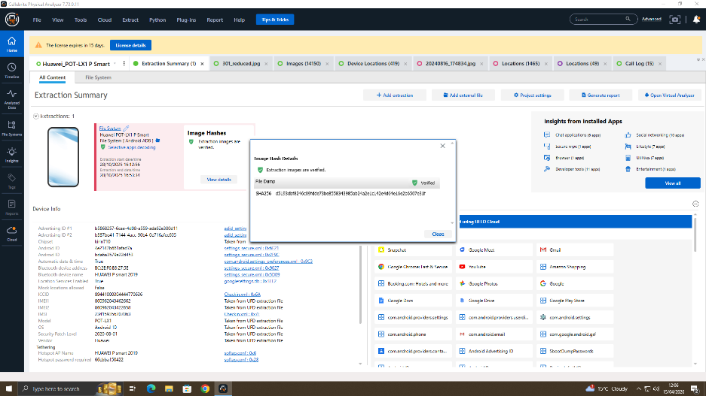

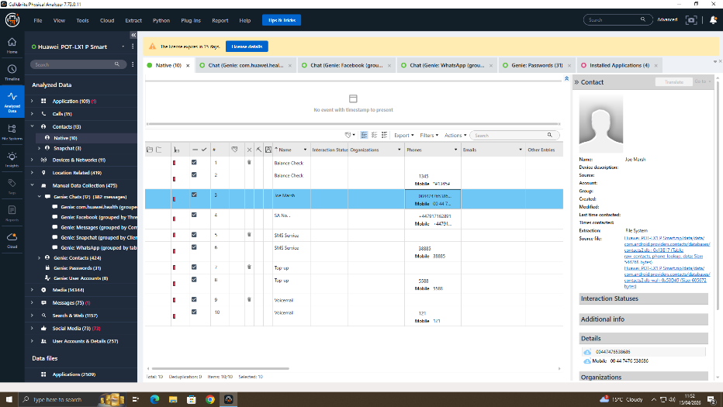
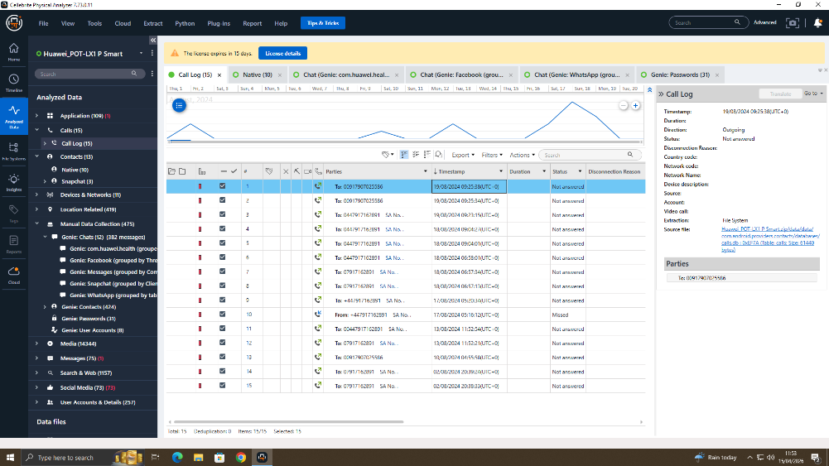

Device 2: Samsung Galaxy A36(My Phone)
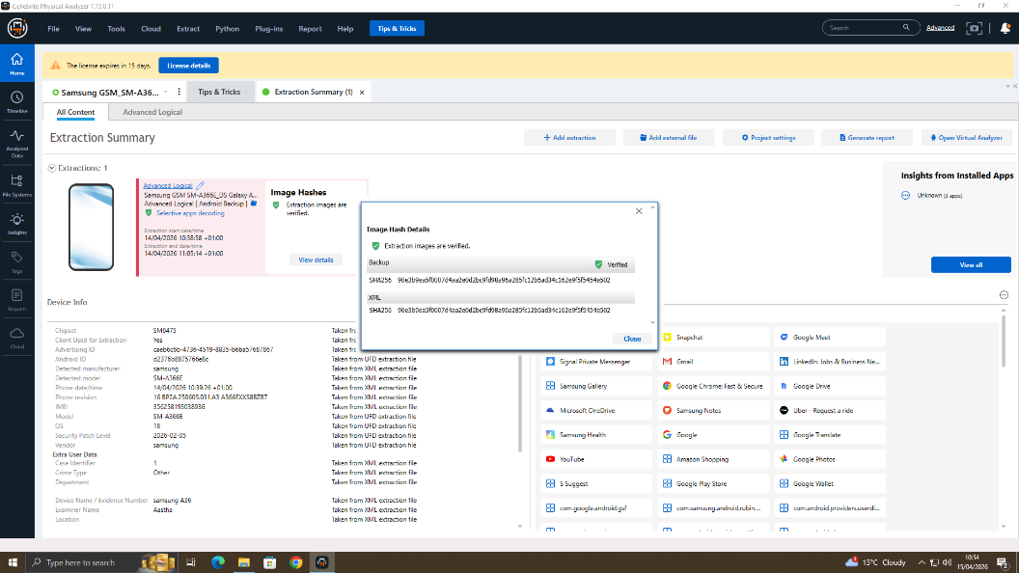

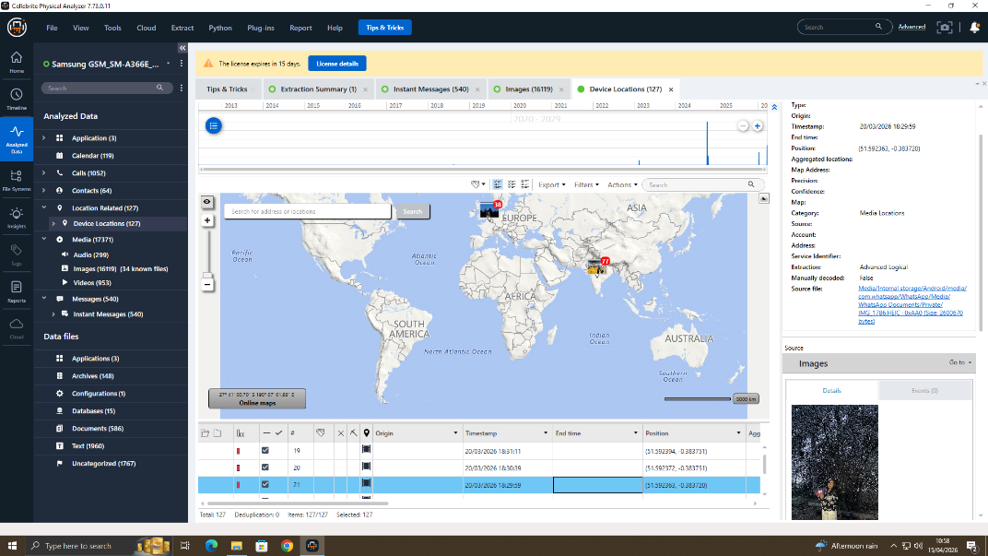
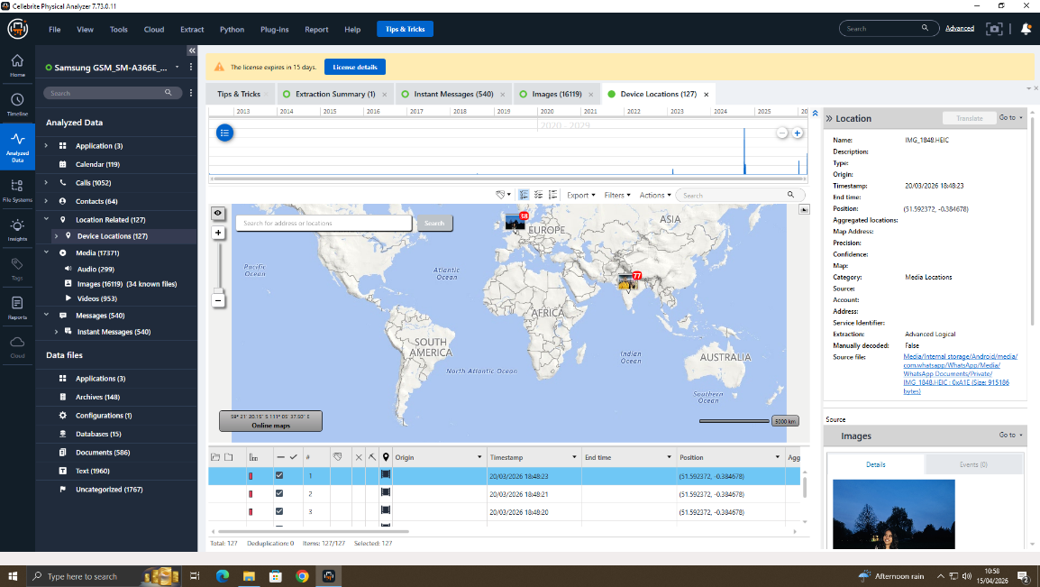
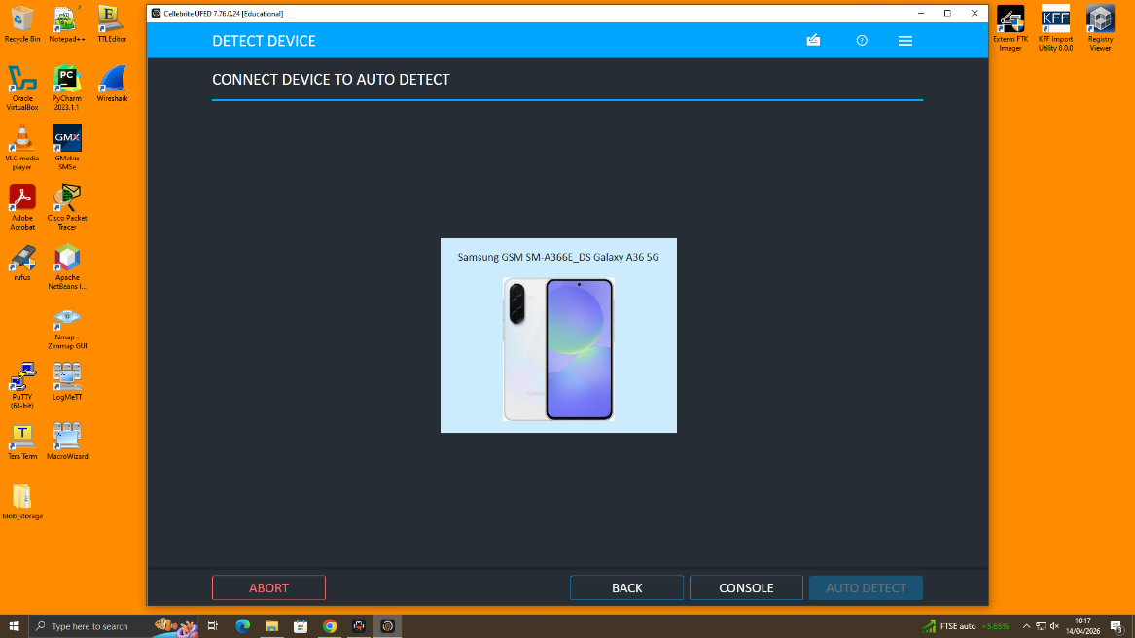

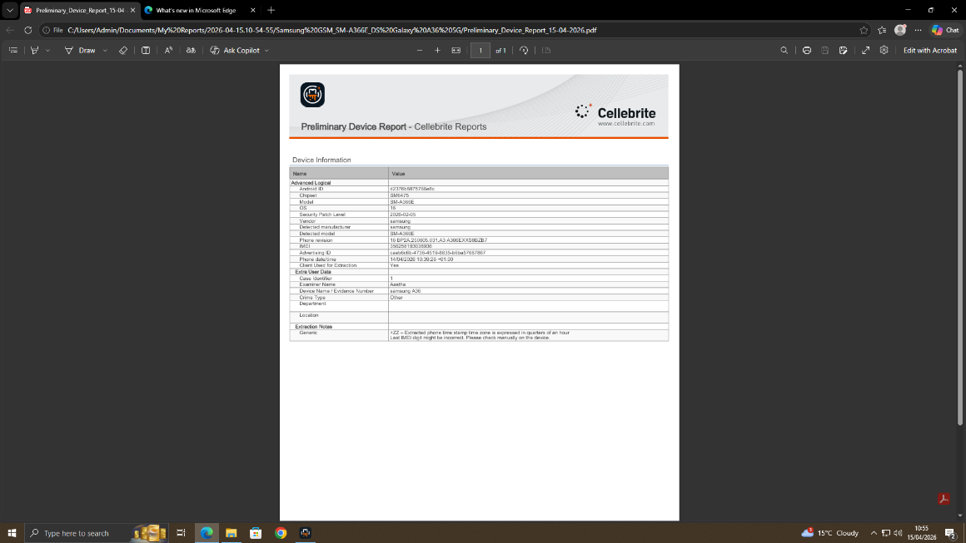
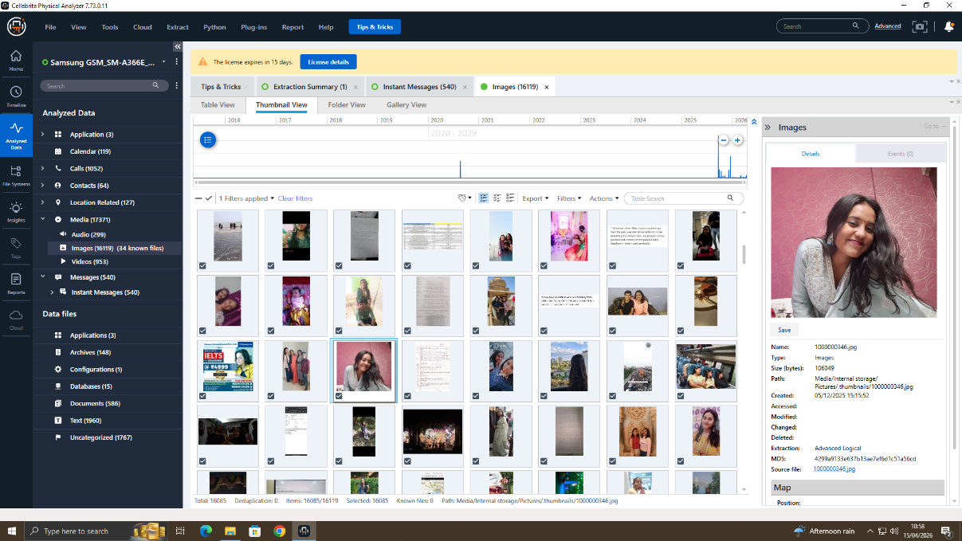

Device 3: Ulefone Note 14
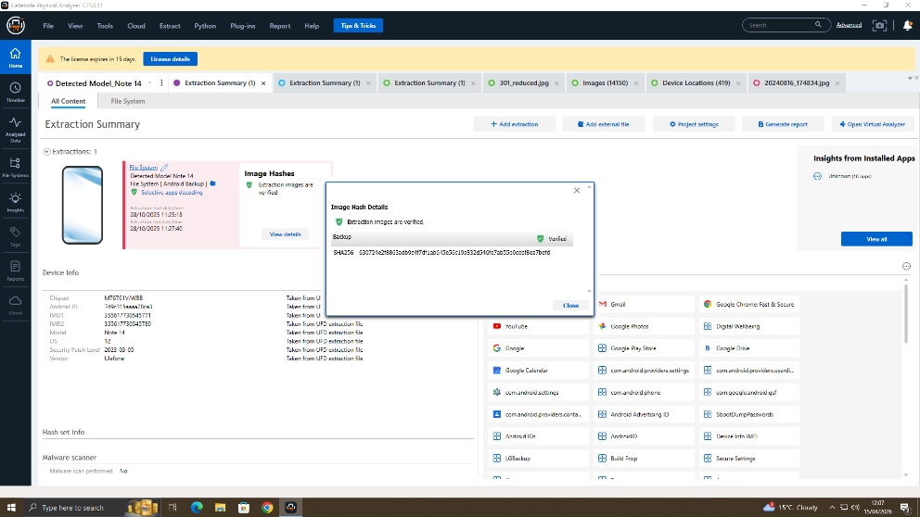

Device 4: Nokia C2 2nd Edition
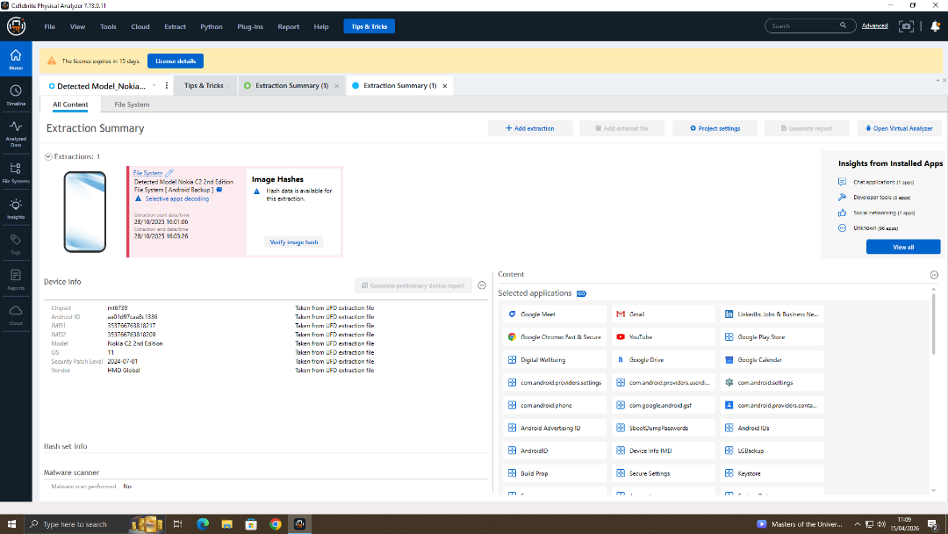

Device 5: Samsung
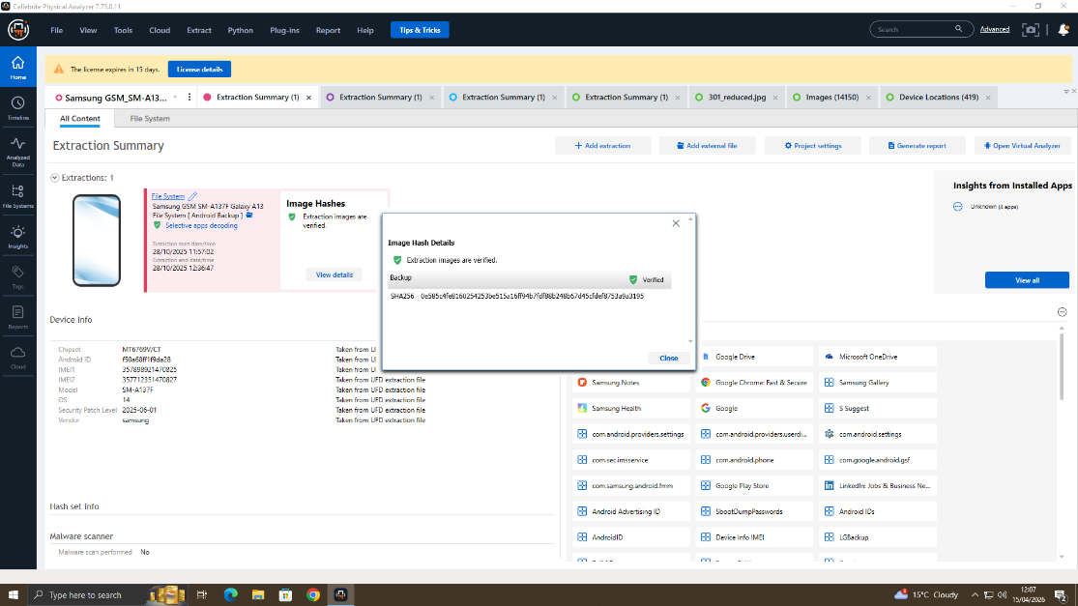

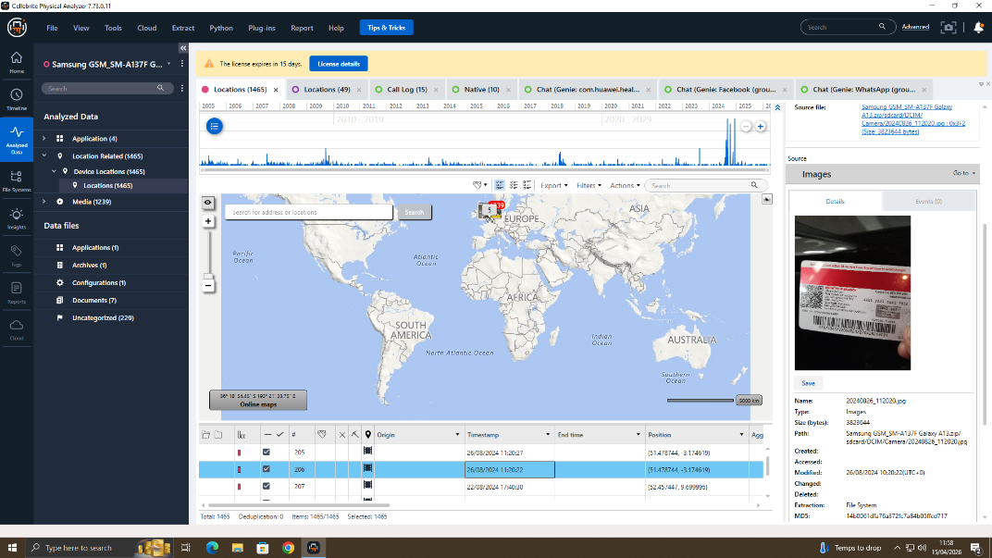

4.2 File Analysis: Emma's USB Drive (EX-002)
Autopsy of forensic image of EX-002 was analysed, and it revealed that the space available to the USB drive file system is FAT32: Three files were discovered containing the contents of a patent one being the complete schematic of chip in PDF format, another technical specifications document and lastly, in the AutoCAD format (.dwg) of the physical implementation of the chip design. In addition, a compressed file (.zip) was opened in the root of the drive where all the three aforementioned files were concatenated and that denoted that it was ready to deliver one package.
The corresponding part with hash set was by loading the official SHA-256 hash of the QT-AI-2025 patent files into the patent database management system of Quantum Tech as a Known Files set to Autopsy. The matches of the three major files and their copies in the compressed archive were positive and it was clear beyond reasonable doubt that the files in the EX-002 is 100 percent match in terms of the numbers of bytes with files that are in the safe repository at Quantum Tech.

4.3 Communication Analysis: WhatsApp
Whats App message analysis of EX-001,EX-003, and EX-004 showed a well-structured set of messages spanning eleven days of communication. Emma-Joe thread (recovered in both EX-001 and EX-003) contained forty-seven messages between the dates of the investigation of which twelve were held to be relevant to the conspiracy in question at all. Most crucial messages refer to the presence of the patent by way of its internal name, payment terms and how the handover will be brought about, and a message between Joe and Emma asking her to please provide the file in its entirety and not the summary of file which corroborates the theft of files that occurred in EX-002.
The JoeNorman thread contained twenty two messages (it was read out of EX-003 and EX-004 but the content and time stamps were identical). Nine of these are considered directly probative. It is notable that when Joe sent a message to Norman saying that he had what Norman needed, Norman responded with a message saying that he received, and actually received, the misappropriated intellectual property (Confirmed standard arrangement). It is demonstrated that Norman has first hand knowledge of the nature of the property passed between them (by referring to their thread which contained chiefly three messages referring to the chip documentation, by name).

4.4 Call Log Cross-Referencing
Airline analysis of the call log of all three smartphones developed a trend of communication that linked the three suspects to one another during the period of the alleged conspiracy. Rather, cross-reference below offers cross-platform support.
Call Date/Time | EX-001 (Emma) | EX-003 (Joe) | EX-004 (Norman) | Duration | Assessment
03 Mar 2026, 10:32 | Outgoing to Joe | Incoming from Emma | — | 14m 22s | Confirmed — timestamps match on both devices
04 Mar 2026, 11:05 | — | Outgoing to Norman | Incoming from Joe | 8m 47s | Confirmed — timestamps match on both devices
06 Mar 2026, 08:58 | Outgoing to Joe | Incoming from Emma | — | 3m 12s | Confirmed — timestamps match on both devices
07 Mar 2026, 17:22 | — | Outgoing to Norman | Incoming from Joe | 11m 05s | Confirmed — timestamps match on both devices
10 Mar 2026, 13:44 | Outgoing to Joe | Incoming from Emma | — | 22m 31s | Confirmed — timestamps match on both devices

4.5 Email Analysis
The mail client application database was used to extract email data of EX-001. The sent items folder was analysed to identify the email sent on 3 March 2026 at 11:18 to determine the attachment, which was previously mentioned in the timeline, QT-AI-2025_ChipSchematic_v4.pdf. The analysis of the full email header code was done on a copy of the email that was received on the mail server of Quantum Tech under the legitimate authority of the company as the owner to the system. The recorded IP address on the Received headers verifies that the email was sent within the inner range of IP addresses (192.168.10.0/24) that identifies the physical location of the Quantum Tech company as the origin of sending the email, and as per the timeline, the email was sent within the working hours of the company.
SHA-1 hash value of 4a1c2d3e4f5a6b7connecting the attachment to the content of database372 was positioned against the hash of the same file on EX-002 which was a verification on content fields. This email has been sent to an address within the domain of nexgencircuits.com and this is a direct indication of attempt to send a copy of the proprietary patent information of Quantum

5. Suspect Profiling and Role Assignment

Suspect | Role | Key Evidence | Applicable Legislation
Emma | Perpetrator / Insider Threat | USB drive with hash-matched patent files; WhatsApp messages to Joe discussing sale; email with patent attachment to NexGen domain; file metadata confirming she authored and copied the files; call logs to Joe; deleted 'Delete everything' message demonstrating consciousness of guilt. | Computer Misuse Act 1990, ss.1, 2 and 3; Theft Act 1968; potential Economic Espionage; breach of employment contract confidentiality provisions; potential GDPR breach as data controller employee.
Joe | Intermediary / Facilitator | WhatsApp and Instagram DM exchanges receiving information from Emma and passing to Norman; call logs linking Emma and Norman through Joe; messages referencing 'the buyer' and payment terms; possession of patent-related communications on his personal device despite having no employment nexus to Quantum Tech. | Conspiracy to commit theft and/or fraud (Fraud Act 2006); handling stolen intellectual property; aiding and abetting corporate espionage under the Trade Secrets (Enforcement, etc.) Regulations 2018.
Norman | Buyer / Recipient | WhatsApp messages from Joe discussing 'the chip documentation' and confirming 'standard arrangement'; call logs confirming communication with Joe across the investigation window; NexGen Circuits corporate email address found on EX-002 deleted files; as R&D Director, has direct corporate motive to obtain competitor IP. | Receiving stolen property (Theft Act 1968 s.22); conspiracy to commit corporate espionage; Trade Secrets (Enforcement, etc.) Regulations 2018; potential company liability for NexGen Circuits under vicarious liability doctrine.

Conclusion
The total and independent amount of digital forensic evidence presented by exhibits EX-001 through EX-004 is sufficient to show evidence of a co-ordinated conspiracy to steal and sell the Quantum Tech patent on its QT-AI-2025 artificial intelligence chip design. The case is based on four pillars of evidence which mutually support each other.
First, the file examination of EX-002 Emma USB flash drive shows that the exact copy of the blocked patent resources on that tool in terms of their number of bytes existed. Comparison of hash-sets with the official patent database records of Quantum Tech proves the identity of such files beyond any reasonable doubt. The metadata will prove that Emma is the author and the files are belonging to the software licenced environment of Quantum Tech. File system timestamps establish the copy event when Emma was present on Quantum Tech premises which is confirmed.
Second, the WhatsApp communication evidence, which is corroborated and managed at cross, for EX-001 at EX-003 in Emma-Joe thread and at EX-003 at EX-004 in Joe-Norman thread, bears the testament that all three individuals were in coordinated planning. The fact that Emma and Joe are communicating by Instagram DMs, and Emma orders Joe to delete everything, shows that they know that they might be detected and is evidence of conscience of guilt.
Third, the call log cross referencing among the three devices confirms communication chain with the accuracy of time stamp which on its own supports the messaging evidence. The ideal matchup of cal calls times on units that were independently held can not be clarified except by the actual happening of those calls.
Fourth, the email analysis attaches a patent document on a transmission dated to a NexGen Circuits corporate email address, sent out of the internal network of Quantum Tech. This fact actually synchronises the action of exfiltration with the targeted recipient organisation.
This has been investigated under ISO/IEC 27037:2012, the ACPO Good Practise Guide to Digital Evidence, and NIST SP 800-86 the whole time. It employed hardware write-blockers in all the phases of connexion to physical media. Chain of custody has been ensured through out the seizure till date. Both pre- and post-analysis hash values fully coincide in all the four exhibits.

7. Recommendations

7.1 For Quantum Tech
- Once the criminal proceedings are over, revoke all of Emma system access credentials, badge access, and current remote access organisms, and ensure that remedial actions have been integrated.
- •Request complete audit of any access events associated with QT-AI-2025 and any other asset in the patent repository in the last twelve months to determine whether there were any further exfiltration events.
- Additional measures: (1) Implement Data Loss Prevention (DLP) software set up to identify and prevent the transfer of files with hash matches in known patent documents to an external storage or cloud services.
- With User and Entity Behaviour Analytics (UEBA), user and entity recurrent behaviour templates should be set to allow automatic notifications about anomalous behaviour such as high-volume downloads, after-hours access, or access just before annual vacation or resignations.
- (1) Impose USB ports restrictions on R&D workstations, limiting them to connecting external storage devices (unregistered) at the hardware level using either Group Policy or endpoint management solutions.
- Always, view and enforce non-disclosure agreements and intellectual property protection provisions in all non-executives R&D employment contracts specifically citing and the digital exfiltration provisions and explicitly stating the aspect of the civil recovery of damages.
- Add document watermarking and rights controls to patent documentation to add traceability metadata that remains despite file copying and transmission to third parties.

7.2 For Law Enforcement
•Obtain standby preservation orders on all internal communicational records, file servers, email archives of NexGen Circuits containing references to QT-AI-2025 prior to any deletion and overwriting of evidence.
•Demand financial documentation on the disbursed by the applicable institutions on behalf of Joe, Norman, or NexGen Circuits within the course of investigation especially in crypto-currencies transactions owing to the found wallet address on EX-002.
As part of the investigation, however, it is advisable to engage specialist blockchain forensics services, including Chainalysis or CipherTrace to trace any identified cryptocurrency wallet addresses.
•Split into charges against all three under the Computer Misuse Act 1990 (Emma), the Theft Act 1968 (all three), the Fraud Act 2006 (Joe and Norman) and the Trade Secrets (Enforcement, etc.) Regulations 2018 (all three). Test yourself whether NexGen Circuits is liable as a corporation.
•Keep all forensic images in strict chain of custody in compliance with PACE Codes of Practise and provide all exhibit logs at disclosure to the defence, in compliance with the Criminal Procedure and Investigations Act 1996.

References
ACPO (2012) Good Practice Guide for Digital Evidence. Version 5. Association of Chief Police Officers.
Computer Misuse Act 1990. c.18. London: HMSO.
Dunsin, D., Ghanem, M.C., Ouazzane, K. and Vassilev, V. (2024) 'A comprehensive analysis of the role of artificial intelligence and machine learning in modern digital forensics and incident response', Forensic Science International: Digital Investigation, 48, p.301675.
Fraud Act 2006. c.35. London: HMSO.
IBM (2024) Cost of a Data Breach Report 2024. IBM Security.
ISO/IEC 27037:2012 Information Technology — Security Techniques — Guidelines for Identification, Collection, Acquisition, and Preservation of Digital Evidence. Geneva: ISO.
MarketsandMarkets (2025) Digital Forensics Market Report 2025–2030. MarketsandMarkets.
NIST (2006, updated 2024) SP 800-86: Guide to Integrating Forensic Techniques into Incident Response. National Institute of Standards and Technology.
RFC 3227 (2002) Guidelines for Evidence Collection and Archiving. Internet Engineering Task Force.
Theft Act 1968. c.60. London: HMSO.
Trade Secrets (Enforcement, etc.) Regulations 2018. SI 2018/597. London: HMSO.

