Student name: Wishaakh Ali
Student Id: 2526546
Module name: Problem-Solving and Decision-Making
Module code: LCLM4004
Lecturer: Annamarie Dufficy
Title: Individual Report Basil’s Bakery

Table of Contents
Task 1: Overview of Case Study 3
Task 2: Solution A Proposal – Community Delivery Network 3
Task 2: Solution B Proposal – Local Business Partnership Scheme 3
Task 3b: Evaluation Results and Justifications 4
Task 4b: Justifications for the Implementation Plan 4
Task 5b – Justification for KPI and SMART Objectives 4
Task 6: Key Findings 5
References 6
Appendices 8
Appendix 1: Task 3a – PMI Evaluation Table 8
Appendix 2: Task 4a – Implementation Plan 10
Appendix 3: Task 5a – KPI & SMART Objectives 11

Task 1: Overview of Case Study
The bakery is owned by Basil, who specialises in using organic ingredients to make his products, it is situated in Coventry. Basil’s Bakery was doing well before the Covid-19 pandemic. Despite recovering from the COVID-19 pandemic's impacts, Basil's Bakery continues to struggle with sales. Sales are still lower than what they were in 2019, raising questions about the business growth. The main issue that the bakery faces is the reduced customers and shifting to working remotely. The retail park has seen a reduction in visitors due to empty units and office workers' lunchtime purchases have decreased due to remote work. The business profitability is now under even more strain due to rising costs of operating machinery and ordering products. Furthermore, the bakery has a restricted range of services, limiting its capacity to attract customers outside of the area it serves. The present difficulties facing the company are a result of these elements working together.

Task 2: Solution A Proposal – Community Delivery Network
The establishment of Solution A is recommended for Basil’s Bakery as this will increase sales and target customers to place orders. Community delivery network allows food to be ordered by customers for same-day delivery (Zhao et al., 2024). The delivery network strategy would address the growing demand for convenience and broaden Basil's customers beyond those who visit the retail store (Pai and Mayya, 2022). By delivering products to customers instead of depending on customer visits, the system immediately addresses decreased foot traffic (Sharffudin and Yadav, 2025). Additionally, homes and nearby companies may make recurring purchases from delivery services (Keeble et al., 2022). Therefore, the bakery would become less reliant on actual customer traffic.

Task 2: Solution B Proposal – Local Business Partnership Scheme
Solution B recommends that forming connections with nearby companies, workplaces and cafés through wholesale partnerships can increase sales for Basil’s small business (Kadaba et al., 2023). This will give Basil's Bakery an opportunity to provide baked goods to organisations. This strategy reduces the business to depend on walk-in customers and generates an extra source of income. Collaborating with local companies could boost order volumes and brand awareness (Kazantsev et al., 2022). Building relationships and negotiating contracts, however, can take a lot of time (Köhler et al., 2022). Additionally, demand may change based on partnership needs. Despite its advantages, the solution can take longer to produce measurable outcomes.

Task 3b: Evaluation Results and Justifications
The Plus Minus and Interesting (PMI) analysis revealed that Solution A, the community delivery service, is superior since it provides more advantages in general than solution B (see Appendix 1). Offering a simple delivery option allows Basil's Bakery to reach more customers and enhances sales, even though it is more expensive to launch. In contrast, partnering with nearby companies is less expensive, but it can take longer to see benefits and rely on other companies' willingness to collaborate (Köhler et al., 2022). Overall, local delivery service is the best option since it directly solves the bakery's loss of sales and changing customer needs while fostering future business expansion (Onsei-Ozigagun et al., 2024).

Task 4b: Justifications for the Implementation Plan
Implementing the plan follows a logical sequence (see Appendix 2) to ensure that the community delivery service is implemented successfully and with the least amount of interruption feasible (Shobana et al., 2023). Firstly, Basil would need to conduct market research to assess customer needs before investing into the service. Prior, to securing a delivery method, prepare pricing and packaging it is crucial to ensure that staff are trained and understand the new procedures (Fraile et al., 2023). Marketing commences as soon as the service is prepared to attract customers to begin benefiting from it right away. Basil is in charge of overseeing the project as he is familiar with the industry. Monitoring regular enables Basil to identify issues earlier and make any adjustments.

Task 5b – Justification for KPI and SMART Objectives
Basil can determine whether customers are using the new service for delivery and whether it is increasing revenue by using the selected KPI and SMART Objectives (see Appendix 3) (Almasarweh et al., 2024). A clear indication of customer demand and the effectiveness of the service can be obtained by measuring the quantity of delivery orders each month. The SMART objectives also help Basil to monitor increases in sales and customer satisfaction within reasonable timelines. This will allow Basil to identify If the targets are not achieved, he may examine customer comments and based on this information he can enhance the delivery procedure and implement further marketing initiatives.

Task 6: Key Findings
This report identified key findings from the factors that have contributed Basil’ Bakery reduced decline in sales issue and it has outlined what can be done to improve sales and financial revenue. Using the KPI and SMART objectives tools assisted to provide a better insight to both the solutions and which one has more chance of success for the business overall.

• The primary issue influencing sales is still decreased customer foot traffic, implementing a solution can assist Basil’s Bakery.
• Delivery services can broaden market access and improve accessibility for customers.
• Compared to local partnerships, community delivery offers more growth potential.
• Structured implementation lowers risk and increases operational effectiveness.
• KPIs and SMART goals offer quantifiable performance indicators to help improve business sales (Zerine and Islam, 2025).

References
Almasarweh, M.S., lbrahim AlHassan, H., Mustafa, S., Al-Hamad, A.A.S.A., Nawasra, M., Ahmad, A.Y.B. and Alsmad, L.A. (2024) ‘Performance measurement: Key performance indicators as drivers in assessing risk and improving value in the services sector’, Journal of Project Management, 9(4), pp. 1-18.

Dal Mas, F., Massaro, M., Paoloni, P. and Kianto, A. (2023) ‘Translating knowledge in new entrepreneurial ventures: the role of business plan development’, VINE Journal of Information and Knowledge Management Systems, 53(6), pp.1159-1177.

Dasallas, L., Lee, J., Jang, S. and Jang, S. (2024) ‘Development and application of technical key performance indicators (KPIs) for smart water cities (SWCs) global standards and certification schemes’, Water, 16(5), p.741.

Fraile, F., Psarommatis, F., Alarcón, F. and Joan, J. (2023) ‘A methodological framework for designing personalised training programs to support personnel upskilling in Industry 5.0’, Computers, 12(11), p.224.

Kadaba, D.M.K., Aithal, P.S. and KRS, S. (2023) ‘Government initiatives and digital innovation for Atma Nirbhar MSMEs/SMEs: To achieve sustainable and inclusive economic growth’, International Journal of Management, Technology, and Social Sciences (IJMTS), 8(1), pp.68-82.

Kalina, V., Lhota, J. and Kalender, Z.T. (2025) ‘Effective project portfolio management for SMEs: A conceptual framework using business intelligence tools’, Procedia Computer Science, 253, pp.745-756.

Kazantsev, N., Pishchulov, G., Mehandjiev, N., Sampaio, P. and Zolkiewski, J. (2022) ‘Investigating barriers to demand-driven SME collaboration in low-volume high-variability manufacturing’, Supply Chain Management: An International Journal, 27(2), pp.265-282.

Keeble, M., Adams, J. and Burgoine, T. (2022) ‘Investigating experiences of frequent online food delivery service use: a qualitative study in UK adults’, BMC public health, 22(1), p.1365.

Khan, S.H., Kureshi, N., Aslam, M.S. and Rafique, S. (2023) ‘Balance scorecard (BSC): Incorporating" Key performance indicators"(KPI) in the Evaluation of the Healthcare System’, Pakistan Armed Forces Medical Journal, 73(6), p.1727.

Köhler, J., Sönnichsen, S.D. and Beske‐Jansen, P. (2022) ‘Towards a collaboration framework for circular economy: The role of dynamic capabilities and open innovation’, Business Strategy and the Environment, 31(6), pp.2700-2713.

Onesi-Ozigagun, O., Ololade, Y.J., Eyo-Udo, N.L. and Oluwaseun, D. (2024) ‘Data-driven decision making: Shaping the future of business efficiency and customer engagement’, International Journal of Multidisciplinary Research Updates, 7(2), pp.19-29.

Pai, S. and Mayya, S. (2022) ‘A study on consumer preferences with reference to online food delivery amenities’, International Journal of Management, Technology and Social Sciences (IJMTS), 7(2), pp.144-166.

Seghezzi, A. and Mangiaracina, R. (2021) ‘On-demand food delivery: investigating the economic
Performances’, International journal of retail & distribution management, 49(4), pp.531-549.

Shahriar, M.M., Parvez, M.S., Islam, M.A. and Talapatra, S. (2022) ‘Implementation of 5S in a plastic bag manufacturing industry: A case study’, Cleaner Engineering and Technology, 8, p.100488.

Sharffudin, S. and Yadav, V.K. (2025) ‘A Review of Online Food Delivery (OFD) Impact on Food Businesses’, Future of Business Administration, 4(1), pp.58-67.

Sharma, H.L., Priyamvada, C. and Chetna, C. (2023) ‘PMI (Plus-Minus-Interesting): An attention-directed strategy for enhancing creative thinking among elementary school students’, Int. J. Multidiscip. Res, 5, pp.1-15.

Shobana, J., Gangadhar, C., Arora, R.K., Renjith, P.N., Bamini, J. and devidas Chincholkar, Y. (2023) ‘E-commerce customer churn prevention using machine learning-based business intelligence strategy’, Measurement: Sensors, 27, p.100728.

Stavropoulou, E., Spinthiropoulos, K., Ragazou, K., Papademetriou, C. and Passas, I. (2023)’ Green balanced scorecard: A tool of sustainable information systems for an energy efficient business’, Energies, 16(18), p.6432.

Supriani, Y., Meliani, F., Supriyadi, A., Supiana, S. and Zaqiah, Q.Y. (2022) ‘The process of curriculum innovation: Dimensions, models, stages, and affecting factors’, Nazhruna: Jurnal Pendidikan Islam, 5(2), pp.485-500.

Tadić, S. and Veljović, M. (2021) Home Delivery: A Framework for Structuring. International Journal for Traffic & Transport Engineering, 11(1).

Voth-Gaeddert, L. (2024) ‘Improving use of SMART goals in science diplomacy: an overview of concepts and approaches’, Journal of Science Policy & Governance, 1, pp.1-5.

Zerine, I. and Islam, M.M. (2025) Analytics Playbook: Strategies for Smart Decision-Making. Essay Publication Research and Consultancy:

Zhao, Y., Papier, F. and Teo, C.P. (2024) ‘Market thickness in online food delivery platforms: The impact of food processing times’, Manufacturing & Service Operations Management, 26(3), pp.853-872.

Appendices

Appendix 1: Task 3a – PMI Evaluation Table

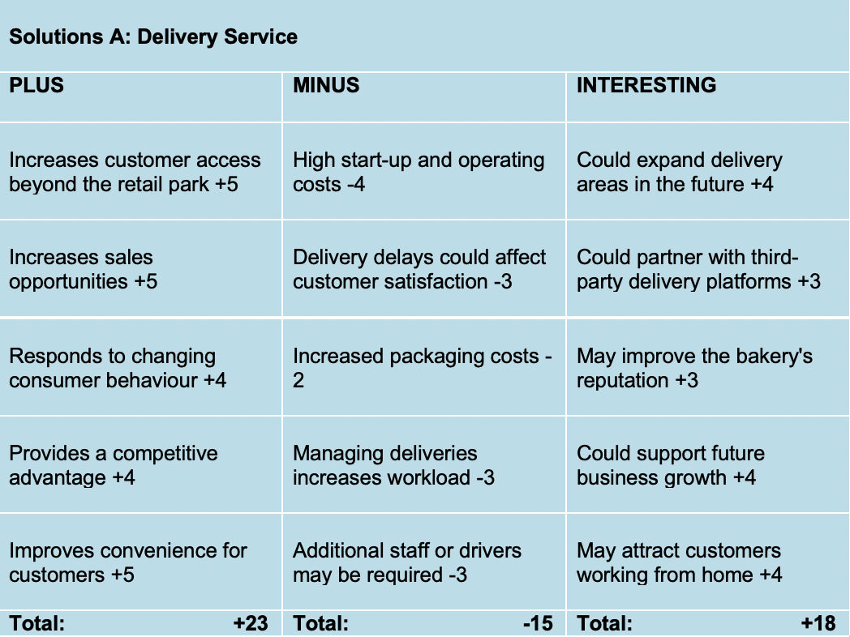

Overall Total = +26

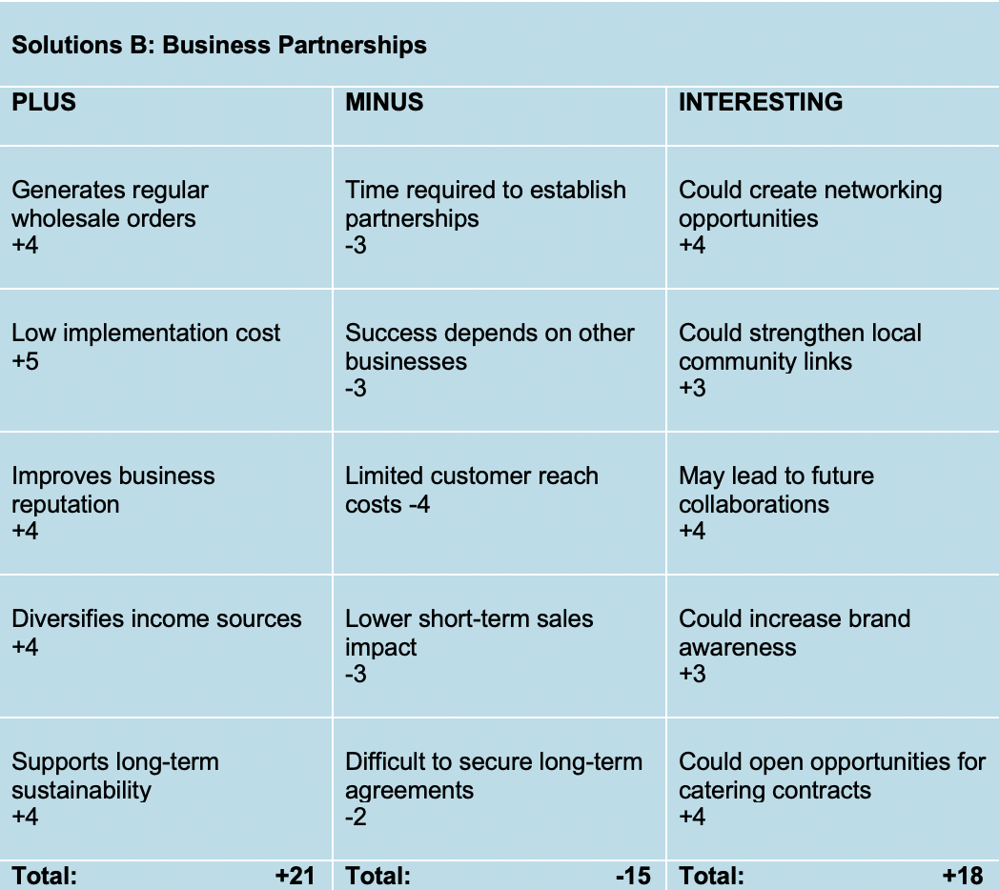

Overall Total = +24
Preferred Solution A: Community Delivery Service
The Plus, Minus and Implications (PMI) technique was used to compare two possible solutions for Basil's Bakery: introducing a community delivery service (Solution A) and creating partnerships with local businesses (Solution B). PMI is a simple decision-making tool that helps businesses look at the good points, bad points and possible future effects of each option before making a final decision (Kalina et al., 2025). The PMI tool makes it easier to compare different ideas in a fair and organised way as it allows individuals to think in a creative way (Sharma et al., 2023).
For Basil's Bakery, both solutions could help improve sales, but each has different strengths and weaknesses. Solution A – the community delivery service would allow the bakery to reach more customers, especially people working from home or those who cannot visit the shop (Tadić and Veljović, 2021). However, the delivery service would also involve extra costs, such as delivery of equipment, packaging and staffing (Seghezzi and Mangiaracina, 2021). On the other hand, these partnerships may take time to build and are less likely to increase sales immediately. Business partnerships would cost less to introduce and could provide regular wholesale orders from local organisations but is time consuming. Using the PMI method helped compare both options before choosing the most suitable solution.

Appendix 2: Task 4a – Implementation Plan

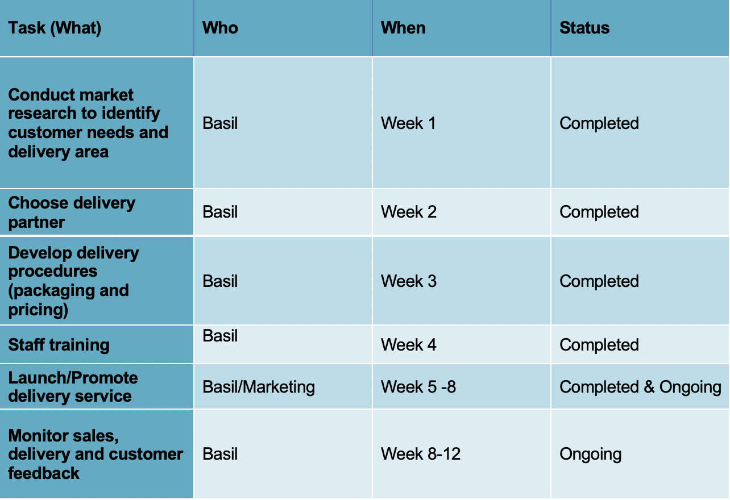

An implementation plan is used to show the steps needed to introduce a new business idea in an organised way (Dal Mas et al., 2023). It sets out what needs to be done, when each task should be completed and who is responsible for carrying it out (Shahriar et al., 2022). This helps businesses stay organised, manage their time effectively and reduce the risk of problems during the implementation process (Supriani et al., 2022).
For Basil's Bakery, the implementation plan focuses on introducing a community delivery service. First task is to carry out market research to understand customer demand and identify the best delivery areas. Basil will then choose the most suitable delivery method before creating delivery procedures, pricing and packaging. Once these are in place, staff will be trained so they understand how to manage orders and provide good customer service. The delivery service will then be launched and promoted through social media and local advertising. Finally, Basil will monitor customer feedback, delivery performance and sales to identify any improvements that may be needed and ensure the new service is successful.

Appendix 3: Task 5a – KPI & SMART Objectives

Key Performance Indicator is: Number of delivery orders received each month

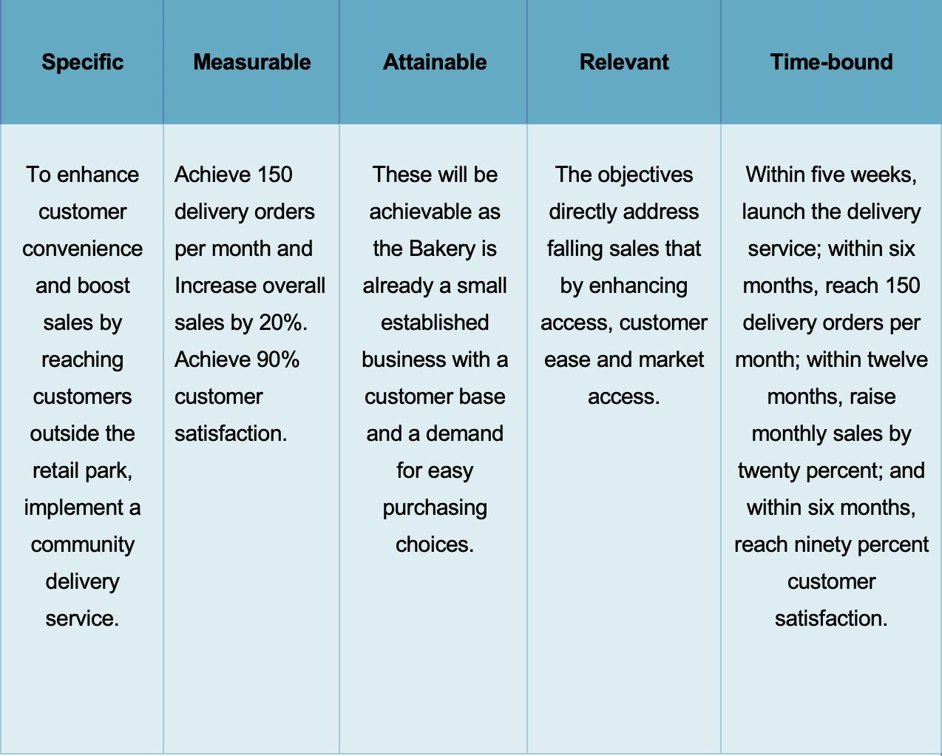
Key Performance Indicators (KPIs) are used by businesses to measure how well they are achieving their goals (Dasallas et al., 2024). They provide clear results that can be monitored over time and help managers decide whether a new strategy is working (Zerine and Islam, 2025). Alongside KPIs, SMART objectives are used to set clear targets that are Specific, Measurable, Achievable, Relevant and Time-bound (Voth-Gaeddert, 2024). Using both together helps businesses measure progress and identify areas that need improvement (Stavropoulou et al., 2023).
For Basil's Bakery, the chosen KPI is the number of delivery orders received each month, as this directly measures the success of the new community delivery service. The SMART objectives include achieving 150 delivery orders per month, increasing monthly sales by 20% and reaching 90% customer satisfaction within the agreed timeframes. These targets give Basil clear goals to work towards and provide a simple way to measure whether the delivery service is improving sales, attracting more customers and meeting customer expectations. Regular monitoring will help Basil review progress and make changes if necessary.

