
Skills for the Workplace
Module Assignment Submission
Student Name: | Samuel Edayi
Student Number: | 1706729
Module No: | BMSK4003
Module Title: | DIGITAL SKILLS AND RESEARCH METHODS
Lecturer name:

Statement of Confirmation of Authenticity
By the act of making this submission, the student declares that this is the work of the student named above. The work has not, in whole or in part, been knowingly presented elsewhere for assessment, or where assessment has been built on a previous assessment, this has been identified. Where materials have been used from other sources it has been properly acknowledged. If this statement is untrue, the student acknowledges that an assessment offence has been committed.
Attention is drawn to the plagiarism and unfair practice policies of both the University and of ILM.

Table of Contents
Introduction 3
Describe Technology & its importance in our life 3
Use of social media in workplace 4
Appropriate use of technology in work place though social applications 6
Safety and security of the social media and web based applications for the workplace 7
Conclusion 8
Bibliography 9
Appendix 1 11
Appendix 2 12

Introduction

This report will be focused on the importance of technology in a work place. We discuss about the way how could solve a problem by using technology.
Technology helps a company to find a new & innovative way to improve the culture of an organization. In this era of modern science every organization needs to depend on technology. Technology helps to make an efficient workplace and improve their labour force. Technology helps an organization to achieve the best outcome form their worker. Technology helps to increase productivity.
We also discussed about the effect of using technology too much. We also talk about some bug of modern technology. We might need to suffer to cyber-attack form hacker. It may cause data losing & money losing in an organization. In that case, we need to secure our web-site, social profile, and data centre from Cyber-attack. We have to ensure a strong security to secure our organization from hacking. We need to update security system regularly. We also have to be careful about our given information in our social profile. Every organization can enjoy the blessings of modern science by ensuring the best possible security system. (forbes, 2017)

Describe Technology & its importance in our life

What is technology?
Technology is a Greek word. “Techne” means skill and “logia” means combination of art. Technology means a combination of skill or process by which we can easily do our work. (study, 2016)Technology is a knowledge of using a system to get the job done. We use technology to complete our task faster. We also can use technology for communication & marketing of our organization. (wiley, 2016)
How important in our life?
Technology play an important part in different sector of our life. First of all, technology helps an organization to enhance their networking. It helps to ensure more effective communication. Every company wants to increase their productivity. With the help of technology any company can increase their productivity. It also helps to enrich human resource which results a nice organization culture and efficient workforce. Technology opens the door of innovation and creating new ideas. It ensures the best use of natural resource. Technology also helps in education sector. Now a day anyone can easily communicate without presenting a certain place. So, we can realize the blessings of technology in our life. (useoftechnology, 2017)
Are employees distracted from work?
As technology offer lots of benefits in one’s life every want to enjoy that power. By using technology, we can be benefitted in our business sector. We can easily keep communication via using social applications. Like Facebook, Twitter, LinkedIn profile helps a person to maintain relationship. But sometimes too much using of technology may distract our worker from work. Use of technology is good for organization to expose their business. If we control the amount of using technology we can achieve our desired success. (edudemic, 2015)

Use of social media in workplace

- Save time: Now a day we can easily keep our communication without presenting in that place. So, it helps to save our valuable time.
- Save money: By using social application we can maintain our communication without spending money. Social application like Email, Facebook, Skype helps to save our money. (importantindia, 2015)
- Enhance networking: Social media helps to increase network. Applications like Skype, LinkedIn, Tweeter, Facebook, Gmail helps to keep a borderless communication around any parts of the world. In order to keel a fluent communication and enhance organization’s networking social media can play a major role for any company. (sites, 2015)
- Marketing: Social media can play a major role in digital marketing. Facebook is now the easiest way to grab attention of any consumer. Any company can communicate with their consumer via their Facebook page. It also helps to provide information to any consumer around the world. (shrm, 2017)
- Improve relationship: Social media helps to build and maintain a good inter personal relationship among workers. They can easily interact each other and share their ideas. (theolsongroup, 2017)

Use of LinkedIn in Business promotion
LinkedIn is one of famous social applications by which we easily can share our ideas. We can share our thoughts, ideas, innovations by writing a blog in that application. We need to create a profile to share our written blog. It also helps to promote yourself. LinkedIn profile also helps to provide one’s information and personal interest to audience. LinkedIn helps to promote an organization & helps them in their marketing. Organization needs to keep their profile updated to grab market (rawsoninternetmarketing, 2015)
- Helps in digital marketing
- Promote a business product
- Build more effective online business
- Helps to attract a consumer
- Help to build an efficient team met
- Inspire new ideas for business
- Helps to enhance networking
So, if we can use LinkedIn properly it will help a lot in every sector of business. (thebalance, 2016)

Appropriate use of technology in work place though social applications

Social media or applications opens a new door of possibilities for all business sectors. We have use it appropriately if we want to achieve the best benefit from the technology. Technology helps an organization to sheltered information in data centre. It also helps to maintain privacy of our saved data. (lbmcep, 2017)
- We have to secure the detail information in a written format. If we secure all those in our hard drive it will increase the chance of hacking
- We need to keep monitoring our used technology to ensure our security. It also helps to keep updated our working procedures
- We have to keep those devices which we usually used in workplace. Manager needs to observed pc and phone that a worker use
- We cannot allow any personal device in an official meeting or discussion. It helps to protect company’s privacy
- Facebook is a new way to digital marketing but we have to be very sensitive on what information we can provide and what not (business, 2015)
- We also need to keep uploading blog on our organization’s LinkedIn profile which helps to reach more audience
- Email is the most famous application for sharing data. We have to be careful of using email and we also need to ensure that item we are sending.
- Twitter profile also helps an organization to make a strong foundation of business. We can easily provide information to our follower consumer which helps to increase sells. (socialmediaexaminer, 2016)

Technology helps to ensure a good collaboration into every sector of an organization. We have to provide updated news on new product or offer though social profile to our consumers. Social application is the best way to grab attention. People also like to buy product from online. Future business will me more dependable on online. So, it is high time to ensure a perfect collaboration within all social applications. We need to train our labour force on using social application properly. We have to make them skilful on that sector to ensure good communication. Communication is the way of building a relationship. By trained them perfectly we can ensure a good professionalism and discipline into our organization’s culture. (lexology, 2017)

Safety and security of the social media and web based applications for the workplace
As the use o social media is increasing day by day risk of using it also rises. We normally use Facebook, Tweeter, LinkedIn, Viber, Imo for our regular needs. Facebooks is the most famous among all of them. Hacker target the week security system of an organization. They try to break the security system and damage resource. We need to secure our data centre from them. We need to recut some specialised who can protect our server form hacker. We also need to maintain some rules to keep us secure. (bcs, 2016)
Cyber- attack results & our necessary steps
Data losing & it’s prevention steps:
Cyber-attack results losing of information for an organization. When a hacker hacked an organization’s data centre they grab all the confidential information of that organization. Social media is a big media for hacker. Sometimes we provide or save some of our confidential document in internet. That is not secure for any organization. Hacker usually hacked with the help of internet so we need to be careful on that. We should try to save all our important data in a different hard drive which is not connected to internet. (socialmedia, 2015)
Break privacy system & it’s prevention steps:
Hacker target the week security system of an organization. Every organization need to set up a safe and strong security system. When company face cyber-attack, they are losing important information of their employee & dealer. Which create a security crisis in a company. Hacker break the privacy system and damage the storage system totally. We need to use a good quality antivirus to prevent hackers. We also need to keep updated our security path. If hacking happens we have to handle that situation professionally. (blog, 2016)
Reputation damage & it’s prevention steps:
Cyber-crime damages a company’s reputation badly. If company fail to secure confidential documents or information other company feel afraid to do business with that company. If results a lots of profit loss and networking as well. We need to ensure a strong security system to keep a good reputation in market. We have to use high quality tools or software. We also need to take help from the police to identify the hackers and try to ensure punishment as early as possible. (blog, 2017)

Conclusion

In this entire report we discussed on the modern technology and how we can use to create new opportunities. We have discussed on social applications and the use of them in our workplace. If we want to enhance sells we need to target our consumers. Social media applications help to get a big audience by spending a low advertising cost. We also know about cyber attack and how we can create a good security system to prevent hacking. We have to be careful on the use of social applications in different purpose. We should not over have exposed our product. We also give enough facilities to our worker so that they will give us the best possible service. If we can ensure those facilities and use technology properly we can be succeeded in professional field. (slideshare, 2017)

Bibliography
bcs. (2016). Retrieved from http://www.bcs.org/content/conWebDoc/45818
blog. (2016). Retrieved from https://blog.dashburst.com/social-media-risks/
blog. (2017). Retrieved from https://blog.dashburst.com/social-media-risks/
business. (2015). Retrieved from https://www.business.qld.gov.au/running-business/marketing-sales/marketing-promotion/online-marketing/facebook/benefits
edudemic. (2015). Retrieved from http://www.edudemic.com/the-4-negative-side-effects-of-technology/
forbes. (2017). Retrieved from https://www.forbes.com/sites/louisefron/2017/12/03/how-technology-can-transform-workplace-humanity/#3e3b60b22f00
importantindia. (2015). Retrieved from https://www.importantindia.com/24015/importance-of-science-and-technology-in-our-daily-life/
lbmcep. (2017). Retrieved from https://www.lbmcep.com/blog/5-tips-to-using-technology-professionally-in-the-work-place
lexology. (2017). Retrieved from https://www.lexology.com/library/detail.aspx?g=334b0532-1b94-4247-82d6-62dbfff0e19c
rawsoninternetmarketing. (2015). Retrieved from https://rawsoninternetmarketing.com/social-media-6-benefits-linkedin-company-page/
shrm. (2017). Retrieved from https://www.shrm.org/resourcesandtools/tools-and-samples/toolkits/pages/managingsocialmedia.aspx
sites. (2015). Retrieved from https://sites.google.com/a/my.shu.ac.uk/shusome/employability
slideshare. (2017). Retrieved from https://www.slideshare.net/suebeckingham/whyyou-need-a-professional-online-presence-and-how-to-do-it-rscon5
socialmedia. (2015). Retrieved from http://socialmedia.biz/2015/09/29/the-3-major-risks-of-using-social-media-in-your-business/
socialmediaexaminer. (2016). Retrieved from https://www.socialmediaexaminer.com/how-to-use-twitter-for-business-and-marketing/
study. (2016). Retrieved from https://study.com/academy/lesson/what-is-technology-definition-types.html
thebalance. (2016). Retrieved from https://www.thebalance.com/how-to-use-linkedin-to-promote-your-home-business-1794731
theolsongroup. (2017). Retrieved from https://theolsongroup.com/5-reasons-social-media-workplace-can-help-employees/
useoftechnology. (2017). Retrieved from https://www.useoftechnology.com/technology-today-tomorrow/
wiley. (2016). Retrieved from https://www.wiley.com/WileyCDA/WileyTitle/productCd-0470710403.html

Appendix 1:
Personal Twitter:

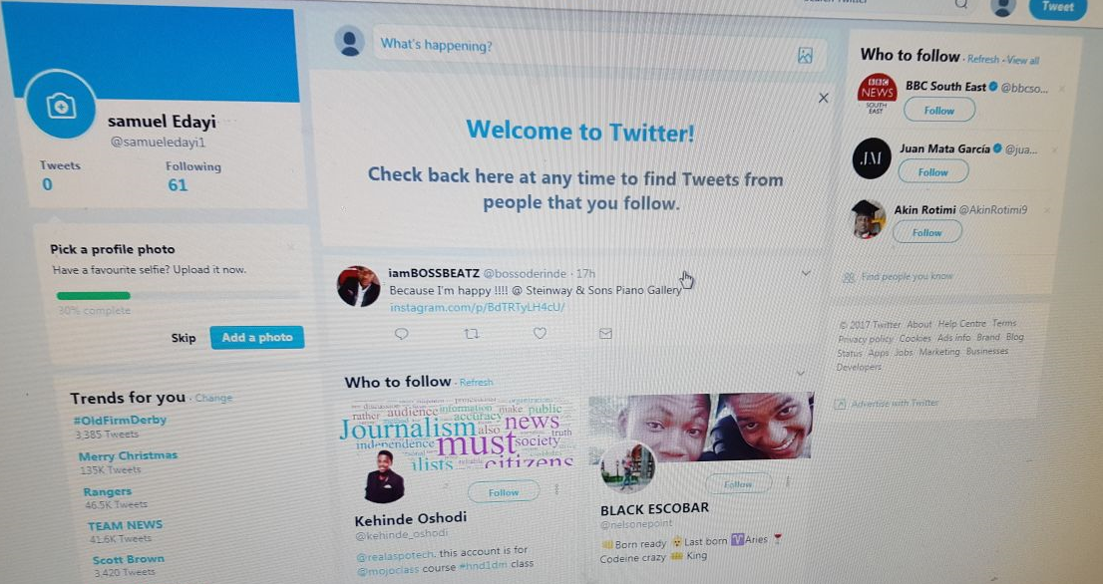
Personal LinkedIn:


