LECTURER: MS. ADESEWA AJAYI
STUDENT: Alexandra Nicut (1919639)
MODULE: Academic and Employability Skills (BMSW4001_LON)

REFLECTIVE OUTCOME AND LEARNING DEVELOPMENT IN RELATION TO ACADEMIC AND EMPLOYABILITY SKILLS MODULE 2020.

Introduction
This reflective report is based on my personal refection upon Academic and Employability Skills, and is aiming to encourage students to study, develop academic strengths, and reflect upon their own background to check for the value of continuing to study.
-In this report you will find the following topics:
- Presentation and public speaking skills
- Reflective writing
- Gathering relevant information
- Analytical and critical thinking
-Based on these 4 topics, I will demonstrate through reliable sources, books, academic research, journals, and analysis how useful these topics were when practiced within my class and properly explained by a professional.
-Furthermore, I will use Gibb’s “reflective cycle” (1998), the model of Driscoll (1994), and Kolb’s “Experiential Learning Cycle” (1948) to support the findings and my personal reflection of in-class outcome.
-I will demonstrate what a “SWOT” analysis is, using the model learned in term 1.
-Moreover, I will introduce you to three most famous analysts and critical thinkers that have changed the world and I recommend more to those that need to reflect and improve personal and academic areas.
WHAT IS REFELCTIVE LEARNING?
Learning, developing and our abilities have a common perspective towards employability and reflection which enables us to reveal the unknown and the unrecognised (Edinburgh, 2020).
A personal reflection can be my own experience when decided to enrol University. Why? To improve my life in different aspects that I thought I was considerably deficient.
1.Presentation and Public speaking skills

-Gibb’s model of reflection (1988)
Description:
Our presentation and speaking in public attitude depend on our education and reflects our level of efficiency, capacity and abilities which may serve us well in employment and future career options. According to University of Edinburgh (2020), reflection is the ability that we need throughout our entire life. Is constructive in learning, evolving while in work, can sustain you with private enterprise and structure your general competence to get hired, be flexible and productive (See Appendix A).
Feelings:
The very first question after I passed the entry exam to the University, my concerns about speaking in public were accentuating my emotions and there was a fear which I could not control at the time. The opening, the possible questions, the pre-talk conversations, and the speaking was part of my presentation for the very first class.
Public speaking promoted by authors, is the way through which students are meant to enhance skills that will improve the deliverance of a particular information (Nie et al., 2020). Presentation and public speaking were one of the topics we have learned about in-class. This lesson was valued because has improved my body-language, my speech and boosted my motivation and determination to achieve, explore and find more.
Evaluation:
Soon as the lesson started and our lecturer introduced herself, my behavior changed, and my confidence begin to raise. Her natural gestures, her eye-contact with each one of us, her clear speech, and her replies to our questions were fascinating me.
After the first week of study, everything became much easier to comprehend as everyone understood the quality of good leadership.
According to Morgan (2017), a leader should have followers, be understood, and accepted by his/her followers. Soon as the presentation and the acceptance took place, the learning outcomes become easy to perceive and efficiently used afterwards.
Analysis:
Mahatma Gandhi (1869-1948)
Was an Indian politician, nationalist, and led pacifist and non-violent activities to improve the perceptions about woman, lower casts among Indian culture and fought for British rule to be reconsidered. Also known as a Human Rights activist, Mahatma Gandhi aimed and encouraged independency throughout his life.
“Give a man a fish and you feed him for a day. Teach a man to fish and you feed him for a lifetime” (Morgan, 2017, p. 222).
When the presentation and the public speaking is delivered by a professional, an individual can learn more and apply in practice efficiently.
Conclusion:
Moreover, I would personally start to follow Gibb’s model (1988), because it is used by Universities and hospitals to improve emotional distress and solve issues related to expression and understanding (O’Brien, 2014).
Action plan:
I am planning to continue my studies in becoming a Mental Health Nurse by taking into consideration the models of reflection, presentation, sources provided by professionals in class and structure a career path using SWOT analysis (Please see bellow’s example).
STRENGHTS | WEAKNESSES
-trustworthy and loyal  -confident and reliable  -good listener and problem solver | -soft hearted  -lacking employability skills  -hardly trust someone
OPORTUNITIES | THREATS
-Obtain a merit or distinction certificate for this module  -Undertake another 3-year Nursing Course  -Work in a Mental Health organisation | -having nobody to support me  -lack of experience  -financial costs required for further study

2. Reflective writing
Driscoll (1994)
What? So what? Now what? Are the main three elements through which reflective process is structured and was promoted by the model of Driscoll (1994). This model is designed to learn from an experience but improve for the next one. According to Nursing and Midwifery Council NMC (2019), nurses are encouraged to reflect constantly upon their activities and were quality of care can be enhanced.
Using our awareness, we can determine whether the experience was positive or negative and analyse the event to identify learnings.
Driscoll (2000) explained the followings:
What? Being a description of what happened in the past.
Reflecting upon my “Academic and Employability Skills” (2020) module, writing was one of the most important lessons to help me pass my assignments successfully. Academic writing using Harvard style, was something that I never experienced before. Summarising and paraphrasing were discussed, and videos were provided to improve your understanding when writing (See Appendix B).
So what? As an analysis of the event, feelings and discovered areas or learning outcomes.
Gradually, I was thought by my lecturer, where to find the “Harvard Referencing Handbook”, how to use it, and when to use it in my exam’s papers. At first, I was confused just by looking at so much information. However, in week 3, the assignments were discussed in class in details and I was able to apply everything that was written in my own piece of work. I was so satisfied to find out that I can transform a usual letter into an academic report.
Now what? Reflecting on the event, what am I thinking now?
I remember that one of the assignment tasks was to write a report using research methods. Many people prefer to spend time online search for materials such as, articles, magazines, books, and other sources of inspiration while some are not technology friendly at all (Andrew Mound, 2017, p. 111). Using technology in my favor was easy but finding reliable and credible sources was the hardest part for which I needed academic support.
Going back to where I started from, the outcome of in class experience has improved with each lesson, which was always supported by evidence and facts.

3. Gathering relevant information
-Driscoll (1984)

What is CRAAP TEST?
Quality information and authenticity may be tested using CRAAP TEST which stands for:

C- Currency (information must be appropriate, up-to-date and academical edited)
R- Relevance (audience)
A- Authority (the experts in the field)
A- Accuracy (never rely on a single source)
P- Purpose (what is the perspective and the transmitted influence)
So what?
Sarah Blakeslee (2004) thought of an acronym so that she can give name to her searching model. CRAAP test was meant to gather relevant information from different sources and then be compared with each other to find the right one. The test does not only help students like me, but also librarians which are passionate of literacy (Blakeslee, 2004, p. 6-7).
Using Academic database such as “EBSCOhost”, not only that improves authenticity and the credibility of your sources, research and information but also a self-raising knowledge, perception and understanding of the obtained information and therefore correctly transmitted to the reader.
Millions of worldwide users and thousands of institutions are using EBSCOhost as an intuitive research platform through internet (EBSCO, 2020).

Now what
When looking for relevant information, I have found that following stages such as: recency, impartiality, credibility, consistency, and relevance have proved to be authentic and accurate.
Every stage of this list includes questions to support users in establishing whether a source is truthful or not (Batchelor, 2017).

“When writing an assignment, you will be expected to acknowledge other people’s work by referencing them in a recognized and consistent format” (David, 2020).
Paying attention to details, to the sources and weather the information is accurate or not, contributes towards the reference list which usually stands right at the end, after the conclusion and written separately from the context. Any appendices are to follow if any are included in your academic piece of work.
The most common referencing styles are:

- The Harvard System (often called the 'Author Date System'),
- American Psychological Association (APA),
- Chicago System,
- Modern Language Association of America (MLA),
- Modern Humanities Research Association (MHRA), (Bristol, 2002-2015).

Gathering relevant information and referencing is one of the most important aspects that lecturers and academic officials are looking to and expect to be perfect.
In United Kingdom, if Harvard referencing is not applied correctly in an academic report, loses its value and therefore, as a student cannot expect good marks.

4.Analitycal and Critical Thinking
-Kolb’s Learning Cycle (1984)
Concrete experience
Critical thinking at a University level, means that criticism, searching for a single point of view, or doing a superficial research, will not accomplish a comprehensive thinking but checking every information and question the arguments, details and all your study findings (Leeds, 2020).
During my term one at University, I have encountered good experiences related to my modules and bad experiences with my class mates. While I was trying to focus on my learnings and reflect upon questions, some students described this as being annoying. However, this has only motivated me more and determined me to prove them wrong.
Reflective observation
I have acknowledged the competition between us, but I never gave up.
One of the worst experiences was when we had to work in groups of 4 for an exam and one of them categorically refused participation until the last 3 hours of submission deadline. She then realised that her work will be marked individually but must be submitted by the team leader only (Griffith & Dunham, 2015), which was me at the time (See Appendix C).
Learnings/ conceptualisation
My reflection upon this module and overall experiences did not delay on fructifying and showing its benefits. I have passed all my assignments in term one, and I got merit marks for 3 out of 4.
Furthermore, I was accepted by the “Student Union” organisation as a “Course Representative” member and had the opportunity to meet officials from the university such as the principal, Dr Audsin Dhas , our librarian, Ms. Ivana Curcic and a representative from each London campus offices.
Personal feedback but also discussions about our modules took place at that meeting and I felt so privileged to be invited. Many of the unsatisfactory issues have been resolved just then and a time frame was set for all the others.
Active experimentation
Albert Einstein (1879-1955)
Winner of the Nobel prize in Physics, he created the “Quantum Theory” basics after his discovery of “photoelectric effect”. He was famous for philosophy, research, mathematics, and formulas through which he succeeded in turbo-dynamics and gravitation.
Nelson Mandela (1912-2013)
Was elected the president of South Africa after spending 20 years in prison for resisting prejudices. He campaigned for freedom and justice, becoming one of the most inspirational people worldwide.
“During my lifetime I have dedicated myself to this struggle of the African people. I have fought against white domination, and I have fought against black domination. I have cherished the ideal of a democratic and free society in which all persons live together in harmony and with equal opportunities. It is an ideal which I hope to live for and achieve. But if needs be, it is an ideal for which I am prepared to die” (Mandela, 1979, p. 48).
Reading about these inspirational people has empowered the knowledge achieved in class, encouraged me to move on when something doesn’t go right, to let go bad experiences, hope for the best and seek for help to those that are willing to offer.

FINAL CONCLUSION

My learning reflection in relation to Academic and Employability skills module, has already brought me to a higher level of education. My personal reflection has increased considerably, and my learning has become active again after a long gap.
I recommend to all students, to reflect on their experiences, to undertake further study, listen and follow advice from professionals and learn from the best how to improve in the future.
Reading additional books, research and reflect upon learnings may improve behavioural issues, attitude and boost confidence when facing employability.

References
Andrew Mound, M. S. a. P. K. T., 2017. Certificate in Higher Education: Skills for the Workplace Student Yearbook. In: Certificate in Higher Education: Skills for the Workplace Student Yearbook. First Edition ed. London(United Kingdom): SAGE Publications, Ltd., p. 552.
Batchelor, O. (2017) ‘Getting out the truth: the role of libraries in the fight against fake news’, Reference Services Review, 45(2), pp. 143–148. doi: 10.1108/RSR-03-2017-0006.
Blakeslee, S. (2004) ‘The CRAAP test’, LOEX Quarterly, 31(3), pp. 6–7. Available at: https://commons.emich.edu/loexquarterly/vol31/iss3/4/.
O’Brien, R. (2014) ‘Expressions of hope in paediatric intensive care: A reflection on their meaning’, Nursing in Critical Care. doi: 10.1111/nicc.12069.
Bristol, U. o., 2002-2015. Referencing Systems. [Online]
Available at: http://www.bristol.ac.uk/arts/exercises/referencing/referencing%20skills/page_05.htm
[Accessed 17 11 2020].
David, U. o. W. T. S., 2020. University of Wales Trinity Saint David. [Online]
Available at: https://uwtsd.ac.uk/library/student-essentials/referencing-handbooks/
[Accessed 8 11 2020].
EBSCO, 2020. EBSCO Information Services. [Online]
Available at: https://www.ebsco.com/products/ebscohost-research-platform#:~:text=EBSCOhost%20Research%20Platform%20EBSCO%20host%20is%20an%20intuitive,information%20they%20need%20fast.%20Why%20EBSCOhost%20for%20research%3F
[Accessed 24 10 2020].
Edinburgh, U. o., 2020. University of Edinburgh. [Online]
Available at: https://www.ed.ac.uk/reflection/reflectors-toolkit/employability
[Accessed 7 11 2020].
Griffith, B. A. & Dunham, E. B., 2015. WORKING in TEAMS Moving to High Potential to High Performance. London: SAGE Publications Ltd.
Leeds, U. o., 2020. University of Leeds. [Online]
Available at: https://library.leeds.ac.uk/info/1401/academic_skills/105/critical_thinking
[Accessed 02 11 2020].
Mandela, N., 1979. I am prepared to die. In: I am prepared to die. London: London : International Defence & Aid Fund for Southern Africa, p. 48.
Morgan, P., 2017. The business student's guide to study and employability. In: S. T. L. A. N. M. N. H. Kirsty Smy, ed. The business student's guide to study and employability. London: SAGE Publications Ltd, p. 222.
NursingAnswers.net, 2020. NursingAnswers.net. [Online]
Available at: https://nursinganswers.net/reflective-guides/atkins-and-murphy.php
[Accessed 5 11 2020].
online, B., 2020. Biography online. [Online]
Available at: https://www.biographyonline.net/people/inspirational.html
[Accessed 30 10 2020].

Appendix A

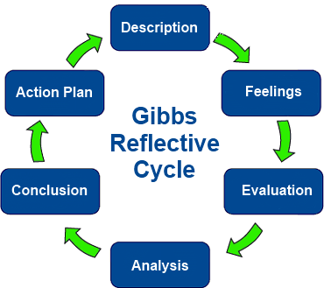
This Photo by Unknown Author is licensed under CC BY-SA-NC

Appendix B

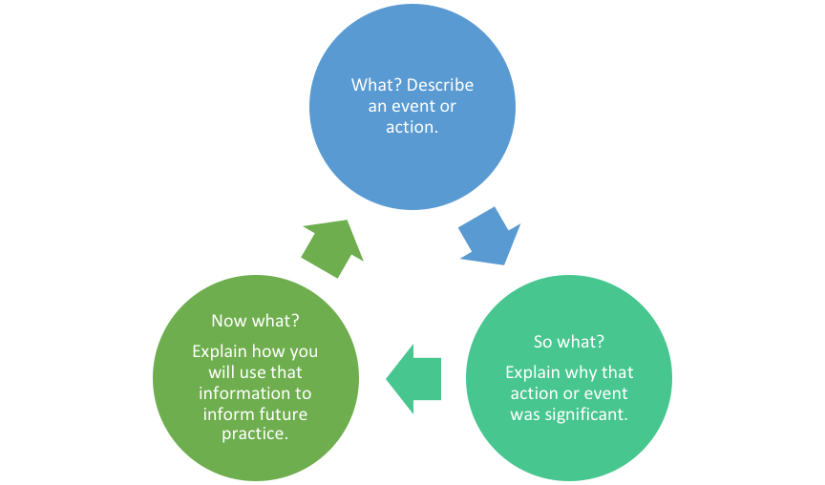
This Photo by Unknown Author is licensed under CC BY-SA

Appendix C

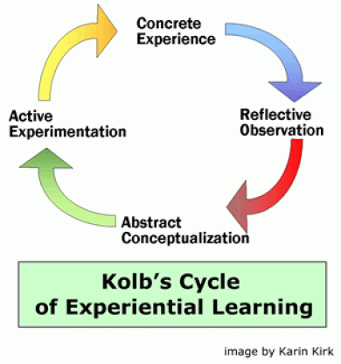
This Photo by Unknown Author is licensed under CC BY-NC

