Debenhams Change Management
Malgorzata Szpila
1712241
2021

Executive Summary
This paper examines Debenhams attitudes about change based on how organization and individuals perceive their goal. This study suggests that improved understanding of the soft and hard factors could improve implementation outcomes and perhaps contribute to the improvement of the situation in which the organization found itself.

Contents
Executive Summary 2
1. Introduction 3
2.1 Background 3
2.2 The Reason for change 4
2.3 Change models benefit 5
2.4 Leadership in relation to change 7
2.5 Change agents 7
2.6 Culture of Organization Model Handy, Hofstede 7
3.0 Conclusion 8
4.0 Recommendations, PDP plan 9

1.0 Introduction
In XXI century, process of globalization had an in incredible impact on cross border traded in good in services. Countries have built international cooperation to expand their businesses and that cross-border transitions have continue to grow. Companies become more and more competitive, and these are required to seeking a constant opportunity for development.
There are many techniques, practices and tools helping organizations to find possibilities for their capability to change and achieve greater effectiveness by improving its current processes, strategies, and structures. Any innovative company needs to have its central goal based on completeness because that can help them to win in the marketplace. One of the major factors of that win is the art of reaction to the changing market demands and while there is always someone saying that, but the change is hard, that change is the crucial part of organizational development and cannot be ignore.
During the last two decades the new concept of e-commerce have evolved due to popularity of the Internet. This easily accessible tool provides new business opportunities for commercial organization. Now in 2021 it is hard to imagine any retailer who is not using this powerful tool in order to promote its products and services. Concepts like internet marketing, social media marketing, email marketing, affiliate marketing or concept marketing are on everyday use by retailer.
This study presents the concept of change management based on Debenhams’ attempt to expanding its use of mobile app and online services. The company environment displays the following characteristic: long sales tradition; in general people like the company because they have a nostalgic relationship with them, however they do not feel excited about their products anymore, strong growth in online sale but lack of mobile app and wide customers profile by age which indicates that the older customers are the target group but also Debenhams has a strong customer base below the age of 34 which showed how diverse the organization currently operates.

2.1 Background
When thinking about the history of British fashion in the sales context, surely the very first association will be the name Debenhams. When in 1778 William Clark established a draper store in London, where he was selling expensive fabrics, gloves, bonnets, and parasols he initiated a new era of the store chains in the United Kingdom. During its 242-year history the brand has established itself in the British consumer's consciousness as a store with long-standing sales tradition (Roberts, 2019).
The company is a department store chain with its headquartered in London and primarily operates in the United Kingdom, Ireland, and Denmark (under the Magasin name) while also it also uses a franchise store system in other countries. As of 2018 the gross transaction value in the United Kingdom amount represents 81% of the total and international 19% (Edison, 2018). Shoppers can also use DEB’s mobile-enabled website and various range of mobile apps that allows them to shop online or scan the product barcodes in store (Debenhams Press Centre, 2011). The company offers clothes, cosmetics, furniture, toys, household goods and electrical appliances but what distinguishes the store from the competition is a mix of its own brand with international designer pieces (MarketLine, 2021).
Debenhams is the home to some of the most successful fashion designers including Nina Ricci, John Rocha, Julien Macdonald, Mathew Williamson and many more where these amazing collaborations provides customers high-end quality products at high-street prices (Debenhams Blog, 2020). Undoubtedly, Debenhams was the first place who understood the change in people shopping behaviour, who were no longer designer shoppers or high street shoppers only, but the fashion become kind of mix and match between both. Shoppers started to follow fashion icons, like Olivia Palermo who has showed the way how to be stylish without having to spend a fortune on clothes and accessories. And over the years Debenhams has used on this trend perfectly, having always most wanted clothes on the shelves of their stores (MarketLine, 2021) (Debenhams, Blog, 2020).
As shown in the chart below, Debenhams’s market position is close to the middle of the brand range with a slight tilt into the more premium brand like House of Fraser, John Lewis, or Cost. Customers profile by age indicates that the older customers are the target group but also Debenhams has a strong customer base below the age of 34 which showed how diverse the organization currently operates (Edison, 2018).
Despite Debenhams long sales tradition in 2020 the organization came in the process of closing after its failing to secure a rescue deal which means it went into administration (twice, over the last two year) (Adams, 2021). Unfortunately, all its 118 stores are set to close, and the brand has been bought out by rapidly growing online store Boohoo (Richardson, 2021).
Although the final failure was preceded by strong changes at multiple levels (growth in beauty, improve fashion products, change instore experience) one of which was to continue to growth in digital (Debenhams Report, 2019).
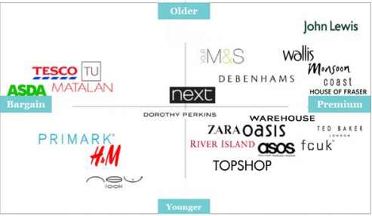
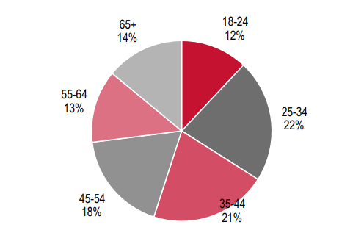
Figure 1 Customers profile by age
Figure 2 Market position

2.2 The Reason for change
At some point every organization will undergo a change or transition to remain competitive, current, and profitable. Whether it is about extending products, growing department, hiring new employees, acquisition or physical move, these changes can have a significant impact on the outcome of any business (Stobierski, 2020).
Fashion industry is one of the most dynamic environments where retailers are forced to deliver the top product that capture the latest consumers trends. The highly fashionable trends last just for one season, so the respond needs to be super-fast and accurate (Coachon and Swinney, 2011). Also, in 2021 the market retailers are huge with constantly emerging organizations who meet the consumers needs and understands shopper’s behaviour.
In 2018 Debenhams began to lag, retailers like Asos or Boohoo started to lead the way. Debenhams decided to implement the planned change with the aim of improving the way how the organization operates and gain more sales. Thereupon in 2018 DEB put in place plan for their online store and app which in plan should affect an existing brick-and-mortal model into an e-commerce business. The plan was based on rethinking their shareholder about shopping experience at Debenhams.
The need for this transformational change was triggered by a few external factors; significant change in shopping behaviour, constantly grow of new competitors and high cost of traditional shop floors. Over the years Debenhams showed its rapid grow by opening new shops (from 2006 to 2017 the organization double it number of stores) but at the same time the shopping behaviour and consumers spending has changed. Firstly, because uncertainty caused by Brexit and then by Covid outbreak (Thomas, 2020). This change was urgent due to organization’s financial problems because Debenhams was left with many underperforming shops, which dragged along high cost, that includes rents, rates, wages, and maintenance.
Debenhams needed to respond decisively, research done by Google and conducted by KANTAR (Smart Shopper, 2020) showed that in this dynamic environment where physical stores are still a crucial part of the business but omnichannel strategies and all touchpoints of consumer journey are even more relevant. The same studies showed that the main factor for consumers’ willingness for buying is convenient, they want products that can be easily ordered through their phones or computers which then are delivered to their homes (Allen and Smidt, 2020).
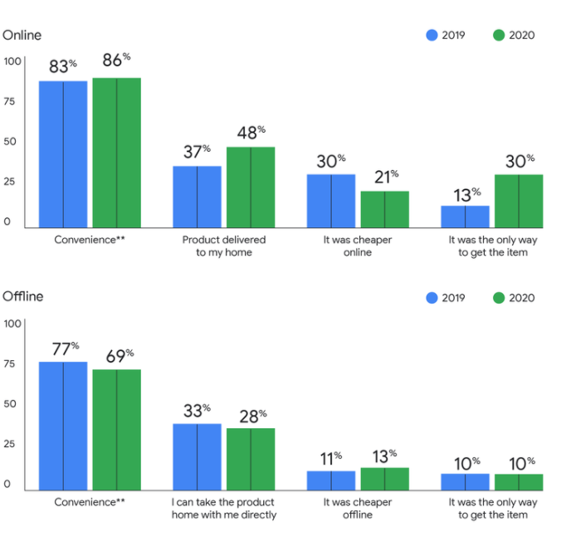
Summarizing, all the above factors argued that this change was needed, relevant and hopefully feasibility. Authors of the book ‘Making sense of change management’ (2012) based on research carried out by Gareth Morgan (1986) noticed that there are four basic organizational metaphors which helps to understand about how any organizational change works. These are: organizations as machine, as political system, organism and as flux and transformation (Cameron and Green, 2012). Debenhams is seen like rational enterprises designed and structured to achieve desired goal – new season always means beginning of the new “life cycle” (Van De Ven and Poole, 1995). Launching new collection, advertising, diffusion, attempt to sell as much as possible and then clearance as the new season is on the horizon. This picture of the organization shows operations which are well-defined, precisely planned and implies procedures and standards which had a solid pattern. This approach works well while the organization is in stable situation, but as indicated in Cameron and Green (2012) studies there are some limitations of this metaphor. Any significant change will be experienced by stakeholders as a major overhaul and there is a possibility that there may occur resistance which need to be well managed.
Figure 3 Drivers of online vs offline purchases (Smart Shopper, 2020).
Wherefore, Debenhams change needed to be made as seamless as possible, because any attempt to change ‘well-functioning’ processes could easily be rejected by any of the stakeholders. The successful organizational change will depend on how well the people of the organization understand the reasons for the change.

2.3 Change models benefit
While planning implement change strategies it is important to focus on choosing the right approaches and models. Change management is not an easy process that needs expertise, time and dedication but also requires employees to be involvement because without their engagement the whole process might result in a failure. Before any attempt to change the organization must figure out why there is a need of change, what are the main motivators and what benefits it can bring. Determination of these factors allow organization to choose the right change management model and approach. Some of the change management researchers suggested that two-thirds of planned changes fail due to lack of efficiency (Bakari, Hunjra and Niazi, 2017). Complying appropriate models and theories is crucial because it helps to plan, organized and structured sense of urgent change (Kotter, 1995).
Common change management models are:
1. Lewin’s Change Management model
2. McKinsey 7s Model
3. Kotter’s Change Management Theory
4. Nudge Theory
5. ADKAR Model
6. Bridges Transition Model
7. Kubler-Ross Five Stage Model
8. Bullock and Batten Planned Change, and many more.
Back to the theory of Cameron and Green about organization as machine, they also suggest that there is a link between Gareth Morgan’s metaphors with the change models. The research indicates that the machine metaphor due to the nature and structure of organization will work well with Lewin’s model, Bullock and Batten planned change and Kotter’s Eight steps approach (Cameron and Green, 2012).
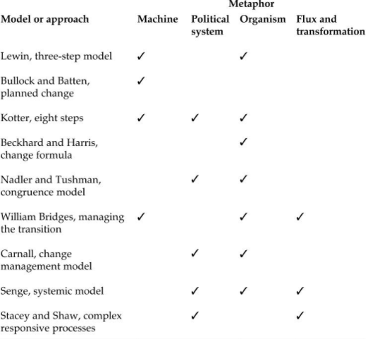
Proposed by Kurt Lewin, is the early fundamental planned change helps managers and leaders to monitor, plan and evaluate changes by using structure for rapid response (Hussain, 2018). This popular concept often meets with criticize for being too simple and straightforward. However, understating and wisely applied provides an essential view into planning change. According to Lewin to change can only happened when there is a strong motivation to undergo. The model is known as Unfreeze – Change – Refreeze, and these three steps refers to the analogy of changing the shape of a block of ice (MindTools, 2020). Lewin suggest that to begging any successful change first there is a need to understand why the change must take place and it is important that this information is widespread between all the employees. The staff sometimes need to change the existing believes, attitudes etc. to get to the higher level of operational efficiency. The key aspect of unfreeze stage are preparation and communication. The next phase, change, always takes time to support the change completely so it is important to communicate regularly about benefits, explain how the change will affect them, be open to deal with any eventual questions. The essence of the final stage is for people to be advised and supported to continue working in the new way, provide them any necessary training and identify the barriers to sustaining the change. The refreeze stage also require people to provide feedback and celebrate the implementation of the successful change itself to reinforce the original objectives to the change (.
Figure 4 Models of change and their associated metaphors
Another popular change management model was created by John P. Kotter where the author identified and extracted the eight factors which are useful tool mainly focuses on employee’s response to change. The 8-step Process for Leading Change helps mobilize employees and emphasizes communication inside organization (Kotter, 1947). The managers and leader must create a compelling case for change and make people to understand why they must move from to current state to future state. Kotter suggest that there is a need to identify the key people who can act as change champions or change leaders. He also talked about the importance of the short, clear, and understandable vision for change with some emotional and creative element, because it should be relevant to the people who are involve. It is not enough to have a vision without using it, so he stressed out that the leader should communicate the vision but also become the vision they want to see. As the people got into the body of change, they might find some obstacles and there is a moment where the leader must step in and help to overcome those obstacles. Then create a short-term win to “buy” people and show them the benefits of the change at early on stage. Leaders and managers must build on the change, which means constant repeating the above steps for quite a while. And the last step is to anchor the change, make sure that the change sticks to organizational procedure and people’s day to day wok.

2.4 Leadership in relation to change
Leader who leads the change has a key role at every step of the process, he/her shapes behaviour of other people. Hence is not surprising the rising interested in the concept of Authentic Leadership over the years. Leaders who exhibit openness and transparency are willingly to involve employees in the decision-making process considering their observations (Bakari, Hunjra and Niazi, 2017). The need for ethical and moral leadership in the context of organizational change cannot be ignored as indicated by Henderson and Hoy’s (1983) the authentic leader has been defined as one of the main factors in organizational change process which result in great self-awareness and self-regulated positive behaviour of other participants.
The nature of leadership at Debenhams had a very conventional Industrial Economy executive team: CEO, CFO, Technology and Supply Chain Director, Transformational and People Director, Managing Director, Fashion and Home. Debenhams has six executives while the Neilson and Wulf (2012) suggest the average number of executives is ten positions. The observation suggests that the responsibility of managers are composites which make it harder to find a balance between their priorities. However, what is most noticeable is the lack of the person who would be responsibility for online sales, someone who would be a kind of CEO of Business Platforms with the target to implement the proposed change.
Previous CEO of Debenhams Sergio Bucher has been widely describing changes about moving toward fully integrated channels supported by a new progressive web app. He stressed the importance of mobile devices which in 2019 were more than a half of online orders (Debenhams Report, 2019). Unfortunately, after examination of the reports for three years back, there is no information about anyone who could be an example of the above-described authentic leader. From positive psychology perspective as well as from technical point of view that leader should be a crucial part of this change. Leaders held responsibilities for the failure and success of the changes and its role is to create meaningful environment for the success.

2.5 Change agents
Fred C. Lunenburg (2010) suggest that despite the size of the organization there is a need of one or more change agent in order to coordinate the change effort. In his research Managing Change: The Role of the Change Agent, he also indicates the importance of the relationship between the change agent and the decision makers inside the organization. The agent can be internal or external, and both of those types has its own pross and cons. For example, external agent can bring new perspective which were not notice by internal agent, but at the same time due to the lack of understanding the company history, value, procedures, or staff the external agent may misjudge some of the situations.
Lunenburg distinguish four types of change agents (outside pressure type, people change technology type, analysis for the top type and organization development type) who has at least three roles; research, training, and consulting (Lunenburg, 2010). However, without a doubt any change needs a visionary who primary responsibility will be to lead employers to believe in that change (Harvard Business, 2020).

2.6 Culture of Organization
According to Kotter (1995) not anchoring changes in the corporation’s culture is one of the eight factors why transformational efforts fail. Understanding an organization means understating its culture, without the feeling of actual climate of the organization it is almost impossible to implement any change. The culture of organization is made up of habits, traditions, symbols, stories etc. and referring to the one of the most common use organization’s culture definition offered by Deal and Kennedy (1982) is ‘the way we do thing around here’ and culture change is described as ‘movement from the current know state to a potential unknown state’ (CIPD, 2020).
There are two important factors which are especially important while there is an attempted to change in corporate culture. The first one is to show employees how the new system, approach, attitudes, and behaviours could help them to improve their performance. People needs someone who would oversee their steps because when people are left on their own it is very likely they will create inaccurate links which will have their roots in the past approach. The second factor is to take important time to show the next generation of CEO that the change really matters (Kotter, 1995).
The failure of this change can have a significant impact on an organization. According to CIPD (2020) it can have a negative impact on market position of organization as well as the engagement and retention of employees. The attempt to undertakes cultural change it is often associate with possibility of failure because of its delicate nature. The studies done by the Cochrane Collaboration suggested that there is a lack of quality evidence on the effectiveness of strategies to change (2011). Researchers noticed that there is no agreed definition of organizational culture and hence not realisable practise for measuring it. But it does not mean that the culture change is impossible or useless. It is important to be sensitive and explore each of the existing culture layers. Schein (2010) concludes that there are three main culture level of any organization: Observable Artifact, Espoused Values and Basic Assumption, deep knowledge of the currently prevailing standards might help in fining allies to the proposed change.
Shawn Murphy in his article Culture change pitfalls and how to avoid them, suggest that to avoid culture change failure leaders should follow three simple steps, which are practical solution; 1. Avoiding crating fanfare over the planned change, 2. Using stories which will allow employees to connect with the change, 3. Ensuring that all the groups (formal and informal) are involved in the culture change.
Even though the organizational culture change is not an easy task, the culture of any organization is the element which always should be considering while applying any types of changes. The useful tools to determine the type of ruling culture are Hofstede’s Culture Dimension which helps to understand different countries and Handy’s four dimension of change.
Debenhams indicates the culture that accepts power differences and encourages bureaucracy, also shows high respect for authority. In 2019 Stefaan Vansteenkiste become a new CEO of Debenhams after Sergio Bucher stepped down as chief executive (Imms, 2019). Vansteenkiste is a well-know for his ability for cutting cost, but he has no experience in fashion retail and online sales.

3.0 Conclusion
Organizational change is a crucial element for companies in order they want to stay competitive as Richard Branson suggest, “Every success story is a tale of constant adaption, revision and change. A company that stands sill will soon be forgotten” another successful business executive Jack Welch said, “Change before you have to”. These quotes could be the essence of value of change, showing that the change is an essential part of business life, because of a constant changing within external environment but also the internal decisions have an impact on future growth of the business.
The reasons why Debenhams failed for its change management process is unclear but there are many factors which indicated big mistakes during this process.
1. The current manager was so focus on getting his contest that he dives straight into the design phase. The CEO talk a lot about implementing mobile app instead of identified all the condition and activities around. There is a strong feel of disorganisation on various level, from not knowing who exactly their target group is to lack of product which could expose the dynamic of the organization.
2. Debenhams also failed to adopt quickly to the current trend which made it hard to complete against their competitors like ASOS, Boohoo or Primark whose online presence is super strong and adequate.
3. Lack of commitment caused by insufficient emphasize the need of change. The Board of Directors showed no interested in mobile app because they believe the shopping experience inside the store is their only focus, even they were conscious about company competitive situation, market position and financial problem. Their focus on the potential revenue drops when their competitors have introduced mobile app while ago and an important patent expires in their minds.

4.0 Recommendations
After a challenging period for Debenhams, there is a time to ask the question what went wrong? Why the change that seemed right like no other, did not help them to survive the crisis?
Managing change can be tough and the amount of research, schools, ideas shows that there is no agreement on which factors are the key for desired transformation. Recent research showed that there are more than 6.153 books on Amazon about “change management” which indicates there are many ideas about how the change should look like. At recent years, the focus is based only on soft issues, such as leadership, motivation, or culture and while these elements are equally important, managing these aspects alone cannot guarantee the success of transformational project. It is not easy task to change the nature of the organizations’ relationships when these are deeply rooted in people behaviours, and even harder it is to measure if these changes actually took place.
Sirkin, Keenan and Jackson (2005) noticed that the change management should be based on hard factors as well. Companies should be able to influence the elements quickly, measure their progress during the change and easily communicate their importance. Research suggested the four factors which are determine the outcome of any transformational initiative, they named the initiative DICE, while D stands for duration, I – integrity, C – commitment and E – effort.
Debenhams failed at most of the stage of change management process because people did not believe it the importance of the change but maybe it happened because the board did not believe in importance of the soft skills factors which are desired for transformation? What could happen if the leader start with hard factor, which shows specific numbers, measure the progress and are easy to communicate.
Debenhams has a strong rooted culture which is not easy to change, so instead of trying to change it all maybe they should gain more resources, spend more time to explain people why this change was necessary to avoid anxiety, cynicism, and resistance. All the key stakeholders should receive the explanation how the change will affect them, because people want to understand the implication and eventual impact. This step builds the trust which then can turn into commitment to the transformation.
The finding of this research confirms that the starting change process includes recognition of the need and then translation this need into a desire change. Deciding who will participate in the process and create workable and effective relationships between these participants. Managing change involves implement and where necessary, modifying plans to move toward a desire goal. Shows the importance of applying appropriate change models and highlight that any organization should have its own change agents and leader who would exhibit openness and transparency.

5.0 Appendices

SWOT analysis
S  - 14.6 growth in online sales, driven by mobile orders rising 64%  - cooperation with third-party online sales like ASOS and ZALANDO who know the current trends | W  - At the beginning of the November the market shares fall by 21% after poor sales  - Without mobile app it is leading lack of consumer engagement
O  - Consumer’s age 25-34s are most likely to engage with multichannel retailing | T  - Consumers are being to adopt more cautious spending habits.  - Brexit would be negative for UK retailers on currency devaluation and consumer confidence.

PESTLE analysis

PESTLE
Political – Brexit made it difficult for retailer to effective plan their future in the UK
Economic – UK inflation in accelerated in 2018, people started to make savings and their spending continue to slow down
Social – millennial generation has higher expectation on what company should to deliver; quality, sustainability, values
Technological – consumers become obsessed with mobile app grown, the end-to-end transaction will also move to mobile. The popularity of online shopping is not slowing down
Environment – again millennial consumers are expecting to see sustainable products, also they are prepped to pay more for them
Legal – The General Data Protect Regulation has come into force in 2018, transparency over how the organization is using its customers’ personal data.

6.0 Reference List
- Adams, Z. (2021) Boohoo buys Debenhams brand in £55million deal but when are the shops closing? And is there a closing down sale? Available at www.ibc.co.uk [Accessed: 20.03.2021].
- Allen, E. and Smidt, F. (2020) 8 ways consumers in the UK adapted their shopping behaviour this year. Available at: www.thinkwithgoogle.com [Accessed: 20.03.2021].
- Bakari, H., Hunjra, A. I., and Niazi, G. S. K. (2017) ‘How Does Authentic Leadership Influence Planned Organizational Change? The Role of Employees’ Perceptions: Integration of Theory of Planned Behavior and Lewin’s Three Step Model’, Journal of Change Management, 17(2), pp. 155-187.
- BBC (2020) Debenhams: Over 200 years of history. Available at: www.bbc.co.uk [Accessed: 20.03.2021].
- Cameron, E. and Green, M. (2012) Sense of change management. A complete guide to the models, tools and techniques of organizational change, 3rd Edition, London: Kogan Page
- Coachon, G.P. and Swinney, R. (2011) ‘The value of Fast Fashion: Quick Response, Enhanced Design, and Strategic Consumer Behaviour’, Management Style, 57(4), pp. 778-795.
- Cochrane Collaboration (2011) ‘The effectiveness of strategies to change organisational culture to improve healthcare performance: a systematic review’, Implementation Science, 6(33), pp. 1-8.
- Debenhams Blog (2020) Designers at Debenhams: Happy 21st Birthday. Available at: www.blog.debenhams.com [Accessed: 20.03.2021].
- Debenhams Press Centre (2011) Shopping goes truly mobile. Available at: www.web.archive.org [Accessed: 20.03.2021].
- Debenhams Report (2019) Strategy in Action. Available at: www.ir.debenhams.com [Accessed: 20.03.2021].
- EDISON (2018) Debenhams Offering Value. Available at: www.edisoninvestmentresearch.com [accessed: 20.03.2021].
- Harvard Business (2020) Common types of organizational change and how to manage them. Available at: www.hbr.org [Accessed: 20.03.2021].
- Hussain, S., (2018) ‘Kurt Lewin's change model: A critical review of the role of leadership and employee involvement in organizational change’, Journal of Innovation and Knowledge, 3(3), pp. 123-127.
- Imms, K. (2019) Debenhams’ new CEO a ‘risky’ choice. Available at: www.drapersonline.com [Accessed: 20.03.2021].
- Kotter, J. (1947) Leading Change. Boston: Harvard Business Review Press
- Kotter, J. P. (1995) ‘Leading Change: Why Transformation Efforts Fail’, Harvard Business Review. Available at: www.bhr.org [Accessed: 20.03.2021].
- Lunenburg, F. C. (2010) ‘Managing Change: The Role of the Change Agent’, International Journal of Management, Business and Administration, 13(1), pp. 1-6.
- MarketLine (2021) Company profile Debenhams plc. Available at: www.marketline.com [Accessed: 20.03.2021].
- Murphy, S. (2017) 3 Culture Change Pitfalls and How to Avoid Them. Available at: www.humansynergistics.com [Accessed: 20.03.2021].
- Neilson, G. L. and Wulf, J. (2012) ‘How Many Directors Reports?’ Harvard Business Review. Available at: www.hbr.org [Accessed: 20.03.2021].
- Richardson, A. (2021) Will Debenhams reopen at the Bullring in Birmingham – new statement release. Available at: www.birminghammail.co.uk [Accessed: 20.03.2021].
- Roberts, L. (2019) Timeline: A complete history of Debenhams from 1778-2019. Available at: www.theindustry.fashion [Accessed: 20.03.2021].
- Schein, E. H. (2010) Organizational culture and leadership. San Francisco: Jossey-Bass.
- Sirkin, H. L., Keenan, P. and Jackson, A. (2005) ‘The hard side of Change Management’, Harvard Business Review, 1, pp. 109-118
- Stobierski, T. (2020) Organizational change management: What it is and why it is important. Harvard Business School Online. Available at: www.online.hbs.edu [Accessed: 20.03.2021].

