An analysis of communication styles/management between departments and its impact on guest service.

Student name: 2243332
Student ID: Aneliya Raykova

AI Declaration
I declare that this research project has been completed without the use of any artificial intelligence tools.

Acknowledgement
I would like to thank the management and employees of Delta Hotels by Marriott Tudor Park that assisted me and guided me throughout my time placement. I would also like to acknowledge my academic supervisors whose pieces of advice and support were valuable during my research project.

Abstract
This research project is a critical analysis of the relationship between the styles of interdepartmental communication, management practises, and its effects on the delivery of guest service at Delta Hotels by Marriott Tudor Park Country Club, in Bearsted, Maidstone, Kent. The hotel is a part of the Marriott Group and operates in an extremely competitive hospitality industry where quality guest satisfaction and service delivery are two areas of performance priority. This research aims at investigating the role of communication within various departments in improving the effectiveness of operations. The front-of-house and the back-of-house is the key to making sure that rooms are prepared, customers are greeted and serve them well. However, communication breakdowns remain a perpetual problem to the entire hospitality business that eventually leads to service delays, inefficiency in the operations, and dissatisfaction among customers.
The main objective of this research was to investigate how different intervention styles of interdepartmental communication affects the procedures of hotels, whether flow of information affects service delivery and define what role of managerial communication practises play in ensuring the same service. The study was focused on determining how communication malfunctions and conflict across the departments impact the satisfaction of guests and service recovery, and how the existing strategies can enhance cooperation and boost the experiences of guests. To achieve the research objective, a qualitative case study approach was embraced with the research onion model of Saunders, Lewis and Thornhill guiding the researcher throughout the study. The research design employed a mono-method secondary research design, which relied on the peer-reviewed journal articles and industry literature published in the last five years. The high-quality sources were retrieved by using inclusion and exclusion criteria and evaluating them with regards to the CASP checklist.
The results confirm that the interdepartmental communication is a key factor of operational efficiency and guest satisfaction in hotel settings. There are formal, organised, and formal communication among the departments, which help in ensuring that coordination is easier, there are fewer interruptions in services and a greater delivery in services to the guests. Conversely, informal, or disjointed communication raises the number of misunderstandings, delays, and errors, thereby impacting adversely on the service quality.
On the other hand, service failures, complaints by guests, and poor service recovery procedures were associated with the breakdown of communication and interdepartmental conflict. Lack of co-ordination within departments leads to rise in operational inefficiencies and a drop in the perception by the guests on the professionalism of the department. These results confirm that communication is not merely a work instrument, and it is also a sociocultural aspect that influences the relationships among the staff, service behaviours, and experiences of the guests.
Based on the findings of the study, some effective recommendations are provided. These involve the introduction of systematic daily briefings and shift passing, the improvement of real-time electronic communication with the help of integrated property management system, the elaboration of coherent standard operating procedures to organise the work of different departments, and cross-training to enhance empathy and collaboration. Also, to maintain the working process and the level of service, managerial dedication to unrestricted feedback and conflict management systems is necessary.

Table of Contents
Chapter 1 Introduction 8
Background study 8
Aims 8
Objectives 8
Research questions 9
Research rationale 9
Problem statement 9
Chapter 2 Literature Review 10
Introduction 10
Theoretical framework 11
Interdepartmental Communication Styles in Hospitality Operations 12
Coordination and Information Flow Between Front-of-House and Back-of-House Departments 13
Managerial Communication Practices and Their Role in Service Consistency 14
Communication Breakdowns, Conflict, and Their Effects on Guest Satisfaction 15
Strategies for Improving Cross-Department Communication to Enhance Guest Experience 16
Conceptual framework 17
Chapter Summary 17
Chapter 3 Methods 18
Introduction 18
Research philosophy 19
Research approach 19
Research strategy 19
Research choice 19
Time horizon 19
Technique and procedure 20
Chapter summary 20
Chapter 4 Findings and Discussion 20
4.1 Findings 20
4.1.1 Overview of Findings 20
4.1.2 Communication Styles Between Departments and Operational Effectiveness 21
4.1.3 Information Flow Between Front-of-House and Back-of-House Teams 21
4.1.4 Managerial Communication Practices and Service Consistency 22
4.1.5 Communication Breakdowns, Conflict, and Guest Satisfaction 23
4.1.6 Strategies for Enhancing Interdepartmental Communication 23
4.1.7 Summary of Key Findings 24
4.2 Discussion 24
4.2.1 Introduction to the Discussion 24
4.2.2 Interpretation of Findings in Relation to Interdepartmental Communication Styles 25
4.2.3 Communication Flow and Its Influence on Guest Service Delivery 25
4.2.4 Managerial Communication and Service Quality Consistency 26
4.2.5 Communication Breakdowns, Conflict, and Impacts on Guest Satisfaction 26
4.2.6 Implications for Cross-Department Collaboration in the Placement Hotel 27
4.2.7 Operational Recommendations for Improving Communication Management 27
4.2.8 Study Limitations 27
4.2.9 Areas for Future Research and Development in Hotel Operations 28
4.2.10 Conclusion of the Discussion 28
Chapter 5 Conclusion and Recommendations 28
5.1 Conclusion 28
5.1.1 Addressing Research Question 1 28
5.1.2 Addressing Research Question 2 29
5.1.3 Addressing Research Question 3 29
5.1.4 Addressing Research Question 4 29
5.1.5 Addressing Research Question 5 30
5.1.6 Summary 30
5.2 Recommendations and Practical Strategies 30
References 35

List of figures
Figure 1: Delta Hotels by Marriott Tudor Park 10
Figure 2: Theoretical framework. 13
Figure 3: Interdepartmental Communication Styles in Hospitality Operations 14
Figure 4: Coordination and Information Flow Between Front-of-House and Back-of-House Departments 14
Figure 5: Managerial Communication Practices and Their Role in Service Consistency 15
Figure 6: Communication Breakdowns, Conflict, and Their Effects on Guest Satisfaction 17
Figure 7: Strategies for Improving Cross-Department Communication to Enhance Guest Experience 18
Figure 8: Conceptual framework. 18
Figure 9: Research onion. 19

Chapter 1 Introduction

Background study

Figure 1: Delta Hotels by Marriott Tudor Park
Source: Marriott Bonvoy (2026)
The Delta Hotels by Marriott Tudor Park Country Club, Ashford Road, Bearsted, Maidstone (ME14 4NQ), is a leading four-star hotel that provides all guest facilities such as leisure facilities, dining areas, and conferencing facilities in the Kent countryside (Marriott Bonvoy, 2026). The premises are a part of the international Marriott chain, and it caters to business and leisure travellers spanning around 30 miles to London and it focuses on comfortable and quality service settings.
Gesture of satisfaction among the guests is an important performance factor in the competitive hospitality industry in the United Kingdom. Haenraets (2025) has shown that the early contact as the guest receives to the front desk can contribute to a total satisfaction score of 20-40%. Alshurideh et al. (2024) highlight the importance of quality of communication in determining the perception of services, loyalty, and repeat visits.

Aims
The aim of the study is to critically analyse the relationship between communication styles and management practises among the critical hotel departments, especially the front desk and housekeeping. Additionally, it also aims to analyse the impact of the concerned relationship on the operational effectiveness and guest satisfaction at Delta Hotels by Marriott Tudor Park.

Objectives
- To investigate the impact of various communication styles within departments on the efficiency of the operations in a hospitality organisation.
- To determine the importance of information flow and coordination of front of house and back of house and their contribution to the development of guest service delivery.
- To assess the value of managerial communication practises towards the consistency and the quality-of-service delivery within the departments.
- To determine how communication breakdowns and interdepartmental conflict impact the guest satisfaction and service recovery.
- To examine solutions and best practices which may enhance cross-department communication and the overall guest experience.

Research questions
- What is the effect of various interdepartmental types of communication within hospitality organisations on operational effectiveness?
- How does flow of information between front of house and back of house teams’ impact on delivery of guest service?
- What is the impact of managerial communication practises on consistency and quality in the guest service outcomes?
- How do the communication failures and interdepartmental conflicts affect guest satisfaction and recovery of services?
- What communication management measures are the most useful in enhancing the collaboration and overall guest experience?

Research rationale
The significance of this research is in the fact that interdepartmental communication is the key to the provision of high-quality guest service within hospitality organisations. In hotels like Delta Hotels by Marriott Tudor Park, the satisfaction of guests is determined by the effective coordination between front-of-house and back-of-house staff. Emeafor et al. (2025) states that the miscommunication may result in delays in services, uneven standards, and decreased loyalty of guests.

Problem statement
Although service standards are already established, the problem of communication gaps among various departments is still a typical issue in hotel management (Patafta and Milohnic, 2022). The links in information flow between front desk and housekeeping might lead to the problem of room readiness, slow responsiveness of guest requests, and poor service recovery in Delta Hotels by Marriott Tudor Park. This operational disturbance may have adverse implications on the perception and satisfaction of guests.

Chapter 2 Literature Review

Introduction
The interdepartmental communication has been widely recognised as a decisive determinant of the level of service and satisfaction among the guests of hospitality organisations. Hotels are also dependent on the integration between front of house and back of house departments, including reception, housekeeping, and food and beverage, to provide a seamless delivery of service. According to Wilson (2025), the style of communication, direction of information, and the managerial practices influence the effectiveness of the operations and the regularity of the experiences of guests. With effective communication, departments work efficiently, which minimises errors, and increases responsiveness of services. Nevertheless, communication failures can also cause delays in terms of service delivery, disagreement, and customer dissatisfaction (Emeafor et al. 2025). The literature review critically analyses academic research on communication management in hotels, determining major themes, theoretical viewpoints, and knowledge gaps that can be used to enhance cross-department cooperation and guest service performance.

Theoretical framework
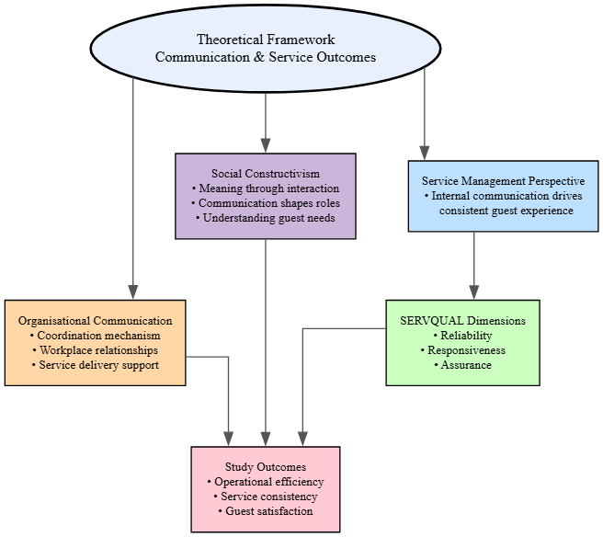
Figure 2: Theoretical framework.
Source: Self-created
This theoretical model is based on the organisational communication theory and service management perspectives. Communication does not just exchange information but in the hospitality environments, it is a mechanism that determines workplace relationships, coordination, and service outcomes (Bigwanto et al. 2024). The social constructivism focuses on the idea that the meaning is made during interactions between the employees and implies that the departmental style of communication determines how staff members perceive roles, duties, and guest needs (Rachmad, 2025). Moreover, the service quality frameworks also emphasise that the stable experiences of the guests are based on the internal communication and coordinated work of different departments. The SERVQUAL model also helps to reinforce the concept that reliability, responsiveness, and assurance are enhanced if teams communicate effectively (Dimitriou, 2022). This study uses these theoretical approaches to find out the implications of the communication practises among the departments on operational efficiency, service consistency, and guest satisfaction.

Interdepartmental Communication Styles in Hospitality Operations
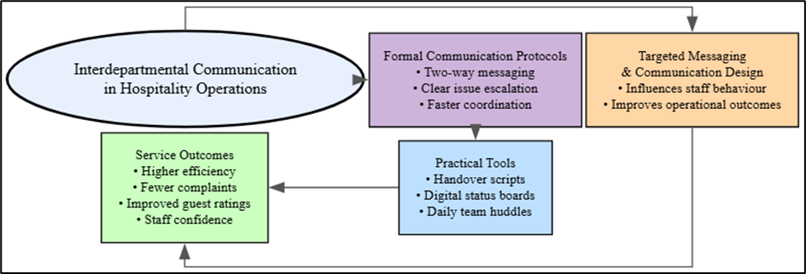
Figure 3: Interdepartmental Communication Styles in Hospitality Operations
Source: Self-created
According to the recent operational research, the cleaning behaviours can be significantly changed through the targeted messaging and defaults. A study by Zinn et al. (2024) showed that the standard room cleaning rates decreased by 99 to 45% when theory-based message interventions were introduced, and these resources indicate that communication design influences the results of operations. Formalised communication protocols and two-way messaging are also associated with quantifiable increases in the efficiency and satisfaction of guests and are found to lower the number of complaints and shorten chains of command in addressing issues (Dhar, 2025). In the case of Tudor Park and other such organisations, it is possible to reduce documented handover scripts, digital status boards, and short daily huddles. This can eventually increase confidence in the services of the employees and ratings of the guest.

Coordination and Information Flow Between Front-of-House and Back-of-House Departments
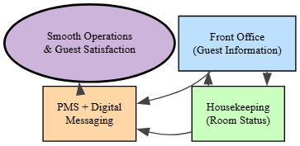
Figure 4: Coordination and Information Flow Between Front-of-House and Back-of-House Departments
Source: Self-created
Open communication and coordination of front-of-house and back-of-house departments is the key to a smooth hotel operation. The front office continually communicates the expected arrivals, departures, occupancy expectations, and VIP room requirements to the housekeeping so that the staffing and rooms are maximised (Ardana et al. 2025). Housekeeping provides real-time status of rooms like in clean or dirty or out of order so that the front desk agents can assign rooms accurately and minimise the waiting time of guests. According to FSM (2025), hotels that have developed communication schemes backed by several Property Management System (PMS) and digital messaging devices are characterised by better guest satisfaction ratings and reduced operational errors, with some hotels registering up to 23% increase in performance.

Managerial Communication Practices and Their Role in Service Consistency
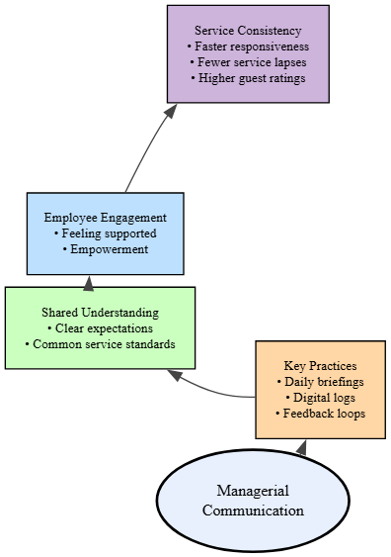
Figure 5: Managerial Communication Practices and Their Role in Service Consistency
Source: Self-created
Managerial communication practices are critical in defining consistency in services throughout the hotel departments by setting expectations, creating understanding, and strategizing operational priorities (Khalil et al. 2024). Good hospitality managers rely on regular briefings, brief logs saved on the computer, and performance feedback loops where the front and back of house teams have a mutual understanding of the service standards and the concerns of the guests. Sheoran (2025) claims that those hotels with formal daily huddles and who use technology to communicate transparently report that the staff responsiveness has improved and the service lapses have decreased, and frontline teams have clear understanding of what to do and what the guest require. Moreover, Mansor et al. (2023) emphasise that managerial communication improves employee engagement and the feeling that the organisation supports them, which is associated with a maximum 20% rise in the rating of the quality of provided services when staff members feel informed and empowered.

Communication Breakdowns, Conflict, and Their Effects on Guest Satisfaction
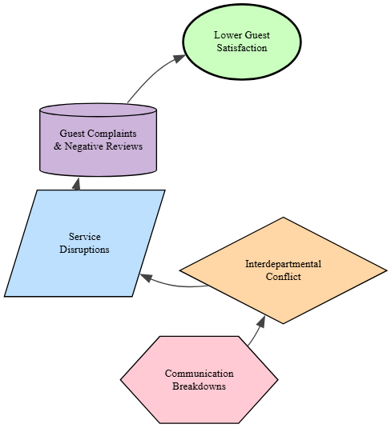

Figure 6: Communication Breakdowns, Conflict, and Their Effects on Guest Satisfaction
Source: Self-created
Miscommunication and inter-departmental conflict in hotels can interfere with service delivery and have a negative impact on customer satisfaction. Failure of information to flow correctly or on time as in the case of housekeeping not updating the status of rooms and the front desk not communicating properly with each other will result in errors like assigning unavailable rooms, responding to service requests slowly and failure to meet expectations (Vidak, Kovačević and Ivona Kovač, 2022). These failures lead to a higher number of complaints and a reduced rating of satisfaction among the guests and the failures in service are often mentioned as the main reason for adverse online ratings. Motivation and collaboration are also negatively affected by conflict caused by the lack of clarity about roles or opposing priorities of front-of-house and back-of-house staff, which only worsens the problem of service inconsistencies (Voss, 2023). Poor communication has been associated with the operational inefficiencies and perceived low quality of service, which has served to undermine the efforts to provide personalised guest experiences.

Strategies for Improving Cross-Department Communication to Enhance Guest Experience
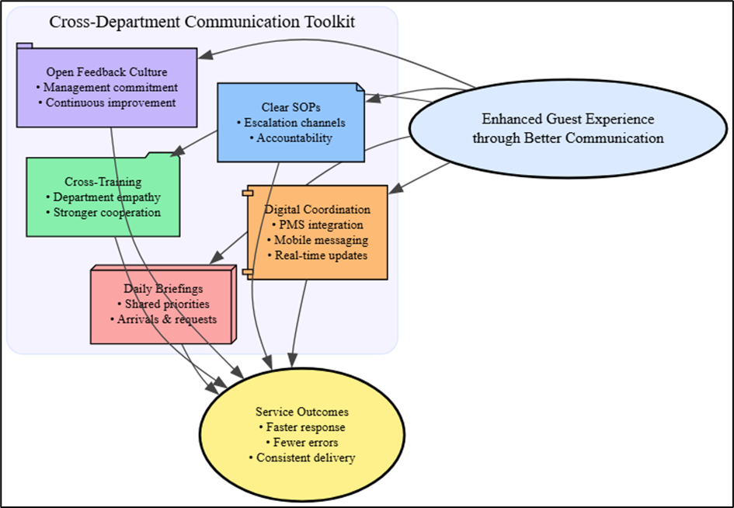
Figure 7: Strategies for Improving Cross-Department Communication to Enhance Guest Experience
Source: Self-created
Enhancing communication between the different departments is critical in improving guest experience in hotels and can be done through establishment of procedures, technology assimilation, and employee training. Daily briefing will mean that front desk, housekeeping, and other operation teams will be on the priorities in terms of arrivals, special requests, and maintenance issues before the service is provided. Real-time information flow and flow of messages through Property Management Systems (PMS) with mobile messaging tools contribute to reducing errors and response time to latest information as it is received (Bouchareb, 2023). According to Hall and Grimm (2025), cross-training of the employees on functions of the department also creates mutual understanding and creates empathy in employees, which enhances cooperation in delivering services. It should have clear Standard Operating Procedures (SOPs) on communication and escalation channels to make sure that accountability and consistency are achieved (Devi, 2025). Collaborative culture is even more reinforced by management commitment to open feedback loops.

Conceptual framework
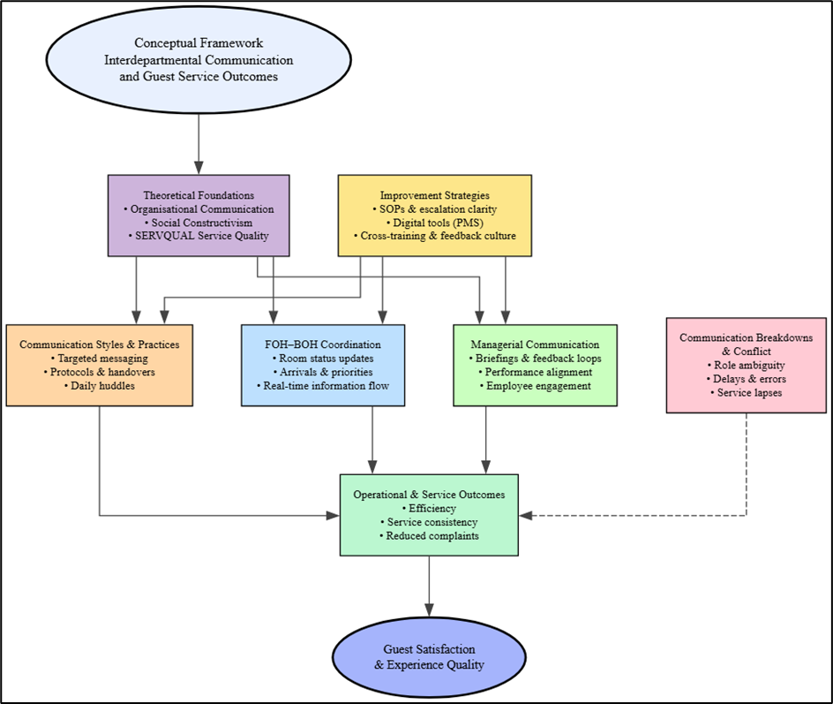
Figure 8: Conceptual framework.
Source: Self-created

Chapter Summary
The chapter has discussed the major scholarly works on interdepartmental communication in the hospitality organisations, and its significance in determining operation efficiency and satisfaction of the guests. The theoretical views that have been pointed out through the discussion are organisational communication theory, social constructivism, and service quality frameworks, which articulate the role of communication practises in employee coordination and service consistency. The structured briefings, digital communication tools, and cross-training were found to be the strategies that are effective to enhance collaboration.

Chapter 3 Methods

Introduction
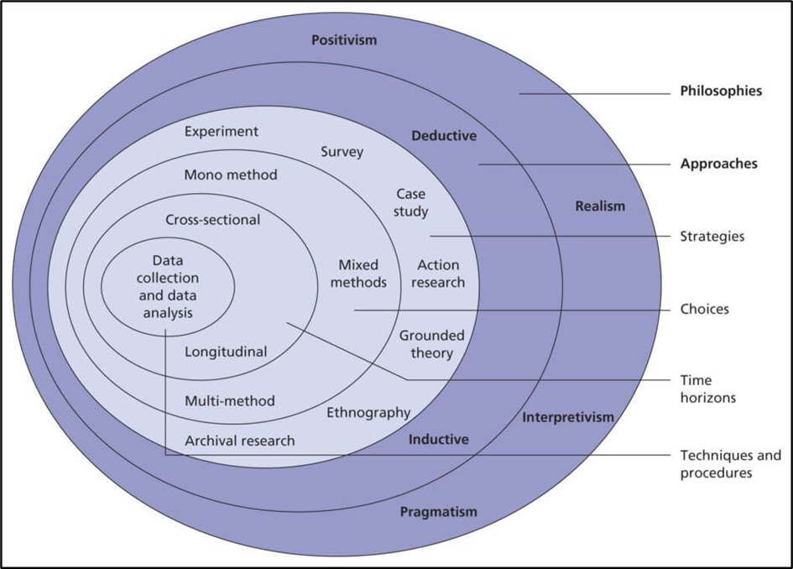
Figure 9: Research onion.
Source: Saunders, Lewis and Thornhill (2023)
This chapter presents the methodological approach which is used in this research based on the research onion framework. The research onion offers a systematic approach to research design by discussing such critical layers as philosophy, approach, strategy, method choice, time scope, and data collection methods (Saunders, Lewis, and Thornhill, 2023). The usage of this framework allows the study to have a systematic and scholarly approach that will help in examining interdepartmental communications and their effect on the guest service in Delta Hotels by Marriott Tudor Park.

Research philosophy
The research philosophy used in this study is an interpretivist-based research philosophy which is founded on social constructivism. Interpretivism focuses on explaining human behaviour with references to the meanings people give to their experiences (Pervin and Mokhtar, 2022). The interactions between employees, mutual understanding, and workplace culture determine communication among the various departments of a hotel (Tham and Winarko, 2024). This understanding of social constructivism acknowledges that knowledge is developed in a social way thus appropriate when examining how communication practices are related to service delivery and satisfaction on the part of the guests in the context of the placement hotel.

Research approach
The research uses a deductive methodology wherein the current theories and academic concepts on interdepartmental communication and service quality are used to conduct the analysis. Deduction will enable the investigation to determine how developed the framework of communications and the principles of service management can be used to explain the operational issues and results of guest satisfaction in the placement hotel (Singgalen, 2024).

Research strategy
Case study approach is used to give an in-depth analysis of interdepartmental communication practises in the Delta Hotels by Marriott Tudor Park. Case studies can be useful in investigating complicated organisational problems in real-life scenarios and can provide a detailed understanding of how inter-departmental communication shapes the results of the guest service provision.

Research choice
This research paper is based on a mono-method qualitative research option, which will only use secondary sources of data. Qualitative secondary research helps in exploring the factors of communication practices, consistency of services, and guest satisfaction through the available peer-reviewed journals, industry reports, and scholarly publications. The emphasis on qualitative evidence helps the research to have a better understanding of the experience and interactions that influence interdepartmental collaboration.

Time horizon
The study follows a longitudinal time since it uses scholarly research and sector findings that have been published within the past few years to analyse the changes and trends in interdepartmental communication in operations of a hospitality industry. Through a longitudinal approach, the study would have the ability to examine how the practices in communication and management strategies change over time especially as service expectations increase and with changes in technology (Khaw et al. 2023). This increases the applicability of the results in enhancing the delivery of guest services in the placement hotel.

Technique and procedure
The pertinent secondary data will consist of quality data collected by means of systematic review of around 40 peer-reviewed journal articles and other academic publications. Inclusion and exclusion criteria will be used to make sure that the results are credible and relevant to the topic of interest since the studies should be published within the past five years and linked to interdepartmental communication and guest service outcomes in the hospitality industry.

Chapter summary
This chapter has presented methodological design of the research based on research onion. It has recognised the interpretivist philosophy based on social constructivism, deductive approach and case study approach that concentrates on Delta Hotels by Marriott Tudor Park. The study has a mono-method qualitative research design, which uses secondary data.

Chapter 4 Findings and Discussion

4.1 Findings

4.1.1 Overview of Findings
This study has indicated that interdepartmental communication is a major determinant of operational efficiency and satisfaction of the guests in the hotel setting like Delta Hotels by Marriott Tudor Park. The literature reviewed suggests that the communication styles that exist between the departments play a significant role in influencing the service coordination and specifically between the front desk and the housekeeping.
One significant observation is that the circulation of information is a key element that can be used to guarantee the availability of rooms, address guest requests, and achieve service stability. As per Das (2023), hotels with real-time communication systems and coordinated handover procedures have a higher chance of minimising service breakdowns and significantly improving the efficiency in the eyes of the guests.
On the contrary, breakdowns in communication, interdepartmental conflict were continuously attributed to service failures, including check-ins that were not met, failed guest expectations, and poor complaint resolution (Tan, 2025). According to the findings, such strategies as daily briefings, cross training and communication technologies are feasible methods to enhance teamwork and the overall guest experience. These findings are a ground on which communication issues in the context of the placement hotel can be dealt with.

4.1.2 Communication Styles Between Departments and Operational Effectiveness
The results indicate that interdepartmental communication in the hotel directly influences the effectiveness in operations and efficiency in providing effective guest service. Front-of-house and back-of-house employees in hospitality organisations rely on constant communication to coordinate operations including room assignment, requests, and service recovery (Deshpande et al. 2024).
Conversely, informal, or fragmented styles of communication usually cause misunderstanding thus causing delays in service and low productivity. To illustrate, there can be misunderstandings in terms of instructions between reception and housekeeping, which can lead to wrong room status information, late cheque-in, or missing preferences of guests (Sheoran, 2025). The results also indicate that mutual respect and teamwork communication improve employee cooperation whereas aggressive or dismissive communication leads to interdepartmental tension and lowers workflow.
Yegon and Kipkorir (2023) argue that excellent communication styles help to coordinate operations, enhance employee working performance, and provide smooth service delivery. The insights are specifically applicable to Delta Hotels by Marriott Tudor Park where the interdepartmental collaboration should be regular to ensure the guest satisfaction and service quality.

4.1.3 Information Flow Between Front-of-House and Back-of-House Teams
The results show that the working of the front-of-house and back-of-house teams is vital in the functioning of the hotel, and the proper flow of information is crucial to the delivery of quality service to the guest. According to Jokipera (2025), reception to housekeeping communication is important in the coordination of room readiness, arrivals, and departures, as well as the response to guest requests.
Nevertheless, it can also be seen that failure in information flow is a usual cause of operational inefficiency. As an illustration, in case of housekeeping taking a long time to report about a room being clean or unavailable, guests will have to face frustration with delayed access or wrong room assignments (Popham et al. 2023). In the same breath, the front desk not communicating the needs of guests or emergency needs can result in lack of satisfaction and unmet expectations. Bouchareb (2023) also indicates that hotels that implement real-time digital communication platforms, built-in property management systems, and standardised handover procedures have a higher level of coordination and reduced errors.

4.1.4 Managerial Communication Practices and Service Consistency
The results show that managerial communication practices have played a pivotal role in ensuring the consistency of services in various departments of the hotel. Managers in hospitality settings serve as major catalysts that enable front-of-house and back-of-house staff to have a consistent understanding of the standards of service, priorities of operation, and expectations of the guests (Islam and Sultana, 2025). The literature emphasises the importance of daily briefing, written instructions, and an organised feedback system to enhance coordination and decrease service variability by providing clear communication to the manager.
The results also indicate that leadership communication influences staff motivation and engagement. Effective and open communication fosters teamwork, but bad communication by managers can lead to confusion, few accountabilities, and higher operational errors (Haryanto and Maianto, 2024). An example of this is when there is a lack of consistency in the instructions on the room preparation or guest complaints and this results in a service gap between reception and housekeeping.
Another factor that promotes the consistency of service quality is managerial communication, as it is necessary to make sure that departments do not have to work independently, but work in a coordinated manner (Gupta et al. 2022). In the case of Delta Hotels by Marriott Tudor Park, the need to reinforce the leadership communication practises is critical in ensuring that the hotel provides credible guest experiences, operational effectiveness, and important levels of satisfaction.

4.1.5 Communication Breakdowns, Conflict, and Guest Satisfaction
The results indicate that interdepartmental conflict and communication breakdowns are sources of serious negative impacts on the guest satisfaction of hotel operation. Widiastini et al. (2024) states that failure of information to be shared properly and in a timely manner between various departments like the front desk and housekeeping increases instances of service failures. Such common problems are delays in room availability, missed requests by guests, and inconsistent delivery of services (Kaul, 2023). The result of these failures tends to cause frustration and complaints in the guests and an overall negative view of the professionalism of the hotel.
Yu et al. (2022) also state that interdepartmental conflict is intricately connected with communication issues. Lack of a clear responsibility, departmental focus and poor managerial leadership can be a source of tension among the teams. To name a few, front desk employees can accuse housekeeping of not being ready to serve the room in time, and housekeeping can experience the pressure of unrealistic requests. This type of conflict decreases collaboration, morale of the staff, and further demeans service performance.
The results also indicate that effective service recovery is frustrating due to communication breakdowns. There may be an escalation of the problem instead of being solved fast when departments do not interact when guests make complaints (Zormpas, 2022). Cross-department coordination is needed because guests usually form an understanding of the quality of the hotel in terms of its efficiency in managing problems.

4.1.6 Strategies for Enhancing Interdepartmental Communication
The results indicate some key strategies that can be applied effectively to improve the process of interdepartmental communication in the hotel operations to have a direct positive effect on the guest satisfaction and the consistency of the service quality. A strategy that has been noted as one of the important strategies in literature is the adoption of structured daily briefings or change of shifts whereby the departments like reception and housekeeping can agree on what to focus on, who comes in and out of the hotel, special requests, and challenges encountered in the operations. Such short-time briefings minimize the lack of understanding and foster advanced service provision.
Technology-based communication systems, such as, integrated property management systems and mobile messaging platforms should also be used as another important strategy. Live-time information about the room status, maintenance, and needs of guests will allow departments to address their concerns more effectively and minimise delays in the service (Rana and Meena, 2026). This is also highlighted in the findings as the cross-training initiatives where the employees are made aware of the other departmental jobs. This style promotes a feeling of empathy, solidifies teamwork, and minimises interdepartmental tension.

4.1.7 Summary of Key Findings
The major conclusions of this study are that interdepartmental communication is a sensitive issue that affects the efficiency of operations and satisfaction of guests in hotel settings. The communication patterns between the departments, especially front-of-house and back-of-house staff, were demonstrated to have a direct impact on coordination, efficiency, and consistency of services (Ngo, 2025). Communication is formal, structured, and respectful and helps to have a smoother operation. Informal or unclear communication makes errors, delays, and dissatisfaction of the guests more probable.
It is also revealed that information flow between housekeeping and reception is a key factor. The information regarding the readiness of the rooms, guest preferences, and service requests should be updated in time to reduce waiting periods and secure the uninterrupted customer experience (Arapou and Kapiki, 2023). The practice of managerial communication was found to be a significant contributor to the quality of service because the leadership was instrumental in the coordination of departments, promotion of service standards, and collaboration.
The study determined that various techniques exist in enhancing the communication process, such as daily briefing, combined digital tools of communication, cross-training, and effective SOPs. The results indicate that interdepartmental communication needs to be reinforced to provide a uniform service and improve the level of guest satisfaction. In the case of Delta Hotels by Marriott Tudor Park, there are great benefits to work on the communication issues to enhance operational performance and guest service results.

4.2 Discussion

4.2.1 Introduction to the Discussion
The research findings have been critically interpreted in this discussion section in the context of the available academic literature on interdepartmental communication and guest service outcomes of hospitality organisations. The results affirm that interdepartmental communication like the front desk and housekeeping practices have a considerable influence on the effectiveness of operations, service delivery, and satisfaction by the guest. This discussion will connect the results with theoretical models such as the organisational communication theory and service quality models to understand how communication styles, flow of information, and managerial practices also lead to both effective and failed services. It also reflects on the consequences of the failure of communication and interdepartmental conflict that will have a negative effect on the perception of guests and service recovery.

4.2.2 Interpretation of Findings in Relation to Interdepartmental Communication Styles
The results support the literature that already demonstrates that communication patterns within the hotel departments are a key to the success of the operations and the quality of the services. According to the theory of organisational communication, how employees communicate decides whether a specific group of employees will be team workers, effective and the level of relationships at work. According to Buhaieva (2025), the coordination between front-of-house and back-of-house teams can be enhanced by formal and structured communication patterns like the presence of clear reporting systems and professional briefings. This is in line with previous research as frequent communication leads to less misunderstanding and increased reliability of the services. On the other hand, informal or disaggregated communication enhances probability of error, latency, and tension between departments (Khan et al. 2024). Additional social constructivist views elaborate that communication modes define common meanings and expectations between the staff, which affect the interpretation of service roles (Burr, 2024). When applied to Delta Hotels by Marriott Tudor Park, respectful and consistent communication practices may reinforce cooperation and halt disruptions in the service.

4.2.3 Communication Flow and Its Influence on Guest Service Delivery
The results are consistent with the literature on hospitality services that highlight the significance of a proper flow of communication in the provision of quality experiences to guests. Service management frameworks point out that the satisfaction of the guests is predetermined by the smooth coordination of the departments and especially by the ability to effectively exchange the information between them in a timely and correct manner (Dzreke, 2025). The study confirms that effective communication flow between the housekeeping and reception enhances readiness of the rooms, less waiting time, and the satisfaction of the guest preferences. This validates the current research that has cited a delay in information as a key source of service breakdowns in hotels. The sharing of updates between departments is more responsive and consistent in-service delivery. On the other hand, disruptions in the communication stream cause operation inefficiency, including wrong room allocation and unfulfilled guest requests, which adversely affect the attitude of the guests (Mandic et al. 2023). In Delta Hotels by Marriott Tudor Park, the improvement of the real-time information flow with the help of structured handovers and the use of digital systems might be instrumental in improving the reliability of the services.

4.2.4 Managerial Communication and Service Quality Consistency
Thompson (2024) views leadership communication as the process of setting common expectations, strengthening service standards, and having employees on both front-of-house and back-of-house teams working towards shared goals. According to service quality models, reliability and responsiveness lie based on coordinated internal communication, which is likely to be influenced by the management practises. The work points at the importance of the managers giving clear directions, feedback, and briefings, which decrease the confusion in operations and the variation of the services. This is in line with the literature that holds that positive communication boosts the engagement and accountability of employees, which increases the predictability of the guest experiences. On the other hand, poor managerial communication may become a source of misunderstanding, lack of collaboration, and poor service delivery (Bahrain et al. 2023). In the case of Delta Hotels by Marriott Tudor Park, the performance of services in the company might be enhanced by enhancing leadership communication with channels of open feedback and interdepartmental alignment meetings.

4.2.5 Communication Breakdowns, Conflict, and Impacts on Guest Satisfaction
The major threats to guest satisfaction in the hospitality operations are communication breakdowns and interdepartmental conflict. Literature on service quality emphasises that customers tend to judge hotels in terms of efficiency, promptness, and quickness in resolving problems. During the breakdown of communication between departments, such as reception and housekeeping, the delays in the room availability procedure, lack of responses to requests, and standard inconsistency are observed (Jun et al. 2024). These are sometimes failures that lead to negative perceptions and frustration by the guests towards professionalism. Intra team conflict exacerbates these challenges further since lack of clear roles and conflicting priorities further worsen team collaboration and undermine service recovery endeavours. According to organisational behaviour, unresolved conflict reduces the morale of the staff and causes obstacles to cooperation, which eventually impacts the service delivery (Irwan, 2024). The communication breakdowns at Delta Hotels by Marriott Tudor Park need to be addressed to ensure that the operational errors are prevented and the guests experience is enhanced.

4.2.6 Implications for Cross-Department Collaboration in the Placement Hotel
The results are relevant to cross-departmental cooperation in Delta Hotels Marriott Tudor Park. Good guest service is dependent on smooth coordination of front desk, housekeeping, and other operating teams. Effective communication systems may minimise delays during services, misunderstanding, and absence of uniformity (Bahrain et al. 2023). In its turn, the weak collaboration can lead to the problem of readiness of rooms, complaints on the part of the guests, and ineffective service recovery. The placement hotel can have the advantage of strengthening teamwork by having proper communication lines and common priorities of the shared services. Better cooperation also helps in increasing employee morale and helps to create a culture of shared responsibility.

4.2.7 Operational Recommendations for Improving Communication Management
The area of improvement in the management of operations at Tudor Park should be on encouraging communication management using practical strategies. Daily contact between departments should be maintained so that there is a synchronisation of arrivals, departures, and special requests by guests. The introduction of real-time digital communication tools into the property management system can decrease the delay in updating the room status (Radman et al. 2022). Accountability can be enhanced by having clear SOPs on the interdepartmental communication and escalation procedures. Cross-training can encourage a better comprehension of the functions of the departments and decrease the conflict (Burke, 2025). Moreover, the managers are also advised to promote transparent feedback channels in order to deal with communication challenges in advance. These measures can make the coordination stronger, minimise service failures, as well as increase the consistency of the guest experience.

4.2.8 Study Limitations
The study has several limitations that must be mentioned. It is entirely based on secondary qualitative findings, that is, it draws on available literature instead of primary data, which is the direct data gathered directly among the staff or guests of the placement hotel. It can restrict the extent of insights in the context of the uniqueness of the operational environment of Tudor Park. The study will mainly be centred on front desk and housekeeping communication, whereas other areas like food and beverage might also play a role in the satisfaction of guests. The studies chosen might not be homogenous in terms of setting and type of hotel and this may impact on generalisability. Regardless of these constraints, the study qualifies to be a robust base to comprehend the effects of communication.

4.2.9 Areas for Future Research and Development in Hotel Operations
Further study must be done by including primary data collection to Delta Hotels by Marriott Tudor Park, which may be in the form of staff interviews, customer surveys, or observation. This would provide an improved understanding of communication issues and service impacts. Further studies could be done to determine communication patterns in more sectors as the food and beverage department, the maintenance department and the event department. The research can also consider the discussion of how new technologies, such as AI-powered communication systems, can be used to improve coordination. Also, longitudinal studies on communication improvement aided by the time would provide useful evidence on service performance outcomes. Such domains would enhance knowledge and make new hotel growth.

4.2.10 Conclusion of the Discussion
The discussion confirms that the importance of interdepartmental communication is a core determinant of operational performance and guest satisfaction in hospitality organisations. The results are consistent with previous research that depicted communication styles, flow of information and management practises to influence service consistency and guest perceptions. Lack of communication and conflict were found to be the major causes of failures in services and decreased satisfaction. In the case of Delta Hotels by Marriott Tudor Park, there are great prospects to increase the quality of service through better coordination via organised forms of communication, embracing technology, and incorporating leadership in the process of coordination.

Chapter 5 Conclusion and Recommendations

5.1 Conclusion

5.1.1 Addressing Research Question 1
The effectiveness of operations in hospitality organisations is highly affected by the various kinds of interdepartmental communication styles. The results prove that formal, structured, and respectful communication positively affects coordination and communication between departments, decreases misunderstandings, and improves the efficiency of the workflow. Conversely, unstructured, or unstable communication enhances negativity and employee stress, undermining the performance of operations (Udeh, 2024). Hotels require clear and timely information exchanges, that is, communication style is a major predictor of service delivery success. In the case of Delta Hotels by Marriott Tudor Park, professional communication habits that are applied on a regular basis may reinforce teamwork and ensure the smooth daily running of operations in the hotel and eventually lead to increased guest satisfaction and reliability of services.

5.1.2 Addressing Research Question 2
The flow of information between the front-of-house staff and the back-of-house staff directly affects the delivery of service to the guests (Jain, 2025). The study proves that efficient updates on the room preparedness, guest orders, and service priorities help the departments to be responsive and efficient. In a situation when information is either delayed or incomprehensive, the guests are affected by frustrations like waiting time, unmet expectations, or inconsistency in the services. Valuable information flow will aid in initiative-taking service delivery whereas poor communication will aid reactive problem-solving and complaints (Wilden et al. 2022). In Delta Hotels by Marriott Tudor Park, responsiveness should be improved through maximising the real time communication channels and organised handovers to reduce inconveniences and offer a smoother guest experience.

5.1.3 Addressing Research Question 3
The practices of managerial communication are crucial in influencing consistency and quality of services in various departments. As Adeniyi et al. (2024) note, the role of leadership is to establish expectations, strengthen service standards, and guarantee consistency between the teams. The results demonstrate that the communication abilities of managers that are clear, frequently give feedback, and promote open communication reinforce employee involvement and responsibility. On the contrary, poor managerial communication brings about confusion, lessens cooperation, and levels up service variation (Giraldi et al. 2024). In the case of Delta Hotels by Marriot Tudor Park, the essence of communication between its leaders is crucial to maintaining uniformity in the experiences of the guests, proper service recovery, and coordinated work of all departments. The managerial practices are thus a source of service excellence maintenance throughout the hotel.

5.1.4 Addressing Research Question 4
The negative impact of communication breakdowns, and interdepartmental conflict has a significant effect on guest satisfaction and service recovery. The study indicates that miscommunication causes service failures including delayed rooms availability, missed guest requests, and poor standards. The competition among units also makes teamwork less efficient, demoralising, and less effective in handling complaints (Luopajarvi, 2024). The quality of the hotel is commonly evaluated by the guests with references to the efficiency of the issues management, i.e. the failure of the communication may ruin the reputation and the loyalty (Roozen and Raedts, 2022). In the case of Tudor Park, the communication barrier and conflict must be prevented to enhance guest satisfaction and efficient service recovery procedures.

5.1.5 Addressing Research Question 5
Structured daily briefings coordinated digital communication systems, cross training, and explicit SOPs are the best communication management strategies to enhance collaboration (Rokhkin, 2025). The results have demonstrated that these methods enhance coordination, minimise misunderstandings and increase service consistency. Real-time updates with the help of technology will assist the departments to react to the needs of the guests faster and cross-training will contribute to empathy and less conflict. According to Subrahmanyam (2025), open feedback channels also encourage a collaborative workplace culture when there is managerial commitment to such levels. In the case of Delta Hotels by Marriott Tudor Park, these are the best practices that can be adopted to make significant improvements in terms of teamwork, operational performance, and overall experience among the guests, which will result in increased satisfaction and loyalty.

5.1.6 Summary
The research findings conclude that interdepartmental communication is a paramount source of operational efficiency and satisfaction among guests in hospitality organisations. There is consistency in communication styles, flow of information and managerial practices that form service consistency, failures and conflict that lead to service failures and dissatisfaction. Effective collaboration can be enhanced by working with strengthening communication guidelines, digital communication, and friendly leadership that enhances service delivery and experience with guests (Arapou and Kapiki, 2023). Communication issues are critical in the case of Delta Hotels by Marriott Tudor Park, which provides business opportunities to improve operational performance, minimise service failures, and high levels of guest satisfaction in a competitive hospitality setting.

5.2 Recommendations and Practical Strategies
- In Delta Hotels by Marriott Tudor Park, effective interdepartmental communication is required to ensure consistency of services, operational effectiveness, and guest satisfaction. Based on the results and conclusions of the literature review, it is possible to recommend a variety of practical suggestions to improve interaction between departments, especially the front desk and the housekeeping and improve the overall experience of the guests. These suggestions are aimed at enhancing communication systems, management, employee interaction, and adoption of supportive technologies.
- Daily communication routines between departments can be introduced. It should incorporate regular morning briefings or change shifts so that all operational teams can be in a clear situation of what comes in, what comes out, if it is VIP guests, special requests and what challenges may arise throughout the day (Santos, 2025). These briefings promote preventive organisation instead of problem-solving. Housekeeping can make rooms available when there is a need to book early, whereas the front desk can better deal with the expectation of guests. The briefings conducted daily also give the staff a chance to voice their concerns, clarify their responsibilities, and fit priorities of services. This will minimise confusion and make the service delivery within the hotel easier.
- Moreover, Delta Hotels by Marriott Tudor Park ought to enhance real-time information exchange by using digital communication systems better. Housekeeping apps and property management systems must also be used to the maximum to provide instant updates on the status of rooms, maintenance problems, as well as guest requests (Jayanti, 2023). Digital reporting in real time eliminates delays which would come about during the process of communicating manually and gives the receiving staff the right information to rely on during room allocation. This is especially necessary during the periods of high occupancy as even minor communication breakdowns will result in the dissatisfaction of the guests. Mobile communication tools, e.g., internal message boards could also increase responsiveness as each of the staff members is able to interact in a fast manner across the departments without depending only on telephone calls or informal verbal communication.
- Another significant strategy is the creation and strengthening of clear Standard Operating Procedures (SOPs) regarding the communication between various departments. The appropriate channels, responsibilities, and the processes involved in managing typical operations problems, including room discrepancies, guest complaints, or urgent maintenance problems, should be detailed by SOPs (Ardana et al. 2025). Staff will be less prone to confusion and conflict provided there is a clear documentation of communication procedures that are to be always adhered to. SOPs are also accountable since the employees are aware of the right individuals to communicate with and action to be taken service circumstances. They should conduct regular training so that all the departments are familiar with these procedures and implement them well.
- Cross-training can also be suggested as another helpful tactic to enhance teamwork and decrease interdepartmental tension (Owino, 2023). Mutual respect and empathy are enhanced when the front desk employees become aware of the housekeeping duties and vice versa. Cross-training facilitates a mutual understanding of operational issues, and it persuades employees to consider service delivery as a team activity as opposed to a departmental exercise (Sachan, 2025). This can minimise blame culture, increase cooperation, and increase the overall service consistency. In the case of Tudor Park cross-training might involve brief departmental shadowing, workshops, or service improvement meetings.
- The quality of service should also be amplified by improving practises of managerial communication to assist in sustaining consistent quality of services. As Asmara et al. (2024) state, hotel managers are important in establishing expectations and reinforcing service standards, as well as in creating a collaborating culture. Managers should use open and transparent forms of communication whereby staff and management should provide two-way feedback. It is possible to conduct regular performance feedback sessions where the employees would learn about the expectations of service and overcome communication barriers in an early stage. Effective teamwork should be actively identified and rewarded by the managers to strengthen the value of collaboration among the departments (Majeed et al. 2023). Effective leadership communication can not only help in engaging, motivating, and holding staff accountable, which lead to better service standards.
- Shen, Qian and Chen (2020) states that communication and guest satisfaction are also important to enhance through conflict management mechanisms. The results indicate that interdepartmental conflict that is not resolved may undermine the effectiveness of teamwork, demoralise workers, and impact service recovery in a negative way. Tudor Park must have definite dispute resolution procedures among departments, which may be mediation by the supervisors, problem solving discussions, or team building programmes. When a supportive climate is established where employees feel free to raise issues, the chances of the conflict turning into service failures are minimised (Morgan, 2025). It might also be useful to train them in conflict resolution, so that the employees can learn how to interact with each other and establish positive communication strategies.
- The organisation needs to increase the coordination on the service recovery by enhancing communication. Visitors usually evaluate the quality of hotels in terms of how well problems are resolved. As such, Tudor Park ought to make sure that departments work together harmoniously in instances of service failures. As an illustration, reception and housekeeping must be fast when it comes to addressing a problem after a room is not ready or a guest request is overlooked (Jayanti, 2023). By implementing a common service recovery plan, with distinct communication roles, one can make sure that issues are resolved effectively and that the guests will feel appreciated. Training on service recovery should be also given where communication skill, empathy and responsiveness are considered.
- Interdepartmental communication audits and continuous improvement programmes should also be taken into consideration by the hotel. Frequent evaluation of communication effectiveness may help to see the common obstacles, service gaps, and areas of improvement. The information presented in the surveys of the staff members, comments of the guests, and the data of the operational performance, may contribute to some valuable insights on the effects of communication on the service delivery (Alabi et al. 2024). Through long term monitoring of communication practices, the Tudor park will be able to change and adjust its strategies to suit the evolving expectations of the guests and the operations of the park. Continuous improvement promotes the culture of learning since communication issues are not overlooked, instead they are solved proactively.
- Moreover, promoting organisational culture is important as a means of maintaining long-term gains. Communication is a technical process but also a cultural one, which depends on workplace relationships and common values (Obeng et al. 2024). Tudor Park must embrace the culture of having the departments consider themselves as one integrated service team. Interdepartmental workshops, team building activities and common service objectives can reinforce relationships and foster cooperation (Zidane, 2025). Once the staff feels personalised and supported, communication is more relaxed, efficient and service oriented.
- It is essential to invest in the development and training of staff. Hospitality communication skills must be considered as one of the core competencies along with technical operational skills. Interpersonal communication, work as a team, cultural awareness as well as conflict management should be part of the training programmes (Guo, 2025). The development of these skills makes the communication of the employees on all levels professional, respectful, and effective. In the case of Tudor Park, communication training should be a priority considering the increasing focus of hospitality on personalised guest service and high service quality.

References
Adeniyi, I.S., Al Hamad, N.M., Adewusi, O.E., Unachukwu, C.C., Osawaru, B., Onyebuchi, C.N., Omolawal, S.A., Aliu, A.O. and David, I.O., (2024). Organizational culture and leadership development: A human resources review of trends and best practices. Magna Scientia Advanced Research and Reviews, 10(1), pp.243-255. Available at: https://pdfs.semanticscholar.org/6f54/63e116afd09ddb23d4c434749d2ab542e5e3.pdf [Accessed 30 January. 2026].
Alabi, O.A., Ajayi, F.A., Udeh, C.A. and Efunniyi, C.P., (2024). The impact of workforce analytics on HR strategies for customer service excellence. World Journal of Advanced Research and Reviews, 23(3), pp.245-263. Available at: https://www.researchgate.net/profile/Olufunke-Alabi/publication/384141853_Data-driven_employee_engagement_A_pathway_to_superior_customer_service/links/66ebf3c1c0570c21fea8f2af/Data-driven-employee-engagement-A-pathway-to-superior-customer-service.pdf [Accessed 30 January. 2026].
Alshurideh, M.T., Al-Sulaiti, K., Al Kurdi, B., Alrawabdeh, W.A., Alzboun, N., Al-shamaileh, M.O.F., Chatra, K., khatib, M.E., Shwedeh, F. and Alzoubi, H.M., (2024, June). Determinants of Repeat Visitation in Hospitality Sector: Exploring the Role of Visitor Orientation, Communication, Engagement, Experience, and Feedback. In International Scientific Conference Management and Engineering (pp. 113-120). Cham: Springer Nature Switzerland. ‌Available at: https://www.researchgate.net/profile/Maher-Al-Shamaileh/publication/396128331_Determinants_of_Repeat_Visitation_in_Hospitality_Sector_Exploring_the_Role_of_Visitor_Orientation_Communication_Engagement_Experience_and_Feedback/links/690906c9a2b691617b692b71/Determinants-of-Repeat-Visitation-in-Hospitality-Sector-Exploring-the-Role-of-Visitor-Orientation-Communication-Engagement-Experience-and-Feedback.pdf [Accessed 30 January. 2026].
Arapou, D. and Kapiki, S., (2023). Enhancing the Guest Experience in Hospitality through Technology: An Outlook of the Future. Available at: https://papers.ssrn.com/sol3/Delivery.cfm?abstractid=4660192 [Accessed 30 January. 2026].
Ardana, I.K., Sadguna, I.G.A.J., Murtono, P.A., Utama, I.P.S.J., Manuaba, I.B. and Mahardika, I.M.O., (2025). English for Room Division Operation. CV Eureka Media Aksara. Available at: https://books.google.com/books?hl=en&lr=&id=UlS3EQAAQBAJ&oi=fnd&pg=PA1&dq=SOPs+should+outline+the+correct+channels,+responsibilities,+and+escalation+processes+for+handling+common+operational+issues,+such+as+room+discrepancies,+guest+complaints,+or+urgent+maintenance+problems&ots=gMBGVhw0PR&sig=1T2ohYrKvLgBmh5DWigVGgRNv5c [Accessed 30 January. 2026].
Ardana, I.K., Sadguna, I.G.A.J., Murtono, P.A., Utama, I.P.S.J., Manuaba, I.B. and Mahardika, I.M.O., (2025). English for Room Division Operation. CV Eureka Media Aksara. Available at: https://books.google.com/books?hl=en&lr=&id=UlS3EQAAQBAJ&oi=fnd&pg=PA1&dq=The+front+office+continually+communicates+the+expected+arrivals,+departures,+occupancy+expectations+and+VIP+room+requirements+to+the+housekeeping+so+that+the+staffing+and+rooms+are+maximised+&ots=gMBGVhz3MO&sig=bRpMmhBTdcUImtSlwBKxyrb84G4 [Accessed 30 January. 2026].
Asmara, K.H.E., Yenni, Y., Harliantara, H., Prawesti, R.E. and Zulaikha, Z., (2024). Role Of Management To Communicate The Excellent Hospitality For Hotel Business. Jurnal Ekonomi, 13(02), pp.1736-1745. Available at: https://www.ejournal.seaninstitute.or.id/index.php/Ekonomi/article/download/4778/3865 [Accessed 30 January. 2026].
Bahrain, N.K., Sakrani, S.R. and Maidin, A., (2023). Communication barriers in work environment: understanding impact and challenges. International Journal of Academic Research in Business and Social Sciences, 13(11), pp.1489-1503. Available at: https://kwpublications.com/papers_submitted/7564/communication-barriers-in-work-environment-understanding-impact-and-challenges.pdf [Accessed 30 January. 2026].
Bigwanto, R., Prasetyo, I.J. and Maella, N.F.S., (2024). Communicative Hospitality: Acts Of Service Among Front Desk Hotelier. Jurnal Ekonomi, 13(03), pp.151-159. Available at: https://www.ejournal.seaninstitute.or.id/index.php/Ekonomi/article/download/4888/3971 [Accessed 30 January. 2026].
Bouchareb, N., (2023). The role of artificial intelligence in improving hotels property management systems (PMS). International journal of economic performance, 6(2), pp.554-567. Available at: https://www.ajol.info/index.php/ripe/article/download/282747/266390 [Accessed 30 January. 2026].
Buhaieva, M., (2025). Business Communication in Professional and Public Activities. Available at: https://dspace.kntu.kr.ua/bitstreams/a9da7700-e305-4e30-b772-7a36b2d727c4/download [Accessed 30 January. 2026].
Burke, M.J., (2025). Team Safety Training. In A Workplace Safety Approach to Good Health: Interdisciplinary Insights for Sustainable Development (pp. 91-116). Cham: Springer Nature Switzerland. Available at: https://link.springer.com/chapter/10.1007/978-3-031-91926-8_4 [Accessed 30 January. 2026].
Burr, V., (2024). Social constructionism. Routledge. Available at: https://eclass.uowm.gr/modules/document/file.php/NURED260/International%20Encyclopedia%20of%20the%20Social%20%26%20Behavioral%20Sciences%20Burr%20Social%20Constructionism%202015.pdf [Accessed 30 January. 2026].
Das, M.P., (2023). Technology and Guest experience: innovations reshaping hotel management. International Journal for Multidimensional Research Perspectives, 1(3), pp.76-95. Available at: https://www.researchgate.net/profile/Chandigarh-Philosophers/publication/379411864_Technology_and_Guest_Experience_Innovations_Reshaping_Hotel_Management/links/6607af8a390c214cfd28f484/Technology-and-Guest-Experience-Innovations-Reshaping-Hotel-Management.pdf [Accessed 30 January. 2026].
Deshpande, A.M., Shinde, A.G., Londhe, R.C. and Parasnis, P.K., (2024). The Importance of Team Work in Hospitality Industry for Interdepartmental Co-Ordination. Rabindra Bharati Patrika, 27(2), pp.69-85. Available at: https://www.researchgate.net/profile/Rupesh-Londhe/publication/378906572_THE_IMPORTANCE_OF_TEAM_WORK_IN_HOSPITALITY_INDUSTRY_FOR_INTERDEPARTMENTAL_CO-ORDINATION/links/65f12c2e286738732d3c631a/THE-IMPORTANCE-OF-TEAM-WORK-IN-HOSPITALITY-INDUSTRY-FOR-INTERDEPARTMENTAL-CO-ORDINATION.pdf [Accessed 30 January. 2026].
Devi, S., (2025). Business Documentation: A Technical Communication Skill. Chyren Publication. Available at: https://books.google.com/books?hl=en&lr=&id=ZvtUEQAAQBAJ&oi=fnd&pg=PP1&dq=Establishing+clear+Standard+Operating+Procedures+(SOPs)+for+communication+and+escalation+channels+ensures+accountability+and+consistency&ots=UJgqQMRypc&sig=kxgcn0dDz6pufH5hLk2Y8LQWMyA [Accessed 30 January. 2026].
‌Dhar, V. (2025). Enhance Guest Experience with Smart Hotel Communication. Hotelogix Blog: Tips & Trends in Hospitality. Available at: https://blog.hotelogix.com/importance-of-communication-in-hotel-industry [Accessed 30 January. 2026].
Dimitriou, C.K., (2022). The critical role that national culture and ethical leadership play in fostering employee commitment to service quality in the hotel industry. Research in Hospitality Management, 12(3), pp.255-271. Available at: https://www.tandfonline.com/doi/pdf/10.1080/22243534.2022.2133770 [Accessed 30 January. 2026].
Dzreke, S.S., (2025). Developing holistic customer experience frameworks: Integrating journey management for enhanced service quality, satisfaction, and loyalty. Frontiers in Research, 2(1), pp.90-115. Available at: https://firjournal.com/index.php/pub/article/download/110/65 [Accessed 30 January. 2026].
‌Emeafor, O.F., Anunobi, N.H. and Eyisi, A.P., (2025). Service Failure Dynamics in the Hospitality Industry. Nsukka Journal of the Humanities, 33(1). Available at: https://www.njh.com.ng/admin/img/paper/NJH-33-1-2025-153-165.pdf [Accessed 30 January. 2026].
‌FSM. (2025). Interdepartmental Communication: How Housekeeping Coordinates with Other Hotel Departments • FSM.How (Facility & Services Management). Available at: https://fsm.how/accommodation-facilities/interdepartmental-communication-hotel-housekeeping [Accessed 30 January. 2026].
Giraldi, L., Coacci, S. and Cedrola, E., (2024). How relational capability can influence the success of business partnerships. International Journal of Productivity and Performance Management, 73(2), pp.601-628. Available at: https://www.emerald.com/ijppm/article-pdf/73/2/601/9520614/ijppm-01-2022-0012.pdf [Accessed 30 January. 2026].
Guo, W., (2025). Conflict resolution in intercultural communication: strategies for managing cultural conflicts. Humanities and Social Sciences Communications, 12(1), pp.1-10. Available at: https://www.nature.com/articles/s41599-025-04391-0.pdf [Accessed 30 January. 2026].
Gupta, M.J., Chaturvedi, S., Prasad, R. and Ananthi, N., (2022). Principles and practice of management. AG publishing house (AGPH Books). Available at: https://books.google.com/books?hl=en&lr=&id=jfa8EAAAQBAJ&oi=fnd&pg=PA1&dq=Managerial+communication+is+a+driving+force+behind+service+quality+consistency,+ensuring+that+departments+work+collaboratively+rather+than+independently&ots=jca_D0353l&sig=72B2Sli4H79tGXvrKNg7Sls43sE [Accessed 30 January. 2026].
Haenraets, B., (2025). Front Desk impact on Customer Satisfaction. Available at: https://www.viqal.com/blog/front-desk-impact-on-customer-satisfaction [Accessed 30 January. 2026].
Hall, L. and Grimm, K., (2025). Cross-Training for Collaboration: Strengthening Library Operations Across Departments. Available at: https://scholarworks.calstate.edu/downloads/9k41zq21z [Accessed 30 January. 2026].
Haryanto, A. and Maianto, T., (2024). Strategy to Improve Employee Performance Supported by Communication, Motivation, and Teamwork. Seascapeid Journal of Economics, Management, and Business, 1(2), pp.73-83. Available at: https://seascapeid.com/index.php/sjemeb/article/download/27/28 [Accessed 30 January. 2026].
Irwan, I., (2024). Workplace conflict: Its impact on employee motivation and productivity. Paradoks: Jurnal Ilmu Ekonomi, 7(4), pp.481-494. Available at: https://jurnal.feb-umi.id/index.php/PARADOKS/article/download/993/722 [Accessed 30 January. 2026].
Islam, M.T. and Sultana, R., (2025). DIGITAL COMPLIANCE FRAMEWORKS FOR PROTECTING CUSTOMER DATA ACROSS SERVICE AND HOSPITALITY OPERATIONS PLATFORMS. Review of Applied Science and Technology, 4(04), pp.109-155. Available at: https://rast-journal.org/index.php/RAST/article/download/82/82 [Accessed 30 January. 2026].
Jain, V., (2025). Transforming Hospitality Through Al, Big Data. Addressing Contemporary Challenges in the B2B Hospitality Sector, p.309. Available at: https://books.google.com/books?hl=en&lr=&id=0ORbEQAAQBAJ&oi=fnd&pg=PA309&dq=Information+flow+between+front-of-house+and+back-of-house+teams+has+a+direct+impact+on+guest+service+delivery&ots=tlgE5aOrRr&sig=IhV7CeQjRCx5fKT7fQeyz-k5bHM [Accessed 30 January. 2026].
Jayanti, J., (2023). Hotel housekeeping management: Changing trends and developments. Available at: https://www.goodfellowpublishers.com/free_files/Cover,%20contents%20and%20preface-f8f17669fde23227142f77e77918d374.pdf [Accessed 30 January. 2026].
Jokiperä, A., (2025). Planning housekeeping for a guesthouse accommodation business. Available at: https://www.theseus.fi/bitstream/handle/10024/885080/Jokipera_Anneli.pdf?sequence=2 [Accessed 30 January. 2026].
Jun, F., Zapanta, A.E., Jacob, P. and Lilian, M. (2024). Work Challenges Among Hotel and Restaurant Management Staff. Randwick International of Social Science Journal, 5(3), pp.388–410. Available at: https://doi.org/10.47175/rissj.v5i3.1023 [Accessed 30 January. 2026].
Kaul, D., (2023). Ai-driven real-time inventory management in hotel reservation systems: Predictive analytics, dynamic pricing, and integration for operational efficiency. Emerging Trends in Machine Intelligence and Big Data, 15(10), pp.66-80. Available at: https://www.researchgate.net/profile/Deepak-Kaul-3/publication/394015205_AI-Driven_Real-Time_Inventory_Management_in_Hotel_Reservation_Sys-_tems_Predictive_Analytics_Dynamic_Pricing_and_Integration_for_Oper-_ational_Efficiency/links/688429a8253dcb78df880caf/AI-Driven-Real-Time-Inventory-Management-in-Hotel-Reservation-Sys-tems-Predictive-Analytics-Dynamic-Pricing-and-Integration-for-Oper-ational-Efficiency.pdf [Accessed 30 January. 2026].
Khalil, N., Che Abdullah, S.N., Haron, S.N. and Hamid, M.Y., (2024). A review of green practices and initiatives from stakeholder’s perspectives towards sustainable hotel operations and performance impact. Journal of Facilities Management, 22(4), pp.653-682. Available at: https://www.emerald.com/jfm/article-pdf/22/4/653/9552323/jfm-03-2022-0025.pdf [Accessed 30 January. 2026].
Khan, M.A., Shoukat, M.H., Zubair, S.S. and Selem, K.M., (2024). Dish the dirt! Dual effects of workplace gossip patterns in linking coworker friendship with incivility in the restaurant context. International Journal of Conflict Management, 35(3), pp.591-610. Available at: https://www.emerald.com/ijcma/article-pdf/35/3/591/9561532/ijcma-04-2023-0080.pdf [Accessed 30 January. 2026].
Khaw, K.W., Alnoor, A., Al-Abrrow, H., Tiberius, V., Ganesan, Y. and Atshan, N.A., (2023). Reactions towards organizational change: a systematic literature review. Current Psychology, 42(22), pp.19137-19160. Available at: https://pmc.ncbi.nlm.nih.gov/articles/PMC9006211/pdf/12144_2022_Article_3070.pdf [Accessed 30 January. 2026].
Luopajärvi, O., (2024). Conflict resolution in small restaurant businesses: impact on profitability. Available at: https://www.theseus.fi/bitstream/handle/10024/872259/Luopajarvi_Oona.pdf?sequence=2 [Accessed 30 January. 2026].
Majeed, M., Irshad, M., Khan, I. and Saeed, I., (2023). The impact of team mindfulness on project team performance: the moderating role of effective team leadership. Project Management Journal, 54(2), pp.162-178. Available at: https://www.academia.edu/download/100279071/PMX1140807_Majeed_et_al._2_.pdf [Accessed 30 January. 2026].
Mandić, D., Panić, A. and Šain, M.Č., (2023, December). Automated service delivery in hotels: balancing efficiency and human interaction for optimal guest satisfaction. In International Scientific Conference on Economy, Management and Information Technologies (Vol. 1, No. 1, pp. 167-174). Available at: https://icemit.vpsblace.edu.rs/index.php/icemit/article/download/4/21 [Accessed 30 January. 2026].
Mansor, F., Huzaimi, Y., Hashim, M.Z. and Omar, S.N.Z. (2023). Employee engagement and organizational performance. ResearchGate. Available at: https://www.researchgate.net/publication/374327540_Employee_engagement_and_organizational_performance [Accessed 30 January. 2026].
Marriott Bonvoy. (2026). Delta Hotels Tudor Park Country Club. Available at: https://www.marriott.com/en-us/hotels/lontp-delta-hotels-tudor-park-country-club/overview [Accessed 30 January. 2026].
Morgan, L., (2025). Workplace conflict. Publifye AS. Available at: https://books.google.com/books?hl=en&lr=&id=7WlLEQAAQBAJ&oi=fnd&pg=PT1&dq=Creating+a+supportive+environment+where+staff+feel+comfortable+addressing+concerns+reduces+the+likelihood+of+conflict+escalating+into+service+breakdowns&ots=bU8_cQq8Cl&sig=wLf5Cv2PHmOjtxlnWG84ox2j3uQ [Accessed 30 January. 2026].
Ngo, H., (2025). Optimizing Supply Chain Efficiency through Performance Management Systems. Available at: https://www.theseus.fi/bitstream/handle/10024/905233/Hanh%20Ngo.pdf?sequence=2 [Accessed 30 January. 2026].
Obeng, E.A., Boateng, P.A. and Boateng, C.A., (2024). Decoding the Language of Strategy: The Role of Interpersonal Communication in Shaping Organizational Culture. International Journal of Research and Innovation in Social Science, 8(2), pp.377-391. Available at: https://www.researchgate.net/profile/Elizabeth-Obeng-5/publication/378689427_Decoding_the_Language_of_Strategy_The_Role_of_Interpersonal_Communication_in_Shaping_Organizational_Culture/links/66a2dc154433ad480e7b15e3/Decoding-the-Language-of-Strategy-The-Role-of-Interpersonal-Communication-in-Shaping-Organizational-Culture.pdf [Accessed 30 January. 2026].
Owino, D., (2023). Employee cross-training as a tool for addressing employee loyalty and business environment uncertainties. Available at: https://www.theseus.fi/bitstream/handle/10024/814262/Owino_David.pdf?sequence=2 [Accessed 30 January. 2026].
Patafta, D. and Milohnić, I., (2022). Challenges of managerial communication in hotel business operations. In 26th Biennial International Congress Tourism & Hospitality Industry-Trends and Challenges (pp. 209-225). University of Rijeka, Faculty of Tourism and Hospitality Management. Available at: https://repository.fthm.uniri.hr/islandora/object/fthm:5888/datastream/FILE0/download [Accessed 30 January. 2026].
Pervin, N. and Mokhtar, M., (2022). The interpretivist research paradigm: A subjective notion of a social context. International Journal of Academic Research in Progressive Education and Development, 11(2), pp.419-428. Available at: https://www.academia.edu/download/88131967/the-interpretivist-research-paradigm-a-subjective-notion-of-a-social-context.pdf [Accessed 30 January. 2026].
Popham, K.L., Emens, E.F. and Harris, J.E., (2023). Disabling travel: quantifying the harm of inaccessible hotels to disabled people. Colum. Hum. Rts. L. Rev. F., 55, p.1. Available at: https://scholarship.law.columbia.edu/cgi/viewcontent.cgi?article=5105&context=faculty_scholarship [Accessed 30 January. 2026].
Rachmad, Y.E., (2025). Social Constructivism Theory. United Nations Economic and Social Council. Available at: https://www.researchgate.net/profile/Yoesoep-Rachmad/publication/396447055_Social_Constructivism_Theory/links/68ec9bd3e7f5f867e6deef21/Social-Constructivism-Theory.pdf [Accessed 30 January. 2026].
Radman, K., Jelodar, M.B., Lovreglio, R., Ghazizadeh, E. and Wilkinson, S., (2022). Digital technologies and data-driven delay management process for construction projects. Frontiers in Built Environment, 8, p.1029586. Available at: https://www.frontiersin.org/journals/built-environment/articles/10.3389/fbuil.2022.1029586/pdf [Accessed 30 January. 2026].
Rana, V. and Meena, P., (2026). Hospitality Operational Functions and Their Smart Solutions. In Smart Operations and Enhancing Guest Experience in the Hospitality Industry (pp. 23-64). IGI Global Scientific Publishing. Available at: https://www.igi-global.com/chapter/hospitality-operational-functions-and-their-smart-solutions/384209 [Accessed 30 January. 2026].
Rokhkin, V., (2025). Improving Cross-Department Communication Process. Available at: https://www.theseus.fi/bitstream/handle/10024/888960/Rokhkin_Vitalii.pdf?sequence=2 [Accessed 30 January. 2026].
Roozen, I. and Raedts, M., (2022). The effects of language errors in service recovery communication on customers’ hotel perceptions and booking intentions. Journal of Quality Assurance in Hospitality & Tourism, 23(3), pp.615-638. Available at: https://repository.uantwerpen.be/docstore/d:irua:5193 [Accessed 30 January. 2026].
Sachan, S., (2025). Human-Centric Logistics Leadership: Sills, Teams, and Continuous Improvement Culture. WISSIRA RESEARCH LAB. Available at: https://books.google.com/books?hl=en&lr=&id=puacEQAAQBAJ&oi=fnd&pg=PT8&dq=Cross-training+promotes+a+shared+understanding+of+operational+challenges+and+encourages+staff+to+view+service+delivery+as+a+collective+responsibility+rather+than+an+isolated+departmental+task.&ots=vyKS3y1AeD&sig=08fYWpyb2oHFUO17gNdiB2ojBOc [Accessed 30 January. 2026].
Santos, C.I.P.D., (2025). The power of hospitality: enhancing intercultural relations through service and experience. Available at: https://recipp.ipp.pt/bitstreams/d1f81459-341f-4e02-8eb9-ee45fd8fdc81/download [Accessed 30 January. 2026].
Saunders, M.N., Lewis, P. and Thornhill, A., (2023). Research methods for business students. ResearchGate. Available at: https://www.researchgate.net/publication/240218229_Research_Methods_for_Business_Students [Accessed 30 January. 2026].
Shen, L., Qian, J. and Chen, S.C. (2020). Effective Communication Strategies of Sustainable Hospitality: A Qualitative Exploration. Sustainability, 12(17), p.6920. Available at: https://doi.org/10.3390/su12176920 [Accessed 30 January. 2026].
‌Sheoran, M., (2025). Hospitality Industry: Insights and Perspectives. Educohack Press. Available at: https://books.google.com/books?hl=en&lr=&id=Y5dIEQAAQBAJ&oi=fnd&pg=PT8&dq=hotels+that+implement+structured+daily+huddles+and+use+technology+for+transparent+messaging+report+improvements+in+staff+responsiveness+and+fewer+service+lapses,+with+frontline+teams+gaining+clarity+on+tasks+and+guest+needs&ots=BsQ6UO-YQz&sig=4IkH9QZ8I0FTIoqsxdUC1WITxLw [Accessed 30 January. 2026].
Singgalen, Y.A., (2024). Hotel Customer Satisfaction: A Comprehensive Analysis of Perceived Cleanliness, Location, Service, and Value. Journal of Business and Economics Research (JBE), 5(3), pp.352-369. Available at: https://www.researchgate.net/profile/Yerik-Singgalen/publication/384936108_Hotel_Customer_Satisfaction_A_Comprehensive_Analysis_of_Perceived_Cleanliness_Location_Service_and_Value/links/670ee662ec56a35d0d36d537/Hotel-Customer-Satisfaction-A-Comprehensive-Analysis-of-Perceived-Cleanliness-Location-Service-and-Value.pdf [Accessed 30 January. 2026].
Subrahmanyam, S., (2025). Fostering a collaborative culture: the role of leadership. In Knowledge Sharing and Fostering Collaborative Business Culture (pp. 377-396). IGI Global Scientific Publishing. Available at: https://www.researchgate.net/profile/Zahid-Hussain-86/publication/390089397_Knowledge_Sharing_and_Fostering_Collaborative_Business_Culture/links/67de8ae1e2c0ea36cd9524ad/Knowledge-Sharing-and-Fostering-Collaborative-Business-Culture.pdf#page=399 [Accessed 30 January. 2026].
Tan, S., (2025). Positive Approaches to Conflict at Work. Taylor & Francis. Available at: https://books.google.com/books?hl=en&lr=&id=rHJyEQAAQBAJ&oi=fnd&pg=PT6&dq=communication+breakdowns+and+interdepartmental+conflict+were+consistently+linked+to+service+failures,+such+as+delayed+check-ins,+unmet+guest+expectations,+and+ineffective+complaint+resolution&ots=km-8nzhiaQ&sig=f3Dhyu9F94RAF308fcqqehRJ7OI [Accessed 30 January. 2026].
Tham, M. and Winarko, H.B., (2024). The Communication Performance Analysis of the In Room Dining Division at Hotel “A” as the Basis for the Formation of Organizational Culture. Enrichment: Journal of Multidisciplinary Research and Development, 2(7). Available at: http://www.journalenrichment.com/index.php/jr/article/download/155/148 [Accessed 30 January. 2026].
Thompson, S., (2024). Full House, Short Staff: Strategies for Restaurant Success. eBookIt. com. Available at: https://books.google.com/books?hl=en&lr=&id=ecMdEQAAQBAJ&oi=fnd&pg=PT1&dq=leadership+communication+establishes+shared+expectations,+reinforces+service+standards,+and+ensures+that+employees+across+front-of-house+and+back-of-house+teams+work+towards+common+goals&ots=N3QrhKsNRW&sig=Jx4J8S4BqVlBxZm8IbtmXJkthbI [Accessed 30 January. 2026].
Udeh, E., (2024). Examining The Impact of Operation And Production Management Failure On Customer Satisfaction And Organizational Growth: A Qualitative Study. European Journal of Political Science Studies, 7(1). Available at: https://oapub.org/soc/index.php/EJPSS/article/download/1716/2289 [Accessed 30 January. 2026].
Vidak, I., Kovačević, M., and Ivona Kovač. (2022). THE IMPORTANCE OF COMMUNICATION SKILLS IN HOSPITALITY. 5.Međunarodni Kongres O Ruralnom Turizmu/ 5th International Rural Tourism Congress. Available at: https://www.researchgate.net/publication/368765788_THE_IMPORTANCE_OF_COMMUNICATION_SKILLS_IN_HOSPITALITY [Accessed 30 January. 2026].
Voss, J., (2023). Exploring the Relationship Between the Emotional Intelligence of Restaurant Managers and Employee Motivation. Keiser University. Available at: https://search.proquest.com/openview/24dfca5c9a413a2aab2f11ff3630bf66/1?pq-origsite=gscholar&cbl=18750&diss=y [Accessed 30 January. 2026].
Widiastini, N.M.A., Santiara, I.M. and Rahmawati, P.I., (2024). Analysis Operational Efficiency Strategy and Improvement of Hotel Housekeeping Communication System. Jurnal Manajemen Pelayanan Hotel, 8(2), pp.338-353. Available at: https://mapindo.ejurnal.info/index.php/manajemen_pelayanan_hotel/article/download/339/237 [Accessed 30 January. 2026].
Wilden, D., Hopkins, J. and Sadler, I., (2022). The prevalence of systems thinking in supply chain management: A systematic literature review. Systemic Practice and Action Research, 35(4), pp.491-526. Available at: https://pmc.ncbi.nlm.nih.gov/articles/PMC8532405/pdf/11213_2021_Article_9578.pdf [Accessed 30 January. 2026].
Wilson, O., (2025). Enhancing Operational Efficiency and Guest Satisfaction in Hotel Management: A Strategic Approach. OTS Canadian Journal, 4(5), pp.72-81. ‌Available at: https://journal.canadian-ots.ca/index.php/ots/article/download/52/51 [Accessed 30 January. 2026].
Yegon, G.K. and Kipkorir, C.S.S., (2023). Performance Measurement and Effective Communication: Strategic to Service Delivery. British Journal of Multidisciplinary and Advanced Studies, 4(4), pp.73-90. Available at: https://ir-library.ku.ac.ke/bitstreams/b5fa43a6-2b93-4127-8422-6dc0b37203d3/download [Accessed 30 January. 2026].
Yu, Q., Barnes, B.R. and Ye, Y., (2022). Internal market orientation, interdepartmental relationships and market performance: The pivotal role of employee satisfaction. European Journal of Marketing, 56(5), pp.1464-1487. Available at: https://www.emerald.com/ejm/article-pdf/56/5/1464/1546949/ejm-11-2020-0800.pdf [Accessed 30 January. 2026].
Zidane, K., (2025). Exploring the role of team building activities in internal marketing effectiveness: a conceptual framework. Management and Entrepreneurship: Trends of Development, 2(32), pp.187-196. Available at: https://management-journal.org.ua/index.php/journal/article/download/593/326/ [Accessed 30 January. 2026].
Zinn, A.K., Greene, D. and Dolnicar, S. (2024). Communicating default changes to hotel room cleaning without reducing guest satisfaction. Journal of Cleaner Production, 483, pp.144266–144266. Available at: Available at: https://doi.org/10.1016/j.jclepro.2024.144266 [Accessed 30 January. 2026].
Zormpas, N., (2022). Customer Escalations Management: The Golden Recipe. Nikolaos Zormpas. Available at: https://books.google.com/books?hl=en&lr=&id=cveJEAAAQBAJ&oi=fnd&pg=PT8&dq=When+departments+do+not+collaborate+during+guest+complaints,+problems+may+escalate+rather+than+being+resolved+quickly&ots=0kDp_c_v_u&sig=HzmHpdhiQKTdwcG3p8XSj4ilcsw [Accessed 30 January. 2026].

