Name: Cristian Ioan Spridon
Student number:2118625
Module: BMSW4003 – Digital Skills and Research Methods
Lecturer: Abdi Rahman
Assignment: Individual report – „Are staff and students confident in using technology to collaborate?”

Abstract

The purpose of the report was to analyse the responses given to the questionnaire created for the first part of the module, the main question being „Are staff and students confident in using technology to collaborate?”. The report will also identify the research design through research questions, the methods used to do the questionnaire and analyse it and the ethical considerations that were used for the primary research. The results were not entirely concluded because of the number of only three participants, but they were properly analysed, and it was identified that, overall, people feel confident in using the MS 365 pack at least at a basic level. The questions asked were related to age, gender, confidence level and the use of technology to collaborate. The conclusion was that more questions need to be added to the questionnaire, and more participants need to be questioned, preferably from the university environment, in order to be relevant to the main question.

Contents page

Table of Contents
Abstract 2
Contents page 3
Introduction 4
Research design 5
Results 7
Discussion 8
Conclusion 9
References 10
Appendix 11

Introduction

The following report aims to analyse the mini-research project created for the first part of the module that was trying to examine how students and staff use technology to collaborate with UWTSD in order to see the results of the questionnaire created and analyse them. According to Sales Force (2021), digital skills are the foundation of the future workforce due to the adoption of technology across all industries, and soon enough, they will be essential for the survival of each business. Each person needs to have nowadays at least entry-level digital skills such as computer literacy, data entry, social media, web-based communication and research, word processing, email and chat, secure information processing, while the more advanced skills may include programming, web and app development, digital business analysis, digital marketing, design and data visualisation and many more. LinkedIn (2019) enforces the same idea that digital technology touches every aspect of day-by-day life and identifies that there is a big skill gap in most organisations that need to properly train their employees, hire people that have at least a base of digital skills and boost digital skills such as content creation, social media, SEO, cloud-based software, basic coding skills and multi-device capabilities in the company.

Research design

The chosen research question for the questionnaire was „Are staff and students confident in using technology to collaborate?” a question extremely important in order to understand what the level of digital skills is both in students and even lecturers, and what needs to be done further in order to increase those digital skills. The lecturers that lack the basic digital skills need to first learn themselves in order to teach the students afterwards. Based on the importance of digital skills in the workforce, the students need to learn during the university years at least the basic skills and be more involved in their personal development.

According to Lumen Learning, the most common ways of conducting primary research are through surveys by asking the participants their opinions and behaviours, through interviews by asking questions in a one on one or small group setting and through observations of people or other measurable events. Other methods may include case studies, focus groups, data and text analysis and clinical trials. Based on the chosen question, the method used for conducting primary research was through a questionnaire created with MS forms, the questionnaire has the following questions:

- Gender
- Age range
- Confidence level of using MS 365 pack
- Favourite mode of communication
- And the chosen question, “Are staff and students confident in using technology to collaborate?”

The creation of the questionnaire and the use of primary research, in general, has a couple of advantages such as being self-conducted, filling the gaps that the secondary research cannot fill, can be used together with secondary research for a complete study, answers specific questions that each business needs to know, more targeted questions on the subject of interest, conclusive results, ownership of data, more accurate and more useful (Qualtrics, 2022). Based on the fact that the participants in the questionnaire are staff and students from TSD, the results of the questionnaire can be used in order to create and develop programmes that will help both students and staff to develop the skills that are lacking, programmes that will be targeted specifically to their needs.
Roulston (2018) identifies that the main strategies to recruit participants include using personal or professional connections, using flyers or other types of advertisements, emails and letters and face to face interactions. For the questionnaire created, the participants used were recruited through university, both students and lecturers, in order to have a correct answer to the chosen question and to be part of the age brackets chosen of 18 to 30, 31 to 40 and 41 to 50. The questionnaire was sent directly through email and WhatsApp for easy access, and the results were kept in an Excel sheet and analysed through graphs and tables.

Based on the ethical considerations identified by Business Research Methodology, the ones used for this questionnaire were full consent from participants, an adequate level of confidentiality and anonymity because the questionnaire didn’t require any personal information and a representation of primary data in a biased way was avoided. Also, questions such as “Gender” were given the possibility to respond with “Prefer not to say” in order to protect the participant.

Results

The results from the questionnaire created identified a high confidence level in using the MS 365 pack for men and women with ages ranging from 18 to 30, 31 to 40, and 41 to 50. The preferred method of contact for men from 18 to 30 was WhatsApp, for men from 31 to 40 was email, and for women from 41 to 50 was WhatsApp. All of the participants agreed that the staff and students are confident in using technology in order to collaborate. The questionnaire will need more participants and multiple questions added in order to properly establish the confidence level of using the Office pack, but based on the results, people feel confident enough that they can use MS 365 at least at a basic level. In order to create a comprehensive study that can be used further, new questions need to be added in order to understand if the level of confidence is only for the basic skills, if more people feel the same about the technological collaboration during their time at the university and what can be done in order to encourage people to develop their current digital skills for their future careers.

Confidence level of using the MS 365 based on the questionnaire’s results

Discussion

Based on the short literature included in the introduction, but also other sources such as Build Digital Space (2022), digital skills are extremely important in everyday life because they can boost online learning, give people opportunities in order to fill the skill gaps in the workforce, support effective communication, increase efficiency and productivity, help employees to easier evaluate the information, are extremely important for the future, can increase someone’s income, enable creativity and improve security. The results of the questionnaire fit with the literature because every person that responded feels confident that they can use technology to collaborate, have at least basic skills of the MS 365 pack and can communicate with others through digital channels such as email and WhatsApp. Also, using the digital platform for the university is also proof that most of the students and lecturers are able to deal with online platforms, learn them, collaborate through them and adapt the skills learned in the future workplace, where there is a big probability that they will use another digital platform. Based on the results of the questionnaire, both men and women over 30s feel more confident than younger people that they can use MS 365, probably based on their life and work experiences where they already have contact with applications such as Word, Excel or PowerPoint. Also, a further questionnaire needs to be created in order to understand if the level of confidence is only based on basic knowledge, what tools the participants actually use and if the participants are interested in developing these skills further.
The hypothesis that digital skills are the future in any industry has been confirmed, with one clear example that a couple of years ago, university meant studying in class and giving written exams on paper, while now the students are participating in online events, conferences, doing digital presentations and assignments and even collaborating with other students and lecturers through a digital platform. Amoah et al. (2021) identified in their journal that the pandemic of Covid 19 accelerated even more this process of digitalisation, and it has been the catalyst for the adoption and increase of use of digital tools in the workplace, employees identifying both challenges and opportunities in using new technologies and working from home. In the same manner, the students started using online conferences for teaching, online uploads for their assignments, online presentations and other digital tools to be able to pass their university modules with high grades. This period can be considered an opportunity for students that were forced to learn new digital skills, and although some of them considered this a challenge, at the end of the period, they managed to do everything was asked with the help of lecturers and friends, and they are able now to apply this knowledge in any field.

Conclusion

In conclusion, according to the survey created at the university, the participants responded with confidence that they know how to use the MS 365 pack, other tools and online platforms and that they are confident that staff and students are properly using technology in order to collaborate. It can be easily seen through the research that digital skills are becoming more and more important in all industries, and employees that lack digital skills will have to learn and adapt in order to keep up and keep their jobs. It is not a matter of growing at the moment, but people might actually lose their jobs if they are not willing to develop these digital skills. Students nowadays have the advantage to learn during university years most of the important digital tools such as MS 365, email, online platforms and editing apps, but it is up to them to keep developing these skills in order to fill up the gap that there is in the market at the current moment. Based on the literature and the situation created by the implementation of technology due to the pandemic, the report concluded with the fact that the staff and students are now more confident than ever to use technology to collaborate.

References

Amoah, J.A., Khan, Z., Wood, G., Knight, G. (2021) Covid-19 and digitalization: The great acceleration, available at: https://www.sciencedirect.com/science/article/pii/S0148296321005725 (Accessed at: 5 Apr 2022)

Build Digital Space (2022) 9 reasons why digital literacy skills are important, available at: https://builddigitalspace.com/9-reasons-why-digital-literacy-skills-are-important/ (Accessed at: 30 Mar 2022)

Business Research Methodology (2021) Ethical considerations, available at: https://research-methodology.net/research-methodology/ethical-considerations/ (Accessed at: 29 Mar 2022)

LinkedIn (2019) The importance of digital skills in the workplace, available at: https://www.linkedin.com/pulse/importance-digital-skills-workplace-james-alderman/ (Accessed at: 29 Mar 2022)

Lumen Learning (2022) Methods of primary research, available at: https://courses.lumenlearning.com/olemiss-writ250/chapter/methods-of-primary-research/ (Accessed at: 30 Mar 2022)

Qualtrics (2022) Everything you need to know about primary research, available at: https://www.qualtrics.com/uk/experience-management/research/primary-research/?rid=ip&prevsite=en&newsite=uk&geo=RO&geomatch=uk Accessed at: 5 Apr 2022)

Sales Force (2021) Why digital skills are the foundation of our future workforce, available at: https://www.salesforce.com/news/stories/what-are-digital-skills/ (Accessed at: 29 Mar 2022)

Appendix

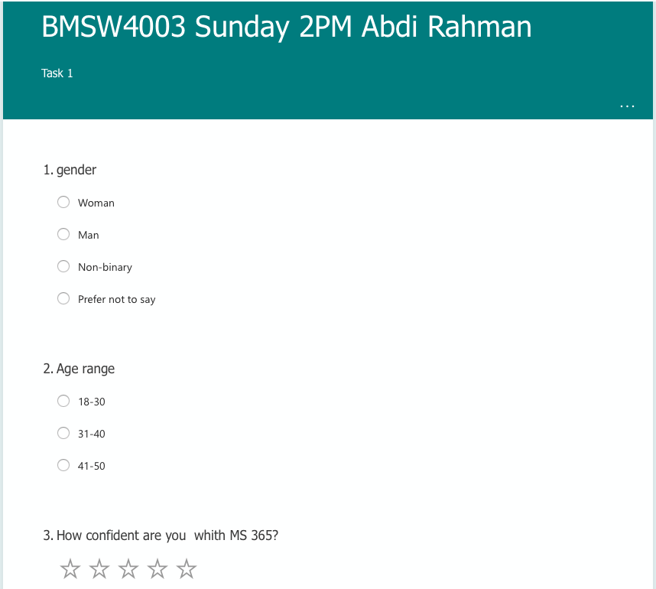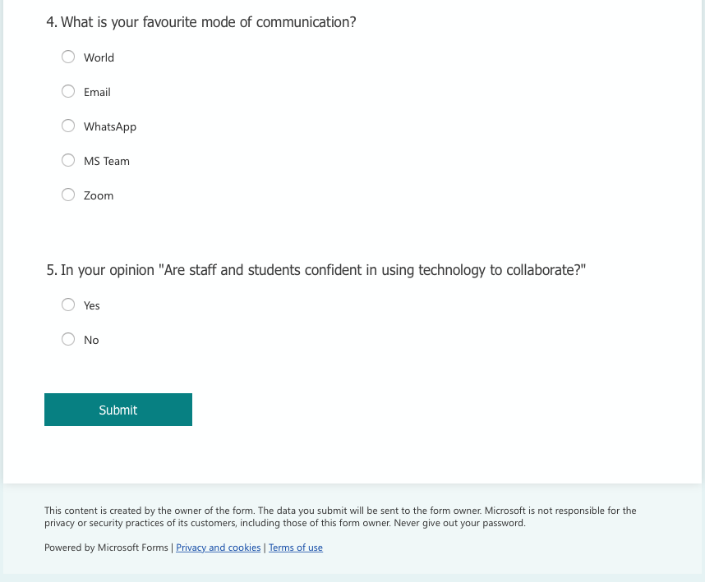
Image 1 - Questionnaire

