Harry Mcquillan-Butt p146303
Turbo charger analysis
advanced engine technology

08
Fall

Table of Contents
introduction 2
Ford Ecoboost factory fitted turbo strip down and rebuild. 3

introduction
The purpose for this assignment is for students record and assess the ability a turbocharger has to affect the volumetric efficiency of the cars engine, in order to do so the students must be able to understand the operating principles of a turbocharger and be able to document them, document the steps (with pictures) of dissembling and rebuilding a turbocharger as well as the checks to be carried out whilst doing so t ensure that everything required is present and in working order. Eventually the assignment will come to a conclusion in which the student will be able to discuss the differences in efficiency of different turbos, as well as different turbos setups and then go on to compare turbochargers to other forms of forced induction systems used on modern production, an example of which is supercharging engines.

Research

a turbo charger is a compressor which increases intake the pressure of an internal combustion engine, it is driven by the power which it generates off of the pressure of the exhaust gases. (Collinsdictionary.com, 2018)
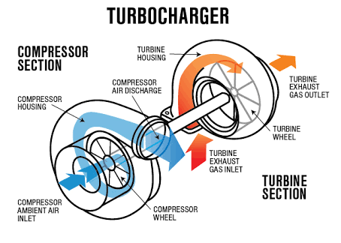(Anon, 2016)
One of the most common reasons for fitting a turbo charger to an engine is to improve the engines efficiency. Turbo chargers are able to improve a cars efficiency by increasing the engines volumetric efficiency.

The volumetric efficiency of an internal combustion engine describes the engines ability to force air into its cylinders. A higher volumetric efficiency percentage means that the cylinder has a higher volume of air which in turn means it has a higher pressure. For two engines both with the same displacement, the engine with the higher volumetric efficiency is always going to deliver more power and more torque. (Education.seattlepi.com, 2018)

One of the benefits of installing a turbo charger is that it allows you to push an engines efficiency to over 100 percent (100% being atmospheric pressure) due to the fact that the air is being pressurised into the cylinders.

Turbo maps

This assignment requires students to be able to read turbo maps (compressor maps) to enable them to match a turbo to an engine.
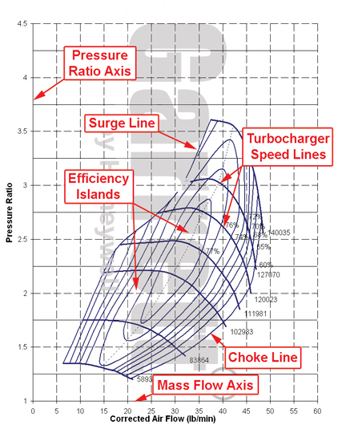
Pressure ratio axis: axis with pressure ratios
Surge line: Surge is defined as the operating point at which centrifugal compressor peak head capability and minimum flow limits are reached.
Efficiency islands: Efficiency Islands are concentric regions on the maps that represent the compressor efficiency at any point on the map. The smallest island displays the compressors peak efficiency, as the islands get larger the efficiency gets smaller until the surge and choke limits are reached
Turbocharger speed lines: these are lines of constant turbo speed
Choke line: typically defined by the point at which the efficiency drops below 58%
Mass flow axis: axis displaying the mass of air flowing through the compressor at any given period of time.
(Garret, 2018)

Ford Ecoboost factory fitted turbo strip down and rebuild.
The first job the students carried out in order to complete this assignment took place in the universities engine laboratory, where they were tasked with un assembling a ford ecoboost turbocharger whilst documenting and taking pictures off the process and various components. Once the students had completed the turbocharger strip down, they then had to reassemble the turbocharger, using the correct lubricants, to a standard that is acceptable for the turbocharger to be used for the same purpose by future students. The process was supervised by both the workshop technician and Gwyn Thomas, the lecturer for the module, as well as supervising they were also there to offer guidance, knowledge and help if required by the students.

Below is the documented process that the students followed when stripping down the turbocharger as well as pictures taken during the process to aid the readers understanding.

The image below displays the complete turbocharger fully assembled in which you can clearly see the, exhaust manifold, the turbine housing, the v clamp, the compressor housing as well as the waste gate actuator and the vnt rod.
The exhaust manifold directs the engines exhaust gasses into the turbine housing, the turbine housing contains the exhaust gasses and directs them into the turbine, once the exhaust gasses have been passed through the turbine they are then treated and omitted into the atmosphere by the cars exhaust system. Whilst this process in being carried out on the turbine side of the turbo, the compressor side works simultaneously. The turbine, which is being powered by the exhaust gasses, sucks air into the compressor housing through the cars air intake system. Once inside the compressor housing, the air is naturally fed into the compressor due to the structure of the housing, the air is then compressed and forced into the engines cylinders through a series of pipes to be where it will eventually be mixed with fuel and burnt. The function of the waste gate actuator and the vnt rod will be explained later in this part of the assignment.
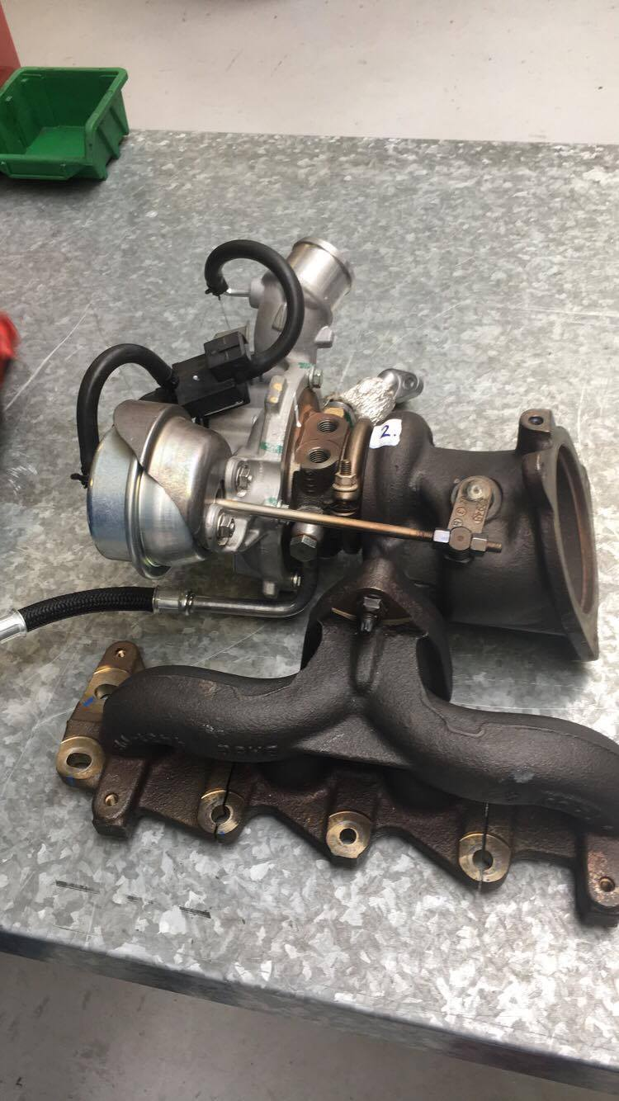

The first step that the students took towards dismantling the turbo was separating the main large components from the main assembly. To do so the students first disconnected the exhaust manifold from the turbine housing by removing the three nuts that clamp it onto the turbine housing, next the students disconnected the vnt rod from the turbine housing by loosening and removing the nut on the outside of the waste gate arm, whilst taking great care no to touch the second bolt to ensure that the waste gate remains in the same position when the turbo is rebuilt and that the waste gate is able to seat itself fully to ensure a tight seal in order too keep boost pressure up. Now that the turbine housing is free from all of the components that connect to it other than the main turbo assembly itself, the students are able to loosen off the v clamp sealing the turbine housing to the bearing housing and then remove the turbine housing when it is free.

With the turbine housing free from the rest of the system the students were able to closely inspect the turbine housing in order to gain an understanding of how its functions as well as certain as well as looking at its specific design features and its refinements which define the route which the accelerated gases take. The image below displays the exhaust turbine housing along with the rest of the assembly that it has been removed from (including the exhaust manifold).
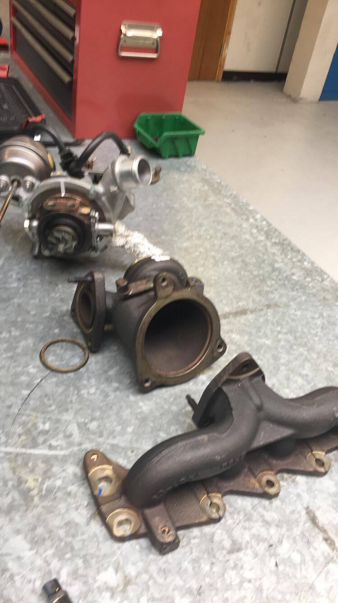

now that the turbine housing has been removed the student were able put it to one side. With the housing now clear from the workspace, the students began to inspect the bearing housing with the exposed turbine blades. The students seased the opportunity to check the condition of the exhaust turbine, checking for any damage that is visible as well as spinning the turbine to ensure that it is able to spin freely without interruption (great care has to be taken by engineers when inspect blades on either a turbos turbine or compressor due to the fine sharp blades as well as loose shards of metal) the students also checked for other signs of damage such as excess oil and discoloration of components caused by excessively high temperatures.

Now that all of the checks that are possible so far have been completed, the students are ready to remove the compressor housing from the bearing housing. The turbine housing is removed using the same method as the students adopted to remove turbine housing, which just means removing the v clamp by loosening the nut off. With the compressor housing removed the students were able to observe the condition of the inside of the compressor, checking for clear indications of faults such as loose metal shards in the housing which would signify that the compressor blades may be damaged as well as notifying the engineer of the possibility that foreign body’s could have been sucked into the cylinders causing further damage to the engine.

With the compressor housing put to one side the students were left with the bearing housing in front of them, exposing both the compressor blades and the turbine blades. The next step was to disassemble the bearing housing in order to gain access to the shaft connecting the two turbines, the bearings and the spacers, this step was carried out by the workshop technician due to the danger imposed by the sharp blades as well the assembly containing small and delicate parts which the students would be liable for breaking and possibly misplacing.

The image below displays the turbocharger assembly with the turbine housing removed, this helps to give the reader an understanding of how the turbines look when exposed as well as displaying the way in which the bearing housing sits within the water jacket (picture also includes v clamp which is used to hold parts of the turbo housing together.
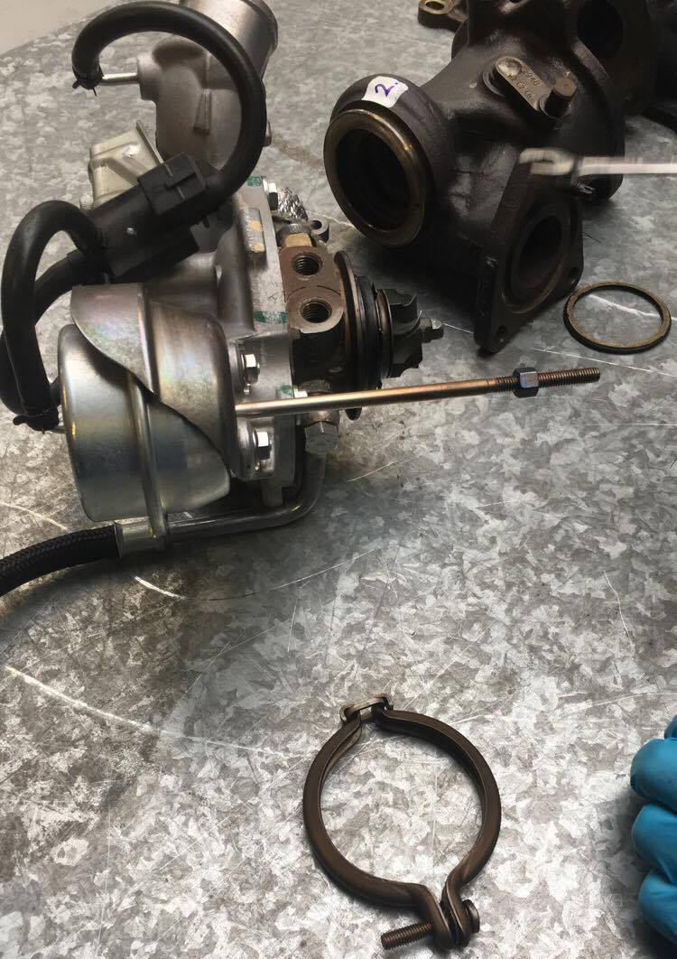

With only the water jacket holding the bearing housing in front of him, the workshop technician removed the one bolt which holds the bearing housing in place and stops it from rotating (similar to the screw used on road car disk breaks to keep them in place on the hub) within the water jacket. With the bearing housing removed from the water jacket, the technician then undone the torque key on the end of the exhaust turbine whilst using his other hand to ensure that the compressor shaft doesn’t turn(whilst wearing gloves as this is where the oil for the bearings is contained), by doing so the technician was able to remove the turbine from the shaft and the slide the shaft out of the compressor end (the compressor is fixed onto the shaft). Once this was done the casing was opened, again by one screw and the bearings, spacer and two oil rings which stop the oil that lubricates the bearings from seeping out of the casing and disturbing the air flow over the turbine and compressor blades. It is very important for the technician to check all of the internal components thoroughly as well as the other components., this is due to turbo rebuilds being costly so customers would not want to have to pay twice, as well as the main factor which is that turbochargers operate at rpm’s of well over one hundred thousand which means that the smallest defect is able to cause large amounts of damage to the turbo as well as the rest of the cars engine if they go wrong, due to the speed at which debris is able to leave the moving parts. Another common fault is for weak points in the turbo to give in under the high pressure that is caused by the fast moving gasses.

The picture below is of the technician disassembling the bearing housing and its internal components; in his hand is the compressor blade and shaft. At closer inspection you are able to see the bearings, spacer and oil rings on the shaft, on the bench is the actual bearing housing as well as the cap which encloses the bearings in the housing, the exhaust turbine blade and the gold half washer like component which the technician said was specific to fords, the technician explained to us his theory of what it was for, which he reckons is used to circulate the oil around the bearings and coat the inside of the bearing housing in order to ensure for good oil circulation to prevent the bearings from seasing.
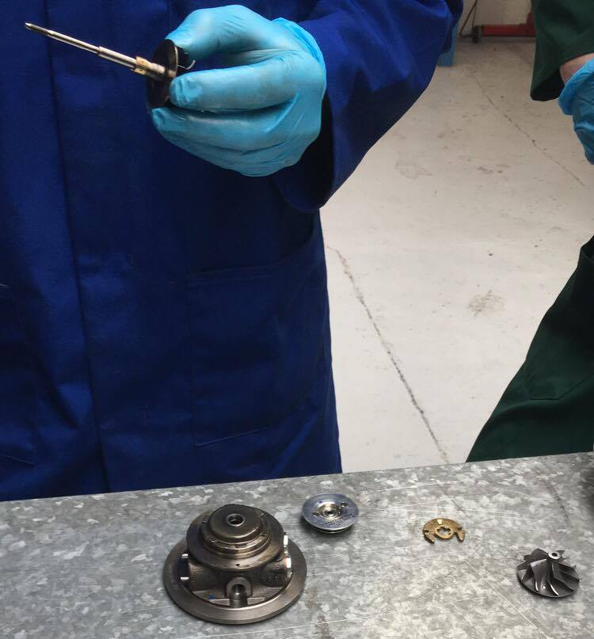

Bibliography
Anon, (2016). [online] Available at: https://www.quora.com/How-many-blades-are-there-in-the-turbocharger-of-an-IC-engine [Accessed 7 Apr. 2018].
Collinsdictionary.com. (2018). Turbocharger definition and meaning | Collins English Dictionary. [online] Available at: https://www.collinsdictionary.com/dictionary/english/turbocharger [Accessed 4 Apr. 2018].
Education.seattlepi.com. (2018). What is Volumetric Efficiency?. [online] Available at: http://education.seattlepi.com/volumetric-efficiency-5041.html [Accessed 8 Apr. 2018].
Garret, (2018). [online] Available at: https://www.turbobygarrett.com/turbobygarrett/ [Accessed 6 Apr. 2018].

