
Strategic choices and strategy actions of AstraZeneca
MODULE NAME: STRATEGIC MANAGEMENT AND SUSTAINABILITY
STUDENT NAME: SAMUELA PRIANKA SOUSA
STUDENT ID: 2030400
MODULE LECTURER: DR HOSSEIN SHOKRI
SUBMISSION DATE: 20/12/2023

Table of Contents
1.Introduction 1
2. Key Business and Corporate Strategies Identification 1
AstraZeneca's Corporate strategies 1
AstraZeneca's Business strategies 2
Porter's Generic Strategies 2
The Ansoff Matrix 3
3.Analysing AstraZeneca's resources and capabilities. 4
Value chain Analysis 5
Value System Analysis 5
VRIO framework For AstraZeneca 6
4.Evaluating Strategy in Action 7
Evidence and Examples: 8
5. Evaluating Sustainability Efforts 8
6. Future Strategic Direction and Recommendations 9
7. Conclusion 10
8.References 11
9. Appendix 12
SWOT Analysis for AstraZeneca PLC 12

Title: Strategic choices and Strategy actions of AstraZeneca

1.Introduction

AstraZeneca, a British multinational pharmaceutical company, is highly trusted in global healthcare innovation for many years. AstraZeneca’s mission statement is to revolutionize the well-being of individuals impacted by rare diseases by creating and providing cutting-edge medications, along with supportive technologies and healthcare services. AstraZeneca has set its presence as a key player in the pharmaceutical landscape. With a primary listing on the London Stock Exchange, the company's strategic actions and market influence are of significant interest, particularly for stakeholders seeking insights into the details of corporate and business strategies (AstraZeneca, 2023). AstraZeneca has navigated strategic landscapes as an experienced leader. As a strategic planner entrusted with the task of conducting a comprehensive analysis, this report will explore into the core of AstraZeneca's corporate and business strategies. Through the lens of strategic choice and action, we will explore the frameworks behind the company's key strategies. This report aims to solve the rationale behind AstraZeneca's chosen path and explore the planning between its resources, capabilities, and strategic objectives. They have three priorities designed to deliver their growth, through innovation strategy, Science and Innovation, growth and therapy area, leadership and people and sustainability (AstraZeneca, 2023).

2. Key Business and Corporate Strategies Identification

AstraZeneca's Corporate strategies

AstraZeneca conveys a comprehensive corporate strategy, emphasizing its dedication to delivering innovative medicines through excellence in development and commercialization. The company's commitment is to become a global biopharmaceutical company with a focus in main areas such as Respiratory, Inflammation & Autoimmunity, Cardiovascular & Metabolic Disease, and Oncology. (AstraZeneca, 2023). AstraZeneca's corporate strategy extends to concentrating efforts on priority growth platforms, progressing the Phase II pipeline, launching specialty care products, rebuilding the research and development (R&D) engine through innovation, and simplifying the business for increased productivity. The company also expresses a clear view for diversification, highlighting the importance of focused efforts and resource concentration (AstraZeneca, 2013).

AstraZeneca's Business strategies

On the business strategy front, AstraZeneca outlines specific actions, including driving on-market growth platforms, progressing pipeline projects, launching specialty care products, and strategically giving importance to business development and acquisitions. These targeted initiatives aim to steer the company through a period of patent expiries and revenue declines while maximizing the potential of existing assets (AstraZeneca, 2013).

Porter's Generic Strategies

A framework for understanding how companies can achieve a competitive advantage. There are three main strategies outlined by Michael Porter: Cost Leadership, Differentiation, and Focus (Whittington et al., 2019). AstraZeneca, being a pharmaceutical company, often emphasizes differentiation through innovational research and development, bringing new drugs to the market, and maintaining a strong focus on scientific innovation.

Differentiation: Seeking to be unique in the industry in ways that are valued by the customer. AstraZeneca may differentiate itself through innovation, research and development, and the production of specialized drugs, establishing a distinct market position. Some key aspects to consider are Product and service attributes, Customer relationships, Complements.
Focus: Concentrating on a specific market segment, product line, or geographic area. AstraZeneca might focus on specific therapeutic areas or patient demographics, tailoring its strategies to meet the unique needs of those markets more effectively. It’s worth noting that companies can adopt a combination of these strategies, and their approach may evolve over time based on industry dynamics and internal capabilities (Whittington et al., 2019)

The Ansoff Matrix

The Ansoff Matrix is a strategic planning tool that helps businesses decide their product and market growth strategy. It consists of four growth strategies: Market Penetration, Market Development, Product Development, and Diversification (Whittington et al., 2019).

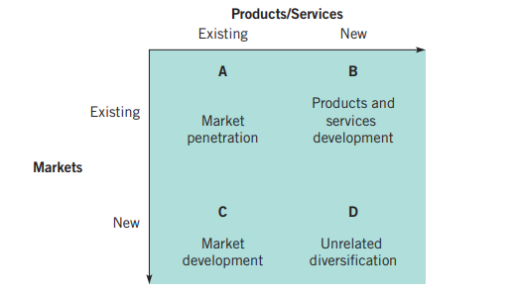
Source: exploring strategy twelfth edition

Market Penetration: Identify AstraZeneca's efforts to increase market share in existing markets, explore strategies such as increasing sales to existing customers or launching new formulations of existing drugs, investigate promotional activities or partnerships to strengthen their position in current markets. Product Development, AstraZeneca's initiatives to introduce new pharmaceutical products, examine any research and development investments to create novel drugs or improve existing ones, Assess partnerships or collaborations for innovation in drug development. Market Development, Explore AstraZeneca's expansion into new markets or regions, identify efforts to introduce existing products to new geographical areas, assess partnerships or regulatory strategies for entering new markets. Diversification, Analyses AstraZeneca’s ventures into new therapeutic areas or industries, explore any acquisitions or partnerships that signify diversification beyond their core pharmaceutical business, Assess the rationale behind diversification and how it aligns with the company's overall strategy. The Ansoff Matrix helps in understanding a company's growth strategies by examining the combination of new and existing markets and products (Whittington et al., 2019)

3.Analysing AstraZeneca's resources and capabilities.

Resources
- Development facilities in several countries.
- Many experienced scientists who are employed by the company, including other employees total of 83,500 worldwide.
- A strong pipeline of potential blockbuster drugs.
- A focus on the discovery, development, and commercialisation of prescription medicines in Oncology, Rare Diseases, and Biopharmaceuticals (AstraZeneca, 2023a).

How these resources align with the current business and corporate strategies.
Development facilities and manufacturing sites across various countries demonstrate a widespread, Global operational presence. A substantial number of employed expert scientists signify the company's research and development capabilities. A robust pipeline of potential blockbuster drugs indicates their focus on innovation and future revenue generation. A clear focus on specific therapeutic areas like Oncology, Rare Diseases, and Biopharmaceuticals showcases their strategic direction in drug discovery and development. These resources and capabilities contribute to AstraZeneca's successful position in the pharmaceutical industry. The graph below shows its profitability due to their strategies (AstraZeneca,2013).

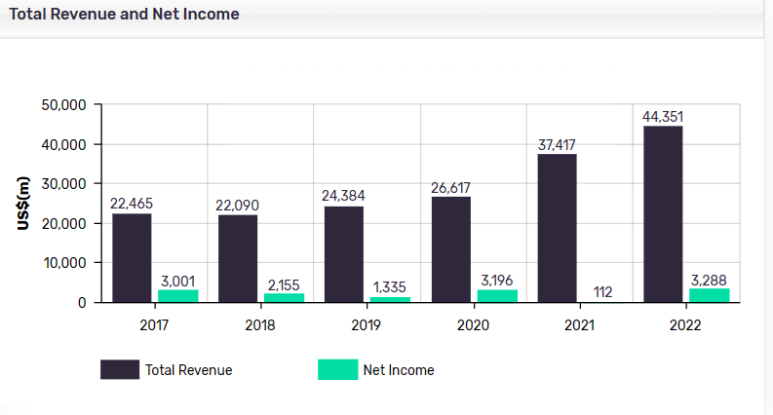
Source: MarketLine

Value chain Analysis

The value chain is a concept introduced by Michael Porter to describe the sequence of activities that a firm engages in to create and deliver a product or service to customers (Stobierski, 2020).

- Primary Activities:
Inbound Logistics: AstraZeneca's global presence and extensive manufacturing sites demonstrate efficient inbound logistics, ensuring a timely and cost-effective supply of raw materials. Operations: Efficient operations are crucial for product quality and timely delivery. Outbound Logistics: AstraZeneca's distribution network ensures the timely and reliable delivery of medicines to diverse markets, contributing to customer satisfaction. Marketing and Sales: The company invests in marketing efforts to promote its pharmaceuticals, including those focused on special therapeutic areas like Oncology. Sales operations are critical for revenue generation. Service: AstraZeneca's commitment to patient support programs and access initiatives represents added value, contributing to overall customer loyalty and satisfaction. (AstraZeneca ,2023)

- Support Activities:
Infrastructure: AstraZeneca's global infrastructure, including offices, laboratories, and IT systems, supports the entire value chain by providing the necessary backbone for operations. Human Resource Management: The extensive team of scientists and other professionals is a crucial resource for research and development, contributing to the company's innovative capabilities. Technology Development: Ongoing investment in technology and innovation supports drug discovery and development, enhancing the company's competitiveness. Procurement: Strategic partnerships and efficient procurement practices ensure a stable supply of quality raw materials for drug manufacturing. (AstraZeneca,2023); (Stobierski, 2020).

Value System Analysis

AstraZeneca's relationships with suppliers are vital for ensuring a consistent and high-quality supply of raw materials, contributing to the reliability of its operations. The diverse customer base, including healthcare providers and patients globally, relies on AstraZeneca for access to innovative and life-saving pharmaceuticals. Customer satisfaction is crucial for maintaining market share. Distributors and wholesalers play a role in the outbound logistics, contributing to the efficient delivery of pharmaceuticals to various markets. AstraZeneca competes with other pharmaceutical companies in therapeutic areas like Oncology. Its ability to innovate and bring new drugs to market influences its competitive position. Collaborations and partnerships with research institutions and other pharmaceutical companies contribute to AstraZeneca's overall innovation capabilities (Benito, Petersen, and Welch (2019).

VRIO framework For AstraZeneca

Value: AstraZeneca’s commitment to delivering innovative medicines demonstrates the value of its research and development efforts. The company's focused portfolio in core therapy areas (Respiratory, Inflammation & Autoimmunity, Cardiovascular & Metabolic Disease, and Oncology) addresses significant medical needs, adding value to its offerings. Rarity: AstraZeneca’s emphasis on distinctive science and a growing late-stage pipeline suggests to rare and unique assets in the pharmaceutical industry. The company's collaborations with institutions like the Swedish medical university Karolinska Institute and Moderna. Imitability: The pharmaceutical industry is highly regulated, making it challenging for competitors to replicate AstraZeneca's specific drug formulations and research processes. Their focus on innovation, investments in bioscience and partnerships, indicates efforts to maintain a level of distinctiveness that is not easily imitated. Organization: AstraZeneca's strategic priorities, including focusing on growth platforms, progressing the pipeline, and rebuilding R&D, show organizational commitment to leveraging its resources effectively. AstraZeneca's resources, and capabilities, as analysed through the VRIO framework, appear to possess value, rarity, and elements of inimitability. However, organizational effectiveness will be crucial in fully capitalizing on these advantages. Continuous adaptation and improvement in response to industry dynamics (Whittington et al., 2019).
Resources and capabilities | Value | Rarity | Imitability | Organisation
 | V | R | I | O
Brand reputation | yes | yes | no | yes
Focus on innovation and Research & Development | yes | yes | yes | yes
Financial resources & government funds | yes | yes | yes | yes
marketing and website updates | yes | no | no | yes
Ability to Attract highly qualified researchers | yes | yes | yes | yes

4.Evaluating Strategy in Action

AstraZeneca has demonstrated notable success in implementing key business and corporate strategies. To evaluate their performance, we can apply the Suitability, Acceptability, and Feasibility (SAF) framework. (AstraZeneca, 2020)

Suitability: AstraZeneca's focus on therapeutic areas such as Oncology aligns with the growing demand for innovative treatments in these segments, demonstrating strategic suitability. The emphasis on a strong drug pipeline reflects suitability, indicating a commitment to innovation and future revenue streams. The establishment of development and manufacturing facilities across countries showcases suitability in adapting to diverse market needs. Successful collaborations, like partnerships for drug development or distribution agreements, highlight the company's strategic suitability in navigating the complex pharmaceutical landscape (AstraZeneca, 2023a).

Acceptability: AstraZeneca's financial success, evidenced by revenue growth and profitability, demonstrates the acceptability of their strategies to stakeholders, including investors and shareholders. Adherence to regulatory standards in the pharmaceutical industry ensures the acceptability of their products, contributing to positive perceptions among consumers and regulatory bodies. The company's commitment to ethical practices in research and marketing enhances acceptability among both the medical community and the public. Positive clinical outcomes and patient experiences with AstraZeneca's drugs contribute to the acceptability of their strategies, fostering trust among healthcare professionals and patients (AstraZeneca, 2023a).

Feasibility: AstraZeneca's extensive team of scientists and research facilities support the feasibility of their strategies, ensuring ongoing innovation and drug development. The feasibility of their global presence is supported by the presence of manufacturing sites in numerous countries, allowing for efficient production and distribution. AstraZeneca's ability to navigate and gain access to diverse markets demonstrates the feasibility of their strategies in overcoming regulatory, cultural, and market-specific challenges. Efficient allocation of financial and human resources to support ongoing research, development, and commercialization indicates the feasibility of their long-term strategies (AstraZeneca, 2023a).

Evidence and Examples:

- COVID-19 Vaccine Development: AstraZeneca's collaboration with the University of Oxford for COVID-19 vaccine development is a prominent example of successful strategy, showcasing adaptability and a rapid response to global health challenges. The commercial success of oncology drugs like Tagrisso and Lynparza reflects the effective execution of the strategy in focusing on high-demand therapeutic areas. The company faced challenges with patent expirations for certain groundbreaking drugs, affecting revenue streams. However, successful strategies to control this impact, such as new drug launches and strategic alliances, demonstrate adaptability. AstraZeneca's strategies align well with industry trends, demonstrate acceptability to stakeholders, and are feasible given their capabilities and resources. While facing challenges, the company has exhibited resilience and strategic agility, particularly evident in their response to the COVID-19 pandemic. Continuous evaluation and adaptation will be crucial for sustaining their success. (AstraZeneca,2020).

5. Evaluating Sustainability Efforts

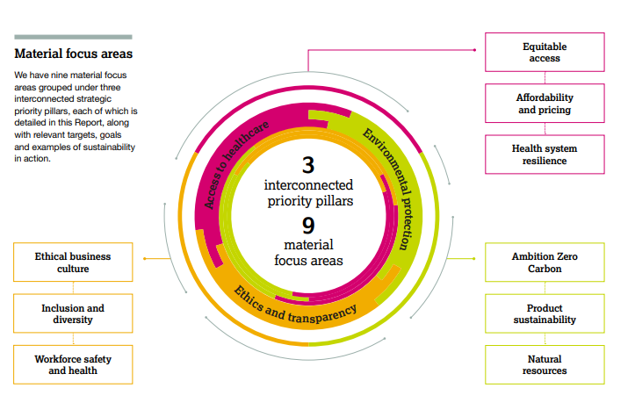
Source: AstraZeneca’s sustainability report 2022

AstraZeneca has taken significant steps in integrating sustainability efforts into its overall strategy, reflecting a commitment to environmental responsibility and social impact. AstraZeneca has committed to being carbon neutral by 2025. This includes reducing its operational carbon footprint, investing in renewable energy, and offsetting remaining emissions. The company's focus on sustainable manufacturing practices, including energy-efficient technologies and waste reduction, contributes to a lower environmental impact. sustainability efforts extend to providing access to healthcare in low-income countries. Initiatives like the AstraZeneca Young Health Programme aim to address non-communicable diseases in underserved communities. The company's strategy includes efforts to ensure affordability and accessibility of medicines, aligning with sustainable development goals related to health and well-being (AstraZeneca, 2020).
AstraZeneca demonstrates commitment to sustainability through transparent reporting on environmental and social performance. This engages stakeholders and allows for accountability. Collaborations with NGOs, government agencies, and other stakeholders amplify the impact of sustainability initiatives, fostering a holistic approach to societal and environmental challenges. They have incorporated green chemistry principles into drug development, emphasizing environmentally friendly processes and reducing the ecological impact of pharmaceutical manufacturing. The company explores bio sustainability approaches, aiming to create medicines that have a positive impact on both patients and the environment.
Sustainability is integrated into AstraZeneca's core business strategy, reflecting a recognition that long-term success is intertwined with environmental and social responsibility. Addressing sustainability challenges, such as climate change and global health disparities, is not only a societal responsibility but also a strategic move to control risks associated with regulatory changes and shifting consumer preferences. AstraZeneca's sustainability efforts go beyond compliance, involving a proactive commitment to environmental responsibility, social impact, and innovation. The integration of sustainability into their overall strategy demonstrates a recognition of the connection between business success, societal and environmental well-being.

6. Future Strategic Direction and Recommendations

Embrace digital health technologies for personalized medicine, remote patient monitoring, and data analytics. This aligns with industry trends, enhances patient outcomes, and positions AstraZeneca as a leader in the evolving healthcare landscape. Invest in the expansion of the biopharmaceutical portfolio. Biopharmaceuticals often have unique therapeutic benefits and can contribute to a competitive edge in the rapidly advancing field of biotechnology. Expand efforts to provide affordable and accessible medicines globally, especially in developing regions. Addressing global health disparities not only aligns with sustainability goals but also fosters goodwill and strengthens AstraZeneca's reputation.

7. Conclusion

In conclusion, the analysis of AstraZeneca's strategies reveals a company leading pharmaceutical innovation, with a strong emphasis on sustainability. Their focus on therapeutic areas like Oncology aligns with industry trends, makes it competitive. AstraZeneca's sustainability efforts extend beyond compliance, with carbon neutrality commitments, green manufacturing practices, and a commitment to global health access, Sustainability is the core business strategy, enhancing both reputation and long-term success. The response to the COVID-19 pandemic, including vaccine development and global partnerships, represents AstraZeneca's strategic alertness. AstraZeneca's strategic choices not only impact its competitiveness but also position the company as a responsible global player, contributing to positive brand perception and societal impact. As the pharmaceutical industry evolves, AstraZeneca's strategic adaptability and commitment to innovation and sustainability positions it for continued success in the dynamic and socially conscious global market (AstraZeneca,2020). AstraZeneca's future success lies in strategic adaptation to industry trends and a continued commitment to sustainability. By embracing digital health, expanding the biopharmaceutical portfolio, and addressing global health disparities, the company can position itself for long-term growth. Moreover, integrating circular economy practices, ensuring supply chain sustainability, and advancing bio sustainability in R&D will contribute to competitive advantages through environmental responsibility, regulatory compliance, and positive brand perception.

8.References

AstraZeneca (2013). AstraZeneca outlines strategy to return to growth and achieve scientific leadership. [online] www.astrazeneca.com. Available at: https://www.astrazeneca.com/media-centre/press-releases/2013/astrazeneca-growth-scientific-leadership-strategy-21032013.html#.
AstraZeneca (2020). Sustainability Report 2020. [online] Available at: https://www.astrazeneca.com/content/dam/az/Sustainability/2021/pdf/Sustainability_Report_2020.pdf [Accessed 29 Nov. 2023].
AstraZeneca (2023a). AstraZeneca. [online] Astrazeneca.co.uk. Available at: https://www.astrazeneca.co.uk/.
AstraZeneca (2023b). Locations. [online] careers.astrazeneca.com. Available at: https://careers.astrazeneca.com/locations#region.
AstraZeneca Annual Report (2022). What science can do AstraZeneca Annual Report and Form 20-F Information 2022. [online] Available at: https://www.astrazeneca.com/investor-relations/annual-reports/annual-report-2022.html [Accessed 25 Nov. 2023].
Benito, G.R.G., Petersen, B. and Welch, L.S. (2019). The global value chain and internalization theory. Journal of International Business Studies, 50(8), pp.1414–1423. doi:https://doi.org/10.1057/s41267-019-00218-8.
Market Line (2023). AstraZeneca Plc. [online] Uwtsd.ac.uk. Available at: https://advantage-marketline-com.ezproxy.uwtsd.ac.uk/Company/Summary/astrazeneca_plc [Accessed 12 Dec. 2023].
Stobierski, T. (2020). What Is a Value Chain Analysis? 3 Steps. [online] Harvard Business School. Available at: https://online.hbs.edu/blog/post/what-is-value-chain-analysis.
Verbeke, A. (2013). International Business Strategy. Cambridge University Press.
Welch, L.S., Benito, G.R.G., Petersen, B. and Netlibrary, I. (2007). Foreign operation methods : theory, analysis, strategy. Cheltenham, Uk ; Northampton, Ma: Edward Elgar.
Whittington, R., Regner, P., Angwin, D., Johnson, G. and Scholes, K. (2019). Exploring Strategy. 12th ed. Hoboken: Pearson.

9. Appendix

SWOT Analysis for AstraZeneca PLC

Strengths

Widespread geographic presence reduces business risks: AstraZeneca boasts a global presence across various regions, including Europe, Middle East, Africa, Southeast Asia, and the Americas. With operational sites spanning the UK, Sweden, China, Puerto Rico, the US, and many more countries, the company strategically positions itself for diverse formulations and local/regional supplies. In FY2022, revenue distribution reflects a well-balanced structure. This extensive footprint not only reduces risks but also allows for cost efficiencies and close customer relationships (Market Line, 2023). Significant R&D capabilities and manufacturing and supply resources: AstraZeneca possesses robust research and development (R&D) capabilities, with a focus on creating innovative medicines for diverse diseases. Its R&D scope includes biologic medicines, immunotherapies, novel delivery devices, oligonucleotides, and emerging drug platforms. The company's pipeline comprises 121 projects as of December 2022, supported by global R&D centres in the UK, the US, and Sweden, alongside additional sites. AstraZeneca collaborates extensively, with over 1000 partnerships and global patent protection in 90+ countries. In FY2022, it allocated US$9,762 million (22% of revenue) to R&D, leveraging these capabilities and resources to efficiently manufacture products addressing unmet needs for a broad customer base (Market Line, 2023). Financial performance of the business: AstraZeneca's revenue and profit growth attract investments, with sales reaching US$44,351 million in FY2022, marking an 18.5% increase from US$37,417 million in FY2021. This growth is drove by the introduction of 20 new medicines, including three in 2022 alone. Fourteen medicines contributed significantly to sales revenue. Operating margin surged from 2.8% in FY2021 to 8.4% in FY2022, reflecting the company's adept control of operating expenses and a notable increase in net profit from 0.2% to 7.4% (Market Line, 2023).

Weaknesses

Huge liabilities pose operational risk: AstraZeneca faced a rise in liabilities in the recent year, impacting its liquidity for meeting short-term obligations. In FY2022, current liabilities increased by 16.4%, reaching US$26,293 million compared to US$22,594 million in FY2021. This surge is attributed to higher lease liabilities, borrowings, and trade and other payables. The reported current ratio for FY2022 stands at 0.8. The substantial increase in liabilities may impact the company's market credibility and pose operational risks in fundraising for investments (Market Line, 2023).

Opportunities
Approval of product by CHMP: Regulatory approval brings opportunities for the company. In September 2023, AstraZeneca revealed that its medicine received a recommendation for approval in the EU for monotherapy in treating advanced non-small cell lung cancer. Additionally, in June 2023, Soliris (eculizumab) earned a recommendation for expanded use in the EU, including the treatment of refractory generalized myasthenia gravis in children and adolescents aged six to 17 years who are anti-acetylcholine receptor antibody positive. Contract and agreement: The company leverages contracts and agreements to enhance its market standing. In November 2023, AstraZeneca revealed a collaboration and investment agreement with Cellectis, a clinical-stage biotech company. This partnership aims to accelerate the development of next-generation therapeutics, focusing on areas with significant unmet needs such as immunology, oncology, and rare diseases. Global Cardiovascular Device Market: AstraZeneca anticipates benefiting from the cardiovascular device market's growth. The global market, valued at US$56,849.4 million in FY2022, is projected to reach US$73,851.3 million by FY2027 (CAGR 5.4%). Key segments include cardiac rhythm management devices, set to reach US$16,966.3 million (CAGR 5.0%), transcatheter heart valves poised to hit US$12,216.04 million (CAGR 11.3%), cardiac assist devices at US$4,769.09 million (CAGR 6.2%), and atherectomy devices reaching US$984.7 million (CAGR 6.4%) by FY2027, according to in-house forecasts (Market Line, 2023).
Threats
Competitive Pressures from Generic Manufacturers: The biopharmaceutical industry faces intense competition, potentially prompting the company to raise market prices and resulting in a decline in market share. Technological advancements and new medicine launches contribute to this competitive landscape. AstraZeneca primarily contends with major pharmaceutical players like Actelion Pharmaceuticals Ltd, GSK plc., Hikma Pharmaceuticals PLC, Merck KGaA, Novartis AG, and Teva Pharmaceutical Industries Limited. Foreign exchange risks in the business: The company, operating globally, faces currency fluctuation risks as it reports financials in US dollars. With 61% of revenue coming from non-US countries, it uses foreign exchange hedging, like forward contracts, to mitigate risks. Despite these measures, there's no guaranteed protection against the impact of exchange rate movements on the company's results. Regulation in different countries might hamper revenue growth: AstraZeneca operates in a regulated industry, obtaining approvals from bodies like the FDA in the US, EMA in Europe, and SFDA in China. Compliance with diverse local and international laws is crucial for its products, R&D, and manufacturing. Securing marketing approval is a time-consuming and costly process, and any failure to comply with regulations may adversely impact the business (Market Line, 2023).

