1.1
Time management

What is time management?
Time management refers to managing time effectively so that the right time is allocated to the right activity. Effective time management allows individuals to assign specific time slots to activities as per their importance. Time management refers to making the best use of time as time is always limited. Ask yourself which activity is more important and how much time should be allocated to the same? time management plays a very important role not only in organizations but in our personal lives.
In my daily routine I purely rely on memory to fit everything I need to do daily although that can have its done falls. I currently work in contact centre from 9.30 till 6pm. With me living 25 mins away from work I rely on my own memory knowing that leaving my house 9am gets me into work on time. Traffic can interrupt my journey, so time then isn’t against on my side. A future tool to use to help me avoid being late would be the use of would be a satnav to have the use of technology to tell me about traffic before coming to it. Planning my journey ahead would also help in my time management as you can never be sure what to expect with traffic and weather.

Academic writing

Academic writing is the writing done for academic purposes. It is entering into conversation with others, but the way this conversation is carried out differs from how everyday conversations unfolds. Academic writing involves expressing your ideas, but those ideas need to be presented as a response to some other person or group; and they also need to be carefully elaborated, well supported logically sequenced, rigorously reasoned, and tightly stitched together. Academic writing is a means of producing, codifying, transmitting, evaluating, renovating, teaching, and learning knowledge and ideology in academic disciplines. Incorrect grammar can affect the context of the sentence the meaning may be different from the reader. Spelling grammar is the same outcome is it is not clear it makes out that I’m lazy and my marks could be affected. A huge part of academic writing is referencing, if the work that’s being done isn’t being referenced then it is plagiarism, and I can be kicked off the course.

Criticality
Critical thinking is important for making judgements about sources of information and forming your own arguments. It emphasises a rational, objective, and self-aware approach that can help you to identify credible sources and strengthen your conclusions. Critical thinking is important in all disciplines and throughout all stages of the research process. The types of evidence used in the sciences and in the humanities may differ, but critical thinking skills are relevant in both. In academic context, critical thinking can help you determine whether a source is free from research bias, provide evidence to support the findings and consider alternative viewpoints.

Reflection writing
Reflection offers the opportunity to consider how your personal experiences and observations shape our thinking and our acceptance of new ideas. Lecturers do ask to write reading reflections. They do this to encourage us to explore our own ideas. Reflection writing can help us improve our analytical skills because it requires you to express what you think, and more significantly, how and why we think that way. The skills this course has taught me is the ability to communicate online and face to face and in addition the ability to improve my written skills. One skill I wont like to improve on would be emotional intelligence. Emotional intelligence is defined as the ability to understand and manage your emotions, as well as recognize and influence the emotions of those around you. The term was first coined in 1990 by researchers john Mayer and peter Salovey, but was later popularized by psychologist Daniel Goleman.

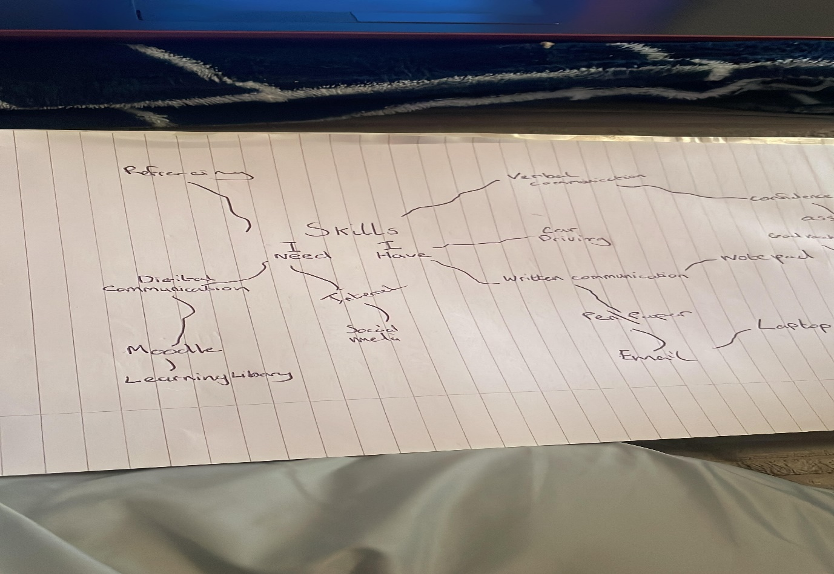
Critical writing is writing which analyses and evaluates information, usually from multiple sources, in order to develop an argument. A mistake many beginning writers make is to assume that everything they read is true and they should agree with it since it has been published in an academic text or journal. It is normal to be critical of sources or fake news or to question whether the sources is reliable or not. For example, in the sport football the fake news that arises in the summer with sagas suggesting whether certain players are moving to different clubs etc.

1.2
This mind map provides evidence of skills that I require attention on and skills that I already have and competent with. The skills where I have strength are in the digital area and the verbal area. The verbal communication skills have made me able to be assertive and direct with good vocabulary. Confidence defiantly plays a huge role in in my strength for verbal communication. Also, a skill of mine would be in the digital area with social media as id be able to learn via the laptop, Moodle and the general internet itself. so I would class that is skill that I have. I can also make use of libraries. I gain my verbal confidence through the job I do what it requires to do my job. Demonstrating presentations would be ideal skill as standing up Infront of people is something that often comes up in my job.
The skills I need to work on to help develop my learning will be my written communication skills with better help needed with grammar and spelling so people can understand and communicate with me better. It can help me be a lot better with referencing in future. The tools I can use to help me succeed will be research via internet doing study skills and also using mind maps. Referencing is a skill that id like to improve on and ill be able to improve that ill have to follow APA 7 referencing convention. A skill that I will have to focus on is critical thinking with tools like study skills and mind maps to help me improve my critical thinking. What is critical thinking? Its to have the ability to effectively analyse information and form a judgement. To think critically , I must be aware of my biases and assumptions when encountering information , and apply consistent standards when evaluating sources
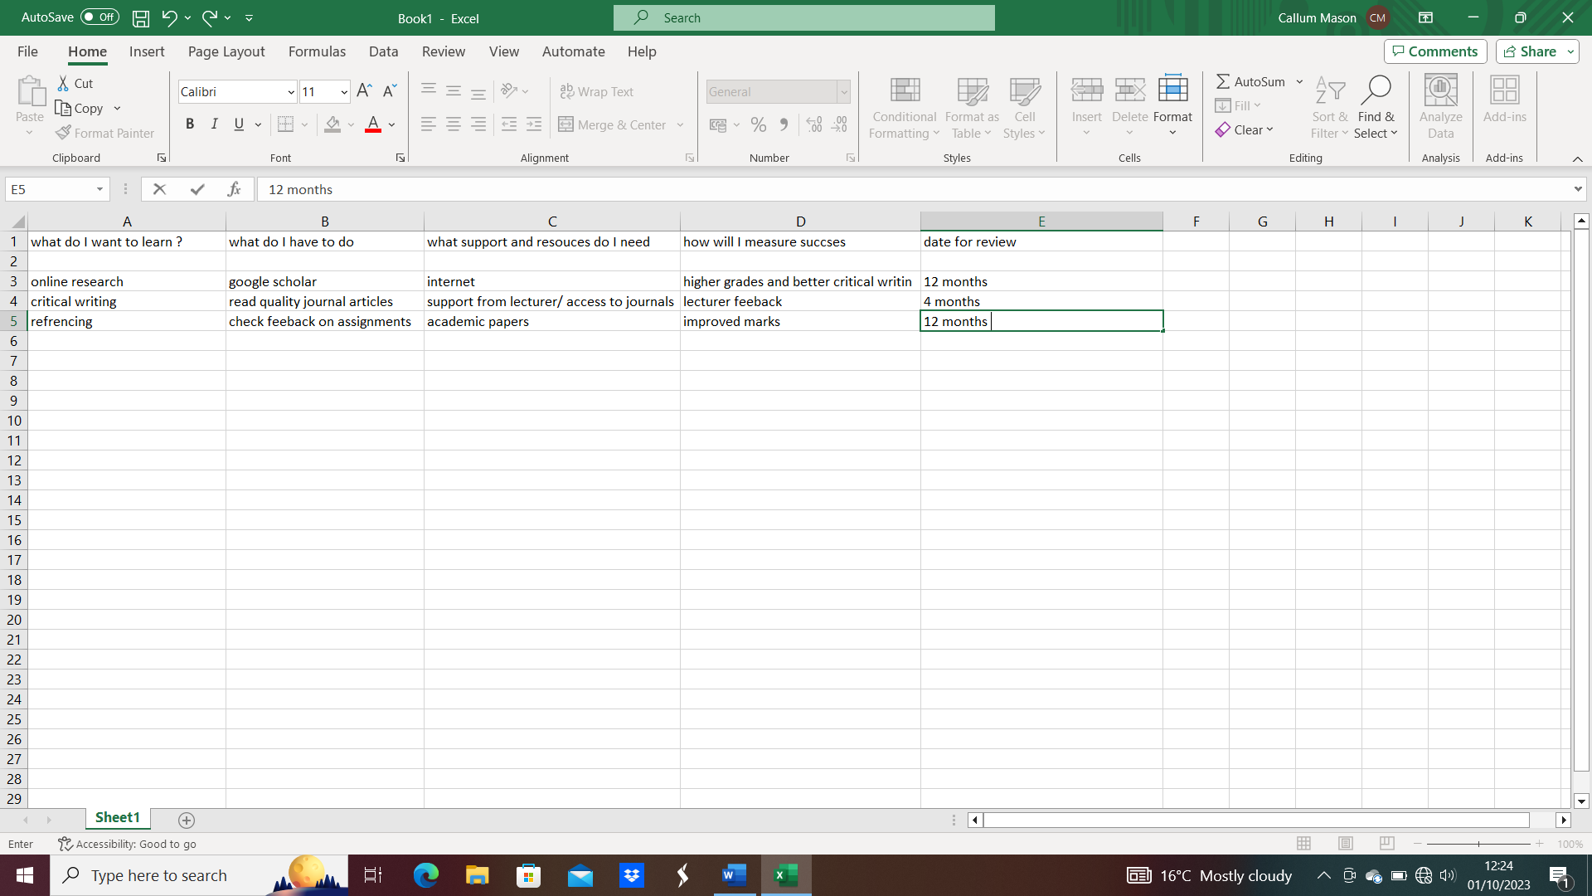
1.3
This chart will identify what skills I need to improve on not just to help me with this course but how these skills can help me in future life. This chart will also show how I will measure success over the best time period. I can also identify how I will find success and the resources I need to find the success in these skills to help me perform better so I can achieve higher grades.
The first skill identified in this chart that needs improvement is online research. Online research is a skill id like to improve as it plays a huge factor is finding the right information, I need to complete my course correctly. But in even life online research is a handy skill to have in life currently. Best way for me to improve on this skill would be a google scholar where it provides a simple way to broadly search for information I need. Best way for me to measure my progress on online research will be to check my grades and my critical writing. The next skill this chart shows will be critical writing and how I will be able to improve my critical writing. The resources I must support my critical writing will be support from my lecturer and free access to journal articles. Reading journal articles will be the main act in improving this skill. I will measure my success via my lecturer feedback every 4 months. the last skill the chart shows is referencing how to develop my referencing skills. By checking feedback on assignments and support from lecturers ill be able to improve my referencing skills over the a 12 month period as after that time scale I should see improvements on my grades.

References
http://www.managementstudyguide.com/time-management.htm
http://www.routledge.com/blog/article/what-is-academic-writing-and-other-burning-questions-about-it
http://www.scribbr.co.uk/working-sources/critical-thinking-meaning/
http://www.//.trentu.ca/academicskills/how-guides/how-write-university/how-approach-any-asssignment/how-write-reflection-paper
https://online.hbs.edu/blog/post/emotional-intelligence-in-leadership

