Critical Analysis of Management theories relevant to the work place.

Executive Summary
This report includes the summary of the theory of McGregor, implemented in Promenadenhof, Linz, Austria, a food and hospitality industry where the author had a career with many years of experience as an employee and manager of the industry. The theory was very effective in operation in the organization of Promenadenhof, Linz. The management theory in Promenadenhof, Linz has evaluated by the author where an excellent development and success were found within the industry, identified a good working environment, work practice, positive work attitude within workplace align with the individual and organisational values and beliefs.
Employees were found well motivated, well engaged, innovative, hardworking and excellent performance, positive attitude within the workplace.
In this report the author critically assessed and considered that a good practice of the management and motivation theory made possible the management to engaged the employees to achieve the organisational objectives. The core of the organisation refers their human assets were well motivated and they put their full effort and ability for a continuous success of the organisation.

Content page:

Introduction: Page 3

Findings Page 5

Conclusion Page 11

References Page 12

Bibliography Page 13

Appendices Page 14

Introduction
Author in his real-life experience as a manager in Promenadenhop, Linz, Austria driven a successful management and a motivation theory of McGregor and Maslow’s Hierarchy of needs. Author claims himself as an evidence of primary sources and as for secondary evidence has been recognized from the online information’s such as media, local government information and business reviews. Author took the opportunity to evaluated his argument using the critical thinking tools such as RED model and concluded how this management and motivation theories engaged the employees for a better performance and benefited the organisation for a continuous success to achieve the goal.
Critical thinking and tools of critical thinking, RED model.
Critical thing is important for understanding and an active thought process by asking questions critically instead of face value. The common questions are What, Who, Where, How, Why. It refers the ability to analyze information objectively and make a reasonable judgement.
(Plymouth University, 2010)
RED models

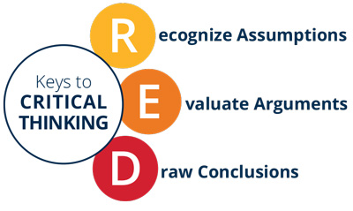
According the Persons critical thinking red model there are three approaches to breakthrough the evidences such as: Recognize assumption, Evaluate Arguments and Draw conclusion.
(PersonTalentLens, 2019)
The author used the model to understand by analysing the evidences and to judge a positive conclusion.
Recognize assumption: To analyse this approach author claimed himself as primary evidence for the successful implementation of management and motivation theory of McGregor and Maslow’s Hierarchy of needs. Author claims, the theories had an effective use within the organisation to motivate and engage the employees to achieve the organisational purpose. As for the secondary evidences author present here the online information’s such as media, local government information and business reviews. (Appendix 1) As for the evidence author refers the references.
Evaluate Arguments: Author took opportunity to evaluate critically the evidences which reflect on a good practice of management and motivation theories behind the success of the organisation and proud for its human assets seen as motivated (Appendix 2) and rewarded for their excellent work performances and identified a positive behavioural relationship within the organisation.
Draw conclusion: Author conclude and put forward the judgement that the management and the motivation theory of McGregor and Maslow’s Hierarchy of needs, identified successfully
implemented within Promenadenhof, Linz. individual’s beliefs, values and attitude meet align with the organisational values and beliefs, Individuals and Organisation both has benefited, together achieved and drew an example of successful organisation.

Findings:
‘’Management is a social process ... the process consists of ...planning, control, coordination and motivation’’ E.F.L Brech (1957)2
Organization is a frame work of management process formed by group of people, a social entity, organising of its people, purpose and structure lead by organisational theory which is purely known as management theory.
(Cole,2004, p.6-7)
Author has recognised that management process known as management theory which enables organisation to set and achieve objectives by planning, organising, controlling organisational recourses and gaining of people's commitment to achieve the organisational goal throughout the human motivation.
Development of management theories:
In the early contributor of management theories such as two greatest Classical and Scientific theorist Henri Fayol (1841-1925) and Frederick Winslow Taylor (1856-1915) their approaches were prescriptive and were set as what managers should to do in order to achieve leadership function within the organisation. Other early social scientist Mayo (1980-1949) and McGregor (1960) known as Human relation theorist, they were concerned about social relation and individual's behavior at work place such as employee motivation, interpersonal communication and leadership style. An early major influence here was Abraham Maslow’s 1950s/60s motivation theory based on hierarchy of human needs contributed achieving organisational effectiveness include other contributors such as Likert, Argyris and Herzberg.
(Cole,2004)
A German sociologist Max-Weber (1864-1920) develop the theory of authority structures which has named as Bureaucracy, the definition of role within a hierarchy. Weber's ideas and theory increasing bureaucracy would lead to increasingly efficient operation has also impact on modern organisation.
(Brooks, 2009)
The author recognized that Henry Mintzberg has argued many management theorists has facets about the management, but they completely forgot the other facets. He attempted to repair the fault and given a composite view of manager and their task about essential managing.
Mintzberg’s (1973) key contributes in his book ‘The Nature of Managerial Work’ where he poses the question “What do managers do?” and he describes the ten “working roles of managers” for the essential managing in the organisation.
(Lamond, 2003)
Author has researched about some of the management theories contributed from the early age to modern time and their practice in the organisation. Author admits the importance and the values of the theories how they are benefiting the organisation and Individuals.

Value of management theory
The value of the management theory is not a single approach to the organisation, management provides all answer, an approach that yield benefits to the managers. A knowledge and understanding of management theories will help awareness and appreciation of all the complexities of a modern work place. Use of management concepts in technical organisation, Flores and Utley suggest that ‘A look back at the theories and principles that have been taught in the past could give an indication of the success of any new approach and help to prepare today’s and tomorrow’s manager for the future’
(Mullins, 2016)
Early theories in Motivation
The author argues that Since the early age and industrial revolution many management theories has been contributed by management theorists which has adopted by many organisation to organise its people, purpose and achieve goal throughout the motivation. In regards the American social scientist such as Abraham Maslow, Douglas McGregor, Frederick Herzberg, Resins Likert, and D. C McClelland introduced different model of motivation theories in the organisation which triggers to human behavior, satisfy and drives to individual and people for the excellent work to achieve organisational goal and which is very much concerned to the management theory adopted by the managers for the essential managing the organisation.
Author as a manager claims, the two theories such as McGregor’s theory X and theory Y and Maslow’s higher-Level needs theories were adopted in the Promenadenhof and had been managed for Sixty-five (65) employees and twelve (12) trainees. Author also claims employees found well-motivated, engaged actively to contributed their full effort at the workplace, individuals pursued themselves for their own development and better performance, team worked together for the common goal and individuals shared new ideas and actively participated to achieve the organisational goal.
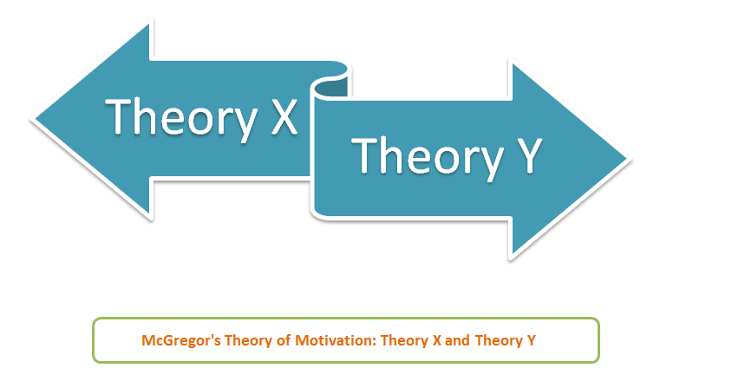
McGregor’s a social psychologist in 1960’s he developed two theory, explained how managers belief and understand what motivates their people and how can they affect in their management style. This two-theory known as theory X and theory Y and very important in today’s workplace.
(Brooks, 2009)

Theory X
While managers have a pessimistic view of their people and assumed that they are unmotivated and they dislike their work, the managers prompt take decision to encourage the team by rewarded or punished constantly to make sure that the job has done right in time. The management assume the workers such as they dislike their work, lac of responsibility and need to guided, controlled, forced to deliver the work, no ambition and need to rewarded to achieve goal.
(Mindtools, 2019)
According to the McGregor theory, Author as an executive manager in the organisation approached theory X with have several tiers of supervisors to oversee and directs the employees. Management authority has rarely delegated where managers and supervisors actively intervened to get the job done. As an executive manager author has adopted the theory X, took responsibility to successfully managing the employees, motivated them to bring back their work ability, improved the performance to achieve the organisational goal.
Theory Y
Managers express a positive opinion about their employees where their workers are very participative, take responsibility and very innovative to this management style. This why a collaborative and trust base relation encouraged between managers and team workers. In this management style workers are happy to do their task in their own initiative, self-motivated, take ownership, involve for decision making, creative, take responsibility, take challenges, solve problems, need a very little direction and shows interest for the further development.
(Mindtools, 2019)
This style of management Author has implemented, participated and enjoyed in his career for many years in the organisation. During the long-time career in the organisation author begun his career as a junior employee in the hospitality department in Promenadenhof, Linz, Austria. During the service time author has devoted his career with active working, participating in new ventures, take initiative, decision making, took responsibilities, took extra load to help each other and maintained and followed the organisational values to achieve the organisational goal. Author expressed to develop himself to bring forward his career and to take the leadership in future in the organisation, thus he succeeded later on, due to the practice of McGregor management theory ‘Y’ was adopted by the organization Promenadenhof, Linz.
Mostly the Theory X and theory Y has been used for a hands off approach in the operation for the better performance and to achieve the organisational goal.
Theory X mostly used for the new employees in the workplace to guide and control them in the crisis, also motivating them high performance towards the organisational objectives. Theory Y has also benefited to those employees also to the lower level in the organization in the Promenadenhof, Linz who involved in decision making and would like to take responsibility such as Author achieved the management position in the organisation for the useful practice of Theory Y.

Use of Maslow’s Hierarchy of needs at Promenadenhof, Linz, Austria.
Other motivation theory of Maslow’s hierarchy of needs has been implemented in the Promenadenhof to satisfy the groups of need of the employees.
Maslow’s human motivation led him a theory of needs based on hierarchy model. In 1950s/1960s, this model made a considerable influence and development in the management theory. Maslow’s hierarchy theory first published in 1954 and most people are motivated by the desire and satisfy by specific group of needs. The needs are;
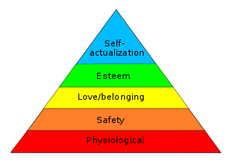
- Phycological needs: needs for food, sleep etc.
- Safety needs: needs for stable environment, free from threats.
- Love needs: needs related to affectionate relation with others
- Esteem needs: needs for self-respect, self esteem
- Self-actualization needs: needs for self-fulfillment.
There are assumption of theory Y, they are closely related to Maslow’s higher-level needs.
(Cole,2004)
In Maslow’s term theory ‘X’ they are motivated only by psychological and security needs.
(Brooks, 2009)
Author in his real-life experience as a manager has implemented Maslow’s human motivation theory in the Promenadenhof mostly for the new and lower level employees who have been motivated by the Physiological and safety needs to fulfilled their desires. On the others hand the individuals perused their personal growth and development, desired to achieve own goals they also satisfied by the growth of needs, had also recognized and rewarded to fulfil the next set of needs as such highest level of desires self-actualizations to satisfy themselves in the Promenadenhof.
Author himself also benefited from Maslow’s human motivation theory in the organization, recognised and rewarded many times for his hardworking, excellent work performance and positive work attitude, he received higher level of training in the management for the development, received incentives and other rewards for the achieving the organisational goal.
Overall Maslow’s human motivation theory had a good impact within the organisation, seen well-motivated employees, had positive work attitude, excellent work performance, had made Promenadenhof successful in business in financially, with a huge turnover of satisfied customers, positive feedback and retained staff.

An example: Promenadenhof and international Culinary festival Linz, Austria 2010.
In 2012 Linz, Austria was selected as a culinary city in Europe, as a leading food industry in the Linz. Promenadenhof, Linz selected as a Hotspot food industry and the Executive Director Robert Seeber was been nominated the Chairman, on behalf of all Hotspots food industry in the culinary city Linz.
(Nachrichten.at, 2011)
Promenadenhof, Linz was recognised for a good practice of management within in the Hotspot food industry and a good practice of motivation theory has also brought the whole team a positive work aptitude, an effort to achieve the goal as such author and his team were also been rewarded for the best work performance in the international culinary festival.
(ÖGZ, 2010)
Beliefs, Values and Attitude
According to Mullins ‘Beliefs are concerned with what is known about the world they are Centre on, what is on reality as it is understood. Values are concerned with what should be and what is desirable and Attitude influences and distinguishes individual behavior is a person’s attitude.’.
(Mullins, 2016 p-131)
The Author argued that beliefs is powerful component of human nature, human brain influence when expectation are high, the facts the workplace culture impact on individual’s behavior. Beliefs drives behavior and behind every decision and action beliefs influence. Beliefs helps brain to categorise the priority of work what to do, good or bad.
Beliefs are non-evaluative and do not determine behavior they only indicate what the hold on the belief is true.
(Rollinson, 2005)
Values are the principles of individuals the wisdom, values have a great impact on behavior. Values influence from the culture, national and geographical and has a big impact on workplace.
Author defines attitude are the holders or individual’s reflection of experience, feeling and evaluation of his understanding on any matter such as the work is interesting or boring. In the other word attitude is a mental process they are the combined effect of beliefs and values and can be seen directly.

Author’s Values, Beliefs and attitude at the work place
Every individual has a different beliefs and Values what they belief in and is mostly desirable. As an employee and manager author had a professional attitude in the workplace. Workplace at Promenadenhof, Linz practiced and driven the McGregor’s management theories which enabled employees and author to perform well to achieve the organisational goal. Valued laid by the author expressed interest to pay an excellent Customer service, maintained a good employee’s relationship, positive attitude, behavior, and communication. Motivation strategies which supported and satisfied the basic and physiological needs for the employees of the new and lower level employees and those who pursued for their further development and to fulfil the highest needs as such leadership position.
Author’s strong ethics such as belief and values (Appendix 3) align with the organisational beliefs and values has driven the author to reflect on, a positive attitude in the workplace, engaged actively for the better performance, good relationship with the management, staff and customers, a continuous success and to achieve the organisational goal.

Values, Beliefs and attitude at Promenadenhof, Linz, Austria.
In Promenedanhof, Linz organisational values has been developed from the employee’s behavioral expectation. Value statement has been produced for the staff members of the organisation. Individuals pursued their behavior align with the Organisational values and belief to achieve the management objectives in Promenedanhof, Linz. According to McGregor’s theory X and theory Y it has been identified by the author that, from an active overview of mangers there was a continuous control of employee’s behavior to meet the management objectives. Using the motivation theories, a huge engagement of employee’s participation has seen towards the achievement of organizational success. Organisation had own beliefs and values, a guide line to achieve its mission and vison.
Katz (1960), categorised the four functions of Attitude for the useful functional approach within the organisation such as adjustment function, ego defense function, value expressive function and knowledge function.
(Rollinson, 2005)
The great attitude from the management of the organisation in Promenadenhof refers quicker conflict solution, personal development program and training, motivating employee rather than punishing, ego-defense action to defend self-image, value expression function where employees had opportunities to take part in decision scion making and knowledge function support to develop them and to create an excellent workplace culture for the employees.

Conclusion
Author concludes and refers that Promenadenhof is a successful organisation and they have achieved their organisational goal in terms of financial and organisational development. They have been recognised by their valued customer and business partners. (East Midlands Airport Travel, 2017) The organisation is successful not only for their excellent rating and feedback but also, they were nominated by the state for their excellent management experience and retained employees. All this was possible as the organisation driven by a strong management and motivation theory of McGregor theory X and theory Y where management and employees both benefited. Organisation maintained a workable culture and employees found attractive work place to work as they were valued by the organisation. A good practice of Maslow’s motivation theory also engaged them for an excellent performance, for their own development towards a continuous success of the organisation. Author as an employee experienced the good management strategies, valued by the organisation and recognised for the hardworking and achievements.
Promenadenhof launched their business 2001 (Appendix 4) and now a days within the food industry they stand in rating top 1 to 10 position in the upper Austria. (Tripadvisor.co.uk, 2019) Presently (Seeber gastro) the prime organization of Promenadenhof, Linz holds two other food operating business in the Upper Austria, Linz. (Horizont-wifi, 2013) due to a good practice of management theories which has driven a continuous development and success for the business.

References:
Plymouth University. (2010). Critical Thinking. [online] Available at: https://www.plymouth.ac.uk/uploads/production/document/path/1/1710/Critical_Thinking.pdf [Accessed 1 May 2019].
PersonTalentLens. (2019). Critical Thinking University TM. [online] Available at: https://talentlens.in/critical-thinking-university-tm [Accessed 1 May 2019].
Cole, G. (2004) Management Theory and Practice. Sixth Edition. London: Thomson.
Brooks, I. (2009) Organisational Behavior. 4th edition. Harlow: Pearson education limited.
Lamond, D. (2003). HENRY MINTZBERG vs HENRI FAYOL: OF LIGHTHOUSES, CUBISTS AND THE EMPEROR’S NEW CLOTHES. The Journal of Applied Management & Entrepreneurship 8(4):5-23, [online] 10(5-6), pp.293-293. Available at: https://www.researchgate.net/publication/235747965_'Henry_Mintzberg_vs_Henri_Fayol_Of_Lighthouses_Cubists_and_the_Emperor's_New_Clothes'/stats [Accessed 27 Mar. 2019].
Mullins. L. J, (2016) Management & Organisational Behavior. Eleventh Edition. Harlow: Person education limited.
Mindtools. (2019). Theory X and Theory Y Understanding People's Motivations. [online] Available at: https://www.mindtools.com/pages/article/newLDR_74.htm [Accessed 28 Apr. 2019].
Brooks, I. (2009) Organisational Behavior. 4th edition. Harlow: Pearson education limited.
Nachrichten.at. (2011). Culinarium Art Festival Linz 2012: 12 Kochstars kommen im Marz. [online] Available at: https://www.nachrichten.at/freizeit/essen_trinken/Culinary-Art-Festival-Linz-2012-12-Kochstars-kommen-im-Maerz;art115,771425 [Accessed 2 May 2019].
ÖGZ. (2010). Spartenpraesidium in Oberösterreich steht fest | Gast. [online] Available at: https://www.gast.at/gast/www.gast.at/gast/www.gast.at/gast/spartenpraesidium-oberoesterreich-steht-fest-87271 [Accessed 2 May 2019].
Rollinson, D. (2005) Organisational behavior and analysis an integrated approach. Third edition. Harlow: Person education Limited.
Horizont-WiFi. (2013). Team | daskonzept | Horizont-WiFi. [online] Available at: http://www.horizont-wifi.at/daskonzept/team [Accessed 2 May 2019].
East Midlands Airport Travel. (2017). Welcome to Linz Package. [online] Available at: https://fly.eastmidlandsairport.com/holiday/welcome-to-linz-package-8423b5d06ef29393a578cf3de800e5eb/overview [Accessed 2 May 2019].
Tripadvisor.co.uk. (2019). Beautiful traditional decor - very good food - Promenadenhof, Linz Traveller Reviews - TripAdvisor. [online] Available at: https://www.tripadvisor.co.uk/ShowUserReviews-g190428-d1319498-r333751883-Promenadenhof-Linz_Upper_Austria.html [Accessed 2 May 2019].

Bibliography:

Mintzberg, H. (1989) Mintzberg on management. London: Collier Macmillan Publisher.
Weightman, J. (1999) Introducing Organisational Behaviour. 1st edition. Harlow: Addison Wesley Longman limited.

Index 1

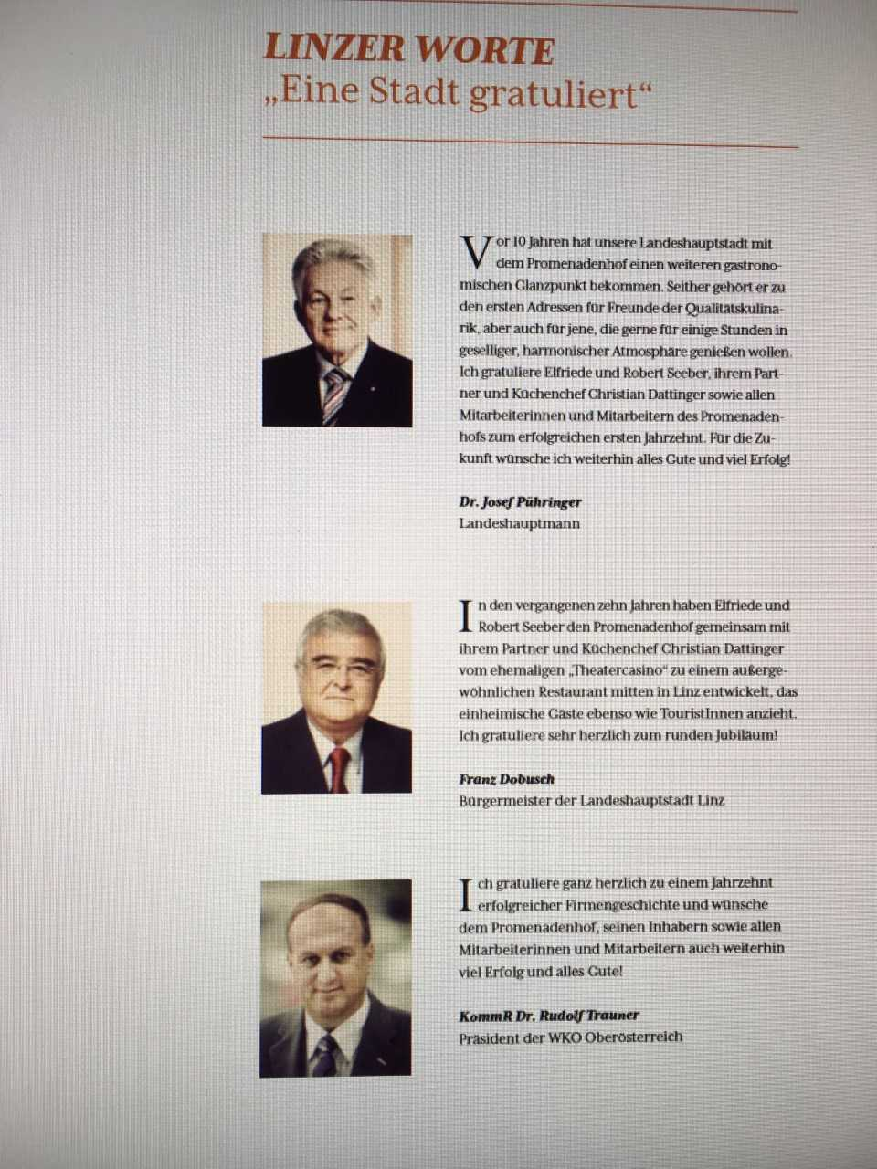

Index 2
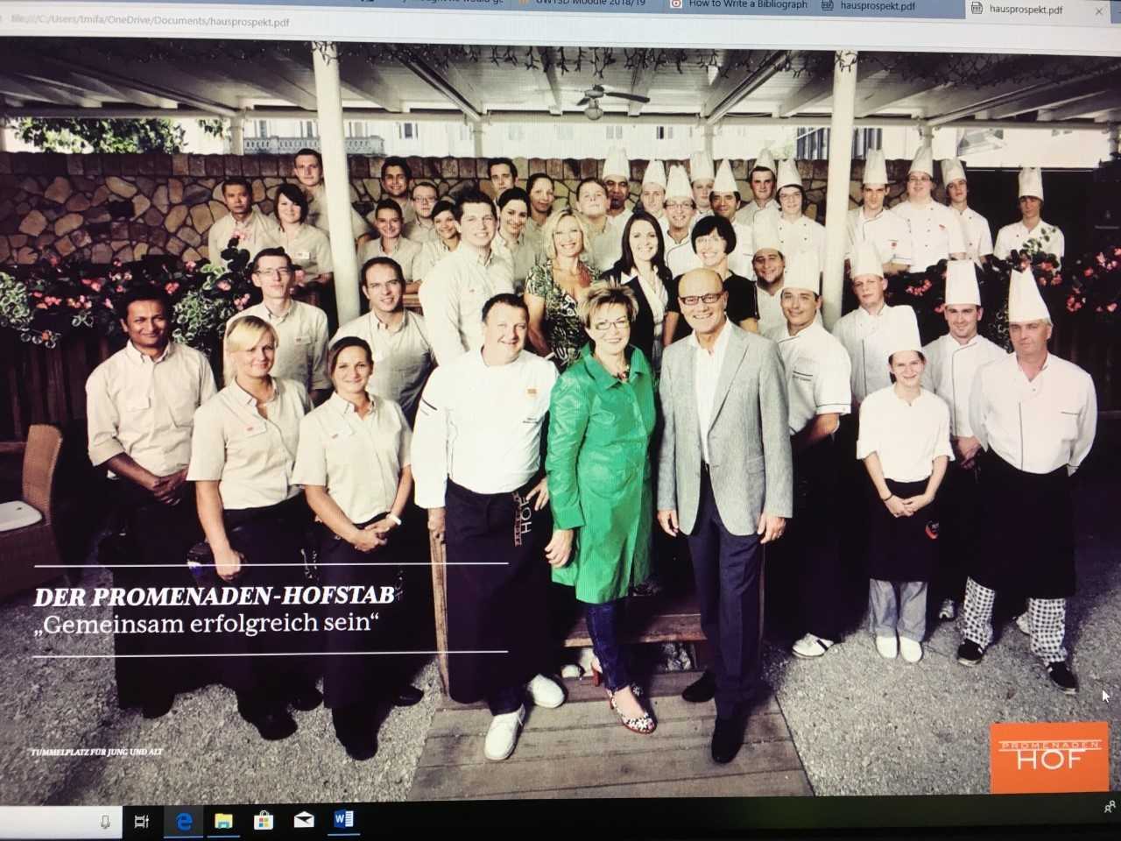

Index 3
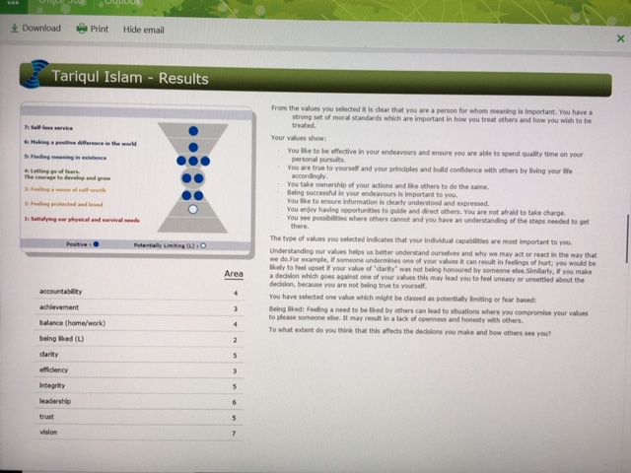

Index 4
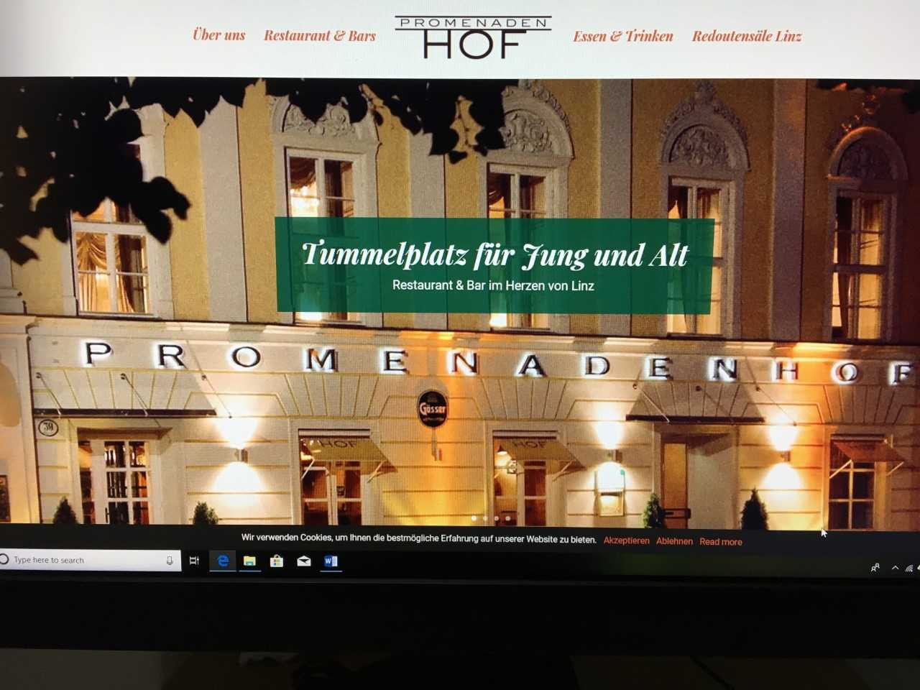
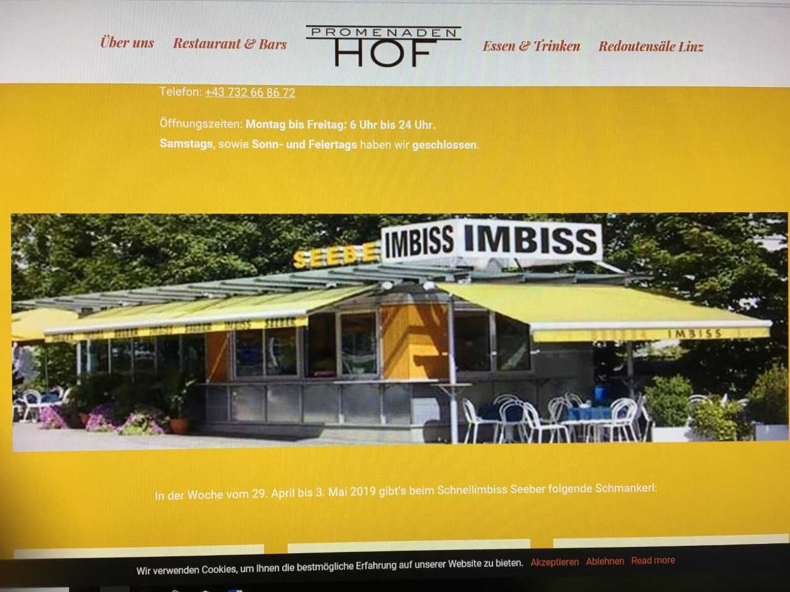


Author Tariqul Islam, BA Leadership and Management, UWTSD, Swansea Business Campus.

