Cover sheet- Sophie Brewer
For this assessment I have submitted the following:
- Component 1- Personal Development Plan

- Component 2- Briefing paper

- Component 3- Written essay

I have not used AI during this assessment.

Component 1- Personal Development Plan
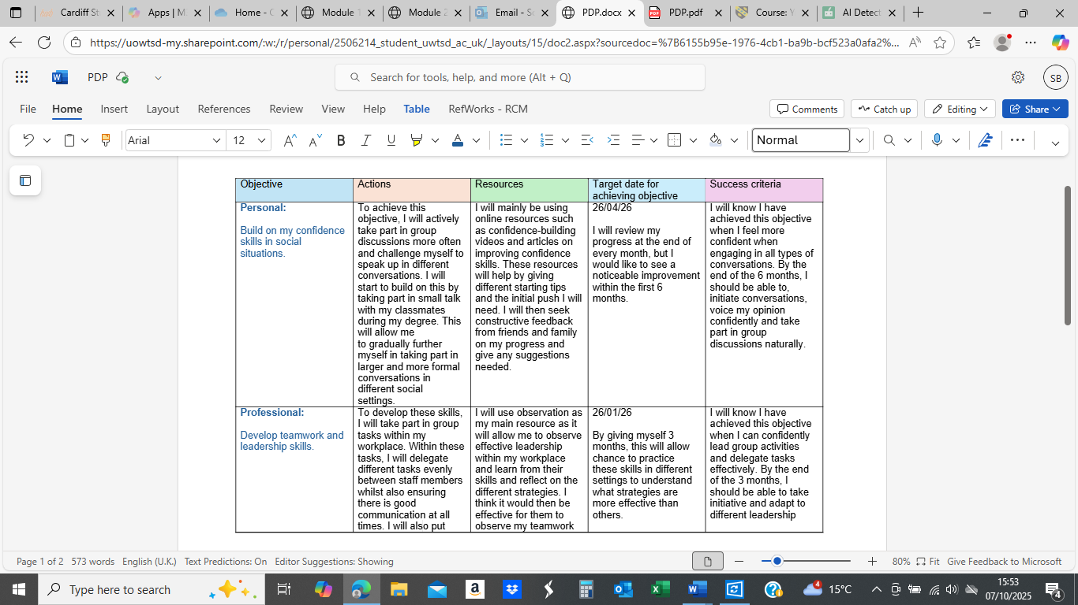
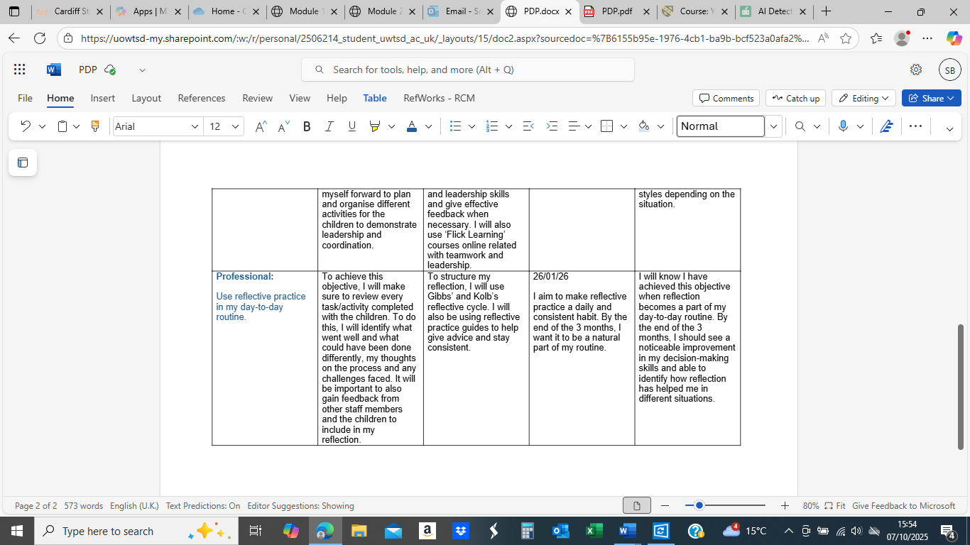

Component 2- Briefing paper
What is reflection and reflective practice?  Reflective practice can have many different meanings, depending on how it is understood. According to Finlay (2008), “For some, reflective practice simply refers to adopting a thinking approach to practice. Others see it as self-indulgent navel gazing. For others still, it involves carefully structured and crafted approaches towards being reflective about one’s experiences in practice.” This shows that reflection means having time to think about a certain experience and ask yourself different questions to improve on it next time. It is important to use reflective practice during a university degree or work, as it can help develop certain skills and allows individuals to learn from past experiences and others. Reflection can also help make connections between theory and practice to improve daily performance and understanding. Overall, reflective practice is about learning from past experiences to become more effective in the daily routines, whilst supporting the need to improve on professional practice and academic studies. It is important to use reflective practice in early years settings as it helps practitioners adapt the approach for the next experience and develop problem-solving skills whilst ensuring they are meeting every child’s individual needs (Finlay,2008). | Why is reflective practise important to EY practice?  Reflective practice is something that is essential in early years, as it helps us as practitioners to improve on our professional practice, which supports the children’s learning and development. This helps us to regularly question ourselves during an experience on what went well and what could be improved. This makes sure we are meeting every child’s individual needs, which then goes on to create a more supportive, inclusive and effective learning environment. According to Toole (2023), “By reflecting on your interactions with children, you can gain a deeper understanding of how children learn and develop. This knowledge can then be used to plan and implement more effective learning experiences.” This is highlighting that reflection allows us as practitioners to identify what has been successful and make any changes needed to improve the children’s learning. Reflective practice also allows us to become more aware of each child’s needs so that we can adapt activities to suit each developmental stage, leading to a more improved outcome for the child. Reflection can also support teamwork within early years as it allows practitioners to have reflective discussions which leads to improved practice and new ideas being made. It also encourages continuous professional development to ensure the best practice and the highest quality of care (Paige-Smith and Craft, 2003).
The theory of reflective practise: The different theories of reflective practice are based on how we think regarding our personal experiences and how we can improve on them during future practice (Smith, 2003). Gibbs and Kolb’s reflective theories suggest that reflection is a structured process designed to help individuals evaluate and analyse their experiences by asking questions such as what went well, what could be improved and how to make this a better learning opportunity in the future. These theories suggest that reflection connects both theory and practice, which allows us as practitioners to develop a deeper understanding of their needs, which leads to better outcomes for the children. The reflective theories encourage practitioners to think critically and helps develop their judgement and confidence on future experiences. By using reflective practice in day-to-day routines, it allows practitioners to identify any improvement needed and adapt the experience for the needs of the children, which is extremely important in early years practice. This connects to Gibbs and Kolb’s theory as it highlights how reflection helps practitioners analyse their experience and connect theory to practice (Susskind and Susskind, 2008).
Gibbs’ model:  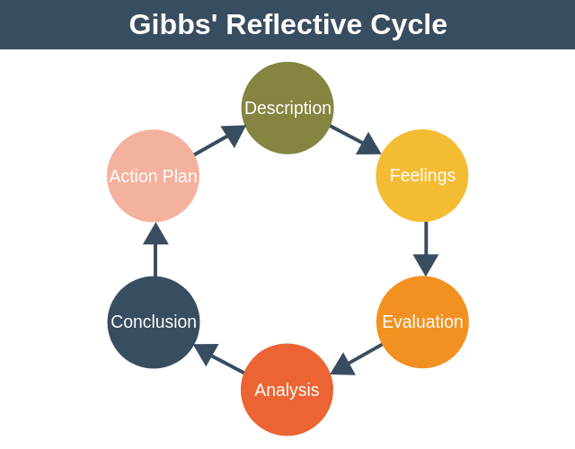(Denis,2020). | Kolb’s model:  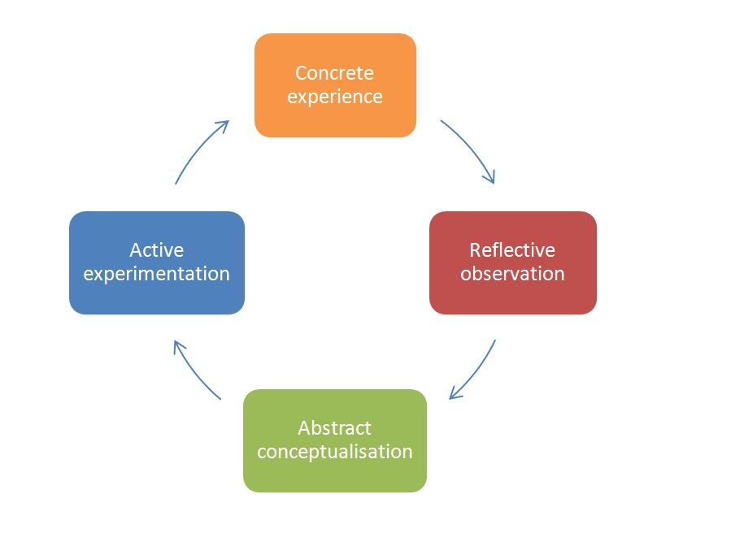(Ginley, 2015).
Analysis of models – compare/contrast/pros/cons: Both Gibbs’ and Kolb’s cycles promote learning through reflection, which supports reflective practice in early years settings, as it allows practitioners to learn from experience to provide better outcomes for the children. However, Gibbs’ reflective cycle provides a more structured approach which encourages us as practitioners to reflect in six stages. He guides practitioners to describe their experience, process their feelings, evaluate and analyse the experience, come to a solid conclusion and develop an action plan for future improvement. (Markkanen et al., 2020). This is extremely helpful in early years, as it can enhance the relationship between practitioners and the children, as we are supporting their individual needs. On the other hand, Kolb’s model focuses learning through four stages – concrete experience, reflective observation, abstract conceptualisation and active experimentation. This encourages practitioners to link theory with practice by applying new ideas in future experiences (Vince, 2022). Overall, both cycles support early years practitioners to develop an emotional and professional understanding of experiences, which leads to more effective practice, while Gibbs’ model is more practical and emotional and Kolb’s is more theoretical and adaptable.
Conclusion: In conclusion, reflective practice is essential in early years education for professional development, as it allows us as practitioners to learn from past experiences and continue to improve on the quality of the practice for the best interest of the children. Structured practice such as Gibbs and Kolb’s cycle also allows practitioners to evaluate and analyse their experience, which leads to a deeper understanding of emotions and helps them make meaningful changes to enhance children’s learning and development. Reflection also helps link theory to practice, as it makes sure practitioners are meeting each child’s stages of development and individual needs. Overall, reflective practice encourages ongoing learning which leads to a more inclusive and supportive environment for the children.

Reference list
- Denis, G. (2020). Gibbs’ Reflective Cycle. [online] Expert Program Management. Available at: https://expertprogrammanagement.com/2019/05/gibbs-reflective-cycle/ [Accessed on 14/10/2025].
- Finlay, L. (2008). Reflecting on ‘Reflective Practice’ [online]. Available at: https://oro.open.ac.uk/68945/1/Finlay-(2008)-Reflecting-on-reflective-practice-PBPL-paper-52.pdf. [Accessed on 08/10/2025].
- Ginley, M. (2015). Reflective Model According to Kolb - Dr Nicole Brown. [online] Pinterest. Available at: https://uk.pinterest.com/pin/187814246944414509/ [Accessed on 14/10/2025].
- Markkanen, P., Välimäki, M., Anttila, M. and Kuuskorpi, M. (2020). A Reflective cycle: Understanding Challenging Situations in a School Setting. Educational Research, 62(1), pp.46–62. Available at: Full article: A reflective cycle: Understanding challenging situations in a school setting. Accessed on [16/10/2025].
- Paige-Smith, A. and Craft, A. (2011). Developing Reflective Practice in the Early Years. [online] Google Books. Available at: https://books.google.co.uk/books hl=en&lr=&id=RShFBgAAQBAJ&oi=fnd&pg=PP1&dq=why+is+reflective+practice+important+to+early+years+practice&ots=4lhQyR164S&sig=xD3OOCcdREK4_uqyJ5QQdFtMQfo&redir_esc=y#v=onepage&q=why%20is%20reflective%20practice%20important%20to%20early%20years%20practice&f=false [Accessed on 13/10/2025].
- Smith, T. (2003). CONNECTING THEORY AND REFLECTIVE PRACTICE THROUGH THE USE OF PERSONAL THEORIES. [online] Available at: https://files.eric.ed.gov/fulltext/ED501125.pdf [Accessed on 14/10/2025].
- Susskind, N. and Susskind, L. (2008). Connecting Theory and Practice. Negotiation Journal, 24(2), pp.201–209. Available at: Connecting Theory and Practice | Negotiation Journal | MIT Press. [Accessed on 24/10/2025].
- Toole, L. (2023). The Importance of Reflective Practice in Early Years. [online] Showcase Training Ltd. Available at: https://showcasetraining.co.uk/2023/12/06/the-importance-of-reflective-practice-in-early-years/. [Accessed on 13/10/2025].
- Vince, R. (2022). Reflections on ‘Behind and Beyond Kolb’s Learning Cycle’. Journal of Management Education, [online] 46(6), pp.983–989. Available at: Reflections on “Behind and Beyond Kolb’s Learning Cycle” - Russ Vince, 2022. Accessed on [16/10/2025].

Component 3- Written essay
In early years, professional practice means ensuring you are showing commitment and responsibility daily by respecting the children, families and colleagues you work with. Professional practice can also include looking for ways to improve by reflecting on experiences/activities and ensuring you are behaving in the correct manner (Green, 2019). The role of a professional includes providing children with a safe and stimulating environment where they can learn and develop, a professional should also be aware of their role and ensure they are following the standards and policies of the setting. As a professional, you should always act in the best interest of the children by maintaining confidentiality and communicating on a day-to-day basis with your co-workers and the parents (Green, 2019). In early years, a professional will also have to understand each child’s development, become a role model and support inclusion and diversity to ensure each child reaches their full potential (Castle, 2009).
“Values shape the direction of the profession, and in many ways members of the general public evaluate the profession if the practitioners adhere strongly to the values that they cherish.” (Andras, 2025). This highlights that values play an essential role in professional practice, and values such as respect, empathy, inclusion and kindness are important when becoming a professional practitioner, as they guide them when interacting with others. Having such values allows practitioners to build strong relationships with their children, families and colleagues to ensure they feel safe and supported (Andras, 2025).
“The Professional Practice Model utilizing relationship-base care was well developed, disseminated and enculturated at an exemplary level.” (Johnson and Ezekielian, 2014). This is stating that building a strong relationship and communicating effectively in professional practice is important, as it creates a supportive and safe environment for the children. By creating this safe space, it allows the children to build on their confidence and can help them to feel valued, which supports every aspect of their development. This can also influence families and colleagues, as it allows everyone to work closely as a team with the child’s best interest at heart (Johnson and Ezekielian, 2014). Overall, strong communication and healthy relationships are the most important things in professional practice because they form the foundation for everything else around them. It helps children feel safe and supported and builds trust between them and the practitioner, which promotes more positive learning experiences and better outcomes (Johnson and Ezekielian, 2014).
Having an in-depth knowledge and understanding when in professional practice is essential because it ensures practitioners are carrying out their roles safely and efficiently whilst reaching high-quality standards of care (RCGP, 2024). It allows practitioners to identify and respond to abuse and neglect effectively by recognising any signs of physical, emotional or sexual abuse. Once a professional judgement is made, practitioners must then know how to respond appropriately by following their setting’s policies to make sure everyone involved remains safe (Welsh Government, 2022). Another thing practitioners must do that requires a deep understanding is report any safeguarding concerns, as it is key that the report is clear, factual and includes any required evidence. Additionally, professionals also must understand that sharing information with relevant multi-agencies allows organisations, such as social services, health boards or the police, to work together to ensure the child’s safety (RCGP, 2024). Having a wide range of knowledge and understanding also ensures that practitioners are improving on the quality of care by remaining child focused. This increases trust and allows them to meet their individual needs. It also helps reduce any future risks, as practitioners can identify any concerns early on and put in measures that prevent any cases from developing into a more serious matter (Care Learning, 2024). Overall, having a deep understanding of professional practice is extremely important, as it plays a vital role in all areas of safeguarding.
Partnership and multi-agency working are important in professional practice, as they ensure the most effective, reliable and highest level of care. Working in partnership and through multi-agencies can lead to more improved results, through working effectively as a team to solve the problem together. When the different sectors come together, they can take a more holistic approach which enables them to address every issue from all angles, which will increase their understanding of the matter, leading to a faster referral (Atkinson, Jones and Lamont, 2007). Multi-agency working has also been proven to have a positive effect on professional practice, with research showing "improved access to services, through speedier and more appropriate referral, and a greater focus on prevention and early intervention.” (Atkinson, Jones and Lamont, 2007). This explains that partnership is effective, as it allows professionals to prioritise early intervention to prevent any issues worsening, which ensures high-quality safeguarding.
Observations and planning cycles are crucial in early years, as they inform professional practice about their stage of development and the children's progress. It also allows practitioners to get to know the children and understand them on a deeper level. According to Brodie (2025), “Without knowing your children, understanding their interests and existing knowledge, you cannot plan meaningful, challenging and exciting activities for them.” This emphasises how important it is for practitioners to spend time engaging with the children to gain a deeper understanding of their development, which leads to a more effective learning environment for the children to develop new skills. It also allows practitioners to be responsive to the child and take a child-centred approach. The only way for practitioners to do this is to spend valuable time observing the child in different environments, as each child can behave differently outdoors or indoors and can be developing differently in each area (Brodie, 2025). Through observation, practitioners can understand the child’s interests, stages of development and their preferences, which allows practitioners to make suitable activities and use suitable resources for each individual child depending on their stages. Observation and planning cycles can also be extremely important when it comes to identifying children with special educational needs. For many children, additional needs only become noticeable when they start to develop, and practitioners will be able to notice things such as specific patterns, delays, speech and language struggles or social interaction. Observations are then a good way to provide valuable evidence which supports early intervention to ensure each child gets the help they need (Jones, 2025). Therefore, observations and planning cycles are essential in professional practice, as they allow practitioners to adapt to each child's individual needs, seek additional support if needed and plan activities/experiences to ensure each child reaches their full potential.
The principles of the United Nations Convention on the Rights of the Child inform professional practice by ensuring that each individual child has the right to be heard, the right to an education and the right to be at the heart of each practice (Lansdown, 2014). The UNCRC consists of 4 principles, which include “non-discrimination, the best interest of the child, the right to life, survival and development and the right to be heard” (UNICEF, 2022). By having these principles in place, it ensures that practitioners can value each child and support their holistic wellbeing and development. These principles ensure practitioners are actively listening to each child, giving them the opportunity to make their own decisions about their learning and allowing them to express themselves in their own unique way. It also ensures that every environment is inclusive for all the children, no matter their ability, background, ethnicity or circumstances, as this ensures that each practice has the child’s best interests at heart. Having these principles in place in professional practice is very important, as it ensures that everyone is focusing on a child-centred approach, which ultimately makes sure that every decision that is made within a practice is made with the rights of a child as the focus. This will lead to practitioners building healthy and trusting relationships with the children and their families, which will encourage each child’s confidence and development to grow within each setting. Overall, these principles make sure that each child is protected and cared for.
To conclude, professional practice is guided by many different things, such as reflective observation, planning and ensuring children’s rights and wellbeing are being cared for. By creating observations for each child, it allows practitioners to understand their development, and they will then be able to identify any needs early and plan activities/experiences depending on their development to promote inclusion. Partnership and multi-agency working make sure that every child has the appropriate support if needed, ensure their safety and enhance their learning opportunities. Lastly, the UNCRC principles ensure that children are valued and respected and that their interest to is the centre of every decision. If a practitioner pulls together every approach, it creates a safe and inclusive environment so that every child can reach their full potential and develop successfully.
Reference list
- Andras, M. (2025). PROFESSIONAL VALUES, ETHICS, AND PROFESSIONALISM OF PUBLIC RELATIONS PRACTITIONERS. [online] Hcommons.org. Available at: https://works.hcommons.org/records/85d2a-dh979/files/professional-values-ethics-and-professionalism-of-public-relations-practitioners.pdf [Accessed on 20/10/2025].
- Atkinson, M., Jones, M. and Lamont, E. (2007). A Review of the Literature Multi-agency Working and its Implications for Practice: Contents Contents 2. [online] Available at: https://www.nfer.ac.uk/media/qy5hccud/mad01.pdf. [Accessed on 23/10/2025].
- Brodie, K. (2025). Observation, Assessment and Planning in The Early Years - Bringing It All Together. [online] Google Books. Available at: https://books.google.co.uk/books?hl=en&lr=&id=bDLrW8TkFgoC&oi=fnd&pg=PR3&dq=How+does+the+observation+and+planning+cycle+inform+professional+practice+and+ensure+practitioners+are+meeting+the+needs+of+children%3F&ots=6cHIV6Ub1d&sig=ANl32uPhbk2KUzZauYqhevkdDqc&redir_esc=y#v=onepage&q&f=false [Accessed on 23/10/2025].
- Care Learning (2024). 1.1 Justify the Importance of Continually Improving Own Knowledge and Practice and That of the Team - Care Learning. [online] Care Learning. Available at: https://carelearning.org.uk/qualifications/level-3-diploma-care/unit-141/1-1-justify-the-importance-of-continually-improving-own-knowledge-and-practice-and-that-of-the-team/#google_vignette. [Accessed on 23/10/2025].
- Castle, K. (2009). Number 3 DIMENSIONS OF EARLY CHILDHOOD Fall. What Do Early Childhood Professionals Do? [online] 37(3). Available at: https://static.virtuallabschool.org/activities/professionalism/FC.Prof_4.Nurturing_E1.DimensionsEarlyChildhoodCastle.pdf. [Accessed on 24/10/2025].
- Green, B. (2019). Understanding and Researching Professional Practice. [online] Google Books. Available at: https://books.google.co.uk/books?hl=en&lr=&id=Jsz7EAAAQBAJ&oi=fnd&pg=PP3&dq=what+is+professional+practice&ots=8MYE5e7xWc&sig=9xlGZVx5xox-O8DHs-ObxG8Rjp4&redir_esc=y#v=onepage&q=what%20is%20professional%20practice&f=false [Accessed on 20/10/2025].
- Johnson, L. and Ezekielian, J. (2014). Use of a Professional Practice Model to Illuminate the Importance of Relationships. Creative Nursing, 20(2), pp.127–136. Available at: Use of a Professional Practice Model to Illuminate the Importance of Relationships - Linda Johnson, Jamie Ezekielian, 2014 [Accessed on 20/10/2025].
- Jones, C. (2025). Supporting Inclusion in the Early Years. [online] Google Books. Available at: https://books.google.co.uk/books?hl=en&lr=&id=IdLQwPdTpZ8C&oi=fnd&pg=PP1&dq=observing+sen+children+in+early+years&ots=O2ORCCfiqX&sig=shUgxnvlwoS9mR9c4KUDQUgMh5E&redir_esc=y#v=onepage&q=observing%20sen%20children%20in%20early%20years&f=false [Accessed 23/10/2025].
- Lansdown, G. (2014). 25 years of UNCRC: Lessons Learned in Children’s Participation. [online] UNCRC. Available at: https://ojs.library.carleton.ca/index.php/cjcr/article/view/12/3 [Accessed on 23/10/2025].
- RCGP (2024). Summary of safeguarding Standards and Capabilities. [online] Rcgp.org.uk. Available at: https://www.rcgp.org.uk/learning-resources/safeguarding-standards-knowledge-capabilities. [Accessed on 23/10/2025].
- UNICEF (2022). UN convention on the rights of the child (UNCRC). [online] unicef. Available at: https://www.unicef.org.uk/what-we-do/un-convention-child-rights/. [Accessed on 23/10/2025].
- Welsh Government (2022). Keeping Learners Safe. [online] Available at: https://www.gov.wales/sites/default/files/publications/2022-04/220401-keeping-learners-safe.pdf. [Accessed on 23/10/2025].

