Describe and assess soil remediation techniques
Sergio Garate - M2X8740
Ioan Chidgey - 150837
2017

Content page

Introduction………………………………………………………….. Page 2

Soil remediation………………………………………………….… Page 3

In-situ methods…………………………………………………………………..…. Page 3 & 4

Bioventing

- Description

- Advantages and Disadvantages

Phytoremediation

– Description

- Advantages and Disadvantages

Ex-situ techniques....................................................................... Page 5 & 6

Thermal Desorption treatment

- Description

- Advantages and Disadvantages

Land farming (biological treatment)

- Description

- Advantages and Disadvantages

Conclusion……………………………………………………….…… Page 7

In-situ methods

Ex-situ methods

Bibliography…………………………………………………..….…. Page 8

1 Introduction
Environmental remediation is the process that consists of the removal of pollution and/or contaminants that can be harmful to the natural environment within such things as; groundwarters, sediment, soils and surfacewater. This pollution to soil can harm each aspect of the environment and cause harmful effects upon the ecosystem.
This form of land degradation is correlated to both man-made toxic waste and natural occurrence of materials such as heavy metals. Chemical such as pesticides and herbicides, along with waste water occurring through industrialisation are the most common factors that contribute to this high danger level of contaminated soil.
Humans, plants and animals as well as the soil itself is put at risk through containing these harmful contaminants. For example; Animals that graze from polluted soils can fall ill and become diseased. The problems do not stop there where if humans then eat from products grown in this soil or the animals themselves, they can become ill and develop irreversible conditions and lifelong damage which could result in death (everythingconnects.org, 2013).
There are many different techniques in order to remediate soil. Those of which fall below either an in-situ, this is where the soil is treated at site of a contaminated soil, or ex-situ where the soil is unearthed and taken to an outside source in order to treat. This report will cover several different types of soil remediation techniques under these two methods, giving a description and discuss the advantages and disadvantages of each individual ones as well as ex-situ and in-situ methods as a whole. Some of these techniques include the following;
-Thermal desorption
-Phytoremediation
-Excavation or dredging
-Landfarming
-Surfactant enhanced aquifer remediation (SEAR)
-Pump and treat
-Solidification and stabilization
-In situ oxidation
-Bioventing
-Soil vapour extraction
-Nanoremediation

And many more.

2 Soil remediation techniques

2.1 In-situ methods

2.1.1 Bioventing

2.1.1.1 - Description
The ultimate goal in Bioventing is to achieve microbial transformation of pollutants to a harmless state by adding nutrients and moisture to enhance bioremediation (Philp and Atlas 2005). This aerobic processes uses bacteria that require the reaction of oxygen to break down the contaminants and pollutions within waste waters. These plants inject controlled amounts of airflow via a compressed to work within the contaminated water where the aerobic microbes can react, reproducing and eliminate waste within the polluted water. Masse of solid waste that the microbes are unable to degrade or remove settles into sludge form. In order to continue this process successfully the newly formed sludge will have to be removed by a system of pumps. This will reduce the risk of clogging and give the ability to continue with the process until the soil has been rid of all contaminants.
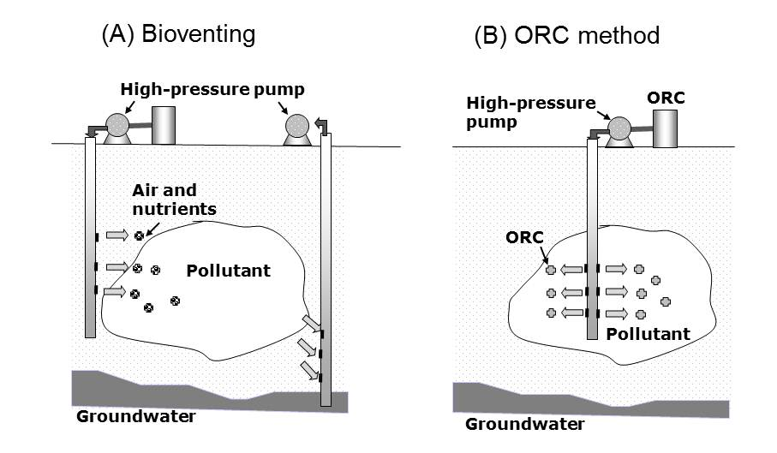
Image 2.
The Bioventing technique or remediation.
(Naofumi Shiomi, “Bioremediation Method for Shallow Layers of Soil Polluted by Pesticides”, 2013)

2.1.1.2 - Advantages and disadvantages

The use of aerobic methods such as this is frequently used when the water table is too high for effective septic system use. This often occurs in rural or small community areas where other forms of central sewage systems would bare more cost and the implementation of such would from impractical.
This form of bioremediation with the use of aerobic treatment units are more expensive to operate than septic systems. This is due to the constant use, professional inspection and maintenance needed for this method of remediation. Factors such as the constant need to empty units in order to avoid blockages singlehandedly show the expense that this method uphold. More equipment, staff, and time put into this particular technique.

2.1.2 Phytoremediation

2.1.2.1 - Description
The phytoremediation process is the use of plants to mitigate, stabilise, or remove the toxic effect of both organic and inorganic pollutants from ground and surfacewater. This is where plants are deposited into the ground and mainly inorganic substances and meals including; cadmium, zinc and copper, are absorbed through the roots of the plant and held within the roots, stems, and leaves. The phytoremediation technique can fall under both in-situ and ex-situ methods in order to deal with close sureface metals as well as though that accumulate deeper down. However, the main use of this method is in-situ due to the close sureface contaminants such as metals on road sides. These trees can then be planted can be planted road side to help reduce the pollution from where people commute through frequently.
There are over 400 species of trees and plans that are seen as suitable to use in the form of remediation. Each species hold different values and each absorb different contaminants at various amounts. Through a site investigation it is possible to choose an appropriate plant in order to deal with the present contaminants to coincide with the proposed site.
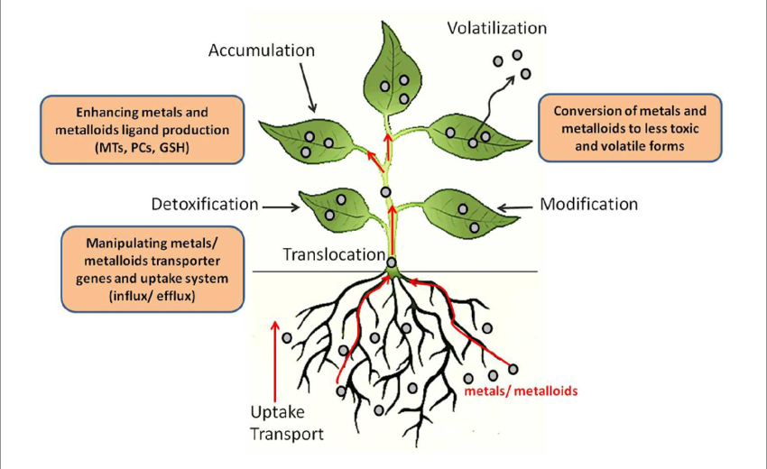
Image 1.
Figure show the process of metal/metalloids being absorbed from by a plant. (Potential Biotechnological Strategies for the Cleanup of Heavy Metals and Metalloids, 2016)

2.1.2.2 - Advantages and Disadvantages
The advantages of this remediation technique is that it offers a wide range of support throughout the lifecycle of the project. The method cost a considerable amount less than other techniques but also provides a protected barrier to the polluted area and things such as aesthetic values once the project is complete. The only problem with this technique process, although the use of organic materials that serve other purposes alongside this remediation of contaminants, the timescale of this remediation can prove strenuous. For example; if the site is intended to be a park of some sort, the site should not be open to the public until the remediation process is complete or complete enough to allow safe passage of use without causing harm to the users. Although this technique proves more valuable than others due to its use in low or moderately contaminated sites, the timescale is the still a problematic factor. Therefore on projects such as this maybe other forms of techniques would be better suited for the site, or used in conjugation with other methods. Again, this is dependent on the timescale of the opening for public use.

2.2 Ex-situ techniques

2.2.1 Thermal Desorption treatment

2.2.1.1 - Description
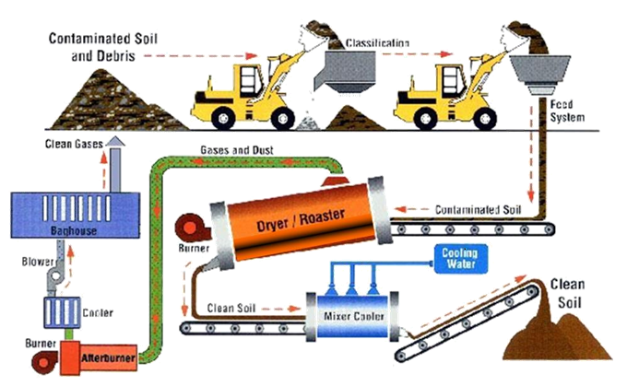
Thermal desorption is an ex-situ technique that remediates low or moderately distillate organic soil compounds, such as petroleum and specially nitrated compounds using high temperatures. Through the course of the remediation process the soil goes through a number of different chambers of the plant being heated and cooled in separate parts to ensure complete success in the process and to then have the ability to dispose of the contaminants safely. These temperatures are range between 100 - 900ºc throughout the complete process. Through separating the contaminants and the soil then putting through an oxidiser. This elevation of heat once in the oxidiser permanently destroy the contaminants and they can then be disperse in controlled admissions. Throughout the course of the pre-proses treatment the soil with slowly get separated from particle through hand sorted, size filtering, a cleaning magnet and through heat. Once the pre-proses is complete the soil with be loaded into the thermal treatment system, where the soil is recycling process begins. The main component of the thermal treatment system is the rotary dryer drum. This is where the soil gets lifted and dropped through the hot gas. This cause the lower boiling point of the sediment to turn into vapour. The mollified contaminants are them streamed through to the thermal oxidiser where hydrocarbons are reduced to carbon dioxide is and water.
Picture 3.
The thermal desorption carbonization process plant

2.2.1.2 - Advantages and Disadvantages
This system is capable to up to 99.99% destruction of contaminates and meets the requirement for a vast array of sites. This method provides this at a range of different temperatures. This method of remediation is effective and efficient. Along with the correct site and soil investigation and target treatment % the project can be very successful. Depending on what use the soil have when returned depends on the success % needed for the final recycled product. In cases where the success % is not high enough could mean a costly job of re-treating the soil again before being able for use. In cases where the use of lower temperature thermal treatment, it was found to be the most effective and commercially attractive solution for field application in a South West England. A case study of a 20 ha telecommunications manufacturing facility contaminated with Aroclor 1254 (up to 1300 mg kg− 1) (Norris et al., 1999). Experiments showed that thermal desorption resulted in 48–70% decomposition of PCB in sediments, but on the other hand lead to unwanted formation of dibenzofurans (Sato et al., 2010). These dioxins still pose a threat to a site and in the event that they are put back without being treated correctly or to the degree of treatment needed they could further contaminate the soil that has just been treated.

2.2.2 Land farming (biological treatment)

2.2.2.1 - Description
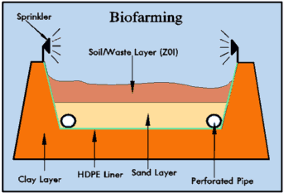
Landfarming is an ex-situ bioremediation technique that excavates contaminated soil from the site and is taken elsewhere to be treated, relayed and then returned to the original site. The development into landfarming began as a way for gas and oil companies to manage by-products of drilling explorations. It has been developed to incorporate the drill waste of these explorations back into the ground safely once treated. The waste and contaminated soil are taken from the production station to a landfarm where topsoil would have been pre-excavated and stockpiled ready to relay once the settlement has placed there. This is where the sediment is diluted with soil amendments and spread across the large excavated area. At first an element of atmospheric degradation is implemented for a short while causing the clays to dry up and crack on the surface. The sediment is then worked into the soil and the underlying sands creating moisture retention in the upper layers of the soil to help establish a deeper organic zone. The topsoil is then replaced back over the top of the mix of drilled soil and sand. On large scale landfarming projects the rehabilitation investigation of the soil is ongoing until the contamination is treated well enough in order to re-deposit to its original site. However, on smaller projects if there is only very thin layer spread and is left, atmospheric degradation takes place where the wind and sun treat the soil and cause the hydro carbons to break down more rapidly. Sometimes this is enough to treatment for the soil and is classed as in-situ bioremediation.
Image 4.
Figure showing the different layers incorporated within the landfarming technique

2.2.2.2 - Advantages and Disadvantages
A massive advantage to this form of bioremediation is that it does not an extensive amount of preliminary assessments of the contaminated site before the remediation process begins. This is due to the depth of which the soil is excavated from, and the state of the pollution or contaminant in correlate to the depth in which the soil has been excavated. This can controlled easily to optimise different processes to determine variables (pH, temperature, and vitiating mixture) that affect this and in turn enhances the bioremediation process effectively. Thus making the initial stage cost less by shortening it, needing to implement less labour.
Landfarming is the simplest of all ex-situ bioremediation techniques, however the limitations that coincide with the method sees that its use is not so extensive. The fundemental drawbacks of landfarming are obvious to see. That being the need for a large space of operation to farm the soil, the reduced efficiency in inorganic pollutant removal, and of course the additional cost to the project due to the excavation process. (Khan et al. 2004; Maila and Colete 2004). In addition this technique is not suitable for deal with soils with toxic volatile pollutants. This is due to process of pollutant removal this method is designed to treat with limitations when stood with certain weathering constraints, such as in tropical climates. Therefore, in comparison to other ex-situ bioremediation techniques, landfarming isn’t as efficient or cost affective and more time consuming. Making other methods a more liable choice.

3 Conclusion
The above report acknowledges two techniques under both in-situ and ex-situ bioremediation methods. The matter of choosing the right method of treatment to the soil can sometimes prove to be tricky. Mostly this will lie on the type of soil, funding of the project and the convenience of incorporating the chosen technique within the project.

3.1 In-situ methods
The advantages of using an in-situ technique is that all the work is done on the sight and any work that is done won’t affect the site in a negative manor. This mean that the site remains clean, and operational. Most of these methods are very simple and all account for exposure of free contaminants in the air, such as dust particles etc. Also, due to all works being carried out on site, which mean there isn’t need to excavate the soil in order to transport it from site to be treated. This ultimately leads to the reduction of expense and possible obtaining more time to the project is considerably less in comparison to some of the ex-situ bioremediation techniques.
The most effective in-situ methods of bioremediation are those of the aerobic procedures such as Bioventing or Biosparging. These methods see that the remediation of the proposed sites are dealt with efficiently and effectively, controlling any waste as it arises. The only problems with these types of bioremediation is that of the soil consistency. In such an event that a silt soil is present another technique, such as the thermal desorption, could prove a better fitting method. Another is the cost of the lifecycle from start of the implementation of the plants to the running work-life. The maintenance of the facilities during the lifecycle or the plan can prove costly by the supervision and expertise needed to run, maintain and inspect the plant on a regular while in use.

3.2 Ex-situ methods
Ex-situ techniques to remediate waste and contaminates originally consisted of simply excavating the polluted soil to an external site in order of the removal of the contaminates. Moving on from the less environmentally conscious methods of simply just excavating, technology has developed alternative ways to treat polluted soils. Although this technique for decontamination requires the removal of soil prior to the treatment, it can be faster, easier to control and usually more able to treat a wider range of toxins and soils. This is due to the more extensive look that we have into the soil after the excavation while the process of the plants the soil gets put through. Selected bioremediation techniques also have the ability to treat most if not all contaminants within certain polluted soils. For example the 99.99% destruction of contaminates within the thermal desorption treatment method.
Due to ex-situ methods of bioremediation requiring the need of excavation and transporting from site in order to be treat the contaminated soil correctly and effectively, the initial cost of the project will always start considerably higher than in-situ methods. Because of this them, more often than not, the ex-situ methods don’t come as first point of call. Instead the in-situ methods will be the first method people will look to if possible. Simply because of the cost and the simplicity that it brings to certain projects.

4 Bibliography
Agency), S. (. E. P., no date. Land remediation and waste management guideline. [Online]
Available at: https://www.sepa.org.uk/media/28317/land-remediation-and-waste-management-guidelines.pdf
Anon., 2013. Soil pollution. [Online]
Available at: http://www.everythingconnects.org/soil-pollution.html
Anon., 2017. [Online]
Available at: https://en.wikipedia.org/wiki/Polychlorinated_dibenzodioxins
Bioremediation, no date. In-Situ and Ex-Situ Bioremediation. [Online]
Available at: http://bioremediationstudy.tripod.com/id8.html
bioremediationsoil, no date. Ex Situ Bioremediation of Soil. [Online]
Available at: https://bioremediationofcontaminatedsoil.wordpress.com/2014/02/07/ex-situ-bioremediation-of-soil/
Christopher Chibueze Azubuike, C. B. C. a. G. C. O., 2016. Bioremediation techniques–classification based on site of application: principles, advantages, limitations and prospects. [Online]
Available at: https://www.ncbi.nlm.nih.gov/pmc/articles/PMC5026719/
Health, I. J. o. E. R. a. P., 2010. Health Risk-Based Assessment and Management of Heavy Metals-Contaminated Soil Sites in Taiwan International Journal of Environmental Researc. [Online]
Available at: https://search-proquest.com.ezproxy.uwtsd.ac.uk/docview/763404106?accountid=130472&rfr_id=info%3Axri%2Fsid%3Aprimo
Helena I. Gomes, C. D.-F. A. B. R., 2013. Overview of in situ and ex situ remediation technologies for PCB-contaminated soils and sediments and obstacles for full-scale application. [Online]
Available at: http://www.sciencedirect.com/science/article/pii/S0048969712015318#bb0975
Kareem A Mosa, I. S. K. K. O. P. D., 2016. Potential Biotechnological Strategies for the Cleanup of Heavy Metals and Metalloids. [Online]
Available at: https://www.researchgate.net/figure/298258246_fig1_FIGURE-2-Potential-biotechnological-strategies-for-phytoremediation-Toxic-elements-can
Laitinen, J., 2006. in-situ and groundwater bioremediation techniques and applications. [Online]
Available at: https://www.theseus.fi/bitstream/handle/10024/8455/TMP.objres.427.pdf
MarkTemple, C. a., 2006. Health impact assessment and community involvement in land remediation decisions. [Online]
Available at: https://www.sciencedirect.com/science/article/pii/S003335060600134X
MichaelGadd, M. G. M. a. G., n.d. Aerobic and anaerobic biosynthesis of nano-selenium for remediation of mercury contaminated soil. [Online]
Available at: https://www.sciencedirect.com/science/article/pii/S0045653516317301
Olson, N., 2010. Thermal Desorption of Contaminated Soil - ESMI Companies. [Online]
Available at: https://www.youtube.com/watch?v=33WCkfQw2l0
She-Jiang Liu, Z.-Y. Z. J. L. a. J. W., 2013. An anaerobic two-layer permeable reactive biobarrier for the remediation of nitrate-contaminated groundwater. [Online]
Available at: https://www.sciencedirect.com/science/article/pii/S0043135413005198
Team, G. E., 2015. Aerobic vs. Anaerobic Wastewater Treatment. [Online]
Available at: https://greentumble.com/aerobic-vs-anaerobic-wastewater-treatment/
YuKai Energy Technology Co., L., no date . [Online]
Available at: http://www.shyukai.com.cn/EN/en_product/chanpin01/127.html

