THE ROLE OF HR MANAGERS AND FACILITATING POSITIVE EMPLOYEE RELATIONSHIPS
A CRITICAL ANALYSIS
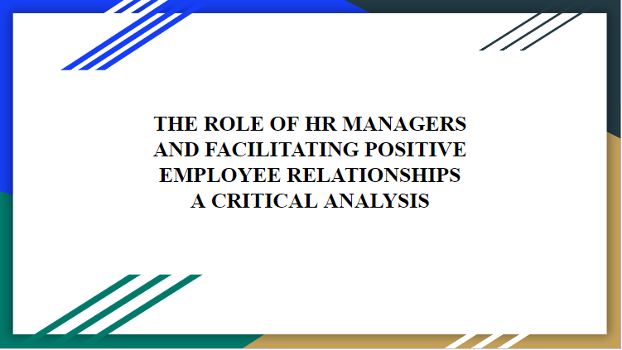
Introduction
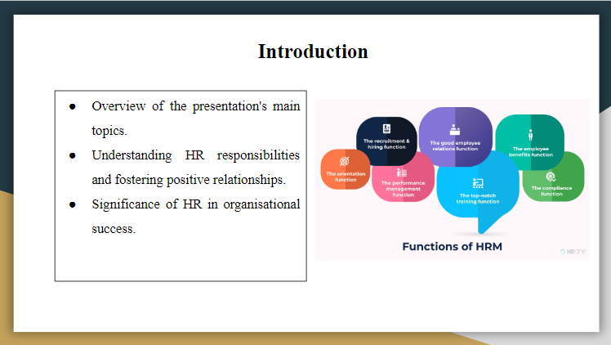
This slide provides a brief overview to cover the presentation and tries to make others understand the role that HR managers have to play in building better and positive relationships in workplaces. The presentation is aimed at learning HR roles to know how they contribute to the success of an organisation through influential people management and employee engagement.
Key Responsibilities of a HR Manager
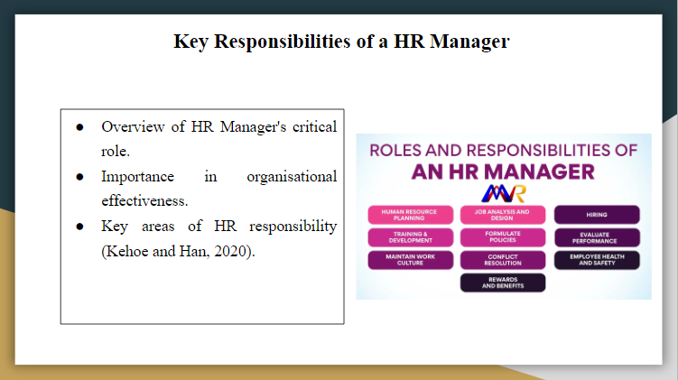
The reason HR managers play a central role in organisational effectiveness is that their role encapsulates several functions of best human resources. This slide, therefore, looks at what the HR managers do to ensure the smooth running of operations in an organisation and mainly their role in recruitment, employee relations, and implementation of policies.
Day-to-Day Work of a HR Manager
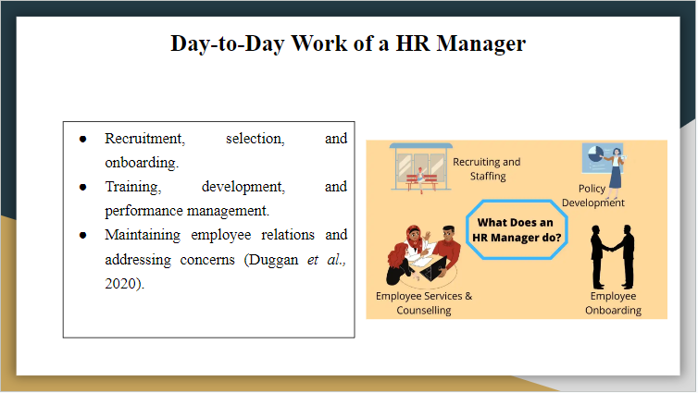
Also, the HR manager sees to it that the entire process of recruitment, selection, and onboarding attracts the right kind of talent into the organisation. Training and development programs regarding the enhancement of employee skills and the management of their performance are also focused upon. Maintaining positive and cordial relations with the employees and resolving their concerns is part and parcel of the significant daily work associated with the job.
Wider Remit of the HR Manager Role
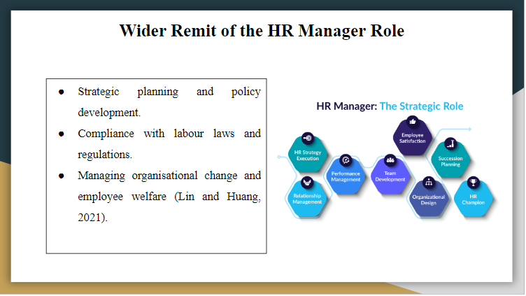
Beyond daily tasks, they are also into strategic planning and policy development to align HR practices with organisational goals - ensure compliance with labour laws and regulations that manage organisational change, and focus on employee welfare and wellness programs supporting a healthy environment.
Expectations from an HR Manager
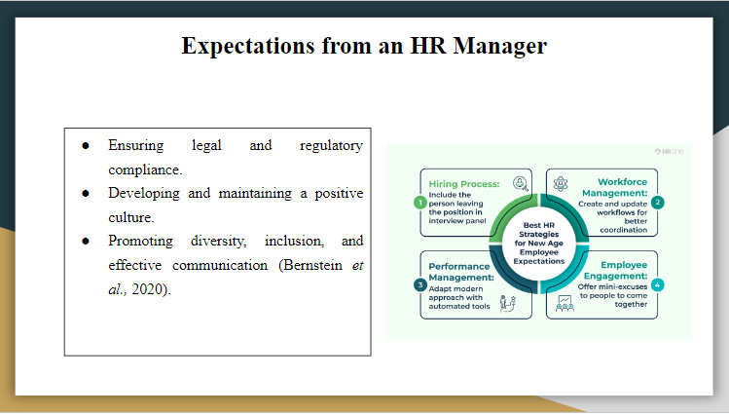
They have to ensure that their organisation complies with all the laws and regulations on labour; in other words, they should persist in adhering to their labour laws. The HR manager has a vital role in developing and sustaining the organisational culture, promoting diversity and inclusiveness, and establishing communication between the management and the employees.
Transition to Q2
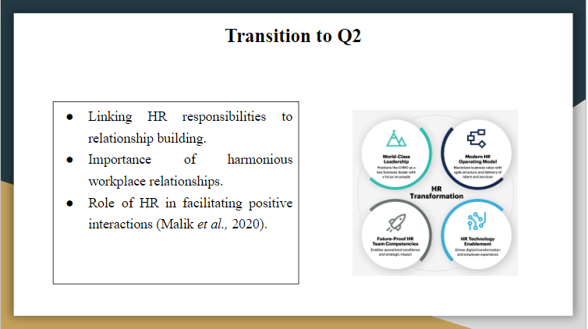
Having deliberated over some of the critical roles and responsibilities of human resource managers, the team then diverted attention to the part played in positive workplace relationships. The same being conveyed sets the stage for explaining how HR can best facilitate positive, strong relationships at different organisational levels and across departments.
Types of Relationships in an Organisation
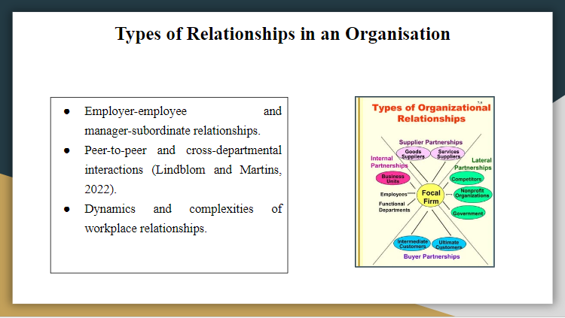
Some of the discussed nature of relationships included the employer-employee relationship, manager-subordinate, and peer-to-peer, among others that cut across different departments in an organisation or a working institution. Insight and mastery of the dynamics in the following relationships count with any human resource manager for a well-organised environment. Every type of relationship has its challenges and opportunities, for which proper HR practices can help develop the same for better organisational coherence and productivity.
Factors Influencing Employer-Employee Relationships
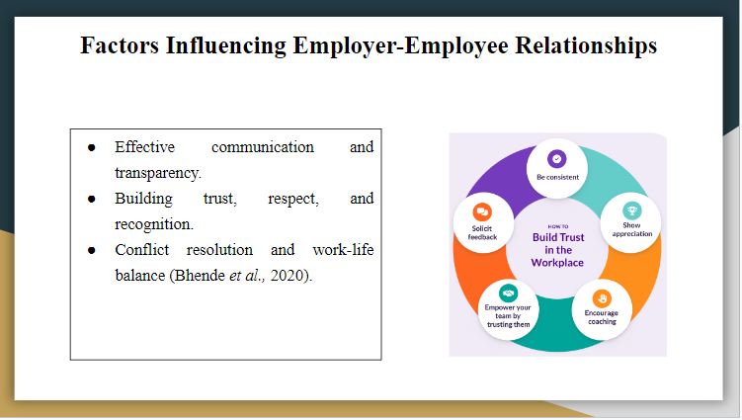
Good, open communication will form the foundation of the relations between employers and employees. It is through building respect and trust that one can have a conducive working atmosphere, while rewards and recognition build morale and motivation. The conflict resolution mechanisms will be instrumental in resolving disputes expeditiously and fairly. Apart from that, an excellent work-life balance promotes the well-being of employees, helping to reduce stress and allow better job satisfaction, leading to an involved and more productive workforce.
Practical Examples of HR Facilitation
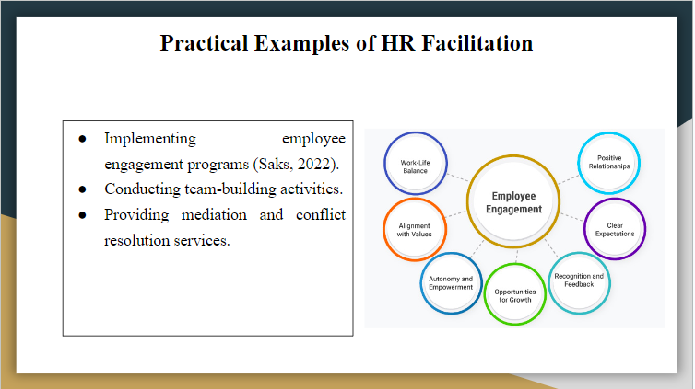
HR Departments may significantly increase office relationships by adopting numerous engagement programs, from regular team-building to social events that create camaraderie and cooperation. Mediation and conflict resolution services are needed to help handle disputes constructively. Other open-door policies and proper lead-up of feedback and appraisal also make employees feel valued and understood and make employees' efforts at work synchronised with the objectives of the firm. These are examples that remain very appreciable and demonstrate very well how HR can be very helpful in the creation of a positive, cohesive work environment.
Personal Experience: Positive Practices
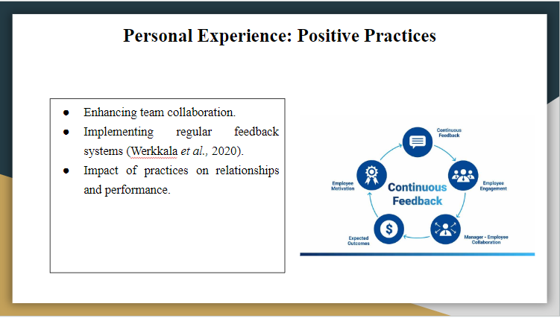
Based on my experience, I believe team collaboration could be enhanced through well-structured programs such as cross-departmental projects and workshops. Regular feedback systems ensure that employees are correctly grounded and appreciated when necessary, and this has kept them motivated and more productive in their work. Further, welfare initiatives such as stress management sessions, fitness challenges, and the like have initiated a significant work-life balance for all employees. Overall, these practices increase the satisfaction of staff and, therefore, help to procreate and sustain a positive working culture that everybody in the organisation embraces.
Conclusion
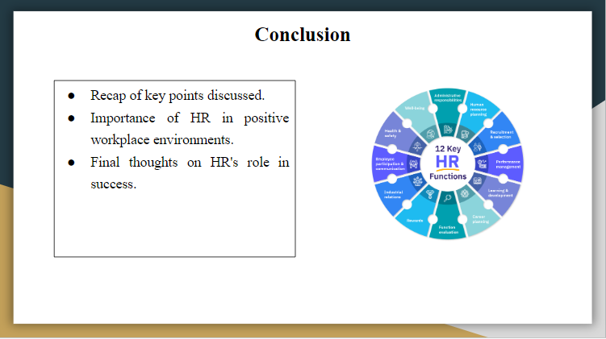
In conclusion, HR managers play a pivotal role in fostering a positive work environment and driving organisational success. The team elaborated on their crucial roles and responsibilities comprising operational and strategic roles and how they contribute toward an enabling environment for the workforce. Effective human resource practices, especially in communication, conflict management engagement, etc. contribute significantly to nurturing employer-employee that are value adding. Day-to-day examples from the perspectives of our experience underline the practical approach, which further enhances work teamwork and morale. In all, the HR department needs to be proactive and facilitative in turning the organisation competent and adopting a high-performance approach to sustain an organisation's competitive advantage.

References
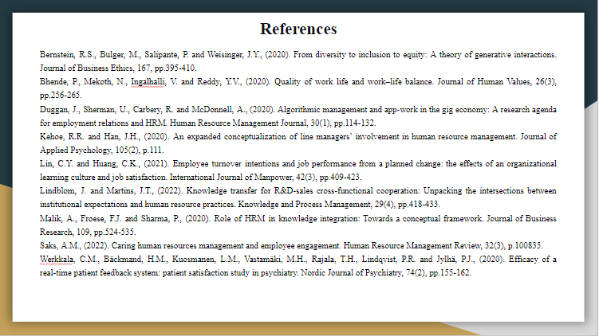
Bernstein, R.S., Bulger, M., Salipante, P. and Weisinger, J.Y., (2020). From diversity to inclusion to equity: A theory of generative interactions. Journal of Business Ethics, 167, pp.395-410.
Bhende, P., Mekoth, N., Ingalhalli, V. and Reddy, Y.V., (2020). Quality of work life and work–life balance. Journal of Human Values, 26(3), pp.256-265.
Duggan, J., Sherman, U., Carbery, R. and McDonnell, A., (2020). Algorithmic management and app‐work in the gig economy: A research agenda for employment relations and HRM. Human Resource Management Journal, 30(1), pp.114-132.
Kehoe, R.R. and Han, J.H., (2020). An expanded conceptualization of line managers’ involvement in human resource management. Journal of Applied Psychology, 105(2), p.111.
Lin, C.Y. and Huang, C.K., (2021). Employee turnover intentions and job performance from a planned change: the effects of an organizational learning culture and job satisfaction. International Journal of Manpower, 42(3), pp.409-423.
Lindblom, J. and Martins, J.T., (2022). Knowledge transfer for R&D‐sales cross‐functional cooperation: Unpacking the intersections between institutional expectations and human resource practices. Knowledge and Process Management, 29(4), pp.418-433.
Malik, A., Froese, F.J. and Sharma, P., (2020). Role of HRM in knowledge integration: Towards a conceptual framework. Journal of Business Research, 109, pp.524-535.
Saks, A.M., (2022). Caring human resources management and employee engagement. Human Resource Management Review, 32(3), p.100835.
Werkkala, C.M., Bäckmand, H.M., Kuosmanen, L.M., Vastamäki, M.H., Rajala, T.H., Lindqvist, P.R. and Jylhä, P.J., (2020). Efficacy of a real-time patient feedback system: patient satisfaction study in psychiatry. Nordic Journal of Psychiatry, 74(2), pp.155-162.

