Research Raport

Student Name/Id Student-Anamaria Nicolaescu 2120243
Module name- Digital Skills and Research Methods
Module code- BMSW4003
Lecturer-Abdi Rahman

Table of Contents

Introduction 3
Research Design 3
Research Question 3
Methodology 3
Ethical Considerations 4
Results 5
Usage of MS Teams 5
Ranking of MS software 6
WhatsApp vs. Others apps 6
Digital tools to collaborate 7
Ranking Applications 7
Analysis 8
Discussion 9
Digitisation through MS office 10
Conclusion 12
References 13

Introduction
Technology has been progressing at a quicker rate for quite some time. This has had a wide range of consequences on people's lives. The majority of educational institutions throughout the world have embraced the use of technology in their studies and research employing MS facilities. The student's performance has improved as a result, allowing them to compete in UWTSD. The application of scientific procedures to increase performance is referred to as technology. With the advancement of technology, a plethora of technical instruments have been available for students to use in their studies. Smart technology could be used in these devices to improve global society's access to information. Technology has proven to be crucial in research investigations among current generations of pupils. The expanded availability of e-learning systems and search engines that allow students to access knowledge from all around the world is one of the most significant technological developments (Kelly, Lesh, & Baek, 2018). Learning has also been enhanced as a result of advancements in technology, which have reduced time constraints and burdens.

Research Design

Research Question
- What digital tools does UWTSD employ to help students with their education and research?
- What beneficial effects does improved technology have on students' study methods?

Methodology
This research is a survey-based analysis that will explain the computational foundation that UWTSD utilises to support students through the use of Microsoft technologies such as MS Word, Teams, and other similar programs. The survey, which was performed, gives broad information about secondary and postsecondary educators' time limits and massive workloads. The study also looks at how these educators, what motivates them to learn and teach, and how they use new technologies in the classroom. Furthermore, the research is interested in learning more about the effects that technological advances have on the education sector. The report will start with social occasion information through a review and afterward assemble methodologies utilising a blended techniques approach. These systems and approaches will support a superior comprehension of blending as well as the examination of different methodologies for a more reasonable cycle. There might be an opportunity to give a more assorted viewpoint and a superior understanding of the intricate cycles. The study data concerning members and their contemplations on advanced innovation in college are the key information acquired. Secondary information will be accumulated from the web and the historical backdrop of the institute to decide how powerful advanced innovations are.

Ethical Considerations
Ethical consideration is a set of values and standards that should be observed when dealing with human concerns. No one acts in a way that is harmful to society or an individual because of ethical considerations. It prevents people and UWTSD from engaging in violent behavior. The following are the research's ethical considerations:

- When formulating the interview, questionnaire, or focused questions in the group, undesirable, discriminatory, or offensive language will be avoided.
- The most crucial considerations will be anonymity and privacy for all participants.
- An acknowledgment of areas where the dissertation has incorporated numerous parts written by other authors will be included in the report, as well as an acceptable system of references and citations.
- Participants who volunteer to be respondents are critical to the study's success. These participants will have the option to leave if they are uncomfortable with the research.
- The study's respondents will be notified before the project begins. This material will cover everything regarding the research, including enough details, as well as the assurance of data privacy.
- The research will examine and analyse a better level of objectivity in maintenance.

Results

Usage of MS Teams
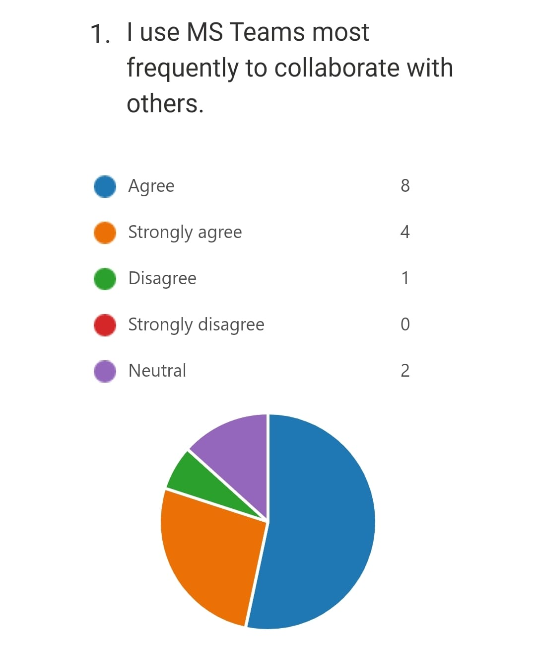
The survey was done among 15 participants, 8 of which use MS teams to collaborate with others, as seen in the graph above.

Ranking of MS software
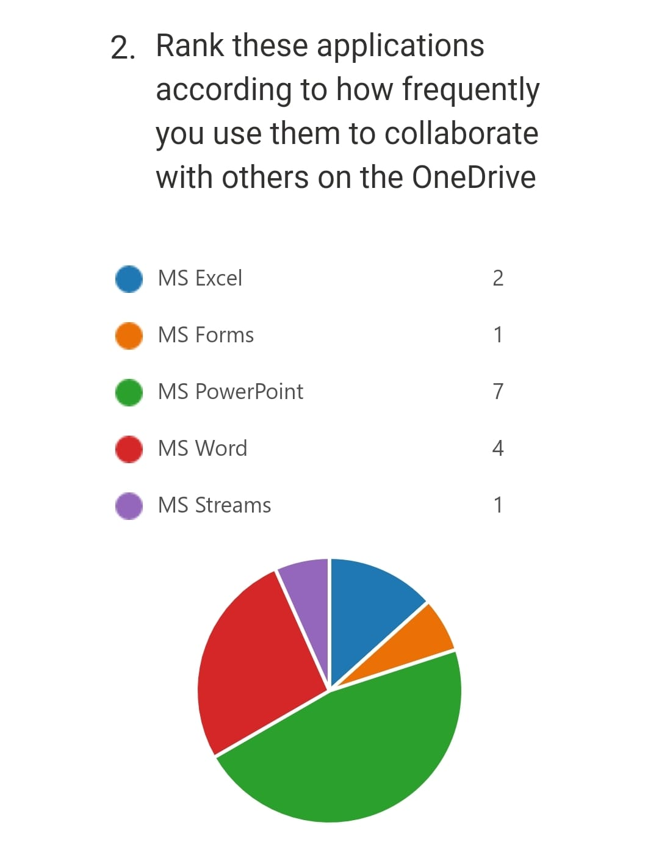
According to the graph above, it has been found through a survey that around 47% of participants find MS Powerpoint, 27% use MS Word, 13% use MS Excel, where 1% use MS Streams and MS Forms, the most useful application to collaborate with others on the OneDrive.

WhatsApp vs. Other apps
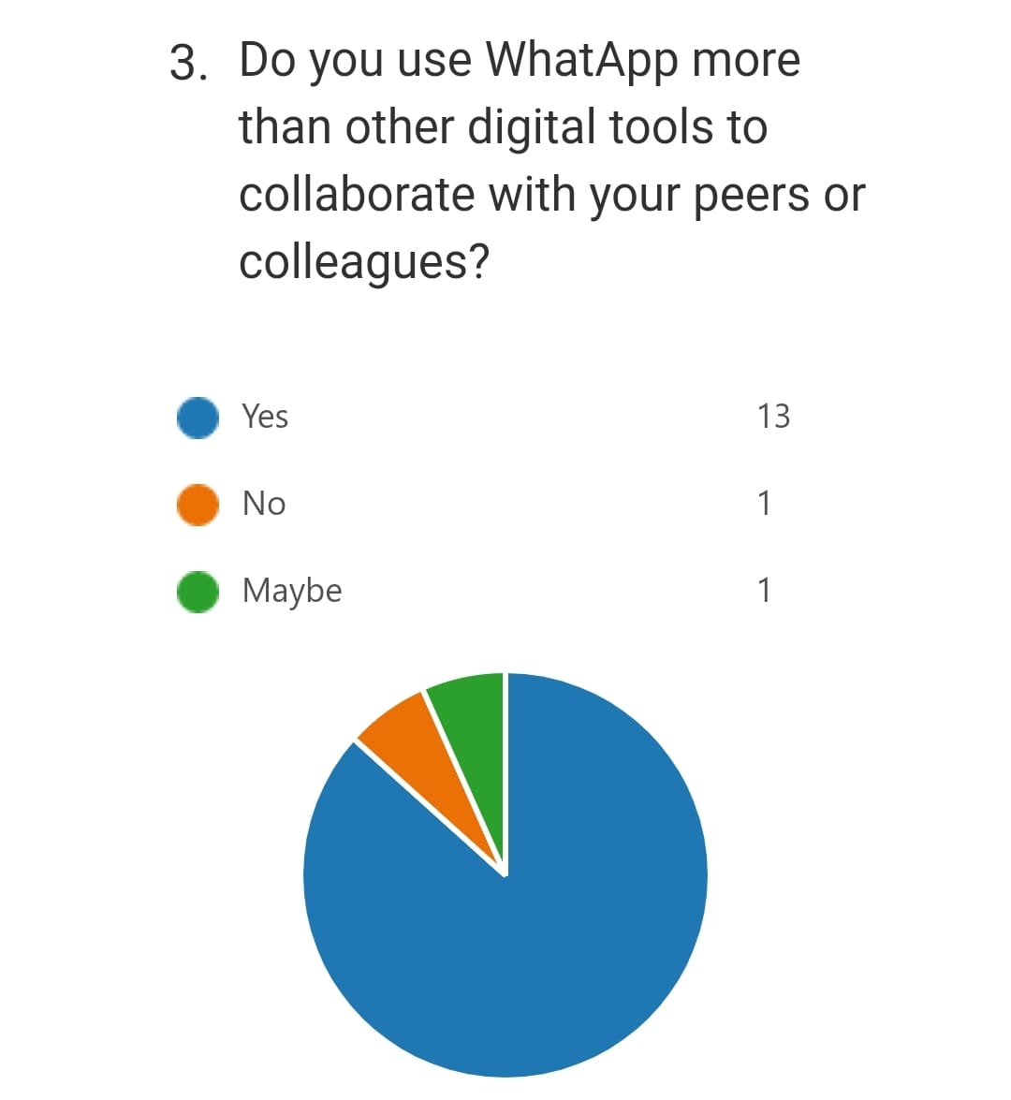
According to the survey, 87% of all the participants agreed that they use WhatsApp more than other digital tools to collaborate with their peers or colleagues.

Digital tools to collaborate
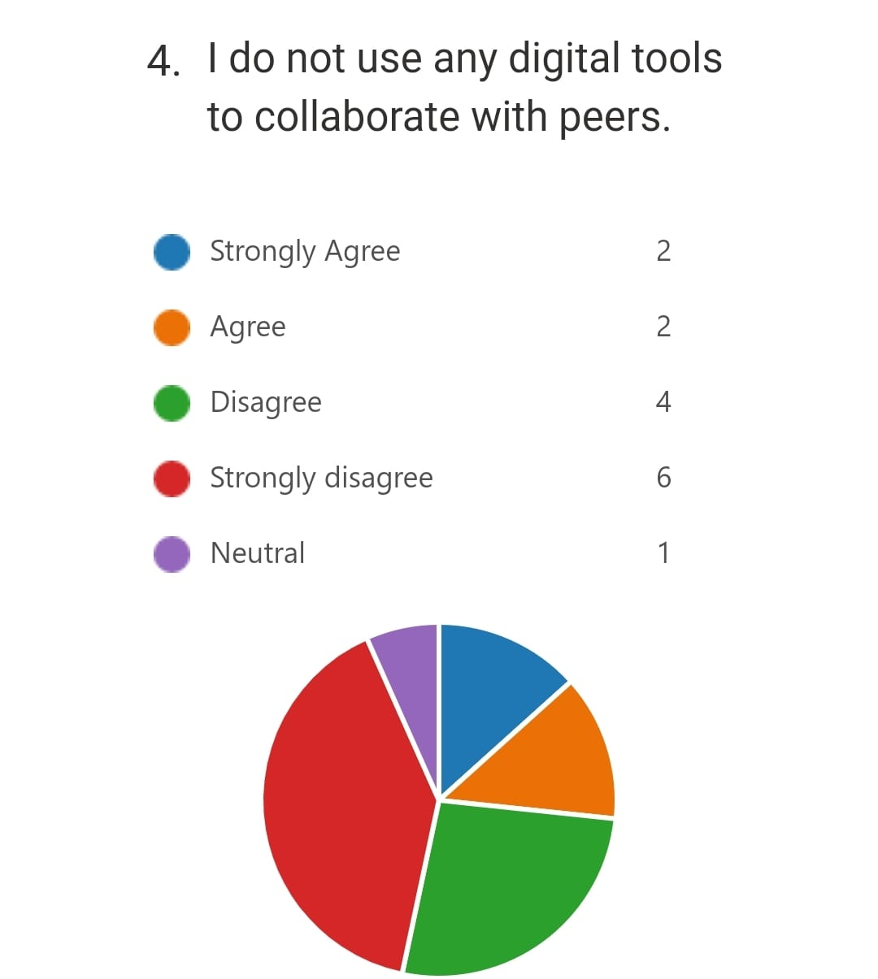
This question in the survey got different results from which 40% of all participants were strongly disagreeing on this point 27% were disagreeing, 13% were agreeing and strongly agreed and 1% stayed neutral on this point.

Ranking Applications
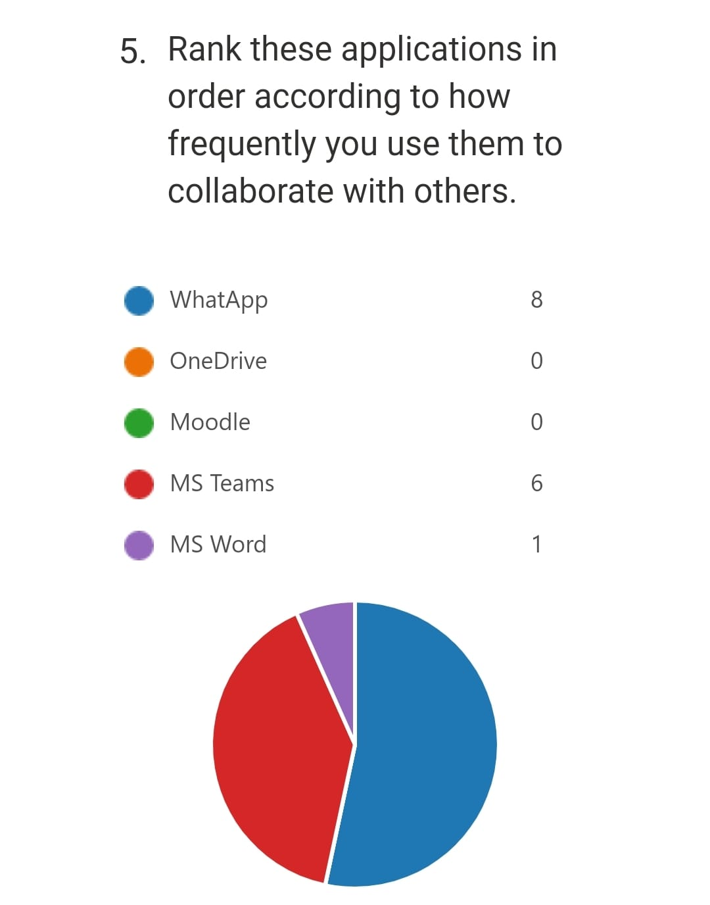
Many students are found to be aware of the different Applications for collaboration with others, 53% of people opted for WhatsApp as their primary application, 40% chose MS teams, and 1% chose MS word.

Analysis
Technology has progressed at a rapid rate. This has had a tremendous effect on people's lives. The majority of universities and colleges around the world have embraced the way of studying and conducting research with more advanced technological tools (Kila, 2019). The majority of these kids have grown up with constant technology improvements that have improved their schooling and made information more accessible. At the University, enhanced technology facilities have largely superseded conventional educational techniques. For example, before the advent of new technology facilities, traditional facilities such as the chalkboard, hard copy textbooks, and whiteboard were used, but these have now been superseded. University students have reaped many benefits as a result of these developments, including higher academic performance due to enhanced research methodologies. The program had the utilisation of innovation in instruction has likewise added to the improvement of e-learning among understudies. Microsoft has made it simple for the teachers to advantageously convey their notes to the understudies a lot of simple and that's only the tip of the iceberg. Furthermore, teachers can distribute their notes online as PowerPoint introductions or pdf records for understudies to download and peruse. The utilisation of better innovation makes an assortment of qualities that are wealthy in data and are coordinated so that members can learn by sharing and building their insight. Knowing and understanding what these qualities are and how they can be utilised has assisted understudies with further developing their opportunities for growth in an air that upholds scholastic accomplishment. It has likewise assisted understudies with finding out about the utilisation of innovation in training. Furthermore, engagement between students and UWTSD instructors, as well as interaction among students, should be improved. In general, UWTSD students want to participate in online learning using the Microsoft Teams platform. According to the data above, UWTSD students provide a confident response. This research revealed that students' impressions of MS Teams are in the best category, implying that UWTSD students had the best perception of the application.

Discussion
The major goal was to investigate the various effects that enhanced technology might have on students' research methods. According to the results of the poll, modern technology is playing a vital role in providing the best possible support for students and educators. It has simplified the way educators teach their students as well as the way they do research. Both sides have been able to undertake more research and innovate as a result of the usage of technology in education. Instructors can, for example, experiment with new ways of teaching in class, assist students outside of class, evaluate their students' learning processes, and create learning resources to aid them in completing their assignments. The expansion in the use of MS Teams by UWTSD understudies has been paired with amplification in the use of MS Teams by colleges that have shifted to extremely remote working situations for quite some time. Teachers at all levels conduct surveys to determine the best ways to communicate with understudies to accomplish remote learning. MS Teams has evolved into the most effective tool for enhancing or replacing various executive learning capacities that have been modified specifically for educational reasons.
Microsoft reports that a lot of instructive schools and colleges are utilising MS Teams for crossover or remote learning in the hour of Covid. In a various bow to the meaning of Teams in remote class, Microsoft by and by pronounced more imaginative highlights especially for the understudies. Perhaps the best component of this specific device for understudies is the ability to tie in a few different assets and fills in as a center point for both joint effort and content. The use of additionally created advancement has worked with and lessened their positions. For example, students can walk unreservedly starting with one area and then onto the next without conveying their hard reading material to explore. Additionally, they are not restricted to a given range like homeroom. They can complete their investigations in any area as long as the spot is associated with the web. As the study uncovers, a greater amount of these instructors and students are available to embrace new advances to assist them with combatting these difficulties. From the examination, the vast majority of the people that were evaluated insisted that the utilisation of further developed innovation in training helps in working on the effectiveness, correspondence, and capacities of understudies to review outside their study hall.

Digitisation through MS office
There are many kinds of digitalisation that are tracked down nowadays. As indicated by Maslow, associations are a lot mindful and serious as far as advanced gifted individuals in the new previous years for the outrageous contest and difficulties which empowers the adequacy in the working environment and the association. Computerised abilities are not the same as an association, sort of work, and expected set of responsibilities. The fundamental digitalisation which is required for the working environment is given underneath. As associations nowadays for the most part subject to the different data sets, servers, and numerous specialised perspectives are executing, representatives ought to be well gifted and prepared in the enlistment technique by associations. Per Hofstra, he expressed that hard abilities like systems administration and abilities for running different instruments are significant for the workers in an association to adapt up to the authoritative. Different abilities are required for the workers in an association. Abilities are isolated into two classifications. Delicate abilities and hard abilities. As a result of the digitalisation and mechanical progression in the work environment, representatives ought to be well-talented in different abilities. These abilities are known as hard abilities. Hard abilities comprise the IT abilities among the workers and staff. In an association, workers have ID cards and they should be aware of the utilisation of ID cards, how to punch it in the scanner tag, how to give mail, ho to correspondence in the outside and inward servers (Extranet and intranet), and a lot more purposes of programming and applications. Fundamental coding and programming working, virtual entertainment making due, SEO (Search Engine Optimisation), and so on are the principle and most demandable abilities for a representative or a competitor. Because of the modernised and innovative headway of late years, associations are fundamentally reliant upon the digitalisation of the UWTSD. The greater part of the UWTSD has the IT support group, inner information base server, and correspondence framework which empowers the chance for the UWTSD. Taylor expressed that digitisation is a viable element for the university to accomplish authoritative objectives, digitalisation is a significant variable for the associations. To keep a superior digitalisation in the work environment, representatives ought to be talented. Workers ought to have different hard abilities like information surfacing, keeping up with messages, data set taking care of, and a lot more issues. Staff and workers ought to have the information on giving messages, utilising portable cell phones with different applications and apparatuses. Thus, associations ought to enroll the most ideal competitors.

Conclusion
Although technology has been sluggish to catch on in the homeroom, the vast majority of its benefits have begun to emerge. It has enhanced traditional educational approaches by giving more personalised experiences both outside and inside the classroom. As a result, schools and colleges should start using web-based correspondence entries, electronic course reading, and other better web-based services to provide understudies plenty of time to do their exams. Because information technology and communication continue to play a critical role in ensuring that students' academic concepts are realised in this innovation-driven century, educational institutions should devote more resources to upgrading technology.

References
Akhter, N, 2018. Relationship Between Internet Addiction and Academic Performance among University Undergraduates. p. 1793 (8)19.
Hashem, Y, 2019. The Impact of Social Media on the Academic Development of School Students. ResearchGate, pp. 46-52 (Vol 6)1.
Kila, C, 2019. Impacts of Technology on University Students' Life and Academic Progress. ResearchGate.
Naizabekov, S, 2020. Negative Impacts of Social Networking Sites on Academic Performance of Students.
Kelly, A. E., Lesh, R. A., & Baek, J. Y, 2018. Handbook of design research methods in education: Innovations in science, technology, engineering, and mathematics learning and teaching. Routledge.
Schmid, R. F., Bernard, R. M., Borokhovski, E., Tamim, R. M., Abrami, P. C., Surkes, M. A., & Woods, J, 2018. The effects of technology use in postsecondary education: A meta-analysis of classroom applications. Computers & Education, 72, 271-291.
Lin, C. A., & Atkin, D. J, 2018. Communication technology and social change: Theory and implications. Routledge.
Sekaran, U., & Bougie, R, 2016. Research methods for business: A skill-building approach. John Wiley & Sons.
Mertens, D. M, 2018. Research and evaluation in education and psychology: Integrating diversity with quantitative, qualitative, and mixed methods. Sage publications.

