An Exploration into the Use of Animals in Society and Art

Megan Kane
2103250
Independent project ADAA6000
Fine Art: Studio, Site and Context BA (Hons)
Ryan Moule, Estefani Bouza and Alex Duncan
Word Count: 5,498
Submitted in partial fulfilment of the requirements for BA (Hons) Fine Art
University of Wales Trinity Saint David, Swansea
(Submitted Friday 15th, 2023)

Table of Contents:

List of Illustrations....................................................................................................................................3
Definitions of Terms.................................................................................................................................5
Introduction............................................................................................................................................6-7
(Word count: 342)
Chapter One............................................................................................................................................7-12
(Word count: 1051)
Chapter Two..........................................................................................................................................12-21
(Word count: 2308)
Chapter Three.......................................................................................................................................21-27
(Word count: 1394)
Conclusion............................................................................................................................................28-29
(Word count: 403)
Appendix...............................................................................................................................................29
Bibliography..........................................................................................................................................31

Total Word Count: 5,498

List of Illustrations:

Figure 1. Anon. (c. 17000 BC) Lascaux Hall of Bulls [Cave painting of a bull and horses].
Available at: https://www.mediastorehouse.com/fine-art-finder/artists/paul-serusier/rock-painting-bull-horses-c-17000-bc-23369858.html (Accessed: 19th December 2023)

Figure 2. Synders, F. (c. 1620) The Pantry [Painting: Oil on Canvas].
Available at: https://www.wikiart.org/en/frans-snyders/the-pantry (Accessed: 2nd November 2023)

Figure 3. Synders, F. (c.1628-30) Pythagoras Advocating Vegetarianism [Painting: Oil on Canvas].
Available at: https://www.rct.uk/collection/403500/pythagoras-advocating-vegetarianism (Accessed: 2nd November 2023)

Figure 4. Hirst, D. (1993) Mother and Child (Divided) [Sculpture: Calf and mother cow preserved formaldehyde and presented in glass vitrines]
Available at: https://www.artimage.org.uk/18487/damien-hirst/mother-and-child--divided---1993 (Accessed: 15th November 2023)

Figure 5. Tansey, M. (1981) The Innocent Eye Test [Painting: painting of a cow stood in front of Paulus Potter’s The Young Bull, 1647, Oil on Canvas].
Available at: https://www.metmuseum.org/art/collection/search/484972 (Accessed: 23rd November 2023)

Figure 6. Viva!. (n.d.) [Photograph: Slaughtered cows]
Available at: https://www.google.com/url?sa=t&rct=j&q=&esrc=s&source=web&cd=&ved=2ahUKEwi63dWyu4-DAxUbRUEAHeeOBqoQFnoECBoQAQ&url=https%3A%2F%2Fviva.org.uk%2Fanimals%2Fslaughter-how-animals-are-killed%2F&usg=AOvVaw3mINjO5ThrKbvTc8gReBoS&opi=89978449 (Accessed: 9th December 2023)

Figure 7. Hirst, D. (1991) The Physical Impossibility of Death in the Mind of Someone Living [Sculpture: Tiger shark preserved in formaldehyde presented in glass vitrine]
Available at: https://www.widewalls.ch/magazine/damien-hirst-shark-the-physical-impossibility-of-death-in-the-mind-of-someone-living (Accessed: 2nd November 2023)

Figure 8. Cross, D. (2013) Basking Shark Currach [Sculpture: Basking Shark skin stretched over wooden currach]
Available at: https://www.anothermag.com/art-photography/gallery/7710/dorothy-cross/0 (Accessed: 2nd November 2023)

Figure 9. Cross, D. (1993) Bust [Cow udders and Tailors Dummy]
Available at: https://www.dorothycross.com/1999-88/udders (Accessed: 2nd November 2023)

Figure 10. Nitsch, H (2017) 150.Action [Performance]
Available at: https://varenne.art/exhibitions/13-dark-mofo-hermann-nitsch-150.-action-mona-hobart-curated-by-olivier-varenne-michel-blancsube/ (Accessed: 2nd November 2023)

Figure 11. Nitsch, H (2017) 150. Action
Available at: https://www.theguardian.com/culture/2017/jun/20/can-blood-guts-and-gore-in-art-be-beautiful-nitsch-shows-it-can (Accessed: 10th December 2023)

Figure 12. Kounellis, J. (2006) Untitled [Installation: Meat hanging on hooks]
Available at: https://www.flickr.com/photos/rogertwong/15717144727 (Accessed: 25th November 2023)

Definition of Terms
Within this thesis, the term ‘non-human animal(s)’ is used, this is typical within literature regarding animal rights as it distinguishes humans, who some may argue are animals, from other animals. This term acknowledges that all other beings are sentient to some extent and can display human characteristics like pain, compassion and memory. To clarify, when the lexical ‘animal(s)’ is used the meaning is the same as ‘non-human animal(s)’.
The term ‘non-human’ is used to describe everything that surpasses the human.

Additionally, the term ‘the more-than-human world’ used by James Bridle in Ways of Being (2022), recognises that humans are just one species, among many others, that co-habit Earth. We are interdependent on the otherness and diversity of the planet. So, human actions surpass our society beyond the knowledge that we currently have. I have used this stolen this term throughout my essay (Bridle, 2022).

Introduction:
This thesis seeks to investigate the human relationship with non-human animals by considering their use in society and art. There is an immediacy to the subject of our contemporaneous use of natural resources, in particular animals, because of intersecting factors such as the climate crisis, the Covid-19 pandemic and factory farming. Therefore, we urgently need to reassess our position within the world for our species’ survival.
As advanced apes, we depend on the ‘more-than-human’ world (Bridle, 2022) but, currently we have lost our connection to Earth which has led to the driving concepts of anthropocentrism and human superiority. Anthropocentrism, the notion that humans are the most significant and central beings on Earth, has led to our destruction of the planet as we overuse and overconsume natural resources, creating a shift towards manmade materials that pollute the environment and are non-biodegradable for example, plastics. Despite our overflowing material abundance, we do not leave room for our excess so, over half of the UK’s supposedly ‘recycled’ plastic waste is sent overseas (Greenpeace, n.d. p.8.) Thus, the result of our actions are invisible to us so, perceptions remain the same and progress is slow. Similarly, the meat and dairy industries attempt to hide their mistreatment and slaughter of animals, as well as their extensive waste.
One can observe the everchanging human-animal relationship through art; from the first depictions of animals on cave walls to still life paintings that glamorised the death of animals to portray power and wealth, shaping society’s associations with animals and food. The ongoing human obsession with abundance and excess can be observed in art and provides us with the history behind our contemporaneous use of materials and abuse of Earth.
The extreme use of animals in Contemporary Art creates controversy by recontextualising the death of animals that occur on a larger, more wasteful scale in the meat and dairy industry, highlighting our moral hypocrisies regarding the treatment of animals. However, these works can be dangerous as they advertise anthropocentrism and human superiority which leads to our abuse and subjugation of nature.

Chapter One:
When exploring the human-animal relationship it is important to consider how animals have been depicted in art throughout history as they have helped define our current relationship with the Earth. As can be seen in Figure 1, animals have informed, influenced and shaped our understanding and emotional reaction towards the world as depictions of animals on cave walls were the first encounters that humans would have had with images of animals.
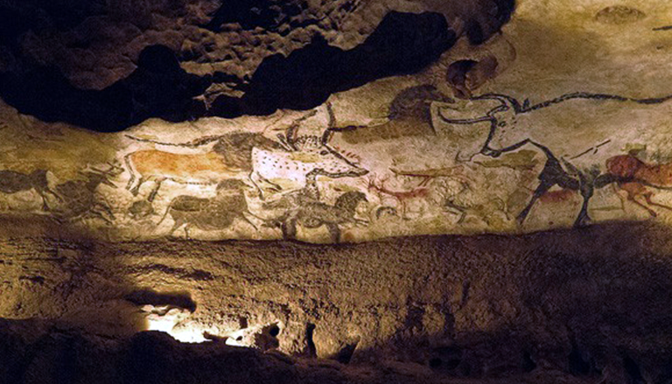
Figure 1: Lascaux Hall of Bulls
However, still-life paintings, specifically those portraying animals killed in hunting - a sport reserved for the aristocracy in the 17th century – present animals as commodities. In still-life paintings, dead animals are typically arranged alongside other inanimate objects like tableware, fruit, or vegetables, normalising their death as they blend in with the rest of the composition. Furthermore, some artists even glorify the killings as they construct and paint the dead bodies beautifully, transforming the carcasses into spectacles and glamorising their death.
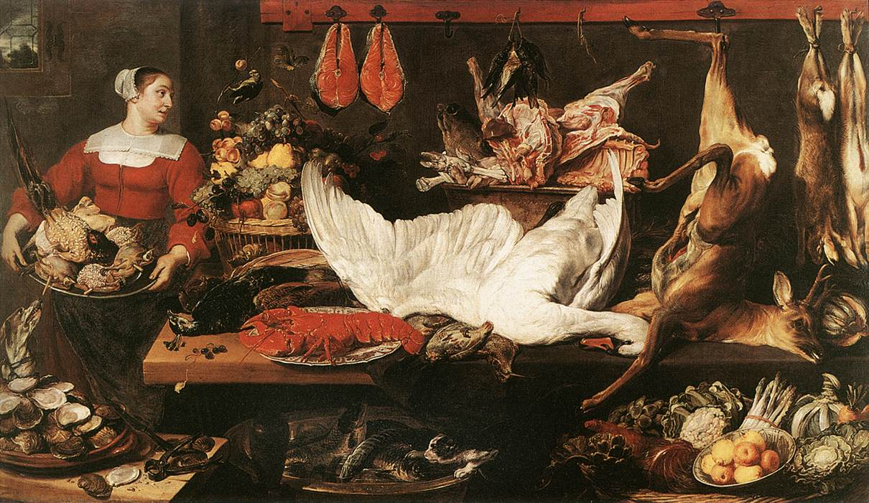
Figure 2: The Pantry (Synders, c. 1620)
Figure 2 is an example of this ideal representation as Synders transforms large piles of dead carcasses into spectacular compositions that serve as a sign of status and privilege, illustrating the owner’s prerogative to kill. The painting’s element of abundance creates various layers: a maid who is carrying a tray of quails and a pheasant, surrounded by two wicker baskets of fruit and vegetables, a variety of meat prepared for consumption as well as other dead animals. Synders’ inclusion of the white swan and deer, two visually striking elements that occupy the centre of the scene, assist with the overall grandeur of the painting as well as its larger-than-life size.
At face value, it could be argued that Synders’ painting asserts social superiority through his use of animals by supporting the perception that hunting animals is inextricably linked to being wealthy and powerful through the aestheticisation of the hunt and consequential kills. It is interesting to consider this historical relationship between animals and symbolism as traditional depictions of animals and the hunt have shaped the deeply ingrained societal attitude that the consumption of meat links itself to the notion of masculinity.
I witnessed firsthand how toxic this widely accepted view is when my partner was labeled ‘a pussy’ (Little quoted by Allen in Appendix, 2023) for becoming vegan because he did not conform to his gender norm. So, he was no longer considered strong or sufficiently masculine, a stereotype that derived from the notion that men historically fulfilled the role of the hunter.
Carol Adams explores this connection between toxic masculinity and animal consumption in The Sexual Politics of Meat (1990) suggesting that meat consumption, violence against animals and women are related. Similarly, one can observe our disrespect towards animals mirrored by our abuse of the natural world. Thus, it is obvious that we must reassess our problematic relationship with animals as we are interconnected and interdependent on the more-than-human world. The complexity and scale of Earth makes it difficult to comprehend the extent of the impact that our actions can have, however, it is essential for human survival.
Adams’ statement that ‘meat eating is the most frequent way in which we interact with animals’ (Adams, 2000, p.51) illustrates the current disconnect between humans and nature and demonstrates the issue surrounding human superiority and anthropocentrism as we abuse our power and damage human, and non-human environments.
It could be argued that historical depictions of animals as commodities killed for our pleasure (Figure 2) have encouraged humans to abuse the power disparity between us and the non-human. This has resulted in disrespectful attitudes that have led to animal exploitation and mass-suffering in contemporary society, leaking into the culture of the times as observed in Contemporary Art.
Conversely, Palmeri argues that Synders’ paintings ‘indicate his sympathy with arguments against the hunt’ (2016, p. 59) by considering that there was a:
‘Widely accepted moderate position at the time [that] provided grounds for condemning wasteful killings by monarchs and high nobles’.
(2016, p. 56).
It is interesting that historically the general attitude towards hunting was morally condemnable if excessive and wasteful if we reflect upon our current relationship with animals for example, 220 million land animals are killed for food every day, and when you factor in marine animals that number increases to somewhere between 2.4 and 6.3 billion (Winters, 2022, p.3).
These figures indicate the extent of how wasteful and unsustainable our food system is. However, they also make it difficult to recognise the difference that detrimental uses of animals in art can have on society. Yet, art has an essential role, raising questions and aiding a migration from the conventional way of thinking; art offers a perfect space to discuss difficult topics like our relationship with the non-human.
Synders’ work is an example of this as Palmeri argues that his paintings are a ‘pre-history of critique – especially of trophy hunting’ that foreshadowed questions about protecting other beings that were more explicitly raised by thinkers like Jeremy Bentham in the later 18th century (2016, p.72).
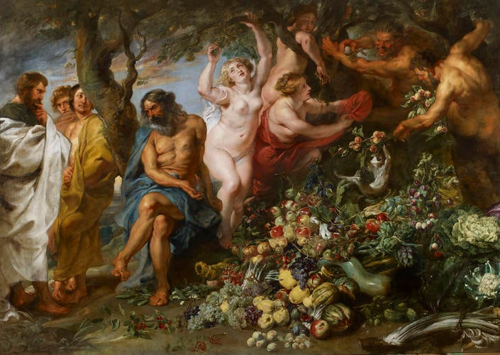
Figure 3: Pythagoras Advocating Vegetarianism (Synders, c. 1620)
Synders’ painting Pythagoras Advocating Vegetarianism (1620) indicates an awareness about the interconnectedness of all life and the painting can be seen to glamorise plants over meat. In comparison to The Pantry, colourful and luscious fruit and vegetables replace the bodies of dead animals to celebrate the goodness of natural foods. Furthermore, ‘noble and thoughtful men are contrasted with greedy and bestial fauns, but the fauns are gentle vegetarians’ (Royal Collection Trust, n.d.), suggesting that we should use human superiority to adopt the role of protector rather than abusing our power and causing an incomprehensible amount of animal suffering every day and that we also should avoid living excessively.
Michel de Montaigne wrote in his essay On Cruelty that when an innocent and defenseless stag at the end of the chase turns to his pursuers and tearfully pleads for his life, the scene has always seemed to him a “very unpleasant spectacle” (1580, p. 316). We can observe some of the thinkers and creators in society experiencing and expressing reservations about hunting due to the animals’ suffering. This suggests that art has always played an activistic role regarding the critique of human interaction with animals, because it allows us to reflect on our actions and discover new perspectives.

Chapter 2:
Our problematic relationship with animals has continued - exacerbated by contemporary society and the capitalist, consumerist system. Moreover, despite art being materially connected to animal suffering throughout history due to its reliance on dead animals and their body parts to provide traditional art supplies like brushes made from animal hair and pigments made from crushed insects (Fairley, 2022), Contemporary Art highlights the necessity of a discussion about our use of animals in art and society through its extremity. Contemporary artists have exposed our moral ambiguity and hypocrisy when it comes to non-human animals through controversy and discussions that their work has prompted.
Contemporary Art can be seen as an enabler of animal suffering when we consider artists like Damien Hirst for example, who endorses disrespectful treatment of animals through his approach to using them in his art. Hirst’s barbaric attitude towards animals can be observed through his perception of cows as ‘death objects’ and ‘walking food’ (Hirst quoted in Morgan, cited by Tate, n.d). Thus, it can be assumed that Hirst feels no remorse for using a cow and a calf in his piece Mother and Child (Divided) (1993), as he has no respect for them. Hirst’s art is dangerous as it reinforces prejudice towards other species, also known as speciesism, which encourages human superiority and animal subjugation.
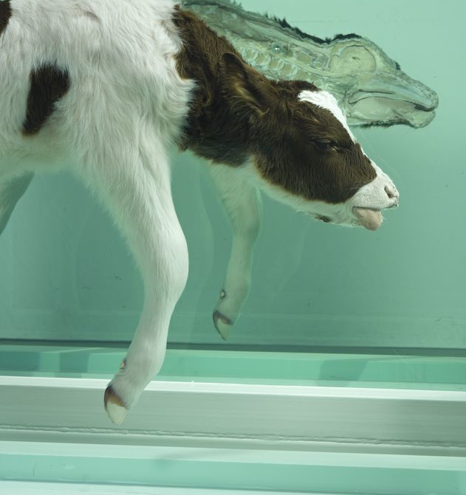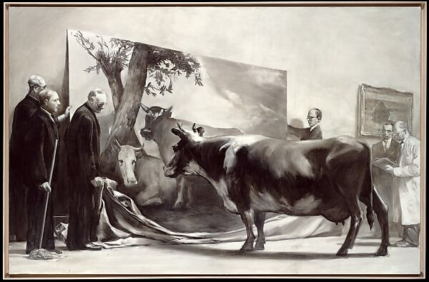
Figure 4: Mother and Child (Divided) (Hirst, 1993) Figure 5: The Innocent Eye Test (Tansey, 1981)
Hirst’s art attempts to ‘prod viewers into reflection’ by creating sculptures that have a visceral materiality (Broglio, 2011, p. 10). Therefore, it could be argued that Hirst has a callous approach and, is obvious in his choice of material as he, himself admitted that ‘cut us all in half, we’re all the fucking same’ (Goldstein, 2017).
Figure 4 depicts a sculpture made from a cow and calf, bisected and preserved in formaldehyde solution, presented in two pairs of glass vitrines. The artwork resonates with viewers as we are made of the same matter as the animals – flesh, blood and bone - which the viewer can observe as the cows’ viscera is on display. Despite knowing that we are made from the same matter, we question other animals’ experiences. The problem is that humans measure the intelligence of other animals based on our own. For example, we study their self-awareness with the MSR test, commonly known as the mirror test. Figure 5 depicts something similar to the mirror test, as a group of scholars observe a live cow's reaction to a painting of a cow. This image is an example of the role that art plays when it comes to exploring our connection to nature and our position within the world. The mirror test demonstrates the dangerous effect that anthropomorphizing animals can have as we measure animal behaviour and intelligence in human terms:
‘[It] inhibits our true understanding of the fascinating world around us... And, what’s worse, this bias we inject across the natural world makes it even harder to understand ourselves’.
(Dunsworth cited by Sholl, 2017).
‘Innocent Eye’ refers to an uneducated individual looking, which in this circumstance is the cow. It is interesting to reflect on the notion of education because it is essentially a man-made concept that is regarded as important within our society. To gain further understanding about the world, animals become victims of our abuse as we conduct horrendous tests on them. Thus, we must recognize the role and importance art has, because it encourages looking and analysing, which deepens our knowledge of the world without animal suffering. Animals have different strengths to us for example, dogs have a sense of smell that is 10,000 to 100,000 times more acute than a human’s (Jenkins, DeChant and Perry, 2018) yet, instead of admiring this, we falsely disregard their ability to feel pain by linking it to their lack of human intelligence. Thus, continuing to exploit them, exercising our human superiority and justifying our actions.
Hirst’s work could be viewed as an opportunity to change this perception as the viewer can observe the animal’s internal and discover that we are not dissimilar in our biological make-up. Controversy surrounding the death of animals for art, cows in this instance, might have developed from Hirst’s recontextualisation of the animals; the cows are in a gallery not on a farm or a slaughterhouse. Therefore, the death of the cows for Hirst’s art is less easily justified than when one increases the demand of dead cows to consume potentially because an animal's death for art is not excused by the propaganda that the meat industry ingrains into us from a young age for example, that meat is essential for our survival. Moreover, it could be because the psychological phenomena of cognitive dissonance – a defense mechanism that occurs in your brain when your behaviour and beliefs contradict, like eating meat and loving animals (Winters, 2022) – is not affecting Hirst’s viewers as they observe from an outsider's perspective and are not complicit in the suffering and death of the animals. Thus, a viewer is more shocked and repulsed by Hirst using a dead cow and calf for art than eating its flesh.
Although the viewer's cognitive dissonance is not functioning in this circumstance, when purchasing meat, it typically would be. People often justify eating dead animals because non-human animals are not deemed as intelligent as humans. This is why Hirst’s work is dangerous, because he explores the theme of death through other animals’ deaths. By demanding animals to be killed for art, Hirst endorses human superiority and reinforces our prejudice towards other species as essentially, the animals are killed for human pleasure, like they are in the meat industry. In defense of Hirst’s work, the cows were sourced from a slaughterhouse so, arguably the animal’s deaths were inevitable even if they hadn’t been used for art. However, this merely highlights the difficulty of viewing animals as commodities, whom are only there to fulfil some end determined by the human’ (Coester, 2019).
The commodification of non-human animals threatens human survival as a species because it is inextricably linked to the capitalist system that prioritises money over humans, nonhuman animals and the environment. One can observe this through the green washing and humane washing that certain industries adopt as a marketing technique to convince us that their products are either sustainable – in the case of green washing – or ethical – in the case of humane washing. For example, lexicals ‘humane’ and ‘kill’ are juxtapositions so, arguably, we cannot kill an animal humanely.
Hirst’s transparency about the animals’ deaths unintentionally confronts our moral hypocrisy and willful ignorance regarding animals. Schemes like the RSPCA Assured label and Red Tractor, formed to ‘rebuild trust in British Farming’ after outbreaks of Salmonella and BSE (Viva, n.d.), encourage this lack of education about animal agriculture by offering a façade of welfare that is not always upheld as many exposés have shown for example, ‘horrific scenes of animal abuse [were] recorded at Red Tractor-approved dairy farm in Wales’ at the time of writing (Stone, 2023).
Hence, it seems absurd that the RSPCA ‘raised concerns over the treatment of animals and insects by Damien Hirst following claims that almost one million creatures have died as a result of his work’ (Goldstein, 2017), as they are connected to animal agriculture which slaughters at least 1.2 billion land animals a year in the UK (Foreman, 2023). AD Harvey, previously RSPCA-Assured, collected chickens that can no longer lay eggs for slaughter. Footage released showed workers carrying excessive amounts of chickens by one leg and slamming the crates closed on their wings and heads (Allott, 2023). A worker was even caught stating:
‘It only takes one idiot to just come in here and film what we do... and all the animal rights lot will be down here. They all think chicken walk around in fields, think 20 chickens in a field will feed the nation.’
(Worker quoted by Allott, 2023).
The worker comments on our cognitive dissonance and the lack of transparency with animal agriculture enabled by assurance schemes. Hirst makes his treatment and use of animals visible, that is why his art is so controversial. Paul Mcartney suggests that there would be similar outrage if animal agriculture was more transparent, like Hirst, with his statement ‘if slaughterhouses had glass walls, everyone would be vegetarian’ (2010).
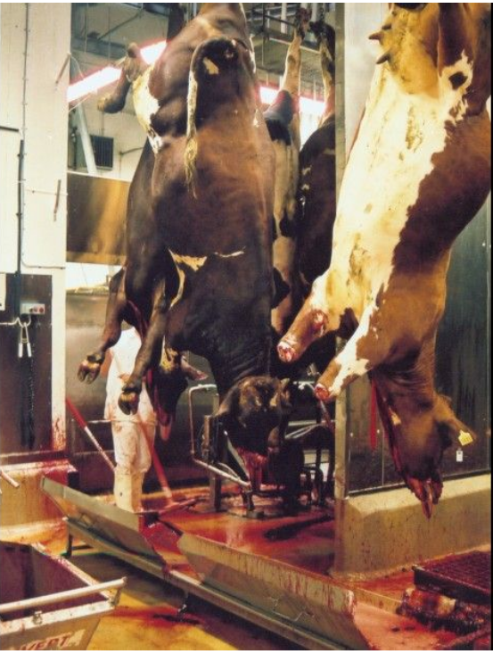
Figure 6. Slaughtered Cows
Hirst explores death and mortality in The Physical Impossibility of Death in the Mind of Someone Living (1991), which consists of a preserved tiger shark submerged in a glass vitrine of formaldehyde so, the animal’s death is visible like in Mother and Child (Divided). However, Hirst’s shark began to decay so, the gallery stretched the shark skin over a fiberglass mould. Hirst stated that this ‘didn’t look as frightening... You could tell it wasn’t real. It had no weight’ (Hirst cited by Vogel, 2006) and offered to replace the shark.
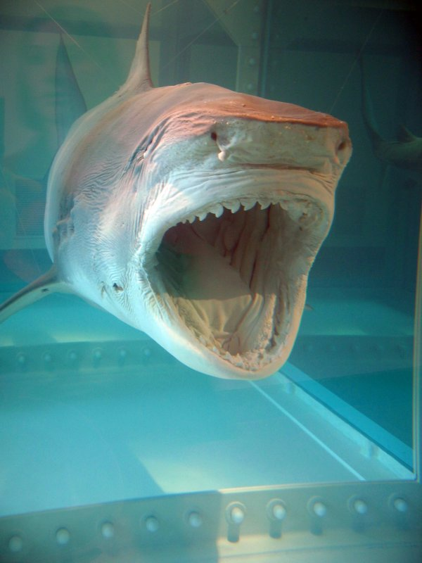
By replacing the shark, Hirst further demonstrates his callous approach to using animals for art as he does not question sentencing more animals to death to achieve his concept. Instead, Hirst engaged in a debate about whether the artwork should be considered as the same piece as the original, stating ‘I come from a conceptual art background... it’s the same piece’ (Hirst cited by Vogel, 2006). This indicates that Hirst views sharks as inanimate objects that assist him with the creation of his concepts and not as individual beings. He is unable to sympathise with the sharks as sentient beings that had separate lives and different experiences, just like two individual humans would. This shows the extent of his human superiority as he advertises his detrimental attitude and treatment of the natural world through his art.

(Left) Figure 7: The Physical Impossibility of death in the Mind of Someone Living (Hirst, 1991)
(Right) Figure 8: Basking Shark Currach (Cross, 2013)

It is interesting to compare Figure 7 with Figure 8 as Hirst uses the entirety of the shark, claiming that his sculpture had ‘no weight’ (Hirst quoted by Vogel, 2006) when the shark skin was moulded over fiberglass after it began to decay. Whereas Cross used solely the skin of a washed-up basking shark. Her sculpture certainly has weight despite excluding the majority of the shark’s carcass because it is cleverly partnered with the skeletal currach. Cross’ sculpture has been constructed from ethically sourced materials that provoke the viewer into reflecting upon the human relationship with the natural world, especially when comparing it to Hirst’s work.

Both artworks explore death and mortality yet, the artists have very different processes of doing so: Hirst uses animal carcasses as a material, sentencing many animals to death for his art whereas, Cross works organically with found objects. Cross’ Basking Shark Currach presents us with a sculpture that successfully depicts a shark like Hirst’s but avoids inflicting more death on the non-human. Cross’ sculpture comments on our position in, and relationship to the world as she relies on debris washed ashore, a process facilitated by the movements of nature – a peaceful collaboration.

Cross’ piece is eerily beautiful and mystical because the sculpture suggests a shark rather than physically being a shark highlighting the obviosity and lack of creativity that Hirst’s sculpture suffers from. Furthermore, Cross’ process of reusing items that nature essentially gifts her strongly contrasts Hirst’s process of destroying animals in the natural world. In summary, Cross’ process is more sustainable than Hirst’s because he participates and endorses the destruction of the planet; by killing creatures and their habitats, we are – essentially, circuitously – killing ourselves. The sustainability of art processes is something that we need to consider moving forwards because Earth is in a critical state and art gives artists the opportunity to set a president and inspire society.

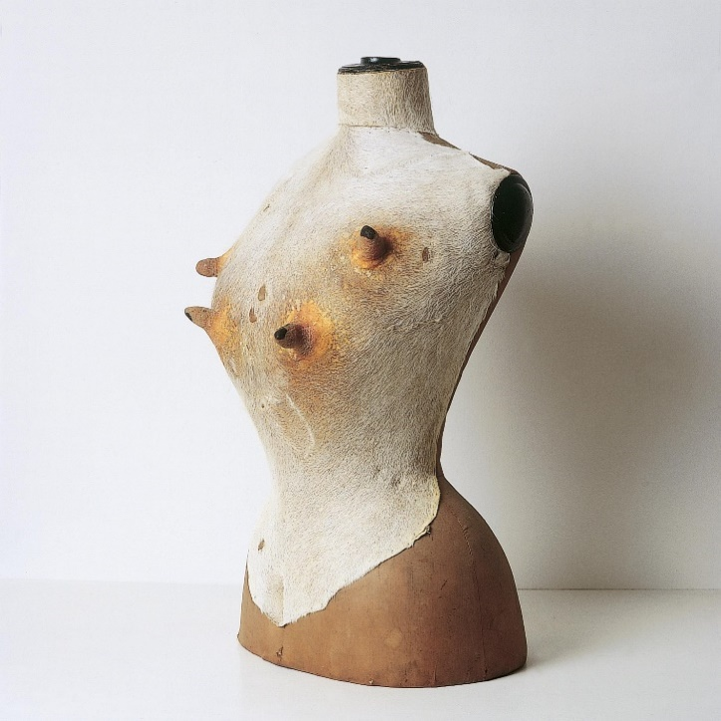
Figure 9: Bust (Cross, 1993)

Cross’ earlier work consisted of cow udders and skins sourced from abattoirs in which cows were killed for the leather industry (Cross, n.d.) for example, Bust (1993). Thus, it could be argued that Cross previously exploited animals for art in a similar way to Hirst. It is significant that it was these types of works that gave Cross the widespread attention and recognition she received, as her process resembles Hirst’s. Therefore, both artists use bodies and body parts of dead animals in their work to provide shock and spectacle, which is inextricably linked to their infamy.

However, Cross’ sculpture is made from the offcuts of cows that are classed as by-products so, essentially the products she uses are waste. Cross approaches the use of cow udders from a feminist standpoint, visually connecting the mammary glands of cows to the human. Thus, exploring the intersection of feminist and animal studies which relates nature and the non-human to humans. Studying Cross with an advocacy approach, her link between human and cow mammary glands is interesting when we reflect on the typical process that dairy cows will endure: artificial insemination, pregnancy, birth, baby taken away, milked, and repeat, until she is slaughtered because she can no longer produce milk. By demonstrating that breasts and udders have the same purpose, we can sympathise with the emotional and physical turmoil that a dairy cow, a mother, will experience throughout her life.

It seems Cross, unlike Hirst, had compassion for the animals as she stated ‘I would cry. Even back then when those cows arrived there was a sadness’ (Cross cited by Barry, 2022). Cross comments on the grotesqueness of dealing with the wet skin and ‘know[ing] that an animal had at one time occupied it’ (Cross cited by Barry, 2022). As a result, Cross has moved away from working with flesh, instead she uses conventional materials for her sculptures like marble to depict flesh, which she states has the same essence ‘because we are all carbon in the end’ (Cross cited by Barry, 2022) thus, demonstrating that we can explore flesh without using animals.

Chapter 3:

Reflecting on the suggestion that Hirst’s work is about ‘theatre and playing with audience expectations and taking it to absolute extremes’ (Hattenstone, 2009), it is important to explore the connection between Hirst’s work and Performance Art, particularly Hermann Nitsch’s. Hirst and Nitsch push boundaries, exploring extremes and its effect on the audience by using animal carcasses. Both artists have received a huge amount of controversy for example, Nitsch’s 150 Action was cancelled and relocated because of an online petition that collected more than 21,000 signatures in response to Nitsch’s plan to use a bull’s carcass (Wahlquist, 2017).

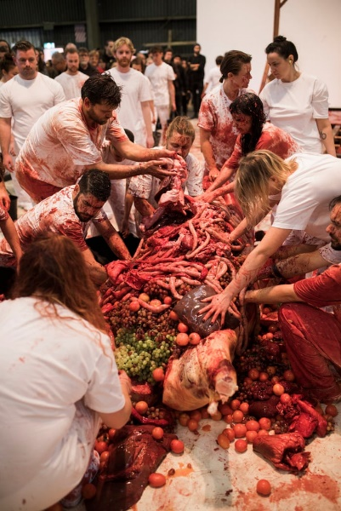
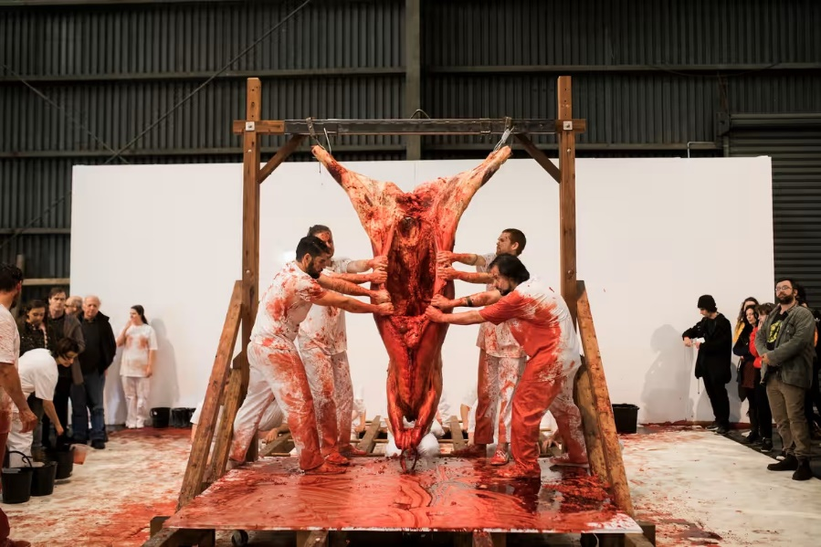
Figure 10 and 11: 150.Action (Nitsch, 2017)

150 Action was Nitsch’s 150th staging of the ‘bloody, sacrificial ritual’ that was part of his performance series Orgy Mystery Theatre that used meat, fish, fruit and blood – similar to the inanimate objects depicted in traditional still life paintings like Synders’ The Pantry. Thus, normalising the dead animal as it is presented and used amongst other quotidian objects. Figure 10 presents a similar scene of abundance to Figure 2 as the food is displayed in a feast-like manner, reflecting our contemporaneous obsession with excess and relating the notion of meat to greed and power.

In response to criticism surrounding 150 Action, Dark Mofo’s creative director, Camichael, confirmed that no living animals would be slaughtered instead, a carcass would be sourced locally, from a site that kills animals ‘humanely, adhering to Australian standards’ (Ruiz, 2017). Repeatedly, we encounter the notion of animals being killed ‘humanely’, a subjective social construct as Australian standards regarding animal agriculture ‘fall below’ those in the UK (Mussell quoted by Farhoud, 2021). For example, it is not compulsory to have CCTV in the slaughterhouses and the painful process of heat branding is legal (Farhoud, 2021). We can observe that the ‘humane’ treatment of animals is an interchangeable term because there are many differences in its definition throughout the world.

This correlates to speciesism because it is socially acceptable and considered as moral to consume animals such as, pigs, chickens, sheep and cows in the UK whereas, China’s Yulin Dog Meat Festival is considered widely as ‘disgraceful animal torture and cruelty’ (O’flynn, 2015) mainly because of how we perceive dogs, our companion animals, in the UK. It is interesting to reflect on the links between our perception of animals, our treatment of them and the law behind animal welfare as Nitsch was arrested multiple times for actions related to Orgies Mystery Theatre performances and expelled from Italy for dismembering a sheep (Green, 2022).

Barcio argues that ‘the carnage that accompanies the performances Nitsch stages is nothing compared to what a typical worker in a commercial slaughterhouse sees five minutes into an average shift’ (2017) so, Nitsch’s recontextualisation of animal slaughter, dismemberment and disembowelling transforms the legality of his actions. Thus, it can be assumed that the controversy surrounding both Nitsch’s and Hirst’s work, and the illegality of Nitsch’s, relates to the animal’s viscera that confronts the viewer that is hidden within animal agriculture. This suggests that although an action is legal in one context, it does not necessarily mean that it is moral.

The violent imagery surrounding the internal of the animal mirrors human materiality so, Nitsch’s repurpose of animal blood - a symbol of pain and suffering - provokes strong reactions and repulsion unintentionally. Blood can also symbolise power, with this in my mind, the carcasses used in Nitsch’s performances, and The Pantry signify our human superiority causing the subjugation and destruction of animals and nature.

Smith’s argument that ‘violence thinly disguises the work’s basic tameness and laziness’ (Cited by Green, 2022) correlates to the obviosity of Hirst’s work as previously discussed in Chapter 2. At face value, the exploration of human life and death through the use and slaughter of non-human animals is exciting and revolutionary. However, beneath the violence, the works are ‘tame’ and lack creativity. Although, Nitsch does not use violence to shock like Hirst, but to create intense scenes that awaken all the senses so, it is difficult to comment on the overall successfulness and effect of the artist’s work as one can only imagine the smell that would be present during the performances with the carcasses.

Despite this, we can observe that Nitsch’s use of the animals avoids waste because the meat is cooked and eaten in feasts that accompany the performances (Barcio, 2017). Additionally, it is metaphorically consumed during the piece by the performers. Nitsch utilises more of the animal than a typical western meat eater would since the shift from frugally using the whole of the animal, adopted during the war to ensure everyone had access to meat, to our current privileged position of purchasing prime cuts at supermarkets to our convenience. Nitsch blurs the lines significantly between the literal consumption of meat - perceived as moral - and his use of animals for art – considered immoral and even illegal in some circumstances. Nitsch’s recontextualisation of butchery affects whether the piece is considered as moral:

‘RSPCA Tasmania did not object to the humane slaughter of beasts for food but did object to Nitsch’s performance and criticised it for its lack of respect to animals’.
(Rakewell 2017; Wahlquist, 2017)

Arguably, the rearing and slaughter of animals for human consumption is similar to Nitsch’s demand of meat for artistic endeavours because he creates intense, sensory experiences that metaphorically lead to consuming the animal; ‘Before, he was hungry and now… he’s not hungry anymore’ (Nitsch cited by Convery, 2017). Nitsch argues that his use of animals fulfils vital human needs and desires in a way that is like our societal, moral slaughter of animals for consumption.
Walsh, the founder of MONA, stated that the event sparked ‘conversation about the appropriateness of slaughter’ before it even took place (Ruiz, 2017). Like Hirst, Nitsch unintentionally provokes controversy and discussion concerning the use of animals for art which helps us to understand the complexities of our moral stance regarding their societal use.
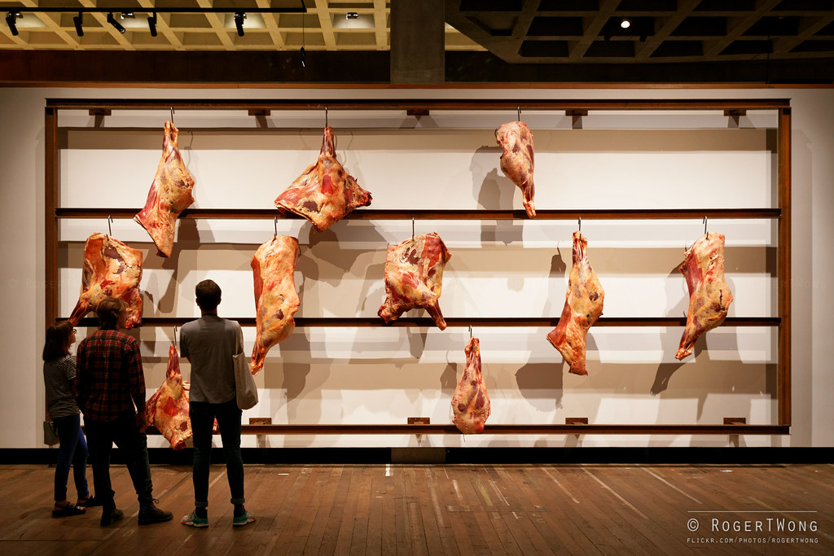
Figure 12. Untitled (Kounellis, 2006)
Walsh draws further comparison with Jannis Kounellis’ Untitled (2006), an installation of raw meat hanging on hooks, because the work was less controversial as the imagery is less violent and confrontational. Kounellis excludes the viscera, depicting a scene that is visible to most in butchers and shops across the UK. The absence of blood in the piece dismantles the connection between flesh and the death of a living being. This disconnect is strengthened through the dismemberment of the animal as it is not presented as a whole, like in Hirst’s work and the beginning of Nitsch’s performances.
Walsh questions whether ‘Is it possible that those who oppose [Nitsch’s] performance are aiding and abetting the iniquitous system, by concealing one more slaughter?’ (Walsh, 2017) indicating that Nitsch’s work (although unintentionally) has an important role in highlighting our moral hypocrisies surrounding the use of animals. Nitsch exposes the violent image of an animal’s death through his performances of ‘carnage’ (Barcio, 2017), offering an opportunity for viewers to reflect on the invisible violence that their decisions create. Although, Walsh’s statement demonstrates the difficulty of the scale of society’s demand for dead animals as he suggests that ‘one more slaughter’ (ibid) will not affect our situation. This might be true however, Walsh’s statement demonstrates that he clearly fails to accept that the cow was an individual, in the same way that humans are. Walsh compares Nitsch’s and Kounellis’ work, stating:

‘The only reason I can think of as to why that is okay, but Nitsch’s meat isn’t, is that Kounellis’ meat is killed for food and repurposed (side-effect), whereas Nitsch’s is killed for performance and later eaten (the side-effect is the only ‘legitimate’ purpose). I hate that Nitsch insists on eating the meat. I want clarity of intent—I want the audience to ponder why meat for food is okay (at least people aren’t protesting at Mona’s barbecue) but meat for ritual or entertainment isn’t’.
(Walsh, 2017).

Walsh indicates that he wants Nitsch to refuse to eat the carcasses used for his art because that would trigger louder questioning of our collective acceptance of mass animal suffering and slaughter for human pleasure. Thus, Walsh highlights that just because the consumption of animals is historically and widely accepted it does not mean that we should consider the actions moral because when they occur in a gallery, we typically condemn them like in Hirst’s and Nitsch’s work.

Conclusion
In conclusion, this thesis has explored the complexity of the human-animal relationship relating to our current disconnect from nature. We have looked at the affect that cultural differences can have on our perception of certain animals and consequentially our treatment of them, and how controversial reactions to cultural events and contemporary art - that uses animals to physicalise mortality, making death visible - highlight our moral ambiguity and hypocrisy regarding factory farming and the slaughter of billions of animals every day.
Synders establishes that the shift from consuming meat to exclusively plants is not radical, but more peaceful and less damaging to the planet, long before scientific links between factory farming and climate crisis were discovered. Synders and Adams demonstrate that there is a correlation between our violent treatment of animals and the abuse of the planet.
However, the meat and dairy industries ensure that our destructive actions are invisible because they prioritise money over socio-economic issues. This lack of transparency denies us the opportunity to reflect and change. It is clear there is space so, we must use art to explore the notion of the victim of the non-human, referring to animals and nature.
Although unintentional, Hirst’s and Nitsch’s work unsettles viewers by allowing them to explore the violent imagery that correlates to a being’s death. Their works offer us a new context behind the slaughter of animals, abandoning the lies and propaganda that is usually delivered with an animal's death. Thus, people can observe the hidden actions that they are implicit in from an unbiased, outside perspective. When controversy is expressed, one can reflect on their morals and feelings about the treatment of animals.
Moving forward, art seeking to change perceptions about this subject, should create a similar effect and provoke the same reactions of disgust, shock and repulsion that Nitsch and Hirst do. This will highlight the viewer’s moral hypocrisy but needs to be executed without the suffering and unsustainable materials. Using waste products, like Cross, is the best example of this from using offcuts that are by-products from the meat and dairy industries to deconstructing washed-up animals. Cross peacefully works with nature, an additional thought-provoking layer to her art that comments on our relationship to the more-than-human world. This is where the future of art must go, so that it can educate and advertise new ways of living to viewers and filter through into society.

Appendix

Megan Kane in conversation with Jack Allen, my partner:

Megan: I am currently writing my dissertation and I’m interested in the societal associations of meat with the notion of masculinity. As a vegan male can you describe your feelings about being a vegan:

Jack: Very positive really, I am proud that I have the confidence to question my feelings and behaviours, even if it means not letting societal norms affect my decisions and actions. Going vegan has encouraged me to research my nutrition and health a bit more so, now I am fully aware of the food that I am putting into my body. I have tried so many incredible new foods since my diet has changed.

Megan: Can you tell me some of these new foods:

Jack: nutritional yeast, soya mince, an array of mushrooms. I have even gone alkaline vegan for a while

Megan: You talk positively about being vegan Jack, has there been any negatives:

Jack: Regarding my physical and mental health definitely not, we were fattys before going vegan! However, some people in my life found it kind of offensive, I guess? I dont know it was weird, not everyone was approving.

Megan: Can you give me an example:

Jack: Yes, my cousin Morgan, who is the same age and gender as I found out, I didn’t tell him. But, I remember we went for a meal with my Grandad, and he described me as a pussy for ordering a vegan option.

Megan: How did that feel:

Jack: It was upsetting, it is not nice to think that someone's view or respect has changed just because you have made a choice based off on what is best for you. I also had some instances with my Dad too. It’s a massive problem because abstaining from animal products is thought to be a girl's thing, so when it's not it ruffles a few feathers, I think.

Megan: Thank you for letting me interview you, I love that you're going against the genders norms and standing up for your beliefs.

Bibliography
Aloi, G. (2012). Art and animals. London; New York: I.B. Tauris.Apollo Magazine. (2017). Beauty and the (dying) beasts. [online]
Available at: https://www.apollo-magazine.com/beauty-and-the-dying-beasts/ [Accessed 14 Dec. 2023].

Barcio, P. (2017). The (Un)Intentional Controversy in Hermann Nitsch Art | Ideelart. [online] IdeelArt.com.
Available at: https://www.ideelart.com/magazine/hermann-nitsch [Accessed 23 Nov. 2023].

Baker, S. (2013) Artist/Animal. Minneapolis: University of Minnesota Press.

Barry, R. (2022). Dorothy Cross presses the flesh. [online] Apollo Magazine. Available at: https://www.apollo-magazine.com/dorothy-cross-irish-sculptor-interview-frith-street/ [Accessed 14 Dec. 2023].

Bridle, J. (2022) Ways of Being Ireland: Allen Lane

Coetser, Y.M. (2019). Cruel Art: Intersections between Art, Animals, and Morality. de arte, pp.1–19.
Available at: https://www-tandfonline-com.ezproxy.uwtsd.ac.uk/doi/epdf/10.1080/00043389.2019.1643072?needAccess=true [Accessed 23 Nov. 2023].

Coleman, E. et al. (2021) ‘Artistic Freedom or Animal Cruelty? Contemporary Visual Art Practice That Involves Live and Deceased Animals’, Animals (Basel), 11(3), pp. 812-. Available at: https://doi.org/10.3390/ani11030812. [Accessed 23 Nov. 2023].

Convery, S. (2018). Can blood, guts and gore in art be beautiful? Nitsch shows it can | Stephanie Convery. [online] the Guardian.
Available at: https://www.theguardian.com/culture/2017/jun/20/can-blood-guts-and-gore-in-art-be-beautiful-nitsch-shows-it-can. [Accessed 23 Nov. 2023].

Corman, L. (2015) ‘Attending to Artists’ Voices: A Review of Artist/Animal by Steve Baker’, Journal of Animal Ethics, 5(1), pp. 83–91.
Available at: https://doi.org/10.5406/janimalethics.5.1.0083. [Accessed 23 Nov. 2023].

CROSS, A. (2018) ‘The Animal Is Present: The Ethics of Animal Use in Contemporary Art’, The Journal of aesthetics and art criticism, 76(4), pp. 519–528.
Available at: https://doi.org/10.1111/jaac.12587. [Accessed 23 Nov. 2023].

Cross, D. (n.d.). Udders (1992–1995). [online] Available at: https://www.dorothycross.com/1999-88/udders. [Accessed 23 Nov. 2023].

Elbaor, C. (2017). Hermann Nitsch Performance Stirs Protests in Tasmania. [online] Artnet News.
Available at: https://news.artnet.com/art-world/hermann-nitsch-tasmania-929576. [Accessed 23 Nov. 2023].

Fairley, G. (2022). Vegan art materials: taking the animal out of art. [online] www.artshub.co.uk. [Accessed 23 Nov. 2023].
Available at: https://www.artshub.co.uk/news/career-advice/vegan-art-materials-taking-the-animal-out-of-art-2554096/ [Accessed 14 Dec. 2023].

Featherston, D. (2013). Intersection of Nonhuman Animals and Art. [online] philpapers.org.
Available at: https://philpapers.org/rec/FEAION [Accessed 15 Dec. 2023].
Foreman, P. (2023). Inside the UK Farming Industry: How Are Animals Kept And Killed In Britain? [online] Plant Based News.
Available at: https://plantbasednews.org/culture/ethics/inside-uk-farming-industry-how-animals-killed-britain/ [Accessed 23 Nov. 2023].

Goldstein, C. (2017). How Many Animals Have Died for Damien Hirst’s Art to Live? We Counted. [online] artnet News.
Available at: https://news.artnet.com/art-world/damien-whats-your-beef-916097. [Accessed 23 Nov. 2023].

Green, P. (2022). Hermann Nitsch, an Artist With Guts, as Well as Blood, Dies at 83. The New York Times. [online] 23 Apr
. Available at: https://www.nytimes.com/2022/04/23/arts/hermann-nitsch-dead.html. [Accessed 23 Nov. 2023].

Hattenstone, S. (2009). Simon Hattenstone views Marcus Harvey’s new artwork. [online] the Guardian.
Available at: https://www.theguardian.com/artanddesign/2009/feb/21/marcus-harvey-margaret-thatcher. [Accessed 23 Nov. 2023].

Jenkins, E., DeChant, M. and Perry, E. (2018). When the Nose Doesn’t Know: Canine Olfactory Function Associated With Health, Management, and Potential Links to Microbiota. [online] Frontiers.
Available at: https://www.frontiersin.org/articles/10.3389/fvets.2018.00056/full 29 March 2018 [Accessed 13 Dec. 2023]
Kritzinger, N. (2017). What you need in the afterlife: Steven Cohen’s ‘put your heart under your feet… and walk!’ [online] ArtThrob.
Available at: https://artthrob.co.za/2017/11/16/what-you-need-in-the-afterlife-steven-cohens-put-your-heart-under-your-feet-and-walk/ [Accessed 15 Dec. 2023].
Lovgren, S. (2005). Chimps, Humans 96 Percent the Same, Gene Study Finds. [online] National geographic.
Available at: https://www.nationalgeographic.com/science/article/chimps-humans-96-percent-the-same-gene-study-finds. [Accessed 23 Nov. 2023].

O’flynn, E. (2015). Simon Cowell and Ricky Gervais lead calls to ban dog meat festival. [online] Mail Online.
Available at: https://www.dailymail.co.uk/news/article-3135889/Simon-Cowell-Ricky-Gervais-lead-call-ban-disgraceful-animal-torture-cruelty-Chinese-dog-meat-festival.html [Accessed 14 Dec. 2023].

Pagliarino, A. (2021). A Measure of Happiness—The Use of Live Animals in Contemporary Art Installations. AICCM Bulletin, 42(1), pp.26–42.
Available at: https://www-tandfonline-com.ezproxy.uwtsd.ac.uk/doi/full/10.1080/10344233.2021.1989257 [Accessed 23 Nov. 2023].

Palmeri, F. (2016). A Profusion of Dead Animals: Autocritique in Seventeenth-Century Flemish Gamepieces. Journal for Early Modern Cultural Studies, [online] 16(1), pp.50–77.
Available at: https://www.jstor.org/stable/jearlmodcultstud.16.1.50?seq=1 [Accessed 14 Dec. 2023].

Paul McCartney. (n.d.). ‘If slaughterhouses had glass walls, everyone would be vegetarian.’ [online]
Available at: https://www.paulmccartney.com/news/if-slaughterhouses-had-glass-walls-everyone-would-be-vegetarian. [Accessed 23 Nov. 2023].

Rizk, M. (2013). Issue 19. Antennae, [online] (Issue 19).
Available at: https://www.utoledo.edu/al/art/pdfs/rizk_ANTENNAE_2011.pdf [Accessed 23 Nov. 2023].

Ruiz, C. (2017). Storm erupts over Nitsch’s bull slaughter at Tasmanian museum. [online] The Art Newspaper - International art news and events. Available at: https://www.theartnewspaper.com/2017/04/19/storm-erupts-over-nitschs-bull-slaughter-at-tasmanian-museum [Accessed 14 Dec. 2023].

Sholl, A. (2017). It’s time we stopped anthropomorphising animals. [online] Metro. Available at: https://metro.co.uk/2017/07/19/its-time-we-stopped-anthropomorphising-animals-6767457/. [Accessed 22 Nov. 2023].

Singer, P. (1975). Animal Liberation. London: The Bodley Head.

Stone, R. (2023). Horrific scenes of animal abuse recorded at Red Tractor approved dairy farm in Wales. [online] Viva! The Vegan Charity.
Available at: https://viva.org.uk/media-centre/horrific-scenes-of-animal-abuse-recorded-at-red-tractor-approved-dairy-farm-in-wales/. [Accessed 22 Nov. 2023].

‘Mother and Child (Divided)’, Damien Hirst, exhibition copy 2007 (original 1993) | Tate. [online] Tate. Available at: https://www.tate.org.uk/art/artworks/hirst-mother-and-child-divided-t12751. [Accessed 22 Nov. 2023].

TRASHED HOW THE UK IS STILL DUMPING PLASTIC WASTE ON THE REST OF THE WORLD. (n.d.).
Available at: https://www.greenpeace.org.uk/wp-content/uploads/2021/05/Trashed-Greenpeace-plastics-report-final.pdf. [Accessed 22 Nov. 2023].

Viva!The Vegan Charity. (n.d.). Red Tractor Overview. [online]
Available at: https://viva.org.uk/red-tractor-overview/. [Accessed 22 Nov. 2023].

Vogel, C. (2006). Swimming With Famous Dead Sharks (Published 2006). The New York Times. [online] 1 Oct.
Available at: https://www.nytimes.com/2006/10/01/arts/design/01voge.html. [Accessed 22 Nov. 2023].

Wahlquist, C. (2017). Bloody Dark Mofo artwork using slaughtered bull ‘crosses the line’, RSPCA says. [online] the Guardian.
Available at: https://www.theguardian.com/culture/2017/apr/19/bloody-dark-mofo-artwork-using-slaughtered-bull-crosses-the-line-rspca-says [Accessed 22 Nov. 2023].

Walsh, D. (2017). Rising tide – Blog. [online] Mona. Available at: https://mona.net.au/blog/2017/04/rising-tide?utm_source=mail2&utm_campaign=MB17-02&cmp=1&utm_medium=edm [Accessed 14 Dec. 2023].

Winters, E. (2023). THIS IS VEGAN PROPAGANDA : (and other lies the meat industry tells you). London: Ebury Press

S.L.: Vermilion.www.rct.uk. (n.d.). Sir Peter Paul Rubens (Siegen 1577 - Antwerp 1640) & Frans Snyders (Antwerp 1579 - Antwerp 1657) - Pythagoras Advocating Vegetarianism. [online]
Available at: https://www.rct.uk/collection/403500/pythagoras-advocating-vegetarianism#/:~:text=This%20subject%20offers%20interesting%20contrasts [Accessed 22 Nov. 2023].

