

Assessment 1 – Reading Task Template
PART 1: Upload your photo of your A3 in-class notes here:
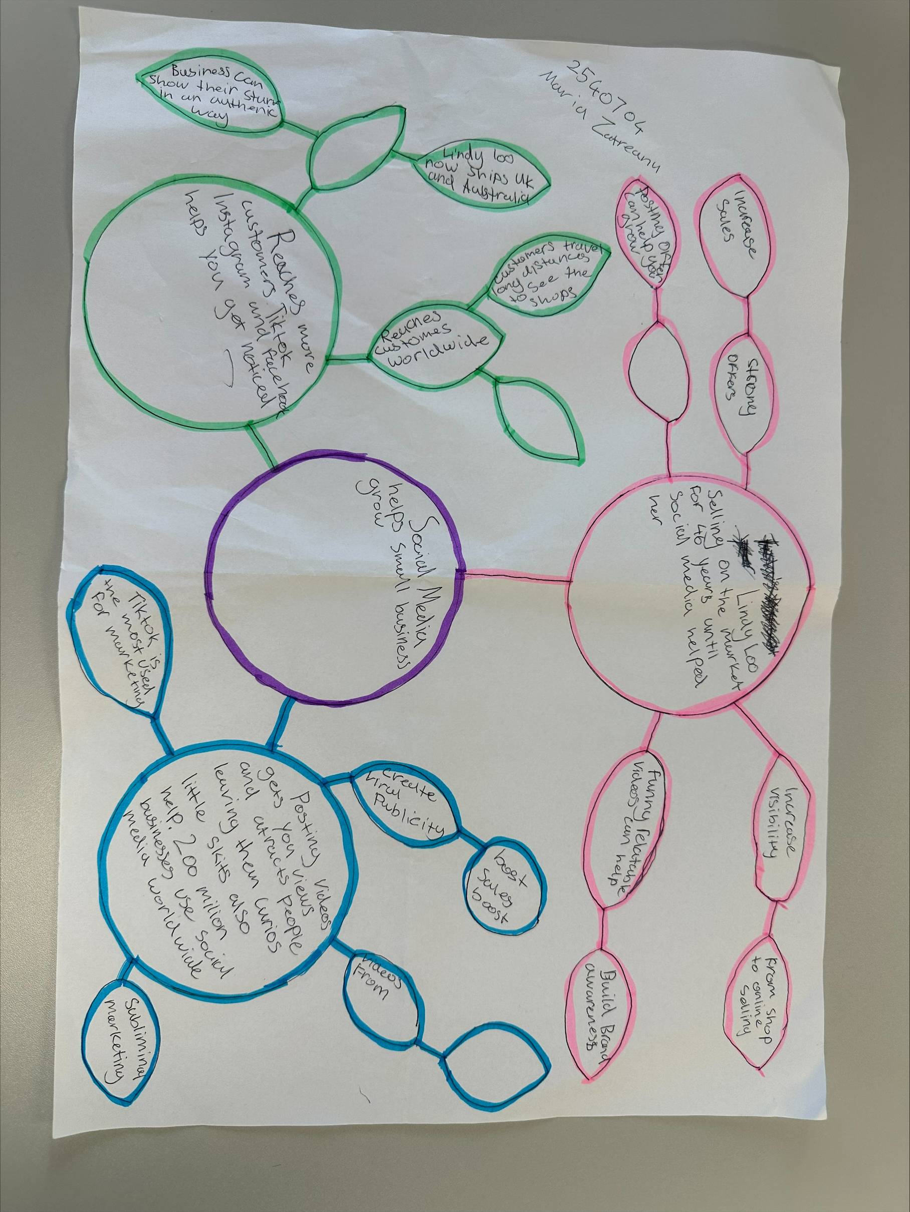

PART 2:
- Answer every question below in 1-3 full sentences.
- Use your own words. Do not use generative AI to answer these questions.
- Include a specific detail from the text when asked.
REMINDER
- The main idea is the overall message of the whole text.
- A key point helps to explain the main idea.
- A specific detail or example from the text shows that the key point is true.

- What is the main idea of the whole text?
The main idea of the text is how social media helps small businesses grow.

- What is one key point that supports the main idea, and which specific example from the text shows this?
One key point is that social media helps businesses attract more customers. The specific example is The Honeywood text; people travelled 3 hours to try its famous burger due to customers posting about its food.

- What is a different key point that supports the main idea, and which specific example from the text shows this?

A different key point is spudman became very popular after his videos went viral , which brought many more customers to his jacket potatoe stall.

- Which part of the text do you think is most important, and why?

The most important part of the text was how social media makes any small business grow very fast.

Reflection:
- What did you find difficult in this task (including in-class components), and why was it difficult?
The article and mind map was tricky but very interesting to learn , although the laptop skills were difficult for me , need to learn how to work on them better.

- What helped you with this difficulty, and how did it help you?

Reading very carefully the text helped because you have time to understand and learn ,made it easier to find the key points.

