Research Methods
Kayleigh Davies
149186
Research Methods
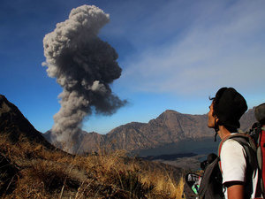
CRITICALLY ANALYSE THE IMPACT OF SEISMIC ACTIVITY ON EUROPEAN TOURISM

Contents page

Chapter title Page Number

- Introduction 3
Aims and objectives …………………………………………………………………………3
Rationale for research ………………………………………………………………………3
Literature review ………………………………………………………………………………4

- Research Methodology 5
Sampling …………………..………………………………………………………………………5
Ethical considerations and risks ….…………………………………………………….5
Data Analysis …………………………………………………………………………………….6

- Conclusion 6

- Appendices 7

- References 9

Introduction

This is a research proposal aimed to find out the impact volcanic activity has on European travel. I will inspect how British air travel was affected using a relevant case study and advise developments for future mishaps. I will conduct primary research to collect data on the public’s existing knowledge of volcanic eruptions to determine changes in travel motives to countries with tectonic activity. According to (Hussey & Collis, 2014), research is a “systematic process of investigating to generate knowledge” conducted to achieve a single outcome.

Aims and Objectives

To identify how tectonic activity has affected European tourism

- Investigate the history of volcanic activity around Europe using relevant case study.
- Carry out secondary research into this geographical issue.
- Assess whether volcanic activity affect the decision making of tourists?
Rationale for research
Several factors trigger volcanic activity from tectonic plate movement, extreme weather and the effects of climate change states (Heffernan-Marks, 2017). The most recent outburst of Eyjafjallajökull occurred in March 2010 and again in April after 2 centuries in dormancy. The eruption happened beneath an ice sheet resulting in an explosion of ash creating fiery sunsets across the continent. The tourism industry was affected massively at the peak of the Easter holiday’s where tourism is at its highest. I want to investigate if natural disasters such as this would put people off travelling to a certain destination for security and safety measures or whether this is another increasing form of adventure tourism.

Literature review
Tectonic activity is seismic movement along crustal plates explaining the phenomenon of continental drift. This theory was first recognised in 1915 by Alfred Wegner who clarifies these relative motions of movement cause volcanic activity, earthquakes and tsunamis (Wegner, 2011). Volcanic activity is an opening in the earth’s crust that ejects molten lava, hot gases and ash during eruption from pressure below the surface. These can be active which occur regular or dormant, that have high degree of unpredictability. An erupting volcano is one of the most powerful forces of nature. Although volcanoes can be destructive, they are responsible for creating rich agricultural soil and minerals to locals. Every country with active volcanos are monitored closely to share information and alert warnings. Pyroclastic flow and ash holds the most dominant threat to those living in the radius. The gas and ash majorly affect the climate which can result in issues worldwide. Volcanoes have fascinated humans since ancient times. Europe is home to the most well-known volcanoes including Mount Etna and Mount Vesuvius both situated in Italy. Mount Vesuvius is the volcano responsible for destructing Pompeii, wiping out human life of the roman cities back in 79AD. It is deemed as the most dangerous active volcano due to 3 million people living in the surrounding areas who are potentially always at risk. In agreement with (Owen, 2018), The catastrophic event of Pompeii is renown worldwide for burial of citizens “beneath tons of volcanic ash and debris” that engulfed a whole city within minutes. (volcanoes.org, 2012) announces there are currently 60 active volcanoes in regions such as Greece, Turkey and the Canary Islands.

Air travel receive significant implications if an explosion is severe. From delayed travel, stranded passengers and disruption to future flights, having a plan of action in place for when this disaster occurs is essential. Scientists monitor air quality, so the government can take necessary precautions. Study of volcanoes across Europe Is prevalent with careful study and monitoring of activity provided valuable scientific data to prevent casualties from eruption. In 2010, The Icelandic volcano Eyjafjallajökull wreaked unprecedented travel chaos throughout Europe damaging the fragile economy of over 2.5billion Euros (Gabbat, 2010). The BBC broadcasted via news video another volcano located closely to this site has signs of activity with hundreds of recorded tremors. This could “threaten to melt glacier ice and promote wide spread flooding” from billions of gallons of ice melting which could have “global implications” (Kane, 2010). Despite eruptions causing havoc for international air travel, a positive outcome of all this is that volcano tourism is on the rise. Since 2010, there has been a major boost to the Icelandic economy after struggling with fiscal crisis. The government body of tourism development “promote Iceland” announces a 50% increase in arrivals from the US since the monetary crisis. (VisitIceland, 2018). Reykjavik airport is the islands main hub who spotted a 25% increase over 2010 in transatlantic stopover passengers.

Despite the Icelandic air space being at a halt, its evident tourism is still on the rise. (Weekly, 2012). Travellers were opting for cruise holidays last minute because of this. The crisis did not impact ships ability to sail although passenger struggles were getting to and from vessels. The ability to get passengers to ships was undermined by a situation affecting every element of travel and leisure. Royal Caribbean cruises LTD said the volcano disrupted 6% if passengers on ships globally. (Travelweekly, 2010) Other areas of the tourism industry were hit far more severely. This treacherous adventure appeals to daring tourists thanks to improvement of monitoring systems and technology which enables visitors to come face to face with natural forces. Most eruptions throughout Europe have settled down resulting in thrill seekers travelling further afield to more active destinations like Japan. Geologists and volcano experts are now guiding these tours to provide knowledge and understanding of the area. Volcanoes are now approachable offering well established routes including cable cars, roads and trails. Italy is a hotspot for guided tours costing as little as 60 euros per person. Visitors can reach the highest point of Mount Etna with spectacular views of the Mediterranean Sea. Train routes circles the base of volcano in 3 hours passing remarkable black lava and hot springs.

Research Methodology

Secondary research is collecting existing data from online sources such as academic journals and websites. Online news reports provide me with up to date material that back up my work. Government reports can provide statistical data of current volcanic activity and how authorities are dealing with this geographical issue. The GOV.UK website is vital to use for travel advice. When searching keywords “Iceland volcano” the last warming was issued on November 17th, 2017 (GOV.UK, 2018) indicating higher levels of activity than normal. I will use websites such as (Nationalgeographic, 2015) to provide me a better understanding of the history in depth. BBC news and google news can portray statistical figures affected. I want to investigate the airport websites to grasp what was done to keep everything under control. It’s important to find out procedures for better understandings. I would conduct primary research from what I have found out. I would create a questionnaire on google forms that enables greater control on the information gathered. I can collect qualitive and quantitative data to a wider audience using social media as my platform. I can observe results as they go directly into a spreadsheet making data understandable when I evaluate findings. The aim of this questionnaire is to find out what people know on this topic so in future we can suggest recommendations if this were to happen. I would ask questions to quiz their knowledge on key facts and find out if their travel decisions would change based on volcanic activity. Primary would be a better form of research for me as I can see people’s current views on this subject. The questionnaire can be found on (Google Forms, 2018)
Sampling
My sampling will be intended for frequent travellers and holiday goers, some who may have experienced first-hand impacts of the travel chaos. Using social media as my main platform can reach out to a wider audience where I expect random people to answer the questionnaire. Hopefully, reaching around 30-50 people will make my results solid from the range of answers I’m hoping to receive back. Due to ethical reasons, answers must only be obtained from those over the age of 18. Questions that are included such as “would you be interested in Volcano tourism?” will hopefully help me achieve the set objectives. See Appendices.1 for examples questions I personally created using google forms if I were to do this primary research in future.

Ethical considerations & risks
When undertaking research, risks are highlighted with the focus being not enough participants which creates difficulty when sampling. It is significant to obtain random samples to ensure the overall result is not biased. If I fail to comply with random samples similar patterns could be surfaced. If these issues did arise, distributing the questionnaires throughout the university would be my next step to ensure I reach my objectives. Using university students is a great idea as you automatically know there will be a variety of ages, genders from different demographic areas which would help the final research results. It is advised all participants involved are over the age of 18 when filling out my questionnaire.

Data Analysis
Firstly, I will examine genders, age and current residence to recognise any patterns listed. The first 3 questions asked are to assess the publics volcanic trivia as well as their relationships with humans over the course of history. I am expected to see people situated in Wales having less amount of knowledge from no first-hand experience opposed to someone living in the disaster radius. The next questions were aimed personally to determine if volcano tourism could spark interest amongst applicants. I can see from the responses if willingness to engage in this area could be a possibility. Following this relates back to the aim of assessing change in traveller motives. I predict mixed results on this but the majority stating No due to expert opinions monitoring closely who issue government alert warnings when necessary. However, I reflect answers of yes for safety and security measures. The final question is designed to asses whether participants are informed enough on what to do in an emergency procedure. From this I can recommend that people lack information in specific regions within Europe and distribute contingency plans. These results will convert to a spreadsheet displaying charts summarising the data collected. Evaluation will show patterns in certain answers which could illustrate individuals are not feared when travelling to substantial risk destinations.

Conclusion
It is evident natural disaster if one of the leading factors affecting the tourism industry. From a tourism perspective the most damaging aspect is traveller perception on a destination. Natural disaster leads to considerable amount of infrastructure damage depending on the extent which hinders recovery. Activity is unwanted in omnipresent areas thriving off tourism. This proves difficulty to arise from, especially less economically developed countries whom feel the affects long after initial impact. Protected areas like Mount Etna are now accessible as attractions for the whole world to witness. Pleasure periphery zones in the world are most commonly subject to geographical catastrophes. The outcome of this requires bold decisions which often tend to be discounted rates of travel to restore the countries economy. This approach is beneficial short term but fails to last in the long run. Natural disasters are more profound, attributed from drastic weather patterns due to climate change. Unexpected disasters are more severe as no warning can be issued out fast enough to prepare.
The world tourism organisation released the annual report asserting the tourism industry and emergency services are to congregate and explore topics of cooperation in assisting victims of natural disaster to facilitate rapid recovery (UNWTO Annual Report, 2012). Fortunately, Europe is a continent with strong economies who don’t dependent on tourism for livelihood. Risks tend to diminish after initial impact. Response and recovery is the most effective management in overcoming these inevitable issues. The sector should consider disasters of this kind to safeguard sustainability to business’s. Having a contingency plan in place is designed as an alternative action to emergency circumstances. In Conclusion, Tourism authorities must adapt to change and use as an advantageous opportunity. Following the footsteps of Pompeii allowing tourists to explore profound history of a lost cities ruins.

Appendix
Appendices 1. Questionnaire Sample
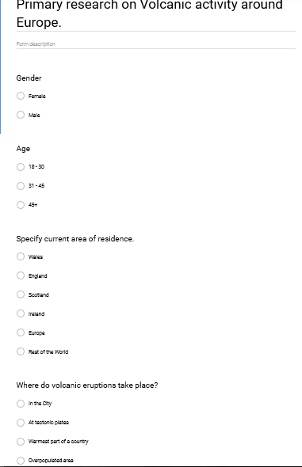 | 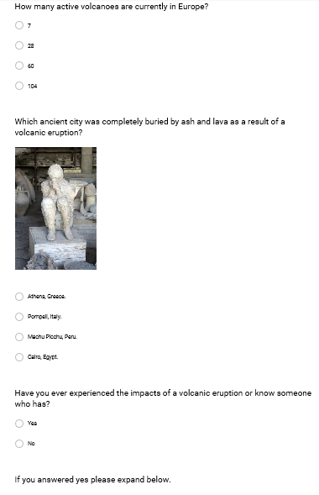
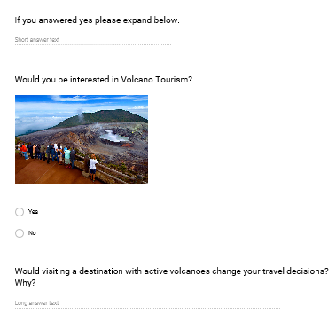 | 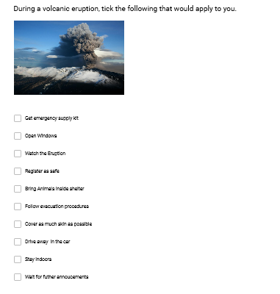

Gantt Chart
Timeline of activity | Date | Achieved
Chose research title | 06/02/2018 | √
Research Background  Aims and Objectives | 07/02/2018  10/02/2018 | √  √
Create Questionnaire | 13/02/2018 | √
Distribute questionnaire | 15/02/2018 | √
Analyse the data | 22/02/2018 | √
Build the report | 24/02/2018 | √
Ethical Consideration | 02/03/2018 | √
Finalise | 04/03/2018 | √
All activities recorded with
the Gantt chart were achieved
by the deadline.
Kayleigh Davies.

References

Books:
Business research:4th edition by Roger Hussey and Jill Collis 2014 (Hussey&Collis,2014)
The origin of continents and oceans by Alfred Wegner 2011. (Wegener,2011)
Websites:
(Heffernan-marks, 2017) https://cosmosmagazine.com/geoscience/why-do-volcanoes-erupt
(volcanos.org, 2012) https://www.volcanoes.org.uk/
(Gabbat, 2012) https://www.theguardian.com/world/2010/apr/27/iceland-volcano-cost-business-europe
(Gov.uk, 2018) https://www.gov.uk/foreign-travel-advice/iceland/natural-disasters
(Kane,2012) https://www.youtube.com/watch?v=8y2vNFhcaws
(visiticeland, 2018) https://www.inspiredbyiceland.com/about-iceland/
(weekly, 2012) http://www.travelweekly.com/Europe-Travel/Iceland-Crisis-as-opportunity?a=europe
(travelweekly, 2010) http://www.travelweekly.com/Cruise-Travel/Impact-of-ash-crisis-felt-in-all-sectors-of-travel-and-tourism
(UNWTO annual report, 2012) http://cf.cdn.unwto.org/sites/all/files/pdf/annual_report_2011.pdf
(Nationalgeographic, 2015) https://www.nationalgeographic.com/archaeology-and-history/archaeology/pompeii/
Googleforms, 2018) https://docs.google.com/forms/d/e/1FAIpQLSd6FVCCm1qv3AIblp0l90gf2gaL4l0gDaiIkyZaNBZo3jHdXw/viewform?usp=sf_link

