WORKSHEET 1 – TESTING (Using Variables)

- Original code:

using System.Runtime.ExceptionServices;

internal class Program
{

//This program will enable a user to input their Surname, National Insurance Number,
//and Age and each of the values will be displayed on the screen.
private static void Main(string[] args) //Program Start Point
{
//VARIABLES
string Forename; //Variable Forename declared as a string - Will store user's first name
string Surname; //Variable Surname declared as a string - Will store user's last name
string NINumber; //Variable NINumber declared as a string - Will store user's National Insurance number
int Age; //Variable age declared as an integer - Will store the user's age

//Forename
Console.WriteLine("Please enter your First Name/ Forename: "); //Requests input from user
Forename = Console.ReadLine(); //Gets input from user

//Presence Check
do
{
if (Forename.Length == 0)
{
Console.WriteLine("Error: Invalid entry!"); //Error message
Console.WriteLine(" ");
Console.WriteLine("Please enter your First Name/ Forename: "); //Requests input from user
Forename = Console.ReadLine(); //Gets input from user
}
}
while (Forename.Length == 0);

//Surname
Console.WriteLine(" ");
Console.WriteLine("Please enter your Last Name/ Surname: "); //Requests input from user
Surname = Console.ReadLine(); //Gets input from user

//Presence Check
do
{
if (Surname.Length == 0)
{
Console.WriteLine("Error: Invalid entry!"); //Error message
Console.WriteLine(" ");
Console.WriteLine("Please enter your Last Name/ Surname: "); //Requests input from user
Surname = Console.ReadLine(); //Gets input from user
}
}
while (Surname.Length == 0);

//National Insurance (NI) Number
Console.WriteLine(" ");
Console.WriteLine("Please enter your National Insurance (NI) number (e.g. PE 25 34 12 B): "); //Requests input from user
NINumber = Console.ReadLine(); //Gets input from user

do
{
do
{
if (NINumber.Length == 0) //Presence Check
{
Console.WriteLine("Error: Invalid Entry!"); //Error message
Console.WriteLine(" ");
Console.WriteLine("Please enter your National Insurance (NI) number: "); //Requests input from user
NINumber = Console.ReadLine(); //Gets input from user
}
}
while (NINumber.Length == 0);

do
{
if (NINumber.Length < 13) //Length Check
{
Console.WriteLine("Error: NI Number entered is too short!"); //Error message
Console.WriteLine(" ");
Console.WriteLine("Please enter your National Insurance (NI) number: "); //Requests input from user
NINumber = Console.ReadLine(); //Gets input from user
}
}
while (NINumber.Length < 13);

do
{
if (NINumber.Length > 13) //Length Check
{
Console.WriteLine("Error: NI Number entered is too long!"); //Error message
Console.WriteLine(" ");
Console.WriteLine("Please enter your National Insurance (NI) number: "); //Requests input from user
NINumber = Console.ReadLine(); //Gets input from user
}
}
while (NINumber.Length > 13);
}
while (NINumber.Length != 13);

//Age
Console.WriteLine(" ");
Console.WriteLine("Please enter your age (e.g. 24): "); //Requests input from user
Age = Convert.ToInt32(Console.ReadLine()); //Gets input from user

do
{
do
{
if (Age == 0) //Presence Check
{
Console.WriteLine(" ");
Console.WriteLine("Error: Invalid Entry!"); //Error message
Console.WriteLine(" ");
Console.WriteLine("Please enter your age (e.g. 24): "); //Requests input from user
Age = Convert.ToInt32(Console.ReadLine()); //Gets input from user
}
}
while (Age == 0);

do
{
if (Age < 15)
{
Console.WriteLine(" ");
Console.WriteLine("Error: You are not old enough to have a National Insurance Number!"); //Error message
Console.WriteLine(" ");
Console.WriteLine("Please enter your age (e.g. 24): "); //Requests input from user
Age = Convert.ToInt32(Console.ReadLine()); //Gets input from user
}
}
while (Age < 15);

do
{
if (Age > 101)
{
Console.WriteLine(" ");
Console.WriteLine("Error: Invalid Entry!"); //Error message
Console.WriteLine(" ");
Console.WriteLine("Please enter your age (e.g. 24): "); //Requests input from user
Age = Convert.ToInt32(Console.ReadLine()); //Gets input from user
}
}
while (Age > 101);

if (Age > 14 && Age < 101)
{
break;
}
}
while (Age !> 14 && Age !< 101); //Range Check

//Display Values to the user
Console.WriteLine(" ");
Console.WriteLine("First Name/ Forename: " + Forename);
Console.WriteLine("Last Name/ Surname: " + Surname);
Console.WriteLine("National Insurance (NI) Number: " + NINumber);
Console.WriteLine("Age: " + Age);

Console.WriteLine(" ");
Console.WriteLine("Please press enter to exit program");
Console.ReadLine();
}
}
- Code Testing

For each test below, run your code and enter the values provided. Provide a screenshot of the programme running. Did the programme behave correctly or did it do something unexpected? Fill in a box for each test below.

Surname:
- Enter JONES
- Leave blank
- Enter 123

National Insurance Number:
- Enter PE 25 34 12 B
- Leave blank
- Enter AB 11 22 33 44 55 66 77 (ie too long for National Insurance number format)

Age
- Enter 34
- Enter 150
- Enter -4
- Enter a letter

Test:
Surname i. Enter JONES

Screenshot(s) of output:
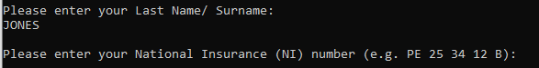
Result: Did the programme behave as expected ie syntactically and logically correct?
YES
A valid input was entered so the program requested the next piece of information.

Test:
Surname ii Leave blank

Screenshot(s) of output:
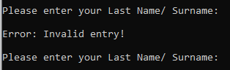
Result: Did the programme behave as expected ie syntactically and logically correct?
YES
Presence check worked and detected the lack of an inputted value from the user and therefore displayed an error message.

Test:
Surname iii Enter 123
Screenshot(s) of output:
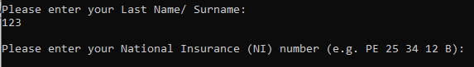
Result: Did the programme behave as expected ie syntactically and logically correct?
YES
No validation has been included to exclude numeric values as some people may be excluded as it is known for some people to have numbers included in their names.

Test:
National Insurance Number i Enter PE 25 34 12 B
Screenshot(s) of output:
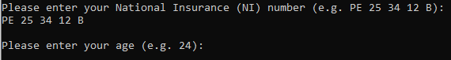
Result: Did the programme behave as expected ie syntactically and logically correct?
YES
Length check was used to ensure that 13 characters are entered by the user (including the spaces).

Test:
National Insurance Number ii Leave blank
Screenshot(s) of output:
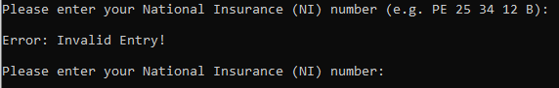
Result: Did the programme behave as expected ie syntactically and logically correct?
YES
Presence check identified missing input so it displayed an error message.

Test:
National Insurance Number iii Enter AB 11 22 33 44 55 66 77 (ie too long for National Insurance number format)
Screenshot(s) of output:
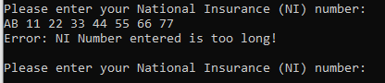
Result: Did the programme behave as expected ie syntactically and logically correct?
YES
Length check limited the number of characters to be entered as 13 as that is how many characters are included in a NI Number (including spaces).

Test:
Age i Enter 34
Screenshot(s) of output:
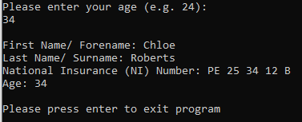
Result: Did the programme behave as expected ie syntactically and logically correct?
YES
A valid input was entered and since it was the last piece of information requested, it displayed all of the information to the user.

Test:
Age ii Enter 150
Screenshot(s) of output:
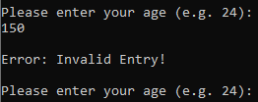
Result: Did the programme behave as expected ie syntactically and logically correct?
YES
Range check was used to ensure that a valid age was inputted which does not allow ages over 100.

Test:
Age iii Enter -4
Screenshot(s) of output:
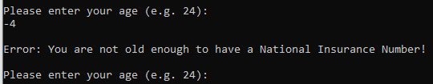
Result: Did the programme behave as expected ie syntactically and logically correct?
YES
Range check does classes ages below 15 as invalid as National Insurance Numbers usually arrive just before the individual’s 16th birthday but sometimes after leaving the possibility of a 15 year old being able to use this program.

Test:
Age iv Enter a letter
Screenshot(s) of output:
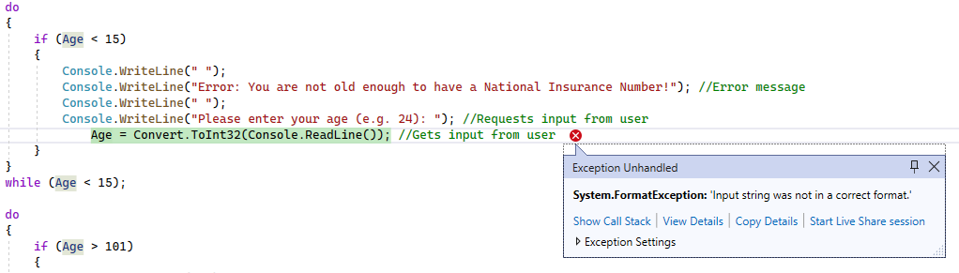
Result: Did the programme behave as expected ie syntactically and logically correct?
YES
Validation was not implemented to account for the potential input of non-numeric values as it is not expected and it informs me that the data type for the variable is an integer not a string by exiting the program and displaying it on the line that caused the break so the input therefore requires a numeric value of which is a whole number.

- Consider the results of the above tests and revisit your code in order to solve the problems. (Note: you may not be able to solve all of them, but solve as many as you can.)

Paste your revised code here:
[Copy and paste your revised code here – note, do not use a screenshot]

Was unable to prevent inputs other than integers from being inputted from test Age iv.

