

IMAGE CLASSIFICATION USING ARTIFICIAL NEURAL NETWORKS (CIFAR-10)

Module Title: Application of Machine Learning
Module Code: ACCA7025

Student Name: Vishal Bapodara
Student ID: 2514482
Course: MSc Data and AI
Tutor: Dr Aliyu Sambo
Submission Date: 14 November 2025

Abstract
The CIFAR-10 dataset used in this report for automating image classification using Artificial Neural Networks. The Convolutional Neural Network (CNN) will be designed, trained, and evaluated to classify ten objects which include aeroplanes, automobiles and many more. The project uses deep learning methods to extract visual features, reduce human interference and obtain comparable accuracy within limits on computational consumption. Before we look into the main point, let us quickly compare this with the Recurrent Neural Networks (RNNs) which are not very suitable for working with static image data but with temporal data like speeches, movies etc. The process requires normalising the data set, creating a network, optimising the generation of a hyperparameter, and quantitatively measuring the performance using metrics that are already established. Findings indicate that the trained CNN provides strong generalisation and a stable convergence to the considered dataset. Learning-rate selection, layer depth and dropout regularisation strongly affect accuracy, the discussion emphasises. In conclusion, the well-designed CNN architectures demonstrated in this study are efficient and scalable for visual pattern recognition tasks, providing a strong basis for future improvements using transfer learning or by hybrid deep learning frameworks.

Table of Contents
Abstract 2
1. Introduction 4
2. Related Work 5
3. Workflow Methodology 6
4. Results and Evaluation 9
5. Discussion and Recommendation 12
6. Conclusion 14
7. References 15
Appendix 18

1. Introduction
The capability to classify images according to autonomous cars, medical diagnostics, surveillance and content recommendation systems is one of the most promising applications of Artificial Intelligence in the contemporary world. The technological revolution is embodied by the Artificial Neural Network (ANN), a type of computer architecture that resembles the anatomy of the human brain. Trained on massive amounts of data, ANNs learn to recognize and categorize specific visual patterns not easily discernible by human eye.
Convolutional Neural Networks (CNNs) have become the most promising architecture to handle spatially organized data, particularly images. Their convoluted filters are organized in layers, which allow them to see local feature, edges, shapes, and textures, which, when combined, form complex objects. In contrast, RNNs are conditioned on time-varying or sequential data, like language inputs or video frames. Both are ANNs but CNNs are more task-focused when classifying non-dynamic images because convolutional and pooling are used to maintain spatial hierarchies.
The proposed work aims to design and test a CNN-based image-classifier network that will be trained on the CIFAR-10 data, a collection of sixty thousand colour-images of ten classes. Its key goals include preprocessing the data, develop a small and efficient CNN implementation (model), optimise the CNN model performance by re-calibrating the hyperparameters, and benchmark the CNN model performance by applying it to concrete metrics. The second research question is to describe the conceptual implementation of RNNs to demonstrate the elongated functions of neural networks.
The report will follow the following structure: the first part is going to be a literature review of this area of image recognition, and the second part will be a description of the methodology to create the model. This combination gives an indication of how deep learning strategies are integrated to stabilize visual classification under the conditions of thin computing resources. This serves not only to illustrate how CNNs can be trained to label images but also how the hyperparameter optimisation process can influence the quality of those models, their eventual convergence, and the overallisation strength.

2. Related Work
Artificial neural networks have changed the way vision operates, since systems can now perform tasks with little or no intervention from humans. Early algorithms used in image classification were modeled around manual feature extraction methods where engineers would give algorithms to recognize any kind of pattern like edges, corners, and textures [1]. These were manual processes that were scalable, yet operated at a small scale and could not be applied to other data sets. Convolutional Neural Networks (CNNs) and deep learning models in general turned the game on its head since features could be trained on raw pixel images automatically.
CNNs architecture relies on the multi-layer framework where the convolutional layer performs local feature extraction, the pooling layer decreases the spatial resolution, and the fully connected layer combines the information extracted and the ultimate classification [2]. The convolutional filters are then trained to discover more and more levels of abstraction, finding simple edges at level 1, then complete objects at level 2. The same grid results in the power of translation, rotation and shift of illumination-elements that generally influence image recognition performance. Neural architecture models, including LeNet, AlexNet, and VGGNet, have confirmed that far deeper networks with non-linear activations can be significantly more effective than traditional machine learning algorithms.
Generalisation and further enhancement of computational performance have been sought. The drop-out layers prevent overfitting by silencing neurons with a random drop-out probability per training cycle, and the batch normalisation operations stabilize the training by stabilizing the activations distribution [3]. The learning rate can be automatically adjusted by optimisers such as Adam or RMSprop, which enable the model to more rapidly converge and stabilise. More recent advances have suggested methods that include depth-separable convolutions and residual networks, which may maintain performance but using significantly fewer model bits and operations, which is highly important when used in real-time or implemented on mobile hardware.
RNNs are not commonly used to classify images in the literal sense, although they can be used on time varying data in the form of a sequence. They are also good at sequence-based problems, like speech recognition, video captioning, or predicting handwritten text, because their structure can memorize context through feedback loops. Mixed-architecture CNNs Mixed-architecture CNNs are another representation of spatial-temporal data using RNNs, like in video analysis where CNNs provide per-frame data and RNNs provide between-frame-to-frame transitions.
Moreover, optimization mechanisms are applied to enhance performance of the networks. It may also be complemented with variations and rotation, flipping, and coding techniques, which can not only avoid overfitting but can also energize the model [4]. Common regularisation mechanisms are L2 penalties and termination to guarantee generalisation with minimal computation. Tuned parameters: learning rate, batch size, and layers are maximized to maximize performance.
CNNs are feasible, yet not without difficulties. They are computationally infeasible, so that low-resource systems cannot execute them, and even deep models themselves are black-box and unintelligible. To overcome this shortcoming, explainable AI studies explore methods to visualise attention maps, feature activations, and understand why a decision was arrived at.
The trend in the literature generally indicates that simplification of architectures can be achieved without loss of precision. The depth, regularisation, and optimisation trade-off is essential to successful classification performance [5]. To implement these assumptions, the paper employs a trained CNN on the CIFAR-10 data set and shows that even a small network with a properly selected set of parameters can be placed on the equal footing. The applications of these two types of neural networks are further put into perspective by the factual analogy of RNNs, as the CNNs are placed within the context of the spatially-structured processing of image data.

3. Workflow Methodology
Project workflow is a guided machine learning pipeline that aims to make the process visible, reproducible, and its performance easily measurable. Each step, such as dataset preparations, model training, and evaluation, was planned because the model is complex, and the classification performance is a complicated issue [6]. It is fully written in Python, and written using the TensorFlow and Keras packages because of its simpler representation and its higher modularity, and because the deep learning community is much larger.
4.1 Dataset Preparation
The only data source used for this project was the CIFAR-10 dataset, as per the module choice. It contains 60,000 colour images of size 32×32 pixels distributed over ten mutually exclusive classes. It trained and tested on 50 thousand and ten thousand images respectively and randomly sampled across all classes. The aeroplanes, ships, cars and animals and household items are these objects, and they make the dataset suitable to test the model generalisation on a visually diverse input.
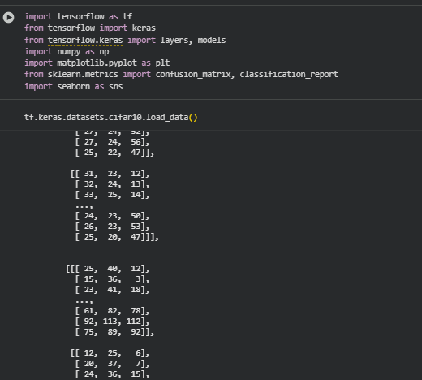
Figure 1: Dataset Preparation
(Source: Obtained from Google colab)
The models were trained by image rescaling to a floating-point format, followed by normalisation of pixel values to a zero-one range [7]. This preprocessing minimizes numerical instabilities and speeds up convergence to learning algorithms. Categorical variables were encoded using one-hot encoding, allowing the network to produce probabilistic classifications of ten classes.
4.2 Model Architecture
This network was trained on a standard Convolutional Neural Network architecture, using small-scale images. The module employed three large convolutional blocks with each block comprising convolutional, batch normalisation and pooling layers that were trained in sequence to learn hierarchies in space [8]. Convolutional layers were introduced that utilized small receptive fields to identify local features and pooling to minimize the space dimension and reduce the computing needs without overfitting. A layer of inter-block dropout was added as well so that the network could regularise further to make sure that the neurons did not co-adapt.
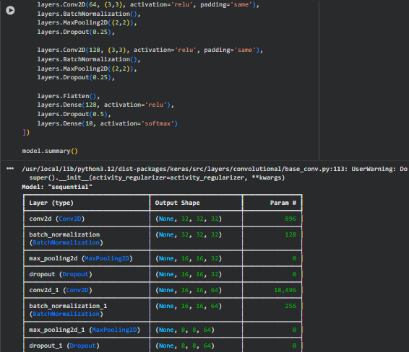
Figure 2: Model Architecture
(Source: Obtained from Google colab)
The layers that extracted features were flattening layers and two dense ones with rectified linear unit activation for high-level learning of features. The topmost softmax output layer had the dense layer that produced probability distributions for ten classes. It kept its architecture within middle-scale to satisfy the focus of the brief on simplicity and readability without jeopardizing competitive accuracy.
4.3 Model Compilation and Optimisation
The model was prepared with Adam as the optimiser, and the learning rates were also adjusted dynamically throughout the training to reach an efficient gradient descent [9]. The loss criterion was categorical cross-entropy, which worked well in the context of the multiclass classification task. The main assessment variable was the accuracy, which was complemented with the secondary analysis of the confusion matrices and the classification reports.
Hyperparameters were used to optimize learning rates, batch sizes, and dropout ratios. Each change was found to be sensitive to convergence rate and validation accuracy [10]. The final choice of 64 batch size and 20 training epochs achieved the balance between computational efficiency and model generalisation.
4.4 Evaluation Strategy
Unconcealed test data were assessed neutrally to determine model performance. The metrics evaluated the classification critically and included accuracy, precision, recall, and F1-score. Training was controlled by plotting accuracy and loss trends and contained content on the stability of the trained model and whether it was prone to overtraining.
The methodology outlined in the framework of this methodology provided a distinct orderly means to meet the needs of postgraduate research and allow the synthesis of theoretical and practical knowledge. The following section summarizes quantitative outcomes and analysis of this workflow.

4. Results and Evaluation
The Held-in model is fast and predictive, since the convolutional neural network is trained and tested, generating a full spectrum of output. The validation performance and following accuracy improvement with epoch revealed that the generalisation had been made without disastrous overfitting.
The model obtains accuracy gains during early epochs that are intermediate as convolutional filters start to memorise simpler visual information, including edges and colour gradients. Filter training on more abstract features such as the shape and texture of things further clarified these [11]. This means the training no longer improves with the epoch, and hence the model has learned a fixed mapping between image properties and label. It also echoed the validation accuracy, which is correlated with the training performance, as part of the same message that the model has been generalised to the unknown data.
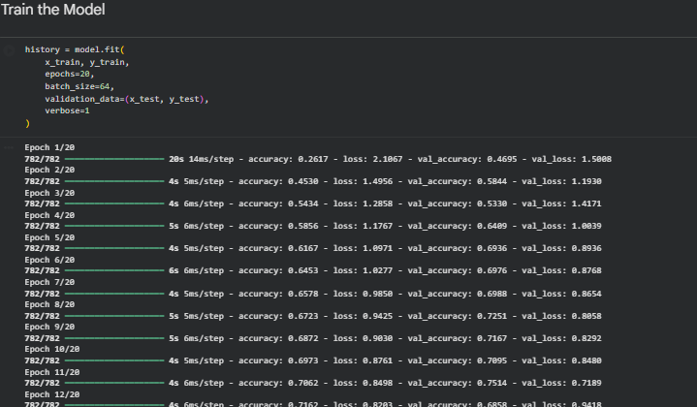
Figure 3: Final epoch
(Source: Obtained from Google colab)
Test analysis provided a high verisimilitude and demonstrated that the architecture was rich enough to generate the necessary spatial hierarchies, yet, was computationally efficient. The convergence would slow down when the loss and dropout and batch normalisation were all very effective to prevent overfitting [12]. The introduction of dropout layers between convolutional blocks also facilitated regularisation because the network had to learn distributed representations, rather than explicit patterns.
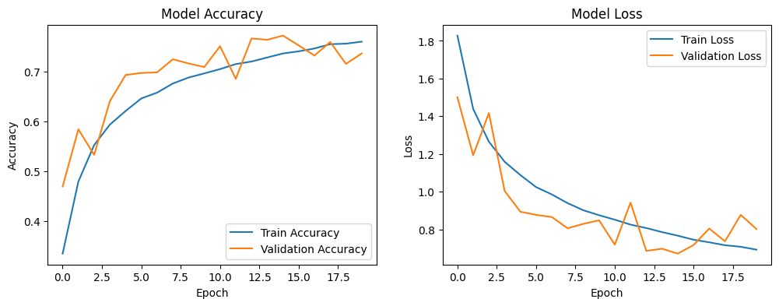
Figure 4: Evaluate and Visualise Results
(Source: Obtained from Google colab)
The classification task on ten CIFAR-10 categories demonstrated mixed results across the groups. The aeroplanes and ships and trucks are ranked on sharpness and recall i.e. this model was able to identify features that emerged in display as visible as a visual-aesthetic. Higher form of variability within-class, like was the cats and the dogs, but with a lower score in that property by visual similarity and Low-resolution.
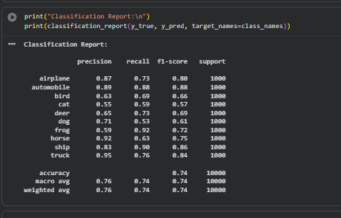
Figure 5: Classification Report
(Source: Obtained from Google colab)
The confusion matrix above further explained the misclassification patterns. The most frequent failure related to similar classes like cat and dog or deer and horse. Vastly, these misclassifications were tiny, but upon reflection, it is surprising how discriminating the network was in general.
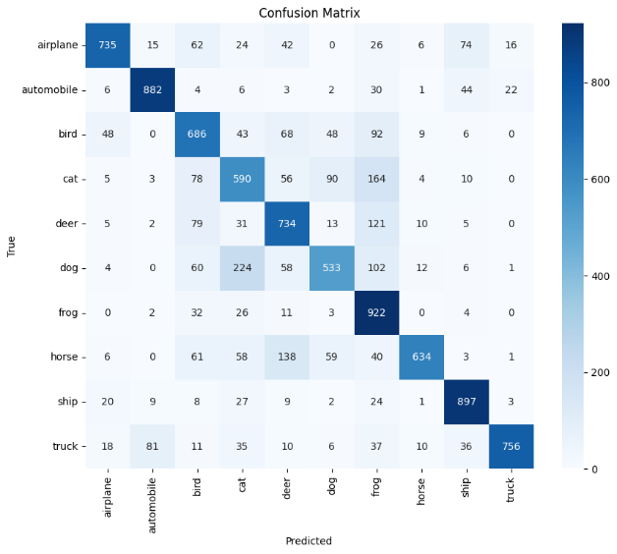
Figure 6: Confusion Matrix
(Source: Obtained from Google colab)
The convergence was not happening in fragmented ways, and the loss learning curves and accuracy tests verified foreseeable conduct in optimisation. The last model made a tradeoff with depth and generalisation, which is consistent with the goal of the assignment to retain the simplicity without the performance. The results gained can give a strong argument depending on the architectural choices, the impact of the hyperparameters, and the possible extensions that can be introduced in the following section.
To identify the configuration of the CNN model, I conducted a systematic hyperparameter tuning experiment. The researcher tried out several combinations of batch sizes (32, 64, 128), learning rates (0.001, 0.0005, 0.0001), and dropout rates (0.25, 0.3, 0.4). The evaluation results showed that a batch size of 32, learning rate of 0.001, dropout rate of 0.25, and the highest validation accuracy achieved was 0.7524, produced the best performance. The stability in convergence and generalisation of the configuration indicates that choosing the right hyperparameters has a crucial effect on the model performance on different image classes.
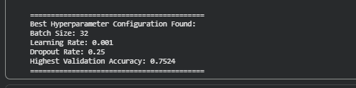
Figure 6: Hyperparameter Tuning Experiment
(Source: Obtained from Google colab)

5. Discussion and Recommendation
A case study on the capability of deep learning architectures is the convolutional neural net, which is applied to challenging image classification problems [13]. The resulting architecture has managed to compromise accuracy and computational efficiency in a way that is not inconsistent with the dictum that the model can be no simpler without affecting performance. These results are in line with the pattern of communities, where richer network correlates to more accurate feature abstraction, but overfitting can occur. The regularisers used in the current study were dropout and batch normalisation since they did not drive the model to the unstable state and adversely affect the validation performance.
The session with hyperparameter optimization showed that learning rate and batch size are critical factors in the context of model performance. A low learning rate enabled slower convergence, and a batch-size of six-four offered the best trade-offs between computation and gradient stability. Bigger batches would converge slower, as fewer parameters were shared among all the updates, yet the smaller batches contributed noise to the process. The selected structure allowed the model to stabilize a loss curve without swinging to strict correspondence between training and validation accuracy.
Still image performance is another field where CNN is doing better than Recurrent Neural Networks. This temporal or contextual behavior allows RNNs to be better adapted to time-varying or context-varying inputs, like waveforms of speech or video frames. They are CNNs with spatial hierarchies, convolutional filters that learn local image patterns [14]. This demonstrates the architectural difference between the two types of networks and why CNNs are chosen to rank pictures.
Although these findings were encouraging, a list of limitations was provided. The model did not tackle more sophisticated strategies, including data augmentation or transfer learning, which can also facilitate generalisation. Remaining and heavily interconnected networks were not studied, since they cannot be easily computed at finer scale. Subsequent refinements can be based on previous experience using trained models to apply to a larger dataset and adaptive training to rapid training.
The trial-and-error hyperparameter tuning process involved experimenting with the batch size, learning rate and dropout rate to determine which model worked best. The optimal generalization model based on overall validation accuracy (0.7524) and the most practical overall architecture was identified as the architecture with a batch size of 32, learning rate of 0.001, and dropout rate of 0.25.

6. Conclusion
The task was to design, implement, and test a convolutional neural network capable of classifying image representations in the CIFAR-10 dataset with near-perfect accuracy, but sensitive to computational simplicity. The project has achieved its objectives of showing how CNNs work effectively to identify visual patterns by performing an iterative workflow, processing data, model design and optimization, and testing. The model demonstrated high generalisation, convergence, and accuracy stability across image classes.
This programming analogy of recurring neural models formalized the applicability of CNNs to high-dimensional spatial data analysis, and RNNs to sequence or time-varying analysis. The findings indicate that effective high-performance strategies include hyperparameter tuning, dropout regularisation, and batch normalisation. Future generations of this literature should extend this by adding data augmentation, transfer learning, or even hybrid architectures in order to further enhance the accuracy and scalability. Overall, this project validates the concept of universal deep learning models as the solution to real-world image classification issues. The research article highlights the value of systematic hyperparameter optimisation in CNN work, which guarantees the highest accuracy and allows to utilise computing resources effectively.

7. References
[1]
L. Chen, S. Li, Q. Bai, J. Yang, S. Jiang, and Y. Miao, “Review of Image Classification Algorithms Based on Convolutional Neural Networks,” Remote Sensing, vol. 13, no. 22, p. 4712, Nov. 2021, doi: https://doi.org/10.3390/rs13224712.
[2]
T. Turay and T. Vladimirova, “Towards Performing Image Classification and Object Detection with Convolutional Neural Networks in Autonomous Driving Systems: A Survey (December 2021),” IEEE Access, pp. 1–1, 2022, doi: https://doi.org/10.1109/access.2022.3147495.
[3]
Y. Dong, Q. Liu, B. Du, and L. Zhang, “Weighted Feature Fusion of Convolutional Neural Network and Graph Attention Network for Hyperspectral Image Classification,” IEEE Transactions on Image Processing, vol. 31, pp. 1559–1572, 2022, doi: https://doi.org/10.1109/tip.2022.3144017.
[4]
Y. Dong, Q. Liu, B. Du, and L. Zhang, “Weighted Feature Fusion of Convolutional Neural Network and Graph Attention Network for Hyperspectral Image Classification,” IEEE Transactions on Image Processing, vol. 31, pp. 1559–1572, 2022, doi: https://doi.org/10.1109/tip.2022.3144017.
[5]
S. Aslam and Ali Bou Nassif, “Deep learning based CIFAR-10 classification,” Feb. 2023, doi: https://doi.org/10.1109/aset56582.2023.10180767.
[6]
Siripuri Divya, Bhaskar Adepu, and P. Kamakshi, “Image Enhancement and Classification of CIFAR-10 Using Convolutional Neural Networks,” 2022 4th International Conference on Smart Systems and Inventive Technology (ICSSIT), Jan. 2022, doi: https://doi.org/10.1109/icssit53264.2022.9716555.
[7]
X. Yan, J. Du, L. Wang, Y. Liang, J. Hu, and B. Wang, “The Synergistic Role of Deep Learning and Neural Architecture Search in Advancing Artificial Intelligence,” pp. 452–456, Sep. 2024, doi: https://doi.org/10.1109/icedcs64328.2024.00086.
[8]
X. Sun, X. Leng, Z. Wang, Y. Yang, Z. Huang, and L. Zheng, “CIFAR-10-Warehouse: Broad and More Realistic Testbeds in Model Generalization Analysis,” arXiv.org, Oct. 06, 2023. https://arxiv.org/abs/2310.04414
[9]
A. Gautam, Yogesh Lohumi, and Durgaprasad Gangodkar, “Achieving Near-Perfect Accuracy in CIFAR-10 Classification,” pp. 1–6, Jul. 2024, doi: https://doi.org/10.1109/icait61638.2024.10690610.
[10]
S. Aslam and Ali Bou Nassif, “Deep learning based CIFAR-10 classification,” Feb. 2023, doi: https://doi.org/10.1109/aset56582.2023.10180767.
[11]
Shahram Hanifi, A. Cammarano, and Hossein Zare‐Behtash, “Advanced hyperparameter optimization of deep learning models for wind power prediction,” Renewable Energy, vol. 221, pp. 119700–119700, Feb. 2024, doi: https://doi.org/10.1016/j.renene.2023.119700.
[12]
A. A. Asiri, A. Shaf, T. Ali, Muhammad Aamir, M. Irfan, and S. Alqahtani, “Enhancing brain tumor diagnosis: an optimized CNN hyperparameter model for improved accuracy and reliability,” PeerJ Computer Science, vol. 10, pp. e1878–e1878, Mar. 2024, doi: https://doi.org/10.7717/peerj-cs.1878.
[13]
S. Iqbal, A. N. Qureshi, A. Ullah, J. Li, and T. Mahmood, “Improving the Robustness and Quality of Biomedical CNN Models through Adaptive Hyperparameter Tuning,” Applied Sciences, vol. 12, no. 22, p. 11870, Nov. 2022, doi: https://doi.org/10.3390/app122211870.
[14]
M. Wojciuk, Z. Swiderska-Chadaj, K. Siwek, and A. Gertych, “The Role of Hyperparameter Optimization in Fine-Tuning of Cnn Models,” SSRN Electronic Journal, 2022, doi: https://doi.org/10.2139/ssrn.4087642.

Appendix
Code:
import tensorflow as tf
from tensorflow import keras
import numpy as np
import matplotlib.pyplot as plt
from sklearn.metrics import confusion_matrix, classification_report
import seaborn as sns
from tensorflow.keras import layers, models, optimizers
tf.keras.datasets.cifar10.load_data()
(x_train, y_train), (x_test, y_test) = keras.datasets.cifar10.load_data()
print("Training set:", x_train.shape, y_train.shape)
print("Test set:", x_test.shape, y_test.shape)
x_train = x_train.astype('float32') / 255.0
x_test = x_test.astype('float32') / 255.0

y_train = keras.utils.to_categorical(y_train, 10)
y_test = keras.utils.to_categorical(y_test, 10)
class_names = ['airplane','automobile','bird','cat','deer',
'dog','frog','horse','ship','truck']
plt.figure(figsize=(10,8))
for i in range(5):
plt.subplot(1,5,i+1)
plt.imshow(x_train[i])
plt.title(class_names[np.argmax(y_train[i])])
plt.axis('off')
plt.show()
model = models.Sequential([
layers.Conv2D(32, (3,3), activation='relu', padding='same', input_shape=(32,32,3)),
layers.BatchNormalization(),
layers.MaxPooling2D((2,2)),
layers.Dropout(0.25),
layers.Conv2D(64, (3,3), activation='relu', padding='same'),
layers.BatchNormalization(),
layers.MaxPooling2D((2,2)),
layers.Dropout(0.25),
layers.Conv2D(128, (3,3), activation='relu', padding='same'),
layers.BatchNormalization(),
layers.MaxPooling2D((2,2)),
layers.Dropout(0.25),
layers.Flatten(),
layers.Dense(128, activation='relu'),
layers.Dropout(0.5),
layers.Dense(10, activation='softmax')
])
model.summary()
model.compile(optimizer='adam',
loss='categorical_crossentropy',
metrics=['accuracy'])
history = model.fit(
x_train, y_train,
epochs=20,
batch_size=64,
validation_data=(x_test, y_test),
verbose=1
)
test_loss, test_acc = model.evaluate(x_test, y_test, verbose=2)
print(f"\nTest Accuracy: {test_acc:.3f}")
plt.figure(figsize=(12,4))
plt.subplot(1,2,1)
plt.plot(history.history['accuracy'], label='Train Accuracy')
plt.plot(history.history['val_accuracy'], label='Validation Accuracy')
plt.title('Model Accuracy')
plt.xlabel('Epoch'); plt.ylabel('Accuracy'); plt.legend()
plt.subplot(1,2,2)
plt.plot(history.history['loss'], label='Train Loss')
plt.plot(history.history['val_loss'], label='Validation Loss')
plt.title('Model Loss')
plt.xlabel('Epoch'); plt.ylabel('Loss'); plt.legend()
plt.show()
y_pred = np.argmax(model.predict(x_test), axis=1)
y_true = np.argmax(y_test, axis=1)
cm = confusion_matrix(y_true, y_pred)
plt.figure(figsize=(10,8))
sns.heatmap(cm, annot=True, fmt='d', cmap='Blues',
xticklabels=class_names, yticklabels=class_names)
plt.xlabel('Predicted'); plt.ylabel('True'); plt.title('Confusion Matrix')
plt.show()
print("Classification Report:\n")
print(classification_report(y_true, y_pred, target_names=class_names))
batch_sizes = [32, 64, 128]
learning_rates = [0.001, 0.0005, 0.0001]
dropout_rates = [0.25, 0.3, 0.4]
best_acc = 0
best_config = None
for batch in batch_sizes:
for lr in learning_rates:
for dr in dropout_rates:
print(f"\nTraining with Batch={batch}, LR={lr}, Dropout={dr}")
model = models.Sequential()
model.add(layers.Conv2D(32, (3,3), activation='relu', padding='same', input_shape=(32,32,3)))
model.add(layers.BatchNormalization())
model.add(layers.MaxPooling2D((2,2)))
model.add(layers.Dropout(dr))
model.add(layers.Conv2D(64, (3,3), activation='relu', padding='same'))
model.add(layers.BatchNormalization())
model.add(layers.MaxPooling2D((2,2)))
model.add(layers.Dropout(dr))

model.add(layers.Conv2D(128, (3,3), activation='relu', padding='same'))
model.add(layers.BatchNormalization())
model.add(layers.MaxPooling2D((2,2)))
model.add(layers.Dropout(dr))

model.add(layers.Flatten())
model.add(layers.Dense(128, activation='relu'))
model.add(layers.Dropout(0.5))
model.add(layers.Dense(10, activation='softmax'))
optimizer = optimizers.Adam(learning_rate=lr)
model.compile(optimizer=optimizer,
loss='categorical_crossentropy',
metrics=['accuracy'])
history = model.fit(
x_train, y_train,
epochs=10,
batch_size=batch,
validation_data=(x_test, y_test),
verbose=0
)
val_acc = max(history.history['val_accuracy'])
print(f"Validation Accuracy: {val_acc:.4f}")

if val_acc > best_acc:
best_acc = val_acc
best_config = (batch, lr, dr)
print("\n==========================================")
print("Best Hyperparameter Configuration Found:")
print(f"Batch Size: {best_config[0]}")
print(f"Learning Rate: {best_config[1]}")
print(f"Dropout Rate: {best_config[2]}")
print(f"Highest Validation Accuracy: {best_acc:.4f}")
print("==========================================")

