

Work Based Project
How Will Hitting the 2050 Net Zero Target Affect the Construction Industry?

Dafydd Allcock

HND

Year 2

Contents
Chapter 1 3
Provisional Title of Project 3
Overview 3
Research questions & Aims and Objectives 3
Research methods 3
Significance of Research 4
Chapter 2 4
Literature Review 4
Introduction 4
What is Net Zero? 4
Implications for the Construction Industry 5
Carbon Footprint of Construction 5
Sustainable Building Practices 5
Retrofitting and Upgrading 5
Advancements made in Construction that help hit the target. 5
Building Information Modelling (BIM) 5
Off-Site Construction and Modularization 6
Smart Systems and Automation 6
Policy Frameworks and Regulations 6
Building Regulations 6
Funding and Incentives 6
Challenges of Hitting the Net Zero Target 6
Cost Implications 6
Skills and Workforce 7
Chapter 3 7
Research Methodology 7
Research Objective 7
Data Collection Methods 7
Chapter 4 8
Findings 8
Introduction 8
Chapter 5 12
Discussion 12

Chapter 1

Provisional Title of Project
The target of hitting net zero carbon and the impact it will have on the construction industry in the United Kingdom.

Overview
In this project I will be researching the net zero target that was set by the UK Government with the intention of making the United Kingdom net zero carbon by the year 2050. As the construction industry is one of the biggest contributors of carbon emissions in the UK there needs to be big changes in the coming years for the UK to hit the target, this means there will be big changes in the industry. I will also investigate the cost impacts that companies in the construction industry could expect to see with all the changes that will need to be implemented.

Research questions & Aims and Objectives
The hypothesis for this project would be “Is the net zero target achievable by the construction industry in the United Kingdom by 2050, and what impact will it have on the industry?”. In this project I aim to see whether that the net zero carbon target is realistic for the construction industry specifically, and to see what impacts it will have, negative or positive.
My main objectives for this project are:
- To research the net zero strategy put in place by the UK Government to see what plan is in place to reduce the carbon emission of the construction industry.
- From the findings of my research evaluate the cost impact this will have on contractors throughout the UK.

Research methods
My main method of research for this project will be reading through government documents and independent research documents. When the net zero target was announced the government released 368 page “Net Zero Strategy” along with many other documents regarding the net zero target, so there is plenty of government documents to gather information from for my research.
I will also prepare a questionnaire related to my research; this can then be sent out to my colleagues in the commercial department to get the opinion of a QS on this topic as they have more experience in the industry. I will also send it to our operations director who has been researching sustainable construction to get the point of view of more experienced people working in different roles. I feel that it is important for me to get the people from various roles within my company to as it’s important to know the opinion of people within different roles as they will have different opinions and point of views. I also think it will be beneficial for my research to have the opinion from somebody on the client side of the industry. As the clients will be affected by this big change in the industry as well. The cost will be one of the largest changes for the client side, the time it takes for projects could also be affected. The questionnaire will need to be written in a way to include both negative statements about the topic, and the positive statements as we want to know they’re opinions whether it be good or bad. I will test the questionnaire with my close colleagues, friend or classmates before fully sending it out to see if its working and to get feedback on it, then revise it using that feedback to improve on it.
However, I feel that the main method of research will be the government documents as there is so much information that has been published as becoming net zero carbon is a mutual goal worldwide so there is plenty of information.

Significance of Research
Due to climate change sustainability is becoming a key part of life in today’s world. Sustainability is now prevalent across almost all industries, especially now in construction due to the massive amounts of carbon that the industry emits a year. As I work in the construction industry as a quantity surveyor, this is something I need to consider now on my projects, and I feel that it will become even more of a key factor in the coming years as we edge closer to the target net zero date of 2050. I feel like my research will benefit me with my work, and to gain knowledge on sustainability and to maybe even help my company understand the affect that this might have on us in the coming years.

Chapter 2

Literature Review

Introduction
The urgent need to combat climate change has led to drastic efforts to achieve net-zero emissions by 2050 in the UK. The construction industry is a massive contributor to greenhouse gas emissions, plays a vital role in meeting this target. This section will explore what is currently known about hitting the net zero target and the effects it will have on the construction industry in the United Kingdom.

What is Net Zero?
Net zero means to achieve balance between the greenhouse gas emissions produced and emissions removed from the atmosphere(Institute for Government, 2019). It calls for things such as minimizing emissions through energy efficiency, adopting renewable energy sources, and offsetting remaining emissions. The UK government has committed to achieving net-zero emissions by 2050, which is in line with the targets set by all the leading nations.

Implications for the Construction Industry

Carbon Footprint of Construction
The construction industry contributes significantly to carbon emissions through energy consumption, materials production and building operations. Achieving net zero will require reducing both embodied carbon (emissions from materials and construction processes) and operational carbon (emissions during building use). The cost of changing over to more renewable materials will be expensive and could have a knock-on effect throughout the industry. The construction industry is responsible for 38% of the CO2 emissions in the UK, and in 2019 the energy consumption from building operations increased by 9.95 gigatonnes (Environmental Journal, 2023)

Sustainable Building Practices
Hitting the net zero target means that a big shift toward more sustainable building practices. This includes designing more energy-efficient buildings, using low-carbon materials, adopting renewable energy technologies, and using efficient waste management systems. This also includes the construction plant and equipment used on site, as a majority of the plant is powered by diesel, a big change of equipment will need to be made to electric plant for the construction industry to lower the industries emissions enough to hit the 2050 target, which can prove difficult due to cost implications, availability and the reliability.

Retrofitting and Upgrading
Retrofitting existing buildings to improve energy performance is essential in achieving net zero. The construction industry must embrace retrofitting techniques, such as insulation upgrades, window replacements, and system optimizations, to reduce operational carbon emissions, it’s widely believed that as we approach the target date of 2050, smaller jobs like retrofits and upgrades will become increasingly popular. Although these smaller retrofitting jobs can be tedious, they offer more opportunity to the construction industry as they could offer more work.

Advancements made in Construction that help hit the target.

Building Information Modelling (BIM)
BIM allows constructors to carry out efficient planning, design, and construction processes, leading to reduced waste and energy consumption. It enables virtual simulations, energy modelling, and lifecycle analysis, enhancing sustainability in building projects. BIM has played a major role in the improvement of energy efficiency in new buildings and will continue to play a massive role, especially in the future.

Off-Site Construction and Modularization
Off-site construction methods like modularization and prefabrication, can minimize waste, enhance efficiency, and reduce carbon emissions. Prefabricated components manufactured in controlled environments offer opportunities for resource optimization and streamlined construction processes, to ensure that the industry hits the target off site construction will play a big part in lowering the emissions. Off-site construction can also speed up the programme of a project if done correctly and can improve the quality of work as it is assembled in a controlled environment.

Smart Systems and Automation
Integrating smart systems and automation into buildings can optimize energy use, monitor and control emissions, and improve overall performance. Intelligent systems for lighting, HVAC, and energy management contribute to energy savings and carbon reduction. In recent years smart systems have become increasingly popular in homes due to the cost-of-living crisis, as it gives people more power over their spending on energy.

Policy Frameworks and Regulations

Building Regulations
Stringent building regulations and energy performance standards are crucial for achieving net zero. The UK government has introduced regulations mandating higher energy efficiency standards and renewable energy integration in new buildings. Building regulations Part L is a great example of this, Part L of the Building Regulations focuses on the conservation of fuel and power in new and existing buildings undergoing renovations. The regulations set requirements for the energy performance of the building, the insulation levels etc.

Funding and Incentives
Financial incentives, grants, and funding schemes are essential for encouraging the construction industry to adopt sustainable practices. Governments and financial institutions can provide support to facilitate the transition toward net zero, encouraging investment in renewable technologies and low-carbon building materials. Over the past 3 years as a company, we have noticed our work slowly shift from petrol stations, to building electric vehicle chargers, this is due to the increase in funding into preparing the country’s infrastructure to cope with the net zero future.

Challenges of Hitting the Net Zero Target

Cost Implications
Arguably, the cost of transitioning the industry to net zero is the biggest challenge. Transitioning to net zero will involve additional costs for sustainable technologies, materials, and additional training for the workforce. However, long-term savings from reduced energy consumption and operational costs can offset initial investments over many years, and many will argue that the cost implications are a small price to pay when talking about the future wellbeing of the planet.

Skills and Workforce
The construction industry needs a skilled workforce well-versed in sustainable practices and technologies. Ensuring an adequate supply of skilled professionals and offering training programs will be critical for the industry's successful transition. To achieve this major investment into new training will need to be put into the industry which again adds on to the cost implications of hitting the target.

Chapter 3

Research Methodology

Research Objective
The objective of this research is to investigate the impact of hitting the net zero target on the construction industry. The project aims to understand the effects, challenges, and opportunities that arise from transitioning to net zero and identify the strategies and measures that the government has put in place to try ensure that the construction industry to achieves the goal.

Data Collection Methods
Questionnaires & Surveys: Handing out questionnaires and or surveys to construction companies, or individual professionals to gain data on the readiness of the individual companies and professionals to achieve net zero, it will also be a good way to see if any of the companies doing the questionnaire has taking any action towards trying out more sustainable methods of construction etc. It would be beneficial to question a lot of people with the questionnaire to gather a variety of opinions on the topic, it would also be beneficial if there was a variety of people with different experience levels, and different jobs to see the opinion of everyone on the matter.
Interviews: Carrying out interviews with the industry stakeholders is another great way of gathering information on this topic, this will include construction companies, construction workers. This qualitative method of data collection and will provide first hand insights into the challenges, strategies, and implications of hitting the net zero target in the construction sector. This will be an excellent way to get an insight into the opinions of other companies about the target and to see how different companies think that the change will affect the industry.

Chapter 4

Findings

Introduction
Fifteen questionnaires were handed out and ten of which were returned, which gives a return rate of about 67%. The questionnaires were sent out electronically on Microsoft Forms via e-mail, the return rate could have been improved by printing out the questionnaire and handing them out and collecting in person. The forms were sent out to various individuals that work in the construction industry; these individuals varied in experience.
Question 1
Question 1 asked for their role within the construction industry.
Role | Total
Contracts Manager | 5
Quantity Surveyor | 6
Project Manager | 3
Buyer | 1

The majority of individuals targeted were quantity surveyors and contracts managers, as is shown by the below chart.
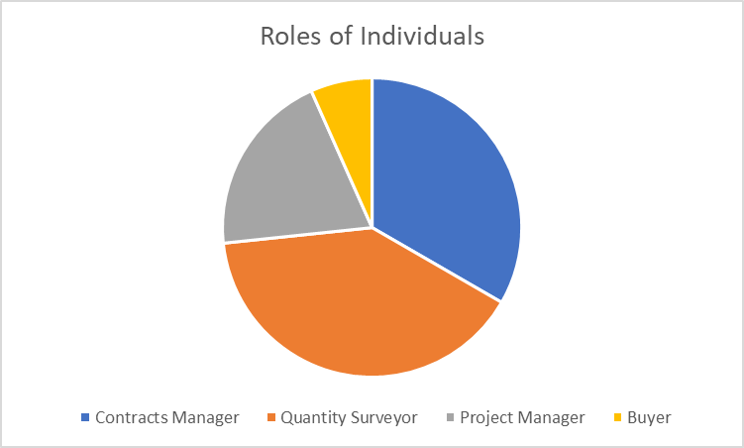

Question 2
Question 2 aimed to assess how many years’ experience they had working within the construction industry.
0 - 1 Years | 1
2 - 3 Years | 3
4 - 6 Years | 6
7 - 9 Years | 3
10+ Years | 2

A good mix of experienced and newer individuals were selected for the questionnaire but over 73% percent had been working in the construction industry for over 4 years, so the majority picked were experienced.
Question 3
Question 3 asked the individuals how familiar they are with the 2050 Net Zero goal.
Very familiar | 5
Somewhat familiar | 10
Not familiar at all | 0

All the individuals targeted by the questionnaire were at least somewhat familiar with the net zero goal but only 34% were very familiar.
Question 4
Question 4 asked the individuals if they had observed any changes or initiatives within the construction industry related to achieving the net zero goal, they were also asked to provide examples if they answered yes.
Yes | 12
No | 3

Of the 12 that answered yes to question 4, only 7 individuals provided and example. The most common explanation was relating to their clients asking for more sustainable options, for example one client asking for a car park to be done using carbon neutral asphalt.

Question 5
Question 5 asked what the potential benefits of the net zero goal for the construction industry in their opinion are and to select all answers that apply.
Increased demand for sustainable and energy-efficient buildings | 9
Opportunities for innovation and development of new technologies | 7
Job creation and economic growth | 13
Enhanced reputation for companies embracing sustainability | 8
Other | 5

Of the 15 peoples that returned the questionnaire 13 of which chose job creation and economic growth which makes it widely believed to be the biggest benefit to the construction industry.

Question 6
This question asked how prepared do you think the construction industry is currently to meet the net zero goal in the UK?
Very prepared | 2
Somewhat prepared | 7
Not prepared at all | 6

Question 7
Do you believe that achieving the net zero goal will require significant changes in the supply chain of construction materials?
Yes | 13
No | 2

Over 86% of individuals believe that significant changes will be needed to the supply chain of construction materials if we are to hit net zero.

Question 8
This question asked the individuals if the availability of sustainable construction materials currently a challenge in the UK?
Yes | 9
No | 6

60% of the individuals believe that sustainable construction materials are difficult to come by in the UK
Question 9
This question asked the individuals “Do you believe that the hitting the net zero goal will have a negative impact on the construction industry?”
Yes | 11
No | 4

Question 10
Do you believe the UK government and industry associations are providing adequate support and guidance to assist the construction industry in achieving the net zero goal?
Yes | 2
No | 13

Chapter 5

Analysis and Discussion
The purpose of the above questionnaire is to obtain data from workers within the construction sector on the effects that hitting the net zero target will have on the industry. The data obtained from the questionnaire was needed to get the opinion of other individuals of other individuals about the matter, and to ensure that the opinion was not biased, individuals from different companies, different trades, and different experiences we targeted to gain a wider understanding of how people think this will affect the industry. The first two questions of the questionnaire were asking the individuals of their roles and experience level, this adds another factor to analyse their opinions.

Question 3
This question asked the individuals how familiar they are with the 2050 Net Zero goal.
As shown in the below graph 67% of the individuals were somewhat familiar with the target, and the other 33% were very familiar with it. None of the respondents were not familiar with it at all.

Although it is good that all of the respondents were at least somewhat familiar with the net zero target, more should very familiar with the target as all of the respondents were in a management role. More training on sustainability should be given out to managers in the construction industry to insure that everyone is prepared when the time for change comes.

Question 4
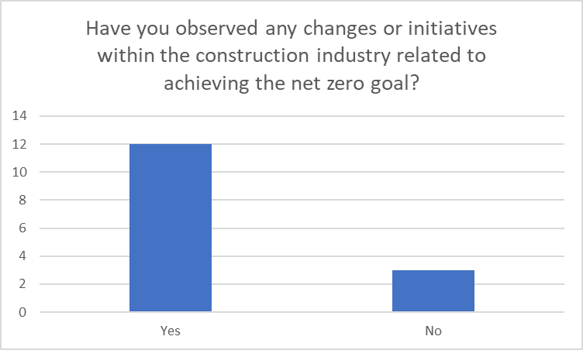
On this question the respondents were asked if they had observed any changes or initiatives within the construction industry related to achieving the net zero goal, they were also asked for an example if their answer was yes.
As shown in the graph, 80% of the respondents had observed a change/initiative in the industry related to achieving the net zero goal.
Only 4 of the respondents gave examples of any changes they had observed within the industry, these answers were: increase in clients requesting low carbon materials, increase in training on sustainability, increase in retrofitting/upgrading jobs and more requests for offsite construction.
This question gives an insight into the future of the industry and gives an idea of the sort of changes the industry must make to hit the target.

Question 5
On this question the respondents were asked what the potential benefits are of achieving the net zero goal for the construction industry. This question was set out to get an insight into the opinion of other professionals within the industry.
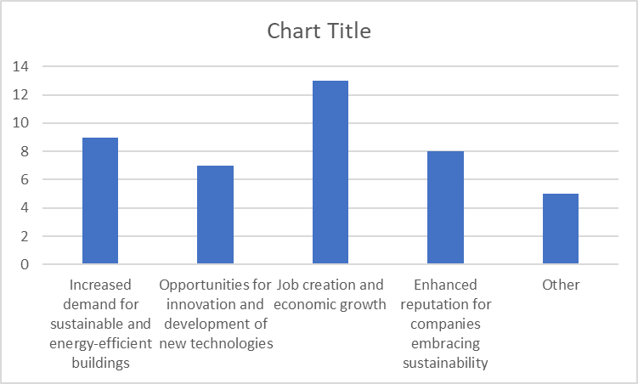
Of the fifteen respondents 86% believed job creation and economic growth was a potential benefit, and many of the respondents chose more than one answer. This shows us that other people believe that the change to net zero could have a positive impact on the industry.
Question 6
The respondents were asked how prepared they think the construction industry is currently to meet the net zero goal in the UK.

Only 13% of the respondents believed that the construction industry was very prepared to achieve net zero, whereas 40% thought the industry was not prepared at all to achieve net zero. This is a disturbing figure as it shows that not much has been done to prepare the industry it, and as the industry is accountable 38% of the UK’s CO2 emissions there will need to be drastic changes in the industry to hit the target, which could negatively affect the industry.

Question 7
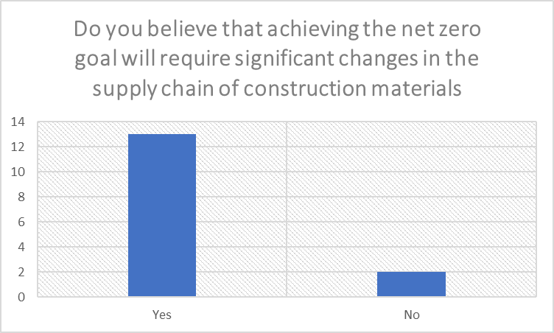
86% of respondents think there will need to be changes in the supply change of materials. If this is the case, this could a big affect on the industry. The majority of construction materials are transported on the road, which is not a sustainable way to travel (Frontiers, 2022). Massive changes to the whole supply chain, from production, to the transport will need to be changed. This will likely negatively impact the industry due to cost implications and efficiency of new systems.
Question 8

The above graph shows that 60% of the respondents believe that the availability of sustainable materials is an issue in the UK. Again to reach the target change needs to be made and the production of sustainable materials needs to be increased, this could provide more jobs in the sector, but has the potential to lower the costs of sustainable materials.
Question 9

73% of the respondents believe that the construction industry will be negatively affected by hitting the net zero goal.
Question 10

Only 2 of the respondents believe that the government are providing enough support to help the industry become more sustainable to achieve the goal. A big change is needed in the industry if it is to hit the target, the government will need to invest into more training on sustainable building practices etc.

Chapter 6

Conclusion
In conclusion, this project explored the impact of the net zero target on the construction industry in the United Kingdom. The net zero target, which aims to achieve carbon neutrality by 2050, will require significant changes in construction practices and infrastructure development. The goal of the report was to examine the challenges and opportunities that arise from this ambitious goal. The construction industry will face the challenge of adopting new technologies and practices to reduce its carbon footprint, from sustainable materials to energy-efficient designs and renewable energy integration, the industry needs to embrace low-carbon construction methods.
The net zero target presents many opportunities for the construction industry, as the demand for more sustainable buildings and infrastructure rises, there will be a larger market for sustainable materials, and the companies that adapt to the changes will have a more competitive market advantage in the industry.
The goal of the research was to see what sort of effect going net zero will have on the construction industry, and by looking at the research carried out within the literature review and the data collated from the questionnaire, it’s clear that the construction industry is going to be heavily affected by the UK achieving net zero emissions by 2050. After reviewing the data it’s clear that the construction industry will be affected in both negative and positive ways, but the constructors that continue to adapt to the changes, and value sustainability and sustainable building practices will reap the benefits.

Reflection
On a personal level this project has strengthened my understanding on how urgent and important the transition of moving to a net zero future really is. This project has helped me develop a greater sense of responsibility of making change in my life to be more sustainable, after a lot of reading into the subject I have gained a lot of knowledge on ways to be more sustainable not only in the workplace, but also in my personal life.
Professionally, this project has enhanced my research and analytical skills. It has taught me how to gather and analyse information and data from various sources. The project has helped me get a deeper understanding of the construction industry, and the changes that the industry will need to make in the coming years to hit the target, it has also made me aware of some of the challenges the industry faces in making the change. This project will benefit me in my professional life as I’m now much more aware about sustainability, and know how to become more sustainable in construction, this will help me a lot years down the line when there will be an increase focus on sustainability in the construction industry.
Moving forward, there are a few aspects I would like to change or improve based on my experience with this research project. Firstly, I would work on my time management, this has always been a struggle of mine, but on this occasion, I found it very difficult to. To rectify this problem setting clear goals and creating a schedule for me to follow.
The journey of the project was difficult, but also enjoyable at the same time. Some difficulties I encountered throughout this project was the response rate with the questionnaire, initially I sent out emails with the link to the questionnaire and a brief explanation on the purpose of the questionnaire, this proved to be an ineffective way to do it as I only received few responses, to resolve this issue I resent the questionnaire and called up the individuals just to have a quick chat about the questionnaire and explained the purpose of it, after the phone calls my response rate increased dramatically which really helped me with my research.
Given what I now know after completing this project I would try to structure the questions within the questionnaire better, to be able to analyse the data better. I would also take time to stick to a schedule, so that I do not fall behind in my work.
This project has strengthened my ambition for sustainability, I think this has helped make me better as a person, but has also helped me gain important knowledge that can be used in my professional life. As the years go on and we get closer to 2050 there is going to be a massive focus into sustainability, and this project has helped prepare me for this and has given me an insight into some of the challenges I may encounter in the future and how to overcome the challenges.

Bibliography
UK Government (2021). Net Zero Strategy: Build Back Greener. [online] GOV.UK. Available at: https://assets.publishing.service.gov.uk/government/uploads/system/uploads/attachment_data/file/1033990/net-zero-strategy-beis.pdf.
UK Government (2022). Net zero review: terms of reference. [online] GOV.UK. Available at: https://www.gov.uk/government/publications/review-of-net-zero/net-zero-review-terms-of-reference.
Shepheard, M. (2019) UK net zero target, Institute for Government. Available at: https://www.instituteforgovernment.org.uk/article/explainer/uk-net-zero-target (Accessed: 01 May 2023).
Neill, P. (2023) Construction industry accounts for 38% of CO2 emissions, EnvironmentJournal. Available at: https://environmentjournal.online/features/emissions-from-the-construction-industry-reach-highest-levels/ (Accessed: 01 May 2023).
Dhawan, K. et al. (2022) Greening Construction Transport as a sustainability enabler for New Zealand: A research framework, Frontiers. Available at: https://www.frontiersin.org/articles/10.3389/fbuil.2022.871958/full#:~:text=Construction%20transport%20is%20almost%20entirely%20road%20bound%2C%20one,greening%20%28de-carbonisation%29%20opportunity%2C%20with%20potentially%20far-reaching%20sustainability%20impacts. (Accessed: 01 May 2023).
Consultus_Group (no date) Net zero, The Consultus International Group Limited. Available at: https://consultus.com/net-zero/?gad=1&amp;gclid=CjwKCAjwscGjBhAXEiwAswQqNFsC7snafcxEw7So7PnrIwI37GSFS8h316ikcRwGHzNhMsWppzT0VBoCv04QAvD_BwE (Accessed: 02 May 2023).
Net zero in UK construction – where are we now? (no date) Osborne Clarke. Available at: https://www.osborneclarke.com/insights/net-zero-uk-construction-where-are-we-now (Accessed: 03 May 2023).
George, S. (2023) Report: UK’s construction sector won’t reach net-zero without circular economy focus, edie. Available at: https://www.edie.net/report-uks-construction-sector-wont-reach-net-zero-without-circular-economy-focus/ (Accessed: 03 May 2023).
Net zero 2050 - will ‘whole life’ carbon assessments help or hinder the UK construction industry? (no date) Net Zero in Construction | The Access Group. Available at: https://www.theaccessgroup.com/en-gb/blog/con-net-zero-construction/ (Accessed: 05 May 2023).

