

The Reality of the arts

What is the reality of being a musical theatre actor?

By Tegan Theobald

2104493
BA Musical Theatre
Elen Bowman
Content Page

- Introduction Page 3 to 3
- Literature Review Page 4 to 8
- Evidence of development Page 9 to 13
- Synopsis of my first draft Page 14 to 17
- My Final Script: The Reality of the arts Page 18 to 24
- Performance and conclusion Page 25 to 25
- Bibliography. Page 26 to 27

Introduction

This piece follows a girl who is being forced to be in the musical theatre industry where she doesn’t want to. It follows a difficult relationship with not only her mum but herself until something that isn’t quite the ordinary shows up and helps her grow and find herself instead of being stuck in her mum's ways.

Musical Theatre is perceived as fun and an easy job according to many people. But it is far more than that. Musical theatre is a job that has always intrigued me and inspired me. As a job it isn’t as easy as people think. You get told you aren’t good enough on a daily basis and you are exhausted and defeated after auditions but there is something rewarding about being able to entertain people every night once you have found the right job. I decided to explore the not so good things about this industry in my play and explore the pressure that one goes through to get far in this industry. I also explored the relationships between loved once and how this industry can affect them. Through the storyline of this character, I hope there will be a clear understanding that this industry isn’t as easy as it seems and to not pressure people you love into doing something that they don’t want to do anymore.

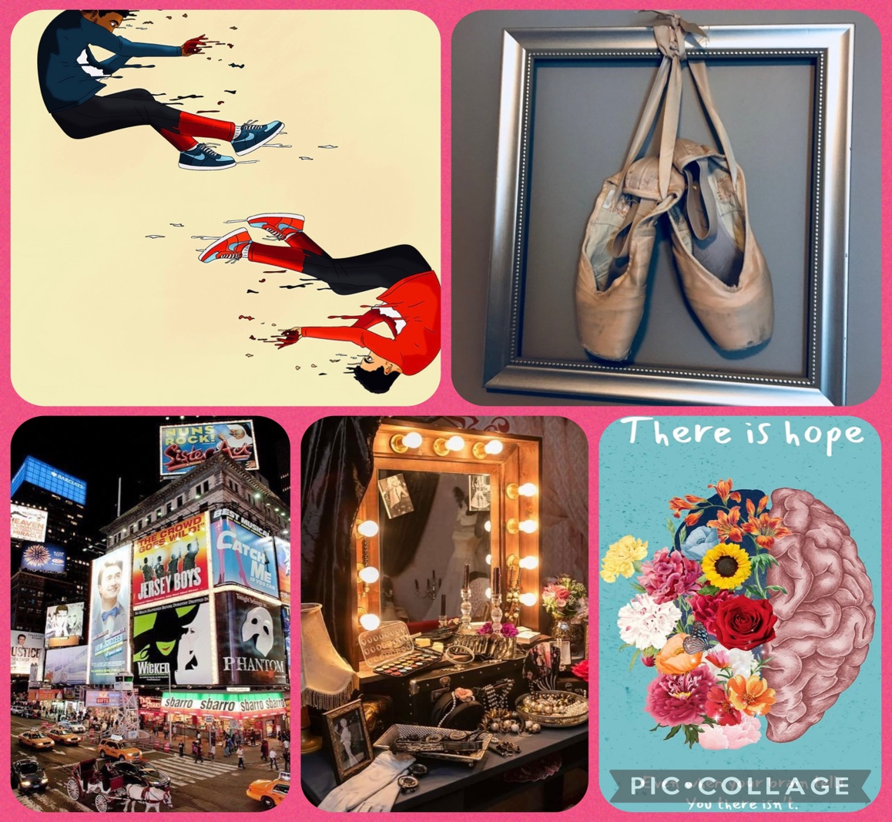

Literature Review-Tegan Theobald

To start off my research, I watched a movie called look both ways which follows a girl whose life is split into two parallel realities. This idea caught my eye and drove me to use this idea for my individual project. I investigated it more after watching it to see the reality of choosing a different path. The question of “what if” that was in the summary of a website really intrigued me because from a personal experience I always wonder for example if I turned left instead of right would I end up in the same place or would I have a completely different journey and it’s good to see that I’m not the only one who thinks like that. What I have come to realise with this movie is that the realities both end on different outcomes what I want to see is having to realities but in a way, you end on the same outcome. This movie doesn’t touch on anything to do with my storyline which is about the expectations vs reality of musical theatre, but I will use the basic idea of parallel realities to build on my storyline. My argument on this point of research would be to show similar elements of both girls in their lives because coming from a director point if I was to put this story on the stage it would be hard to find two people who are either identical twins or look the same so to show that they are the same girl I would bring similar things into each storyline and possibly at the same time. For example something as simple as having a moment with the same character doing the same thing like both versions of the same girl having a cup of tea with their mum or something just to make sure the element of the being the same person comes across more clear.

https://en.m.wikipedia.org/wiki/Look_Both_Ways_(2022_film)
Wikipedia. (2023). Look Both Ways (2022 film). [online] Available at: https://en.m.wikipedia.org/wiki/Look_Both_Ways_(2022_film) [Accessed 20 Feb. 2023].

https://screenrant.com/look-both-ways-movie-ending-explained-detail/
Smith, J. (2022). Look Both Ways Ending Explained (In Detail). [online] ScreenRant. Available at: https://screenrant.com/look-both-ways-movie-ending-explained-detail/ [Accessed 20 Feb. 2023].

My next point of research is a website that explain 12 expectation vs reality of musical theatre points. The idea of expectation vs reality intrigued me in a way because it’s truthful. Everyone thinks about the expectations of musical theatre is easy, but the reality is that it isn’t what everyone thinks. It dives into first performance expectations and realities first auditions. People on the outside will argue that it’s just playing around on stage and it’s nothing serious, but this website helps me see how serious and hard it is to get into a career like this. It also mentions how people show this on tv shows and movies and how it looks so easy, and everything goes to plan but then goes to explain “Life is not a tv show” and goes on to explain it isn’t easy and it takes time to build up a career like this. I want to touch in a lot of these expectations vs realities in my individual project because are truthful to not only me and my personal experience but to others such as famous actresses or even students starting off in a drama school or university. I haven’t really got an argument with this point of research because it is very truthful but looking at reviews on this website there was arguments stating that it is still easy but and they don’t understand that all these realities of doing musical theatre is pushed aside because at the same time of the job being very difficult it is fun and very rewarding especially when you get to watch people enjoy your work and it also points that out that it is a rewarding job.

https://performerstuff.com/mgs/10-of-the-best-expectations-vs-reality-moments-theatre-edition/
PerformerStuff More Good Stuff. (2016). 12 of the Best Expectations vs. Reality Moments: Theatre Edition. [online] Available at: https://performerstuff.com/mgs/10-of-the-best-expectations-vs-reality-moments-theatre-edition/ [Accessed 20 Feb. 2023].

My next point of research is a personal blog on a website by Hayley Festeryga. She dives into how she fell in love with musical theatre and how she loves the uniqueness of the career. What I found interesting was that she also went into how she fell out of love and how she lost her passion for musical theatre. This was interesting to me because that one thing I want to show in my individual project is the struggle and falling out of love with the career because it’s the reality. It’s not always fun as people think and Hayley shows that in this blog. I relate to it strongly and that’s why I want to include this research a lot as it will relate to my characters and story line.
As person who also has many times fell in and out of love with the industry, I can use mine and Hayley’s information to convey this in my piece strongly.

https://bandology.ca/my-experience-in-musical-theatre/
Caju (n.d.). » My Experience in Musical Theatre. [online] Available at: https://bandology.ca/my-experience-in-musical-theatre/ [Accessed 20 Feb. 2023].

My next point of research is the song Defying Gravity from the musical Wicked written by Stephen Schwartz. The song is where Elphaba finds her power in the fact that she is different. I’ve always known this song but when I investigated it, it does show the struggle she has gone through even though all she’s done so far is good. The context of this song shows similarities to one of my characters in my play and it will help me develop that character further. It also shows that she was naïve and told that she would get good things from what she did and in reality, she didn’t and that relates to my project in a way of being naïve and being told good things and you’re made to ignore the bad where in reality there is a lot worse than good. I am also using Elphaba as part of my story and the song, so it was helpful to research into it further to find the deeper meaning behind it. The quote “Elphaba finds power through her own outsider status” speaks out to me and about musical theatre because all musical theatre students are outsiders and that’s what brings them together and with that it can help me develop not only the plot but the characters too. The argument with this song would be people think it’s a good song and it is positive, and it is in a way because she is finally letting herself be free as herself and not letting anyone “bring her down” but she had to go through all of the negativity to finally say enough is enough. That really relates to my individual project because the person who doesn’t get everything she wants and finally does its going through all that negativity to come out better and it isn’t fair on them.

https://en.m.wikipedia.org/wiki/Defying_Gravity_(song)
Wikipedia. (2021). Defying Gravity (song). [online] Available at: https://en.m.wikipedia.org/wiki/Defying_Gravity_(song).

My next point of research is a poem called Defying Gravity by Lark Morrigan. This poem is saying how they carry to much weight on their shoulders and how they would like to be free from all the stress and pain. The words Defying Gravity means to do something that is impossible, and that is very much what the career is. It may not have anything to do with musical theatre, but it can be used for anything. This poem is very truthful and relatable to any situation and that’s what I’ve researched it. It’s impossible to be completely free and some may argue otherwise but you will never be free and that is said in the poem in other words. It’s intriguing to me as I can relate to it with my own personal experiences. I can use it to push the stubbles in my project and to I’m a way explain what it feels like to be stuck with all this weight on your shoulders by using this poem.

https://medium.com/song-of-the-lark/defying-gravity-b0805d034465
Morrigan, L. (2020). Defying Gravity. [online] Song of the Lark. Available at: https://medium.com/song-of-the-lark/defying-gravity-b0805d034465 [Accessed 20 Feb. 2023].

My next point of research is a website on mental health for people in the arts industry. This website touches on all types of people in the industry such as dancers, actors, musical theatre performers and musicians. It touches on all sorts of mental health problems such as depression and anxiety and gives the statistics too. From a personal experience being a musical theatre student, I can relate to the depression and anxiety and how this industry can affect it and it dives deeply into what can cause it. Having all this information will help me be specific about the struggle as that’s something I want to include in my project. It gives all the information on how to help through it as well as all the bad information about it. It’s helpful for as I can use it to further develop and create my project

https://www.theguardian.com/society/2022/may/12/performing-arts-depression-equity-covid-job-insecurity
Sherwood, H. (2022). People in performing arts twice as likely to have depression, Equity finds. [online] the Guardian. Available at: https://www.theguardian.com/society/2022/may/12/performing-arts-depression-equity-covid-job-insecurity.

My next point of research is about a character from the musical Wicked called Elphaba. Elphaba is the main protagonist of this musical and ends up being portrayed as the wicked witch of the west. She is a very kind and intelligent character but terribly misunderstood. What I have read about musical theatre actors and actresses that when they were younger a lot of them were misunderstood and mistreated and that’s why I have researched this character. She is also a part of the storyline in my project, so it was good to research into her character. She is very relatable in the sense of no one really understands her, all she tries to do is good, but it never goes that way and that speaks a lot to me and has already made me think of things to do with my project. People may argue that she isn’t good, and she isn’t relatable but I will argue and say that so many people are like her after the research I have looked into on her.

https://www.charactour.com/hub/characters/view/Elphaba-Thropp.Wicked
www.charactour.com. (n.d.). I’m a match to Elphaba Thropp from Wicked. [online] Available at: https://www.charactour.com/hub/characters/view/Elphaba-Thropp.Wicked.

My next point of research is a personal blog by Marlie Kass on her opinion of is musical theatre a sport. This contains her opinion of if it’s a sport and she agree with that opinion with this quote “Theatre whether it’s a play or a musical, is a a team sport and should be treated as such.” I agree with what she says about people thinking that theatre may look like it’s just entertainment and fun and games and how it’s overlooked but no one realise how physically and mentally draining it can be and how much commitment you have to put in it. This is very helpful for me as that’s one thing I want to highlight in my individual project. It’s very common for people to argue that it’s all just fun and games but until you do theatre yourself, you realise it isn’t that at all and Marlie goes into this throughout the whole blog. This information will help me throughout my piece and to teach people that it isn’t as easy as it seems. She goes into the commitment to the theatre and how time consuming and challenging it can be and again shows people the truth even though she loves it. It shows that even though it’s not counted as an actual sport it’s still as challenging as the regular sports such as “soccer”.

https://gatorfeatures.shorthandstories.com/theatre-is-my-sport/index.html
gatorfeatures.shorthandstories.com. (n.d.). Theatre is My Sport. [online] Available at: https://gatorfeatures.shorthandstories.com/theatre-is-my-sport/index.html [Accessed 20 Feb. 2023]

My next point of research is a website that highlights the perks and benefits of doing Musial Theatre. It contains five different points of benefits which are “Improved self-confidence, Problem solving skills, Teamwork and trust, Social awareness and fun.” This is interesting because a lot of the research I have looked into is the struggle of musical theatre because that is something that I want people to be aware of, but at the same time I don’t want people to forget the good things and why we love the theatre and through researching into this website it shows how many benefits we have. It’s crucial for people to remember the good things otherwise a lot of us wouldn’t want to do it. So this a big thing I want to show and to remember it’s fun.

https://mobilemusicschool.ie/face-the-music-five-great-benefits-of-musical-theatre-workshops/
School, M.M. (2020). Face the Music: Five Great Benefits of Musical Theatre Workshops. [online] Mobile Music School. Available at: https://mobilemusicschool.ie/face-the-music-five-great-benefits-of-musical-theatre-workshops/.

My next point of research is a website called words in a sentence. The reason I chose this website is because I was looking for examples of figments of imagination. This website explains all different examples and most of them are for children but this thing of figment of imagination intrigued me they do stem from children but in my final script it talks about a figment in a way that is someone who helps them as an adult and who builds their confidence towards her mum. By researching this it gave me examples of things that were more fantasy than real, and I argue with that because even if children do look for things that are different their not just like unicorns or something big and scary sometimes a figment can just be a normal kind of person. Even though the website itself didn’t give me my final idea on what I wanted the figment to be it did help me understand it a bit more and think of my own interpretation of what a figment of imagination is or could be.

WORDS IN A SENTENCE. (2017). Figment: In a Sentence. [online] Available at: https://wordsinasentence.com/figment-in-a-sentence/#:~:text=Examples%20of%20Figment%20in%20a%20sentence%20My%20young [Accessed 24 May 2023].

My next point of research is a book by Jacqueline Wilson called Girls under pressure. This book follows a girl who thinks that she is too fat and her 2 friend who are “drop dead gorgeous” and are like models. Ellie the main girl feels the pressure to look a certain way and is jealous of her two friends explains the title “Girls under pressure”. When I investigated into this book further, I like the idea of thinking that my main character in my play isn’t perfect and feels like she will never be good enough for anyone especially her mum. That word pressure really resonated with the subject of my play. It also helped me decide on my final script and product of my play. Even though this book is very much on appearance and my play isn’t, the idea of someone specific putting that pressure on them, either them self or someone else really speaks out to me and my idea. The argument I have with this point of research is that pressure doesn’t always come from looks, and that’s what this book is really on the pressure to look a certain way where my play is the pressure to be the best. But I guess with having that in mind the book does have a certain element of being the best just with how the main character wants to look and mine is about how she feels the pressure to impress her mum and even herself and tries to do everything to make her mum proud.

Wikipedia. (2023). Girls Under Pressure. [online] Available at: https://en.wikipedia.org/wiki/Girls_Under_Pressure [Accessed 24 May 2023].
‌

Evidence of development

When I came up with the idea of what I wanted to do with my project it was the alternate realities because after watching the movie look both ways I was intrigued so I started to develop that sort of idea in a musical theatre way. The context at the start was there was this one girl called Rachel, but she led 2 lives in alternate realities and the one version of Rachel was that she never got any good roles and she only got ensemble roles and herself confidence was bad, but she had the family who still supported her through everything. Then the alternate Rachel was a girl who got all the roles she ever wanted/always had to go for. That was one of the things that made them both a little different but the other thing that was a big difference is that alternate Rachel never had the support, her mum always says to her she will never be good enough or as good as her because her mum failed in the musical theatre industry because she had Rachel young. In the play we follow their separate journeys and their journeys with their mum and then they both have a big audition to be the next Elphaba in Wicked. The Lead Rachel who always gets the roles ends up not getting it at the end but the Ensemble Rachel gets the role but they both end up really happy with the result because they’ve both now turned into what they wanted the most which is each other’s lives.

The first thing we did in our first individual project lesson was talk about our ideas to Elen and each other. The homework at the end of that lesson was if we had a clear idea of what we wanted to do with our individual project we had to go and write an album title and six songs titles to go with our idea and play. I had 2 ideas of what I wanted for the title of the play which was ‘2 Journeys’ or ‘Depends on the answer’. There were six song titles all together and the photo below shows the titles, but we also had to think of the reasons why we would right them specifically. The first one is ‘Woke up the same’ and that means the start of the play where they would be waking up and doing the same things in the morning routine. The second one is ‘The same questions’ which was an idea I had to start off the play where they would both be with their mum and her asking them both the same things. The third one was ‘Auditions’ which refers to what the both girls are going to and the main event that determines the end result for the girls. The fourth one was ‘In the background’ which refers to how Ensemble Rachel has always felt since her dream was to be in the industry but because shes only ever got background characters that’s how she has always felt. The fifth song was ‘Spotlight’ which refers to Lead Rachel and shows her journey throughout her life always being the lead all the time and how it did affect her even if she was getting everything. The sixth and final song title was ‘Not everything is as it seems’ which refers to the end of the play where Lead Rachel doesn’t get Elphaba but Ensemble Rachel does and it is reference to that alternate universe in a way because if you chose the a certain answer it could take you to a different path and that’s what I pictured would have happened to both Rachels which then led to the reason of them both getting something they have never had before. This exercise helped me because the song titles gave me ideas on what monologues to write and I ended up writes 3 monologues and a scene out of the idea of the song titles.

The first monologue is about the lead Rachel after both lead Rachel and Ensemble Rachel get results from their audition at the start of the play.
Lead Rachel: “Yayyy, I got the role…again. You see I tend to get everything I want in this industry, and don’t get me wrong, it’s a good thing…most of the time. Because I’ve been quite well known in this industry since being a kid, everything had been handed to me on a plate. But what about all the other girls who’s auditioned for this role. It’s not fair on them. Some of these girls I have seen in these audition rooms for years, and either always gets ensemble or nothing at all. I don’t even have to work that much and here I am with the leading lady. As I said, I am happy to get things and then not have to be disappointed but, because I have this reputation it gets difficult to keep it up. I have to be little miss perfect all the time. It’s exhausting.”

Ensemble Rachel: Great, ensemble again. That’s all I ever get. Everyone keeps saying to me “Well at least you’re still in the show.” It makes me feel like I’m ungrateful. And I’m not. It’s just, when everyone has always told me since I was a kid, how talented I was, how I would go far in life, I just feel like I’m disappointed everyone that’s told me that. “The industry you’re going into is tough you know” is said to me every single day. For God's sake I know. I researched and researched and looked for all the pros and cons, I know it’s tough. I’m trying to keep my head held high but when it’s the same fucking people getting the same fucking roles, it’s a ballache. Give someone like me a chance. I’m not asking for the lead, but just something that’s a bit different from the fucking ENSEMBLE!

The next thing I wrote was a scene between both Rachels and her mum just a regular conversation in the kitchen to show how she treats them both and an insight to what the relationship is like between mum and the two Rachels.

Both Rachel’s: Morning Mam.

Mam: Morning, you ready for the audition today. (To leading Rachel) make sure you are perfect today. You know you have your reputation to uphold.

Leading Rachel: I know mam. But I always get lead roles, would it be that bad being in the background for once. The shit I get off other people for always getting leads are awful!

Mam: (To background Rachel) you’ll smash it today. Don’t be too disappointed if you don’t get the role. You will always be perfect in my eyes!!!! I will always be proud of you!!!

The last monologue is Ensemble Rachel after she received a phone call saying she has got the role of Elphaba.

Ensemble Rachel: Oh, my Fucking god!!!!! Finally!!!! My dream role! How! Never mind how!!! I’m so happy!! I don’t know what to say. Well, I’ve got a lot to say. I need to phone my mam! I need phone my agent! There’s so much to do! So much to prepare!!! Omg! After everything I’ve been through! I’m finally getting what I deserve! I actually can’t wait to get started! I’ve finally got the recognition I deserve! Okay, let’s get ready to be Wicked!!!!!!
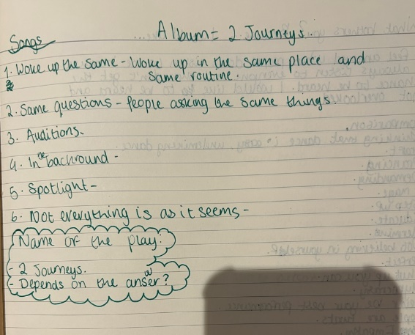

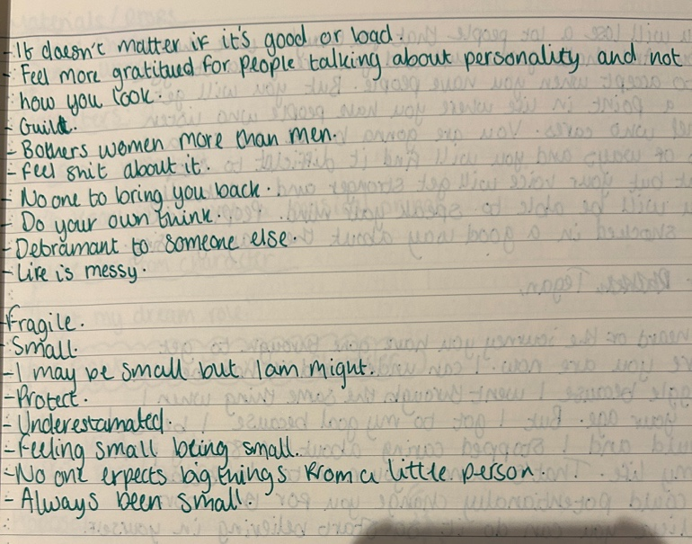
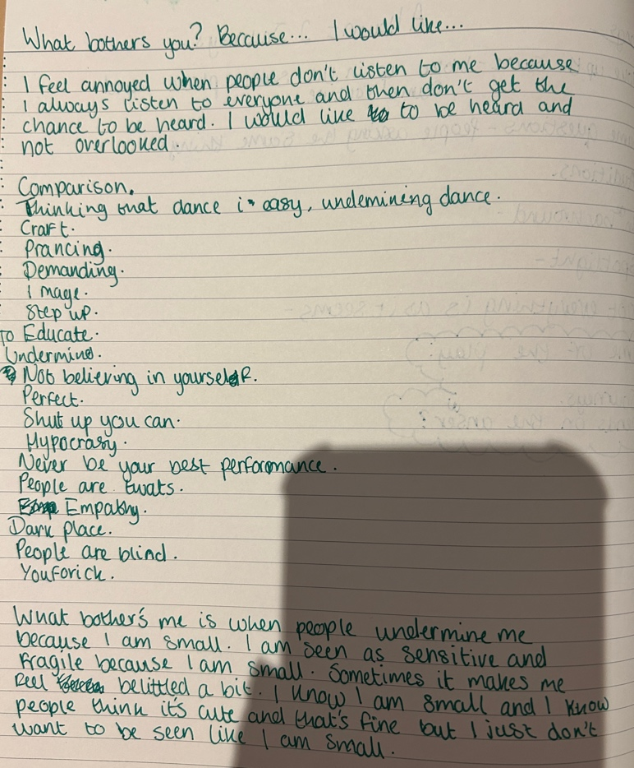
The next thing we did was write about something that bothered me. This was to start thinking about some sort of conflict for our pieces. It was also something personal to us that we could possibly use in our pieces. I wrote down the first one and that was about not being heard or listen too. After while I still agreed with that because I feel like I don’t be heard but then after I decided to go with the fact that people belittle me because I’m short. After we wrote them we had to go and speak about it in-front of the class. Then we would receive words that we used back to us that stood out to other people. I wrote down the words/sentences that people were telling me and when I looked back on them I had realised these two things that bothered me were things I could relate to eschew Rachels and it further helped me develop both of the characters. The not being listened to relates to both of them because Lead Rachel is always shit out and never listened to by her mum and Ensemble Rachel is always belittled and underestimated by the people who audition her.

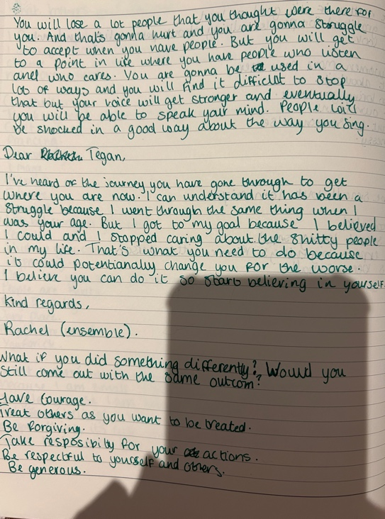
We did a lot of different exercises that would help us to right our pieces. By doing these exercises we got to know the characters more and I felt like I could connect to them. We had to write a letter to ourselves from one of of our characters. I related to Ensemble Rachel more than lead because like her I felt like I was overlooked a lot and belittled and writing this letter helped me with how I wanted to show the difference between both Rachels. In the letter Ensemble Rachel is just saying how she knows what I have been through and it’s tough, but she’s been through the same thing, and she has come out on the other side with her dream. Unlike the other exercises where I was trying to find the conflict I wanted, this helped me find the positive things I wanted in my play. I wanted to it to be a bit more lighthearted than conflict but in my final piece there was a lot more conflict but with a positive ending and I feel like writing this letter to myself from ensemble Rachel really helped that.
In this process of development, I was constantly changing my idea around and finding new ways to improve on it and dig deeper into it. I wrote down the first concept I had. But I couldn’t ever find exactly what I wanted to do and right about. Writing down the concept before I wrote the script did help me because I had an idea of what was going to be the start, the middle and the end. So I wrote down in my notebook the first concept of what my piece to help me write my script.
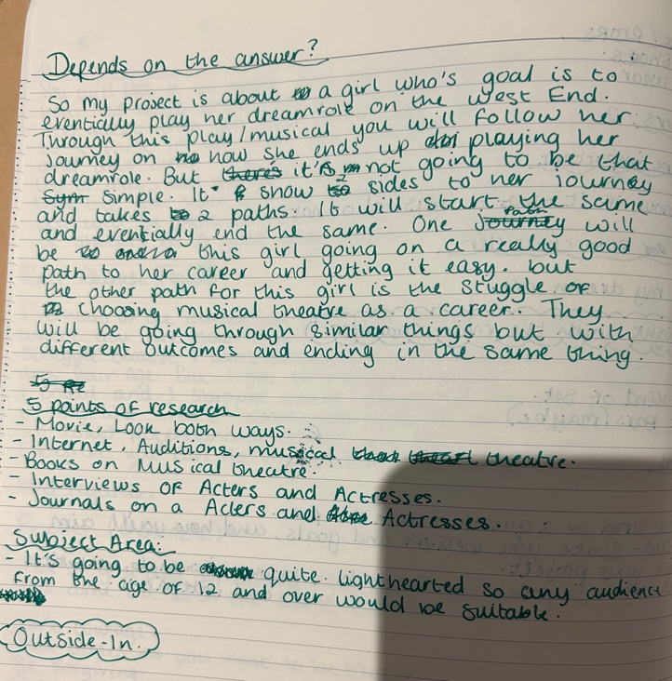
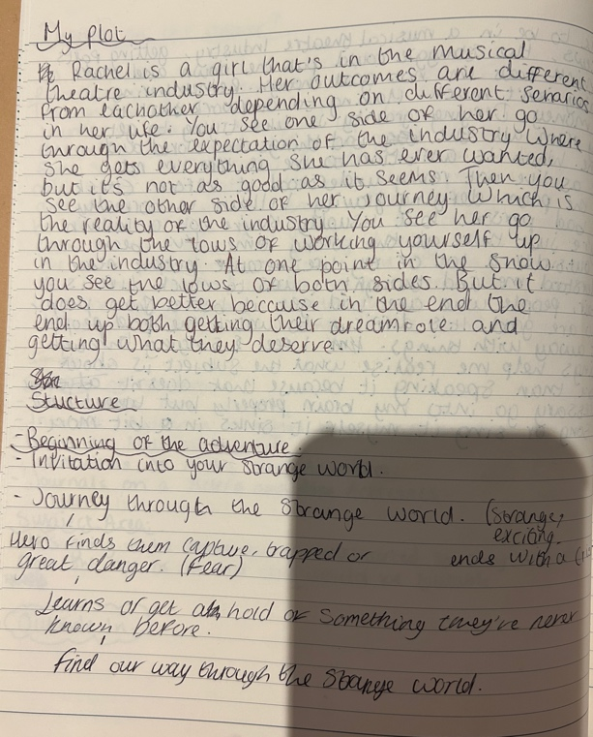

There was a lot of other exercises I set for myself too. I thought by doing these exercises it would further my research and further my development of my script. I looked into what materials and props each character would have on stage and during scenes as well. This was interesting to me because it made me really look into the characters personalities and what I think of them as people. It also helped differentiate between ensemble Rachel and Lead Rachel. Both Rachels would have dance wear and dance shoes, but Lead Rachel would have something colourful and looks more expensive because she has always had everything given to her and she has the money for the expensive dance wear. Ensemble Rachel would have plain black dance wear as it shows that she hasn’t got the same privileges as Lead Rachel does. This would change throughout the script. The further the script would go the more colourful Ensemble Rachel gets and the more dull coloured lead Rachel would get and that would show their growth and development throughout the play.
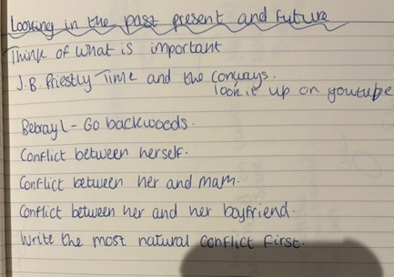
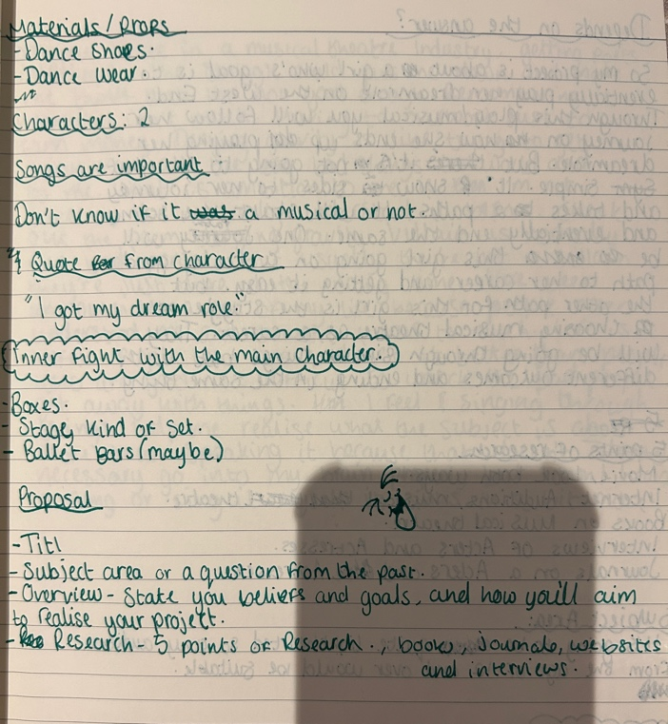

Another exercise I did was write about conflict. That would be a big part in my final production is the conflict between the Rachels and her mum. The Lead Rachel had a lot of conflict mainly because she always seen her mum be horrible to her and pressured her to be perfect every time even though she always got the parts and done her best. That’s something I wanted to show throughout different drafts of my script is that they always have conflict no matter what changed in the context of the play. Ensemble Rachel didn’t have conflict with her mum but she had conflict with herself. Because she was always let down by every casting director she’s ever auditioned for and every agent she’s ever put an application in, she never thought she was good enough. The one thing she had that lead Rachel didn’t have was the fact that she had her family, she just never had the work or the lead roles. It was important to me to show that clear difference between them to show the alternate realities.

The synopsis of my first draft of my script

My first draft script was about the idea of both Rachels starting off at the audition about to perform. It started off with both Rachels speaking to the director/Judge and stating who they are and what role they’re auditioning for. The first person to speak is Lead Rachel, she talks about how she has always been in the industry since she was a young child but it’s not what she wants to do anymore, she was fed up with her mum and everyone around her forcing her to do what they wanted to do. She always had everything handed to her in a plate such as every role she ever auditioned for, every solo in every choir and even the dance solos in every dance show she ever did. But what her family doesn’t know is that she doesn’t want to do that anymore, she wants to live her life and make her own decisions on what she wants to do. Yet she is still here auditioning for the biggest role in musical theatre which is Elphaba in wicked. Then, Ensemble Rachel starts to speak, talking about her life being in the background of everything. At home she is cared for by her friends and supported by her mum. She has grown up wanting to be in the industry but she never got the chance to go to the best child and singing tutors but she grew up poor. But she still got trained and she even taught herself to dance. She speaks about how she’s never got roles and she’s always been in the ensemble or cut from the last round of auditions. She goes in to talk about how she loves this role because she can relate to it. She relates to the fact that Elphaba is misunderstood and underestimated with her peers and that’s how Ensemble Rachel feels too. The both girls then go on to say what they’re going to sing. They sing the ending of the song together and then proceed to that the casting director/hodge and then leave.

They come back onto the stage each with a phone in their hand. They both phone their mum but take it in turns to speak. The mum isn’t on the stage as of yet. Lead Rachel speaks first and just tells her mum that it went well but she doesn’t know if she wants to this anymore, but without her mum speaking it is obvious that her mum isn’t saying the nicest things in the phone to her. She continues to talk and gives up on what she actually wants to say to her mum because she isn’t given her a chance. Then Ensemble Rachel starts to speak and doing the same thing as Lead Rachel she is speaking on the phone to her mum. She explains that the audition went well but not to give her hopes on getting the role or even an ensemble role because it is such a big show and a hard role. Instead of her mum saying horrible things you can tell that all she’s doing is supporting her on the phone, telling her she is proud of her, and she will always believe in her. It shows the difference again between the two Rachels and how they could live such different lives but they’re the same person.

The next scene is the director asking for them to do a scene with the actor who would be playing Fiyero the leading man of Wicked and Elphabas love interest. They both go onto talking about how they feel performing with an actor who is going to play someone and who is quite attractive in a style of a monologue to themselves and to the audience. Ensemble Rachel goes onto say how shes nervous because one she’s never gotten that far in an audition and has never had to do a chemistry test with anyone before. Lead Rachel goes on to say that she is fed up with chemistry tests because she has done so many of them before this one but she will put a lot of effort in just to make her mum proud and happy.

The next scene they’re at home with their mum and Ensemble Rachel speaks to her mum first and she is just asking about how the audition went, but as soon as the mum starts to speak to Ensemble Rachel the attitude and atmosphere changes and the mum turns sour and starts telling her daughter isn’t good enough and that is the first time you actually see this in the play and you see the conflict between them.

After the mum leaves the stage both Rachel’s come together in a mirrored way and they both express what they see in the mirror. And what they see is each other and their lives and how that is what they want. Each other’s life. Lead Rachel goes on to say how she wants a life where her mum is supportive and lets her do things instead of a mum who takes control over her life. Ensemble Rachel goes onto saying that she wants the life where she isn’t overlooked and underrated for her talent. She wants the confidence that lead Rachel has in her talent, and she wants to be given a chance instead of being pushed aside as if she is nothing or only ever good enough for the ensemble roles. But they look at each other as if it is something so impossible that they will never have. They both say at the same time “Please let me be this girl int the future, I can’t keep putting myself through this” to confirm that’s what they want.

This is the last scene:

Last scene: The phone call

Director: (On the phone to Lead Rachel) Hi Rachel, I hope you’re okay. It was a pleasure getting to see you audition and even see you getting to work with our actor who’s playing Fiyero. I am so sorry to inform you, but you’re not our Elphaba at this moment in time. I did enjoy working with you so I will keep in touch if there is anything in the future that I will be working on. Again, I am so sorry but thank you for your time. Have a nice rest of your day. Bye.

Lead Rachel: (To the phone) Okay, thank you. Bye. (To herself) Okay my first rejection. I thought it would hurt more. But I think I’m okay. I’m feeling happy like some sort of weight has been lifted off my chest. I know my mum isn’t gonna like this but hopefully she will finally see me for doing other things. Maybe I can go travelling and seeing the world. I feel like I should be crying but I feel like crying with relief. Omg! Finally! FREEDOM! Hahaha.

Director: (On the phone to Ensemble Rachel) Hi Rachel I hope you’re okay. It was a pleasure getting to see you audition and even see you getting to work with our actor who’s playing Fiyero. I am thrilled to tell you; I have got the role of Elphaba. I thoroughly enjoyed your performances and I hope you still want this role and to work with us. I hope you have a good day and we’ll see you soon. Thank you, Bye.

Ensemble Rachel: (To the Judge) Omg!! Thank you so much! I will be looking forward to working with you too! Thank you, have a nice day, bye! (To herself) Omg!!!!!!! I’m so happy!!!!!! I actually got a role and it’s the biggest role in the industry. And me, someone who is always rejected. Has been told “no” a million times has finally got her one “yes”. I’m in shock. I don’t know how to react. Should I be crying should I be screaming. I don’t know. But I don’t care. I’m so happy! I’m so FUCKING HAPPY! My dream role! A dreamy guy that I get to act with. And an amazing director! Who would’ve thought me would get Elphaba. I can’t wait to tell mam!

Lead Rachel: (On the phone to her mam) Hi mum. I didn’t get it but before you have a go at me, listen to me. I’m happy. I’m okay with it. And I can now do what I want to do. Please don’t be angry because I tried my best. I’m happy now. You never know I could get it in the future but that’s when I want to do it. Not right now.

Mum: Okay. I thought about what you said earlier and if you want a break from it that’s okay. I just want you to have a happy life and I’m sorry that I thought by doing everything I did was going make sure you had a happy good future. I’m proud of you either way. Should we go for a meal tonight?

Lead Rachel: Thank you mum. I needed to hear that! Yes we should! I love you.

Mum: I love you too!!

Ensemble Rachel: (On the phone to her mum) Hi mum. You never guess what. I got the role! I finally got it! I’m so unbelievably happy! I get to work with amazing people on my favourite musical performing my dream role! I can’t believe after everything we’ve been through I’ve got my one yes and it’s the biggest yes in the industry!! I’m so happy! I couldn’t do it without you!

Mum: Omg!!!!!!!! I’m so happy for you my girl!!!! I knew you could do it!!! I’m so incredibly proud of you! I love you so much!!

Ensemble Rachel: I love you too!

(Mum leaves stage and 2 Rachels go back to how they were stood in the mirror position)

Both Rachels: I’m finally her, the girl I see in the mirror.

The End.

After writing this script I wasn’t quite sure if I was too happy with the concept, after discussion I decided to change the concept slightly by changing the idea of alternate realities, changing it into an idea of a figment of imagination. After researching into it I did like the idea because it stemmed from the idea of alternate realities but in a way it was easier because I and a small cast of three and I realised my idea wouldn’t work as well. I decided on keeping the idea of having the personality of lead Rachel as my main character because she had the most conflict and the biggest journey out of the both Rachels and by using this character I had more to work with. I kept the idea of the mum being a failed musical theatre actress and the pressure she puts in Rachel too because it felt like I was showing a different yet very true side of certain actors and actresses lives in the musical theatre industry which is a very hard and trying life.

After a long consideration I decided it was much easier to change my whole script. It was easy because I didn’t have long before it was performed. But the first thing I did after researching into a figment of imagination and what it can mean in different ways, I decided to write a clear and detailed concept to help me write the script. I found writing this and adding quotes and lines that I could possibly use very helpful and gave me a clear journey on what the storyline would include. I liked the concept of the figment being a person that Rachel had created from seeing someone who she had thought was perfect, and that’s what she wanted, perfection. Then this figment of imagination would take Rachel on a journey of defeating her controlling and horrible mum and making her finally stick up for herself and would give Rachel something she had been craving and longing for which was a proper childhood because like the leading Rachel in my original draft of the script, she didn’t have a childhood. I still wanted to keep it light-hearted where it had a happy ending, but I related to the conflict from the original draft therefor I wanted to keep that in there but also make it more, so it seemed true and real. I investigated blogs and interviews and a lot of them say a lot about having a bad childhood or growing up and being rejected all the time and they find that musical theatre is an escape and that really spoke out to me whilst writing my final draft of my script.

My final script: The Reality of the arts.

Characters:
Rachel- Rachel is 18 years of and daughter of Mum. Played by Tegan Theobald.
Mam- Mum is 36 and mum to Rachel. Played by D’breu-Hayling.
Figment of imagination- Figment of imagination is the same age as Rachel. Played by Fleur Sparrow-Gormley.

The lighting is White. The is set in an audition room at the start and the only set is a chair on stage left middle of the stage. The piece starts with both Rachel and the Figment on stage. The Figment is singing in the centre at the front of the stage as if she was finishing her audition. She is singing I will prevail from Wonderland the musical.

Thank you (Smiles and freezes).

Rachel: (Sitting on the chair in looking at the figment, she speaks to the figment, but the figment doesn’t notice) How do you do it? How are you so confident? How is your mum here? My mum never comes to my auditions, she just books them for me even I don’t want to go to them. How are you smiling after that note. Normally I feel defeated after every audition because I’m not perfect. You’re so lucky. You have the talent the confidence and the support! Wow I would do anything for that. You did so much better than me. Great! I feel so much better about myself now!

(Black out here as Rachel moves to stage Right on the bed).

Scene 2:

Rachel goes into her bedroom and the rest of the cast members bring in a table and a pillow and a duvet. The lighting turns to magenta to create a warm happy environment that a girl's bedroom normally gives off. Rachel is sat on her bed she is alone on stage.

Rachel: (Looking at her phone, playing her version of her audition feeling defeated. She starts to picture how she would like her perfect version to look like) If I was anything like that girl, I saw earlier I’d be perfect. At least my mum would be happy. I would have a good relationship with her! I long for that so much! Something that perfect! I will never get it though! Doesn’t matter how many dance classes I do or how many singing classes I do I will never get that. I don’t even see a point in me wishing for it. It’s never going to come true.

Figment of Imagination: (Walking from stage right) You were saying.

Rachel: Mum wants me to be perfect and no one can get me to be perfect. There isn’t such a thing as perfect. Well except for that you. You were amazing! You are stunning had the most amazing voice and even your mum came to support you. That’s never been me. Even with dance classes and singing lessons as a very young child, she would take me to them and leave me there with the teacher by myself. She said it was to help my independence, but I think she just wanted to go shopping. You see I was her mistake, and she tells me this way too often. She was starting off in the musical theatre industry and she was good. She’s always got the roles she wanted, and she was just perfect. Then she met my dad and they fell in love, and she ended up having me at 18. But for some reason she always blamed me for stopping her career, but I didn’t choose to be born. I didn’t choose to come into this world 18 years ago. But because her career failed, she pushes me, so I don’t fail. And don’t get me wrong, I love musicals, I love going to see the shows and I love being in them. But she has pushed it so far, it’s as if I will never be as good as her there for, I won’t be successful. I have always wondered what a life without this would be like, you know, a normal job, a nice relationship with your parents. Right now, that’s what I am longing for. Something that easy, that simple.

Figment of imagination: Okay…there’s a lot to unpack here. Look I can help you with all of that. I can help you stand up to your mum, I can show you how to be confident. God, I can even help you have fun because you seem like you need it. A break from reality. Something out of routine for you. Give you that taste of freedom before you finally break free of it. I already have the confidence and all the other stuff I need to help you with. This ain’t gonna be easy though because you’re so set in you mum's ways.

(Mum walks in from stage left, she comes in with a dance bag and with a stern look on her face)

Mum: Why aren’t you ready, we’re leaving in 2 minutes.

Rachel: Wait where are we going? I haven’t been home long. Can’t I just have an evening to myself.

Mum: (Her face turns from smiley to angry within seconds because she is furious that her daughter is disagreeing with her, even though she thinks she knows what’s right for her) Are you being serious. An evening off, when I was your age, I would never have “The evening” off. I would be going to every dance class every night. You’re lucky I only booked you in for ballet. You need it by the looks, your posture is shocking. I even had good posture just after giving both to you. Your posture is probably why you didn’t do well in the audition. Well, I’m guessing you didn’t do well because you went straight to your room. I never had a bad audition ever. You are my daughter; you should be fucking perfect by now the amount of training you’ve had. You’re fucking useless (She says angrily, she quickly changes her expression to calm) be ready in 2 minutes, I will be waiting in the car.

Rachel: (Saying in a fed-up expression) Fine.

(Lights go to Black out).

Scene 3:

(Lighting is amber and white) Rachel has just finished a ballet class she is exhausted because she had an audition in the morning and then had to do this class. The is sat on a chair in the middle of the stage. The figment grabs a chair to sit next to her. They sit in silence as Rachel is going through her bag to get a drink. Rachel proceeds to drink her drink. The tension is a little awkward between Rachel and the figment.

Figment of imagination: So, I can see why you have problems your mum. She seems like a bitch telling you that your useless and you aren’t as good as her. Who is she to say that. It ain’t fair on you. I know this industry is tough, but I didn’t know she was like the mums off dance mums, or toddlers in tiaras. Normally I like that sort of drama only on the tv, but to watch it for real, and to someone who I wouldn’t exist without, well fuck me that’s rough.

Rachel: You’re not helping you know. By saying all this is just making me think there’s no way I can sort it. I need a way for my mum to stop it because it isn’t fair anymore. I know people have it worse than I do, and I am grateful to still her, but I don’t know, this pressure is too much. And I’m sorry I don’t know what she means by posture because it’s never been as good as it was today.

Figment of imagination: Maybe she’s jealous. It could be a possibility that she thinks you’re more talented than she ever was, and she isn’t happy with that. I get what mums are like sometimes and I know it isn’t nice, but honestly, she is probably jealous that you still have a chance, and she doesn’t. And I am not condoning her behaviour towards you because it’s disgusting. I can’t believe she could ever do something like that to you honestly. Telling you how she was always better than you are. No wonder you have no confidence. But you need to stick up for yourself too. The problem isn’t going to go away on its own. I know she’s you mum and it’s hard to stick up for yourself in situations like this but honestly it isn’t fair on you. I do have 1 question for you, just so I can be clear on what I want to do to sort this out, was she always like this with you since you were born? Was she always telling you you weren’t good enough?

Rachel: In a way, yes. As soon as she knew I could sing that was then for me and my freedom. I would be picked up straight away from school to attend a dance class of sort every day, then after that I would go to an acting class and then after that I would go to a singing lesson. She got the most expensive and best trainers in the whole of Wales to teach me because she wanted me to be perfect. I never had friends growing up. Mum saw it as a weakness to have friends. She always said they would drag me down. I should only ever concentrate on myself. I was never allowed to go to parties or sleepovers or even listen to any music other that musical theatre and stuff I had to know for my auditions. To help my own mind I used to say she did it because she loved me, but now that I am an adult, she shouldn’t be doing this to me.

Figment of imagination: Wait you’ve never been to a sleepover. They’re what makes your childhood a childhood.

Rachel: Well, it looks like I’ve never had one.

Figment of imagination: Well, I’m afraid you’re gonna have to confront your mum. You’re gonna tell her exactly what you need too, including all that about how she makes you feel, even tell her about the girl you saw in the audition. Guilt trip her like she does with you.

Rachel: Are you being serious. I can’t do that. She would never speak to me again.

Figment of imagination:(Says quietly but enough so Rachel can hear her) Would that be such a bad thing.

Rachel:(Says in a furious way) Of course it would be a bad thing. If you hadn’t noticed she’s the only family I’ve got. She may act like shit, but, if I don’t have her, I have no one. I don’t actually think your helping me so just leave me alone. Stay out of my head. I’ll do it on my own.

(Black out again).

Scene 4:

(Lighting goes to amber and whit again)

Mum and Rachel are in the kitchen. Figment just watches and observe Rachel and her mum.

Mum: How was the class? Your posture looks better. I knew you had to go you see. Mum always knows best.

Rachel: It was fine.
Mum: What’s with the attitude? What’s wrong with you. You should be grateful because of it. My mum did all this for me. Took me to every class and look how perfect I was. Where have I gone wrong with you. How can you be so bad? I have done everything my mum did for me. I had every role I ever wanted. You are my daughter you should be as talented as I was. I wish I never had you. You ruined my career. I was about to be Dorothy in the Wizard of Oz and then I fell pregnant with the biggest mistake I have ever made. I was young. I had a life ahead of me and then you came along. I had to get a shit job, I lost my flexibility and posture because my pregnancy. You even made your birth a living hell. If my mother was still around, you would be perfect but instead, you’re worthless useless and talentless. You’re a waste of time.

(Both figment and Rachel start to reply to mum, and they argue, they reply with different things and start to get gradually aggressive)

Rachel: I understand you had such a good life before I was born, I get it, but I try I really do.

Figment: How could you even say that? I have great posture I am good enough. Just because your mum treated you like shit doesn’t mean you should treat me like shit.

(Figment and Rachel repeat the last sentence of each their bit. They repeat three times before Rachel screams the line that the figment says)

Rachel: I’m trying.

Figment: You treat me like shit.

Rachel: Mum I’m really trying.

Figment: You’re a piece of shit.

Rachel:(To mum) You are a piece of shit.

Mum: (Furiously says) What?

Rachel: (she realises what she has done and starts to apologise) I’m so sorry mum I didn’t mean it. I’m so sorry.

Mum: You have never spoke to me like that before. How dare you call me a piece of shit when that’s all what you are to me. A lazy ungrateful spoilt piece of shit. If you ever speak to me like that again I’ll disown you and you will never be welcome in this or any future house of mine again. Do you understand.

Rachel: Yes, mum I’m so sorry.
Mum: Now get out of my sight. (Mum walks off stage)

Scene 5:

(The lights go to magenta again to show that they’re in the bedroom. The table is moved, and Rachel and Figment are back in the room.)

Rachel: Why the fuck did you make me say that. She is never going to speak to me again. You’re ridiculous. I was only trying to say to her that I’m trying to be everything she wants.

Figment: I did it and look, you said it and had the confidence. You may hate it but at least you stuck up for yourself even if I helped you. Now you’ve done it you can do it again. I know you didn’t want to that class earlier, but now you can say no.

Rachel: Don’t you see I can’t because she just walked away. She doesn’t give me a chance to speak she never has. She’s always been the one to tell me how she feels about me. I’ve never done that. And just because I let that slip it doesn’t mean I can do it again.

(They sit silent for a while)

Figment: (Chucks a pillow at Rachel) Oops

Rachel: What the fuck?

Figment: (Chucks another one)

Rachel: Fine (They start having a pillow fight)

(The girls keep having a pillow fight, they laugh and for a little while. They both then sit on the floor. Mum enters)

Figment: Wait have you got any face masks or nail polish.

Rachel: Why do we need that?

Figment: We’re having a sleepover silly!!!

Rachel: Omg! Okay. Yes, I’ll get some.

(Rachel grabs some nail polish and both girls proceed to put on some and they start to play music too. They play Ugly heart by G.R.L because it’s Rachel’s favourite song that isn’t musical theatre)

Mum: What do you think you're doing, first you called me a pice of shit and now your room is a mess pillow everywhere. What’s wrong with you Rachel. It’s like I don’t even know who you are. Even though you have caused me enough frustration today I still did what I thought would be best for you and I’ve booked you a singing class. We got to leave in 5 minutes.

Rachel: (she looks at the figment) I’m not going.

Mum: Sorry? What do you mean you’re not going?

Rachel: I’m not going. I’m finally telling you. I am not going. I love musical theatre but I’m not you. You can’t make me feel shit either about this because. I didn’t decide to be born. You made me and you decided to keep me. I’ve always been grateful for you wanting me to succeed, but this is not the way to do it. You never know I could want to be a police officer or scientist, but you never left choose any other subjects other that music and drama and performing arts. I love the arts, but I’ve fallen out of love with wanting to pursue it because you forced it down my throat since the
day I was born. You constantly tell me I’m not good enough and it isn’t on. I never had a childhood because of you. It was also you not allowing me to go to parties and saying I was allowed any friends because they wouldn’t benefit my career. I should’ve stuck up for myself a long time ago but it’s so hard because you’re so stuck in your ways. It’s so frustrating. All I’ve ever wanted was a mum who was caring and loving. You’ve never been like that to me. I see all these people who go to auditions, and they have their parents or someone there with them but since I was little, I was left on my own when I needed you the most. You are the one person I long for, but you put me down all the time. Saying to your only daughter, the only person who cares about you that she isn’t good enough, is worthless and useless. I will never be perfect for you or for anyone, but I can at least try and be good enough for me. And you have to be okay with that.

Mum: Fine. (Mum walks out)

Figment: We’ll you didn’t need me there now didn’t you. You said everything. I knew you could.

Rachel: Who would’ve thought I could do it. I hope she can forgive me, but I honestly feel like I can breathe again. I’ve just realised, I’m finally like you. The life I long for the life you have, I have it too. Thank you.

Figment: You do realise my life isn’t perfect, I am just happy with it. I have flaws but I don’t let people know them. But I also don’t care enough about them to even recognise them. That’s what you have to start doing. Just because you stood up for your mum once doesn’t mean you’re finished. It’s only the start of your freedom. It’s gonna be better for you but you still have to work on it. I hope I have given you everything you need so I can go.

Rachel: You're going. But but I’ve only just started to get better. You can’t go, what if I just fall into the same bubble I’ve always been in again. You have to stay. You can’t leave me like this, not yet only when I am ready.

Figment: You are ready you just don’t know it. I’m gonna suggest going on a walk or even going to the pub, and just meeting people, you can now. Don’t stay here and wait for things to come to you. You have to go and take them opportunities. I’ll see you soon.

(Figment leaves the stage)

Rachel: I can’t believe she has left me after all that. I am going to be alone now. Wait what did she say, to go out or go to the pub and meet people. I’ve never done that before other than the odd person in work or at audition, but they never speak to me. I can meet people now. Who would’ve thought I’d be able to do that? Who would’ve thought that I would be free. That’s it I’m free (shouts) FREEDOM!!!!!!!!! Wow! That feels nice to say. Who knows what the future holds for me. I could be that scientist if I wanted too. Well, I would have to learn science first. But that’s okay for me. I’m fine with that. Who knows I could be a mathematician. Naaaa, couldn’t be me. But I have so many opportunities now to do whatever I want! The possibilities are endless! I’m so happy! God knows how my mum is gonna treat me, but I don’t care. My eyes have opened to other things.

(The lighting goes to amber and white again to change the scene. The figment slash girl from the audition walks in and Rachel goes up to her as if she is asking for a pint at the pub)

Rachel: Hi can I have a pint of thatchers haze please. (Rachel noticed who it is) Wait, don’t I know you from somewhere, ohh you’re the girl from the audition this morning.

Girl from Audition/figment: Yes I am, I was after you. I don’t know how I could’ve gone after you, you were amazing!

Rachel: Says you, I watched your audition after, and you were incredible.

Girl from audition/figment: Thank you! Here’s your pint, on the house.

Rachel: Awe. You don’t have to.

Girl from audition/figment: My treat, so have you been auditioning for shows for a while.

Rachel: Let me tell you about it! So many! My life doesn’t stop with these auditions.

The end

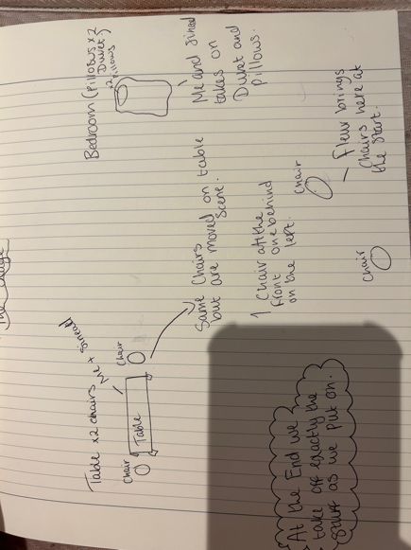
When it came to Tech week I knew exactly what set I wanted. I wanted it to be quite simple but effective because I liked the idea of having set on the stage the whole time, so it was split staged. I had a table on stage left with two chairs either side and a duvet on the floor with a pillow on stage right to resemble a bedroom. We had a few props such as a box that had two glasses, two plates and two sets of cutlery, a book and a makeup bag with nail varnish. This would be used throughout the play as set and props.

Performance and conclusion

The day of tech I knew exactly what I wanted with lighting sound and set, how I set the stage. Me and the rest of the cast was the only ones taking it on and off, but I put us all in order to do it easily and efficient. The performance itself I think went well. On the day of my cast had learned it to their capabilities but it was hard to get time in practice because they had lessons, but we practiced every time we got. They were feeling confident in everything we did some check ins with each other to make sure they weren’t worried. We went over things just before just to make sure we were prepared. I felt like they were prepared, and they worked to their full potential, and we all put all our effort into it.

There are a few things I think I could improve on as a writer and director and that is being sure on what I want my idea to be and explore different thing instead of running with one idea and having to change the whole thing just before the performance, but I felt much better with my final idea. Another thing I could improve on is being more direct on how I want certain scenes to go or how I want them to be performed because as a person I am laid back and I will take on peoples idea more to see how they would like to perform it but some scenes at the start of the practicing period I feel like I could’ve said it a bit earlier exactly how I wanted these scenes to be performed. What I liked about this whole process was being able to create something that is completely mine and I have control over it all. It also helped me feel more creative and in charge and it’s something I don’t get to feel that often because I normally do things in teams. But on the other hand, by doing something that was all mine and I had complete power over I felt pressured into making sure it was perfect and I always had in the back of my mind that it might not be any good and people might not like it. But even though I had these doubts and insecurities, I was over all happy with the result and performance. With doing this process I think I would like to something like this again but more on the technical side of things because I was teching Mareds and I did enjoy that, and also on the directing side of things just so I can learn to improve on it instead but not the writing part because even though it was a good thing to learn I did find it a little difficult to be completely happy with my final idea. The conclusion of my question is the industry isn’t what everybody thinks it is and it is a lot harder that just playing around on stage. It can be very damaging to your mental health by being rejected every day of your life and being told by multiple people that you aren’t good enough, but it is also a really rewarding job, and you can tell people love doing it by all the research I have done for this project.

Bibliography

https://en.m.wikipedia.org/wiki/Look_Both_Ways_(2022_film)
Wikipedia. (2023). Look Both Ways (2022 film). [online] Available at: https://en.m.wikipedia.org/wiki/Look_Both_Ways_(2022_film) [Accessed 20 Feb. 2023].

https://screenrant.com/look-both-ways-movie-ending-explained-detail/
Smith, J. (2022). Look Both Ways Ending Explained (In Detail). [online] ScreenRant. Available at: https://screenrant.com/look-both-ways-movie-ending-explained-detail/ [Accessed 20 Feb. 2023].

https://performerstuff.com/mgs/10-of-the-best-expectations-vs-reality-moments-theatre-edition/
PerformerStuff More Good Stuff. (2016). 12 of the Best Expectations vs. Reality Moments: Theatre Edition. [online] Available at: https://performerstuff.com/mgs/10-of-the-best-expectations-vs-reality-moments-theatre-edition/ [Accessed 20 Feb. 2023].

https://bandology.ca/my-experience-in-musical-theatre/
Caju (n.d.). » My Experience in Musical Theatre. [online] Available at: https://bandology.ca/my-experience-in-musical-theatre/ [Accessed 20 Feb. 2023]

https://en.m.wikipedia.org/wiki/Defying_Gravity_(song)
Wikipedia. (2021). Defying Gravity (song). [online] Available at: https://en.m.wikipedia.org/wiki/Defying_Gravity_(song).

https://medium.com/song-of-the-lark/defying-gravity-b0805d034465
Morrigan, L. (2020). Defying Gravity. [online] Song of the Lark. Available at: https://medium.com/song-of-the-lark/defying-gravity-b0805d034465 [Accessed 20 Feb. 2023].

https://www.theguardian.com/society/2022/may/12/performing-arts-depression-equity-covid-job-insecurity
Sherwood, H. (2022). People in performing arts twice as likely to have depression, Equity finds. [online] the Guardian. Available at: https://www.theguardian.com/society/2022/may/12/performing-arts-depression-equity-covid-job-insecurity.

https://www.charactour.com/hub/characters/view/Elphaba-Thropp.Wicked
www.charactour.com. (n.d.). I’m a match to Elphaba Thropp from Wicked. [online] Available at: https://www.charactour.com/hub/characters/view/Elphaba-Thropp.Wicked.

https://gatorfeatures.shorthandstories.com/theatre-is-my-sport/index.html
gatorfeatures.shorthandstories.com. (n.d.). Theatre is My Sport. [online] Available at: https://gatorfeatures.shorthandstories.com/theatre-is-my-sport/index.html [Accessed 20 Feb. 2023]

https://mobilemusicschool.ie/face-the-music-five-great-benefits-of-musical-theatre-workshops/
School, M.M. (2020). Face the Music: Five Great Benefits of Musical Theatre Workshops. [online] Mobile Music School. Available at: https://mobilemusicschool.ie/face-the-music-five-great-benefits-of-musical-theatre-workshops/.

WORDS IN A SENTENCE. (2017). Figment: In a Sentence. [online] Available at: https://wordsinasentence.com/figment-in-a-sentence/#:~:text=Examples%20of%20Figment%20in%20a%20sentence%20My%20young [Accessed 24 May 2023].

Wikipedia. (2023). Girls Under Pressure. [online] Available at: https://en.wikipedia.org/wiki/Girls_Under_Pressure [Accessed 24 May 2023].

