Talent Management
&
Workforce Planning

Rebecca Rees

Word count - 4285

(AC 1.1)

ParcelCare is operating in a competitive labour market. The CIPD (2024) advises that they strategically position themselves by differentiating their employment offer to attract and retain skilled staff. The CIPD (2024) notes that 81% of organisations are improving employer branding, therefore ParcelCare risks falling behind if it fails to evaluate its approach. Competitor analysis is essential, including a review of rivals’ strengths and weaknesses in pay, conditions, flexibility, and culture. This enables ParcelCare to benchmark and refine its offer while identifying areas of improvement.
Taylor &Woodhams (2022) explain organisational positioning as how a company presents itself in the labour market, shaped by its ability to pay and uphold values. They describe three employer types: ‘employer of cash,’ who pay well but treat staff poorly, ‘employer of values,’ who treat fairly but lack pay competitiveness, and ‘employer of churn,’ who fail at both. They suggest the ideal goal is to become an ‘employer of choice’, offering both good pay and a positive employee experience.
To achieve this, ParcelCare must develop a strong employee value proposition (EVP) that reflects authentic employee experience. The CIPD (2024) states an effective employer brand enhances loyalty, inclusion, and performance, and should remain consistent across the employee life cycle. Data collection through surveys or exit interviews can identify what staff value and where improvements are needed. For example, ParcelCare may wish to analyse competitor offer, such as Amazon’s pay and benefits package, to better tailor its own.
The CIPD (2023) People Profession Survey highlights how embracing hybrid working, digital transformation, and people centred practices supports competitive positioning. ParcelCare could improve operational efficiency and employee experience by investing in workforce planning tools and flexible working options, especially for administrative staff. These actions directly support the organisation’s positioning and appeal as an ‘employer of choice.’ External markets challenges add further pressure, Cockett (2025) in Bon, E. (2025) notes that declining business confidence, rising National Insurance, and higher National Living Wage costs are making recruitment more difficult. The CIPD Labour Markey Outlook (2025) reveals one in four employers plan redundancies, with low pay growth and trade pressures affecting confidence. The CIPD Resourcing and Talent Planning Report, Hogarth & McCartney (2024), highlight strong competition for talent, with 69% reporting difficulty attracting candidates for skilled roles. Retention issues are also growing, with 56% facing challenges and 41% losing new hires withing twelve weeks.
In this climate, ParcelCare must work harder to attract and retain talent by reinforcing its employer brand and offering a unique employment experience. Lievens et al. (2007) argue that in tight labour markets, being an ‘employer of choice’ is no longer enough; organisations must offer a genuine, distinctive EVP to compete successfully.

(AC 1.2)

According to Armstrong (2023), the labour market is the environment where employers seek suitable employees and people look for work. Recruitment challenges often arise from skills shortages or broader economic conditions. Ellis, in Taylor & Woodhams (2022), notes that labour market conditions vary across sectors and understanding these dynamics is crucial for organisations like ParcelCare to inform people management and workforce planning. As employers operate across local, national, and international labour markets, a broad understanding is essential for attracting and retaining talent.
The CIPD’s Labour Market Outlook (Spring 2025) highlights a decline in employer confidence, suggesting an increased uncertainty and pressure on resourcing decisions. Labour supply is measured by the number of people available to work, while demand is reflected in job vacancies. This balance between supply and demand will influence wages and recruitment. Tight markets might increase wage costs and time to hire, whilst a loose market may improve time to hire and reduce turnover.

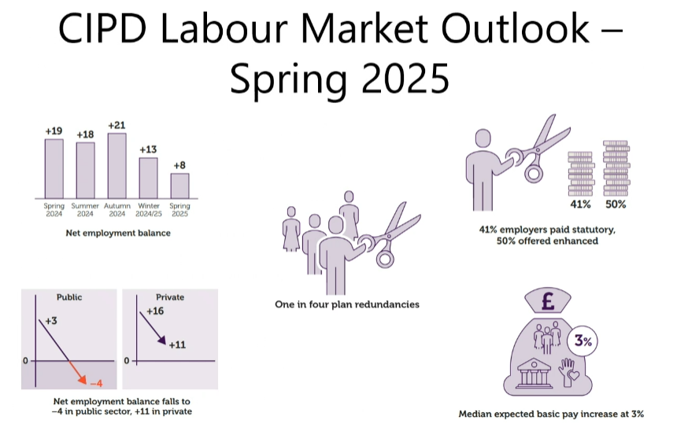 (CIPD 2025)

Taylor & Woodhams (2022) explain that in a tight labour market, demand exceeds supply, driving competition for talent and increasing wages. ParcelCare may need to adapt its employer brand to offer a more competitive package or recruit internationally. In contrast, a loose labour market allows quicker, more cost-effective recruitment, benefiting KPIs like time to hire and easing pressure to enhance benefit packages. Taylor & Woodhams (2022) also note that demographic changes, policy, and technology influence future labour markets. For example, an aging population may shrink the labour pool, requiring inclusive hiring and flexible work to attract older applicants.
Hayden (CIPS, 2025) recommends using a PESTLE analysis: Political, Economic, Social, Technological, Legal, and Environmental factors, to guide workforce planning. ParcelCare can use this tool to anticipate external changes that may affect skills needs or job design. For example, automation could improve sorting, while political regulations ensure compliance with laws such a minimum wage, and environmental goals may push for electric delivery vehicles. PESTLE supports long term planning and workforce adaptability.
According to Ribery et al. (2016), the UK’s deregulated labour market encourages a lean model involving job rotation, teamwork, productivity targets, and temporary contracts. If ParcelCare adopts this model to remain flexible, it may rely more on fixed-term agency workers and implement strict performance targets. However, Rubery et al. (2016) warns that this approach could undermine job security and fair treatment, increasing turnover and disengagement.
Fundamentally, changing market conditions will impact organisations including ParcelCare’s resourcing decisions. These influence how it can recruit, retain and plan its workforce. To remain competitive, they must monitor external trends, adapt its branding and workforce planning, whilst being able to flex when utilising tools like PESTLE to build a resilient workforce plan.

3 (AC 2.1)
Wilkinson & Taylor, in Woodhams & Taylor (2022, p.38), highlight the impact of effective workforce planning, ensuring the right people, with the right skills, are in the right place at the right time to meet business goals. Planning enables ParcelCare to match labour supply with business demand over different timeframes, from daily staffing to long-term leadership. This is particularly relevant for ParcelCare, which experiences fluctuating parcel volumes due to external pressures such as consumer trends and festive periods like Christmas.
Wilkinson & Taylor (2022) outline four key steps in talent planning:
- Forecasting demand
- Forecasting supply
- Identifying gaps
- Making plans
ParcelCare can identify resource shortages (e.g., drivers or customer service staff) and address them through recruitment, training, or redeployment. Using both data driven and managerial judgements techniques, historic data could help forecast demand. Strategies such as upskilling, job redesign, internal promotion, or flexible staffing offer cost effective solutions for ParcelCare. Succession planning is also key, Wilkinson & Taylor, in Woodhams & Taylor (2022), highlight that developing internal talent ensures continuity and reduces reliance on external hires, whilst developing pathways can also boost retention and engagement.
According to Hirsh in the CIPD podcast (2019), workforce planning becomes especially important in tight labour markets with growing skill shortages. ParcelCare, facing these pressures, could benefit by anticipating skills needs and proactively building talent pipelines. Instead of reacting to last-minute vacancies, the business could forecast and prepare.
Hayden, (CIPD, 2024) acknowledges 6 stages of workforce planning, below:

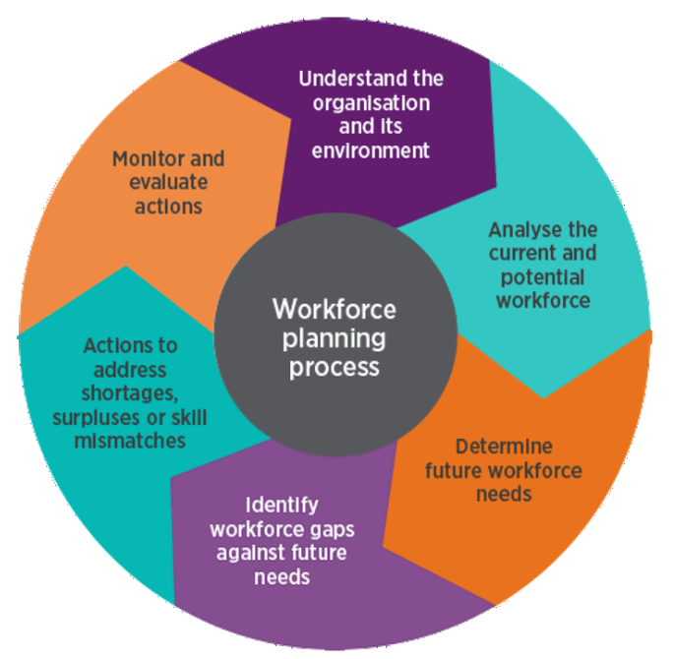

Britnell (CIPD podcast, 2019) notes that workforce planning fosters collaboration across HR, finance, and leadership, aligning people strategy with business growth. For ParcelCare, this supports location planning, and sourcing labour where cost, skills, and infrastructure align. Britnell, also stresses the value of using credible, actionable data to drive strategic decisions.
Hayden (CIPD, 2024) identifies six stages of workforce planning and emphasises that it is flexible, scalable, and suited to organisations of all sizes. Effective planning will support ParcelCare’s long-term goals, reduce risks, and help the business manage change more effectively. Whether facing digital transformation or restructuring, identifying future skills needs, enables investment in people before gaps become business critical.

(AC 2.2)
Workforce planning is essential to ensure an organisation has the right people, with the right skills, in the right roles at the right time. The CIPD (2023a) highlights two key approaches that support this process: the seven ‘rights’ principle and the six-stage workforce planning methodology. The seven ‘rights’ provide a structured way of ensuring workforce alignment with business needs, promoting agility, productivity, and responsiveness to change.

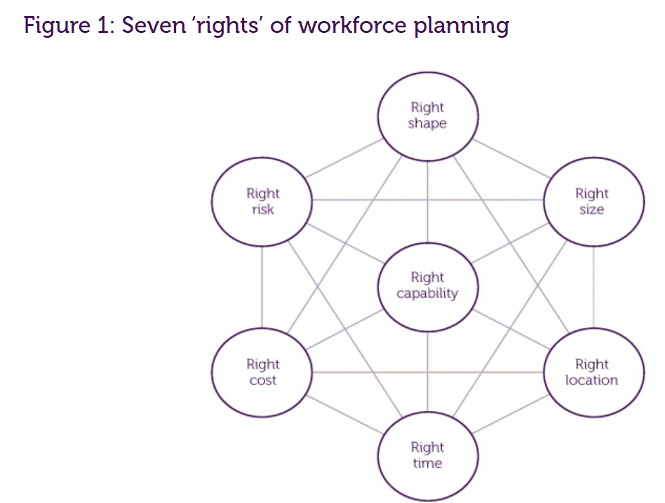
The CIPD (2023a)
To apply this effectively, the CIPD (2023a) recommends using a six-stage methodology comprising: baseline analysis (e.g., PESTLE, SWOT analysis), supply and demand forecasting, gap analysis, action planning, and continuous monitoring and delivery.
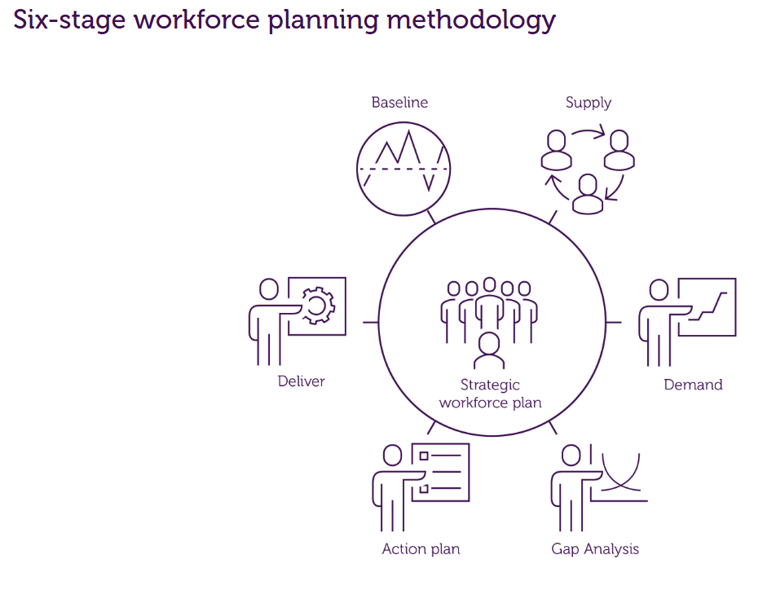
The CIPD (2023a)
In practice, this structured approach helps organisations such as ParcelCare align workforce supply with anticipated demand. For example, using SWOT or PESTLE tools during baseline analysis can help assess external pressures, such as fuel costs or changes in delivery technology, that may impact labour needs.
Workforce planning is further enhanced by data driven techniques, particularly people analytics and predictive modelling. According to Willis Towers Watson (WTW, n.d.), talent analytics can identify behavioural trends, monitor turnover, and detect skills gaps. Predictive tools can forecast future staffing needs based on historical trends, helping to align resourcing with organisational strategy. For example, ParcelCare could use analytics to anticipate driver shortages in the lead up to Christmas, allowing for earlier recruitment and training. In addition, AI-powered dashboards can convert large datasets into actionable insights. This enables managers to track metrics such as absence rates, overtime levels, and labour costs, which supports real-time decision-making. However, WTW warns that the effectiveness of these tools relies on the quality of available data and strong cross-functional collaboration. Smaller organisations may face barriers due to limited analytical capabilities or digital infrastructure. Nevertheless, even basic metrics, like Key Performance Indicators (KPIs), can support data-informed workforce planning.
Armstrong (2023) distinguishes between hard and soft planning techniques, both of which are valuable when used in combination. Hard techniques like demand forecasting estimate future staffing needs using trend data and business plans. Scenario planning helps organisations prepare for different future situations (e.g., automation or seasonal peaks), although these can be resource intensive and are time sensitive. Soft techniques focus on leadership judgement and qualitative insights. Managerial judgement is a widely used forecasting method that draws on managers’ understanding of operational needs. While this provides valuable context, Armstrong (2023) notes that it can lack objectivity and consistency. A combination of top-down and bottom-up input can improve balance and accuracy.
For ParcelCare, adopting a blended approach, combining analytical tools with internal expertise, will support effective and flexible workforce planning. In a volatile labour market, this approach will help the organisation better manage fluctuating delivery demands and plan more strategically for the future.

(AC 2.3)
The CIPD (2024a) highlights that recruitment plays a vital role in organisational success, particularly during periods of labour market pressure. Wilkinson &Taylor in Taylor & Woodhams (2022) explain that recruitment and selection are often considered together, but serve distinct functions. Recruitment focuses on attracting applicants, while selection aims to identify the most suitable candidate. Currently, ParcelCare advertises vacancies on its website and uses line manager interviews to assess candidates. While these are effective, broadening the methods used can improve candidate reach and they quality of their decision making.
Recruitment Methods
1) External Recruitment Services
External recruitment agencies can handle advertising, screening, and assessments (CIPD, 2024a). These services often access wider talent pools and have industry specific knowledge, which can help ParcelCare fill operational roles efficiently. Additionally, they reduce workload for internal staff. However, the use of agencies can be expensive and may not be sustainable in the long term. It may also limit internal control over the process and lead to mismatches.
2) Commercial Job Boards
Commercial job boards such as Monster.co.uk and Fish4Jobs.com are used to advertise vacancies to a wide audience (Armstrong, 2023). These platforms are suitable for high-volume roles like drivers or warehouse workers, which benefits ParcelCare. A key advantage is their reach among active job seekers. However, a major drawback is the large volume of unsuitable applications, which can slow down the recruitment process and require more administrative time, Armstrong (2023) also highlights that this service comes at a cost to the business.

Selection Methods
1) Psychometric Testing
Psychometric tests assess abilities, personality, or aptitude and are often delivered online for high volume roles (CIPD, 2024a). Armstrong (2023) notes innovations such as Deloitte’s gamified assessments measuring traits like resilience and agility. A key benefit is the objective and consistent evaluation of candidates. However, Armstrong (2023) does note these tests require trained professionals to interpret results, must be legally compliant, and should not be the sole decision-making tool.
2) Skills-Based Assessments
The CIPD (2024b) describes these as realistic tasks that reflect job responsibilities, such as simulations or situational judgement tests. These can help ParcelCare identify candidates who are practically suited to the role. Their objectivity and relevance make them more predictive of job performance than traditional interviews. However, they can be time consuming and expensive to develop. If poorly designed, they may not accurately reflect actual role demands.
Using a mix of methods can enhance ParcelCare’s recruitment and selection process. However, each approach must be carefully managed to ensure alignment with organisational values and workforce needs.

(AC 3.1)

Unavoidable turnover refers to employee exit due to factors outside of the employer’s control, for example, redundancy, relocation and retirement. The CIPD Spring, 2025 Labour Market Outlook Report (CIPD, 2025a) addresses that one in four employers are planning redundancies in the next three months, which reflects unavoidable turnover due to economic pressures, or fiscal policy. The CIPD (2024c) report that more employers are aiming to maintain staffing levels, with only 11% planning to reduce headcount, this suggests lower unavoidable turnover compared to previous periods.
Avoidable turnover happens when employees leave due to internal factors, for example this could be poor management, and lack of development opportunities. The CIPD Spring, 2025 Labour Market Outlook report (CIPD, 2025a) details the high rate of employers only offering statutory redundancy pay at 41% and declining recruitment may suggest cost-cutting measures that could be due to NI increases and a fall in morale within the workplace. Additionally, the CIPD (2024c) urges employers to prioritise staff development and upskilling as a means of improving retention, this implies that skills gap and limited development are causes of avoidable turnover.
Push factors can be described as negative factors that drive employees to leave, which include factors like workload and job insecurity. The CIPD spring report (CIPD, 2025a) observes a decline in the net employment balance, and a rise in redundancy intentions, both of which signal job insecurity, which is a key push factor. Furthermore, the report acknowledges that a flat 3% median expected pay increase may not be competitive, especially in a high inflation, cost of living context. The CIPD (2024c) notes that increasing workloads is becoming a push factor to employees, with 36% of employers increasing duties of existing staff.
Pull factors are the external factors that draw staff elsewhere, this could be better pay, career opportunities and development, and or location. The CIPD Spring 2025, (CIPD, 2025a) labour market report would suggest that the fall in recruitment, coupled with the cautious labour market will lead to fewer pull factors, which may help retain employees at ParcelCare. Cockett, (CIPD, 2024c) highlights how the ‘great resignation is over’ which suggests that external opportunities are no longer pulling employees away, with the ‘big stay’ whereby employees are prioritising stability.
ParcelCare’s higher turnover rates, could be driven by unavoidable factors such as redundancy due to market conditions, and also avoidable factors like limited development and increased workload. Current labour market conditions, such as falling recruitment activity and the end of the ‘great resignation,’ reduce external pull factors but intensify the importance of addressing internal push factors. This fundamentally highlights the need for strategic workforce planning to reduce voluntary turnover and support staff retention.

(AC 3.2)

Retention of warehouse staff at ParcelCare is a concern due to competition in the labour market. Effective talent management focuses on attracting, developing, engaging, and retaining staff which is vital to business success. Quilliam, (CIPD 2024) notes that many organisations now view all employees as having potential that can be developed to benefit the business. The CIPD and Omni RMS (2024) recommend strategic workforce planning and in house development to support retention.
Realistic Job Previews (RJPs) give candidates a clear view of the job’s demands and benefits. Indeed (2025) explains that RJPs help applicants self-assess their suitability for the role, reducing early resignations. They can be cost effective, particularly when they are delivered though brochures or videos, and help promote transparency. Hogarth (2021) offers a case study from North Yorkshire Police where outdated recruitment and poor job fit contributed to dysfunctional turnover. The use of realistic job previews and fairer assessments led to improved retention. The CIPD (2022) highlights that flexible and inclusive advertising, such as promoting fair pay and work-life balance, improves role fit and retention. RJPs are particularly useful in physically demanding role like warehouse work, where early exits due to mismatch can occur.
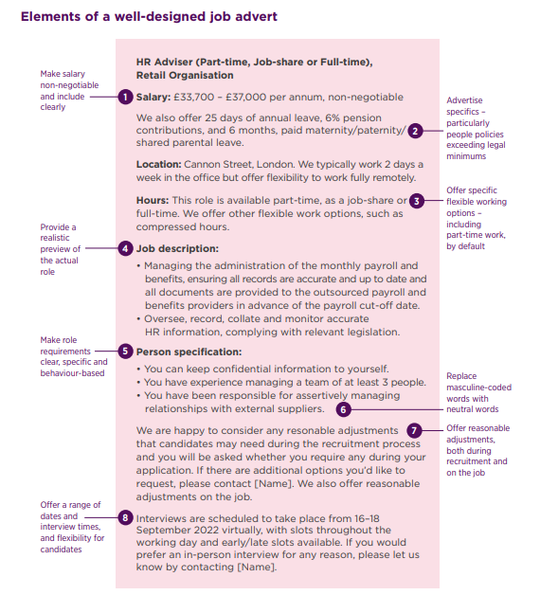CIPD (2022)

Induction plays a crucial role in retention, post hire. McCartney (CIPD, 2024a) emphasises that induction enhances belonging, clarifies expectations, and supports integration. According to the CIPD and Omni RMS (2024), 32% of organisations have improved induction to reduce early turnover. Wilkinson & Taylor in Taylor & Woodhams (2022) explain that effective induction blends support and structure, however, if poorly delivered, new hires may experience an 'induction crisis’ which can increase early exists. Compared to RPJ’s, which filter applicants pre hire, induction secures engagement after applicants begin their employment.
Job enrichment improves motivation by making work more meaningful. Based on the Job Characteristics Model (Hackman & Oldham, 1975), enrichment involves increasing autonomy, task variety, and feedback. Armstrong, (2023) explains that enriched job provides complete, engaging tasks, while Herzberg (1968) emphasises enrichment fosters personal growth rather than just relieving boredom. In comparison to induction and RJPs, which are more process based, enrichment focuses on long term engagement. For warehouse roles, this could include task rotation or skill development to reduce any monotony.
Reward strategies also play a vital role in retention. The CIPD (2025c) distinguished between strategic reward, which aligns reward with organisational goals, and total reward, which includes non-financial aspects like flexibility, development and recognition. A tailored, people centred reward strategy enhances employer branding and supports loyalty. However, it’s success depends on the support of the line manager. Whilst total reward goes further than pay and benefits and includes non-financial aspects, which the CIPD (2025c) include as:
- Work/life balance
- Career development
- Recognition
- Flexible working
- Fair treatment and autonomy (CIPD, 2025c)
Fundamentally, reward could be crucial in a competitive labour market to attract and retain warehouse staff at ParcelCare. Unlike job enrichment, which addressed intrinsic motivation, reward combines both intrinsic and extrinsic motivators. A blended strategy, combining, RJPs, quality induction, meaningful work and fair reward, would give ParcelCare the best chance of retaining its warehouse workforce.

(AC 3.3)

Wilkinson & Taylor in Taylor & Woodhams (2022) define dysfunctional turnover as the loss of employees an organisation would prefer to retain due to their skills, experience or the difficulty in replacing them. Unlike functional turnover, which involves underperforming staff leaving the organisation, dysfunctional turnover negatively impacts business performance and should be addressed by the leadership at ParcelCare. Wilkinson & Taylor in Taylor & Woodhams, (2022) note the impact of dysfunctional turnover, leading to direct costs such as recruitment, advertising, onboarding and training as well as the indirect costs, including productivity loss, lowered morale, and service delivery issues.
The CIPD (2025d) supports this view, highlighting how turnover can become problematic in tight labour markets where recruitment is expensive and skilled labour is limited. This is especially relevant for ParcelCare when experienced staff leave due to internal ‘push’ factors like a lack of progression. The CIPD’s (2024d) Resourcing and Talent Planning Report notes only 31% of organisations calculate the cost of labour turnover, despite the financial impact, including lost productivity and the additional pressures put on the remaining staff. Hogarth (2021) provides a case study from North Yorkshire Police where outdated recruitment and poor job fit led to dysfunctional turnover. A move to a more strength-based recruitment, RJP’s and fairer assessments improved retention and reduced appeals.
The CIPD (2025d) stresses the need to understand who leaves, why and also the associated costs. Although exit interview may not always give honest feedback, data collection is important to shape retention strategies. Wilkinson & Taylor in Taylor &Woodhams (2022) estimate that 90% of voluntary resignations are preventable, with common causes including unfair pay, limited development, poor management, and workplace culture. The CIPD (2025d) recommends key actions to reduce dysfunctional turnover:
- Flexible working: with manageable workloads and adaptable hours.
- Fair treatment: in pay and benefits.
- Wellbeing: through training in stress management.
- Career development: via learning opportunities.
- Employee Voice: ensuring open dialogue (aligned with ICE regulations).
Dysfunctional turnover has serious financial and operational implications. Senior leadership at ParcelCare must act to improve retention and maintain performance.

(AC 4.1)

ParcelCare currently employs the majority of its workforce on permanent, full-time contracts. This is beneficial where stability and continuity of service is needed (Ayling, CIPD 2024), and offers consistency, employee engagement, and reliable customer service. However, they reduce flexibility when demand fluctuates, such as peak seasons or economic downturns, whilst overstaffing during quieter times can also increase cost. The CIPD (2024e) explains that employment rights depend on whether someone is classified as an employee, worker, or is self-employed. This affects their rights, tax code, and the employers’ obligations. ACAS (2025) states that a contract of employment, whether verbal or written, expressed or implied, should ideally be in writing for clarity, and usually only applied to employees, and not agency or casual workers. To meet changing demands, ParcelCare could supplement its workforce using fixed-term and or zero-hour contracts.

Fixed-Term Contracts
Using fixed-term contracts would allow ParcelCare to manage short-term demand, for example during the festive period, without committing themselves long-term. Daniels (2022) explains these contracts are lawful if they clearly state an end date. Silkin (CIPD, 2024) supports their use for maternity cover, seasonal work, or role trials. Under the Fixed-term Employees (Prevention of Less Favourable Treatment) Regulations 2002, fixed-term workers must be treated equally to permanent staff unless justified, this includes training, bonuses, and benefits (Silkin, CIPD 2023). Daniels (2022) acknowledges that after four years on successive fixed-term contracts, workers may be deemed permanent unless objectively justified. Legal risks may occur if fixed-term contracts are misused. In the case of Webley v DWO (2004) it was deemed that ending a fixed-term contract at the agreed date lawful and not unfair dismissal. In contrast, Perez Lopez v Servicio Madrileno (2016) repeated use of fixed-term contracts to meet ongoing staffing needs was rules unlawful under EU law.

Casual Worker – Zero-Hour Contracts
Zero-hour contracts offer flexibility to match labour supply to demand and can be useful to ParcelCare for on call drivers during busy months. Daniels (2022) explains these contracts do not require employers to offer work or workers to accept it. However, consistent patterns of work may trigger employee status and right associated with it. ACAS (2024) and Silkin (CIPD, 2021) stress they must be used fairly, with proper notice, no exclusivity clauses, and policies in places for cancelled shifts. The Small Business, Enterprise and Employment Act 2015 and Exclusivity Terms in Zero-hour Contracts Regulations 2015 make it unlawful to penalise workers for seeking other work, whilst poor use of zero-hour contracts can damage morale and employer brand (Silkin, CIPD 2021). The Department for Business & Trade (n.d.) maintains that the Employment Rights Bill 2024 strengthens protections, including the right to request guaranteed hours and pay for last minute cancellations, which is an important cost consideration for ParcelCare if using zero-hour contracts. Used ethically (ACAS, 2024) and legally, fixed-term and zero-hour contracts can offer ParcelCare the flexibility to manage fluctuating delivery demand.

(AC 4.2)

According to McCarthy (CIPD, 2024a), induction is the process that helps employees transition into their new role and adapt to their new workplace environment. At ParcelCare, onboarding is currently limited to completing new starter forms and basic health and safety training. While this meets basic compliance, it lacks the broader strategies that onboarding can offer. Lewis (2024) highlights those limited approaches fail to deliver the full benefits of onboarding, which include improved engagement, retention, and job satisfaction.
A well-structured onboarding process supports new hires in understanding their job responsibilities, organisational values, and working culture (McCartney, CIPD 2024a). The CIPD Resourcing and Talent Planning Report (2024d) found that 32% of organisations improved onboarding specifically to boost retention. McCartney notes that effective onboarding increases job satisfaction and help employees feel welcome and supported before their start date. It also can improve productivity by providing relevant training and access to support networks, like a ‘buddy’ system, which would be a cost-effective approach for internal training at ParcelCare.
Taylor & Woodhams (2022) warn that poorly planned onboarding can lead to an ‘induction crisis,’ where employees feel isolated or unclear about their expatiations. This may result in disengagement, underperformance or resignation. They advocate for ‘buddy’ schemes and early involvement in team activities which can help new employees feel included and engaged. Additionally, McCartney (CIPD, 2024a) and Taylor & Woodhams (2022) recommend involving senior leaders in the onboarding process to reinforce the culture of the organisation and communicate clear expectations about the role. Armstrong & Taylor (2023) identify, five key aims of onboarding: to create a good first impression, provide essential information, ease the transition into the role, clarify expectations, and reduce early turnover. Lewis (2024) provides further evidence that onboarding should begin before the employee’s first day. She highlights that 44% of candidates accept an offer but never start, and 43% leave within the first 90 days. Early engagement, including welcome emails and pre-onboarding phone calls can reduce anxiety. Lewis acknowledges the importance of equipping managers with tools and templates to ensure consistency and quality of onboarding. The data suggests that structured onboarding leads to reduced turnover. Investment in this area would give significant value for ParcelCare. It supports integration, cultural alignment, and early development, whilst reducing the risk of early exit.

Cases Cited

Webley v Department for Work and Pensions (2004) EWCA Civ 1745 73
Perez Lopez v Servicio Madrileno (2016) IRLR 970 73

Bibliography

ACAS (2024) Zero Hour Contracts https://www.acas.org.uk/zero-hours-contracts (Accessed 14/06/2025)

ACAS (2025) Types of terms in a contract – Employment contracts and the law https://www.acas.org.uk/employment-contracts-and-the-law/types-of-terms-in-a-contract (Accessed 20/06/2025)

Armstrong, M & Taylor, S (2023) Armstrong’s Handbook of Human Resource Management Practice. Kogan Page: London

Ayling, L (CIPD 2024) Contracts of Employment
https://www.cipd.org/uk/knowledge/factsheets/terms-conditions-contracts-factsheet/#what-is-a-contract-of-employment (Accessed 15/06/2025)

Beatson, M (CIPD 2024) Zero Hours Contracts
https://www.cipd.org/uk/knowledge/factsheets/zero-hours-factsheet/ (Accessed 15/06/2025)

Bon, E. (2025) Labour Market Outlook – spring 2025. London: Chartered Institute of Personnel and Development.
https://www.cipd.org/contentassets/cf73843a106949d9b16ac2bc9b526278/8869-lmo-spring-2025-web.pdf (Accessed 02/06/2025)

CIPD (n.d.) Employee Experience
https://www.cipd.org/uk/the-people-profession/the-profession-map/explore-the-profession-map/specialist-knowledge/employee-experience/ (Accessed 18/06/2025)

CIPD (2019) Podcast Episode 150: The Many Merits of Workforce Planning
https://www.cipd.org/uk/knowledge/podcasts/workforce-planning/ (Accessed 05/06/2025)

CIPD (2022) A guide to inclusive recruitment for employers
https://www.cipd.org/globalassets/media/knowledge/knowledge-hub/guides/2023-pdfs/inclusive-recruitment-employers-guide_tcm18-112787.pdf (Accessed 10/06/2025)

CIPD (2023) People Profession 2023: International Survey report.
https://www.cipd.org/uk/knowledge/reports/people-profession-survey-2023/
(Accessed 02/06/2025)

CIPD (2023a) Strategic Workforce Planning: Guide for people professionals https://www.cipd.org/uk/knowledge/guides/strategic-workforce-planning/#six-stages-to-workforce-planning (Accessed 06/06/2025)

CIPD (2024) Employer Brand
https://www.cipd.org/uk/knowledge/factsheets/recruitment-brand-factsheet/
(Accessed 02/06/2025)

CIPD (2024a) Recruitment: An introduction
https://www.cipd.org/uk/knowledge/factsheets/recruitment-factsheet/#recruitment Accessed 08/06/2025)

CIPD (2024b) Inclusive Recruitment: Guide for employers
https://www.cipd.org/uk/knowledge/guides/inclusive-employers/#application-process (Accessed 08/06/2025)

CIPD (2024c) New Focus on Upskilling needed as staff turnover and vacancies are set to decline.
https://www.cipd.org/uk/about/press-releases/new-focus-on-upskilling-needed-as-staff-turnover-and-vacancies-set-to-decline/ (Accessed 08/06/2025)

CIPD (2024d) Resourcing and Talent Planning Report
https://www.cipd.org/uk/knowledge/reports/resourcing-surveys/ (Accessed 14/06/2025)

CIPD (2024e) Employment Status: UK employment law
https://www.cipd.org/uk/knowledge/employment-law/employees/ (Accessed 14/06/2025)

CIPD (2025) SWOT analysis
https://www.cipd.org/uk/knowledge/factsheets/swot-analysis-factsheet/
(Accessed 02/06/2025)

CIPD (2025a) Labour Market outlook
https://www.cipd.org/uk/knowledge/reports/labour-market-outlook/ (Accessed 02/06/2025)

CIPD (2025b) Understanding the Economy & Labour Market.
https://www.cipd.org/uk/knowledge/factsheets/economy-labour-market-factsheet/#cycle (Accessed 05/06/2025)

CIPD (2025c) Strategic & Total Reward
https://www.cipd.org/uk/knowledge/factsheets/strategic-total-factsheet/ (Accessed 12/06/2025)

CIPD (2025d) Employee turnover and retention
https://www.cipd.org/uk/knowledge/factsheets/turnover-retention-factsheet/ (Accessed 13/06/2025)

Daniels, K (2022) Introduction to Employment Law, Sixth Edition. Kogan Page: London

Department for Business and Trade (n.d.) Employment Rights Bill Overview Factsheet https://assets.publishing.service.gov.uk/media/67f6711f555773bbf109e21a/employment-rights-bill-overview.pdf Accessed 15/06/2025)

Hackman, J & Oldman, G, (1975) Development of the job diagnostic survey, Journal of Applied Psychology, 60 (2) p 159.

Hayden, D (CIPD, 2024) Workforce Planning
https://www.cipd.org/uk/knowledge/factsheets/workforce-planning-factsheet/ (Accessed 05/06/2025)

Hayden, D (CIPD, 2025) PESTLE analysis
https://www.cipd.org/uk/knowledge/factsheets/pestle-analysis-factsheet/#what-is-a-pestle-analysis
(Accessed 04/6/2025)

Herzberg, F (1968) One more time: how do you motivate employees? Harvard Business Review, January- February, pp 109-120

Hogarth, A (2021) Transforming resourcing to future-proof policing: North Yorkshire Police. Resourcing and talent planning 2021: case studies. London: Chartered Institute of Personnel and Development. https://www.cipd.org/uk/knowledge/case-studies/transforming-north-yorkshire-police/#meeting-future-talent-needs (Accessed 12/06/2025)

Hogarth, A. and McCartney, C. (2024) Resourcing and talent planning report 2024. London: Chartered Institute of Personnel and Development. https://www.cipd.org/globalassets/media/knowledge/knowledge-hub/reports/2024-pdfs/8662-resource-and-talent-planning-2024-report-web.pdf (Accessed 10/06/2025)

Indeed (2025) https://www.indeed.com/career-advice/career-development/realistic-job-preview (Accessed 11/06/2025)

Lievens, F, Van Hoye, G & Anseel, F (2007) Organisational Identity and employer image: Towards a unifying framework. British Journal of Management, 18 pp 45-59.

Lewis, G (2024) The First 100 days: how to make (or break) a new hire https://www.peoplemanagement.co.uk/article/1870723/first-100-days-or-break-new-hire (Accessed 20/06/2025)

McCartney, C (CIPD, 2024) Selection Methods
https://www.cipd.org/uk/knowledge/factsheets/selection-factsheet/ (Accessed 08/06/2025)

McCartney, C (CIPD, 2024a) Induction
https://www.cipd.org/uk/knowledge/factsheets/induction-factsheet/ (Accessed 10/06/2025)

Quilliam, G (CIPD 2024) Talent Management
https://www.cipd.org/uk/knowledge/factsheets/talent-factsheet/ (Accessed 10/06/2025)

Rubery, J, Keizer, A & Grimshaw, D (2016) Flexibility bites back: the multiple ans hidden costs of flexible employment policies, Human Resource Management Journal, 26 (3), pp 235-51
Silkin, L (CIPD, 2021) Zero-hours contracts: understanding the law. https://www.cipd.org/globalassets/media/knowledge/knowledge-hub/guides/zero-hours-contracts-guide-web-2021_tcm18-10706.pdf (Accessed 15/06/2025)

Silkin, L (CIPD, 2023) Fixed-term contracts: Guide for employers https://www.cipd.org/uk/knowledge/guides/fixed-term-contracts-guide/ (Accessed 20/06/2025)

Silkin, L (CIPD, 2024) Agency Workers: Understanding the law https://www.cipd.org/uk/knowledge/guides/agency-workers-guide/#employment-status-where-do-agency-workers-fit-in (Accessed 15/06/2025)

Taylor, S & Woodhams C. (2022) 3RD ed. Studying Human Resource Management. London: Kogan Page.

WTW (n.d.) Talent Analytics
https://www.wtwco.com/en-gb/solutions/services/talent-analytics (Accessed 06/06/2025)

