Intercultural Competence
Report

Foreign Languages & Cultural Awareness

Module code: BMIH5003

MOHAMMAD MIAH
2118790

Executive Summary:

The Inclusivity Hotel & Spa, London, faces a critical juncture with the imminent integration of the Anglo Cluster team from diverse cultural backgrounds. This report provides a comprehensive analysis and strategic recommendations for effective intercultural leadership in the hospitality industry. Drawing on insights from the GLOBE Project, Hofstede's cultural dimensions, and scholarly works, the report highlights key cultural disparities between the United Kingdom and India, the headquarters of the Inclusivity Hotel company.

The GLOBE Project's cultural dimensions reveal variations in Power Distance, Uncertainty Avoidance, and Individualism-Collectivism. Challenges stemming from these differences are identified, including communication styles, resistance to change, and balancing individual and collective contributions. Concrete examples from the hospitality industry underscore the practical implications of these challenges.

To address these challenges, the report proposes three realistic recommendations. These include implementing comprehensive cross-cultural training, establishing mentorship programs, and organizing regular team-building activities. These initiatives aim to enhance cultural awareness, guide newcomers in navigating cultural nuances, and foster collaboration within the diverse team.

In conclusion, this report emphasizes the importance of a culturally sensitive and proactive approach to intercultural leadership. By implementing the recommended strategies, the Inclusivity Hotel & Spa can not only mitigate potential conflicts but also create a harmonious and inclusive work environment, ensuring the success of the Anglo Cluster team integration.

Table of Contents
Executive Summary: 2
Introduction: 3
Three Cultural dimensions: 4
Key Findings: 5
Challenges of Intercultural Leadership in the Hospitality Industry: A Critical Discussion 6
Recommendations 7
Conclusions: 8
References: 9

Introduction:

In the dynamic landscape of hospitality management, the recent visit to the Inclusivity Hotel & Spa in London, England, has provided valuable insights into the operational intricacies of the esteemed establishment. As the appointed Assistant General Manager, tasked with overseeing the integration of staff from the Anglo Cluster, it is essential to comprehend and navigate the cultural nuances that distinguish the United Kingdom (UK) from India, the headquarters of the Inclusivity Hotel company.
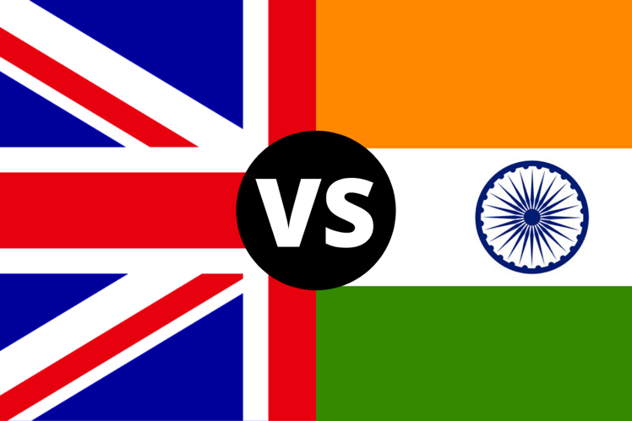
The cultural disparities between these two nations are multifaceted and crucial for effective management. According to Hofstede's cultural dimensions, the UK and India exhibit variances in dimensions such as individualism-collectivism, power distance, and uncertainty avoidance (Hofstede Insights). Additionally, the complexities arising from the imposition of English in India, as explored by Panwar and Mahajan (2022), further highlight the need for a nuanced approach to cross-cultural integration. This report aims to delineate key cultural disparities, drawing insights from scholarly works and cultural dimensions, to inform effective strategies for the seamless incorporation of the Anglo Cluster team into the Inclusivity Hotel & Spa in London.

Three Cultural dimensions:
In the endeavour to integrate the Inclusivity Hotel & Spa's Anglo Cluster team into the London establishment, a comprehensive analysis of cultural dimensions is imperative (GLOBE Project). The GLOBE Project, renowned for its study on culture and leadership, provides valuable insights into the practices and values shaping organizational dynamics. Focusing on the most relevant dimensions for this scenario, we consider Power Distance, Uncertainty Avoidance, and Individualism-Collectivism.
The provided data represents scores on three cultural dimensions - Institutional Collectivism, In-group Collectivism, and Power Distance - for various countries, based on a 1–7-point scale. These scores are sourced from House et al. (2004). The scores offer insights into the cultural tendencies of each country.
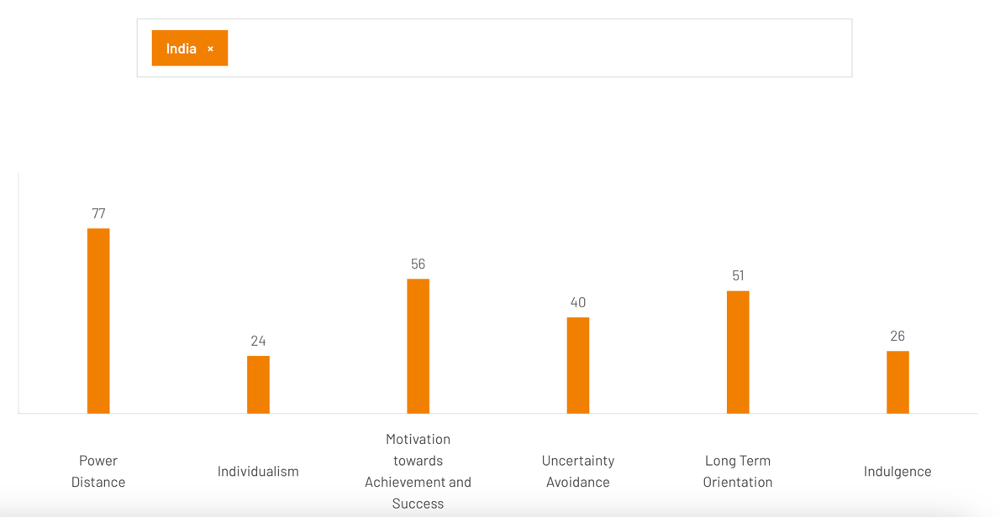

Key Findings:
1. Power Distance:
United Kingdom (UK): The UK exhibits a lower power distance orientation, emphasizing egalitarianism and a relatively flat organizational structure. Decision-making tends to be decentralized, fostering open communication (GLOBE Project). This aligns with the findings from Hofstede's cultural dimensions (Hofstede Insights). Conversely, India scores 2.64 on power distance, reflecting a relatively low preference for hierarchical structures and suggesting a preference for egalitarianism in power distribution. India displays a higher power distance orientation, reflecting a hierarchical organizational structure with respect for authority and centralized decision-making as integral aspects of workplace culture (GLOBE Project) (Panwar & Mahajan, 2022).

2. Uncertainty Avoidance:
- UK: The UK demonstrates a lower uncertainty avoidance, promoting a tolerance for ambiguity and a willingness to embrace change (GLOBE Project). This aligns with the dynamic nature of the hospitality industry in London. In contrast, with a score of 5.32, India exhibits a higher inclination toward in-group collectivism, emphasizing strong bonds and cooperation within social groups. India tends to have a higher uncertainty avoidance, reflecting a preference for structured environments and established procedures (GLOBE Project) (Panwar & Mahajan, 2022).

3. Individualism-Collectivism:
- UK: The UK leans towards individualism, emphasizing personal achievement and autonomy. Team members are expected to contribute independently, fostering a sense of personal responsibility (GLOBE Project). This is consistent with the individualistic tendencies identified by Hofstede Insights. On the other hand, India demonstrates a moderate level of institutional collectivism with a score of 4.71, indicating a balanced approach to collective decision-making within institutions. India places a higher value on collectivism, prioritizing group harmony and collaboration (GLOBE Project) (Panwar & Mahajan, 2022).
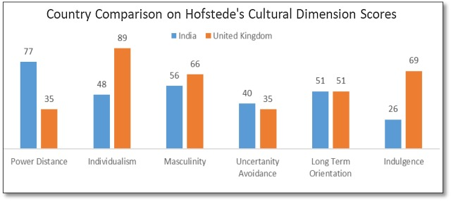
In conclusion, understanding the cultural dimensions through the GLOBE Project's lens provides a nuanced perspective, incorporating insights from both the GLOBE Project and Hofstede's cultural dimensions. Recognizing variations in power distance, uncertainty avoidance, and individualism-collectivism will inform tailored strategies for effective team integration. This cultural sensitivity is crucial as we strive to foster a cohesive and collaborative environment at the Inclusivity Hotel & Spa in London.
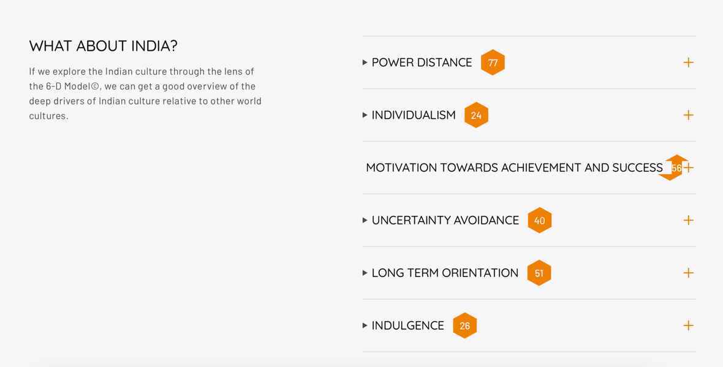

Challenges of Intercultural Leadership in the Hospitality Industry: A Critical Discussion
Intercultural leadership in the hospitality industry presents a myriad of challenges that demand careful navigation for effective team integration, a task particularly pertinent in the context of the Inclusivity Hotel & Spa in London. One primary challenge lies in managing diverse communication styles influenced by cultural backgrounds (Beldona et al., 2022). For instance, the UK's low power distance orientation, emphasizing egalitarianism, may clash with the higher power distance orientation observed in Indian workplace culture (GLOBE Project) (Panwar & Mahajan, 2022). This divergence in communication expectations can lead to misunderstandings and hinder effective collaboration.

Furthermore, the variance in uncertainty avoidance between the UK and India poses potential conflicts. The London hospitality industry's dynamic nature, characterized by a lower uncertainty avoidance, may contrast with the preference for structured environments in India (GLOBE Project) (Panwar & Mahajan, 2022). Adapting to the flexible and evolving nature of the London hospitality scene may challenge the incoming Anglo Cluster team, potentially resulting in resistance or reluctance to embrace change.

Individualism and collectivism also pose challenges in managing an intercultural team. The UK's inclination towards individualism aligns with the expectation of personal achievement and autonomy (GLOBE Project), while India's collectivist culture emphasizes group harmony (GLOBE Project) (Panwar & Mahajan, 2022). Encouraging the Anglo Cluster team to strike a balance between individual initiative and collective goals is crucial for seamless integration.

Concrete examples from the hospitality industry highlight these challenges. Miscommunications due to differences in communication styles can lead to service lapses, impacting guest satisfaction. Resistance to change may hinder the implementation of innovative guest experiences. Striking a balance between individual and collective contributions is essential for creating a harmonious work environment, ensuring that diverse talents contribute to the overall success of the hotel.

In conclusion, the challenges of intercultural leadership in the hospitality industry demand a strategic and culturally sensitive approach. Recognizing these challenges and implementing proactive measures, such as targeted training programs and mentorship initiatives, will be integral to the successful integration of the Anglo Cluster team at the Inclusivity Hotel & Spa in London. This aligns with the findings of Beldona et al. (2022), emphasizing the importance of understanding cross-cultural differences in hospitality management.

Recommendations
To overcome the challenges of intercultural leadership at the Inclusivity Hotel & Spa in London, the Management Team can implement the following realistic recommendations:

1. Comprehensive Cross-Cultural Training:
Develop and implement a robust cross-cultural training program for both existing and incoming staff. This program should focus on enhancing cultural awareness, communication styles, and understanding of diverse work practices. By fostering mutual understanding, this initiative aims to mitigate potential conflicts arising from differences in power distance, uncertainty avoidance, and individualism-collectivism (GLOBE Project) (Panwar & Mahajan, 2022).

2. Establishment of Mentorship Programs:
Introduce mentorship programs pairing existing team members with their counterparts from different cultural backgrounds. This initiative encourages knowledge sharing, provides a support system for newcomers, and facilitates a smoother integration process. Mentors can guide the incoming team in navigating cultural nuances, organizational dynamics, and communication expectations, contributing to a cohesive work environment.

3. Regular Team-Building Activities:
Organize regular team-building activities that promote collaboration and foster a sense of unity among the diverse team. These activities should be designed to encourage open communication, build trust, and strengthen interpersonal relationships. By creating a positive and inclusive team culture, the hotel management can address potential conflicts related to varying cultural values, ensuring a harmonious and productive work environment.

Implementing these recommendations will not only address the challenges outlined in the intercultural leadership scenario but also contribute to the overall success and synergy of the Inclusivity Hotel & Spa in London.

Conclusions:
In conclusion, navigating the challenges of intercultural leadership at the Inclusivity Hotel & Spa in London demands a strategic and proactive approach. As evidenced by the GLOBE Project (GLOBE Project website), understanding, and addressing cultural differences are pivotal for effective team integration. The recommendations provided align with scholarly insights from Beldona et al. (2022) and cultural dimensions outlined by Hofstede (Hofstede Insights) and the GLOBE Project.

By implementing comprehensive cross-cultural training, the hotel management team can equip staff with the necessary cultural competencies to navigate communication nuances and foster a collaborative environment (GLOBE Project) (Panwar & Mahajan, 2022). Mentorship programs contribute to a smoother integration process, drawing from the insights of experienced team members to guide newcomers in navigating organizational dynamics and cultural intricacies (GLOBE Project) (Beldona et al., 2022). Additionally, regular team-building activities align with recommendations from the GLOBE Project, promoting collaboration, trust, and unity among a diverse team (GLOBE Project) (Hofstede Insights).

Incorporating these measures will not only mitigate potential conflicts arising from differences in power distance, uncertainty avoidance, and individualism-collectivism but also contribute to the overall success of the Inclusivity Hotel & Spa in London. This cultural sensitivity and proactive approach underscore the commitment of the hotel management team to fostering an inclusive and harmonious work environment for the Anglo Cluster team.

References:

Beldona, S., Yoo, J., & Baiomy, A. (2022). Cross-Cultural Differences in Home Hospitality: An Exploratory Study. Tourism Culture & Communication. [DOI: 10.3727/109830422x16510695152037] (https://doi.org/10.3727/109830422x16510695152037)

GLOBE Project. (n.d.). GLOBE Cultural Dimensions. [https://globeproject.com/] (https://globeproject.com/)

Hofstede Insights. (n.d.). Country Comparison Tool. [https://www.hofstede-insights.com/country-comparison-tool?countries=india] (https://www.hofstede-insights.com/country-comparison-tool?countries=india)

Hofstede, G. (n.d.). Hofstede's Cultural Dimensions. [https://www.hofstede-insights.com/] (https://www.hofstede-insights.com/)

Panwar, J., & Mahajan, R. (2022). Imposition of English in India and Its Complexities. International Journal for Research in Applied Science and Engineering Technology. [DOI: 10.22214/ijraset.2022.47710] (https://doi.org/10.22214/ijraset.2022.47710)

Hofstede, G. (1980). Culture’s Consequences: International Differences in Work-Related Values. Sage Publications.

House, R. J., Hanges, P. J., Javidan, M., Dorfman, P. W., & Gupta, V. (2004). Culture, Leadership, and Organizations: The GLOBE Study of 62 Societies. Sage Publications.

Javidan, M., Dorfman, P. W., Sully de Luque, M., & House, R. J. (2006). In the Eye of the Beholder: Cross Cultural Lessons in Leadership from Project GLOBE. Academy of Management Perspectives, 20(1), 67-90. [DOI: 10.5465/amp.2006.19873412] (https://doi.org/10.5465/amp.2006.19873412)

Kostova, T., & Roth, K. (2002). Adoption of an Organizational Practice by Subsidiaries of Multinational Corporations: Institutional and Relational Effects. Academy of Management Journal, 45(1), 215-233. [DOI: 10.2307/3069286] (https://doi.org/10.2307/3069286)

Northouse, P. G. (2018). Leadership: Theory and Practice. Sage Publications.

