ACDA6002: Electronic Systems Design 14 Day

Weather Station Design

Niall Rees: 2220587

Introduction

This report details the design procedures to manufacture an amateur weather station capable of logging wind speed, direction using a rotating cup anemometer and potentiometer coupled wind vane, solar irradiance using a PV module, UV levels, Particulate matter using an SPS30 Laser scattering module, GPS Position, temperature, and relative humidity combined I2C module, and VOC levels over a 14-day period. A comparison of available weather stations has been compiled ranging from basic home use items to professional research devices.
The sensors have been selected to achieve accurate measurements whilst providing functionality at low cost for amateur users, utilising digital communications such as I2C and UART serial for simple implementation.
The enclosure design has been proposed, using an IP66 rated GRP enclosure from Schneider, including speciality 3D printed enclosures for individual sensors to maintain weather protection. Full CAD diagrams and assemblies have been created for the proposed solution.
Data storage is provided via a PCB mounted SD card, with host connection for data retrieval via an IP66 panel mounted USB connector.
A full schematic diagram, and circuit functionality has been created, detailing overvoltage protection techniques, filtering, and microcontroller interfacing, as well as PCB design using proper design philosophy for component placement. Microcontroller selection is covered, justifying the use of a DIP package PIC24FJ64GB202 16-bit MCU.
The cost for the prototype has been compiled from readily available parts and places the design between home and professional items.

2.0 Weather Station Overview

A review of current weather stations available has been carried out to assess their measurement systems, accuracy, construction and price point to develop the design covered in this report. Tables 1 and 2 display a selection of current units, ranging from basic home installations to comprehensive research and advanced weather stations. The table displays their main features extracted from the datasheets.
Product Name | W-8681-PRO [1] | WTH600-E-KIT [2] | RK900-03 Weather  Station (Tripod Mounted) [3]
Supplier | Watson | Extech Instruments | Rika Sensor
Temperature Measurement | -30°C to 65°C (±1°C, 0.1°C Res) | -40°C to 80°C, (±0.5°C, 0.1°C Res) | -50°C to 100°C, (±0.5°C, 0.1°C Res)
Humidity Measurement | 1% to 99% (±5%) RH | 1% to 99% (±3%) RH | 0-100% RH (±3%)
Wind Speed | 0 to 50m/s  ±1m/s <5m/s  ±10% > 5m/s | 0 to 50m/s  ±6%, 0.1m/s | 0 to 45m/s  ±0.3%, 0.1m/s
Wind Direction | Yes, Physical Vane | Yes, Wind Vane 16 Points | Yes, Wind Vane 0 - 360°
Light Measurement | 0-400kLux | No | No
Rain Volume Measurement | 0-9999mm ±10% | 0-9999mm ±7% | No
Barometer | Internal, 300 - 1000hPa ±3hPa | Internal, 540 - 1100hPa ±4hPa | 10 - 1100hPa ±0.3hPa
Wireless Capable | Yes, Wi-Fi | RF Between outdoor  and Indoor | No
UV Measurement | No | No | No
VOC Measurement | No | No | No
Particulate Matter | No | No | No
Power Supply | 3xAA Batteries | 3xAA Batteries | 12VDC Lithium Battery/  Mains adapter
IP Rating | Not Stated | IP67 (Transmitter) | IP65
Dimensions | Not Stated | Transmitter: 343.5 x 393.5 x 136 mm | 600x200x500mm (Box)
Weight | Not Stated | 673g (Outdoor Transmitter) | 5kg
Additional Features | Atomic Time, LCD Display  Windchill Calculation | Atomic Time, LCD Display  Windchill Calculation | Datalogging software,  Magnetometer
Storage | Micro SD Card Slot | None Stated | 4 months internal capacity
Price | £219 | £99.95 | £££

Table 1 - Weather Station Features

Product Name | EOLOS-IND [4] | SenseCAP S1000 [5] | GMX531 [6]
Supplier | Skyview Systems | Seeed Studio | MaxiMet
Temperature Measurement | -40°C to 70°C, (±0.8°C, 0.1°C Res) | -40°C to 85°C, (±0.1°C, 0.01°C Res) | -40°C to 70°C, (±0.3°C, 0.1°C Res)
Humidity Measurement | 0-100% RH (±4%) | 0-100% RH (±1.5%) | 0-100% RH (±2%)
Wind Speed | 0.1 to 85m/s  ±0.5m/s, 0.1m/s (Ultrasonic) | 0 to 60m/s  ±0.3m/s <10m/s  ±3% > 10m/s, 0.1m/s Res Ultrasonic | 0 to 60m/s  ±3% to 40m/s  ±5% 60m/s, 0.01m/s Res Ultrasonic
Wind Direction | 0 - 360°, ±3°, Ultrasonic | 1 - 360°, ±3°, Ultrasonic | 0 - 359°, ±3°, Ultrasonic
Light Measurement | No | 0-188000 Lux, 5 Lux Res,  5% Reading Accuracy | 0 - 1600W/m2, res 1W/m2
Rain Volume Measurement | No | 0-200mm/h Intensity (Optical) | 0-1000mm/hr
Barometer | 600 - 1100hPa ±2hPa | 300 - 1250hPa ±50Pa | 300 - 1100hPa, 0.1hPa, ±0.5hPa
Wireless Capable | No | LoRa WAN, 4G Available | None
UV Measurement | No | No | No
VOC Measurement | No | No | No
Particulate Matter | No | PM2.5: 0 - 1000µg/m³, ±10%  PM10: 0 - 1000µg/m³, ±15% | No
Power Supply | 24V | 12 - 24V | 5 -30Vdc
IP Rating | IP65 | IP66 | IP66
Dimensions | 320mm, Ø120mm
Weight | 2.5kg | 2.45kg | 0.7kg
Additional Features | Datalogging software,  External Datalogger | Connection to Datalogger, Software, LoRa Hub,  CO2 Measurement | Dew point measurement,  Digital and analogue outputs
Storage | External Datalogging  accessory required | External Datalogging  accessory required | External Datalogging  accessory required
Price | £££ | $1299 | £2,818
Table 2 - Weather Sation Features

Summarising the features of the weather stations listed in tables 1 and 2 are shown in table 3.
W-8681-Pro |  | WTH600-E-KIT |  | RK900-03 Weather Station |  | EOLOS-IND |  | Sense CAP S1000 |  | GMX531
Good | Bad | Good | Bad | Good | Bad | Good | Bad | Good | Bad | Good | Bad
Adequate temperature  measurement range  of -30°C to 65°C | only accurate to ±1°C. | Low Cost | No light intensity  measurement | enthusiast/professional users | No VOC, UV  or PM measurement | enthusiast/professional users | 24V power supply, heating element built in, only for fixed installations | 0.01°C resolution | Fixed installation only | Professional quality | External datalogger required
Windspeed measurement of up to  50m/s using a cup anemometer - Simple | accuracy suffers over 5m/s  lower quality, durability may be an issue | Good temperature measurement range,  good accuracy and resolution | No VOC, UV  or PM measurement | Largest Temperature measurement range | No wireless capabilities | Largest windspeed range to 85m/s using ultrasonic measurement | High cost | windspeed using ultrasonic measurement | External datalogger | windspeed using ultrasonic measurement | No VOC, UV  or PM measurement
Light Measurement with Lux  output range that covers bright sunlight | No VOC, UV, or  PM Measurement | Good RH accuracy | No datalogging  capabilities | Tripod mounted | No Light, or rainfall measurement | barometer | External datalogger required | Lux level measurement |  | True pyranometer Irradiance | High cost
Wireless Capable | Poor RH Accuracy | Good wind speed  measurement range,  accuracy and resolution |  | Accurate RH |  | IP65 |  | barometer |  | Precipitation rate
Low Power |  | Rain volume measurement. |  | highest accuracy wind speed |  |  |  | Optical rainfall rate |  | barometer
Built in SD |  | IP rating of IP67 |  | Bulit in magnetometer |  |  |  | Wireless capable, cellular, LoRa |  | IP66
 |  | Barometer feature |  | barometer |  |  |  | Particulate measurement output
 |  | Low power |  | 4-month datalogging capacity |  |  |  | · IP66
 |  |  |  | Large battery capacity
Table 3 - Comparison Table of Weather Station

3.0 Micro Controller Selection

To select a microcontroller (MCU) for the datalogger application, microchips parametric search has been used. A PIC24FJ64GB202 [7] 16bit PIC microcontroller has been selected.
Search criteria was chosen to prioritise communication peripheral numbers on the MCU for digital sensors. The PIC chosen has 4 UART, 3 SPI and 2 I2C channels.
The PIC has 9 ADC inputs, a minimum ADC resolution of 10 bits is required. 12bit resolution is selectable.
I2C send data as 2byte packages, having larger 16bit registers is advantageous. Clock speed is high at 32MHz, making data processing more efficient. The PIC is low power capable, thus suitable for battery powered applications with an operating voltage of 2 – 3.6V.
The PIC has one USB interface with full functionality for host connection.
The PIC contains a real time clock, for timestamping readings.
The PIC comes in a 28 pin SPDIP DIL package. This enables the use of an IC socket to allow IC removal for replacement or reprogramming. This package lowers manufacturing complexity.
Program memory is 64KB, enabling scaling and arithmetic functions to be programmed directly.
The MCU is low cost at £4.16 per unit, cheaper than a comparable 8-bit MCU of similar functionality, such as the PIC18F26J53 [8].

4.0 Sensor Specifications

4.1 Wind Speed and Direction

The instrument chosen is the Davis instruments Vantage Pro Anemometer 6410 [9]. Wind speed is provided via a pulse output from a hall effect sensor. Wind speeds measured are 0.5m/s to 89m/s, covering the desired range. Accuracy is acceptable at ±5%, with a resolution of 0.1m/s. Construction is from UV stable ABS and aluminium ensuring durability. An operating temperature of -40°C to 65°C covers the application requirements.
Drip rings deflect water from joints, and sealed bearings mitigate wear from environmental factors. Ultrasonic anemometers alleviate these issues, but at higher costs.
A wind vane provides direction between 0 - 360° using a low friction 20kΩ potentiometer. This provides reliable measurement at lower costs over ultrasound.

4.2 Temperature and Humidity

The sensor chosen is the BME280 from Bosch Sensortec [10] shown in figure 1, in module form provided by DFRobot, SEN0236 [11] in figure 2. This is a combined pressure, relative humidity and temperature sensor communicating via I2C for simple implementation to an MCU. The module has a temperature range of -40°C to 85°C with an accuracy of ±0.5°C. This suits the application. RH measurement between 0-100% at a resolution of 0.1%RH with a deviation of ±2% covers the measured range for environmental monitoring.
A louvered Stevenson cover is required to protect the sensor from the elements while allowing airflow. The design of this is covered in the hardware design section.
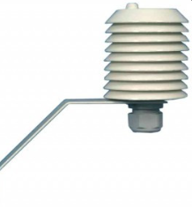
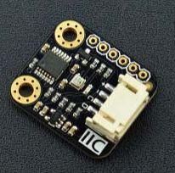
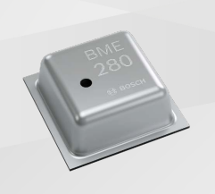

Figure 3 - Stevenson Screen [33]
Figure 2 - SEN0236
Figure 1 - BME280

4.3 GPS Sensor

The GPS receiver selected is the Quectel L76 GPS Module [12] shown in figure 4. Interfacing with the MCU Via a UART port, sending 8bit data packages at 9600 Baud. The message sent to the MCU is a standard National Marine Electronics Association (NMEA) message, expressing position as degrees, minutes and seconds latitude and longitude as well as satellite fixings and time. The module is discrete and simple to implement on to the main PCB. It is low power, at only 15mA consumption during tracking and 21mA at acquisition. Power can be controlled by putting the module to sleep between samples.
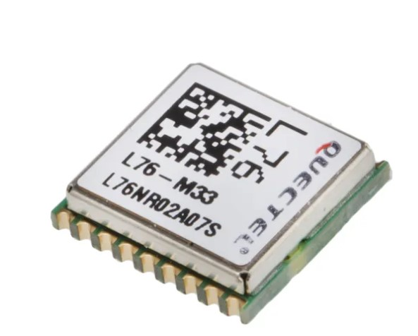
Figure 4 - L76 GPS Receiver

4.4 UV Sensor

UV radiation is categorised into the UVA spectrum with a wavelength of 400 – 315nm, UVB at 315-280nm and UVC, 280-100nm. UVA and UVB are of the most concern to humans, as they are the part of the spectrum that reaches the earths surface, causing skin damage [13].
Measurement can be achieved using a photodiode optimised for UV sensitivity, however its output would need to be amplified to achieve a measured value. Amplifying photodiodes requires a transimpedance amplifier to be constructed [14]. Designing this circuit for battery powered applications requires a single supply Op-Amp amplifier circuit to be designed, examples can be found in [15]. These circuits require careful design to ensure stability and accuracy, application notes surrounding circuit design can be found in [16].
UV measurements will be taken using the SEN0303 UV module from DFRobot [17] shown in figure 5. This module is sensitive to UVA between 350 – 375nm and UVB between 315 – 340nm and provides a digital I2C output for each channel.
The module is low power, at 700nA operating current, and can be made idle, drawing 10uA, making it suitable for battery applications.
The unit is low cost, simple to implement and premade, appropriate to amateur weather forecasters.
The unit needs to be placed in direct sunlight, an enclosure is required to protect it from the elements using a window with UV spectrum transmissibility, discussed in the hardware design section.
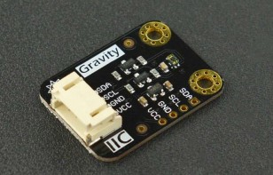
Figure 5 - SEN0303

4.5 Particulate Matter

Measurement of particulate matter (PM) is a leading indicator of air quality. PM measured for air quality is binned into PM2.5, particles <2.5µm and PM10 categories, <10µm. Inhalable particulate is breathed in and captured in the nose or mouth. Respirable particulate, PM2.5 and below, can penetrate further into the lungs, causing adverse health effects.
Measuring PM is carried out using a laser scattering principle. An airflow draws particulate past a laser. The scattered light is detected using a photodiode. The interaction of the particulate and the scattered light pattern can be related to particulate size and concentration.
PM is usually expressed in mass concentration units of µg/m³, or particle counts/m³.
The unit chosen is the Sensirion SPS30 PM Sensor [18]. This sensor measures PM2.5 and PM10 with a maximum range of 1000µg/m³, providing adequate resolution for outdoor air quality monitoring. It is a small, low-cost item. It is a verified sensor, calibrated and compared to an industry standard aerosol meter, providing reliable measurements.
The unit has a long service life of 8 years and is of low power consumption, with idle and sleep modes configurable to reduce consumption, allowing use with battery powered applications.
The unit outputs data using 16-bit registers for each PM size category over I2C. Allowing simple implementation.

4.6 Solar Irradiance

Sunlight brightness is measured using a solar pyranometer with units expressed in W/m². Typical irradiance at sea level is 1000 W/m².
For this design, a solar PV panel has been chosen to measure solar irradiance, the SMK700K10L High efficiency Solar Module [19].
A solar panels output current is directly proportional to solar irradiance, with their short circuit current being approximately equal to full sunlight brightness. Placing a shunt resistor of a known value across the modules output terminals, provides a measurable voltage proportional to solar irradiance at the MCU input.
The module chosen is small, low cost, lightweight, of monocrystalline construction making it robust, efficient, and suitable for external use.

4.7 VOC Level Measurement

Volatile Organic Compounds (VOC) are chemicals that may be harmful to health. These can be emitted from traffic exhaust fumes, industrial solvent use, manufacturing and from household products. VOC levels are typically higher in indoor environments, air quality guidelines for acceptable levels are published such as those shown in [20].
Outdoor VOC levels are of a lower concentration, stated in either µg/m³, ppb or ppb. The sensor chosen is the PS4-VOC-10-MOD from SGX Sensortech [21]. This module contains a solid polymer electrolyte sensor. This sensor technology is a balance of cost, response time, power requirements and accuracy compared to Photo Ionisation Detectors (PID’s), and metal oxide sensors.
The sensor communicates via an 8-bit digital signal via UART interface. The module has a measurement range of 0 – 10ppm TVOC with a resolution of 0.01ppm. This sensitive resolution is necessary to detect low concentration levels in outdoor locations.

5.0 Memory Sizing

The data logger is required to run for 14 days, this is expressed in seconds for memory calculations. Table 4 displays each measured parameter, its memory size in bits and bytes and its sample interval.
Table 4 - Variable List and Memory Sizes
Measured  Parameter | Signal  Type | Signal  Mode | Min  Value | Max  Value | Unit | Resolution | Value  Range | Bits  Required | Bytes | Sample  Rate (s) | Sample  Time | Test  Time (s) | Number of  Samples | Number of Bytes
PM2.5 | I2C | Digital | 0 | 65536 | Counts | 1 |  | 16 | 2 | 60 | 10 | 1209600 | 201600 | 403200
PM10 | I2C | Digital | 0 | 65536 | Counts | 1 |  | 16 | 2 | 60 | 10 | 1209600 | 201600 | 403200
Temperature | I2C | Digital | 0 | 65536 | Counts | 1 |  | 16 | 2 | 60 | 1 | 1209600 | 20160 | 40320
Humidity | I2C | Digital | 0 | 65536 | Counts | 1 |  | 16 | 2 | 60 | 1 | 1209600 | 20160 | 40320
Wind Speed | Pulse | Digital | 0 | 200 | MPH | 1 | 200 | 8 | 1 | 30 | 1 | 1209600 | 40320 | 40320
Wind Direction | 0-3.3V | Analogue | 0 | 360 | Degrees | 1 | 359 | 10 | 2 | 30 | 1 | 1209600 | 40320 | 80640
Sunlight Brightness | 0-3.3V | Analogue | 0 | 1000 | W/m2 | 1 | 1000 | 10 | 2 | 60 | 1 | 1209600 | 20160 | 40320
UVA | I2C | Digital | 0 | 65536 | Counts | 1 |  | 16 | 2 | 60 | 1 | 1209600 | 20160 | 40320
UVB | I2C | Digital | 0 | 65536 | Counts | 1 |  | 16 | 2 | 60 | 1 | 1209600 | 20160 | 40320
GPS Position | UART | Digital | 0 | 65536 | Counts | 1 |  | 8 | 2 | 60 | 1 | 1209600 | 20160 | 40320
TVOC Levels | UART | Digital | 0 | 65536 | Counts | 1 |  | 8 | 2 | 60 | 10 | 1209600 | 201600 | 403200
From Table 4, digital communications over the I2C bus require a 16-bit register per variable. UART communication requires 8 bits, allocated to each variable using this method. Analogue signals for solar irradiance and wind direction have been designated 10 bits to allow 1024 levels, covering their range requirements.
To calculate the memory requirements for the system, the following equations are used.
Equation 1 $T_{Data_{Log}}\left(s\right)=14 Days=1209600s$
Equation 2 $T_{sample}(s)=\frac{1}{f_{sample}(Hz)}$
Equation 3 $Samples=\frac{T_{Data_{Log}}(s)}{T_{sample}(s)} x Sample Time (s)$
Equation 4 $Memory \left(Bytes\right)=Bytes*Samples$
From Table 3, the total memory required for the logging period is 1.57248 MB. A 128MB SD card provides non-volatile storage.

6.0 Connector Specifications

6.1 PCB and Device Connectors

The application is not expected to be experience extreme vibration, shock, or operating temperatures, so standard PCB headers can be used. A selection of pole configurations is used from the JST XH range of connectors [22]. These are fully shrouded and insulated and feature a locking tab to retain the wire receptacle to the board. Table 5 displays the specifications of these connectors, with table 6 summarising the connectors required for all module interfacing.

Manufacturer | JST
Series | XH
Current Rating | 3A
Voltage Rating | 250V
Temperature Rating | -25°C to +85°C
Contact Resistance | 10 mΩ
Insulation Resistance | 1000MΩ
Wire Sizes | AWG 30 to 22
Orientation | Vertical
Shrouded | Yes
Mounting | PCB Through Hole
Pitch | 2.54mm
Mounting Height | 9.8mm
Securing Method | Shouldered/locking tag
Cost | £0.079/ pack 1000 pcs
Table 5 - Connector Specifications

Item | PCB Connector | Item Connector | Item To Board
Sensirion SPS 30 PM | JST XH Series Straight Through Hole PCB Header,  5 Contact(s), 2.5mm Pitch, 1 Row(s), Shrouded | JST ZHR-5 | JST, XHP Female Connector Housing, 2.5mm Pitch 5 Way
SEN0236 RH & T | JST XH Series Straight Through Hole PCB Header,  4 Contact(s), 2.5mm Pitch, 1 Row(s), Shrouded | JST, XHP Female Connector Housing, 2.5mm Pitch, 4 Way | JST, XHP Female Connector Housing, 2.5mm Pitch, 4 Way
VOC Module | JST XH Series Straight Through Hole PCB Header,  4 Contact(s), 2.5mm Pitch, 1 Row(s), Shrouded | JST, XHP Female Connector Housing, 2.5mm Pitch, 4 Way | JST, XHP Female Connector Housing, 2.5mm Pitch, 4 Way
Solar Panel | JST XH Series Straight Through Hole PCB Header,  2 Contact(s), 2.5mm Pitch, 1 Row(s), Shrouded | JST, XHP Female Connector Housing, 2.5mm Pitch, 2 Way | JST, XHP Female Connector Housing, 2.5mm Pitch, 2 Way
UV Level Module | JST XH Series Straight Through Hole PCB Header,  4 Contact(s), 2.5mm Pitch, 1 Row(s), Shrouded | JST, XHP Female Connector Housing, 2.5mm Pitch, 4 Way | JST, XHP Female Connector Housing, 2.5mm Pitch, 4 Way
Wind Direction | JST XH Series Straight Through Hole PCB Header,  3 Contact(s), 2.5mm Pitch, 1 Row(s), Shrouded | JST, XHP Female Connector Housing, 2.5mm Pitch, 3 Way | JST, XHP Female Connector Housing, 2.5mm Pitch, 3 Way
Wind Speed | JST XH Series Straight Through Hole PCB Header,  3 Contact(s), 2.5mm Pitch, 1 Row(s), Shrouded | JST, XHP Female Connector Housing, 2.5mm Pitch, 3 Way | JST, XHP Female Connector Housing, 2.5mm Pitch, 3 Way
USB Header | JST XH Series Straight Through Hole PCB Header,  4 Contact(s), 2.5mm Pitch, 1 Row(s), Shrouded | JST, XHP Female Connector Housing, 2.5mm Pitch, 4 Way | JST, XHP Female Connector Housing, 2.5mm Pitch, 4 Way
Battery | PCB Mount Screw Terminal | Spade Crimp | Ferruled Wires
Table 6 - Cable Connector, Item Connector and PCB Connector Requirements

6.2 USB and SD Card Connector

The datalogger is required to connect to a PC via USB. An IP66, panel mounted item from Bulgin [23] is used. This connector does not require the enclosure to be opened as its externally mounted and connected to the PCB via a moulded lead. Figure 6 displays the connector.

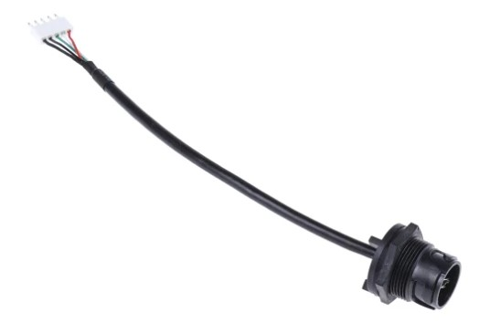
Figure 6 - USB Connector

The SD Card connector is a PCB mount item from Molex [24].

7.0 Hardware and Enclosure Design

To select an appropriate enclosure, the following design requirements need to be met,
- IP66 weatherproof enclosure for moisture and dust ingress protection.
- UV stable material.
- Able to accommodate all components.
- Flexible Mounting – Wall, Tripod, Pole.
- Lightweight and compact for transportation.
The main constraints include battery size, external components, and PCB size. An enclosure from Schneider electric, NSYPLM43VG has been chosen [25]. This is a GRP enclosure, IP66, Lightweight and has support for extra mounting features. At 430 x 330 x 200mm it is manageable to transport between logging sessions. To mount the PCB, an insulating plastic backplate [26] has been specified for modification. Figure 7 displays the enclosure CAD design containing the modules required for the design.
The anemometer assembly is supplied with a bracket to mount externally. The cable will be introduced using an IP66 M20 A2 stuffing gland.

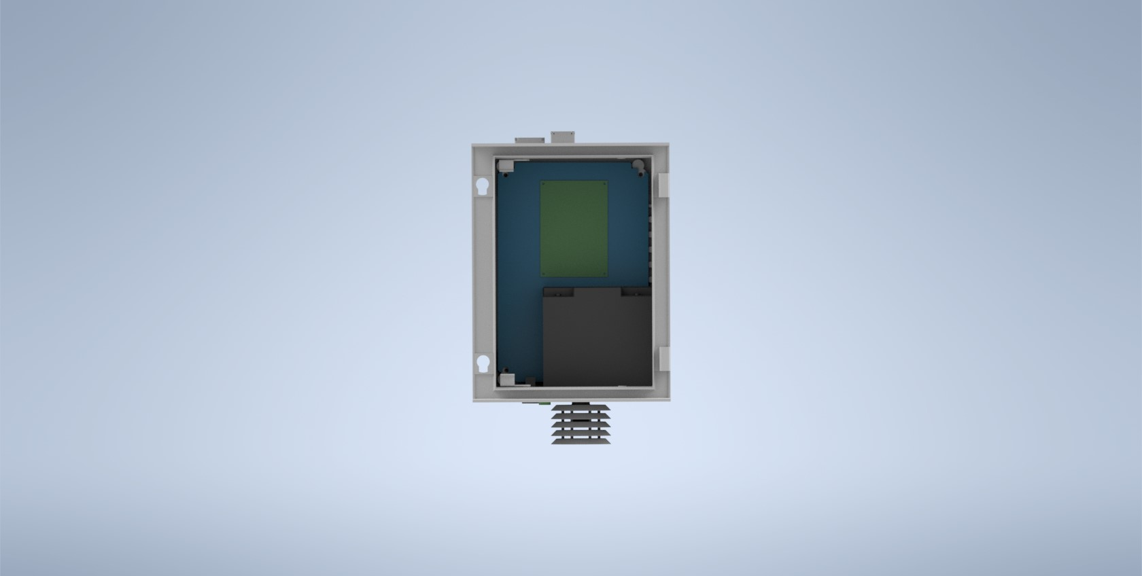
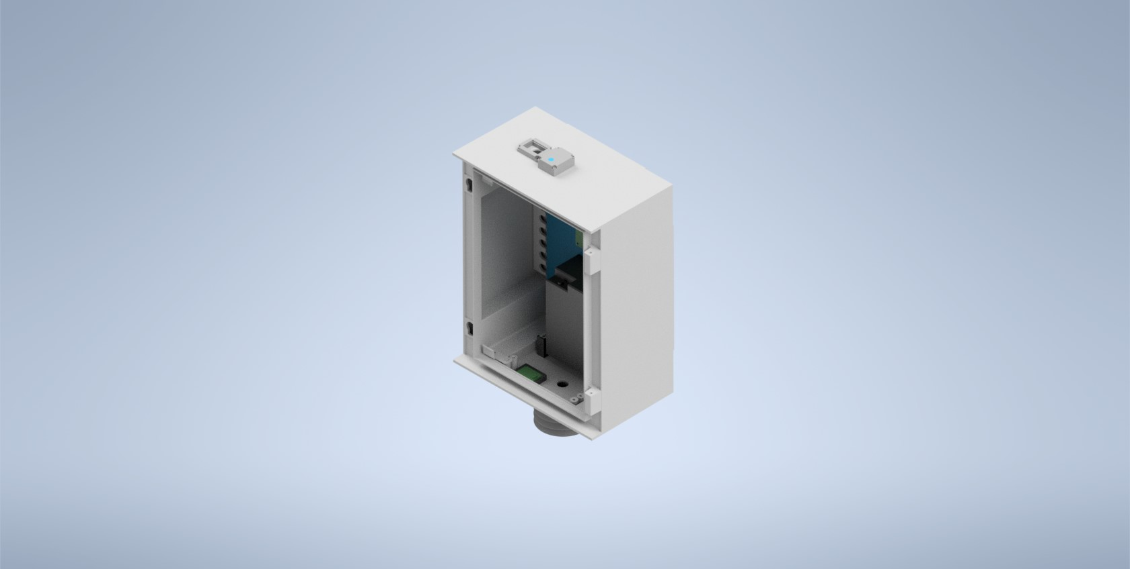

Figure 7 - Enclosure View

7.1 UV Sensor Enclosure

A 3D Printed enclosure, featuring an O – ring seal groove to maintain moisture protection has been designed. This enclosure features a UV spectrum transmissible window [27] to allow light to the sensor. Figure 8 displays the enclosure design.
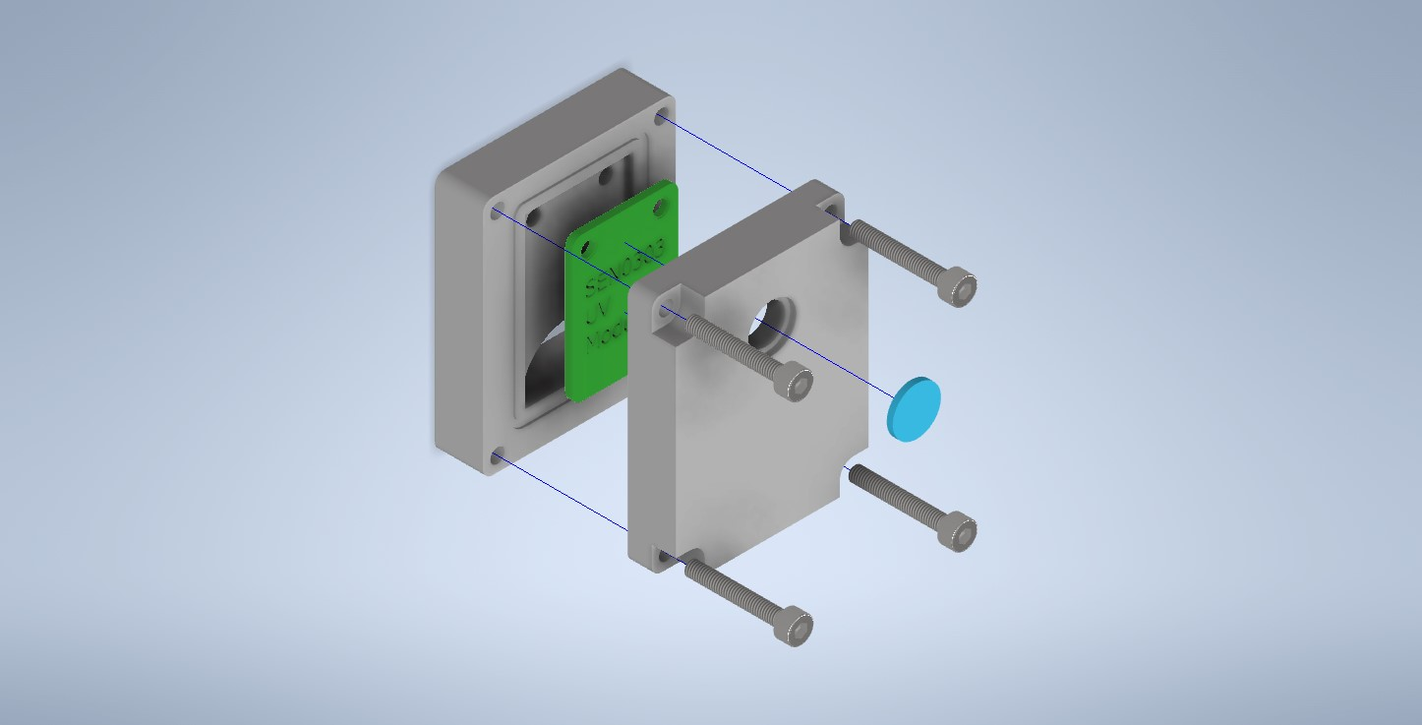
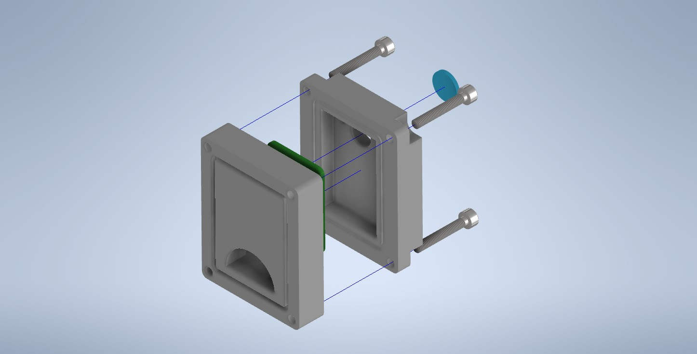

Figure 8 - UV Enclosure Design

7.2 Solar Cell Module

A 3D Printed holder for the Solar PV module has been designed. This features an O-Ring groove for ingress protection to the enclosure. Figure 9 displays the proposed holder.

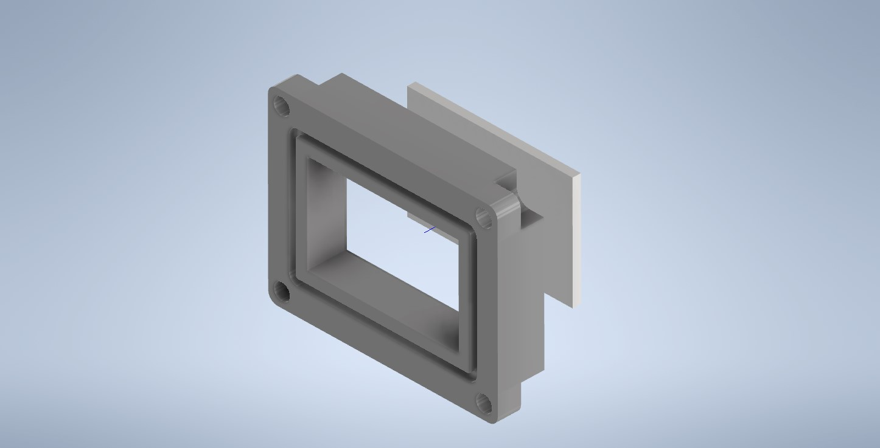
Figure 9 - Solar PV Holder

7.3 PM Sensor Holder

A 3D printed design has been created. This features an O-Ring Groove to minimise moisture ingress. Figure 10 Displays the holder.


Figure 10 - SPS30 Holder

7.4 RH and Temperature Sensor

A Stevenson louvered shelter has been designed to house the module beneath the enclosure. Figure 11 displays the cover, and its location can be seen in figure 7. It is mounted using a standard electrical M20 bushing and IP washer.

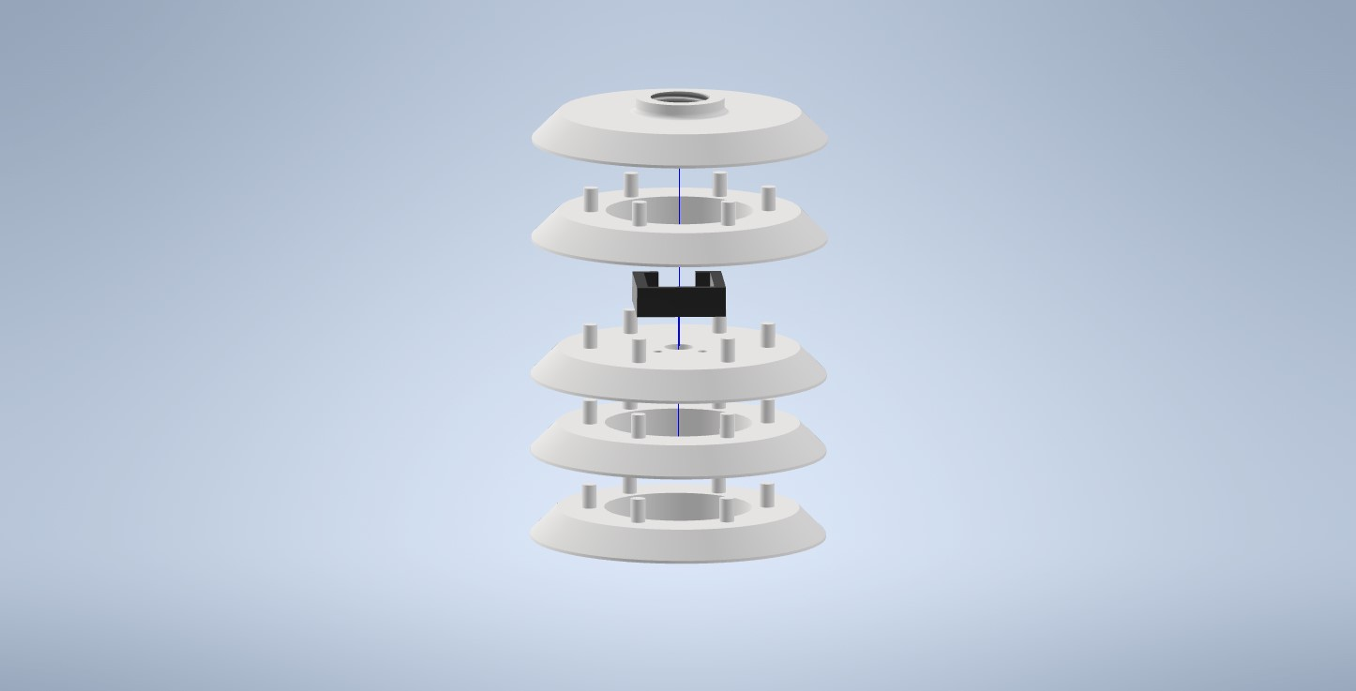
Figure 11 - RH and Temperature Module Cover

7.5 VOC Module Holder

The sensor element is exposed to ambient air, below the enclosure, using an O-Ring groove for protection. Figure 12 displays the holder.
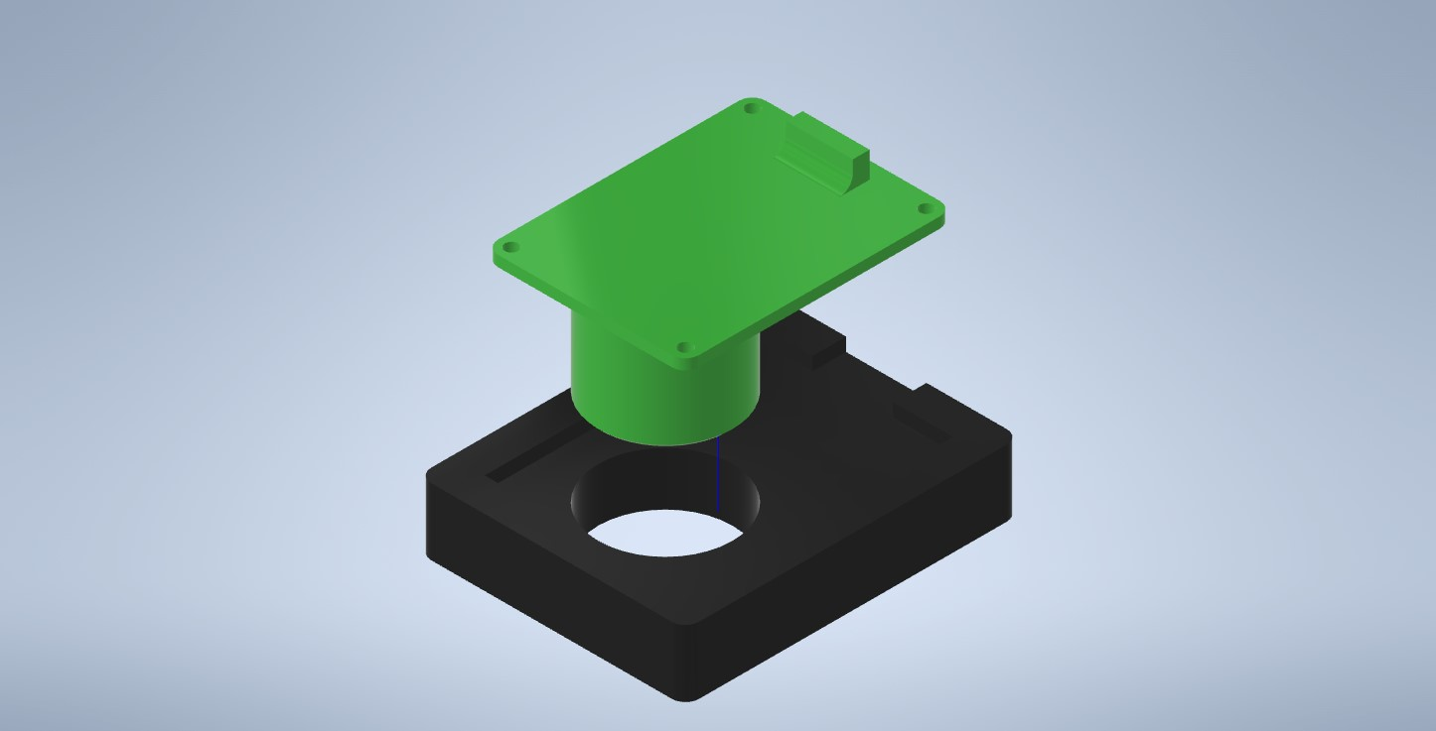
Figure 12 - VOC Holder

8.0 Schematic and PCB Design

This section outlines the design of the datalogger PCB. Including schematics, power supply design and PCB layout diagrams.

8.1 Power supply Design

To size the battery required for the design, current ratings from each module are drawn from the datasheet. The SPS30 PM sensor features an idle mode that it can transition too between readings. This lowers the power consumption of the device. Table 7 displays the power requirements for each device over a 14-day logging period.
Sensor/Item | Current Max (mA) | Current Nominal (mA) | On Time (Hrs) | Idle Time (Hrs) | Test Time (Hrs) | Energy ON (mAh) | Energy Idle (mAh) | Total 14 Day Consumption
VOC | 5 | 5 | 336 | 0 | 336 | 1680 | 0 | 1680
UV | 0.7 | 0.7 | 336 | 0 | 336 | 235.2 | 0 | 235.2
MCU | 0.8 | 0.8 | 336 | 0 | 336 | 268.8 | 0 | 268.8
PM | 60 | 8 | 0.933333333 | 4.666666667 | 336 | 56 | 37.33333333 | 93.33333333
Wind Speed | 1 | 1 | 336 | 0 | 336 | 336 | 0 | 336
Wind Direction | 1 | 1 | 336 | 0 | 336 | 336 | 0 | 336
GPS | 21 | 15 | 336 | 0 | 336 | 7056 | 0 | 7056
RH & T | 2 | 2 | 336 | 0 | 336 | 672 | 0 | 672
LED | 20 | 0 | 0.1 | 0 | 336 | 2 | 0 | 672
Table 7 - Power Requirements
Estimated consumption is 11.35AH for the 14-day period utilising idle modes of modules. The design has been specified with a 20AH 12V Lead acid battery [28].
To provide 3.3V VCC for all components, a switching power IC, TPS560430 [29] from Texas instruments is used to drop 12V to 5V. A standard 3.3V low dropout linear regulator [30] has been used to provide the 3.3V rail.
Using a switching regulator is not preferential, however, a linear regulator to step down from 12V to 5V would dissipate too much heat and waste power. The switching output is supressed to acceptable noise levels and ripple via the 10uH inductor and decoupling capacitors on the output stage, as suggested by the datasheet. Feeding 5V through a linear regulator further reduces noise, with additional decoupling capacitors. The voltage divider R14 and R15 provide a feedback reference for the switching IC.
The Battery is applied via a screw terminal PCB connector PL9, through a PCB mounted toggle switch, 1A fuse and 1N4001 diode. Figure 13 displays the power supply schematic.

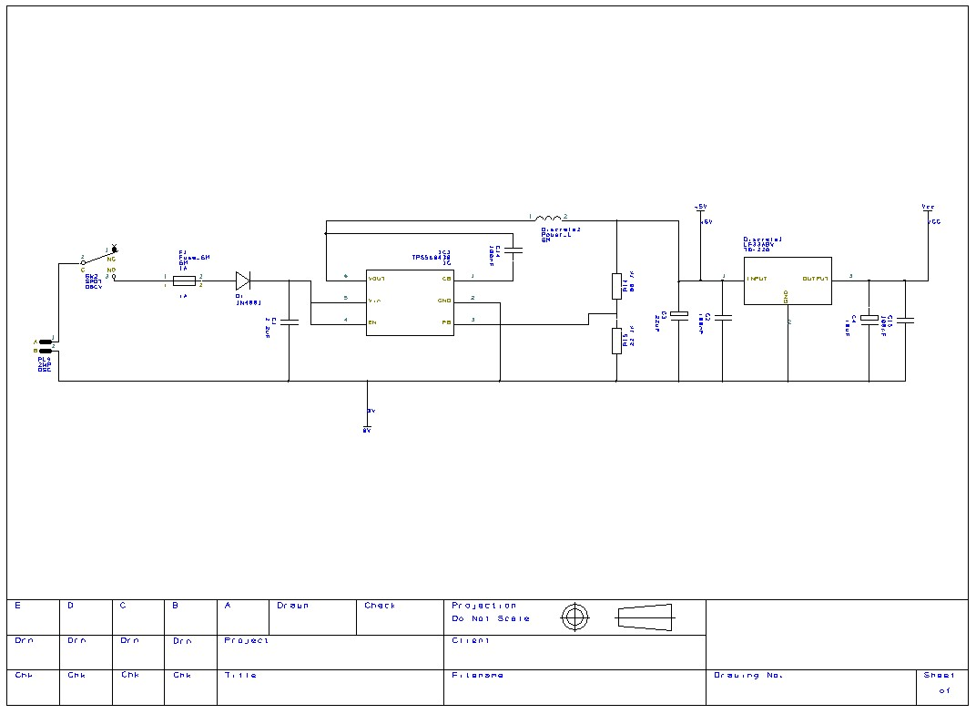
Figure 13 - Power Supply Schematic

8.2 I2C Peripherals

Figure 14 displays the RH, SPS30 and UV Module on the I2C Bus. These are individually addressed, allowing them to take control of the bus when data is requested. Power is supplied via 3.3V VCC. The SDA data, and SCL Clock lines are pulled high to VCC via 1KΩ resistors. These resistors are chosen based on guidelines, to provide sufficient data transfer speed by minimising RC time constant with capacitance of the bus [31].
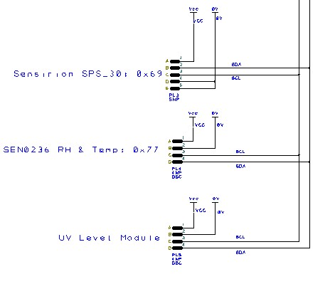
Figure 14 - I2C Bus

8.2 Solar Irradiance

The solar panel is connected via PL6. A an E96, 1% tolerance shunt resistor is placed across the output to provide a measured voltage proportional to the PV module current. This is calculated below using the datasheet short circuit current, equivalent to maximum irradiance of 1000W/m2.
$$Short Circuit Current I_{SC}=29.5×{10}^{-3}A$$
$$V_{ADC}=3.3V$$
$$R_{SH}=\frac{V_{ADC}}{I_{SC}}$$
$$R_{SH}=\frac{3.3}{29.5×{10}^{-3}}$$
$$R_{SH}=111.86Ω$$
$$R_{SH}≅113Ω E96 1\%$$
The 3,6V Zener diode acts as overvoltage protection, with resistor R10 providing current limiting to the ADC. Capacitor C12 is specified to act as an RC filter with a cutoff frequency of 0.05Hz. Figure 15 displays the schematic circuit.

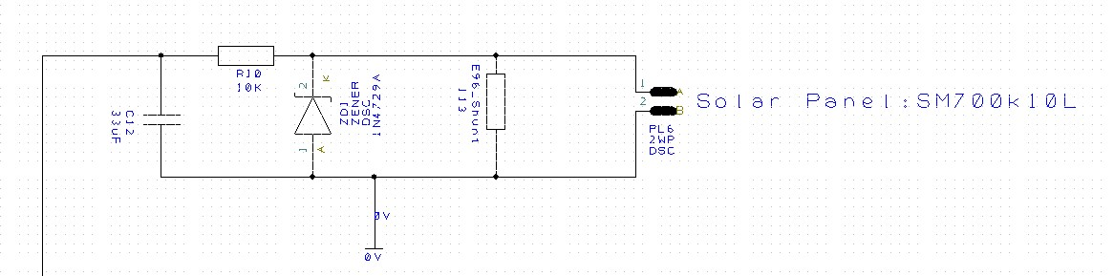
Figure 15 - Solar Panel Interface
8.3 VOC Module.
The VOC Module interfaces to the PCB via PL1. Vcc and Gnd are provided to the module via pins 1 and 2, with a 0.1uF decoupling capacitor for noise rejection. Pins 3 and 4 are the serial Rx and Tx lines on the module. These interface to the Tx and Rx lines of UART2 on the MCU programable peripheral pins. Figure 16 displays the schematic.
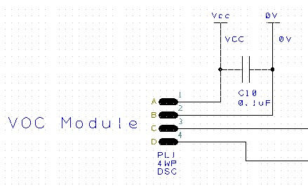
Figure 16 - VOC Module

8.4 Wind Direction

Figure 17 displays the connector and interface for the wind direction potentiometer. PL7 is a 3-way JST XH PCB Connector. Vcc is fed to the pot, and the wiper return comes back on pin 2. The 1N472A, 3.6V Zener, is configured for overvoltage protection. The RC network, R11 and C13 form a 0.05Hz anti-aliasing filter. Reviewing the circuit, a resistor should be placed in series with the diode to limit its current during an over voltage event.
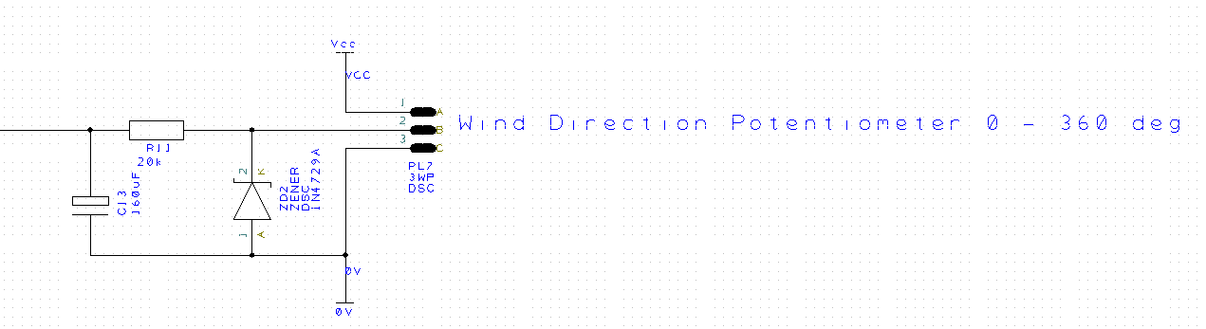
Figure 17 - Wind Direction potentiometer

8.5 Wind Speed Pulse Input

Figure 18 displays the pulse input from the anemometer. The unit is supplied with 3.3V and switched through a hall effect sensor to provide a pulse output proportional to wind speed. ZD3 provides 3.6V overvoltage protection. R12 serves as current limiting to the MCU. This is then fed to a capture compare input, capturing each rising edge pulse through the pre-scaler register. Reviewing the circuit, a series resister to limit the Zener current may be necessary. A pull up resistor to VCC from the pulse input may be necessary, however, circuitry within the device may account for this.
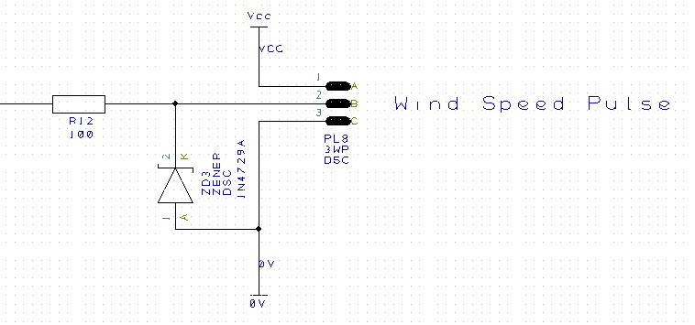
Figure 18 - Wind Speed Pulse

8.6 Status LED

Figure 19 displays the LED to indicate operation. This is a 5mm red LED from Kingbright [32]. The LED is driven directly from the MCU output pin. R13 provides diode forward current limiting; calculated using the below equation.
$$R_{LED }= \frac{\left(V_{s}-V_{LED} \right)}{I_{LED}}$$

$$R_{LED }= \frac{\left(3.3-2.5\right)}{20 × {10}^{-3}}$$
R LED = 40Ω closest size = 39Ω.
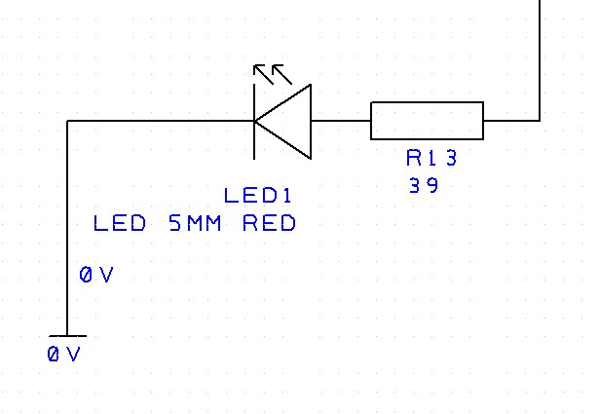
Figure 19 - Status LED Circuit

8.7 USB Connector

Figure 20 displays the USB PCB header. A flying lead is terminated into a 4-pole connector then plugged into the PCB. No power is to be drawn from the host to power the device, therefore only the data lines are connected. R7 provides a pull up resistor on the D+ line.
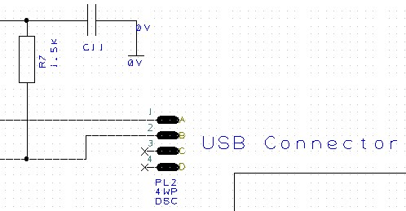
Figure 20 - USB Connection

8.8 GPS Module

Figure 21 displays the GPS Module. Power is supplied to all VCC pins and decoupled using a ceramic capacitor. The serial outputs Rx and Tx interface to UART 3 on the MCU.
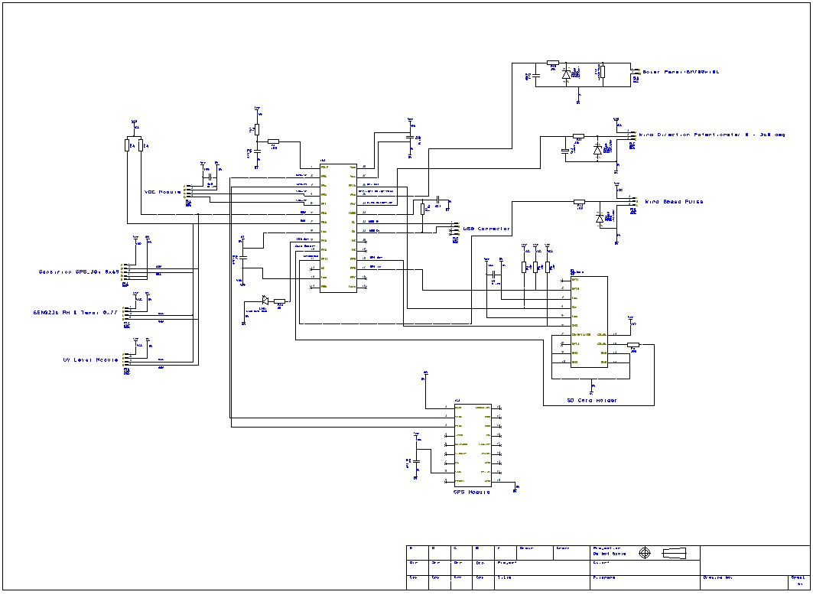
Figure 21 - GPS Module

8.9 SD Card Holder

Figure 22 displays the SD card holder circuit. Communication with the MCU via SPI protocol. The DAT0-data out, and CMD-data input line are interfaced to MCU pins RP8 and RP9. The clock line is connected to the MCU SPI clock, RP15, for transmission timing. All data and clock lines are pulled to Vcc with 20k resistors ensuring positive pulses. The supply is 3.3V decoupled using a 0.1uF capacitor to minimise noise. To enable SPI data transfer, DAT3 is pulled to ground. The holder features a card detection switch, 3.3V is fed to the common, and returns to the MCU through the contact to pin RA3 when a card is inserted.
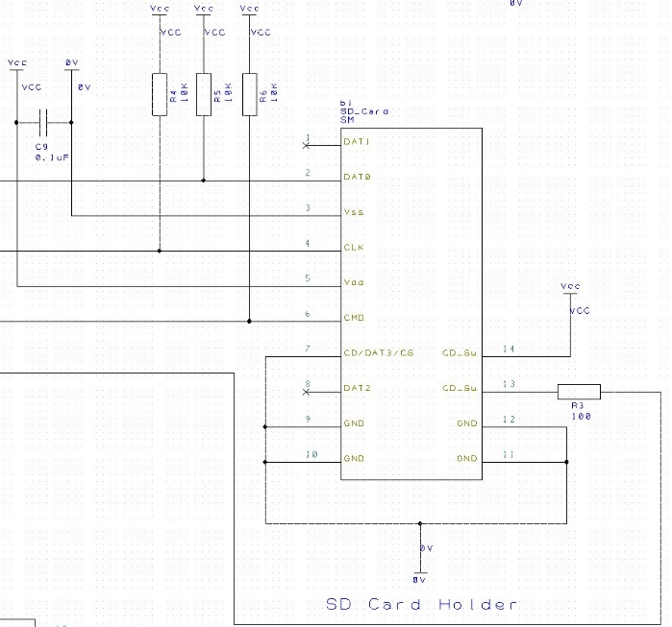
Figure 22 - SD Card Holder

8.10 MCU Schematic

Figure 23 displays the PIC microcontroller schematic, with labelled pin assignments for each module. The supply lines to the MCU are decoupled to ground via 0.1uF ceramic capacitors.
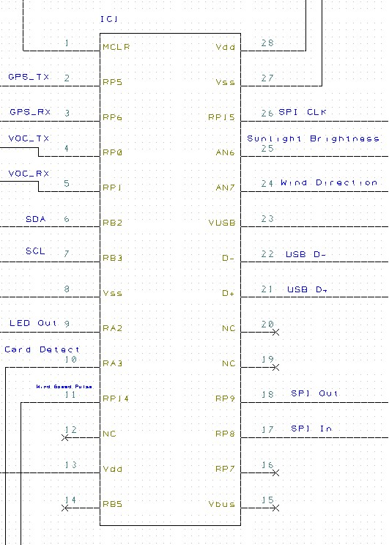
Figure 23 - PIC Microcontroller

Figure 24 displays the total schematic diagram for the weather station datalogger.
Figure 24 - Datalogger Schematic

9.0 PCB Design

to A PCB layout has been created from a schematic design translation. General considerations when completing the PCB design and component placement have been taken.
- Module PCB headers mounted near the perimeter of the board, with the I2C peripherals stacked closely together.
- Power supply components mounted away from the MCU to minimise RF interference from switching IC. Ideally a split ground plane would be introduced using a switching supply. Decoupling capacitors and inductors placed as close as possible to regulators. Linear regulator placed at the board edge to minimise the effects of dissipated heat.
- GPS module located at the opposite end of the PCB to power supply to minimise induced RF noise from switching IC. A large ground plane area is introduced to suppress noise.
- All decoupling capacitors placed as close as possible to microcontroller and IC Vcc and GND pins.
- SD card holder placed at board edge for easy card removal.
- GND plane copper pour used for noise immunity and heat dissipation.
- Vias used to connect nets between layers.
- Larger trace sizes for VCC rails have been used.
- PCB board has holes located at outer edges to use insulated standoffs for mounting to enclosure backplate.
Figure 25 displays the PCB design, featuring the copper pour ground plane.
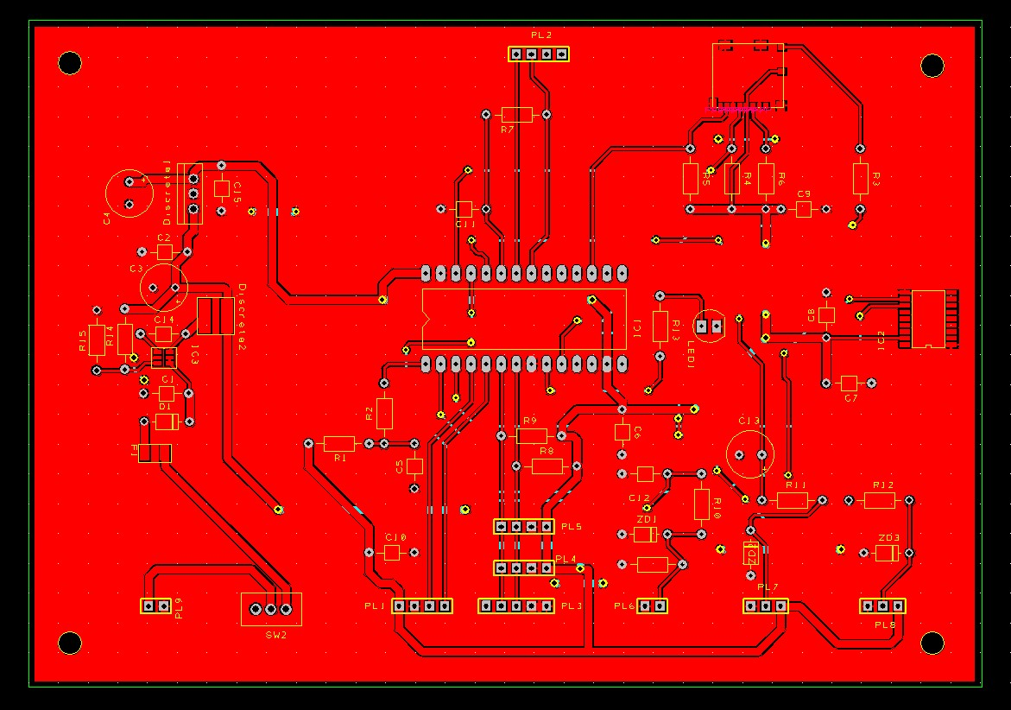
Figure 25 - PCB Layout

10.0 Software Design

For this application, a software flow diagram has been created outlining the modes of operation, and data flow for the design. Figures 26, 27 and 28 displays initialisation mode, data acquisition mode and data upload mode.
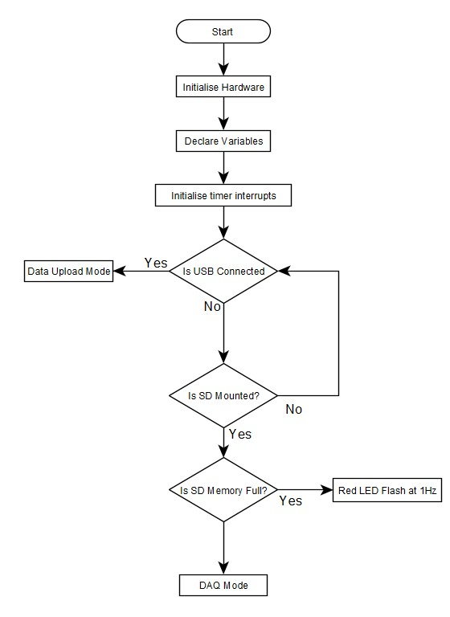
Figure 26 - Initialisation Mode

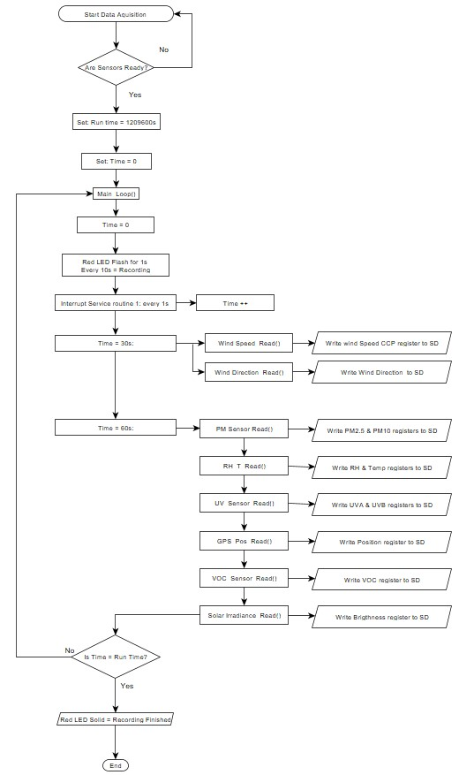
Figure 27 - Data Acquisition Mode
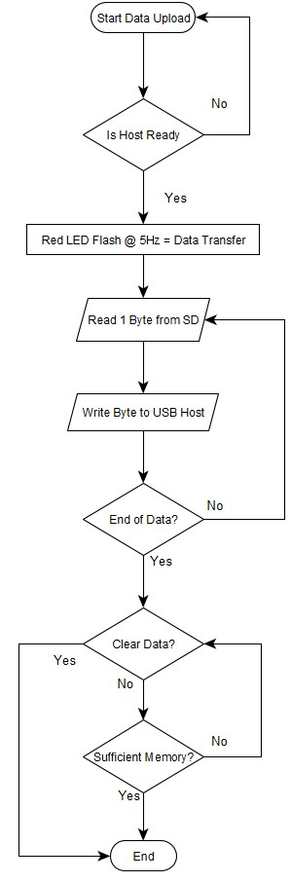
Figure 28 - Data Upload Mode

11.0 Prototype Build Costs

Table 7 displays a bill of materials for the prototype device. This includes the 3D printing service from an online retailer for all sensor enclosures.
Item | Quantity | Supplier | Stock/Part Number | Cost Each | Total
Anemometer & Vane | 1 | Davis Instruments | 6410 | £ 225.00 | £ 225.00
TVOC Module Alt 10ppm | 1 | 254-1739 | PS4-VOC-10-MOD | £ 341.00 | £ 341.00
SEN0303 UV Sensor | 1 | Farnell | 3879706 | £ 7.28 | £ 7.28
T & RH SEN0236 | 1 | Farnell | SEN0236 | £ 15.78 | £ 15.78
PM Sensor Sensirion SPS30 | 1 | RS | 186-2540 | £ 47.92 | £ 47.92
Quectel L76-M33 GPS Receiver | 1 | RS | 908-4108 | £ 9.44 | £ 9.44
Solar Irradiance SM700K10l Cell | 1 | Digikey | SM700K10L-ND | £ 5.49 | £ 5.49
MILL MAX 310-47-114-41-001000 IC Socket | 2 | Farnell | 310-47-114-41-001000 | £ 1.33 | £ 2.66
PIC24FJ64GB202 MCU | 1 | Microchip | PIC24FJ64GB202 | £ 4.16 | £ 4.16
USB Connector Panel Mount,  Socket Type Micro B 2.0 USB Connector | 1 | RS | 912-5114 | £ 15.20 | £ 15.20
SD Card Socket | 1 | RS | 896-7560 | £ 1.81 | £ 1.81
0.1uF Ceramic Caps | 6 | Farnell | 2990794 | £ 0.44 | £ 2.64
10uF Cap | 1 | Farnell | 3416649 | £ 0.44 | £ 0.44
3.6V 1N4729A Zener | 5 | Farnell | 1861444 | £ 0.14 | £ 0.70
1N4377A 5.1V Zener Diode | 5 | Farnell | 1612363 | £ 0.12 | £ 0.60
LF33ABV LDO 3V3 Regulator | 1 | Mouser | LF33ABV | £ 1.10 | £ 1.10
TPS560430 Switching Regulator | 1 | DigiKey | TPS560430 | £ 0.85 | £ 0.85
1N4001 Diode | 1 | Mouser | 1N4001 | £ 0.18 | £ 0.18
SPDT Switch | 1 | RS | 734-7066 | £ 2.40 | £ 2.40
Filter Cap 33uF | 1 | Farnell | 4143894 | £ 1.46 | £ 1.46
RED LED | 1 | RS | 228-5988 | £ 0.30 | £ 0.30
PCB Manufacture | 5 | jlcpcb | 2 Layer | £ 2.16 | £ 10.80
JST ZHR-5 | 1 | RS | 820-1658 | £ 0.06 | £ 0.06
JST XH Series Straight Through Hole PCB Header 5 Way | 1 | RS | 820-1560 | £ 0.23 | £ 0.23
JST, XHP Female Connector Housing, 2.5mm Pitch 5 Way | 1 | RS | 820-1627 | £ 0.11 | £ 0.11
JST XH Series Straight Through Hole PCB Header,  4 Way | 4 | RS | 820-1551 | £ 0.18 | £ 0.70
JST, XHP Female Connector Housing, 2.5mm Pitch, 4 Way | 4 | RS | 820-1618 | £ 0.08 | £ 0.32
JST XH Series Straight Through Hole PCB Header,  3 Way | 2 | RS | 820-1557 | £ 0.15 | £ 0.30
JST, XHP Female Connector Housing, 2.5mm Pitch, 3 Way | 2 | RS | 820-1614 | £ 0.08 | £ 0.16
JST XH Series Straight Through Hole PCB Header,  2 Way | 1 | RS | 820-1554 | £ 0.11 | £ 0.11
JST, XHP Female Connector Housing, 2.5mm Pitch, 2 Way | 1 | RS | 820-1611 | £ 0.08 | £ 0.08
Battery 12V 20Ah Lead Acid | 1 | RS | 727-0391 | £ 81.13 | £ 81.13
10uH inductor | 1 | RS | 169-3787 | £ 0.23 | £ 0.23
Battery Screw Terminal PCB Mount | 1 | RS | 790-1098 | £ 0.62 | £ 0.62
3D Print Mounts | 1 |  |  | £ 131.82 | £ 131.82
NSYMPP43 Enclosure Backplate | 1 | Schneider | NSYMPP43 | £ 23.37 | £ 23.37
NSYPLM43VG Enclosure GRP IP66 | 1 | Schneider | NSYPLM43VG | £ 221.49 | £ 221.49
UV Transmission Window | 1 | Edmund Optics | 48-063 | £ 114.75 | £ 114.75
 |  |  |  |  | £ 1,272.70
Table 8 - Bill of Materials
The total cost of £1272.70 places this prototype, including all sensors within the higher-level amateur weather stations.

12.0 Conclusion and Further Developments

Sensor specifications meet the required measurement accuracy and range. The enclosure design ensures the device is suitable for outdoor environments and can withstand rain, dust, and UV exposure. The sensors and enclosures have been designed for simple manufacturing and assembly. The power supply and battery ensure capacity for increased sampling rates and logging duration. The use of a switching IC for the first supply stage, is not ideal for applications with sensitive analogue circuits and GPS applications due to the 1.1MHz switch frequency. This compromise is due to the supply voltage being far higher than the device operating voltage. Features have been implemented to mitigate the effects of RF interference.
From the review of available products, some additional features have been suggested for the next iteration.
- Barometer function to measure atmospheric pressure. Useful for predicting weather fronts. The SEN0236 Module has this ability, only software upgrades are required.
- Precipitation rate sensor.
- Solar Charging – This will reduce the size of the battery and enclosure.
- Wireless cellular communication, outputting live values to a web server will allow remote monitoring.
- Magnetometer for easy North alignment.

Bibliography

[1] | Watson, "W-8681-Pro Professional WiFi Weather Station" Datasheet.
[2] | Extech Instruments , "WTH600-E-Kit Wireless Weather Station Kit" Datasheet [Revised 18/05/18], 2018.
[3] | Rika Sensor, "RK900-03 Portable Weather Station" [Version 3.0], 2015.
[4] | Skyview Systems Ltd, "Static Weather Sensor EOLOS-IND" Datasheet.
[5] | Seeed Technology Ltd, "SenseCAP All in One Weather Station User Guide" [Version V1.2 2023/06/08], 2023.
[6] | MaxiMet, "GMX531 Compact Weather Station" Datasheet.
[7] | Microchip Technology, "PIC24FJ128GB204 FAMILY" Datasheet [DS30005009C], 2015.
[8] | Microchip Technology, "PIC18F47J53 FAMILY" [Datasheet DS30009964C], 2016.
[9] | Davis Instruments, "Anemometer 6410" [Datasheet DS6410] Revised July 2020, 2020.
[10] | Bosch, "BME280 Combined humidity and pressure sensor" Datasheet BST-BME280-DS001 Revision 1, 2022.
[11] | DFRobot, "Gravity: I2C BME280 Environmental Sensor SEN0236" Datasheet.
[12] | Quectel, "L76 Series Hardware Design V2.0" Datasheet 28/08/2014, 2014.
[13] | Britannica, “Ultraviolet Radiation,” Britannica, 05 Jan 2024. [Online]. Available: https://www.britannica.com/science/ultraviolet-radiation. [Accessed 01 01 2024].
[14] | L. Orozco, “Programmable-Gain Transimpedance Amplifiers Maximize Dynamic Range in Spectroscopy Systems,” Analog Dialog, pp. 1-5, May 2013.
[15] | W. H. Paul Horowitz, “Single Supply Photometer,” in The Art of Electronics Third Edition, New York, Cambridge University Press, 2016, p. 265.
[16] | T. Instruments, “Single Supply Op Amp Design Techniques SLOA030A,” Texas Instruments, Dallas, 2001.
[17] | DFRobot, "Gravity VEML6075 UV Sensor Module" Datasheet.
[18] | Sensirion, "SPS30" Datasheet Version 0.9 November 2018, 2018.
[19] | Anysolar, "IXOLAR High Efficiency Solar MD" Datasheet SM700K10L Revised 08/2023, 2023.
[20] | Public Health England, “Air quality: UK guidelines for volatile organic compounds in indoor spaces,” 13 September 2019. [Online]. Available: https://www.gov.uk/government/publications/air-quality-uk-guidelines-for-volatile-organic-compounds-in-indoor-spaces. [Accessed 11 01 2024].
[21] | SGX Sensortech, "PS1&PS4-VOC-10-MOD Total Organic Volatile Module" Datasheet Issue 1 10/02/2022, 2022.
[22] | JST, "XH Connector 2.5mm Pitch" Datasheet.
[23] | Bulgin, "4000 Series - Micro USB Buccaneer" Datasheet.
[24] | Molex Incorporated, "Micro SD Card Socket" Datasheet SD-104031-001 25/08/2012, 2012.
[25] | Schneider Electric , "NSYPLM43VG Thalassa PLM" Datasheet 23/08/2021, 2021.
[26] | Schneider Electric, "NSYMPP43 Insulating Mounting Plate" Datasheet, 2024.
[27] | Edmund Optics, "10mm Dia Fused Silica Window" Drawing 48063.
[28] | RS Components, "RS PRO Lead Acid Battery 12V, 20AH" Datasheet 727-0391.
[29] | Texas Instruments, "TPS560430 SIMPLE SWITCHER" Datasheet SLVSE22B [Revised June 2018], 2017.
[30] | STmicroelectronics, "LF33ABV LDO Voltage Regulator" Datasheet: D2574, May 2017.
[31] | J. Wu, “Basics of I2C: The I2C Protocol,” Texas Instruments, 2021.
[32] | Kingbright, "T-1 3/4 (5mm Solid State Lamp DSAA4828" Datasheet, 2003.
[33] | Omni Instruments, “Stevenson Screen Model 306,” [Online]. Available: https://www.omniinstruments.co.uk/radiation-shield-model-306.html. [Accessed 08 01 2024].
[34] | Omni Instruments, "Pyranometers" Datasheet, 2018.
[35] | JST, "XH Connector" Datasheet.
[36] | JST, "XAD Connector" Datasheet.
[37] | Molex, "C-Grid III™ Header, Single Row, Vertical, Shrouded, 3 Circuits" Datasheet 90136-1203, 2014.

