Student Name: Erin Smith
P Number: 2000855
Programme of Study: Graphic Design
Module: ADAD4018
Ways of Thinking Lecturer’s Name: Martin Bush

Tasks in the order I received them:
Task 1: Observational Writing = 500 words
Task 2: Manifesto Writing = 500 words
Task 3: Practice-based Writing = 500 words

Task 1: Observational Writing

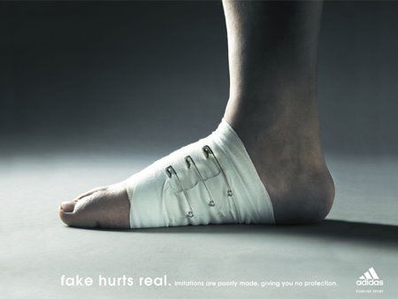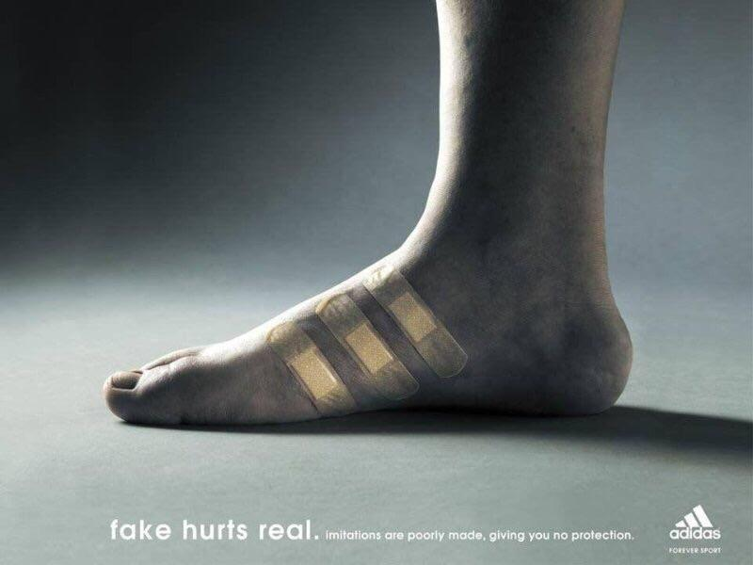

In the 21st century society is subconsciously controlled and manipulated in how to act. Social media is a huge tool helping businesses control their customers impulses. Understanding what trustworthy advertisement is or fraudulent is a puzzle. Technology today has the ability to create hyper realistic imagery, making us question our trust in businesses and how they can mislead and control us. In this task I will take out a semiotic analysis on the above adidas adverts to further investigate this theory.

From birth we are trained that certain symbols and signs reflect a meaning, this is the connection of the signifier and the signified. These almost become instincts. For example, we are programmed to partner the colour red with danger, ‘stop’ or urgency. Everything we process is affected by ‘the continuous transformational process of perception’ (Saint-martin, 1987, p.185). John Berger also had similar ideas that our appreciation for an image depends on ‘our own way of seeing’ (Berger, 1972, p.10). A target market is an important factor in any advertisement attempt. An alternative view to semiosis is the relationship between ‘the sign and the reader of the sign’ (crow, 2003, p.36). In this case Adidas has used an empathetic approach to entice customers to purchase their shoes. The depth behind this advertisement makes customers subconsciously buy.

The above adidas advertisement is simple yet effective. Using an empathetic advertising approach to intrigue the consumer. The injured sore foot suggests the impact from wearing uncomfortable shoes that aren’t adidas. Viewing this image as consumers we might reflect on our own experiences wearing uncomfortable shoes. Unexpected from this company as its brand image is clean, bright and fresh. However, this method allows adidas shoes to be seen in a positive light. The deeper emotional connection accesses a wider audience. The clever use of bandages in the adidas logo shape suggest their shoes will aid or support the feet. This is an indexical image, where there is a direct connection between the sore foot and the bandages, and the viewers own experiences. This advertisement method allows the customers to make their own judgment and opinion on the image. The image and text have a strong relationship in this advertisement. The caption ‘Fake hurts real’ immediately suggests that the ‘Fake’ shoes (being any brand other than adidas shoes) are hurting the ‘Real’ shoes (being adidas shoes).

This is a clear example of how brands use semiotic theory to enhance their advertisement and intrigue consumers. An understanding of semiotic analysis can allow us to review the meaning behind any advertisement, image, design etc.

Task 2: Manifesto Writing
- Be daring and confident in your own opinions.
- Understand that everything isn’t what it might seem.
- Express yourself freely in your designs, no boundaries.
- Do what makes you happy.
- Be conscious of your carbon footprint.
- Filter out false information.
- Be aware and present.
- Have purpose in everything you do.

6. Filter out false information
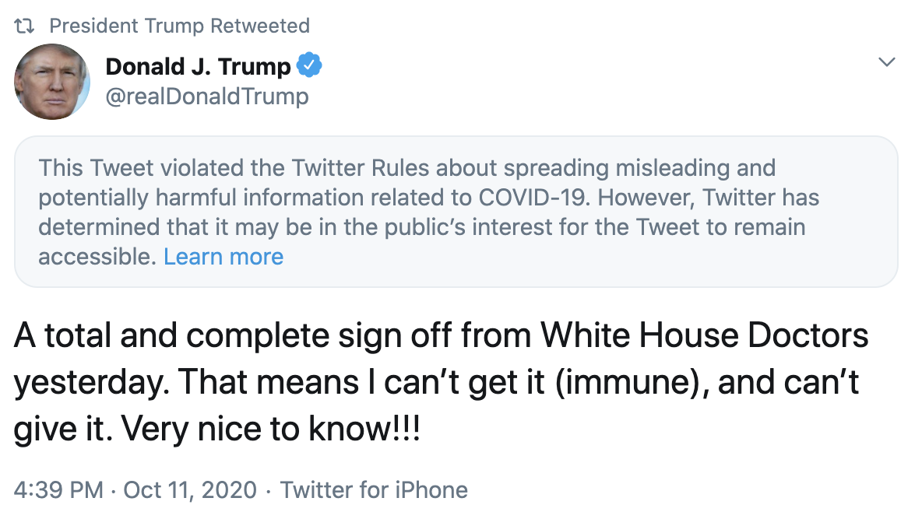

We are living in uncertain times. Corona virus has set off a massive debate, leaving society’s trust hanging by a thread. False information is being spread now more than ever and our leaders seem to be at the for front of guilt. Donald trump being the main culprit, making theatrical insensitive tweets stating false information. The mound of tweets built on lies trump has created has caused his reputation to plummet. This I just one example of how social media is flooded with fake news. Between Twitter, Instagram, Facebook and endless other social media websites, fake news snowballs into a mountain of lies when travelling from one to another, leaving society clueless on how to debunk the truth. This trickles down into mainstream media where there can be serious confusion surrounding important information such as political updates considering Corona virus or Brexit. Moving forward society have to make their own decisions on who and what information to trust, research is a key tool in life to filter out the ‘fake news’.

5. Be conscious of your carbon footprint
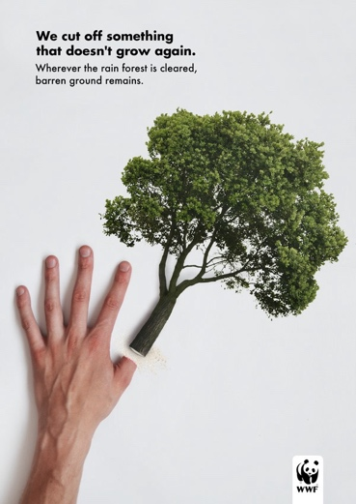
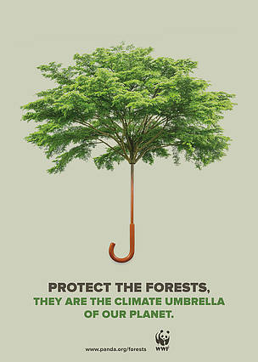

Unfortunately, our parents’ generation has catapulted our earth into a state of desperation. It is our generations responsibility to make the necessary changes for a better future. Our brains are programmed to constantly want more, taking everything our earth offers to the bare bone. As technology advances, the need for paper is minimised in all aspects of life. Specifically, in the Graphic communication industry. A conscious effort needs to be made to dramatically reverse the damage done. Going against the grain and developing ways to encourage the use of sustainable graphic communication materials is vital. A massive contribution by the graphic design community can be to stop annually multi purchasing and updating devices. All advertisements or Public information need to be accessible online. Packaging needs to be simplified to reduce the use of materials. Stop cutting down trees and start planting them. Recycle!

- Be daring and confident in your own views
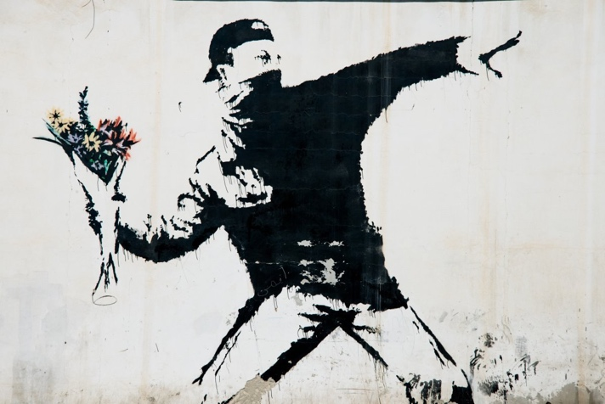

\
From birth we are instructed by society to follow the rules, stay within the lines and do what we are told. Through academic experience and life knowledge I have learnt that taking risks and seeing results come hand in hand. Weighing up the value of risk to result ratio is a challenge everyone faces on a daily basis. Banksy is one example of an artist that takes the risk for a positive outcome, in his case to make a political difference. The above image is just one piece of his work where Banksy is daring and confident in his own views. I strive to follow this ideology in my own work and life choices. Banksy graffiti’s on private property, causing him to be seen as a criminal. From an artist’s perspective, those who break the rules and boundaries society puts us in, are the people who make change and knock down the barriers to freer thinking.

Task 3: Practice-based Writing – Trip to Josephine Bakers chateaux

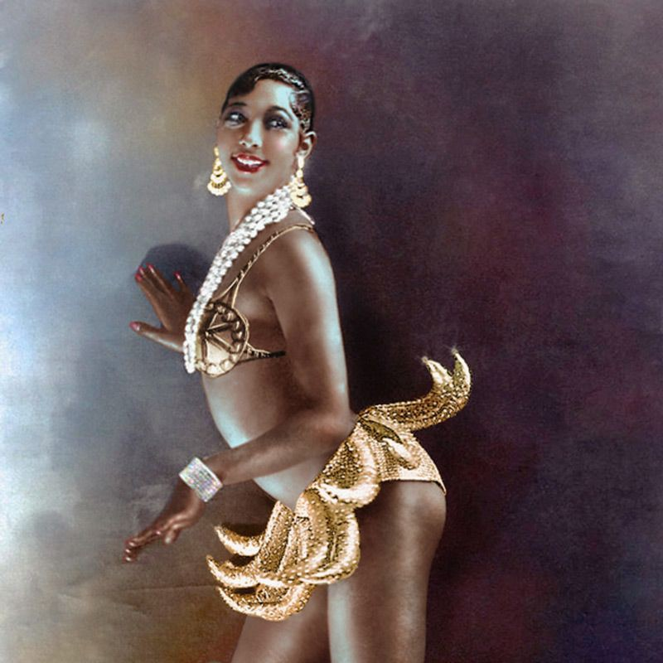

Stumbling across Josephine Bakers chateaux while on holiday in France was an eye-opening experience. Unaware of the icon that is Josephine Baker, I left her home inspired and curious. Her home was filled with glamours costumes, gowns and accessories from her life in the limelight as an exotic dancer. Taking a walk-through Josephine bakers life enchanted me. Josephine Baker being a celebrity through her activism and exotic dancer roles amongst others, gave her a platform allowing her to make changes within society. Both negative and positive issues came along with Josephine’s fame. Her home was filled with graphic poster designs where illustrations of her were created to reflect on her personality and lifestyle. Being a young female designer, this brief experience brought me excitement, hope and courage for my future in the creative industry.

During my time in Josephine’s home, I regret my actions. Being another one of society’s robots, I was fixated on my phone taking pictures of the enchanting materialistic items to later share on social media. Adding to this we wore a headset translating the tour information from French to English, being poorly translated I quickly gave up on it. As a beginner aspiring designer I was in my element, but I mistakenly got lost in the excitement of her life instead of grounding my feet and soaking up all of the depth and knowledge Josephine offered. From later research, I recognised the true brilliance Josephine was and lives on to be. An activist supporting the black rights movement. An artist expressing herself through dance. A mother of 12 adopted biracial children. A feminist breaking boundaries. These are just a few inspirational roles Josephine played. I am frustrated to wonder what more information I could have discovered if I was more present in the experience.

From this experience I have learnt that inspiration is constantly surrounding us. Being prepared for such inspiration is key. Specific to this scenario, to prepare better I should have completed prior research before going to Josephine’s châteaux. Perhaps creating a list of questions to keep me grounded through the experience, and further supporting a more investigative approach to the day.

In future, I intend to be present in all life experiences. Being a designer, I am now aware of the importance to take in your surroundings constantly, where ideas can spark from everywhere and anywhere.

