Name: Louise Ridley
Student No: 1908502
Module code: ECPT6003
Assignment No: A2
Word count: 2508
FINAL

Observation report

Introduction

This report will examine two classroom observations conducted as part of my professional development journey to become a successful lecturer in higher education. The observations focused on two illustration lessons, totalling six hours of teaching practice, Reportage illustration and Narrative illustration. Both of which offered valuable insights into different teaching methods and student engagement strategies. The primary goal of these observations was to understand how experienced lecturers facilitate learning in their teaching environments, with particular attention to fostering engagement, providing constructive feedback, and adapting teaching methods to meet diverse learning needs.

Observational learning is an important area in the field of psychology and behaviour science more generally. Given this, it is essential that behaviour analysts articulate a sound theory of how behaviour change occurs through observation. (Fryling, Johnston and Hayes, 2011)
Using Gibbs’s reflective cycle as a framework (UCD Teaching and Learning, 2020), this report will reflect on each observed lesson, identifying key aspects of effective teaching while also recognising areas for potential improvement in my practice. Each observation is analysed through the lens of the UK professional standards, (Bond, L. 2000) aligning the reflection with the core areas of activity, professional values, and core knowledge that guide high quality teaching in further education.
By analysing these observations, I aim to identify actionable strategies to enhance my own teaching approach, ensuring a balanced, student-centred environment that aligns with professional standards and supports continuous development. This reflective process is integral to my progress as an educator, helping to build an adaptive and inclusive teaching practice that meets the diverse needs of students in creative disciplines.

Observation 1: Reportage Illustration
Date: 19th October 2024
Notes on the lesson (Description)

The lesson focused on introducing students to different types of perspective in illustration. An important foundation when sketching in various positions (Naito, 2020). The lecturer began with a brief yet comprehensive overview of the core perspective principles, such as the horizon line and vanishing points. The students were asked questions to determine how much they knew about the subject before the lecturer went into any more depth. This was to gauge their familiarity with perspective concepts, allowing the lecturer to adjust the lessons pace accordingly. This can be seen as a constructivist approach (Reece and Walker, 2007, P89).
Five different elements of perspective were introduced through PowerPoint demonstration, each slide with detailed, clear images, enabling students to follow along and build an understanding of the techniques in a structured manner, aligning with UK Professional Standards, ‘Plan to deliver effective learning, teaching and assessment,’ (Bond, L. 2000) To enhance the learning experience, students were encouraged to actively engage by sketching alongside the lecturer as he demonstrated perspective techniques live. This hands-on activity allowed students to directly apply each technique to their sketches as they observed. Throughout the lesson, the lecturer adopted a student-centred approach by moving around the classroom, providing individual support and guidance, helping the students as they completed the task. This approach gave each student the opportunity to receive help on the more complex parts of the work offering support when needed, which reinforced their understanding and confidence in the task given. Fostering a supportive learning environment that accommodated varying skill levels. Aligning with UK Professional Standards, ‘Demonstrate commitment to learners, their learning, safety and well-being’ (Bond, L. 2000). To conclude the lesson, the lecturer highlighted references to artists known for perspective techniques, aiming to inspire the students in their own work. This comprehensive and interactive approach to teaching perspective ensured a balanced mix of theoretical instruction, practical application, and inspirational material. Which aligns with UK Professional Standards, ‘Plan to deliver effective learning, teaching and assessment.’ (Bond, L. 2000).

What I have learned (Feelings & Analysis)

During my observation, I noticed that the lecturer employed a structured approach that included direct instruction, hands on task with live demonstrations and individual assistance to effectively facilitate the students understanding of perspective drawing. This teaching approach underscored how valuable a well organised approach can be beneficial to the students, especially when introducing complex concepts that can initially seem challenging. This approach corresponds to a scaffolding technique (Mcleod, 2024b). The introduction to perspective established a strong foundational understanding, where key principles were articulated in a clear and accessible manner. This laid the foundation for subsequent activities, allowing students to develop their understanding in manageable stages. ‘Effective pacing keeps students not only attentive but also excited about learning, transforming potential monotony into vibrant educational journeys.’ (Teachers, 2016). The live demonstrations, served as an essential bridge between theory and application. As students attempted to sketch alongside, they were able to immediately apply the conceptual knowledge they had acquired. This active approach promoted experiential learning (Williams, 2017). allowing students to absorb concepts more effectively through practice. This mirrors Kolb's learning and experimental learning cycle ‘Learning in the process whereby knowledge is created through transformation of experience.’ (Mcleod, 2024) By introducing each technique live, the lecturer demonstrated both the technical skills and thought processes required in perspective, which likely invoked the steps and adjustments needed with guided instruction. The lecturers personalised assistance and feedback further enhanced the learning experience, catering to the varied skill levels within the classroom. By offering this ongoing attention, the lecturer was able to address specific difficulties and correct misunderstandings directly. This may have been crucial for students struggling with more intricate aspects of perspective. This approach contributes to a supportive and inclusive learning environment, encouraging students to seek clarification and ask questions without feeling embarrassed. This aligns with the UK Professional Standards, ‘Value and promote diversity, equality of opportunity and inclusion’ (Bond, L,2000). This support not only reinforce student's technical skills but also promotes confidence, fostering a classroom dynamic where the students feel self-assured and comfortable in engaging openly. One area for improvement is the addition of peer-to-peer interaction which is conceptualised as stemming from constructivist theories of learning, such as the radical constructivism of Jean Piaget, and social constructivism of Lev Vygotsky. (Tenenbaum, 2019). I have observed that some students are reserved when in group discussions. Although the lecturer’s personalised guidance is highly beneficial, incorporating collaborative activities could help further enhance the learning experience. (Groenewald, R.2021) Group or paired exercises would encourage students to exchange their ideas and explore diverse approaches to perspective. (Mcleod, 2024b) Which could foster a collaborative learning environment, where the students build knowledge through open discussions. This approach may be particularly valuable for students who seem hesitant to engage with one another, thereby fostering a more interactive and cohesive classroom environment. ‘Research shows that students who engage in collaborative learning and group study perform better academically, persist longer, feel better about the educational experience, and have enhanced self-esteem.’ (Kapa3iha, 2016).

Observation 2: Narrative Illustration
Date: 22nd October 2024
Notes on the lesson (Description)

This lesson focussed on the fundamentals of character design using basic shapes to build form and structure. The lecturer began by discussing the role of shapes in creating distinct characters, using circles, squares, and triangles to illustrate how different shapes affect character aesthetics and personality. For instance, circular shapes were discussed as portraying friendliness or softness, squares suggest strength or stability, and triangles as implying dynamism or edginess. After a brief presentation with visual examples, students were given a first sketching exercise based on specific shapes. This activity allowed students to apply the theory they had just learned by experimenting with how altering proportions, placement, and combinations of shapes could affect the overall feel and appeal of their own character designs. This scaffolding structure (Mcleod, 2024b), guides students through the process and aligns well with professional standards ‘Demonstrate commitment to learners, their learning, safety and well-being’ (Bond, L. 2000). Helping them understand each step more clearly and gradually build confidence and competence. Midway through the lesson, a collaborative activity was introduced squiggly shapes, in this exercise, each student started by sketching unique squiggly shapes on paper and then passing it to another student to work with.

Collaborative learning is an approach that can be planned and used to enhance student engagement by incorporating the social aspects of active learning. By using face to face or synchronous class time for collaborative learning in blended and online learning times then you have the basis for an effective ‘flipped classroom’ approach (Hamden et al., 2013; Lage & Platt, 2000). (Quoted in, University of Tasmania, 2021)

The students then used their unique shapes to transform into their characters. This activity encouraged students to think creatively and adapt their designs based on another's input, ‘students are engaged when something “jerks” them out of the routines’ (James and Brookfield, 2014, P9) promoting flexibility and fostering an exchange of ideas and interpretations. The exercise also allowed students to view character design from different perspectives. Later in the lesson, the focus shifted to colour theory. The lecturer introduced colour palettes and explained how different colour schemes can influence a character's personality and emotional tone. Through examples on a PowerPoint presentation, ‘Plan and deliver effective learning, teaching and assessment.’ (Bond, L. 2000). students observed how warm, cool, or contrasting colours could affect the energy and appeal of a character. As students worked on refining their characters and background designs, experimenting with colours, the lecturer circulated the room, offering individual feedback to guide their choices in shape and colour. This individualised attention allowed students to clarify questions and receive advice.
Overall, this lesson blended theoretical insights, practical exercises, and collaborative learning. Through structured activities like character shape-based sketches and the collaborative squiggly shapes exercise. Students were encouraged to experiment with different design techniques and gain new perspectives, creating a well-rounded approach to learning character design.

What I have learned (Feeling & Analysis)

This observation highlighted effective strategies for teaching complex concepts in character design. Breaking down the topic into basic shapes such as circles, squares, and triangles, this made character design more accessible for students by providing a simple foundation. This scaffolding approach (Mcleod, 2024b), demonstrated that starting with fundamental shapes allows students to explore aesthetics and personality without feeling overwhelmed, making complex design principles easier to grasp. The lesson's sequential structure progressing from shapes to colour reinforced the importance of layering concepts gradually. This step-by-step approach allowed students to build their skills in a cohesive way, connecting each new concept to the previous one. Observing this progression taught me that layering concepts in a structured way strengthens understanding and retention. The collaborative exercise emphasised the value of peer interaction. By sharing and adapting each other's designs, students gained new perspectives and creative insights, showing me how peer activities can encourage flexibility and broaden perspectives. (Groenewald, R.2021). Finally, the lecturers individual feedback underscored the importance of personal support. Each student received individual support tailored to help them refine their work and build confidence, reinforcing how personalised support can empower students to develop their unique creative voice. Which reflects the professional standards ‘Demonstrate commitment to learners, their learning, safety and well-being’ (Bond, L. 2000).
In summary, I learned that effective teaching combines simplification, structured progression, collaborative exercises, and personalised support and feedback to support skill building and confidence.

Comparative Reflection and professional standards (Evaluation & Conclusion)

Through both observations, I have learned that effective teaching in illustration relies on a balance of structured instruction, interactive hands-on activities, and continuous feedback and support throughout, aligning with professional standards, ‘Demonstrate commitment to learners, their learning, safety and well-being,’ (Bond, L. 2000). In both lessons, the lecturers used visual aids, live demonstrations, and timely feedback to reinforce understanding and guide students through complex concepts. This approach enabled students to apply new ideas immediately, which is crucial for retaining and deepening their learning experience. Which can be seen as a constructivist approach. (Reece and Walker, 2007, P89&90.) I observed that real-time application and interactive engagement were beneficial in helping students grasp design principles and technical skills, allowing them to build confidence and independence in their creative decisions.
Reflecting on these observations has encouraged me to adopt a more balanced approach in my teaching practice. To create an inclusive, student-centred environment, I aim to integrate individualised support opportunities. By respecting individual learners, I recognise the need to provide tailored guidance that honour's each students' unique strengths, challenges, and creative expressions. At the same time, encouraging peer interactions through collaborative exercises, respect the diversity of learning styles, allowing students to benefit from each other’s insights, aligning with Professional Standards, ‘Value and promote diversity, equality of opportunity and inclusion.’ (Bond, L. 2000). This balance of individual and group engagement not only respects diversity but also promotes a more holistic learning experience that accommodates a range of perspectives and learning preferences. Incorporating peer learning is supported by research that emphasises the positive impact of collaborative learning on student engagement and critical thinking. (Chen and Liu, 2020). By grounding my teaching approach in these standards, I can create a more inclusive, responsive, and collaborative classroom environment that encourages each student to explore, learn, and grow both independently and as part of a learning community.

Action Plan

SMART Criteria | Objective | Specifications | Measurement | Achievable Steps | Relevant Professional Standards | Time limit
S: specific | Balance structured guidance with interactive, hands-on activities. | Integrate visual aids, live demonstrations, and immediate hands-on activities in each lesson. | Track student engagement and understanding through formative assessments and feedback  during activities. | Plan lessons with clear objectives and balance of instruction and practice time for each session. | Plan and deliver effective, learning, teaching, and assessment. (Bond,2000) | Implement in the next month, review after each lesson.
M: Measurable | Enhance individual support and inclusivity. | Offer targeted support by moving around the classroom, observing, and giving individualised support and feedback. | Monitor student performance improvements and collect feedback on perceived support levels. | Identify key areas for individual attention each lesson based on task difficulty and student needs. | Demonstrate commitment to learners, learners' safety, and well-being. (Bond,2000) | Begin immediately, review monthly.
A: Achievable | Promote peer interaction and collaborative learning. | Design exercises (e.g., group sketches or idea exchanges) where students work together to build on each other's ideas. | Measure engagement through participations rates and assess student's reflections on collaborative exercises. | Start with small group activities, then expand to more complex collaborative tasks as students become comfortable. | Build positive and collaborative relationships. (Bond,2000) | Implement over the next two months, assess after each session.
R: Relevant | Foster an inclusive and supportive learning environment. | Encourage individual creative expression that respects diverse learning. | Track inclusivity by observing a range of student engagement types, from individual contributions to peer support. | Begin each session with a short check-in to assess students' comfort with tasks, adapting as needed. | Value and promote diversity, equality of opportunity and inclusion. (Bond,2000) | Implement in all lessons, review every three months.
T: Time-Bound | Consistently use feedback to refine teaching methods based on Professional standards. | Collect student feedback after each unit; evaluate it to adjust teaching practices in line with standards. | Conduct formal evaluations at term-end, informal feedback collection after major lessons. | Set up a feedback process with regular review points to allow for continuous improvement. | Plan and deliver effective learning, teaching, and assessment. (Bond,2000) | Setup feedback system within one month; review quarterly.

Teacher Observation Form 1

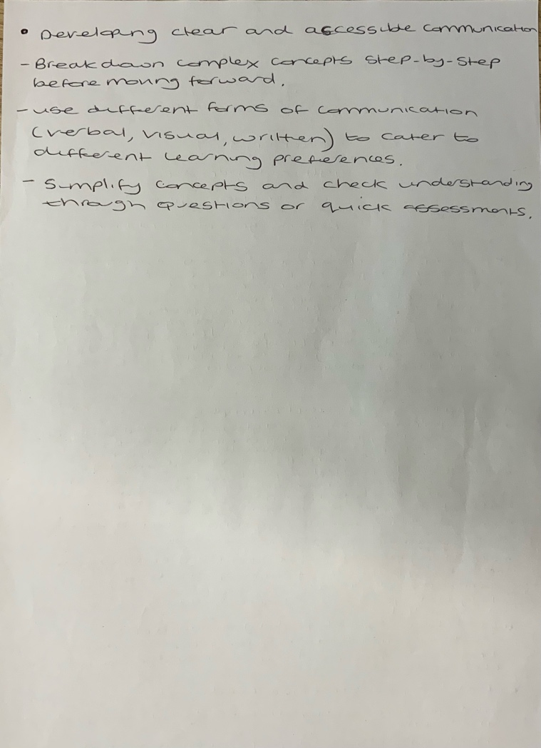
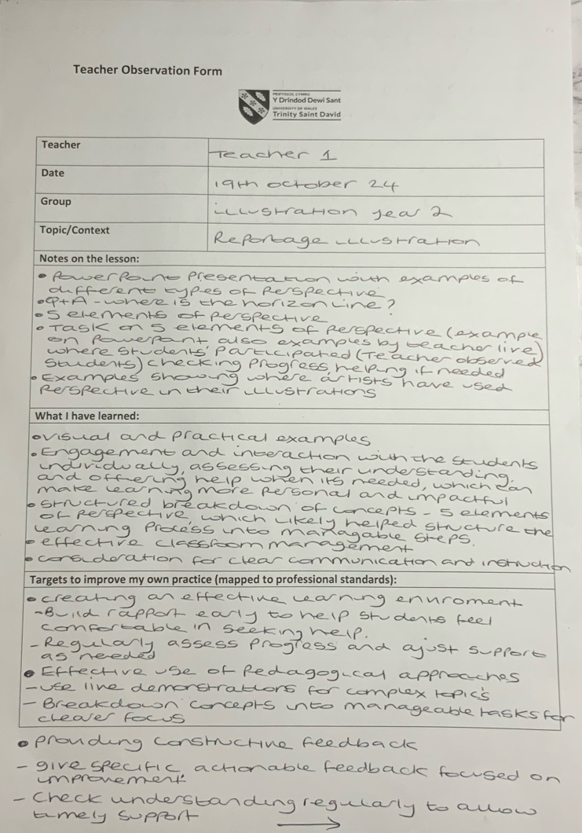

Teacher Observation Form 2

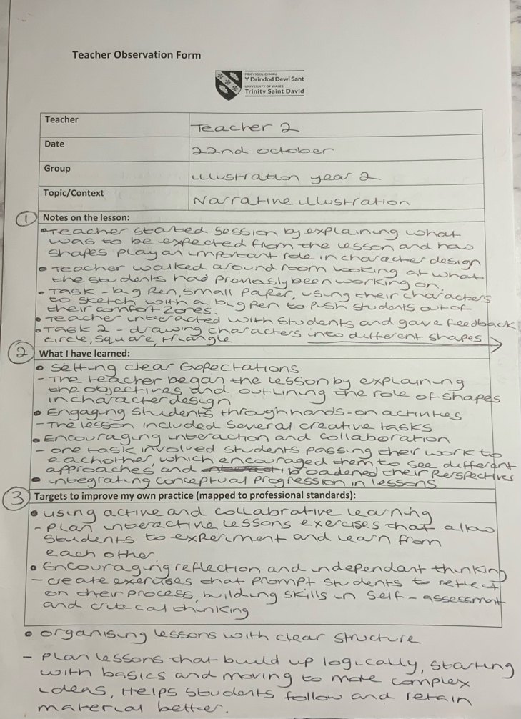
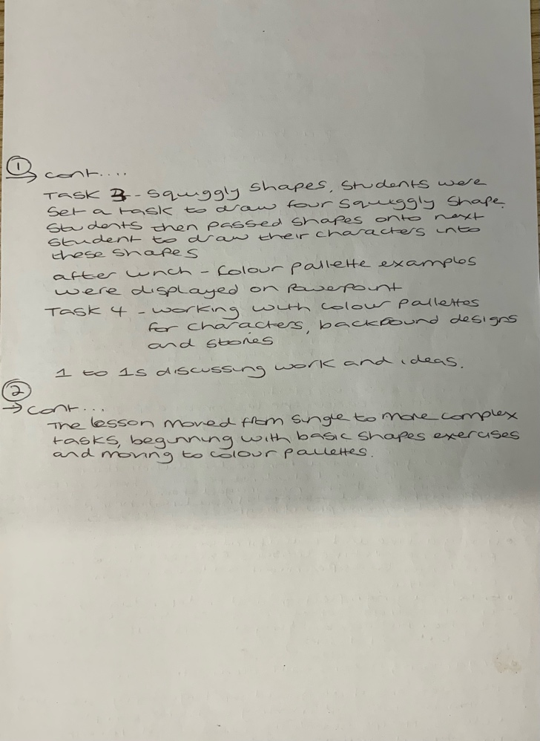

Reference list

Bond, L. (2000) The certification system of the National Board for Professional Teaching Standards: A construct and consequential validity study. Greensboro, N.C: Center for Educational Research and Evaluation, University of North Carolina at Greensboro. (Accessed: 01 October 2024).
Chen, H.L. and Liu, C.Y. (2020). Effects of peer learning on learning performance, motivation, and attitude. International Journal of Education Economics and Development, 11(4), p.420. doi:https://doi.org/10.1504/ijeed.2020.10030596.
Groenewald, R. (2021) The vygotsky theory explained: Fractus learning |, Fractus Learning. Available at: https://www.fractuslearning.com/vygotsky-theory/ (Accessed: 05 October 2024).
James, A. and Brookfield, S. (2014). Engaging imagination: helping students become creative and reflective thinkers. Hoboken: John Wiley & Sons.
Fryling, M.J., Johnston, C. and Hayes, L.J. (2011). Understanding Observational Learning: an Interbehavioral Approach. The Analysis of Verbal Behavior, [online] 27(1), pp.191–203. doi:https://doi.org/10.1007/bf03393102.
Kapa3iha, I. (2016). Chapter 8 Peer to Peer Interaction. [online] Kharkov.ua. Available at: http://psydilab.univer.kharkov.ua [Accessed 10 Nov. 2024].
Mcleod, S. (2024). Kolb’s learning styles and experiential learning cycle. [online] Simply Psychology. Available at: https://www.simplypsychology.org/learning-kolb.html [Accessed 10 Nov. 2024].
Mcleod, S. (2024b). Vygotsky’s Sociocultural Theory of Cognitive Development. [online] Simply Psychology. Available at: https://www.simplypsychology.org/vygotsky.html [Accessed 11 Nov. 2024].
McLeod, S. (2024). Albert bandura’s Social Learning Theory. [online] Simply Psychology. Available at: https://www.simplypsychology.org/bandura.html [Accessed 11 Nov. 2024].
Naito, M. (2020). Medium. [online] Medium. Available at: https://myranaito.medium.com/the-importance-of-perspective-in-art-8cfb292effe [Accessed 11 Nov. 2024].
Teachers, I. (2016). Effective Lesson Pacing Strategies. [online] Impact Teachers. Available at: https://impactteachers.com/blog/pace-2/ [Accessed 10 Nov. 2024].
Tenenbaum, H. (2019). How Effective Is Peer to Peer Interaction in Facilitating Learning. [online] American Psychological Association. Available at: https://www.apa.org/pubs/journals/features/edu-edu0000436.pdf [Accessed 10 Nov. 2024].
UCD Teaching and Learning (2020). REFLECTIVE PRACTICE MODELS. [online] Www.ucd.ie. WWW.UCD.ie Teaching . Available at: https://www.ucd.ie/teaching/t4media/reflective_practice_models.pdf [Accessed 11 Nov. 2024].
University of Tasmania (2021). Collaborative Learning - Teaching & Learning. [online] Teaching & Learning - University of Tasmania, Australia. Available at: https://www.teaching-learning.utas.edu.au/learning-activities-and-delivery-modes/collaborative-learning [Accessed 12 Nov. 2024].

Williams, M. (2017). John Dewey in the 21st Century. Journal of Inquiry & Action in Education, [online] 9(1), p.92. Available at: https://files.eric.ed.gov/fulltext/EJ1158258.pdf [Accessed 11 Nov. 2024].

