
Evidence Of Learning



ellie jones
2205267

‘Preparing For Higher Education’


The format of studying at a university may differ from studying at a school or college. Many people need to be more self-reliant and driven. They have an excellent idea to try to prepare throughout the summer. Many give top tips to follow before joining university; To learn about the university's support for new students, check out the materials on their online website, inquire at the university about workshops and sessions on study skills that can fill in any knowledge or skill shortages and to See whether their course has a pre-reading list that can be completed in advance. An approach means that they set up a student bank account, make sure they apply for any necessary student loans, understand what they are eligible for and how the process works, and establish a budget before they leave. By doing this, they can see if the budget will work for them by testing it out for a few weeks prior to starting school. To assist them produce a plan, it could be beneficial to research the cost of living in the place they intend to move to. Compatibility, friendship, and diversity. A person's first year of college is an opportunity to learn about themselves and meet new people. Make the most of your time at university by being true to yourself with the aid of our best advice and tools. So that they can connect with like-minded individuals, an approach highlights what their neighbourhood and university have to offer. This may include organisations like society, sports teams, support networks, and much more. Join online organisations before they leave, especially those focused on their interests, to meet people before they get to university. putting forth the effort to make friends. It will benefit most from meeting people because that is what university is all about. (2022) UCAS: getting ready for higher education. 1 ed. https://www.ucas.com/undergraduate/results-confirmation-and-clearing/getting-ready-higher-education

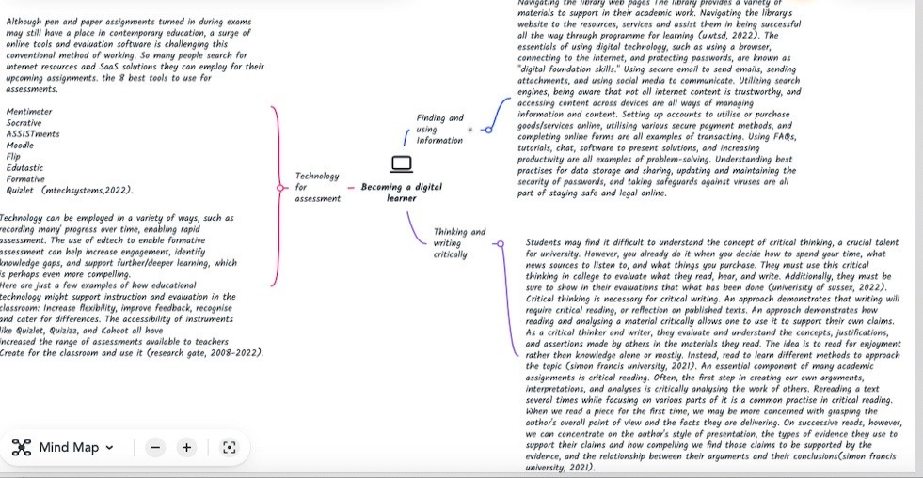
Link to mind map- Becoming a digital learner

Video- please press present to watch video
https://uowtsd-my.sharepoint.com/:p:/r/personal/2205267_student_uwtsd_ac_uk/Documents/Video%20presentation.pptx?d=w1abb19237a04436190d838c88f57fff0&csf=1&web=1&e=xkSUQm

Reflection
A straightforward and user-friendly reflective framework is the Borton's development framework. This enables you to reflect without having to look at the framework, which is why many healthcare professionals prefer it and professional organisations promote it. In my article, I will make use of Borton's reflective tool. I experienced severe stress as soon as I entered university due to the workload, essays, and tasks. For me, attending university brought about a rise in obligations, poor time management, a change in my food and sleeping patterns, and a lack of self-care pauses. Time management is one of the most important things as it is putting deadlines and essays first and not making excuses up to concentrate on rather than work. For me, the period leading up to leaving home was anxious; packing up your possessions and saying goodbye to your family would not be simple. You'll have to take on new duties like managing your finances, paying bills, doing the dishes and cleaning. I began doing my own laundry, occasionally preparing dinner, and making a budget a few months prior. According to one student, "University is different from sixth form or college in that organisation and preparation are more crucial than ever. It is impossible to learn the entirety of a module the night before the test. In addition, there will be several deadlines in a single month that must be met, which is also no easy task. Time management is one of the first things that many students discover when they enrol in college. Have a monthly calendar with the dates of all the deadlines and social engagements filled in, if I could give my younger self one piece of advice. My life has become so much simpler since I started doing this in the second semester. Do not underestimate the importance of checking your student emails every single day. This will stop you from missing deadlines and additional assignments, which will only cause you unnecessary worry.”

References

https://blogs.bath.ac.uk/students/2021/07/20/a-reflection-on-my-first-year/
https://www.coursera.org/articles/communication-effectiveness

https://www.google.com/search?q=values+and+beliefs+information&rlz=1C1GCEJ_enGB1031GB1031&oq=values+and+beliefs+information&aqs=chrome..69i57j33i160.6472j0j1&sourceid=chrome&ie=UTF-8

https://www.highspeedtraining.co.uk/hub/types-of-identity-theft/
https://www.iaa.govt.nz/for-advisers/adviser-tools/ethics-toolkit/personal-beliefs-values-attitudes-and-behaviour/#:~:text=Values%20are%20stable%20long%2Dlasting,see%20it%20as%20being%20important.
https://www.lawinsider.com/dictionary/identity-information

https://www.lib.sfu.ca/about/branches-depts/slc/writing/argumentation/critical-thinking-writing

https://www.planetizen.com/node/56165

https://www.mtechsystems.co.uk/latest-technology/understanding-different-types-of-cloud-computing-services/

https://www.researchgate.net/publication/316443165_The_effect_of_Kahoot_Quizizz_and_Google_Forms_on_the_student's_perception_in_the_classrooms_response_system

https://www.sussex.ac.uk/skills-hub/critical-thinking#main

https://www.uwtsd.ac.uk/library/

https://www.ucas.com/undergraduate/results-confirmation-and-clearing/getting-ready-higher-education

https://uk.indeed.com/career-advice/career-development/team-player

