

Danielle Humphries
1910878

Module ACBA4006
Lighting Layout and Sound Index Calculation

Contents Page
Introduction……………………………………………………………………………..Page 3
Task A……………………………………………………………………………………….Page 4
Utilisation factor………………………………………………………………………Page 5
Suitable layout…………………………………………………………………………Page 6
Building Regulations………………………………………………………………..Page 7
Task B………………………………………………………………………………………Page 8
Sound frequency & wavelength implications…………………………..Page 10
Building Regulations………………………………………………………………..Page 11
Bibliography……………………………………………………………………………..Page12
Referance…………………………………………………………………………………Page 12

Introduction
This document will contain how to calculate and analyse building services for comfort levels in a building. Task A is designed to show the workings out of the Lux level needed for a lighting system in a factory. Task B will calculating the sound reduction index and a scale drawing of the light layout.
Task A
Will involve calculations needed to work out the Lux level needed for the lighting system within a factory that measures 60 metres, 24 metres by 8 metres in height. Taking into account the work surfaces, reflectance’s from the ceiling, the walls and the type of florescent light that is to be installed.
A scale drawing of the light layout will be included. Also will include the building regulations required.
Task B
- Calculate the SRI sound reduction index of a brick wall with a area of 20m² which contains a window with a area of 4m². The values of sound reduction indexes are 50dB for the brick and 10dB for the window.
- Discuss the implications of frequency and wavelength in internal sound management partition wall construction technique and insulation choice.

Task A
A production area in a factory measures 60 metres x 24 metres x 8 metres in height. The factory’s work benches are set at a height of 1m above the floor level. The area’s reflectance’s are 0.3 for the ceiling and 0.5 for the walls. The lighting design specifies florescent lamps in recessed louvre with DLOR of 50% (the actual size for the luminaires is 1200mm (1.2m) in length and 200mm (0.2m) wide)
A Lighting Design Lumen (LDL) output of 18,000 lumens is required.
The illumination required for the factory area is 200 lux at the working plane.

Room Index
RI = (LxW) / (Hm (L + W))
60 x 24 = 1,440
7 x (60 + 24) = 84
7 x 84 = 588
1,440 / 588 = 2.448
Room index = 2.448 or round off to 2.5

Utilisation Factor
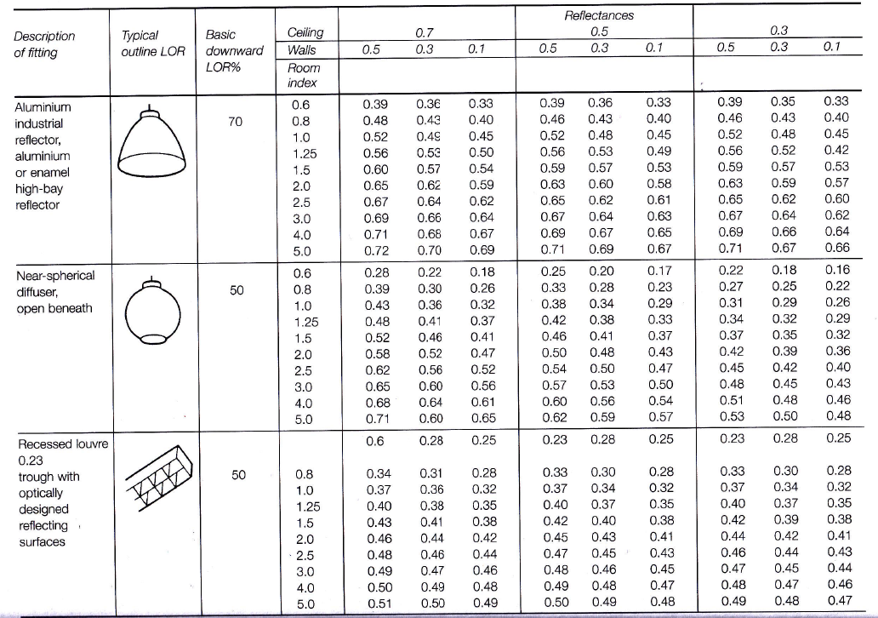

RI = 2.5, DLOR (50%), Ceiling reflectance (0.3) and Wall reflectance (0.5) connected on the table above gives us a UF of: 0.46
Number of lights required
N = E x A / F x UF x LLF 200 x 1440 = 288.000
E = 200 lux 18.000 x 0.46 x 0.75 = 6210
A = 1440 288.000

F = 18.000 6210 = 47
UF = 0.46
LLF = 0.75 Number of lights required 48
Suitable layout for the lamps to be fitted
Smax = 1.5 x Hm = 7
1.5 x 7 = 10.5m
Smax is 10.5m
Suggested layout for the lamps would be 4 rows of 12 lamps. See scaled drawing overleaf.

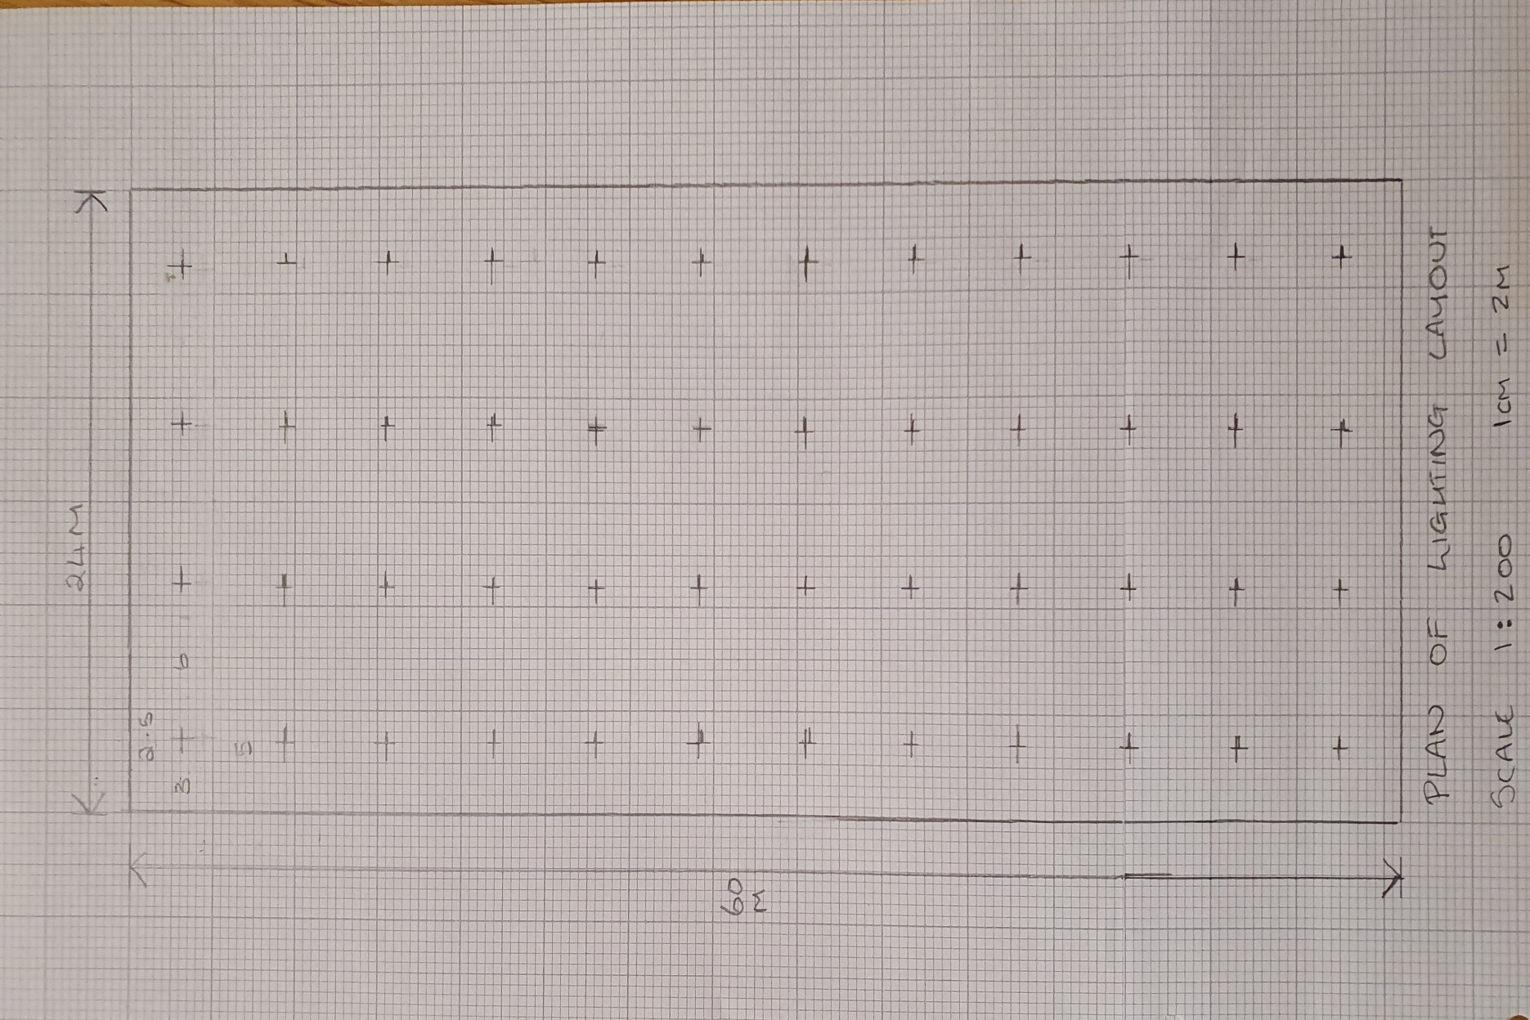

Building Regulations & British Standards
Part L of the building regulations covers all aspects of energy efficiency
- L1A – Conservation of fuel and power (new dwelling)
- L1B – Conservation of fuel and power (existing dwellings)
- L2A - Conservation of fuel and power (new buildings other than dwellings)
- L2B – Conservation of fuel and power (existing buildings other than dwellings)
Link to the above Regulations
https://www.labc.co.uk/sites/default/files/EXT.Approved-Document-L-2014-Conservation-of-Fuel-%26-Power-L2B-Existing-Buildings-Other-than-Dwellings.JMCN_.v1.030417.pdf
British Standards BS EN 12464-1:2011 covers light & lighting in the workplace. (Thorn, 2010)

Task B
- A brick wall area 20m² contains a window of area 4m²
The values of the sound reduction indexes are: 50dB fort eh brickwork and 10dB for the window. Calculate the overall sound reduction index for the entire wall.
- Discuss the implications of frequency and wavelength in internal sound management partition wall construction technique and insulation choice.
Sound reduction index:
BR = A1 = 16m²
W = A2 = 4m²
T⁰ = (T1 x A1) + (T2 x T2)
A1 x A2
Find T1 and T2
Brickwork
SR = 50Db
SRI = 10 x (log₁₀ (1/T))
50 = 10 x (log₁₀ (1T₁))
5 = log₁₀ x (1/T₁)
1/T₁ = 10⁵
T₁ =10 ⁻⁵
= 0.000010 Transmission coefficient for brick
Windows
SR = 10dB
SRI = 10 x (log₁₀ (1/T))
10 = 10 x (LOG₁₀(1/T₂))
1 = log₁₀ x (1/T₂))
1/T₂ = 10¹
T₂ = 10⁻¹
Transmission coefficient for window = 0.10
T₀ = (T₁ x A₁) + (T₂ x A₂)
A₁ x A₂
T₀ = (0.00001 x 16) + (0.1 x 4)
16 + 4
T₀ = 0.00016 + 0.4
20
T₀ = 0.40016
20 = 0.020008
Average transmission coefficient = 0.020008
SRI formula
SRI = 10 x (log_{10 (1/T))}
_{= 10 x (log10} (1/0.020008))
= 10 x (log₁₀ (49.980007)
= 10 x 1.69
SRI for the composite partition = 17 dB
Sound frequency and wavelength implications
Internal sound management is a very important aspect to consider when building or renovating a property, some of the implications that can arise when this isn’t managed correctly and not within Building Regulations can impact the occupier of the properties acoustic feel and ability to relax and enjoy their space. Sound interacts with a surface in 4 different ways these are
- Transmissions
- Absorption
- Reflection
- Diffusion
Ideally in a property absorption is what you would want to reduce sound being transmitted to another room. Larger wavelengths are capable of passing through a wall as they are larger than the walls atoms this is why sound is transmitted through the void and why insulation is needed to trap that sound and change it to a heat energy. See below for more on Insulation.
Partition walls are installed in the purpose to separate 2 rooms, they are cheap, lightweight and are none loadbearing walls. It is important when installing a partition wall you have to take the sound frequency and wavelengths into account, if you install a timber (BS EN 336 Structural Timber) or metal frame leaving it hollow inside you are creating a void between the plasterboards, OSB or plywood of fibreboard, when sound getting’s into the void it resonates, echo’s and amplifies becoming louder this is called the drum effect. Airborne sound is blocked only by mass if the void isn’t filled the sound will resonate (soundproofingstore, 2018)
A partition wall that has an empty void will reflect some sound back into the room the noise is coming from and transfer some noise into the next room through wavelengths, a partition wall with insulation will absorb the sound through the fibres and transmit into heat energy resulting in a reduction of sound energy passing through to the other room.
Insulation
Commonly used insulation to try reducing sound travelling from one room to another is Acoustic Mineral Wool 60kg. Acoustic Mineral Wool is a non flammable product that is produced to a density that will give maximum sound absorption. This product can also be used in the voids of ceilings and joists. (Mark Blinkley, 2016)
The Acoustic Mineral Wool is designed to absorb any sound that will get into this area and stop it amplifying and resonating in the void then out the other side.
Building Regulations
Building regulations for sound are Part E in England and Wales these are over 2 categories’
- E1 Protection of noise from adjoining buildings such as flats, terraces and semis.
- E2 Transmission within the household.
E2 has a current requirement of 40dB of sound reduction. Masonry and concrete meet these requirements however timber or steel walls need acoustic plasterboard and insulation to meet the requirements. Complete soundproofing isn’t needed under E2. (Mark Blinkley, 2016)
Bibliography
Blinkley, M., 2020. Soundproofingstore. [online] youtube. Available at: <https://www.youtube.com/watch?v=Lgt7HIAItmk> [Accessed 17 March 2020].
BUILD. 2020. Reflection, Diffusion And Absorption Of Sound. [online] Available at: <https://build.com.au/reflection-diffusion-and-absorption-sound> [Accessed 17 March 2020].
GOV.UK. 2020. Conservation Of Fuel And Power: Approved Document L. [online] Available at: <https://www.gov.uk/government/publications/conservation-of-fuel-and-power-approved-document-l> [Accessed 17 March 2020].
GOV.UK. 2020. Resistance To Sound: Approved Document E. [online] Available at: <https://www.gov.uk/government/publications/resistance-to-sound-approved-document-e> [Accessed 17 March 2020].
Labc.co.uk. 2020. [online] Available at: <https://www.labc.co.uk/sites/default/files/EXT.Approved-Document-L-2014-Conservation-of-Fuel-%26-Power-L2A-New-Buildings-Other-than-Dwellings.JMCN_.v1.030417.pdf> [Accessed 17 March 2020].
Nantel, A., 2020. Sound.
Nantel, A., 2020. Light.
Nantel, A., 2020. Artificial Light.
Referance
Blinkley, M., 2020. Soundproofingstore. [online] youtube. Available at: <https://www.youtube.com/watch?v=Lgt7HIAItmk> [Accessed 17 March 2020].
BUILD. 2020. Reflection, Diffusion And Absorption Of Sound. [online] Available at: <https://build.com.au/reflection-diffusion-and-absorption-sound> [Accessed 17 March 2020].
GOV.UK. 2020. Conservation Of Fuel And Power: Approved Document L. [online] Available at: <https://www.gov.uk/government/publications/conservation-of-fuel-and-power-approved-document-l> [Accessed 17 March 2020].
GOV.UK. 2020. Resistance To Sound: Approved Document E. [online] Available at: <https://www.gov.uk/government/publications/resistance-to-sound-approved-document-e> [Accessed 17 March 2020].
Labc.co.uk. 2020. [online] Available at: <https://www.labc.co.uk/sites/default/files/EXT.Approved-Document-L-2014-Conservation-of-Fuel-%26-Power-L2A-New-Buildings-Other-than-Dwellings.JMCN_.v1.030417.pdf> [Accessed 17 March 2020].
Nantel, A., 2020. Sound.
Nantel, A., 2020. Light.
Nantel, A., 2020. Artificial Light.
Thorn, P., 2010. Thorn. [Online]
Available at: https://www.cibse.org/getmedia/3b3cba92-f3cc-4477-bc63-8c02fc31472c/EN12464-2011.pdf.aspx
[Accessed 17 02 2020].

