MARKETING AUDIT AND STRATEGIC GROWTH PLAN FOR GREGGS PLC

Module Code: BMBM6016
Module Name: Strategic Marketing

Student Name: Vimal Maddichetti
Student ID: 2207918
Executive Summary
This report provides an integral marketing audit of Greggs Plc, analysing its internal and external environment to recognise opportunities and challenges for business growth and resistance. Using Pestle, Swot, the five Porter forces and the analysis of the value chain, the report assesses Greggs' competitive positioning in the United Kingdom fast food sector. Greggs benefits from strong loyalty to the brand, an effective supply chain and continuous innovation in products, including its popular vegan and healthier food options. However, the company faces challenges such as the increase in costs, disruptions of the supply chain and the increase in the rivalry of brands and worldwide fast-food supermarkets.
Strategic recommendations include product diversification, digital transformation, supply chain optimisation, strategic market expansion and development of the personnel. By improving sustainability, investing in digital participation, and exploring new marketplaces, Greggs can maintain long-term growth. With a proactive approach to progress consumer trends and economic challenges, Greggs is well positioned to reinforce its leadership in the marketplace and future resistance.
Table of Contents
1. Introduction 4
2. External Environment Analysis 4
2.1 PESTLE Analysis 4
2.2 Porter’s Five Forces Analysis 10
3. Internal Environment Analysis 11
3.1 SWOT Analysis 11
3.2 Value Chain Analysis 12
4. Strategic Recommendations 14
5. Conclusion 15
Reference List 16

1. Introduction
This report aims to evaluate Greggs Plc’s current market position and future growth prospects, hence internal and external business environment is analysed. The report will examine the key strategic factors to understand how Greggs can manage the challenges presented by the industry and obtain the benefits related to the emerging opportunities. The fast-food industry in the UK is highly competitive as it is changing consumer preferences, economic circumstances, and technological progress (Greggs, 2025). Consumers are demanding more, such as the obtainability of healthier, convenient food choices. However, businesses are enduring the increase in the cost of operations, the lack of supply chain connectivity and regulatory pressure.
This report will use diverse strategic frameworks that will help to critically evaluate Gregg’s market position. Macro environment such as the PESTEL analysis will be taken into account while Porter's Five Forces will consider competitive pressures. The strengths, weaknesses, opportunities, and threats will be highlighted through a SWOT analysis, and a Value Chain analysis will be an examination of how Greggs understands their operational competencies and their strategic advantages.

2. External Environment Analysis

2.1 PESTLE Analysis
Factors | Discussion | Opportunities/Threats
Political | The UK regulatory environment considerably influences Greggs, specifically in sections such as food security, employment regulations and taxation strategies. Government approaches to minimum wage increases and Brexit-accompanying trade policies have impacted labour costs and supply chain activities (Armstrong, 2021). Furthermore, regulations on advertising high-calorie foods impact how Greggs markets its products, specifically in aiming for younger demographics. Growth into worldwide marketplaces might be assisted by trade agreements post-Brexit, permitting Greggs to arrive in the new marketplaces. Furthermore, changes in employment principles such as wage hikes and working hour restrictions might grow labour expenses.  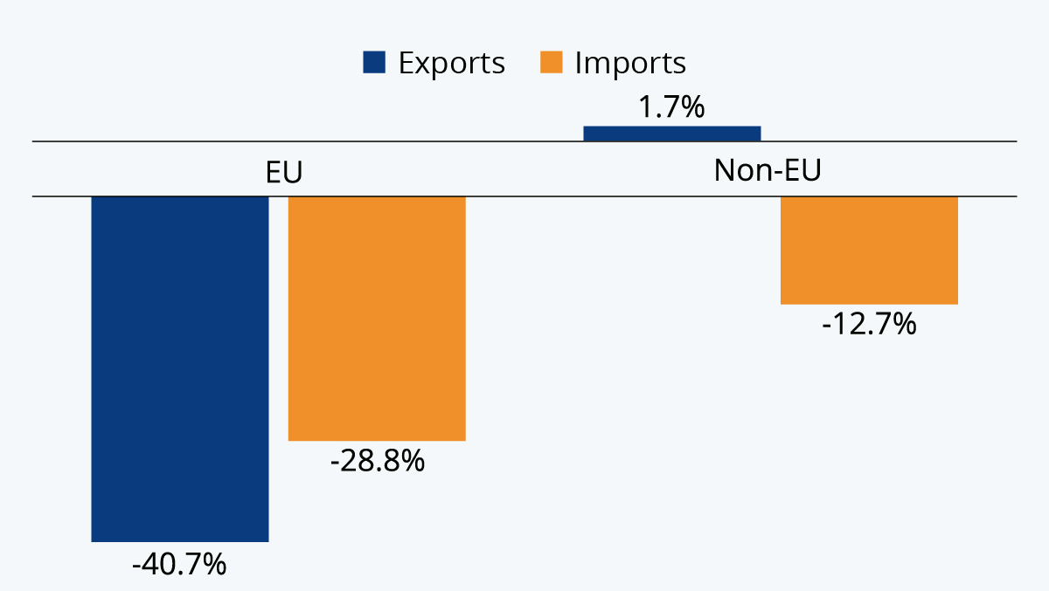  Figure 1: Brexit transition drops in EU trade  (Source: Armstrong, 2021) | Opportunities: Government incentives encouraging healthier food choices can benefit Greggs, specifying its development into low-calorie and vegan products.  Threats: Increased taxation on high-sugar and high-fat foods might affect sales of certain best-selling items.
Economic | The UK economy faced inflationary pressures, increased energy costs, and supply chain disruptions that impacted the fast-food sector. The cost of materials such as flour, dairy and meat increased, growing production costs. Furthermore, consumer spending behaviours have changed due to economic uncertainty, influencing fast food accessibility (Wolf, 2022). Increased demand for food to grab and go as more personnel return to post-pandemic offers an opportunity for Greggs to develop the city centre positions. Supply chain instability due to geopolitical pressure can lead to scarcity and increased costs for key resources.  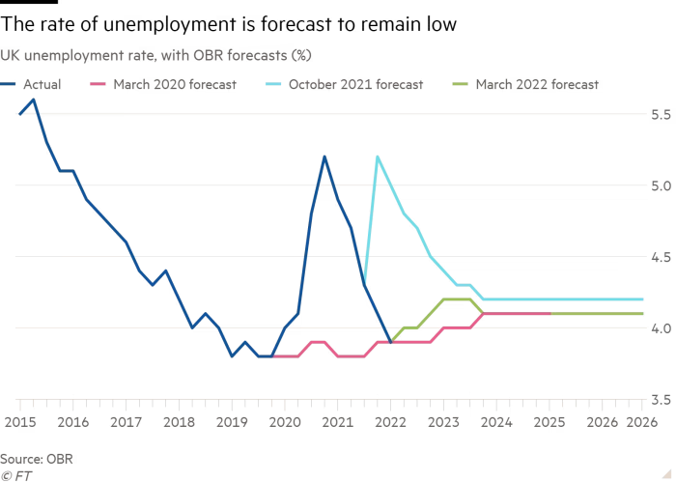  Figure 2: The Future of the UK Economy  (Source: Wolf, 2022) | Opportunities: The growing demand for obtainable food choices throughout economic crises benefits Greggs as it offers economic meals compared to higher-priced competitors.  Threats: Increased inflation and cost of living crises can lead to reduced discretionary spending, impacting general sales.
Social | Consumer preferences in the UK are changing to healthier eating habits, plant-based diets, and ethical consumption. Greggs' replied by introducing vegan options and low-calorie products, meeting the change in customer demands. The rise of moving gastronomic culture has increased the demand for convenience foods, promoting the Greggs business model (Jones, 2020). Increasing focus on ethical brands signifies Gregg’s investment in fair trade and sustainable resources reinforces its market position. Growing allergen and dietary consciousness might cause Greggs to implement recipes and enhance labelling, which might increase operations expenses.  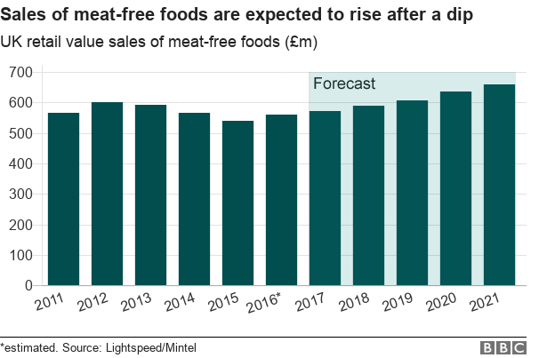  Figure 3: Sales of meat-free food rising  (Source: Jones, 2020) | Opportunities: The expansion of the vegan range based on plants aligns with the increasing demand for meatless products.  Threats: Health-conscious customers might move towards competitors offering more premium and organic or fresh food choices.
Technological | There are digital ordering, self-service kiosks, and AI supply chain management. All of that has become the norm within the food service industry's cutting-edge technology. To meet the consumer base's convenience necessities, Greggs has invested in mobile app and delivery partnerships. Logistics automation and AI investment can improve operational productivity along reduce labour expenses (Kumar et al., 2021). Cybersecurity risks related to digital payment and customer data storage need to be capitalised in security actions.  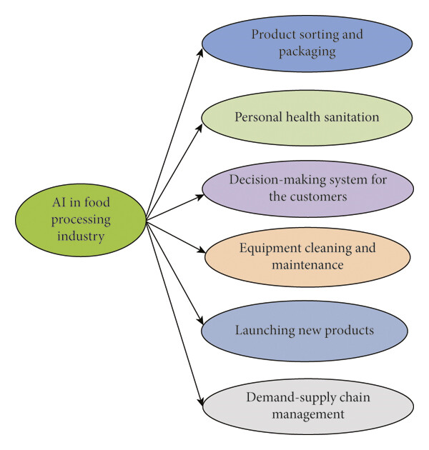  Figure 4: Artificial Intelligence and Machine Learning in the Food Industry  (Source: Kumar et al., 2021) | Opportunities: Application-based loyalty programs offer to improve digital customer commitment and can help to enhance customer retention.  Threats: Greggs, if it doesn't adapt to existing technical trends will risk losing out to entrants who are healthier at digital integration.
Legal | UK food safety laws, employment and data protection laws apply to Greggs. This is crucial to suffering fines and reputational damage, as regards compliance with allergens labelling the regulations, minimum wage laws and GDPR (Shen, Wei and Sheng, 2021). The implementation of good employee strategies can make a company more attractive to employees and even gain particular positive status. Food safety breaches or employee disputes bring about lawsuits and financial penalties as an outcome of legal threats.  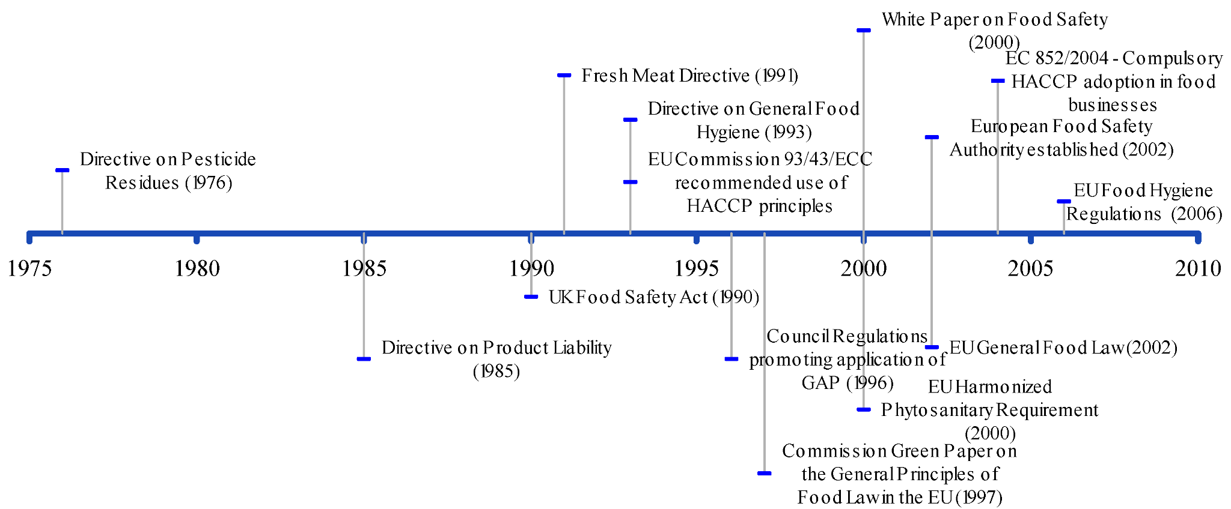  Figure 5: Public and Private Food Safety Standards  (Source: Soon and Baines, 2013) | Opportunities: Ethical sourcing and clean packaging will support and safeguard the brand’s future by staying ahead of regulatory necessities.  Threats: Government laws regarding food labelling and health declarations could need reformulation of certain products.
Environmental | Consumer and regulators standing for sustainability and environmental responsibility is increasing. Greggs has already taken action towards reducing food waste with its usage of eco-friendly packaging and its services of sustainable ingredients (Greggs, 2023). However, the company still needs to work to go along with net-zero emissions targets and decrease its carbon footprint. AI-driven inventory management supports reducing food waste and hence, increasing productivity and decreasing the expenses.  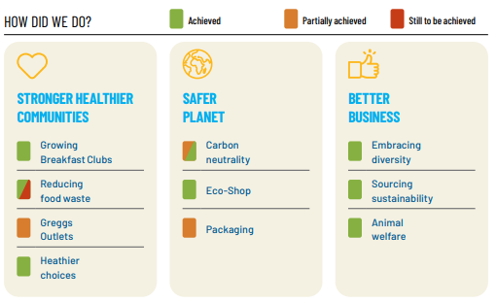  Figure 6: Greggs Plc Net Zero Initiatives  (Source: Greggs, 2023) | Opportunities: Accompanying sustainable and biodegradable packaging initiatives can attract eco-conscious customers.  Threats: Extreme weather actions and climate change may cause susceptible ingredient supply chains and price unpredictability.

2.2 Porter’s Five Forces Analysis
Porter’s Five Forces is a framework which uses four factors to measure competitive dynamics in the industry.
Threat of New Entrants (Low): A major investment in supply chains, branding and entering the UK fast food market. However, new players can compete with Greggs due to economies of scale, strong brand loyalty, and a well-established distribution network. Minor independent bakeries and niche health food brands can still be a challenge on a localised level (Dupin and Filippo Carlo Wezel, 2023). The key threat is developing independent or regional bakeries that offer premium, organic, or speciality products.
Bargaining Power of Suppliers (Low): Greggs is dependent on its key resource suppliers for flour, dairy, and meat. The company has strong supplier relationships and is vertically integrated; hence, it manages costs. Although supplier power increases with rising inflation, supply chain disturbances and Brexit-related import expenses (Dadush, 2023). Through sourcing as locally as possible, Greggs attempts to alleviate threats.
Bargaining Power of Buyers (High): The UK fast food and bakery market has high competition, which is in favour of customers, adding to their bargaining power. By being reasonable, convenient, and continually innovate the menu, Greggs retains its competitive advantage (Greggs Plc, 2025). However, there are substitutes for health-conscious consumers and premium bakery chains.
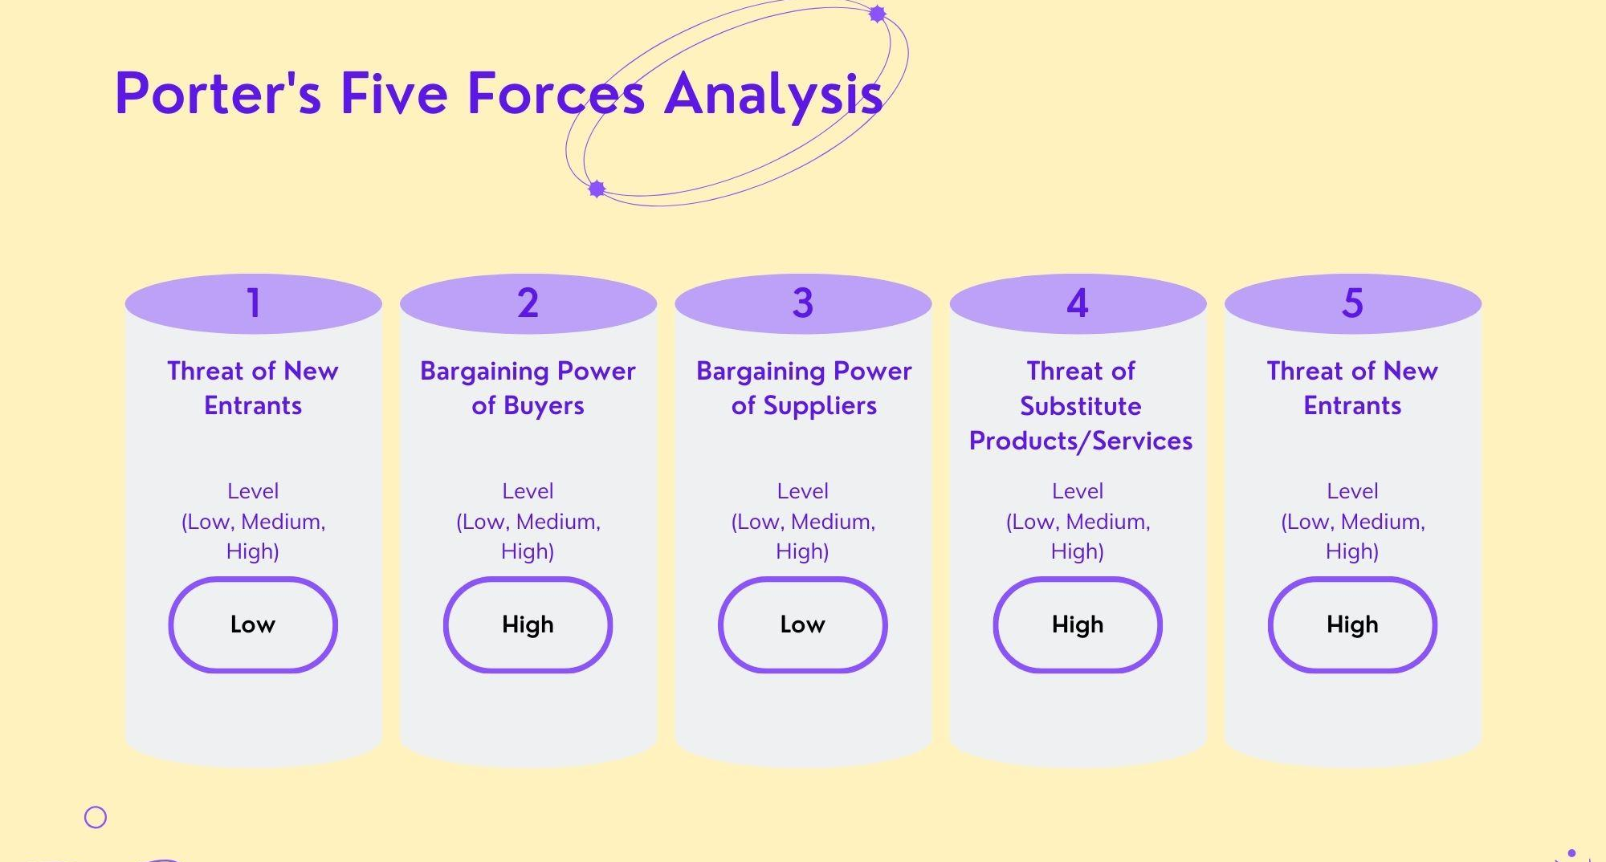
Figure 7: Porter’s Five Forces Analysis
(Source: Self-Developed)
Threat of Substitutes (High): Supermarket ready meals (including the fish), coffee shops and independent bakeries (including the fish) frequently offer fresh, healthier, or artisanal propositions. The cheaper grab-and-go meals are one thing that makes Greggs different to others (Greggs, 2025a). However, the risk still exists as customer preferences transform. Supermarkets and coffee chains growing their fresh food offerings is a key threat.
Industry Rivalry (High): Greggs competes with McDonald’s, Pret A Manger, Costa Coffee, and independent bakeries, making the industry highly competitive (Mintel, 2023). The company’s low-cost, high-volume policy helps maintain a strong market position, but price conflicts and menu innovation drive penetrating competition. The core risk is aggressive pricing and menu diversification from players.

3. Internal Environment Analysis

3.1 SWOT Analysis
SWOT analysis measures Greggs Plc’s strengths, weaknesses, opportunities, and threats to evaluate its market position and strategic direction.
Strengths | Weaknesses
- Greggs has a well-established status inside the UK as a low-priced and convenient bakery chain, leading to high purchaser loyalty.  - The firm has over 2,437 outlets throughout the United Kingdom, it benefits from excessive visibility and accessibility (Statista, 2023).  - The business enterprise’s cost-effective commercial organisation makes it a popular choice for budget-aware customers, particularly at certain stages in monetary downturns. | - Unlike a few competitors, Greggs has a minimal existence outside the UK, proscribing worldwide development opportunities.  - Although there have been recent initiatives to introduce vegan and low-calorie alternatives, Greggs continues to be perceived as a fast-meals brand with high-fat and high-calorie offerings (Smith, 2023).  - The organisation is reliant on the United Kingdom's economic system, making it liable to district economic downturns and market saturation.
Opportunities | Threats
- Greggs has the competence to go into new markets, particularly in Europe, where the call for a low-cost bakery chain is developing.  - The growing call for plant-based and healthier food preferences offers an opportunity for menu diversification (Sharma et al., 2024).  - Improving digital ordering, app-based loyalty programs and delivery partnerships can boost purchaser appreciation and drive income. | - McDonald’s, Pret A Manger, and supermarket bakeries constantly innovate, creating pricing and product challenges (Devlin, 2024).  - Increases in factor prices, labour expenditures, and strength charges ought to impact profitability.  - Government rules on food health necessities and taxation on excessive-sugar merchandise furthermore require product reformulations and enhanced compliance costs.

3.2 Value Chain Analysis
A value chain analysis observes how Greggs Plc creates value through two primary processes of activities that directly impact the provision and sale of products and supporting systems of activities that assist in making the overall process more efficient.
Primary Activities
Inbound Logistics: Centralised supply variation is the source that makes Greggs benefit from ordering ingredients in bulk to keep the cost and quality reliable. The company runs regional bakeries that produce products before delivery of those products to stores to ensure a streamlined production (Goryńska-Goldmann et al., 2020). However, Greggs minimizes disruptions by sustaining good relationships with its suppliers and utilising strategic sourcing.
Operations: Greggs uses a hub-and-spoke production model where the focus bakeries make the food items that are then finalised, brought to the retail outlets, and sold. This approach helped the store alleviate the store difficulty and increase efficiency and maintain the uniformity of product across each location.
Outbound Logistics: Automated logistics and demand forecasting tools support Greggs in reducing waste in stock replenishment and enhancing the stock replenishment function (Kumar et al., 2024). Though fuel price volatility and transportation network disruptions could present risks to maintaining efficiency in the supply chain, these are manageable issues related to item storage, data capture and other supply chain operations challenges.
Marketing & Sales: In using such a strong digital marketing strategy, the firm uses social media, app-based promotions, and limited-time offers to connect with customers. Furthermore, menu innovation, such as the Vegan Sausage Roll, has assisted the brand appeal healthier, and therefore has its value for money proposition (Butler, 2019). Engaging the customer on the company’s loyalty program and mobile app improves customer retention and drives sales.
Services: The convenience of customers is highlighted by Greggs, offering fast service, self-service solutions, and delivery partnership with Just Eat. Maintaining the same service quality for all the locations is a challenge to carry out throughout expansion, and this can be done through investment in staff training and operational competence.
Support Activities
Firm Infrastructure: Greggs is a financially strong company that reinvests in stores, digital transformation, and sustainability. The company has put in place corporate governance policies aimed at ethical business conduct and constancy of long-term stakeholder trust. However, the company was unable to maintain growth and profitability due to economic fluctuations and rising operating costs.
HR Management: Greggs has a good work culture with good compensation, training programs and benefits for staff to enhance job satisfaction and retention (Greggs, 2023a). It has become more committed to workforce development for the operational productivity of the company. However, the firm has difficulty in recruiting and retaining skilled employees, which is specified by the high turnover in a high turnover industry such as fast food.
Technology Development: Become a part of digital transformation. Greggs has invested in AI-driven demand forecasting, mobile ordering and click and collect to offer its customers a better experience at a lower cost (Greggs, 2025c). Customer engagement and loyalty are significantly intensified by the Greggs app.
Procurement: Greggs is focused on cost-effective and sustainable sourcing, which means they are focusing on sourcing elements from ethical suppliers. To win the consumer's favour based on responsible business practice, the company invests in the procurement of fair-trade certified coffee and sustainable ingredients. Furthermore, there is a concern about the raw material costs that fluctuate and supply chain indecisions remain complications that need to be managed proactively.

4. Strategic Recommendations
Expanding Product Choices: Greggs should consider adding more possibilities to its menu to meet changing customer tastes, particularly when it comes to healthier and plant-based foods. Offering a broader range of high-protein, low-calorie, and gluten-free items could help attract more customers (Gasparre et al., 2022). It might be exciting to introduce seasonal items or special limited-time offers to keep things fresh and encourage individuals to come back.
Embrace Digital Trends: Investing in digital tools can improve customer experiences and boost sales. Expanding the Greggs app with more features, personalising promotions using customer data, and improving mobile ordering and delivery services could help build loyalty (Manko, 2022). Being more active on food delivery apps and improving click-and-collect options could attract new customers and increase online orders.
Streamlining Supply Chains: Greggs might want to reinforce its supply chain by observing different suppliers and sourcing more locally to handle challenges like rising costs and trade issues. Focusing on sustainability using eco-friendly packaging and cutting down food waste with smart forecasting can boost both efficiency and brand image (Onyeaka et al., 2023). Moreover, using renewable energy at stores and bakeries would show a commitment to the environment.
Expanding Markets: Greggs should consider about moving into new areas within the UK, particularly places like transport hubs and busy suburban spots. There might also be chances to expand globally in markets where affordable baked goods are in demand. Teaming up with local partners or considering franchising might help make entering new areas smoother (Alon, Apriliyanti and Parodi, 2020).
Invest in Staff and Operations: To keep up quality as they develop Greggs needs to keep investing in employee training and keep staff pleased. Offering good pay, opportunities for growth, and an emphasis on well-being can help keep spirits high and reduce turnover (Soren and Ryff, 2023). Putting consideration on automation, like self-service kiosks and smoother kitchen procedures, will also support growth and constancy.

5. Conclusion
Greggs Plc has become a market leader in the UK fast-food and bakery industry, owing to strategic innovation, brand loyalty, and an operative supply chain. However, to maintain long-term growth and resilience, the business has to be agile and adjust to evolving consumer tastes, economic changes, and competition in the industry. By diversifying its product portfolio, growing digital interaction, and streamlining supply chain sustainability, Greggs can combine its market position. Strategic expansion into new geographic regions and overseas markets will open up new revenue streams. Furthermore, investing in staff development and operational effectiveness will ensure service superiority.
Although existing difficulties like increasing expenditures and a shortage of employees continue to disturb Greggs, its robust base and customer-driven strategy give it a competitive edge. By placing these strategic recommendations into practice, the organisation can accomplish sustainable growth while continuing to be a market leader in fast food.

Reference List
Alon, I., Apriliyanti, I.D. and Parodi, M.C.H. (2020) ‘A Systematic Review of International Franchising’, Multinational Business Review, 29(1), pp. 43–69. Available at: https://doi.org/10.1108/MBR-01-2020-0019.
Armstrong, M. (2021) Infographic: Brexit transition contributes to record drop in EU trade, Statista Infographics. Available at: https://www.statista.com/chart/24402/change-in-uk-trade-eu-non-eu/. (Accessed 26th March 2025).
Butler, S. (2019) Success of vegan sausage roll gives Greggs surge in sales, the Guardian. The Guardian. Available at: https://www.theguardian.com/business/2019/feb/19/success-of-vegan-sausage-roll-gives-greggs-surge-in-sales. (Accessed 26th March 2025).
Dadush, U. (2023) ‘The policy response to global value chain disruption’, Global Policy, 14(3). Available at: https://doi.org/10.1111/1758-5899.13220.
Devlin, E. (2024) Media Bites 6 February: McDonald’s, junk food, Asda, The Grocer. Available at: https://www.thegrocer.co.uk/news/media-bites-6-february-mcdonalds-junk-food-asda/687906.article. (Accessed 26th March 2025).
Dupin, L. and Filippo Carlo Wezel (2023) ‘Artisanal or Just Half-Baked: Competing Collective Identities and Location Choice Among French Bakeries’, Administrative Science Quarterly, 68(3), pp. 867–909. Available at: https://doi.org/10.1177/00018392231179631.
Gasparre, N., Pasqualone, A., Mefleh, M. and Boukid, F., (2022). ‘Nutritional quality of gluten-free bakery products labeled ketogenic and/or low-carb sold in the global market’. Foods, 11(24), p.4095. Available at: https://doi.org/10.3390/foods11244095.
Goryńska-Goldmann, E., Gazdecki, M., Rejman, K., Kobus-Cisowska, J., Łaba, S. and Łaba, R., (2020). ‘How to prevent bread losses in the baking and confectionery industry?—measurement, causes, management and prevention’. Agriculture, 11(1), p.19. Available at: https://doi.org/10.3390/agriculture11010019.
Greggs (2023) THE GREGGS PLEDGE TO DO MORE GOOD Sustainability Report 2023. Available at: https://a.storyblok.com/f/162306/x/3d6a84d1e5/the-greggs-pledge-2023-annual-sustainability-report.pdf. (Accessed 26th March 2025).
Greggs (2023a) Greggs Corporate | Better business, corporate.greggs.co.uk. Available at: https://corporate.greggs.co.uk/doing-good/better-business. (Accessed 26th March 2025).
Greggs (2025) Greggs | About us, @GreggsOfficial. Available at: https://www.greggs.com/about. (Accessed 26th March 2025).
Greggs (2025a) Grab yourself a tasty deal, @GreggsOfficial. Available at: https://www.greggs.com/news/grab-yourself-a-tasty-deal. (Accessed 26th March 2025).
Greggs (2025c) How AI Optimizes Market Analysis, Jollibee Menu Price. Available at: https://greggsmenuprice.co.uk/how-ai-optimizes-market-analysis/. (Accessed 26th March 2025).
Greggs Plc (2025) Greggs Corporate | Our strategy, corporate.greggs.co.uk. Greggs. Available at: https://corporate.greggs.co.uk/about-us/our-strategy. (Accessed 26th March 2025).
Jones, L. (2020) ‘Veganism: Why is it on the up?’, BBC News, 18 June. Available at: https://www.bbc.com/news/business-44488051. (Accessed 26th March 2025).
Kumar, I., Rawat, J., Mohd, N. and Husain, S., (2021). ‘Opportunities of artificial intelligence and machine learning in the food industry.’ Journal of Food Quality, 2021(1), p.4535567. Available at: https://doi.org/10.1155/2021/4535567.
Kumar, P., Choubey, D., Amosu, O.R. and Ogunsuji, Y.M., (2024). ‘AI-enhanced inventory and demand forecasting: Using AI to optimize inventory management and predict customer demand’, World Journal of Advanced Research and Reviews, 23(1), pp. 1931–1944. Available at: https://doi.org/10.30574/wjarr.2024.23.1.2173.
Manko, B.A. (2022) ‘How digital marketing can use a smart phone app to improve any business’s bottom line’, Journal of Information Technology Teaching Cases, 12(2), p. 204388692210756. Available at: https://doi.org/10.1177/20438869221075638.
Mintel (2023) UK Coffee Shops Market Report 2022 | Mintel.com, store.mintel.com. Available at: https://store.mintel.com/report/uk-coffee-shops-market-report.
Onyeaka, H., Tamasiga, P., Nwauzoma, U.M., Miri, T., Juliet, U.C., Nwaiwu, O. and Akinsemolu, A.A., (2023). ‘Using artificial intelligence to tackle food waste and enhance the circular economy: Maximising resource efficiency and minimising environmental impact: A review’. Sustainability, 15(13), p.10482. Available at: https://doi.org/10.3390/su151310482.
Sharma, N., Yeasmen, N., Dube, L. and Orsat, V., (2024). ‘Rise of plant-based beverages: a consumer-driven perspective’. Food Reviews International, 40(10), pp.3315-3341. Available at: https://doi.org/10.1080/87559129.2024.2351920.
Shen, C., Wei, M. and Sheng, Y. (2021) ‘A bibliometric analysis of food safety governance research from 1999 to 2019’, Food Science & Nutrition, 9(4), pp. 2316–2334. Available at: https://doi.org/10.1002/fsn3.2220.
Smith, R. (2023) ‘How a Super Affordable Bakery Chain Became a British Culinary Icon’, The New York Times, 30 December. Available at: https://www.nytimes.com/2023/12/30/world/europe/uk-greggs-fenwick.html. (Accessed 26th March 2025).
Soon, J. and Baines, R. (2013) ‘Public and Private Food Safety Standards: Facilitating or Frustrating Fresh Produce Growers?’, Laws, 2(1), pp. 1–19. Available at: https://doi.org/10.3390/laws2010001.
Soren, A. and Ryff, C.D. (2023) ‘Meaningful Work, Well-Being, and Health: Enacting a Eudaimonic Vision’, International Journal of Environmental Research and Public Health, 20(16), p. 6570. Available at: https://doi.org/10.3390/ijerph20166570.
Statista (2023) Greggs number of outlets 2006-2018 statistic | Statista, Statista. Statista. Available at: https://www.statista.com/statistics/631011/greggs-number-of-outlets-united-kingdom-uk/. (Accessed 26th March 2025).
Wolf, M. (2022) ‘The future of the UK economy is uncertain’, Financial Times, 3 April. Available at: https://www.ft.com/content/759cf7bf-fa10-4490-a274-db1b0a89ee7b.

