Name: Adriana Daciana Petran

Student number: 2210809

Institution and department name: Academic Discipline of Hospitality & Tourism Management
BA International Hotel Management

Project supervisor name: Christopher Wilkin

Module:
Hotel Placement Research Project

Module code:
BMIH6008

Assignment Title:

Hotel Research Project
Analysing the Impact of Health and Safety Standards on consumer Satisfaction in the hospitality industry: A Case Study of Premier Inn Southampton (Cumberland Place)

Date:12.06.2025

AI Declaration:
I confirm that I have not used any kind of Artificial Intelligence (AI) in my work to generate or even write this content. All work that this research project contains is of my own independent research, analysis and critical thinking, made in accordance with the relevant academic integrity guidelines.

Acknowledgement:
I would like to take a moment and thank my supervisor who has guided me and gave valuable feedback to improve my work. Without this support, I would have not been able to finish this work. Furthermore, I am highly grateful to my friends and family who have shown immense support to me. Thanks to everyone along with the placement hotel who made me believe in myself.

Abstract
The project has stated the significance and impact of health and safety standards like hygiene, maintenance cleanliness and employee responsiveness on customer satisfaction within the hospitality industry. Considering Premier Inn Southampton (Cumberland Place) has faced several negative online feedbacks on pest infestations, unclean rooms and staff delaying to respond, the study aims to evaluate how these health and safety issues impact guest perceptions, repeat business and loyalty in the budget hotel sector. Grounded on theories like the SERVQUAL model, Expectancy-Disconfirmation Theory, and Maslow’s Hierarchy of Needs, this study would analyse customer expectations, service gaps and motivational factors and the ways it impacts staff performance and guest satisfaction. The literature review has stated that hygiene is an important driver of perceived service quality and an eminent factor in gaining customer trust. However, poor service and hygiene standards remain quite under-researched in the context of budget hotels. Employing a mixed-method data collection method here, primary data was collected from guest surveys whereas secondary data was collected from guest reviews found online like TripAdvisor. The findings have stated a strong correlation between customer dissatisfaction and poor hygiene practices. Even the survey findings complemented this information and found that over 50% of the survey respondents rated the cleanliness of this hotel to be poor while many even cited delayed housekeeping responses, unprofessional staff behaviour and inadequate maintenance as major issues. Open-ended feedback has showcased the need for better employee training and robust cleaning protocols to be maintained across the property. The survey has also shown that 45% of the guests were dissatisfied with their sanitation and hygiene practices and urgently wanted them to work on this. Furthermore, communal areas were also found to be highly unhygienic. Guests expressed frustration at the slow response of the staff and that made them complain. Many even felt that their expectations were not met and recommended stricter hygiene procedures to be followed to improve their service quality.
Based on the response of the findings gathered, the research has proposed some recommendations for the hotel to improve their performance like implementing structured and robust housekeeping audits, fostering compulsory health and safety training for all employees, implementing a real-time digital feedback or complaint resolution system, forming a partnership with reliable pest control providers and enhancing communication among all departments. These would perhaps help them along their practices with leading hotel chains like Hilton and Marriott and make them even more cost-effective and realistic in the scope of a budget hotel.
Therefore, the research has confirmed that even for budget hotels, one of the foremost things that guests expect is prompt service and consistent hygiene throughout their stay. In this account, the research has stated how health and safety are not just optional luxuries but mandatory standards that affect guest loyalty, online reputation and business growth directly. This project has not just identified critical service delivery gaps within this hotel but has also offered strategic solutions to help them restore their competitiveness and operational quality in the hospitality industry.

Table of Contents
Chapter 1 Introduction 7
1.1 Background 7
1.2 Overview of the case study 7
1.3 Introduction of the hotel brand (location) 8
1.4 Key theme or topic to be discussed 9
1.5 Research Aims, Objectives, and Qustions 9
Chapter 2 Literature Review 11
2.1 Theme 1: The impacts of hygiene on the satisfaction of customers 11
2.2 Theme 2: The quality of services within budget hotels 12
2.3 Theme 3: The link between the retention of guests with the improvement of service quality 14
2.4 Theme 4: The strategic approaches to enhance customer services within budget hotels 15
2.5 Theoretical underpinning 16
2.6 iterature Gap 17
Chapter 3 Methods 18
3.1 Research Philosophy 18
3.2 Methodological Framework 18
3.3 Research Design 18
3.4 Data Collection Method 18
3.5 Sample Size 19
3.6 Sampling Methodology 19
3.7 Data Analysis Methods 19
3.8 Research Gap 19
3.9 Ethical Implications 20
Chapter 4 Findings and Discussion: 21
4.1 Findings 21
4.1.1 Primary 21
4.1.2 Secondary 25
Theme 1: Complaints about the cleanliness and maintenance in the Premier Inn Southampton 25
Theme 2: Inconsistencies in the behaviour of staff and their responsiveness within Premier Inn 28
Theme 3: Feedback of customers and trends of retention for Premier Inn 30
4.2 Discussion 31
4.2.1 The influence of maintenance on the satisfaction of customers 31
4.2.2 The quality of services and their roles to shape the loyalty of customers 32
4.2.3 The quality of hygiene standards as the potential driver for guest retention 32
4.2.4 Feedback informed by guests on best practices of the industry 33
4.3 Addressing the research question and objectives 34
4.4 Implications of the findings 34
4.5 Limitations of the research 35
Chapter 5 Conclusion and Recommendations 36
5.1 Conclusion 36
5.2 Recommendations and Practical Strategies 38
References 42

Chapter 1 Introduction

1.1 Background
Health and safety concerns like poor cleanliness, maintenance issues and unsanitary conditions directly affect guest experiences, leading to dissatisfaction and negative reviews (Singgalen, 2024). At Premier Inn Southampton (Cumberland Place), there have been various negative reviews where clients complained of their unclean rooms with mites and bed bugs, thus showcasing serious lapses in hygiene and cleanliness (TripAdvisor, 2025). Poor sanitation leads to reputational damage and guest dissatisfaction (Umukoro and Owumi, 2025). With cleanliness being ranked as the top priority for over 97% of hotel guests, this showcases how even the slightest breaches in health and safety can affect customer experience and business growth (TheCaterer, 2023).

1.2 Overview of the case study
This case study will examine the impact of safety and health failures on customer satisfaction at the upscale hotel, Premier Inn Southampton (Cumberland Place). Despite having a strategic location and quite positive staff interactions, they have still got mixed reactions to their issues like poor room hygiene and bug infestations. Even one complained of how they complained to the reception about an uncleaned room but despite waiting for half an hour, none came (TripAdvisor, 2025). This undermines their reputation and reflects gaps. The study aims to assess how these standards impact positive user experiences by using real customer feedback to explore the wider implications for the service quality of the hospitality industry.
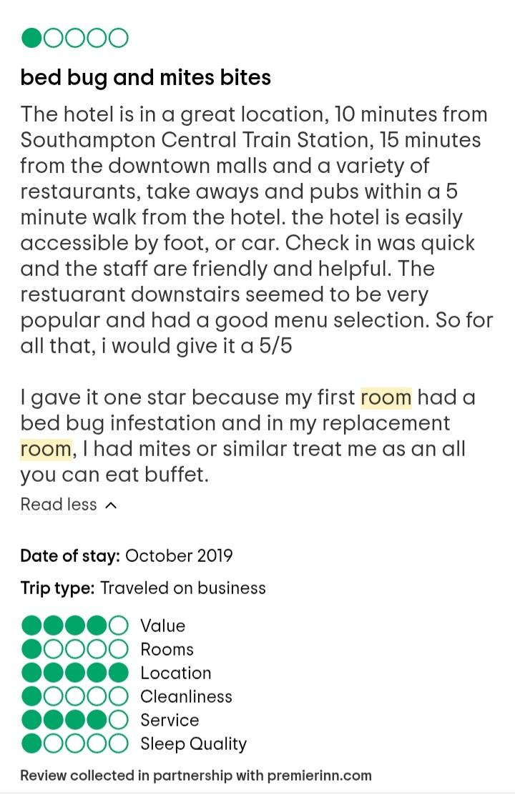
Figure 1: Negative review
(Source: TripAdvisor, 2025)

1.3 Introduction of the hotel brand (location)
Premier Inn is the largest and most trusted budget hotel chain known for offering 800 comfortable yet affordable accommodations in various locations in the UK and beyond (Premier, 2025). The Premier Inn Southampton (Cumberland Place) is located centrally, only 10 minutes away from Southampton Central Train Station and within walking distance from major restaurants, nightlife, etc (PremierInn, 2025). Despite catering to leisure or business travellers, it has been criticised for its poor hygiene and cleanliness standards, raising concerns about its adherence to health and safety regulations.
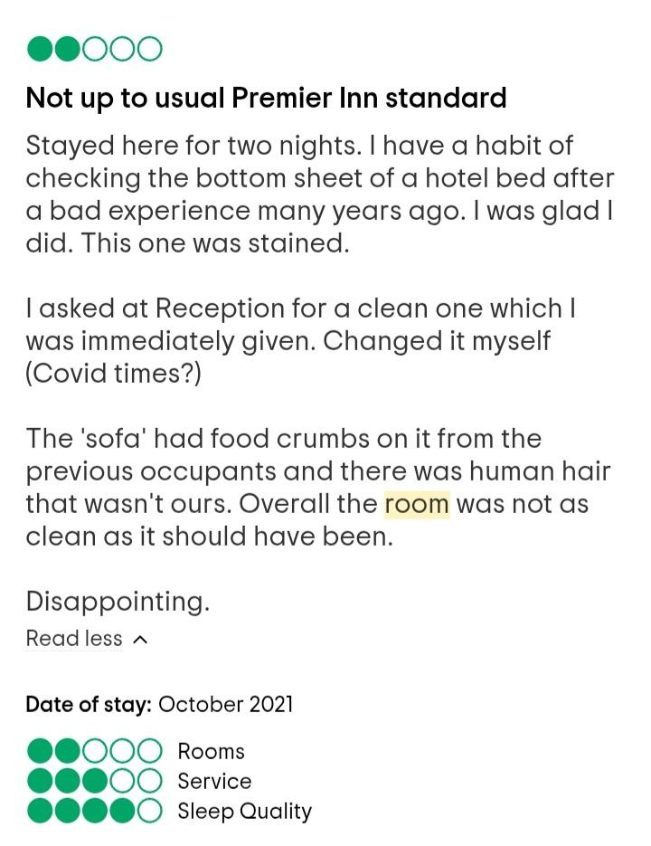
Figure 2: Negative client feedback
(Source: TripAdvisor, 2025)

1.4 Key theme or topic to be discussed
The main theme of this research is to analyse the role of health and safety standards in influencing customer satisfaction within the hospitality industry by focusing on Premier Inn Southampton (Cumberland Place). As cleanliness is an ethical and legal obligation in accommodation services and not just luxury, failure to meet these relevant health standards damages brand reputation, reduced bookings and even legal battles also (Pereira et al. 2021). This case study argues that complying with high hygiene standards is extremely essential to enhance customer trust and satisfaction.

1.5 Research Aims, Objectives, and Qustions
Aim:
It aims to critically evaluate how health and safety standards impact consumer satisfaction in Premier Inn Southampton, (Cumberland Place).
Research Question
1. How do hygiene standards impact customer satisfaction?
2. What is the relationship between service quality like staff interaction, health and safety concerns on customer loyalty?
3. To what extent do hygiene and service quality improvements influence repeat visits and customer retention?
4. What are some improvements that may be integrated to improve hygiene and customer satisfaction?
Objectives
1. To evaluate the impact of hygiene issues on customer satisfaction
2. To examine the direct relationship between hygiene and safety and staff interaction with customer loyalty at this hotel
3. To assess the extent to which improvements in hygiene and service quality can influence repeat visits and customer retention at this hotel
4. To recommend some actionable improvement strategies to improve health hygiene and customer service.

Chapter 2 Literature Review

2.1 Theme 1: The impacts of hygiene on the satisfaction of customers
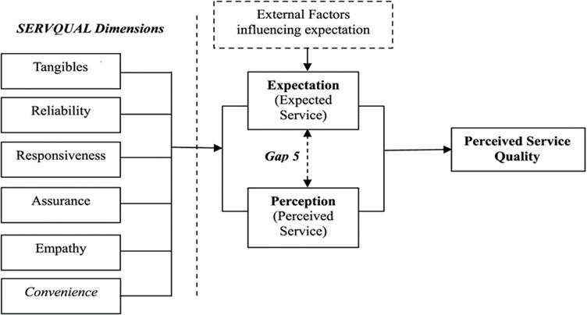
Figure 3: SERVQUAL model
(Source: AlOmari, 2021)
Cleanliness and hygiene are considered as the drivers of customer satisfaction in the hotel industry. As per the views of Hossain (2023), maintaining high levels of hygiene is therefore important for compliance with regulations and maximising the overall guest experience. Ensuring clean rooms and sanitary public areas impacts directly on guests' quality. Based on the SERVQUAL model, tangibles include physical facilities and appearance. As per the views of Sumi and Kabir (2021), these are one of the five parameters influencing perceptions of service quality. When these tangibles are neglected, the service can be lessened to counter the negative impressions generated. As per the views of Yang et al. (2024), guests often cite cleanliness failures as a major source of dissatisfaction. Cleanliness complaints have a disproportionate effect on aggregate ratings of businesses. However, Singh et al. (2023) stated that, while cleanliness is essential towards customer satisfaction, it may be insufficient to ensure loyalty without factors such as service or comfort. This suggests a potential weakness in using gains in hygiene as a strategy towards customer retention. As per the opinion of Islam et al. (2022), the application of the SERVQUAL model is rigid in the context of low-cost accommodation within the hospitality sector. However, customers at budget hotels also expect basic standards of hygiene to be maintained consistently. Hence, hygiene and cleanliness are important principles of guest satisfaction within the hospitality sector. As per the views of Anderson (2025), although these aspects are fundamental for positive guest experiences, they need to be integrated with aspects of service quality to promote repeat visits.

2.2 Theme 2: The quality of services within budget hotels
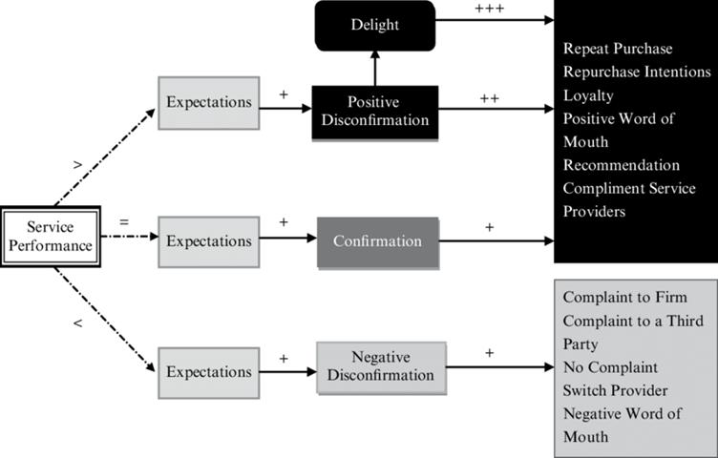
Figure 4: Expectancy-Disconfirmation Theory
(Source: Chen et al. 2022)
In the hospitality sector service quality is considered an important component that impacts guest satisfaction and loyalty. As per the views of Paulose and Shakeel (2022), the quality of personal service tends to make a significant impact on the guest experience. Moreover, visible health and safety measures can make a prominent impact on customer behaviour towards competence. An appropriate theoretical framework for the analysis of the aspect is the Expectancy-Disconfirmation Theory. As per the views of Lee et al. (2022), this theory underscores that customer satisfaction depends on the gap between the expected experience before a visit and the experienced service. If service delivery exceeds customer expectations, they will likely have a higher chance of repeat visits. On the other hand, Park et al. (2023) stated that customer-staff interaction that marked dismissal can alleviate dissatisfaction due to adverse emotional reactions. While budget hotels tend to suffer from limitations in terms of understaffing, poor service is not excusable through lower prices (Wood, 2024). As per the views of Mejia et al. (2021), customers expect employees in budget accommodations to be knowledgeable about health-related issues. Failure of an employee to respond appropriately on such matters not only undermines confidence in the safety culture of the organisation. As per the views of Aggarwal et al. (2024), customers are likely to attribute poor employee behaviour to organisational failure rather than individual failure. However, GURKAN et al. (2025) stated that EDT is limited to low-expectancy situations where guests' expectations are low. Considering these situations, casual service can result in positive disconfirmation, which caters to systemic service quality flaws. As per the views of Adil et al. (2022), consistency is important for businesses considering one malfunction to negate several experiences due to service failure.

2.3 Theme 3: The link between the retention of guests with the improvement of service quality
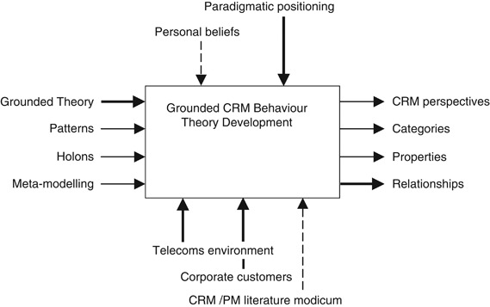
Figure 5: Customer Relationship Management Theory
(Source: Khan et al. 2022)
Repeat business of guests within the hospitality industry is one of the important measures for their profitability. As per the views of Zahra et al. (2023), considering a wide range of factors that play a significant role in repeat business, service standards are the main determinants. Maintenance and service attention create an impression of dependability, which is the importance of guest incentive to re-book. As per the views of Ledro et al. (2022), Customer Relationship Management theory is a useful framework for understanding how service improvements lead to customer retention. CRM is the systematic development of long-term beneficial relationships with customers to exceed their expectations through personalised services. From this perspective, all interactions are considered as the touchpoints that can reinforce the emotional and psychological relationship with the customer. However, Salamah et al. (2022) stated that, although service quality is critical to satisfaction, their contribution to retention is directly related. Development in these areas could meet minimum expectations but are not necessarily translated into loyalty. Most guests regard hygiene as an expectation as its presence will not be valued. In a similar vein, service development is enough to lead to retention unless underpinned by factors like value recognition. Moreover, Zhang et al. (2023) stated that in highly competitive environments, customer retention is the presence of alternative choices. While service standards may be enhanced, customers may choose alternative providers based on convenience. Hence, Yu et al. (2021) stated that this means that hygiene and service matter in customer retention but are not independent.

2.4 Theme 4: The strategic approaches to enhance customer services within budget hotels
Improving customer service in budget hotels involves a prominent effort that transcends reactive maintenance. As per the views of Danforth et al. (2023), successful strategies start with prominent hygiene guidelines and quality monitoring systems in service delivery. Within budget hotels, the issue is to maintain high standards. Therefore, strategies need to be cost-effective with an emphasis on guest-facing improvements. As per the views of Zurita (2025), a key issue in most budget accommodations is overreliance on minimum compliance. This caters to minimum standard service that is prominent to cope with operational demands. Moreover, Yang et al. (2024) stated that most hotels pay attention to physical cleanliness, such as the responsiveness of the staff. As per the views of Muhsen et al. (2023), another shortcoming in strategy implementation is inconsistency due to high staff turnover. Therefore, Tu and Wu (2021) stated that the strategies need to be effective from all levels of the organisation.

2.5 Theoretical underpinning
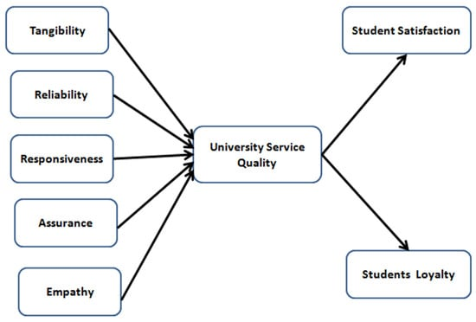
Figure 6: SERVQUAL model
(Source: Jonkisz et al. 2022)
This research is based on a multi-theoretical foundation to comprehensively underscore the impacts of hygiene and service quality on customer satisfaction within the hospitality sector. These theories tend to add a distinct approach to significant elements of the guest experience to enable an informative examination of the research. The SERVQUAL model provides a prominent understanding of service quality. As per the views of Sharma et al. (2024), the model is particularly useful for the application in the evaluation of the physical environment that has a direct influence on customer satisfaction. To cater to the psychological process of customer judgments, the Expectancy-Disconfirmation Theory was employed. This theory posits that satisfaction arises from the discrepancy between anticipated and experienced service. As per the views of Ramasamy et al. (2024), this theory is critical in describing how deviations from expected safety standards can lead to satisfaction or dissatisfaction.

2.6 iterature Gap
It was observed that the majority of existing research concentrates on luxury hotels, with budget accommodation procuring relatively less focus. Most of the existing research generalises customer expectations by ignoring the unique operating constraints prevalent in budget hotels. Hygiene and safety concerns are also typically provided less importance compared to overall service factors. As per the views of Fatima and Elbanna (2023), there is a prominent lack of in-depth research analysing hygiene standards and safety measures as interdependent variables for guest satisfaction in budget hotels. Therefore, this research attempts to bridge the gaps by providing a focused analysis of these parameters both in the context of budget hotels and their standalone contribution to both practical and theoretical contributions.

Chapter 3 Methods

3.1 Research Philosophy
The research employed a positivist research philosophy. This philosophy lays its foundation on the argument that reality is independent of human observation (Maretha, 2023). Positivism is appropriate for this research since its aim is to test the relationship between service quality and customer satisfaction. Through the collection of customer comments, this research aimed to collect data that justifies generalisable conclusions. The employment of data in a positivist dynamic enables the use of interpretation that enhances the reliability of the results (Ali, 2024).

3.2 Methodological Framework
The research adopted a deductive approach in which established theories of service quality will be used to guide the formulation of research questions. Deductive reasoning enables testing of hypotheses on the impact of the research (Casula et al. 2021). In consideration of the hospitality management fields, the approach is valid for established theoretical concepts.

3.3 Research Design
The research has utilised a mixed-methods approach that will align both quantitative and qualitative data. The primary information was collected by conducting surveys, while secondary data was obtained through qualitative assessments. The mixed research design provides a process of comparing data from different sources (Sharma et al. 2023). The use of this approach caters to the validity of the research by aligning the statistical patterns from real customer experiences.

3.4 Data Collection Method
Primary Data Collection:
For this research, Surveys will be developed to measure the behaviour of customers on their overall satisfaction. This will be measured through the use of Likert-scale questions to gather information. The surveys will be sent to the guests through social media to gain access to a wide population. The main objective of the research was to measure how customers feel about different aspects of their experience that influence their loyalty.
Secondary Data Gathering: Review Analysis and Industry Reports
Secondary data will consist of customer reviews which will help in providing guest reviews of safety measures. The secondary analysis uses academic publications to analyse the findings within the industry trends (Dale et al. 2025). The official website of the hotel was analysed to understand how service standards are promoted. These sources were used to identify emerging themes to help in the interpretation of findings.

3.5 Sample Size
To make the survey manageable, a target sample size of 20 responses was established so that the data was significant without being unrealistic. The sample size provided was adequate for pattern identification and categorisation by customer segment.

3.6 Sampling Methodology
The study used purposive sampling to collect the data. Moreover, the controls were aligned to include a combination of respondents to ensure maximum representativeness. Moreover, purposive sampling was utilised for secondary data by focusing on reviews to ensure relevance to the study's purpose.

3.7 Data Analysis Methods
Quantitative information obtained from the surveys is segmented to analysis through descriptive statistical methods that include correlation analysis. This has helped the research to identify relationships between variables. Moreover, qualitative responses were analysed using thematic analysis. This analysis follows significant sentiments that are classified manually (Barun and Clarke, 2023). This methodology facilitates detailed insights to foster a comprehensive discussion of the results.

3.8 Research Gap
Within the context of the research, there has been less focus on budget hotels. Moreover, existing research analyses customer service determinants without regard for the interlinked determinants. There was also limited research that asserts customer reviews and systematic survey data to facilitate a holistic analysis of service quality determinants. This research addresses the shortcomings by focusing on budget hotel businesses and analysing tangible elements of the guest experience.

3.9 Ethical Implications
Ethical compliance was ensured at each aspect phase of the research. All the participants in the survey will be informed of the purpose of the research by providing informed consent. The respondents will be allowed to withdraw at any stage without any penalty. Confidentiality was ensured by avoiding the collection of personally identifiable information.

Chapter 4 Findings and Discussion:

4.1 Findings

4.1.1 Primary
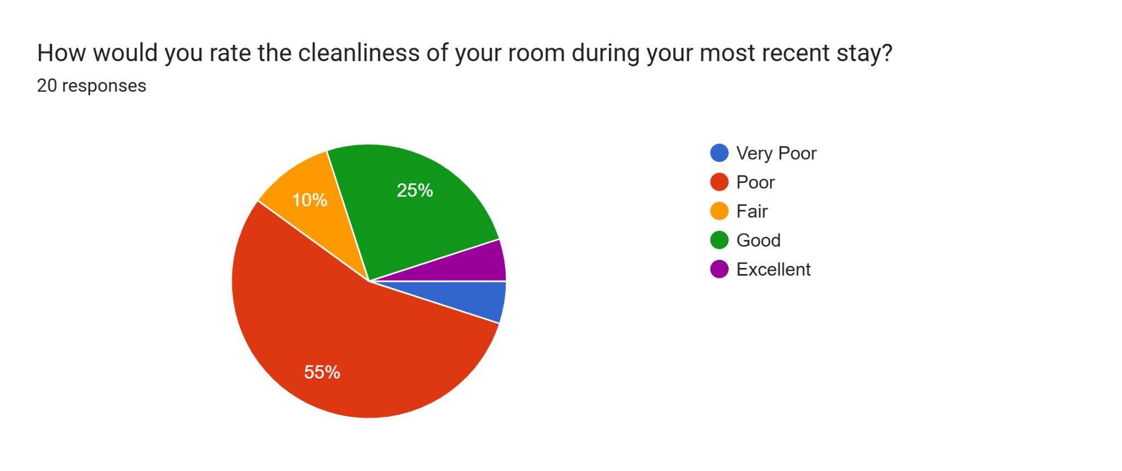
Figure 7: Ratings on cleanliness
From the survey, it was found that most of the customers, more than half of the guests (55%), rated the hotel’s cleanliness as poor, and 5% considered it very poor. On the other hand, 25% believed that cleanliness was good and 10% deemed it fair, in terms of cleanliness. It indicates that more than half of the guests are dissatisfied with the hotel's cleanliness standards. This means below average perception of guests towards Premier Inn at Southampton, resonating a strong area of improvement.
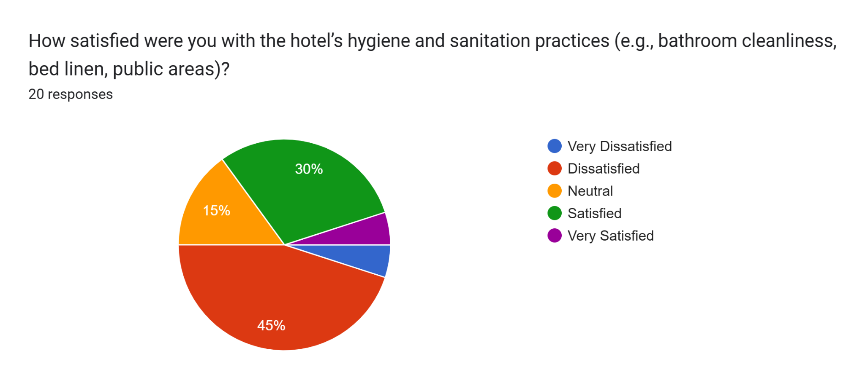
Figure 8: Customer satisfaction level
Drawing upon the satisfaction level, 45% of guests were dissatisfied, and 5% were very dissatisfied with the hotel's hygiene and sanitation process. Only 30% were satisfied, while 15% of guests stayed neutral. It can be inferred that many customers expressed degraded satisfaction with the hygiene level, indicating below below-average satisfaction rate. This advocates the need to reinforce a strong policy and demonstrate more efforts to maintain customer satisfaction.
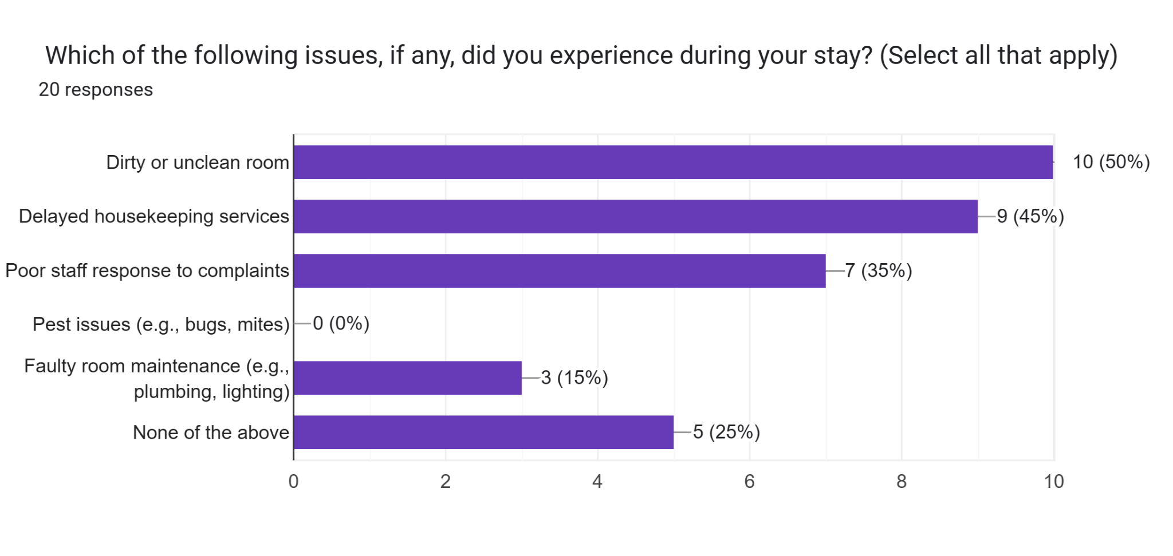
Figure 9: Customer experiences
In terms of issues faced by guests in their stay at the hotel, it was found that 50% of the guests had issues with unclean and dirty rooms. The next major issues faced by guests were delayed housekeeping services, accounting for 45%. It was found that poor staff responses contributed to one of the critical issues faced by 35% of the guests in the hotel. Similarly, faulty room and a lack of maintenance, such as lights and plumbing areas, were considered to be issues faced by 15% of customers. Surprisingly, 25% of the customers did not choose any of the issues, which might indicate their satisfaction level with the Premier Inn.
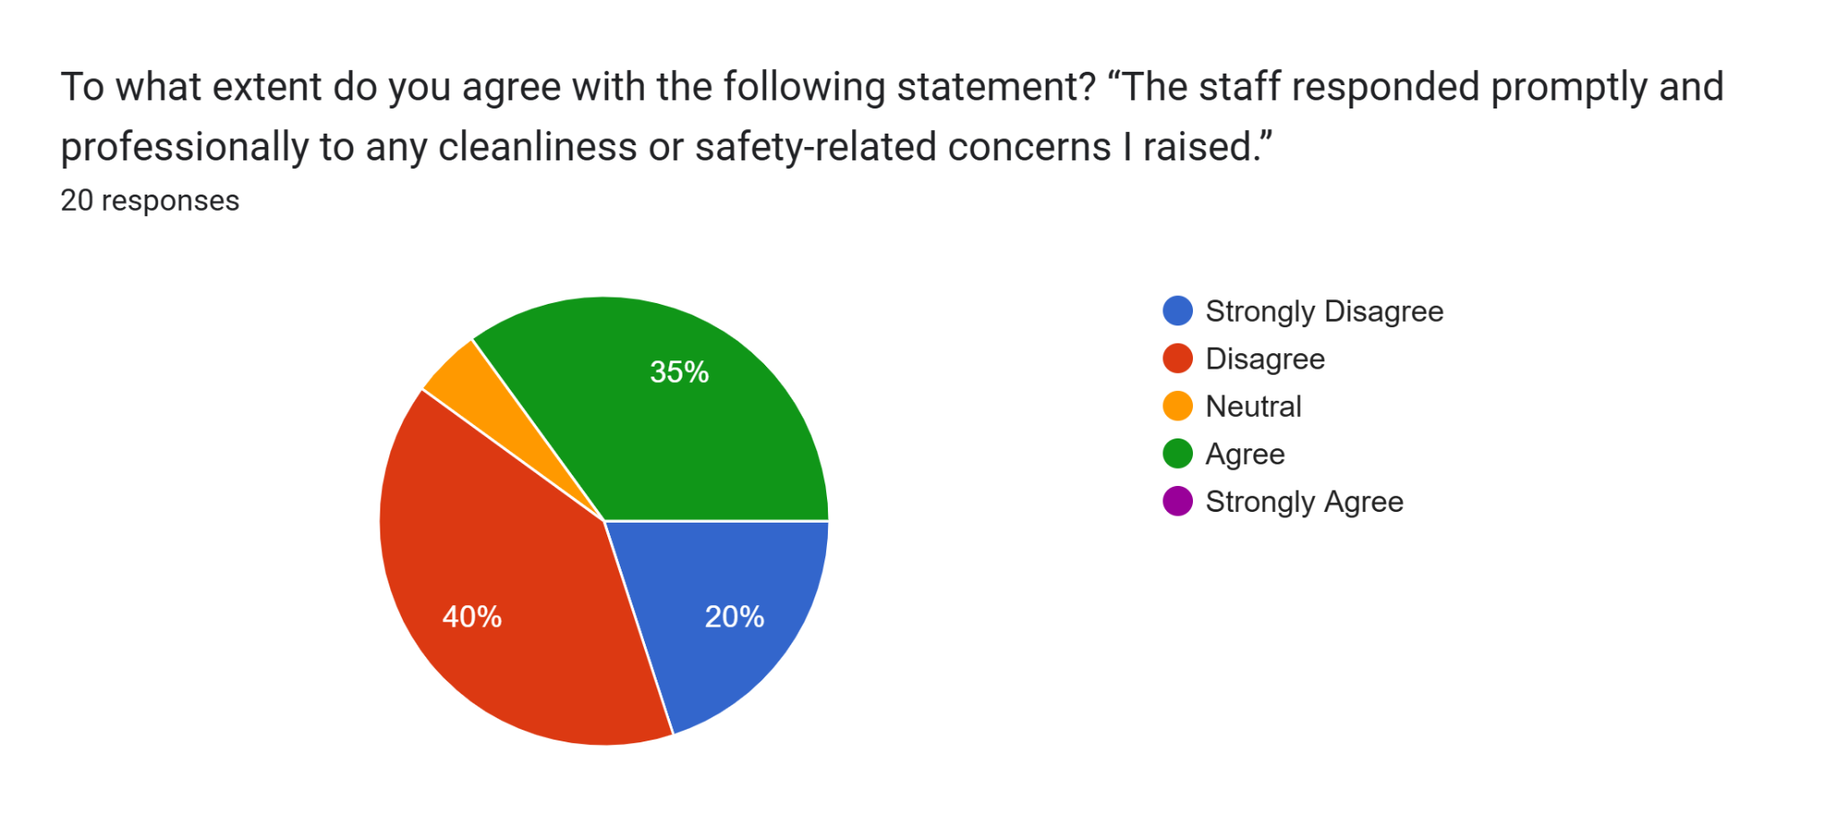
Figure 10: Staff response
When asked about the staff's response to concerns raised by guests at the Premier Inn hotel. It was found that 40% of the customers disagreed collectively, 60% of the guests did not feel that the staff professionally responded to their concerns. Only 35% of the guests agreed, while no guests strongly agreed. This strongly indicates a poor response rate and low confidence of staff in managing guest concerns or requests. This critically confirms gaps in services within Premier Inn, which require urgent redressing.
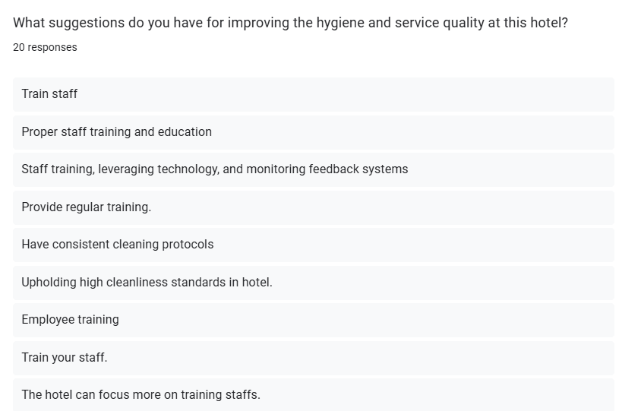
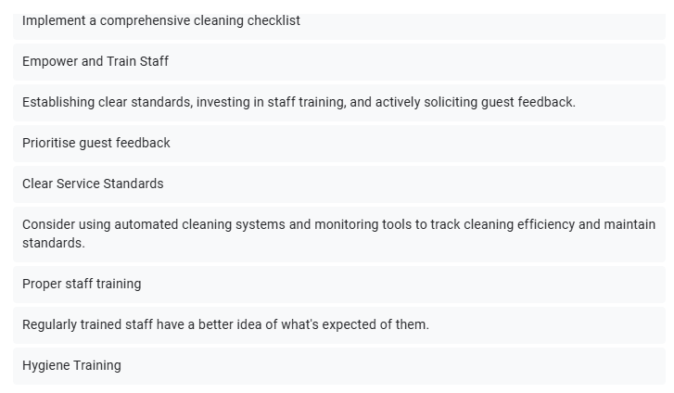
Figure 11: Guest suggestions
In the survey, open-ended questions were also asked of the guests. One of the common suggestions, which was frequently highlighted by guests, was training. It was found that 14 out of 20 guests collectively believed that a lack of efficient training is one of the root causes leading to hygiene issues and gaps in services. Most of the customers suggested training employees, which can help in raising awareness of cleanliness and hygiene standards. Drawing upon the common phrases, another key suggestion was based on setting clear protocols and standards within the hotel. More than 6 respondents considered this strategy to be helpful in maintaining consistent standards across the hotel.
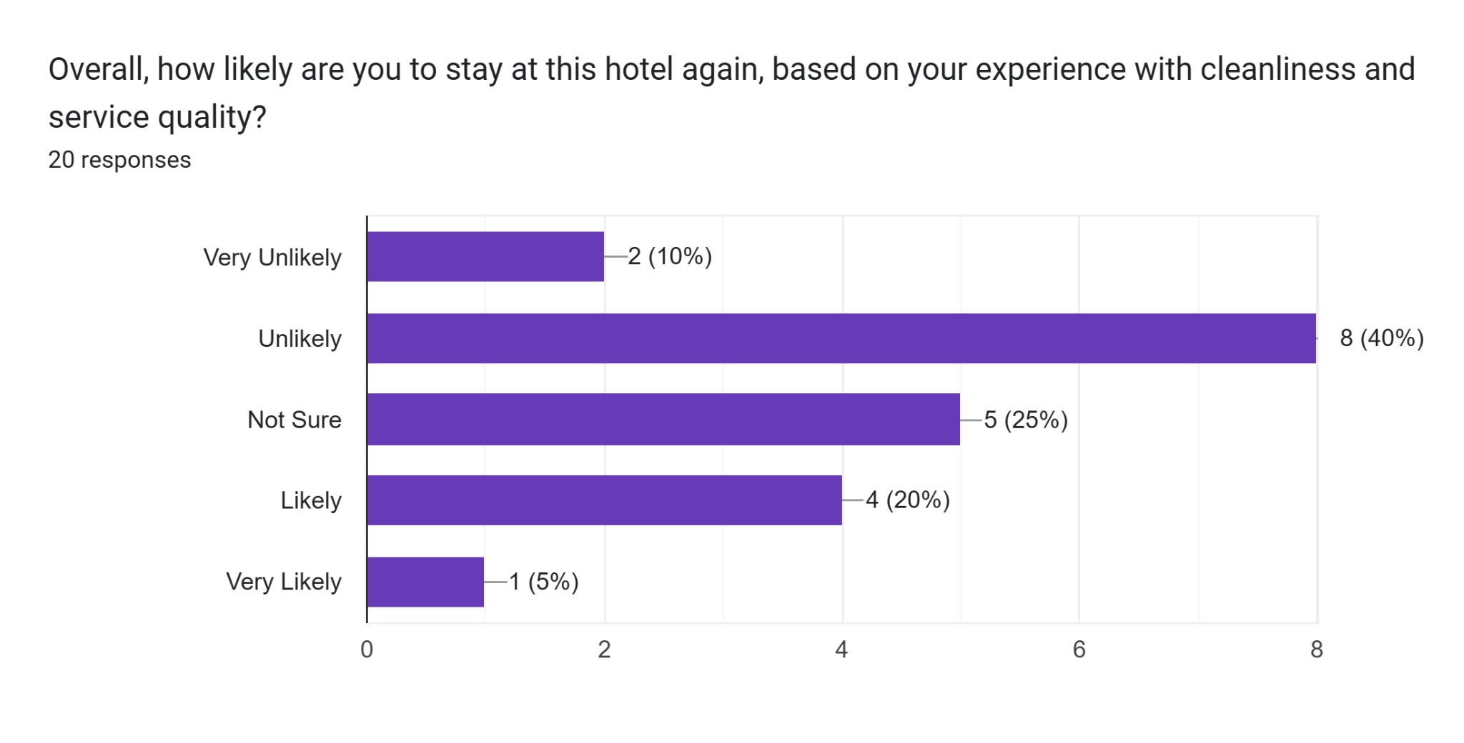Figure 12: Repeat visits
When asked about the guests' likelihood to visit the hotel again, it was found that around half of the guests are very unlikely or unlikely to visit again. While only 25% demonstrated positive perception, 25% of the guests are still not sure if they would repeat. This underscores the impact of services and experiences on customer loyalty.

4.1.2 Secondary

Theme 1: Complaints about the cleanliness and maintenance in the Premier Inn Southampton
Customer feedback on the online review platform, such as TripAdvisor, also reveals the hotel's inability to maintain consistency in terms of cleanliness. Most of the customers were concerned about the maintenance and cleanliness at the Southampton hotel. Many of the customers mentioned dirty room stains, mould in the shower room and windows. Additionally, many of them felt that the high price of the hotel does not reflect the services provided by the staff (TripAdvisor, 2025). On the other hand, a hotel like Holiday Inn at Southampton has higher ratings than Premier Inn. The room services of Holiday Inn were highly praised for their maintained room and cleanliness (TripAdvisor, 2025). As reported, around 92% of Brits consider hotel room linens as dirty items, and 87% tend to check before using them. For UK guests, cleanliness is one of the major concerns. It was found that 42% of them start to clean themselves as they do not trust hotel staff (The Lost Executive, 2020). One of the reasons for increasing complaints about cleanliness is that 78% of the guest believe cleanliness affects their choice to stay at the hotel. When their needs are not met, their perception towards the hotel degrades drastically (PG PRO, 2024). Thus, Premier Inn has failed to meet the basic needs of the guest, indicating inconsistent efforts and a lack of quality control. Other branches of Premier Inn also indicated dissatisfaction regarding the rooms. The staff also did not show any professionalism when it came to deep cleaning (Reviews, 2025). In comparing the hotel with another budget-friendly hotel like Holiday Inn, it was evident that Premier Inn has issues within its culture, as it has been consistently failing to maintain cleanliness and operational efficiency.
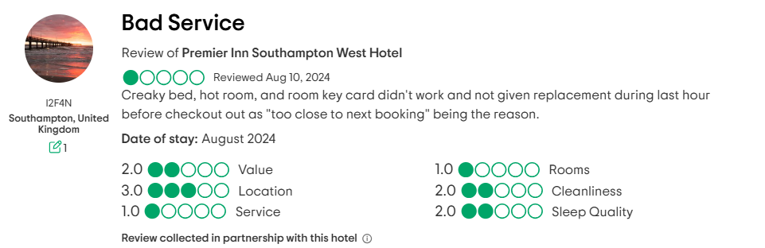
Figure 13: Customer complaints
(Source: TripAdvisor, 2025)
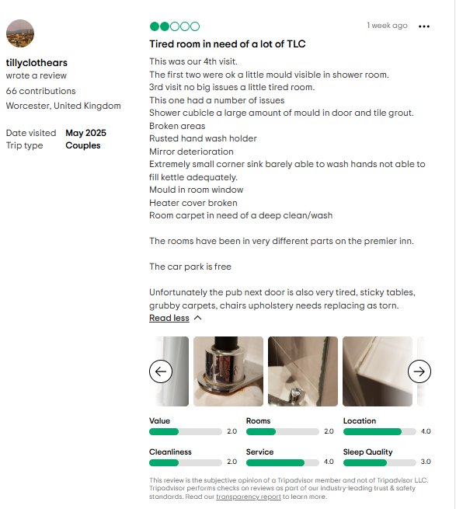
Figure 14: Customer complaints on cleanliness
(Source: TripAdvisor, 2025)
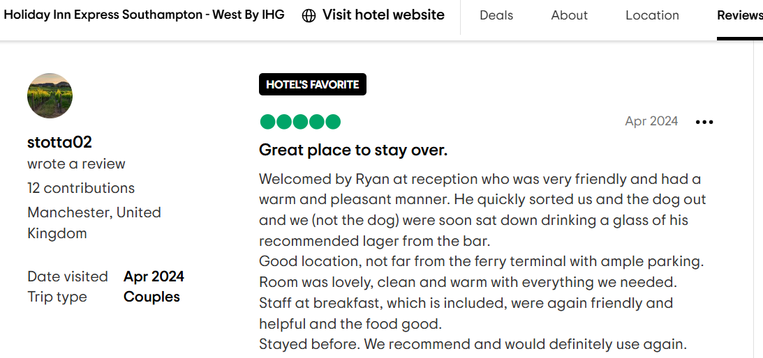
Figure 15: Review of competitor Holiday Inn
(Source: TripAdvisor, 2025)
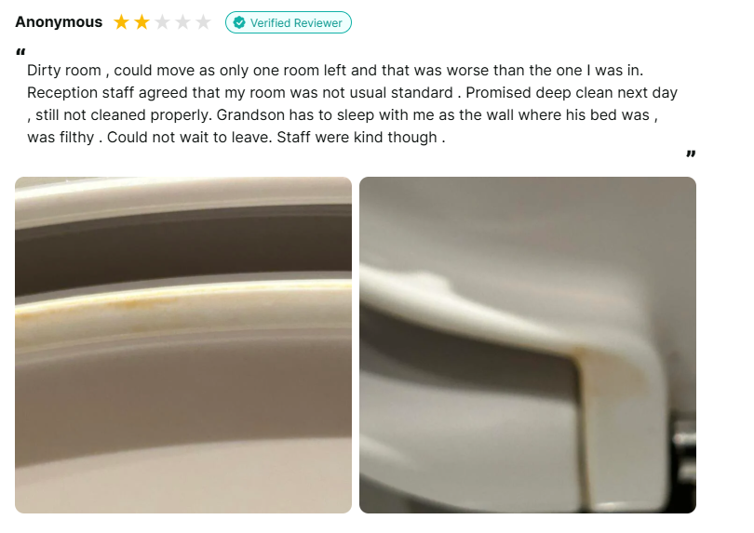
Figure 16: Review of Premier Inn
(Source: Reviews, 2025)

Theme 2: Inconsistencies in the behaviour of staff and their responsiveness within Premier Inn
From the online review platform, it was clear that staff at the hotel were not adequately trained. The behaviour of the staff was rated significantly low, and considered rudeness of staff a serious issue. The poor behaviour of the staff has become a big contributor to guest dissatisfaction (Trip Advisor, 2025). Inconsistencies in the behaviour of staff can severely impact the perception of customers towards the hotel. As reported, 45% of the hotels look for employees based on the staff behaviours rather than technical competence, as it makes a significant difference to customer experience. However, many companies within this industry have misunderstood the importance of effective staff behaviour (Warwick, 2023). However, at Premier Inn, the staff behaviour was highly criticised for their lack of responsiveness and rudeness. Another review of customers revealed that one of the staff members at the hotel shouted at them without making a mistake. Furthermore, the response was also ineffective when the customer complained about the keys. Due to this incident, the customer booked another budget-friendly hotel, such as Travelodge (Trip Advisor, 2025). These reviews demonstrate that the customer service is severely compromised, and the staff at Premier Inn appear to be dismissive and disinterested. On the other hand, companies like Travelodge have been acknowledged by customers, highlighting the attentiveness of staff in solving the customers' issues. Such behaviour of staff significantly undermines the trust of customers, leading to negative word of mouth. As reported, about a third of the UK customers are more likely to pay organisations, even if it means paying more (Statista, 2025). The inconsistency at the Premier Inn hotel aligns with theories like Expectancy-Disconfirmation Theory, suggesting that the decline in effective services and efforts leads to a loss of loyalty. The consistent need of customers for adequate staff behaviour and professionalism is an important area that the hotel needs to redress urgently.
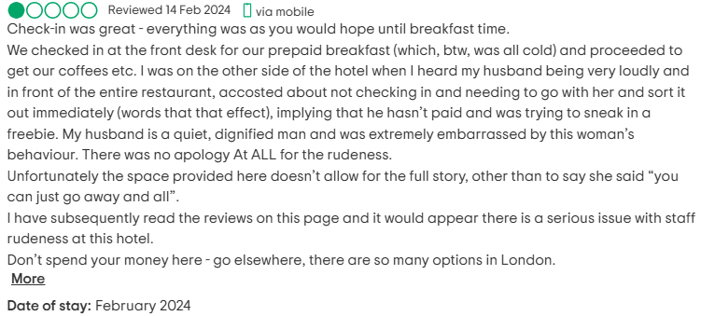
Figure 17: Rude staff behaviour at Premier Inn
(Source: Trip Advisor, 2025)
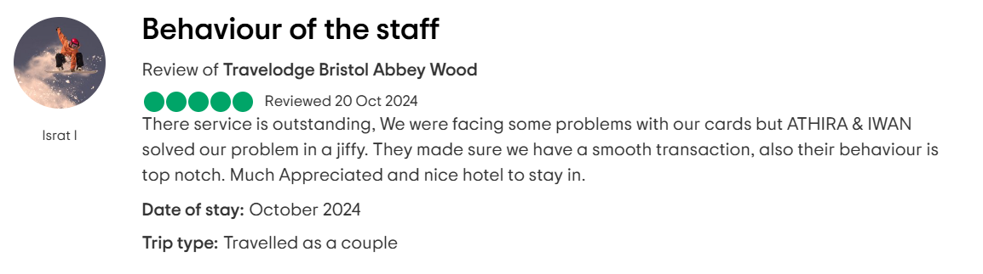
Figure 18: Positive review of staff at Travelodge
(Source: Trip Advisor, 2025)
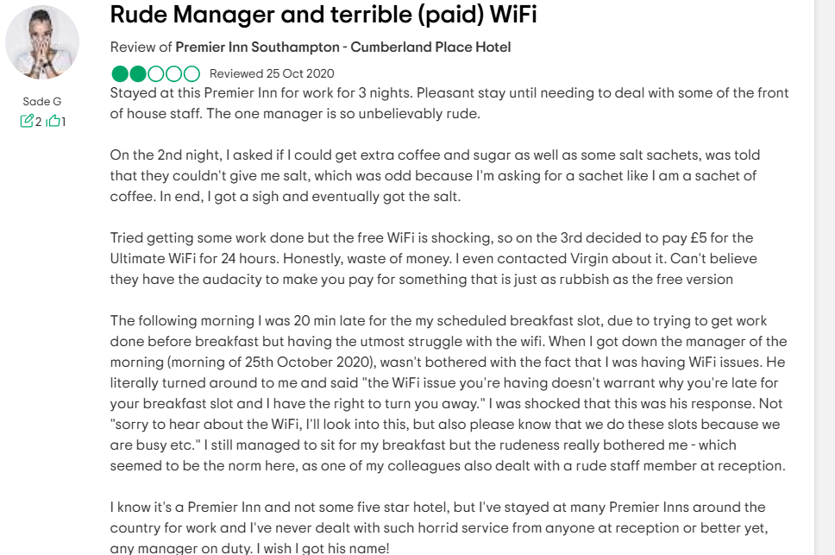
Figure 19: Rude behaviour of the manager
(Source: Trip Advisor, 2025)

Theme 3: Feedback of customers and trends of retention for Premier Inn
As reported, Premier Inn’s brand awareness stands at 93% in the UK. Despite this, only 38% of the customers are loyal to the company, and only 45% of the guests use the services of the hotel (Statista, 2025). However, despite customers' feedback on hygiene and inconsistencies in the services, the company has been able to maintain strong retention. In recent years, around 86% of the bookings, accounting for five million bookings, were done by repeat customers (Marketingweek, 2023). This retention rate at the hotel demonstrates brand loyalty. Despite the increased price of the hotel, the company was able to maintain loyalty. This suggests the concept that customers are willing to pay more for high-quality services. Contrastingly, the primary data from the survey reveals that customers are less likely to visit hotels with poor customer service and a lack of hygiene at Premier Inn. To retain its customers, Premier Inn has integrated an automation strategy to streamline its customer service and reduce its dependency on human staff (Whitbread, 2024). This automation not only helped the company to enhance guest experience but also allowed its staff to focus on more crucial areas. This trend has helped the company to grow by 153% year over year, reflecting the effectiveness of the new approach in customer service (Shijigroup, 2024). However, despite being ranked as the top hotel chain in the UK, with a customer score of 79%, the smaller chain hotels like Hotel Du Vin have scored higher than Premier Inn (Djsresearch, 2022). This indicates that despite its high retention and satisfaction rate, it is still at the risk of falling behind its competitors in terms of service quality and staff interactions.
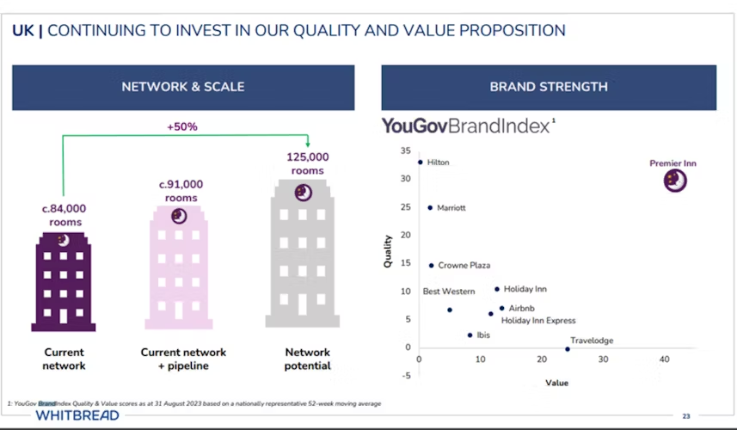
Figure 20: Current operating model of Premier Inn
(Source: Marketingweek, 2023)

4.2 Discussion

4.2.1 The influence of maintenance on the satisfaction of customers
The findings of the research support the prospect that maintenance standards play an important role in customer satisfaction. Considering the survey results it was observed that 55% of the respondents rated the cleanliness of the hotel as poor. On the other hand, only 25% rated it as good. This tends to reflect the prevailing discontent in terms of standards of hygiene. This observation is in support of the primary study aim of measuring the role of hygiene-based problems in determining customer satisfaction. The findings are in accordance with the recognition of cleanliness as a service quality parameter. Clean surroundings instil professionalism by having a profound impact on trust. Supporting the findings of the survey, secondary research identified several complaints on platforms regarding irregular housekeeping practices. These findings are consistent with the findings which incorporate physical facilities as primary components of service assessment. When the tangible factors are violated, customers tend to express more dissatisfaction. Moreover, 50% of the respondents identified unclean rooms as a critical problem. On the other hand, 15% identified maintenance-related issues by reflecting the role of physical maintenance. These findings reflect a considerable gap among guest expectations. The absence of cleanliness affects the brand's reputation, which requires the need for remedial action. Therefore, the discussion underscores that maintenance is a key element towards the delivery of positive customer experiences within the hospitality industry.

4.2.2 The quality of services and their roles in shaping the loyalty of customers
The results of the research indicate that the quality of service is an important aspect of customer loyalty. The results from the primary data underscored that 60% of the survey respondents reported disagreement with staff professionalism. This caters to a low rate of delivery of service in customer perception. This theme is aligned with the imperative that investigates the connection between staff interaction and customer loyalty. Being professional in behaviour by staff members generates confidence and the potential for repeat visits (Harris, 2021). On the other hand, unresponsive behaviour has the potential to significantly damage the hotel's reputation for budget hotels, where the expectations of service may be low. The Gap Model supports this by articulating the gaps that can exist between customer expectations and actual service delivery (Singh et al. 2022). Within this aspect, the failure of staff to handle guest problems effectively creates a gap in delivering service. A cost-conscious industry cannot ignore the relational aspects of service delivery. This is because these are likely to be critical differentiators in competitive markets. The findings assert that training staff and accountability are critical to customer retention and brand image. Creating an emotionally intelligent service culture would effectively bridge the prevailing gap.

4.2.3 The quality of hygiene standards as the potential driver for guest retention
The research underscores the importance of service quality and hygiene to the formation of repeat visits. The findings from the survey results had underscored that more than 50% of the respondents were dissatisfied with the cleanliness of their rooms. Moreover, over 45% were dissatisfied with the delay in housekeeping service. These service weak points are linked with lower levels of satisfaction and reduced repeat visit intentions. This implies that service quality has direct implications for guest retention. This finding supports the aim of the research to quantify the extent to which improvement in service areas can influence repeat visitation. The existing literature always supports the interconnection between customer loyalty, service quality, and hygiene. Through the analysis of the findings, it has been observed that repeat business is a function of the entire guest experience (Paulose and Shakeel, 2022). The Expectancy-Disconfirmation Theory applies as it posits that customer satisfaction and loyalty are a function of a comparison between perceived and expected service (Boihang and Yessoufou, 2022). Where the levels of hygiene and service fall short of expectations, guests experience negative disconfirmation. Moreover, the majority of visitors provided reasons against return visits based on cleanliness complaints and unresponsive staff behaviour. This also substantiates the hypothesis that unresponsive staff behaviour and lack of hygiene are not isolated complaints but ongoing issues that negatively impact long-term customer relationships. Furthermore, some of the reviews demonstrated that complaints on first visits would completely discourage subsequent bookings, illustrating the fragile nature of customer loyalty in the hospitality industry. Therefore, the findings suggest that high levels of hygiene are imperative for long-term retention. Budget hotels should focus on both physical and relational aspects of service to maintain a competitive advantage.

4.2.4 Feedback informed by guests on best practices of the industry
The overall discussion is in line with the research to foster recommendations for practical action to improve. Considering the responses from the survey, a high proportion of respondents 70%, considered inadequate staff training as one of the principal causes of service quality issues. The responses identified a lack of understanding of cleanliness standards as a significant area of weakness that could be addressed through regular training. Moreover, the findings indicated that the guests’ feedback posits the problems of poor responsiveness of the staff. Considering the aspect that the majority of the guests recommended establishing formalised hygiene protocols would allow consistency in services. Such findings are in line with service quality management best practices in the industry. These practices prioritise continuous training to achieve operational consistency (Nordin et al. 2024). Moreover, these recommendations are indicative of a trend of discontent that could pose long-term reputational risks. This is relevant to the hospitality sector, where the standard of hygiene is the priority for guests. Therefore, to preserve its competitive advantage, Premier Inn needs to spend on extensive staff training and institute monitoring programs for service quality that are aligned with guest expectations. These changes are a precondition to sustainable service excellence for budget hotels such as Premier Inn.

4.3 Addressing the research question and objectives
The discussion reflects upon and addresses the objectives and questions properly. The first research question aimed to explore the impact of hygiene standards like maintenance and room cleanliness on customer satisfaction. The discussion has stated that guests prefer proper hygiene practices that were present in Southampton Hotel. This illustrates how important it is for budget hotels also to emphasise more on consistent maintenance and cleanliness of their property. This directly aligns with the first objective. Furthermore, the second question and objective emphasised the relationship between staff interaction, quality services and customer loyalty. The discussion went on to state how inadequate and unprofessional staff response negatively affects client's perception of the hotel and its staff which diminishes loyalty. These findings effectively link with the literature that showcases how staff behaviour is an important element of perceived severe quality and should be focused upon, thus supporting the second objective.
The third question has explored how improvements in service quality and hygiene can boost customer retention and repeat visits. By evaluating the primary and secondary findings, the discussion has showcased how consistency in services and hygiene can be impactful in driving repeat business. This reflects the third objective which measures the extent to which enhanced services affect customer retention. Lastly, the fourth question and objective were also addressed by translating customer feedback and industry insights into strategic recommendations. The actionable strategies emphasised staff training, forming clear hygiene protocols and even implementing service quality monitoring mechanisms. Therefore, these strategies provide practical solutions to the gaps identified, thus fulfilling the last objective.

4.4 Implications of the findings
The findings of the study have implications for hospitality management as well as service delivery practices, especially in the budget hotel sector. The research has illustrated the importance of hygiene and cleanliness as the main elements of guest satisfaction. Poor hygiene not only impacts customer perceptions but also diminishes their satisfaction and likelihood of visiting again, thus indicating that these elements are very essential and should be prioritised. Furthermore, they have underscored the need for improved staff responsiveness and training. Service interactions are essential and shape positive guest experiences and any gaps in professionalism or communication tend to damage client loyalty and trust. This suggests that the management of all hotels must invest substantially in frequent staff development initiatives so that their behaviours and actions (or work) align with positive service delivery matching with the client's expectations. Additionally, it has also revealed that consistent and efficient service quality and clearly established hygiene protocols are integral towards maintaining guest confidence. Hotels must have structured monitoring systems as well as enforce accountability at all operational levels. Considering the wider scale, these findings contribute to the academic knowledge of how hygiene and top-notch service quality intersect with guest behaviour within hospitality settings, particularly post-pandemic.

4.5 Limitations of the research
The research provides significant insights into the interplay between customer satisfaction and service quality. It was observed that there are various limitations that should be taken into account. Primarily, the sample size employed in the primary data collection was relatively low for the research findings of the population. Moreover, the selection of a single location contributes to the limitation of the research findings to other hotels or branches. Moreover, the employment of existing data might not reflect the entire range of guest experiences. Furthermore, the overall nature of the research is unable to cater to the differences in service quality over time. These limitations should be adhered to when interpreting the research findings.

Chapter 5 Conclusion and Recommendations

5.1 Conclusion
The research has critically explored the impact of health and safety standards like hygiene, cleanliness, and maintenance upon customer satisfaction at the budget scale named Premier Inn Southampton (Cumberland Place). This research was initially promoted by a huge number of negative reviews seen on platforms like TripAdvisor where guests have consistently reported of the unclean rooms, delayed maintenance and response from the hotel staff. This has aimed to evaluate how such lapses tend to not just affect customer experience but diminish brand reputation along with customer loyalty, some of the essential parts for any business to run in a highly competitive business world. Furthermore, the introduction section began with showcasing how despite having a strategic location, the brand was criticised for their subpar room cleanliness and not adhering to relevant health and safety standards. In the literature review section, several academic studies like journals and articles have been referred to for understanding the critical role that hygiene and premium service standards have in shaping guest satisfaction. It has been confirmed by many authors that poor hygiene directly affects customer perception along with satisfaction levels. This inclination has been steered due to the upsurge of the COVID-19 pandemic that taught people to always stay neat and clean and choose hygiene overall. Be it in food or accommodations, guests started preferring hygiene and cleanliness as the top priorities while booking hotels and thus this must be emphasised by the hotel service providers. This is not a luxury aspect but a mandatory aspect that cannot be avoided by anyone operating in the hospitality industry. The research has clearly stated that staff behaviour, cleanliness and maintenance tend to be the main pillars of proper service quality in hotels. Even various authors have linked improvements in service with enhancing guest loyalty, post the COVID-19 era, thereby reinforcing the significance of ensuring high standards in the recovery period. The literature review section along with the introduction chapter has been quite effective in establishing the relevance of the project by outlining how health and safety are not only legal requirements but ethical obligations that cannot be missed at any cost. In an industry where online reviews hold a great position in shaping customer choices, it becomes quite essential to maintain high hygiene levels. The aim and objectives are properly aligned with improving the reputation and operational effectiveness of Premier Inn by identifying the weaknesses in offering service delivery and targeted recommendations.
Considering the methodology section, the research has been even more refined as it incorporated a mixed-method approach using secondary data from journals, articles and online reviews and primary feedback collected from random customer or guest surveys. Participants were adults who were over 18 years of age and had previously stayed in the hotel. This was selected so that the proper information regarding the hotel could be known. The feedback focused especially on cleanliness, staff responsiveness, overall satisfaction and facility maintenance. The majority of the responses were on how they were dissatisfied with the service of this hotel where they expected them to adhere to all required health and safety and hygiene protocols. The survey results have enriched the findings of the research that incorporating only secondary methods might not have been. While conducting the survey, ethical considerations were highly respected throughout and informed consent was accepted from the participants along with encouraging voluntary participation and free entry and exit.
Considering the findings gathered, this can be stated that the findings have shown a clear correlation between poor hygiene and customer dissatisfaction. Complaints regarding the unclean bathrooms, and rooms, pest control and highly ineffective response from staff are some urgent areas that the hotel must work towards at the earliest. Furthermore, the study has also confirmed that improving service quality results in better client retention in budget hotels. Be it any five-star hotel or budget accommodations, one of the top priorities of clients is cleanliness and hygiene. This is something that cannot be compromised at all and even if there are any concerns related to this, this does have negative implications on the entire hotel as a whole. Overall, the project has underscored the need for Premier Inn hotels to implement even more robust health and safety standards like introducing staff accountability systems or might even enhance their internal communication. The main aim of all these strategies is ultimately to drive improvements in guest satisfaction, operational effectiveness as well as brand trust.
Therefore, the last part of the research has carefully provided some recommendations for this specific hotel in question to improve customer satisfaction while addressing serious health and safety issues. The first strategy that can be implemented is to have a rigorous housekeeping audit system that would help them keep up with the daily cleanliness standards and maintain them thoroughly. This would also help reduce hygiene-related negative complaints and spread positive word of mouth about their cleanliness standards and improved customer services. Frequent or regular health and safety training alongside real-time guest feedback. Additionally, it might also partner with certified pest control providers to have monthly inspections of their property and come up with relevant preventative treatments like addressing bed bugs. Stronger communication protocols between departments were also recommended to ensure guest issues were shared and solved swiftly without delay. Thus, implementing all of these strategies might help Premier Inn Southampton (Cumberland Place) to enhance guest satisfaction while protecting its reputation and strengthening client loyalty in the competitive budget hotel industry.

5.2 Recommendations and Practical Strategies
1. Implementing Rigorous Housekeeping Audits and Monitoring Procedures
Premier Inn should introduce a structured daily and weekly housekeeping audit system. This means they should have detailed cleanliness checklists of linen hygiene, pest control, bathroom sanitation and dust inspection. Housekeeping supervisors should sign off with completing cleaning logs and reporting any issues faced to the management. This evidence from guest complaints like unclean rooms suggests that current procedures are either poorly enforced or insufficient. Marriott has their Cleanliness Champion model where one staff member who is on shift has to be responsible for quality assurance (Marriott, 2025). Just like this, Premier Inn should also instil the same procedure for accountability and consistency. This audit system must be reinforced by surprise spot checks by the management to ensure that the standards are maintained throughout. This might require increased administrative and staffing time, it might reduce negative reviews and boost guest satisfaction (Kim and Han, 2023).
2. Conducting Mandatory Health and Safety Training for All Staff
There must be regular training offered to the hotel employees like housekeeping, maintenance, and front desk personnel on health, sanitation and safety. Thus it must be mandatory for all the employees to attend. Training sessions must cover some of the important and practical areas like identifying bed bug infestations, tackling client complaints, understanding the health and cleanliness regulations, sanitising high contact surfaces regularly, etc. 59% of employees said that training has improved their overall job performance (DP, 2025). In this case, Premier Inn can also experience better results by training their staff in terms of improving their knowledge of hygiene complaints. They must draw from the quarterly refresher model of Hilton that helps them foster a culture of swift maintenance and cleanliness (DZHABAROVA, 2024).
The Health and Safety at Work Act (1974) legally obligates employers to protect staff and guests, and this training would ensure compliance (Joseph and Namitha, 2021). From a theoretical lens, Maslow’s Hierarchy of Needs suggests that when staff feel equipped and secure in their roles, they perform more confidently and competently (Hayre-Kwan et al. 2021). While high staff turnover in budget hotels may make it challenging to retain trained employees, a digital learning system with short, accessible modules can help ensure continuity without disrupting workflow (Kumar, 2021).
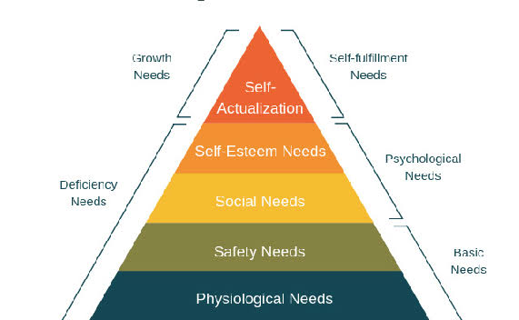
Figure 21: Maslow's theory
(Source: Xue et al. 2020)
3. Introduce a Real-Time Guest Feedback and Complaint Resolution System
To improve responsiveness to guest complaints, Premier Inn should adopt a digital feedback system, such as a mobile app or in-room QR code interface, where guests can report issues instantly, whether it's an unclean room, a pest sighting, or faulty maintenance. These reports should trigger automatic alerts to housekeeping or the duty manager for prompt resolution. This directly addresses the complaint in one review where a guest waited over 30 minutes without any staff response. Hotels like IHG (InterContinental Hotels Group) have implemented “FastTrack Resolution” platforms, solving 80% of complaints within 15 minutes (IHG, 2025). Such responsiveness not only improves guest satisfaction but also enables real-time tracking of recurring problems. Applying the SERVQUAL model, directly reduces the responsiveness and assurance service quality gaps. Although it requires technological investment and some training, the outcome would be better crisis management and fewer publicly visible negative reviews.
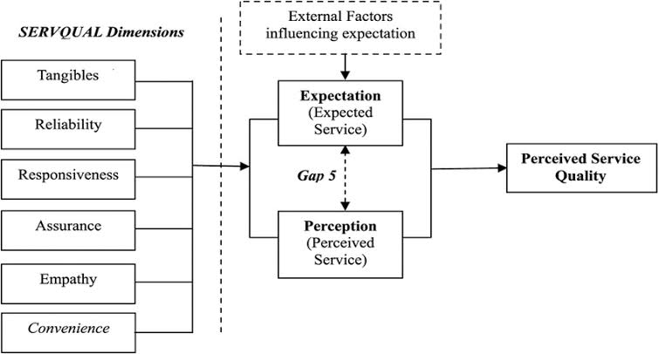
Figure 22: SERVQUAL model
(Source: Namupala, 2019)
4. Partner with a Professional Pest Control Service
Premier Inn must engage a certified pest control company on a contractual basis to conduct monthly inspections and preventive treatments. This is essential to address one of the most damaging complaints like bed bug infestations. Even a single review mentioning mites or insects can irreversibly damage brand credibility, especially when published on high-traffic platforms like TripAdvisor. Travelodge UK implemented a similar pest control partnership after a major incident in 2017 and saw a decline in pest-related complaints. Monthly pest control inspections will also align the hotel with the Food Standards Agency and local Environmental Health requirements (OFORI and YAA, 2024). Using Lewin’s Change Management Model, pest control implementation represents the “change” phase where the organisation redefines its hygiene priorities. To reduce guest concern during treatment, the hotel can schedule inspections during low-occupancy periods and communicate transparently that preventative measures are in place, rather than reactive treatments following complaints (García and López, 2025).
5. Establish Strong Communication Protocols Between Departments
There must be seamless communication between the front desk and housekeeping staff to ensure that guest complaints, especially those related to cleanliness and maintenance, are acted upon immediately (Bigwanto et al. 2024). As seen in one review, delays or failures to respond can result from breakdowns in internal coordination. A basic solution would be equipping the front desk and housekeeping staff with shared devices or apps where room-related complaints can be logged and tracked live. This would help them eliminate the reliance on handwritten notes and instead improve internal communication (Di Sutam et al. 2024). This would boost service excellence and bring positive outcomes in making their roles or expectations clearer.

References
Adil, M., Sadiq, M., Jebarajakirthy, C., Maseeh, H.I., Sangroya, D. and Bharti, K., 2022. Online service failure: antecedents, moderators and consequences. Journal of Service Theory and Practice, 32(6), pp.797-842.
Aggarwal, A., Lim, W.M., Jaisinghani, D. and Nobi, K., 2024. Driving service-oriented organizational citizenship behavior through error management culture. The Service Industries Journal, 44(15-16), pp.1211-1250.
Ali, I.M., 2024. A guide for positivist research paradigm: From philosophy to methodology. Idealogy Journal, 9(2).
AlOmari, F., 2021. Measuring gaps in healthcare quality using SERVQUAL model: challenges and opportunities in developing countries. Measuring Business Excellence, 25(4), pp.407-420.
Anderson, M., 2025. Understanding the Impact of Service Quality on Customer Loyalty in the Hospitality Industry.
Bigwanto, R., Prasetyo, I.J. and Maella, N.F.S., 2024. Communicative Hospitality: Acts Of Service Among Front Desk Hotelier. Jurnal Ekonomi, 13(03), pp.151-159.
Boihang, M. and Yessoufou, K., 2022. Testing the expectancy-disconfirmation theory: Geography, employment status and household size of local communities determine their perspectives of a local mine business in South Africa. Plos one, 17(7), p.e0270815.
Braun, V. and Clarke, V., 2023. Toward good practice in thematic analysis: Avoiding common problems and be (com) becoming a knowing researcher. International Journal of transgender health, 24(1), pp.1-6.
Casula, M., Rangarajan, N. and Shields, P., 2021. The potential of working hypotheses for deductive exploratory research. Quality & Quantity, 55(5), pp.1703-1725.
Chen, W., Dong, B., Hsieh, C.W., Lee, M.J., Liu, N., Walker, R.M., Wang, Y., Wen, B., Wen, W., Wu, P. and Wu, X., 2022. A replication of “an experimental test of the expectancy‐disconfirmation theory of citizen satisfaction”. Public Administration, 100(3), pp.778-791.
Dale, A., Arber, S. and Procter, M., 2025. Doing secondary analysis. Taylor & Francis.
Danforth, K., Ahmad, A.M., Blanchet, K., Khalid, M., Means, A.R., Memirie, S.T., Alwan, A. and Watkins, D., 2023. Monitoring and evaluating the implementation of essential packages of health services. BMJ global health, 8(Suppl 1), p.e010726.
Di Sutam, E., Pei, F.L., Jia, J.T., Muhammad, N.A., Ab-Samat, H., Jeng, F.C., Prakash, J., Muhammad, N. and Sirivongpaisal, N., 2024. A comparative study on user satisfaction from manual to online information system using define-measure-analyze-improve-control (dmaic) in service administrative process. Journal of Advanced Research Design, 122(1), pp.27-45.
Djsresearch, 2022. Premier Inn ranks top hotel chain in Britain, with an average customer score of 79%, survey reveals. Available at: https://www.djsresearch.co.uk/SportLeisureAndTourismMarketResearchInsightsAndFindings/article/Premier-Inn-ranks-top-hotel-chain-in-Britain-with-an-average-customer-score-of-79percent-survey-reveals-05056 (Accessed on: 6 June, 2025).
DP, 2025. Employee Training Statistics, Trends, and Data in 2025. Available at: https://www.devlinpeck.com/content/employee-training-statistics (Accessed on: 5 June, 2025).
DZHABAROVA, Y., 2024. A STUDY OF GOOD PRACTICES OF REPUTATION MANAGEMENT IN THE HOSPITALITY INDUSTRY-THE EXAMPLE OF HILTON CORPORATION. Socio-economic Conditions for the Spread of Epidemics in Afric a Milen PENERLIEV Disbalance in the Recovery of Tourism Markets in Bulgaria after the COVID-19 Pandemic, 1(2), p.34.
Fatima, T. and Elbanna, S., 2023. Advancing sustainable performance management in the hospitality industry: A novel framework based on a health-inclusive balanced scorecard. Tourism Management Perspectives, 48, p.101141.
García, H. and López, J., 2025. Tourism Development in Fragile Ecosystems: Promoting Responsible Practices in Ecotourism. Journal of Tourism, Culture, and Management Studies, 2(1), pp.47-61.
GURKAN, G.C., Özyurt, B. and AYLAN, K.C., 2025. Evaluation of Vegan and Vegetarian Customers’ Reviews Within the Scope of Expectancy-Disconfirmation Model. ENLIGHTENING TOURISM. A PATHMAKING JOURNAL, 15(1), pp.1-25.
Harris, F., 2021. Developing a relationship with nature and place: the potential role of forest school. Environmental Education Research, 27(8), pp.1214-1228.
Hayre-Kwan, S., Quinn, B., Chu, T., Orr, P. and Snoke, J., 2021. Nursing and Maslow’s hierarchy: A health care pyramid approach to safety and security during a global pandemic. Nurse leader, 19(6), pp.590-595.
Hossain, M., 2023. The impact of hygiene practices in the management of restaurants and hotels.
IHG, 2025. Responsible Business Report 2024 and Performance Data. Available at: https://www.ihgplc.com/~/media/Files/I/Ihg-Plc/investors/annual-report/2024/ihg_rbr_24-25_interactive.pdf (Accessed on: 5 June, 2025).
Islam, Y., Sinha, R. and Hassan, A., 2022. Technology application in the tourism and hospitality industry: The contexts of India and Bangladesh. In Handbook of Technology Application in Tourism in Asia (pp. 763-785). Singapore: Springer Nature Singapore.
Jonkisz, A., Karniej, P. and Krasowska, D., 2022. The servqual method as an assessment tool of the quality of medical services in selected Asian countries. International journal of environmental research and public health, 19(13), p.7831.
Joseph, A.A. and Namitha, K.L., 2021. Labour Regualations In Health Workforce–A Critical Analysis.
Khan, R.U., Salamzadeh, Y., Iqbal, Q. and Yang, S., 2022. The impact of customer relationship management and company reputation on customer loyalty: The mediating role of customer satisfaction. Journal of Relationship Marketing, 21(1), pp.1-26.
Kim, J.M. and Han, J., 2023. Examining the negative relationship between length of stay at a hotel and customer satisfaction: evidence from online customer reviews. International Journal of Contemporary Hospitality Management, 35(12), pp.4099-4116.
Kumar, S.V., 2021. A study on adept soft skill & knowledge accompanying hospitality employee retention behavior during Covid-19 lockdown phase. Anais Brasileiros de Estudos Turísticos.
Ledro, C., Nosella, A. and Vinelli, A., 2022. Artificial intelligence in customer relationship management: literature review and future research directions. Journal of Business & Industrial Marketing, 37(13), pp.48-63.
Lee, C.P., Hung, M.J. and Chen, D.Y., 2022. Factors affecting citizen satisfaction: examining from the perspective of the expectancy disconfirmation theory and individual differences. Asian Journal of Political Science, 30(1), pp.35-60.
Maretha, C., 2023. Positivism in philosophical studies. Journal of Innovation in Teaching and Instructional Media, 3(3), pp.124-138.
Marketingweek, 2023. Premier Inn credits brand investment for helping it become ‘one of the UK’s favourite brands’. Available at: https://www.marketingweek.com/premier-inn-credits-brand-investment-for-helping-it-become-one-of-the-uks-favourite-brands/ (Accessed on: 5 June, 2025).
Marriott, 2025. MARRIOTT'S COMMITMENT TO CLEAN - Disability Policy Seminar. Available at: https://disabilitypolicyseminar.org/wp-content/uploads/2022/02/Commitment-to-Clean-DC-Renaissance.pdf (Accessed on: 5 June, 2025).
Mejia, C., Ciarlante, K. and Chheda, K., 2021. A wearable technology solution and research agenda for housekeeper safety and health. International Journal of Contemporary Hospitality Management, 33(10), pp.3223-3255.
Muhsen, Y.R., Husin, N.A., Zolkepli, M.B. and Manshor, N., 2023. A systematic literature review of fuzzy-weighted zero-inconsistency and fuzzy-decision-by-opinion-score-methods: assessment of the past to inform the future. Journal of Intelligent & Fuzzy Systems, 45(3), pp.4617-4638.
Namupala, I.N., 2019. An investigation of the impact of quality of service on customer satisfaction of Nampower residential customers.
Nordin, N., Yusof, Y., Syahriful, A.P. and Bawan, M.Z., 2024, October. Driving Operation Excellence: Shaping Operational Excellence through Competence Maintenance & Engineering Technical Executives for Superior Asset Integrity. In SPE Asia Pacific Oil and Gas Conference and Exhibition (p. D011S005R004). SPE.
OFORI, G. and YAA, M., 2024. ASSESSING THE COMPLIANCE WITH FOOD LAW IN THE HOSPITALITY INDUSTRY: A STUDY OF SELECTED HOTELS IN THE AKUAPIM SOUTH MUNICIPALITY.
Park, J., Yoo, J.W., Cho, Y. and Park, H., 2023. Examining the impact of service robot communication styles on customer intimacy following service failure. Journal of Retailing and Consumer Services, 75, p.103511.
Paulose, D. and Shakeel, A., 2022. Perceived experience, perceived value and customer satisfaction as antecedents to loyalty among hotel guests. Journal of quality assurance in hospitality & tourism, 23(2), pp.447-481.
Pereira, V., Silva, G.M. and Dias, Á., 2021. Sustainability practices in hospitality: Case study of a luxury hotel in Arrábida Natural Park. Sustainability, 13(6), p.3164.
PG PRO, 2024. The Importance of Clean for Guest Satisfaction. Available at: https://pgpro.co.uk/en-gb/articles/the-importance-of-clean-for-guest-satisfaction// (Accessed on: 5 June, 2025).
Premier, 2025. Premier Inn hotels | Book direct. Available at: https://www.premierinn.com/gb/en/home.html (Accessed on: 5 June, 2025).
PremierInn, 2025. Southampton (Cumberland Place) hotel. Available at: https://www.premierinn.com/gb/en/hotels/england/hampshire/southampton/southampton-cumberland-place.html (Accessed on: 5 June, 2025).
Ramasamy, G., Ramasamy, G.D. and Ramasamy, P., 2024. Conceptual review of consumer satisfaction theories with expectation-confirmation and disconfirmation paradigm for business sustainable growth and decision making. F1000Research, 13, p.1399.
Reviews, 2025. Premier Inn Reviews. Available at: https://www.reviews.io/company-reviews/store/www-premierinn-com (Accessed on: 5 June, 2025)
Salamah, A.A., Hassan, S., Aljaafreh, A., Zabadi, W.A., AlQudah, M.A., Hayat, N., Al Mamun, A. and Kanesan, T., 2022. Customer retention through service quality and satisfaction: using hybrid SEM-neural network analysis approach. Heliyon, 8(9).
Sharma, L.R., Bidari, S., Bidari, D., Neupane, S. and Sapkota, R., 2023. Exploring the mixed methods research design: types, purposes, strengths, challenges, and criticisms. Global Academic Journal of Linguistics and Literature, 5(1), pp.3-12.
Sharma, V., Jangir, K., Gupta, M. and Rupeika-Apoga, R., 2024. Does service quality matter in FinTech payment services? An integrated SERVQUAL and TAM approach. International Journal of Information Management Data Insights, 4(2), p.100252.
Shijigroup, 2024. How Premier Inn Significantly Increased Search Success Rates and Overall Bookings Through Collaboration with Shiji. Available at: https://www.shijigroup.com/customers/how-premier-inn-significantly-increased-search-success-rates-and-overall-bookings-through-collaboration-with-shiji (Accessed on: 5 June, 2025).
Singgalen, Y.A., 2024. Hotel Customer Satisfaction: A Comprehensive Analysis of Perceived Cleanliness, Location, Service, and Value. Journal of Business and Economics Research (JBE), 5(3), pp.352-369.
Singh, N., Gupta, M. and Singh, P., 2022. Gap analysis between the customer's expectations and satisfaction of real estate sector using the SERVQUAL model. International Journal of Indian Culture and Business Management, 25(1), pp.1-16.
Singh, V., Sharma, M.P., Jayapriya, K., Kumar, B.K., Chander, M.A.R.N. and Kumar, B.R., 2023. Service quality, customer satisfaction and customer loyalty: A comprehensive literature review. Journal of Survey in Fisheries Sciences, 10(4S), pp.3457-3464.
Statista, 2025. Premier Inn brand awareness, usage, popularity, loyalty, and buzz among hotel customers in the UK in 2024. Available at: https://www.statista.com/forecasts/1335699/premier-inn-hotels-brand-profile-in-the-uk (Accessed on: 5 June, 2025).
Statista, 2025. Share of customers willing to pay more for receiving excellent service in the United Kingdom (UK) from 2020 to 2024. Available at: https://www.statista.com/statistics/1291591/customers-willing-to-pay-for-excellent-service-uk/ (Accessed on: 5 June, 2025).
Sumi, R.S. and Kabir, G., 2021. Satisfaction of e-learners with electronic learning service quality using the servqual model. Journal of Open Innovation: Technology, Market, and Complexity, 7(4), p.227.
The Lost Executive, 2020. A lot of Brits don’t trust hotel room hygiene now. Available at: https://www.thelostexecutive.com/2020/07/17/a-lot-of-brits-dont-trust-hotel-room-hygiene-now/ (Accessed on: 5 June, 2025).
TheCaterer, 2023. Cleanliness is top priority for hospitality guests and customers - News. Available at: https://www.thecaterer.com/news/cleanliness-is-top-priority-for-hospitality-guests-and-customers#:~:text=The%20key%20findings%20of%20the,a%20business%20about%2030%20customers. (Accessed on: 5 June, 2025).
Trip Advisor, 2025. Premier Inn Southampton - Cumberland Place Hotel. Available at: https://www.tripadvisor.co.uk/ShowUserReviews-g186299-d13423973-r775496480-Premier_Inn_Southampton_Cumberland_Place_Hotel-Southampton_Hampshire_England.html (Accessed on: 5 June, 2025).
Trip Advisor, 2025. Travelodge Bristol Abbey Wood. Available at: https://www.tripadvisor.co.uk/ShowUserReviews-g186220-d27687884-r974637353-Travelodge_Bristol_Abbey_Wood-Bristol_England.html (Accessed on: 5 June, 2025).
Trip Advisor, 2025.Premier Inn London Brentford hotel. Available at: https://www.tripadvisor.in/ShowUserReviews-g7377416-d7693566-r989353067-Premier_Inn_London_Brentford_hotel-Brentford_Hounslow_Greater_London_England.html (Accessed on: 5 June, 2025).
TripAdvisor, 2025. Customer reviews. Available at: https://www.tripadvisor.com/Hotel_Feature-g186299-d13423973-zft1-Premier_Inn_Southampton_Cumberland_Place_Hotel.html (Accessed on: 5 June, 2025).
TripAdvisor, 2025. Holiday Inn Express Southampton - West By IHG. Available at:https://www.tripadvisor.com/Hotel_Review-g2007651-d577040-Reviews-Holiday_Inn_Express_Southampton_West_By_IHG-Nursling_Hampshire_England.html#REVIEWS (Accessed on: 5 June, 2025).
TripAdvisor, 2025. PREMIER INN SOUTHAMPTON - CUMBERLAND PLACE HOTEL. Available at: https://www.tripadvisor.in/Hotel_Review-g186299-d13423973-Reviews-Premier_Inn_Southampton_Cumberland_Place_Hotel-Southampton_Hampshire_England.html (Accessed on: 5 June, 2025).
TripAdvisor, 2025. Premier Inn Southampton West Hotel. Available at: https://www.tripadvisor.com/Hotel_Review-g15182447-d571777-Reviews-Premier_Inn_Southampton_West_Hotel-Ower_Romsey_Hampshire_England.html#REVIEWS (Accessed on: 5 June, 2025).
Tu, Y. and Wu, W., 2021. How does green innovation improve enterprises’ competitive advantage? The role of organizational learning. Sustainable Production and Consumption, 26, pp.504-516.
Umukoro, O.S. and Owumi, B.J., 2025. MANAGERIAL IMPLICATIONS OF NEGATIVE CUSTOMER REVIEWS IN THE HOSPITALITY INDUSTRY: A CASE OF SELECTED HOTELS IN ABERDEEN, SCOTLAND. LJGAP DECEMBER 2023, p.111.
Warwick, 2023. Work, wages and employment in the UK’s hospitality sector.Available at:https://warwick.ac.uk/fac/soc/ier/rewage/publications/employment_in_uk_hospitality_-_evidence_paper_-_formatted_edited.pdf (Accessed on: 5 June, 2025).
Whitbread, 2024. Annual Report and Accounts 2023/24 Available at: https://cdn.whitbread.co.uk/media/2024/05/Whitbread-PLC-Annual-Report-and-Accounts-2023_Single_pages-1.pdf(Accessed on: 5 June, 2025).
Wood, R.C., 2024. Working in hotels and catering. Taylor & Francis.
Xue, Y., Wang, J. and Zhang, X., 2020. Research on user experience of smart home under the development of internet. In E3S Web of Conferences (Vol. 179, p. 02060). E3S Web of Conferences.
Yang, T., Wu, J. and Zhang, J., 2024. Knowing how satisfied/dissatisfied is far from enough: a comprehensive customer satisfaction analysis framework based on hybrid text mining techniques. International Journal of Contemporary Hospitality Management, 36(3), pp.873-892.
Yang, Y., Lin, M.S. and Magnini, V.P., 2024. Do guests care more about hotel cleanliness during COVID-19? Understanding factors associated with cleanliness importance of hotel guests. International Journal of Contemporary Hospitality Management, 36(1), pp.239-258.
Yu, J., Seo, J. and Hyun, S.S., 2021. Perceived hygiene attributes in the hotel industry: customer retention amid the COVID-19 crisis. International Journal of Hospitality Management, 93, p.102768.
Zahra, A.R.A., Jonas, D., Erliyani, I. and Yusuf, N.A., 2023. Assessing customer satisfaction in ai-powered services: An empirical study with smartpls. International Transactions on Artificial Intelligence, 2(1), pp.81-89.
Zhang, Q., Ariffin, S.K., Richardson, C. and Wang, Y., 2023. Influencing factors of customer loyalty in mobile payment: A consumption value perspective and the role of alternative attractiveness. Journal of Retailing and Consumer Services, 73, p.103302.
Zurita, M.L., 2025. Accessibility Care Beyond the University Disability Office.

