
leadership skills of managers and motivation theories
Ioana Ienea - 1918148

June 15, 2020
University of wales trinity saint david
Introducing the Modern Workplace | LCBB4003 | Tutor: Uju Ugochukwu


Table of Contents
Introduction 2
Critical analysis 2
Leadership styles 2
Managerial ability 4
Conclusion 6
References 6

Introduction
There has always been a confusion regarding the definition of the management and the leadership meaning. Even though the terms might have similar definitions, a manager and a leader would act differently based on their activities/purposes. Therefore, leadership was defined by Prentice (2004) as "is the accomplishment of a goal through the direction of human assistants. A leader is one who successfully marshals his human collaborators to achieve particular ends". On the other hand, the management literature has developed throughout the years and resuming the definitions, it now could be described as a coordination of activities and people in order to achieve given tasks or objectives. Thus, management could be associated with the armonisation of people and subtasks more likely as a function, whereas leadership refers to the human nature, a more emotional intelligence skill and social aspect of coordonating a team to reach goals. Managing resources and managing people are two different aspects. If a manager is also a leader, a leader cannot be a manager as well.
This report narrows down the importance of the leadership and managerial styles in terms of impact and effectiveness when these styles are implemented differently. The report divides into a section of critical analysis where three styles will be identified. Thus, the core idea of the report would lay into the development of the effectiveness idea of the leadership styles in different situations within an organization. A conclusion resuming the main ideas will be explored and a list of references to demonstrate the research of the author.

Critical analysis

Leadership styles
There are several leadership styles that corresponds to different organizations. If a style works for a certain business, it is not necessarily viable with other businesses. The factors that influence the leadership styles are the social demographic ones. (Mohammed et al, 2012) It is like this because the managerial needs and the managerial diversity in countries differ as there would be different needs in an American organization compared to an eastern one for example. Leaders are meant to develop people (Russell, 2001) and they are responsible for the success of the team. In order to accomplish tasks, as said before leaders need to adopt different leadership styles to cooperate efficiently with the team. There are three leadership styles developed by Lewin in 1930 and 1939 who also provided the base of a continuously approached theory of leaders:
- Autocratic style – It refers to the leader that gives orders without counselling with the team to find the best solutions. Leaders use this style when they have enough information about a situation and when their followers are motivated enough to perform the tasks in the way that the leader wants. "Autocratic leaders typically make choices based on their ideas and judgments and rarely accept advice from followers." (Susman, 2020) Some examples in history to give a better perspective would be Queen Elizabeth I, Napoleon Bonaparte etc.
- Democratic style – The decision-making process involves the team leader to ask for opinions the team to conclude to a decision. In this way, the leader encourages team members to use their creative thinking, critical thinking and other social skills as well. Participative leaders regarding history are Thomas Jefferson, George Washington etc.
- Laissez-fair – This style refers mostly to leaders that gives a lot of freedom to their team. For instance, these leaders do not get involved as they let the team members to manage their own time, resources and would only help if it would be needed to. This style can also be adopted by leaders that "do not have enough control over their work and people". (MindTools, n.d.)
The managerial theory includes different management styles that is appropriate to the leadership styles. Therefore, these leaders could exert their power in different ways to the team members. French and Raven developed in the early 1960's five different types of power. However, the most known and efficient ones are the ones regarding the personal power rather than the formal one. The expert power come from a base of past experiences, skills and knowledge accumulated throughout the years. Particularly, a leader that possesses this kind of power would more efficiently manage a critical situation based on his/her past experiences. Furthermore, the referent power comes from the respect that the followers offer to the leader thanks to successfully handling hard situations generating an indirect respect that comes from the team members. (MindTools, n.d.)
The management theory includes also functions developed by Fayol in 1975 regarding the duties and responsibilities of a manager: planning, organizing, leading, staffing and controlling. Summarising these functions, managers have now specific functions that they need to perform on a daily basis in a regime of managing effectively the resources they currently have. The resources refer to the staff (people), time, cash and assets. However, managers beside the functions they have, they are required to have roles within an organization according to Mintzberg. These roles are correlated to the motivation that the employees have towards the organization to excel in their work. A manager needs to have attributes regarding the interpersonal relationships – a leader, needs to monitor the situation and ensure that the process is a smooth one, as well as the manager needs to have an entrepreneurial spirit and conflict resolution skill.

Managerial ability
The commitment of a manager towards an organization has three different aspect described by Porter et al. (1974): the manager believes in the culture, vision and mission of the business, is eager to represent the business and possess a considerable desire to maintain the organizational commitment of the employees. To motivate the employees, there is need of knowledge regarding the needs and desires that could fulfil workers' perspectives. Depending on what the employee is looking for within an organization, the manager could take into account the wish. Maslow's Hierarchy represents a pyramid of the basic needs of a person to self-actualization (Figure 1). The needs are categorized into three main sections: basic needs, psychological ones and the self-fulfilment ones. After reaching each level or stage, the person would try to achieve the next one. Thus, each and every person would want more from themselves and would push their limits as being motivated to achieve a bigger achievement. For example, if someone has successfully completed the basic needs, he/she would aspire to security aspects and then to finding a love and having friends etc. This principle not only works in general, but also in organizations. Once being employed on a position, the need and wish to be promoted is high until we reach a certain level of commodity and self-fulfilment.
To put emphasize on the importance of motivation within an organization and to highlight this aspect in the roles of a manager, Herzberg defined a Two-Factor Theory (Figure 2). The theory combines hygiene factors and personal motivators of an employee. Increasing the hygiene factors would increase the motivator ones as well. Thus, as a relevant example, someone that would work for an international business would be much more motivated to actively participate and highly motivated to perform well to achieve recognition in such big company. On the other hand, if there is an employee that has frequently conflicts with other employees, the motivation would be reduced due to the stress that the person needs to overcome and the unpleasant situation that he/she needs to cope with. It is not enough only for some persons to have only one aspect high and the other one low. Another example would be regarding the salary that someone would earn. If the pay for a certain position is too low, the motivation to excel and to perform well would be non-existent. The manager needs to find what are the priorities of the employee regarding the time spent within the organization. Would he/she like to advance, or would he/she like to have a big compensation/salary? Organizational behaviour relies its roots in the social aspects.
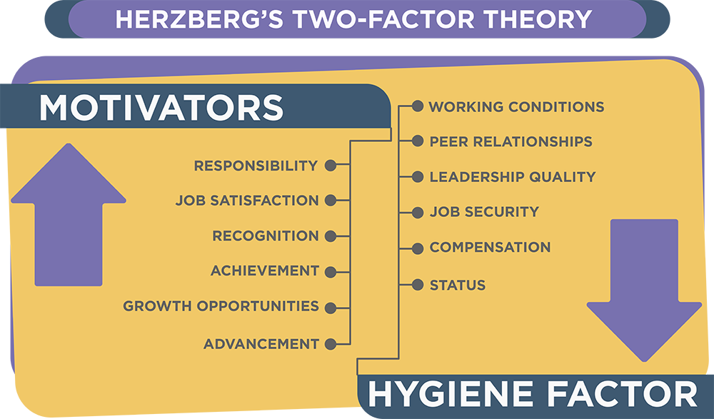

Figure 2: Herzberg's Two-Factor Theory
Figure 1: Maslow's Hierarchy

"Motivation in the workplace is defined as the willingness to exert high levels of effort toward organizational goals conditioned by the effort’s ability to satisfy some individual needs" (UNC, 2015) As stated before, motivation could determine employees to perform better within an organization and to demonstrate the skills and abilities they possess in a positive manner. Managers have the role to develop the willingness of their employees to work hard towards the set goal in order to demonstrate the commitment they have for the wellbeing of the company. A specific example would be the employees of Apple who are put under a lot of pressure to give everything for the company, but the pay is at the same level with the requirements.

Conclusion
Leaders and managers could be two different persons. A manager could be a great leader if the social skills are handled cautiously. "A managerial culture emphasizes rationality and control." (Zaleznik, 1977, p.3) Rather than highlighting the social, cultural and other demographic aspects as a leader would do, managers tend to control in a more realistic manner the situation. Leadership styles need to be associated with the nature of the organization in order to work out. For instance, if a democratic approach within a marketing company would be taken, the creative thinking and critical thinking would be restricted, thus, the decrease in motivation to perform well will appear. Leaders are a great source of inspiration and can inspire others to perform in the same way as they do. Creating a vision and raising the level of the organization to a higher one is what defines the best the capacities of a leader.
Nowadays, the work environment has a lot of stress and employees are put under pressure to meet the requirements given by many superiors. This report explained what motivates the employees to continue under these conditions and specifically, employees are motivated by either hygiene factors or motivators. The importance of leadership skills and managerial aspects is highly important within an organization as they can dictate the performance recorded by the business. A manager with strong and defined leadership skills could be greatly appreciated within an organization thanks to the power they have towards the team.

References
Herzberg, F. (1964). The Motivation-Hygiene Concept and Problems of Manpower. Personnel Administrator (27): pp. 3–7.
Maslow, A. (1954) Motivation and Personality. New York: Harper Row.
Mindtools.com. (n.d). French And Raven's Five Forms Of Power: – Understanding Where Power Comes From In The Workplace. [online] Available at: <https://www.mindtools.com/pages/article/newLDR_56.htm> [Accessed 12 June 2020].
Mindtools.com. (n.d). Leadership Styles: Choosing The Right Approach For The Situation. [online] Available at: <https://www.mindtools.com/pages/article/newLDR_84.htm> [Accessed 11 June 2020].
Mohammed, K., Othman, J. and D'Silva, J. (2012) "Social Demographic Factors That Influence Transformational Leadership Styles among Top Management in Selected Organizations in Malaysia". Asian Social Science, 8(13), p. 51-58.
Porter, Lyman, W., Richard M, Steers, Richard T. Mowday, and Paul V. Boulian (1974) "Organizational commitment, job satisfaction, and turnover among psychiatric technicians." Journal of Applied Psychology, 59: 603-609.
Russell, R. (2001). The Role of Values in Servant Leadership. Leadership & Organization Development Journal. 22. 76-84.
Susman, D. (2020). What Are The Pros And Cons Of Autocratic Leadership?. [online] Verywell Mind. Available at: <https://www.verywellmind.com/what-is-autocratic-leadership-2795314> [Accessed 9 June 2020].
UNC. (2015). The Role Of Motivation In The Workplace. [online] Available at: <http://execdev.kenan-flagler.unc.edu/blog/the-role-of-motivation-in-the-workplace> [Accessed 14 June 2020].
Zaleznik, A. (1977). Managers and leaders: Are they different.

