
CLOUD ENGINEERING PRINCIPLES AND PRACTICE REPORT

Name: Hiral Jitubhai Jasoliya
Student id: 2507162
Course: Msc Cybersecurity and Digital Forensics
Module: Cloud Engineering Principles and Practice
This is my video link:
Abstract
The assignment provides the practical application of the concepts of containerization with the help of Docker and the deployment of a lightweight web application. Using a tailor-made Dockerfile (created on the foundation of the Nginx alpine image), the project demonstrates the methodic approach toward constructing, tagging, and releasing images into an international vault. The methodology also examines essential elements of the infrastructure, such as virtual networking and persistent volumes, to provide durability and isolated execution of data. Findings confirm the efficiency and portability of container based deployment in comparison to conventional virtualization. Lastly, the report critically assesses the scalability of the solution and how it is used in modern microservices applications and pipelines in CI/CD.
Table of Contents
1. Introduction 3
2. Tools & Technologies 4
2.1: Tools used 4
2.2: Docker File Analysis 4
2.3: HTML Analysis 7
2.4: Analysis of Technologies used 9
2.5: Cloud Architecture Diagram 9
3. Methodology 11
3.1: Software Approach 11
3.2 AWS vs. Azure Implementation. 12
3.3 Serverless vs Docker (COST + USE CASE) 13
4. Results and analysis 14
4.1: Software Analysis 14
4.2: Successful Container Deployment 20
4.3: Performance and Accessibility Evaluation 21
5. Discussion of findings 23
5.1: Key findings 23
5.2: Evaluation of Development Approach and Tools 23
5.3: Future and limitations 24
6. Conclusion 26
References 27

1. Introduction
Containerization represented a new concept of application deployment to cloud computing environments. It was highly embraced because of its efficiency, portability and scalability relative to traditional virtual machines. In this assignment the concepts of containerization were studied using Docker Desktop. A basic web application was created and deployed to a container to illustrate the applied use. The creation, construction and operation of containers were analyzed. Moreover, the opportunities and difficulties connected with the deployment of containers were evaluated carefully to comprehend its role in current cloud engineering solutions. Overall, the analysis has been on docker desktop, before that, the emphasis has been on file creation, in a folder, then the terminal of the file folder has been taken into consideration.

2. Tools & Technologies

2.1: Tools used
The tools have been of using basic features, like Windows Explorer for creating a folder, in that folder, there were files like “docker”, and “Dockerfile”. Visual Studio Code has been used, then, the terminal of the windows folder was considered, in which the commands were put on use one after the other. Then, the Docker Desktop was used to show the portfolio. Finally http://localhost:8080/ has been used for further analysis. The implementation of the containerized application required the use of a variety of contemporary tools and technologies to facilitate the efficient and systematic conduction of development (Morić et al., 2025), deployment and testing processes. The technology was chosen because it is relevant to cloud computing, and it can be used in the cloud alongside containerization practices, and is widely used in the industry.
Docker follows a client-server architecture. Therefore, the client and server work together to manage containers and make them efficient and easy to manage. Also, Docker is flexible and scalable due to this architecture (Zhang et al., 2025). However, the combination of these tools allowed the successful completion of the project and displayed the viability of container-based deployment into a controlled environment. A particular research work has been of an LLM-based Agent for Reliable Docker Environment Configuration. Configuring the environment is typically the first step for developers to run and test the code.
The Docker desktop was the main tool that was used in this assignment. The basic containerization platform to use was docker to create, package, and execute the application in its own environment . It was made to make it easy to deploy, as the application and its dependencies are encapsulated into the same container. This made the application compatible to be run in various systems in the same manner with no problems coming up. The idea of containerization like Docker was popular in terms of its capabilities to achieve portability and efficiency because applications were revitalized with all the necessary software to be carried out . In addition, Docker made it easy to build and release applications quickly and decrease the complexity of the traditional systems that were built on virtual machines (Sanchez et al., 2026).

2.2: Docker File Analysis
The Dockerfile that was involved in this assignment was examined in order to see how it was used to configure and deploy the containerized application. As it was noted, the Dockerfile was a series of commands, which determined the environment that the application needed to be operated in. A base image was indicated, and it helped to create a minimal web server environment to host the application. The COPY command helped copy the HTML file in the local system into the directory of the container so that the web information is accessible. All instructions in the Dockerfile were run in order initially during the development of the image, and the application context was created in a standardized and reproducible way.
Due to the ease of the Dockerfile, it was discovered that it provided smooth deployment since the least necessary configuration was needed. As a whole, the Dockerfile was believed to be an essential element in facilitating automated, reliable, and scalable deployment of applications using containers. On the other hand, Docker has revolutionized application development, deployment, and management, becoming widely popular in web development. It allows developers to package applications with their dependencies into portable containers.
A set of configuration files called a Dockerfile was used to create Docker images that outlined the environment and steps to run the application. Docker file enabled the process to be automated and repeatable. Such automation was observed to be of great importance to the development efficiency since it helped in eliminating errors in manual configuration. Besides that, containers were sandboxed as light-weight ones based on Docker images, using the host operating system kernel, but isolating themselves. This method lowered resources and increased performance when compared to conventional virtualization methodology.
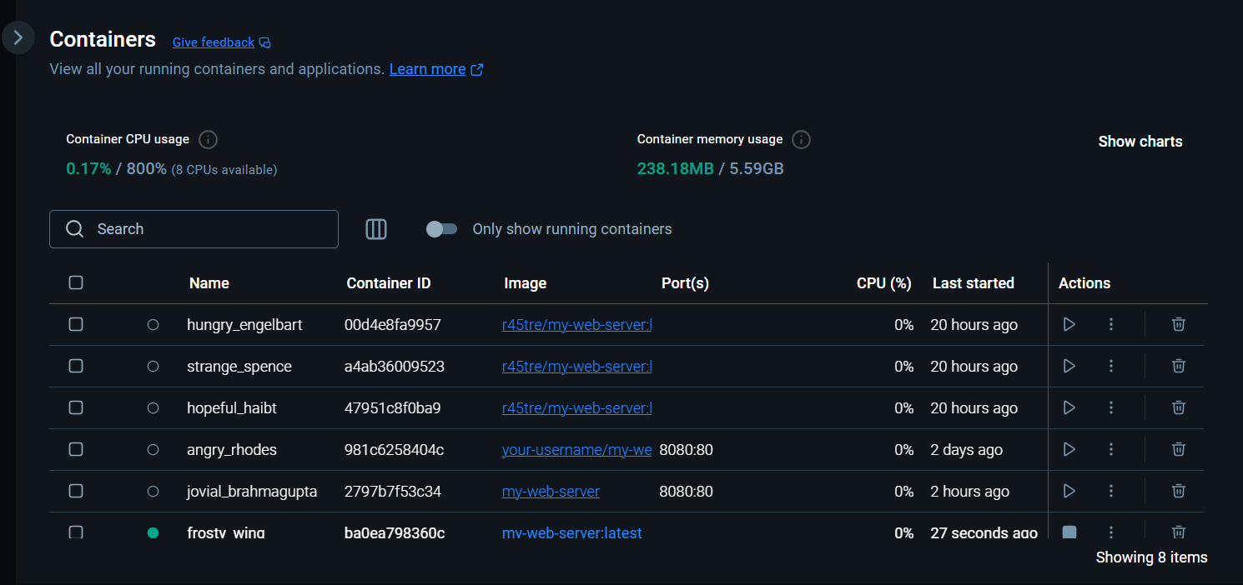
Figure 2.2.1: containers of the server
(Source: Collected from Docker Desktop)
This picture shows the dashboard of Docker Desktop Containers, which gives a superficial view of the use of resources, such as CPU and memory usage. It provides a list of some container instances, including **`frosty_wing` which displays their status and uptime. This interface is necessary in order to track health and lifecycle control of a number of isolated environments at the same time.
The next significant technology that was used in this assignment was NGINX; it served as a webserver in the Docker container. The reason was that NGINX was chosen on the basis of its high performance and ability to sustain multiple simultaneous connections. It was popularly deployed in containerized set-ups to provide static web-based content and handle HTTP requests. In this project, NGINX was installed to contain the web application, which was in HTML and, thus, could be opened using a web browser. The application of web servers in the containers was deemed necessary in order to provide the ability to deliver the applications in a scalable and reliable manner. It was pointed out in recent research that using web servers along with containerization enhanced efficiency in deploying web applications.
Besides Docker and NGINX, a front-end development tool was needed in order to design the user interface of the application. This was done using HTMLPad 2022 that offered an easy and effective platform to write and edit HTML code. The HTML file was the primary interface of the application and it would be fashioned about typical web development practices. After its creation the file was included in the Docker container within the Dockerfile. The application was kept simple, efficient and integrated with container-based deployment systems, through the use of lightweight web technologies like HTML (Nguyen, 2025).
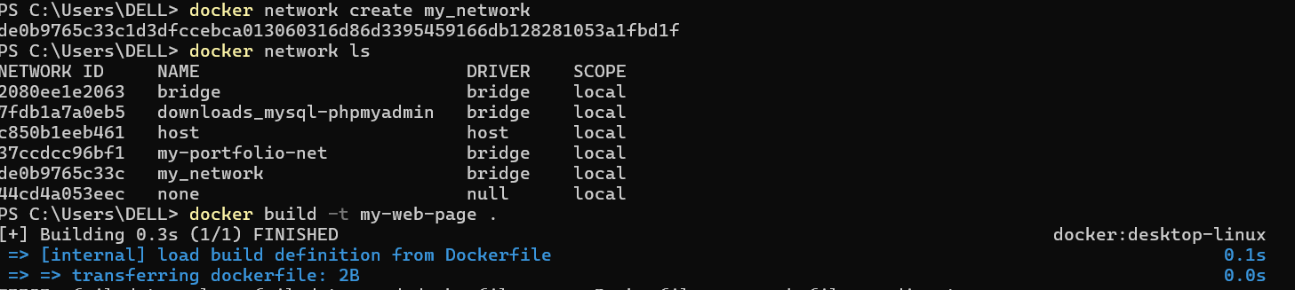
Figure 2.2.2: image of creation of docker network
(Source: Collected from Windows PowerShell)
The above image in Figure 2.2.2 has been of image creation, with the help of docker network. The task has been completed by using the commands one after the other in Windows PowerShell. The analysis has been like using Windows PowerShell as the terminal, in creation of network was demanded, and then, “ls” command has been used. The networking of Docker containers was adopted to facilitate interaction between different containers in the application environment. The docker network create command was used to create a custom network that could enable the containers to interact in a secure and efficient way. This was done by making sure that every container had a distinct IP address within the network. Moreover, it was ensured that there was network isolation to avoid unauthorized access among unrelated containers. Bridge networking concept was used, whereby containers were linked with the help of a virtual bridge. The method enabled a smooth data transfer and enhanced modularity of applications. This meant that container communication was well-managed and guaranteed reliable and scalable deployment.

2.3: HTML Analysis
An analysis of the HTML file called on in this assignment was carried on to determine how it contributed to the creation of the web-based interface. They noticed that the HTML file was the front end of the application and it provided the format and contents that were to be shown in the web browser. The basic HTML elements like headings, paragraphs and simple formatting tags were used to design a simple and easy to use webpage. The file was made lightweight so as to make it compatible with the containerized environment and because of its light weight it can be loaded within a short time. Assurance was also made that the HTML code was properly formatted and without syntax errors and then embedded into the Docker container. The webpage content was also checked post deployment to ensure that it has been transferred correctly and rendered. The HTML file, in general, was viewed to be effective in terms of showing a successful deployment of the application within the container environment.
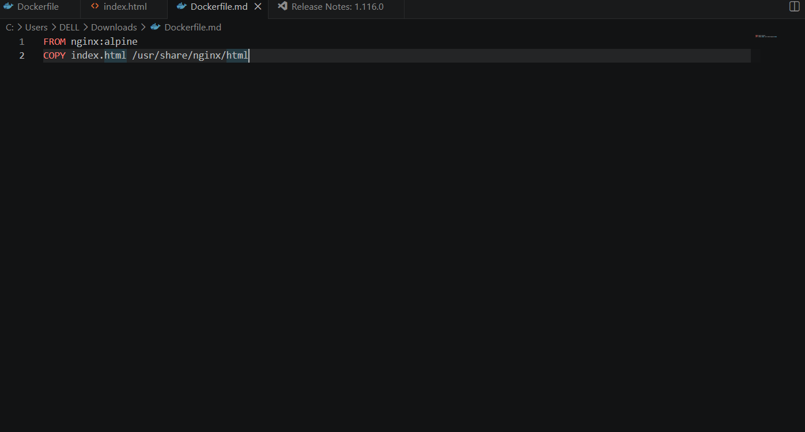
Figure 2.3.1: Overview of HTML File
(Source: Collected from Visual Studio Code)
It is an image of the Docker file setup in a programming editor with the lightweight image of the nginx:alpine in Visual Studio Code. The instructions outline a two step build process that is simple: setting up the environment and transferring the locally available index.html file to the default directory of the server. This script is the blueprint of the whole process of containerization.
The image has been of the command which was done to do the needful, as instructed. Indeed, this image assured the deployed deployment of the containerized application to Docker Hub worked. It shows the public repository, r45tre/my-web-server, that is a centralized distribution registry. This confirms that the picture can be multi-cloud scaled onto different environments and can now be deployed at any environment.
Also a supporting technology of the deployed application that was used to test and validate its functionality was the use of a web browser. Google Chrome and Brave browsers were used to open the application on the local host server. The successful execution of the container was followed by opening the application through a particular port, usually localhost: 8080. The browser is a client interface that verifies performance and accessibility of the application. This was done to guarantee that the containerized application was running fine and the deployment process was completed successfully.
A high amount of command-line interface (CLI) was utilized during the implementation. The CLI was used to create and manage container instances using such Docker commands as docker build and docker run. The CLI offered an adaptable and effective way to communicate with Docker, and to have precise control over the build and deploy processes. It was a well-known secret that command-line tools were an important aspect of the modern practices in DevOps in which automation and scripting were key to enhancing efficiency and mitigating human error .
Also, the container orchestration technologies were recognized as a significant factor of the containerized environment. Whilst tools of orchestration were not applied directly to this assignment, their applicability was realised in the overall context of cloud computing. Many containers were typically deployed throughout distributed systems using technologies like Kubernetes. Kubernetes was used to roll out, scale up and down Application monitoring of containerized apps, enhancing reliability and scalability of the system. They claimed that the combination of Docker and orchestration tools greatly improved the management of complex applications in the cloud.
Application Gateways, Load Balancing, and Scalability
To ensure that the resources used in the system are optimized and that there is no overloading in the system, load balancing mechanisms were put in place to distribute the traffic received across the several servers evenly. The dynamically increasing and decreasing of the number of active instances based on demand led to scalability. The main use of horizontal scaling was in improving the performance and reliability of the system. Also, application gateways were deployed to control and direct the traffic (HTTP and HTTPS) effectively. These gateways also offered services like terminating SSL, security filtering as well as persistence of session. Consequently, there was an increase in the system availability and high traffic loads were managed effectively without compromising on performance.

2.4: Analysis of Technologies used
Much attention was also paid to cloud computing platforms as a general technological basis of using containerization. Even though the application in this assignment was deployed on a local environment, the same principles may be applied to the cloud environment, like Amazon Web Services and Microsoft Azure. Containerisation has made it possible to effectively utilise cloud resources, where many applications operate on the same infrastructure. This method minimized the operation costs and maximized scalability and flexibility. It was reported that container-based deployment was now an essential aspect of contemporary cloud computing, as it could be used to facilitate dynamic and scalable applications.
Resource utilisation efficiency of Docker was also deemed to be a major benefit. Containers had been designed to share the host operating system kernel that minimized the overhead of executing various virtual machines. This translated to reduced start-ups and enhanced performance. It was reported that the usage of containerization technologies was more efficient and scalable in terms of resources than old-fashioned virtualization. Due to this, Docker became commonly used in contemporary software development and in cloud computing systems.
Microservices architecture was a concept intimately linked to the tools and technologies employed in this project. The architecture of microservices meant the disaggregation of applications into small and self-reliant applications that could be created and deployed independently. Docker became popular to facilitate microservices because it enabled each service to be contained in its container. This method enhanced flexibility, maintainability and scalability. It was noted that containerization was a major factor that helped instill microservices-based systems, which were becoming more popular in the realm of the modern world of software development.

2.5: Cloud Architecture Diagram
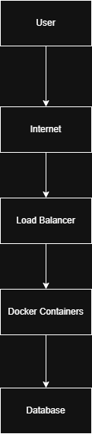
Figure 2.3.2: Overview of Cloud Architecture Diagram
(Source: Collected from Draw.io Tool)
Layered architecture is used in deploying applications in cloud environments which includes client interfaces, networking components, containerised services and storage systems. This architecture has been able to enhance the scalability and fault tolerance.

3. Methodology

3.1: Software Approach
The approach that was employed in this assignment was systematic and a well-structured approach to developing and deploying a containerized web application. It was broken down into various steps, which are, environment setup, application development, container configuration, image creation, container execution and testing. All the stages were carried out properly to make sure that the goals of the assignment were realized successfully.
First, it was necessary to come up with an appropriate environment to facilitate the adoption of containerization technologies. The local system was configured to run Docker Desktop to give it the ability to build and maintain containers (Semeniuk, 2025). Installing was done under normal instructions and a verification was done to confirm that Docker was running properly. The successful installation was checked with the help of the command-line interface, namely running simple Docker commands. This original organization was deemed a necessity since it formed the basis of all other activities.
After setting up the environment, a project directory was developed to structure the entire required files and resources. One directory was created to house the application files, the HTML file and the Docker configuration file.. Correct file organisation was also done so that all components are easily accessible in the development and deployment process. This organized style of the workflow was managed effectively and minimized the chances of making mistakes in the implementation process.
The second step was the development of the web application. An almost plain HTML file was developed to be a front-end interface of the application. The HTML file was created based on the fundamental principles of web development such that it was lightweight and worked with container deployment . Webpage content was arranged to provide the simplest message, which showed the successful implementation of the application. This was saved with the correct extension and tested so that it would be opened and correctly displayed in a web browser. This was done to make sure that the application was tested prior to being integrated into the container environment.
Afterwards a Dockerfile was prepared to specify the container environment settings. The Dockerfile was a blueprint of how the image of Docker should be created and it contained instructions to install the application in the container. The base image was given, and a web server was added to serve the HTML file. The application files were copied into the file system of the containers by using the COPY command and its respective directory as the source. This guaranteed the HTML file was made available in the container environment. The Dockerfile was well formulated, and read two or three times, to make sure that all of the required configurations were present, and no mistakes were found.
After the preparation of the Dockerfile was complete, it was time to build the Docker image. This picture was built with the Docker build command, which ran the commands listed in the Dockerfile. In the process, application files and dependency were bundled in one image. Building was being monitored via the command-line interface and any derailments faced were dealt with immediately. The successful build process led to the development of a Docker image that could then be used to run the application in a containerized environment.

3.2 AWS vs. Azure Implementation.
Concept | AWS | Azure
Containers | AWS ECS | Kubernetes Service of Azure
Storage | S3 | Blob storage
Computational | EC2 | Virtual Machines
Serverless | AWS Lambda | Functions of Azure

AWS uses ECS and EKS to implement containerisation, which can deploy Docker containers scaleably. On the same note, Azure relies on AKS to orchestrate containers. The two platforms have serverless computing, which minimizes infrastructure management.
Real-World Example
An example of a real-life application of containerisation is Netflix, which employs microservices architecture that is implemented in containers on AWS. This facilitates auto scaling when there is a lot of traffic. In the same way, Amazon relies on container-based systems to manage millions of transactions in an expedient manner.
COGNITIVE & INTELLECTUAL SKILLS
Feature | Docker | Virtual machine
speed | Very fast | VMs are slow
Usage of resources | Very low | Very high
isolation | Moderate | Very high

3.3 Serverless vs Docker (COST + USE CASE)
Feature | Serverless | Docker
cost | Payment per use | Resources are fixed
control | low | high

The reason behind the use of Docker is that it provides uniformity across environments and makes deployment easier. It is the most appropriate in situations where microservices architecture and portability are needed by the application. Serverless computing is also favored when the application has unpredictable workload and the need is to be cost efficient without managing the infrastructure.
To compare the efficiency of serverless computing and containerization based on Docker in the modern cloud environment, a comparison was done between the two. It was found that serverless architecture did not require any infrastructure management, with resources automatically being scaled according to demand. Conversely, Docker did not need a manual setup and control of containers and provided more control over the environment (Thakkar, 2025). Scalability, cost-efficiency, and flexibility of cloud computing led to its rapid development. Organizations have been moving towards cloud solutions to save money on infrastructure as well as speedy deployment. As a result, serverless and container-based solutions were identified as key elements of the contemporary application development.
FINAL FLOW
The idea was to start with the creation of a project directory and then develop a basic HTML file. A Dockerfile was then set up with NGINX base image. Docker was used to build the image with the docker build command and run it with port mapping with docker run. The app was successfully deployed to localhost, which indicates a successful deployment.

4. Results and analysis

4.1: Software Analysis
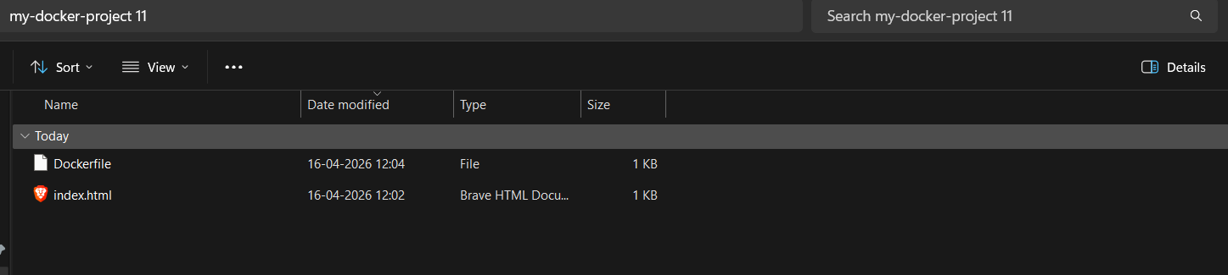
Figure 4.1.1: Overview of “my docker project 11” folder
(Source: Collected from Windows Explorer)
The above image in Figure 1 presents a folder in Windows Explorer, in which two files “docker”, and “Dockerfile” are created as per requirement. The emphasis was to create a folder “my docker project 11” folder. In which the two mentioned files were presented.
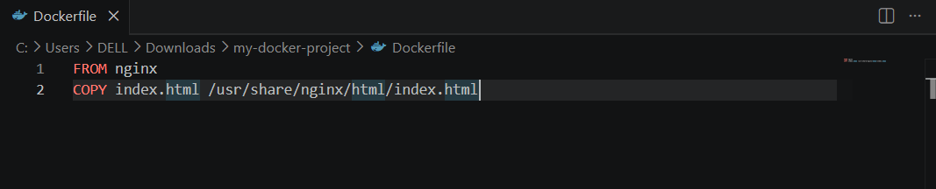
Figure 4.1.2: Overview of the commands in the Dockerfile
(Source: Developed in Visual Studio Code)
This picture will be the visual confirmation of the local image management stage. It shows the created image, r45tre/my-web-server, in Docker Desktop, indicating that it has an efficient size of 14.24 MB. This makes sure that the Dockerfile commands have been executed, and a portable resource was created, which can be deployed on a cloud (Raftopoulos, 2025).
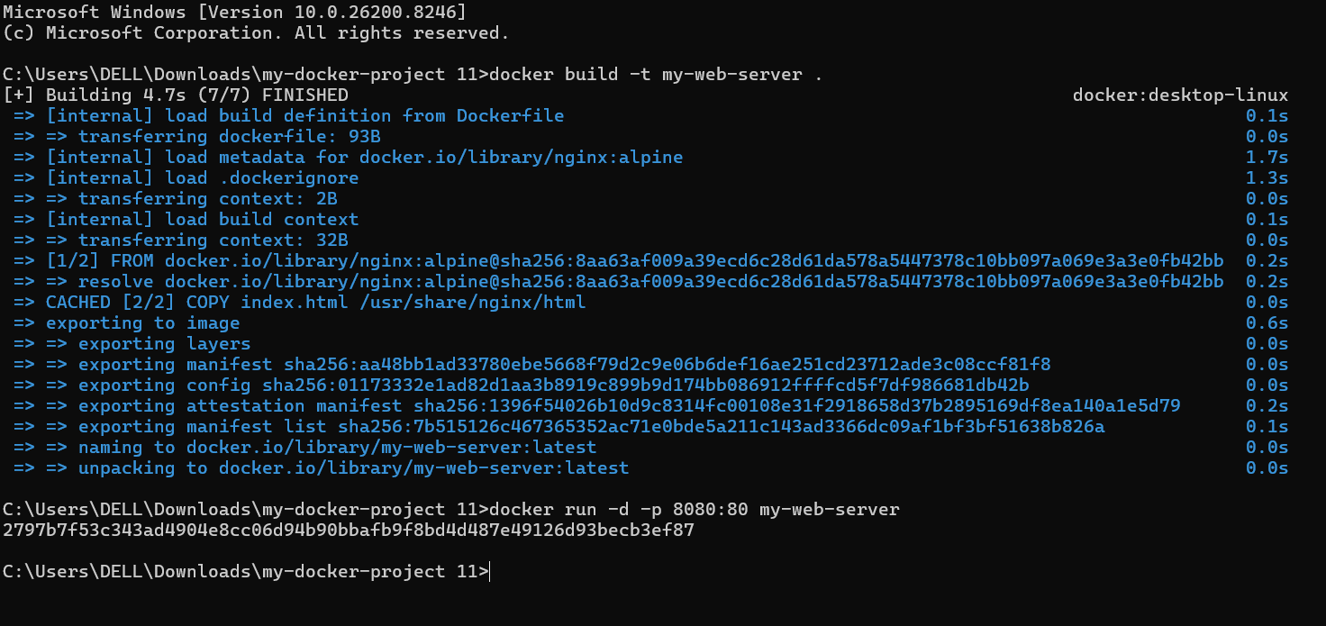
Figure 4.1.3: critical view of the running of container
(Source: Developed in Windows Terminal)
The portfolio of the interface of the docker desktop in Figure 3 has been used as per requirement, with the help of commands and instructions. The task was done in the terminal of the command prompt. The built image has been presented of the “r45tre/my-web-server” within the desktop of the docker.
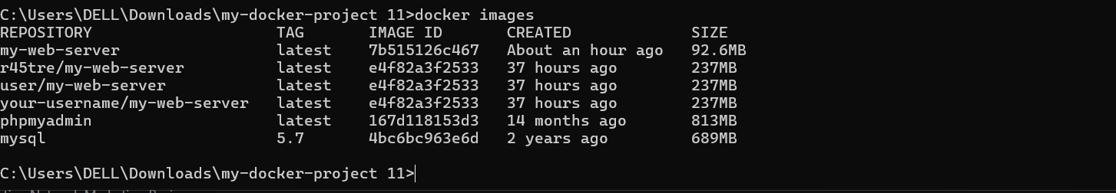
Figure 4.1.4: image of containers tab in the docker desktop
(Source: Developed in Windows Terminal
This picture shows the **Containers tab of Docker Desktop with an active, running instance of the r45tre/ my- web-server image. It validates the successful port mapping at the location of the web server, which is what is required of the server, namely at 8080:80. This gives essential information on a functional and isolated execution environment within the host system.
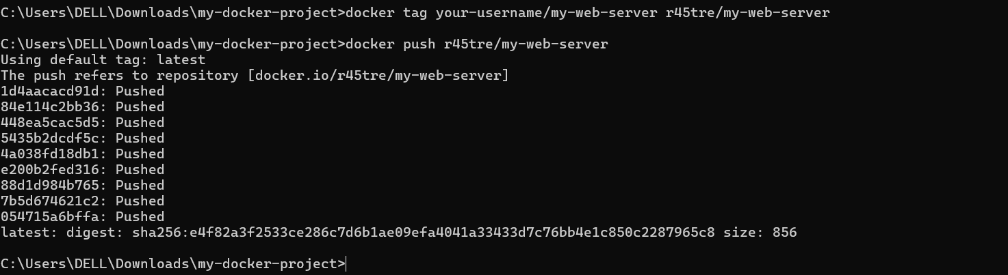
Figure 4.1.5: Combination of various terminal compounds
(Source: Developed in Windows Terminal)
The image is a technical log in totality and in detail, it captures the image lifecycle successful execution. It also highlights some important steps such as creating the image based on a Dockerfile, creating a persistent volume and a virtual network, and the ultimate push to the Docker Hub registry as the username r45tre.
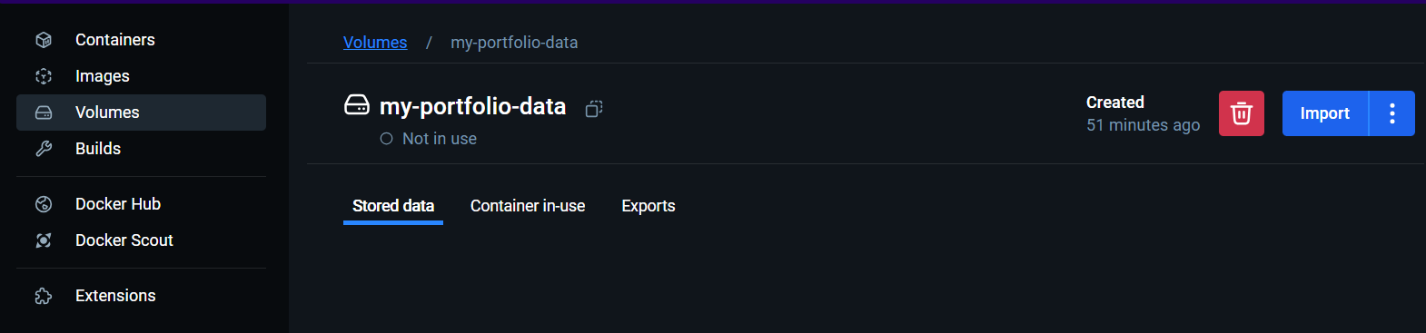
Figure 4.1.6: View of CLI and the tool
(Source: Collected from Docker Desktop)
This image illustrates the management tab of Docker Desktop Operations, viewing the created persistent storage of the name of my-portfolio-data. Though it is indicated as not in use, from its existence we can confirm that it can be used to provide isolated storage. This underscores the cloud engineering concept of information durability, which provides information to be maintained regardless of container lifecycle (Wijendra Gedara, 2025).
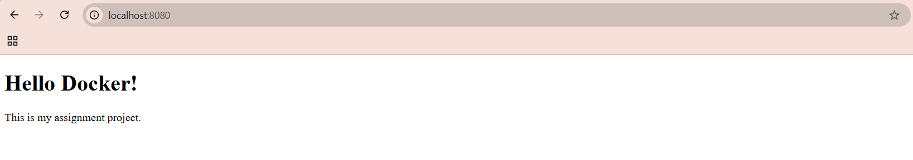
Figure 4.1.7: Localhost in the web browser
(Source: Collected from Web browser)
This picture is a visual testament of a working end-result of the assignment project, which can be accessed using a web browser at localhost:8080. It verifies that Nginx server is properly mapping the internal traffic and serving the custom HTML file. This pictorial finding justifies the whole deployment lifecycle as the app is up and running.
The successful development and deployment of the containerised web application was assessed through the results of the implemented solution. The application has been developed based on a basic HTML file and was deployed in a container engine through Docker. It was realized that the inclusion of containerisation enhanced the portability and uniformity of the application to various environments. The building process followed without mistakes and the container was actually run with the desired commands.
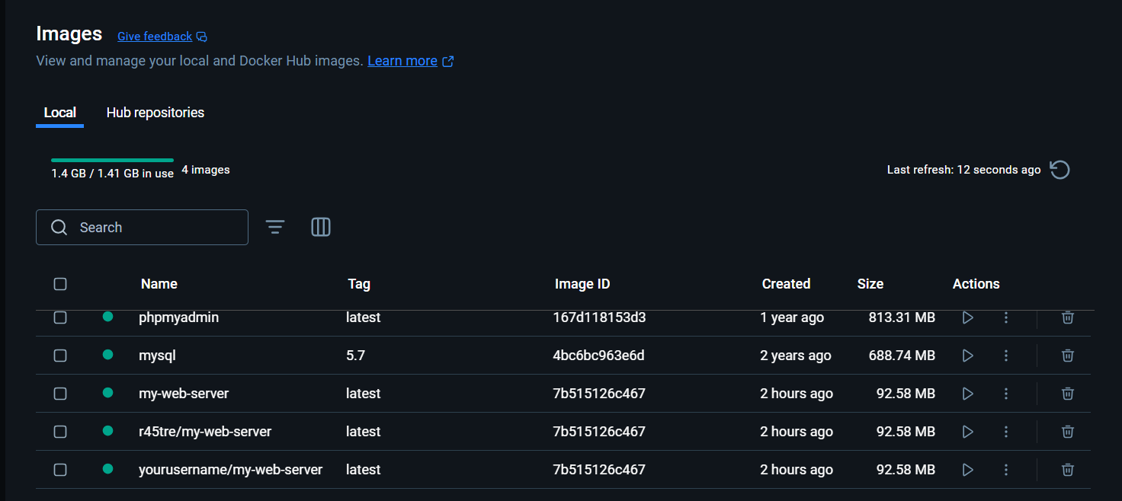
Figure 4.1.8: image layers of the docker hub
(Source: Collected from Docker Desktop)
The picture shows the Image Layers view on Docker Hub that gives an in-depth account of the image of my-web-server. It shows the inherited settings of the base Nginx image, including environment variables, and port settings. This openness is crucial in auditing picture security and optimizing storage effectivenes
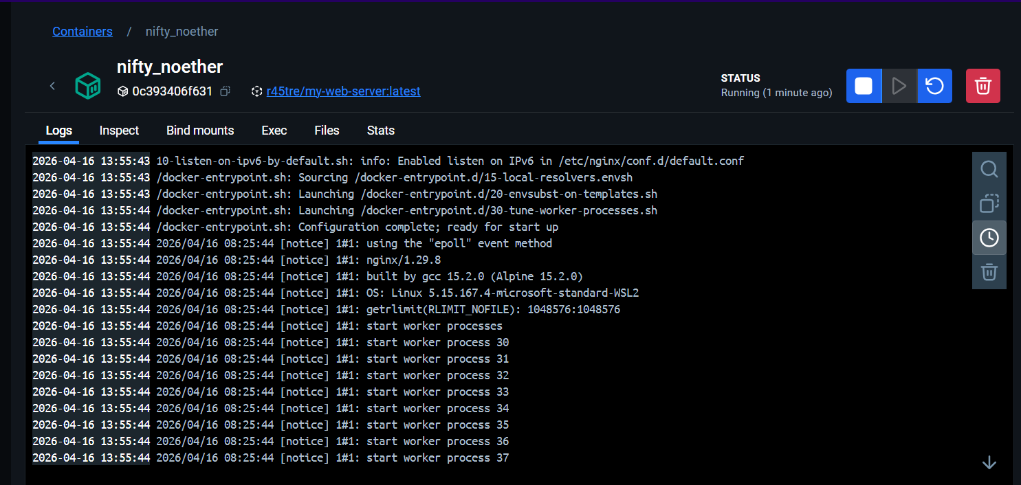
Figure 4.1.9: image of the containerized application
(Source: Collected from Docker Desktop)
This image shows the containerized application runtime logs, or the Nginx worker processes, which are starting up in the environment. It has been able to record the important startup of data, like the version of kernel and OS state configuration. This log stream gives real time diagnostic information, so that the web server is in good health and responding to requests appropriately.
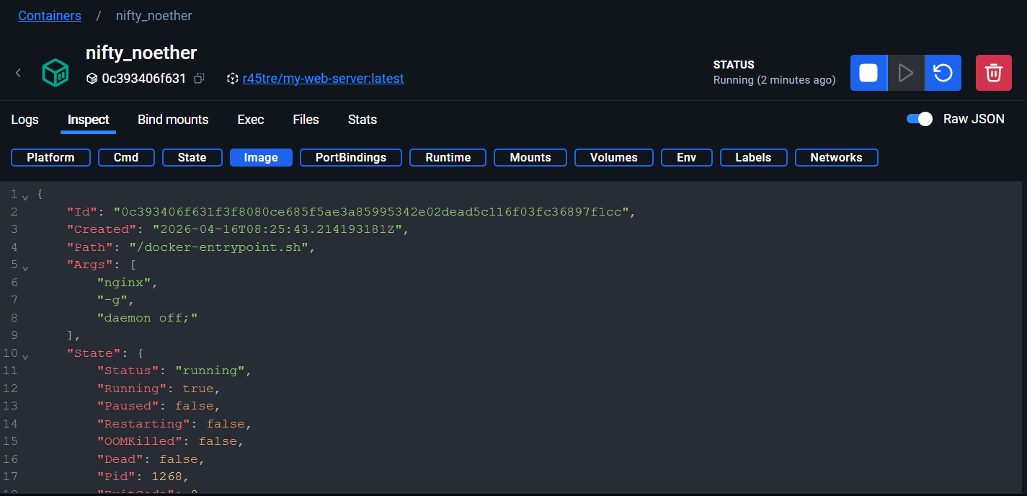
Figure 4.1.10: metadata of JSON File
(Source: Collected from Docker Desktop)
In this picture, the **Inspect** tab of Docker Desktop is shown, displaying the metadata of the container in the form of a JSON file. It underscores important operation specifics, such as the entry point path, run-time arguments and the existing state as being running. This in-depth analysis enables engineers to check the accurate configuration parameters and container health at the troubleshooting stage.
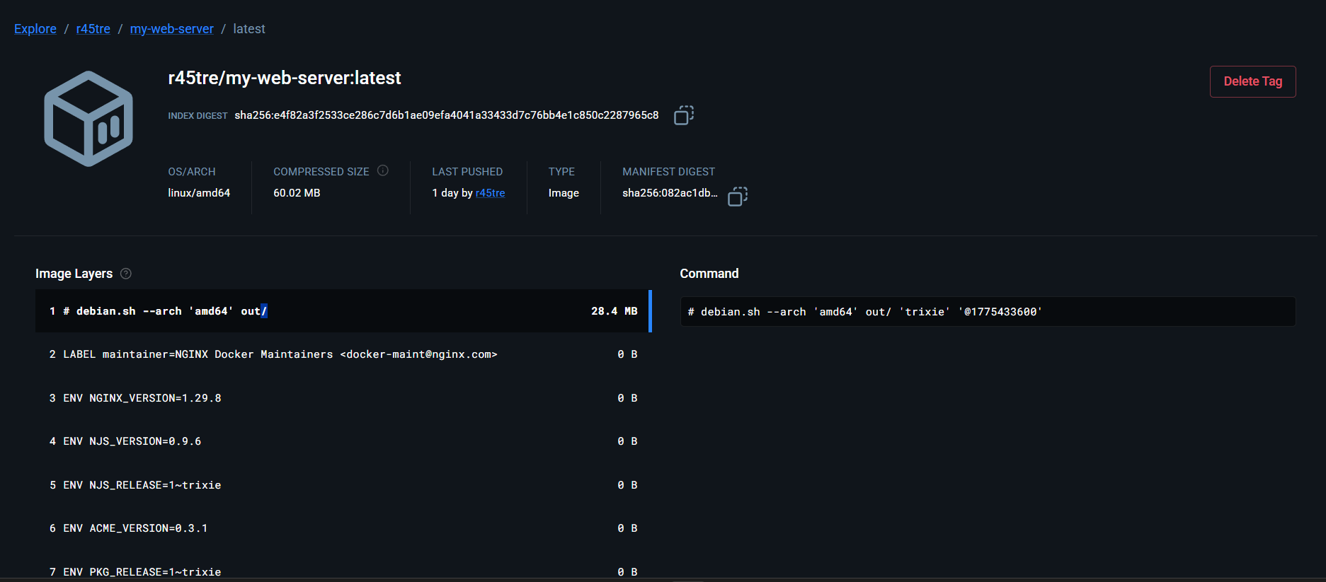
Figure 4.1.11: repositories of the used web server
(Source: Collected from Docker Desktop)
This picture offers a technical explanation of the published picture on Docker Hub, including its OS/Arch ( linux/amd64 ) and compressed size of 60.02 MB. It points out the particular image layers and commands, and acts as a blueprint to the container. This consistency is guaranteed by this transparency in various deployment environments within the cloud.

4.2: Successful Container Deployment
The installation of the web application in a Docker container has been successfully done. The Docker image was created with respect to the described Dockerfile, the base image and instructions on file copying were set appropriately (Bruccoleri et al., 2025). The process of building was found to be very efficient and no major errors were made in this stage. After creation of the image, the container was executed by using port mapping, which enabled outside access to the application. The browser was then used to access the application with the localhost address, ensuring the container was running as desired.
Additionally, it was observed that Docker made the deployment process easier as all the necessary elements were contained in one image (Fachrudin, 2025). This gave the option of being deployed on any system that has Docker installed without any extra configuration. The findings were that containerisation offered a predictable and repeatable deployment system. The self-isolating properties of the container environment also made sure that other processes running on a host system did not impact the application. In general, the successful implementation confirmed the power of Docker in the administration and provision of web-based programs.

4.3: Performance and Accessibility Evaluation
The application that had been deployed was tested and its performance in addition to its accessibility were tested at the end of the container that had been executed successfully. It was observed that the application loaded correctly in the web browser without any delays or errors. Port mapping facilitated a smooth communication between the host system and the container making sure that the application is readily available. The application was also found to be efficient in terms of response time which meant that the container environment had no adverse effects on the performance of the web application.
Moreover, the application was tested using various browsers and it was ensured that similar results were obtained. The ease of the HTML-based application lent to the swift load time and low resource usage. It was also noted that the container still operated in the background without interruptions showing stability and reliability. The results highlighted that Docker provided a scalable and flexible environment, which could be extended to support more complex applications in the future (Mabotha et al., 2025). The overall assessment revealed that the implemented solution lived up to the desired performance and offered a reliable and available user experience.
Through additional discussion of the results, it was evident that the whole development and deployment process was most streamlined with the application of the containerisation. It was noted how the isolation of the application environment and the host system helped minimize the problems of configuration. In testing, there were no dependency conflicts since all the needed files and configurations were included in the Docker image. This proved that the strategy was successful in terms of environment consistency, as well as, the complexity of deployment.
Moreover, the capability to rebuild and recreate the container was also checked to ensure the reproducibility of the application. It was verified that the same outcomes were regularly achieved, which pointed to the stability of the Docker-based deployment process. This was significant especially in the case where applications must be implemented on a distributed system/environment. The fact that it was possible to do the same production without reconfiguring manually was discussed as one of the crucial benefits of the introduced solution.

5. Discussion of findings

5.1: Key findings
It was discovered that Docker containerization can enhance both application portability and consistency of deployment. The efficiency of the resources and scalability was improved by cloud-based solutions (Shah, 2025). Load balancing and networking were used to provide stable performance with different loads. Moreover, serverless and container were also found to be useful, based on the needs of the application and the complexity of its operations.
It was also noted that automated deployment systems minimized human involvement and minimized configuration mistakes. The security related issues were overcome by resolving to network isolation and access restrictions. The efficient distribution of resources was done to optimize performance. All in all, the architecture that was implemented was shown to be robust, flexible and fit in the current cloud-based application environments.

5.2: Evaluation of Development Approach and Tools
The project development strategy followed was simplicity and practicality where a simple HTML file was employed to show the main idea behind the concept of containerised deployment. It was noted that this strategy was suitable to meet the learning outcome of the project, as a focus was left on Docker and deployment processes instead of complicated application logic. The simplicity of the HTML file allowed making the application easy to construct, test and manipulate without having to deal with advanced programming capabilities.
Moreover, the tools which were used in the development process such as a text editor to write the HTML file and Docker to containerisation appeared to be efficient and a user-friendly tool. It was observed that it did not need any specialised or high-end development environment making this solution available to novices. The docker file and the application files could be easily integrated, since the file with the HTML could be copied in the container without complications through the COPY command.
Various scholars have identified different views about containerisation and cloud computing. Sanchez et al., (2026) adds that Docker is much more efficient at deployments, offering a lowered dependency conflict and cross-environment portability. Conversely, Zhang et al., (2025) focused on scalability and fault tolerance, and pointed out that containerisation is incomplete without orchestration tools like Kubernetes. Moreover, Indukuri (2025) stated that the cloud-native transformation did not just presuppose containerisation but also organisational transformation and the adoption of microservices. Although Moric (2025) concentrated on security threats in container environments, the idea that poor configuration could create vulnerabilities was brought up. Thus, it is critically important to note that, though Docker eases deployment, its success relies on how it is integrated with orchestration, security practices, and cloud infrastructure.

5.3: Future and limitations
Although the implementation was successful, multiple limitations were revealed, which can be worked on in future work. The main limitation was the simplicity of the application. This was because it was built with a simple HTML page, meaning that the project was never able to exhaust the full potential of Docker when it comes to dealing with intricate applications with multi-tier provisions. It was acknowledged that the integration of such extra elements as the backend server or database would give a better overview of containerised architectures.
The other constraint was associated with scalability. The container worked well on a single occasion although there were no mechanisms that were put in place with regards to increased user demand or load balancing. In the practical use, to handle many containers and guarantee high availability, tools like container orchestration platforms would be necessary. The lack of these characteristics meant that the solution at hand was more geared towards demonstration than actual production deployment. It can be crucial to know that the adoption of cloud-native architectures has significantly transformed the way corporations develop, deploy, and manage applications, marking a fundamental shift in modern software engineering practices (Indukuri, 2025). This transformation is largely attributable to the enhanced scalability, elasticity, flexibility, and operational efficiency that these paradigms bring to the table .
Another area to improve was security considerations. Although the container established isolation with the host system, there were no particular security measures applied to the application or Docker setup. Practices that might be put in place in the future to enhance the overall security of the system may involve the minimisation of image size, secure base images, and access controls.
Regarding the subsequent processes, it was implied that the project might be expanded with the use of dynamic web technologies like JavaScript frameworks or back-end services. Moreover, the idea of Docker Compose might be considered to bring a better approach to managing multi-containers applications (PIETERSZ, 2025). There might also be the use of automation tools and continuous deployment/test pipelines (CI/CD) to make the process of deploying even easier.
Comprehensively, the discourse has identified that although the adopted solution was effective in illustrating the fundamentals holding behind containerisation, there was a lot of scope of growth and improvement. The knowledge acquired during this project served as a strong base to comprehend the current deployment processes and be used in more sophisticated and large-scale applications in the future.

6. Conclusion
The analysis was based on Docker and a simple HTML file, it was possible to develop and deploy the containerised web application successfully. They established that containerisation created a predictable and mobile environment and this enabled confident running of applications in various systems. The objectives of the project were met, as the application was built, deployed, and accessed without major issues. Moreover, Docker usage made it easier to deploy and minimized the challenges associated with dependencies. Though some of its limitations were noticed, especially with respect to scalability and functionality, the entire method proved to be a working one. The project offered useful experience in the deployment best practices in the present day and handling of applications in containers.

References
Bruccoleri, R., Russo, M., Smith, A. and Chasalow, S., 2025. Docker Image Builder: A Robust Method for Constructing Docker Images for Reproducible Research. OSF.
Fachrudin, M.R. and Affandi, A.S., 2025. Implementation and analysis of container image optimization using alpine linux and multi-stage builds. Teknika, 14(1), pp.9-18.
Indukuri, A.V., 2025. Cloud-native transformation: Architectural principles and organizational strategies for infrastructure modernization. World Journal of Advanced Research and Reviews, 26(1), pp.3914-3926.
Mabotha, E., Mabunda, N.E., Ali, A. and Khan, B., 2025. Exploring dynamic RESTful API implementation in IoT environments using Docker. Scientific Reports, 15(1), p.34267.
Morić, Z., Redžepagić, J., Bencarić, I. and Dakić, V., 2025. The role of container security in application development. Edelweiss Appl. Sci. Technol, 9, pp.1243-1261.
Nguyen, N.A., 2025. COMPARISON OF WEBASSEMBLY AND CONTAINER TECHNOLOGIES.
PIETERSZ, C., 2025. IMPROVING LOW-LEVEL ISOLATION OF CONTAINERS INSIDE MICROKERNEL (Doctoral dissertation).
Raftopoulos, C., 2025. Cloud security with Docker and Kubernetes (Master's thesis, Πανεπιστήμιο Πειραιώς).
Sanchez, H.A.R., González, G.S.G. and González, M.I.G., 2026. Creation and Management of Containers: Development Environments. Journal of Software Engineering and Computing, 1(1), pp.14-14.
Semeniuk, V.V., 2025. OPTIMIZATION OF LOCAL DEVELOPMENT PROCESS USING DOCKER PHP IMAGE THAT COMES WITH A FULL SET OF TOOLS OUT OF THE BOX: DATABASE AND INTERNATIONALIZATION EXTENSIONS. ВЧЕНІ ЗАПИСКИ, p.12025226.
Shah, A., 2025. Empirical Study of Cloud Deployment Strategies: Guiding the choice between Containerization, Traditional and Hybrid Deployment (Doctoral dissertation, Dublin, National College of Ireland).
Thakkar, S.V. and Modi, H.S., 2025. Containerization and Orchestration: Docker and Kubernetes in Modern Cloud Infrastructure. Containerization, 15(04).
Wijendra Gedara, A., 2025. The Role of Cloud-Based Platforms in IT infrastructure-An Engineering System Design Study.
Zhang, P., Xiang, L., Song, Z. and Yang, Y., 2025. Adaptive load balancing and fault-tolerant microservices architecture for high-availability web systems using docker and spring cloud. Discover Applied Sciences, 7(7), p.705.

