Questions and Guidelines for Assessment Component 1



Changemakers: Creativity and Value Creation
Professions (BMHP5014)

Component 1: Online portfolio of set exercises

Student name:JAQUELINE MARISA SILVA MARQUES
Student number:2425635
Lecturer’s name:LAILA SURANI
Table of Contents
Introduction 4
Task 1- Defining Key Concepts in Practice 4
Task 2 - Mind Map 5
Task 3 - Self-Reflection of Group Activity 6
Task 4 – Case Study Analysis of a UK Innovation 6
Task 5 - Research Task 6
Task 6 - Exploring Digital Innovation in Health and Social Care 7
Task 7 - Understanding the NHS Leadership Framework 8
Task 8 – Self-Reflection Journal Entry 8
References 8

Questions and Guidelines for Assessment Component 1

Introduction
This Portfolio develops the creative and innovative use of value creation, change and leadership in relation to digital technology and health and social care. Shows understanding of learning activities during the week and to incorporates theories and frameworks in practice to address current issues (Mallek et al., 2024). There is a growing need to use creative and innovative means to enhance service user outcomes, staff experiences, ensure quality and efficiency and to meet evolving needs and resource pressures. The portfolio explores how these ideas can help in effective improvement and value creation in health and social care through a variety of practical tasks, case analysis, research and reflective exercises.

Task 1- Defining Key Concepts in Practice

Innovation
Innovation includes new or improved ideas, processes or technologies that generate positive change (West and Farr, 1989). In health and social care, innovation can help to meet rising demand, increase efficiency, effectiveness and quality of services. Examples of this include the use of digital monitoring systems in NHS virtual wards for suitable patients to access hospital care at home. Rogers' Diffusion of Innovation Theory provides an explanation of how innovations are adopted when the benefits and compatibility to existing practice is known (Rogers, 2003).
Creativity
Creativity is the production of novel and useful ideas that solve problems or can generate opportunities (Amabile, 2018). It is therefore applicable to health and social care as staff must be able to think practically about the challenges they face, including issues of resources and the needs of service users. For instance, multidisciplinary teams can be imaginative about the ways they can redesign their appointment systems to enhance access. Amabile's Componential Theory proposes that domain knowledge, creative-thinking skills and motivation affect creativity.
Value Creation
In health and social care, creating value is a matter of having an impact and an experience for those using the service and making good use of resources. Porter (2010) states that value in healthcare needs to be about what is achieved, in relation to the cost of achieving it. For instance, digital monitoring can help detect deterioration earlier, which can help to improve outcomes and avoid unnecessary hospital use. Value creation is thus related to quality, service-user outcomes and efficient resource utilisation.
Change
Change is transitioning from existing working to new practices, processes or behaviours. It is crucial in the context of health and social care as the health and social care organisations have to deal with the needs of the population, technological advances and service pressures (Kosiol et al., 2024). Electronic prescribing affects the way medicines are ordered, checked and given, for instance. The Change Management Model by Lewin (1947) visualises successful change as unfreezing established practice, moving into a new approach and refreezing improved practice.

Task 2 - Mind Map

Burnout is a very real health and social care issue as if staff are working too long, have not got enough staff, are overworked emotionally or do not receive enough support within the organisation it can have a negative effect on the wellbeing of staff and the quality of the care they provide. Burnout can lead to exhaustion, loss of motivation, absences, and staff turnover, all of which can add strain to the remaining staff and provide a vicious circle (Nechita et al., 2025). This can result in service users having difficulties in communicating, lower standards of care and safety issues. The mind map shows these interlinked causes, effects and potential solutions, such as supportive leadership, workforce support and flexible working and wellbeing initiatives. The systems-thinking approach of Meadows (2008) is relevant because it underscores the fact that problems occur as a result of relationships and feedback in larger systems. Intervention, therefore, on staffing and organisation must be coordinated instead of isolated interventions.

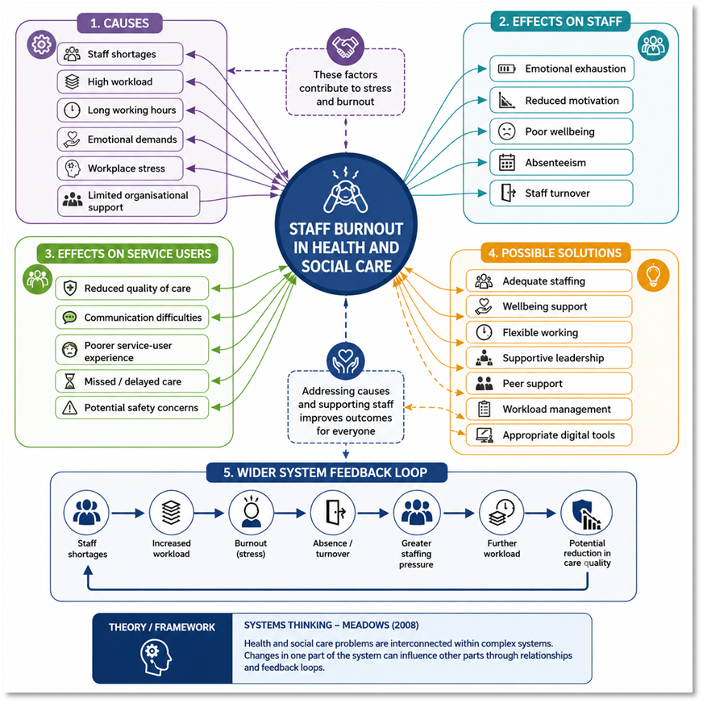

Task 3 - Self-Reflection of Group Activity

I applied Gibbs' Reflective Cycle (1988) to reflect on our group activity about the issues that Stanley would have encountered with delivering vaccines. At first, I was a little shy to contribute, but as the conversation progressed, I became more comfortable. We employed divergent thinking in order to come up with potential causes such as staffing issues, language barriers, cultural differences and a lack of resources without making any judgments at this stage. We then employed convergent thinking and assessed options and found community partnerships, communication and increased staffing and working with community leaders as plausible solutions. I felt it was important to listen to others to gain insight into their views, however I could have backed up my suggestion with more evidence. The activity gave me insight into how creative ideas involve coming up with and choosing ideas that are viable. I will be able to argue my ideas with evidence more confidently and use both approaches to thinking in future to solve health and social care issues.

Task 4 – Case Study Analysis of a UK Innovation

NHS virtual wards help tackle hospital capacity issues by helping the right sort of patient access acute care at home instead of being admitted to hospital (Westby et al., 2024). The innovation is a blend of remote monitoring, digital technology, and multidisciplinary working that delivers personalised care in non-hospital environments. This contributes to the value by making service use more convenient for service users, may help to avoid unnecessary admissions and allow for more effective use of hospital resources. An evaluation of 29 South East virtual wards by NHS England estimated that an average service prevents around 9,165 non-elective admissions per year and saves a net £10.4 million per year (NHS England, 2024). A systematic review also revealed that home-based technology-supported care was as likely or less likely to have higher rates of readmission compared to hospital-based care. Rogers' Diffusion of Innovation Theory indicates that the process of adoption is facilitated when innovations are perceived as having a relative advantage, being compatible, and being of practical use (Rogers, 2003).

Task 5 - Research Task

Nagle et al. (2024) identify work-environment factors as a significant driver of healthcare-worker burnout, noting that occupational stress and organisational conditions are important factors in the wellbeing of staff and patient-centered care. They conclude that the only explanation for burnout is not based on individual factors. Likewise, Norful et al. (2024) reported that organisational factors and individual factors have a relationship with wellbeing and burnout experienced by a group of healthcare assistants, showing how factors in the workplace interact with personal experiences. The two studies highlight the importance of the work environment, but Norful et al. have a narrower focus on HCAs, whereas Nagle et al. have a more general focus on healthcare workers. As a whole, the findings show that burnout is a multi-faceted issue which needs to be addressed on both the organisational and individual level. In line with Maslach et al., (2001) burnout framework, which defines burnout by emotional exhaustion, depersonalisation and diminished personal achievement.

Task 6 - Exploring Digital Innovation in Health and Social Care

Wearable Health Technologies
Smartwatches and other wearable technologies can facilitate management of chronic disease by delivering ongoing and readily available health data to encourage self-monitoring and self-management. A diabetic might use a smartwatch and other related gadgets to track activities and get reminders to stick to a healthier lifestyle, for instance. There is recent evidence suggesting that smartwatches interventions can help supporting patient care and health-related outcomes, depending on the condition and intervention design (Triantafyllidis et al., 2024). However, there are potential barriers to benefits for some service users because of unequal access, digital literacy and data accuracy and privacy issues. According to the Technology Acceptance Model (TAM) (Davis, 1989), individuals will be more inclined to adopt digital health technologies if they consider them as useful and easy to use. Thus, usability and accessibility are significant as well as technological ability.
Electronic Health Records
By providing access to relevant patient data at various points throughout the healthcare journey, electronic health records (EHRs) ease communication for authorised healthcare professionals. For instance, information captured by a GP can help in hospital treatment and subsequent social care or community care, improve continuity of care and multidisciplinary working. EHR can cut down on the use of disjointed paper documents, and help with better, informed clinical choices (Shi et al., 2024). The benefits are contingent upon interoperability, the correct entry of data, staff training and good information governance. Health information is also very sensitive and should also be taken into account when considering cybersecurity and privacy. Perceived usefulness and ease of use are cited as mediators of adoption (Davis, 1989), meaning that EHR system must be technically sound, as well as workable for professionals. This can then help to enhance information flow and assist to coordinate person-centred care.
Digital Technology for Preventative Care and Health Promotion
Digital technologies can help to provide preventative health care by providing health education, reminders to get screened, lifestyle advice, mobile applications and remote monitoring (Jensen, 2024). For instance, a mobile health application could deliver reminders, physical-activity advice and tailored information to adults who are at risk of developing type 2 diabetes, which might promote healthy behaviours and a proactive approach to treatment. A review of the literature conducted in 2024 revealed that digital interventions such as mobile and computer-based can lead to better results with diabetes prevention, however, further long-term evidence is required (Nguyen et al., 2024). Digital prevention is therefore promising, but could exacerbate inequalities for those without a device, digital competency or reliable internet connection. Perceived usefulness and ease of use are central factors in the Technology Acceptance Model (TAM) (Davis, 1989). Preventative technologies should be available, easy to use and accompanied by adequate professional support.

Task 7 - Understanding the NHS Leadership Framework

Overview of the NHS Leadership Framework
The NHS Healthcare Leadership Model offers a definition of NHS leadership behaviours which can underpin good practice in health and care environments. It has nine dimensions: Inspiring shared purpose, leading with care, evaluating information, connecting services, Sharing the vision, Engaging the Team, holding to account, developing capability and influencing for results (NHS England, 2018). These behaviours are vital as they can lead to the development of positive work places, improve team working and motivate staff to work collaboratively to enhance service provision. Shared purpose and team engagement can help staff members to understand their role and how that role contributes to the bigger picture, in particular. Compassion and inclusive leadership help to foster positive workplace cultures and quality care, NHS England says (West and Bailey, 2023). Leadership can then impact staff engagement, innovation and quality through enabling staff to feel supported to identify problems, share ideas and be involved in improvement.
Inspiring Shared Purpose and Creativity
Inspiring Shared Purpose can foster creativity by engaging leaders to bring people together for a compelling reason to improve care. A leader might engage staff in recognising issues in service and encourage ideas and show how innovative thinking helps to meet common patient-centered objectives (Lee et al., 2024). This can help to boost participation and motivation among staff to make things better. NHS England advises to build shared purpose inclusively, with meaningful input from staff and people with lived experience. This is indicative of transformational leadership, in which leaders inspire others towards a shared purpose and inspire them to grow. There are indications that transformational leadership is linked to improved nursing environments and that it can be used to improve teamwork and patient outcomes (Specchia et al., 2023).

Task 8 – Self-Reflection Journal Entry

I see creativity as generating new ideas, which I now understand to be developing solutions to real health and social care problems. I recognise that I took a different view of creativity using Gibbs' Reflective Cycle (1988). The activity of delivering the vaccine was especially a game-changer for my perspective and thinking because it gave me an opportunity to think outside the box and to also think within the box at the same time to develop and test ideas. The experience of learning about digital innovation and leadership also highlighted the need for effective implementation and collaboration-good ideas need to have value. For my future practice, I will apply structured creative thinking, listen to others and service users, and think whether there is an improvement in outcomes, experience and quality of care that innovations can offer.

References

Amabile, T.M., 1996. Creativity in context: Update to the social psychology of creativity. Routledge.
Amabile, T.M., 2018. Creativity in context: Update to the social psychology of creativity. Routledge.
Davis, F.D., 1989. Perceived usefulness, perceived ease of use, and user acceptance of information technology. MIS quarterly, 13(3), pp.319-340.
Gibbs, G., 1988. Learning by doing: A guide to teaching and learning methods. Further Education Unit.
Jensen, M., 2024. The role of digital health technologies in preventing chronic diseases: A public health perspective. Public Health Spectrum, 1(1).
Kosiol, J., Silvester, T., Cooper, H., Alford, S. and Fraser, L., 2024. Revolutionising health and social care: innovative solutions for a brighter tomorrow–a systematic review of the literature. BMC health services research, 24(1), p.809.
Lee, Y.S., Grob, R., Nembhard, I., Shaller, D. and Schlesinger, M., 2024. Leveraging patients’ creative ideas for innovation in health care. The Milbank Quarterly, 102(1), pp.233-269.
Lewin, K., 1947. Frontiers in group dynamics: Concept, method and reality in social science; social equilibria and social change. Human relations, 1(1), pp.5-41.
Mallek, F., Mazhar, T., Shah, S.F.A., Ghadi, Y.Y. and Hamam, H., 2024. A review on cultivating effective learning: synthesizing educational theories and virtual reality for enhanced educational experiences. PeerJ Computer Science, 10, p.e2000.
Maslach, C., Schaufeli, W.B. and Leiter, M.P., 2001. Job burnout. Annual review of psychology, 52(2001), pp.397-422.
Meadows, D., 2008. Thinking in systems: International bestseller. chelsea green publishing.
Nechita, P., Oroian, B.A., Schipor, P.D., Enache, A.L. and Popa, M.V., 2025. The link between work stress, absenteeism, and sickness absence: The impact of burnout on healthcare workers. Bulletin of Integrative Psychiatry, (2).
Nguyen, V., Ara, P., Simmons, D. and Osuagwu, U.L., 2024. The role of digital health technology interventions in the prevention of type 2 diabetes mellitus: A systematic review. Clinical Medicine Insights: Endocrinology and Diabetes, 17, p.11795514241246419.
NHS England (2024). NHS England. [online] England.nhs.uk. Available at: https://www.england.nhs.uk/2024/ [Accessed 29 July 2026].
Norful, A.A., Brewer, K.C., Cahir, K.M. and Dierkes, A.M., 2024. Individual and organizational factors influencing well-being and burnout amongst healthcare assistants: A systematic review. International journal of nursing studies advances, 6, p.100187.
Porter, M.E., 2010. What is value in health care?. New England Journal of Medicine, 363(26), pp.2477-2481.
Rogers, E., 2003. Diffusion of Innovations 5th.
Shi, C., Dumville, J., Rubinstein, F., Norman, G., Ullah, A., Bashir, S., Bower, P. and Vardy, E.R., 2024. Inpatient-level care at home delivered by virtual wards and hospital at home: a systematic review and meta-analysis of complex interventions and their components. BMC medicine, 22(1), p.145.
Triantafyllidis, A., Kondylakis, H., Katehakis, D., Kouroubali, A., Alexiadis, A., Segkouli, S., Votis, K. and Tzovaras, D., 2024. Smartwatch interventions in healthcare: A systematic review of the literature. International journal of medical informatics, 190, p.105560.
West, M. and Bailey, S., 2023. Healthcare leadership: cultures, climates and compassion. In Research handbook on leadership in healthcare (pp. 29-53). Edward Elgar Publishing.
West, M.A. and Farr, J.L., 1989. Innovation at work: Psychological perspectives. Social behaviour.
Westby, M., Ijaz, S., Savovic, J., McLeod, H., Dawson, S., Welsh, T., Le Roux, H., Walsh, N. and Bradley, N., 2024. Virtual wards for people with frailty: what works, for whom, how and why—a rapid realist review.

