

Programme Name: Master of Business Administration
Name and Code of the Module: International Marketing: Principles and Practices LCMB7026
Title: International Marketing: Principles and Practices- Starbucks(canada and india)
Lecturer’s Name: Tushara Balendran
Name:- Naitik Kantibhai Sheladiya
ID of the Student:- 2430954
Submission Date: 19 DECEMBER, 2025

Table of Contents
1. Introduction 4
2. Brand and Country Overview of Starbucks 4
3. Comparison of the socio-cultural context of Country A and Country B 5
3.1 PESTEL framework 5
3.1.1 Cultural Factors Based on Hofstede’s Six Dimensions 11
3.1.2 Advantages and Disadvantages of Hofstede Model 11
3.1.3 Similarities and Differences of Hofested Model 13
3.2 Comparison of similarities and differences of PESTEL 17
4. Comparison of Brand’s STP strategies in Canada and India 18
4.1 Segmentation 19
4.2 Targeting 21
4.3 Positioning 21
4.4 Similarities and Differences of STP 22
5. Comparison of Marketing Mix Strategies in Canada and India 25
5.1 Marketing Mix comparison 25
5.2 Similarities and Differences 26
6. Evaluation of the Performance of Marketing Strategies 28
6.1 Canada’s Performance 28
6.2 India’s Performance 29
6.3 Similarities and Dissimilarity 29
7. Evaluation of marketing ethics practice 30
7.1 Ethical issues in adaptation, pricing, advertising 30
7.2. Overall ethical judgement:- 31
8. Recommendation & Conclusion 32
8.1 Recommnedation 32
8.2 Conlcusion 33
9. Reference List 34
10. Appendix 39

1. Introduction
The present report entails a comparative evaluation of international marketing practices maintained at Starbucks in Canada and India. It focuses on the way the company changes its marketing strategy in two culturally and economically different markets. Some of the socio-cultural environment analysed through the PESTEL framework and Hofstede cultural dimension, as well as an assessment of the Starbucks segmentation, targeting and positioning (STP) strategies, and the 7Ps marketing mix, are evaluated. The report also evaluates the performance and the ethical aspects of the marketing activities of Starbucks in the two countries and finally gives a recommendation on how the marketing effectiveness of this company can be improved in international markets.

2. Brand and Country Overview of Starbucks
Starbucks is an American, multinational company that deals in coffeehouses that was established as a coffeehouse in 1971 in Seattle, United States, by Jerry Baldwin, Zev Siegel, and Gordon Bowker (Starbucks, 2025). The corporation has its headquarters in Seattle, and it is internationally reputed for the provision of high-quality Arabica coffee, espresso-based beverages, and a unique cafe ambience. The mission of Starbucks is to inspire and contribute to the human spirit, one person, one cup, and one neighbourhood at a time, with the help of such core values as ethical sourcing, community engagement, inclusion, and environmental responsibility (Starbucks Canada, 2025). The Starbucks Experience idea focuses on the comfort, quality, and community in its outlets. The choice of Canada and India in this study is based on the fact that these two countries are taken as the representatives of two markets with high strategic significance and yet with starkly different cultures (Le, 2025). Canada is a developed coffee market that is highly ethical, whereas India is an emerging market, and the consumption of coffee is motivated by urbanisation, lifestyle aspiration, and cultural adjustment (Starbucks, 2024). The comparison of international marketing strategies of Starbucks can be fruitfully made in terms of the developed and developing economies due to this contrast.

3. Comparison of the socio-cultural context of Country A and Country B

3.1 PESTEL framework
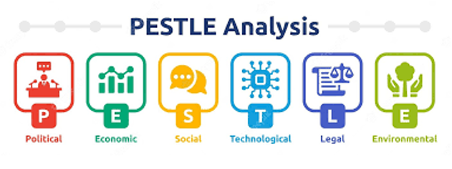
Figure 1: PESTLE
P-Political
Canada: The political situation in Canada is very favorable, open and favorable to a foreign company like Starbucks. The government works hard to foster trade liberalization, foreign direct investment and entrepreneurship. A predictable future of business planning is comprised of clear federal and provincial policies, low political risk and excellent diplomatic relation with key economies.
India: The political landscape in India is largely stable, and it is concerned with the development of economy and the inflow of foreign investment. The business expansion is aided by government programs like the Make in India, Startup India and the liberalized FDI regulations in retail and food services. Nevertheless, the work of the policy can differ in each state, and the bureaucratic process can delay approvals and make work more complicated (Stechyson, 2025). Regional politics can also have an impact on the process of licensing and compliance.
Favorable and Unfavourable: Canada, U.S. tariffs on goods of Brazil and Canada have also upended the global coffee market. This is essentially extending coffee inflation higher than grocery inflation. However, in India, the current political environment is supporting the overall growth of the coffee industry with the possibility of international expansion. The Ministry of Commerce and Industry has also established a 10-year roadmap for extending the production of coffee. Comparison states that the political conditions of both India and Canada are facing diverse challenges, and this has impacted the international and national expansion of the coffee industry. In contrast, the political condition is more challenging in Canada than in India, and India has greater potential for the marketing and expansion of businesses like Starbucks.
E-Economic
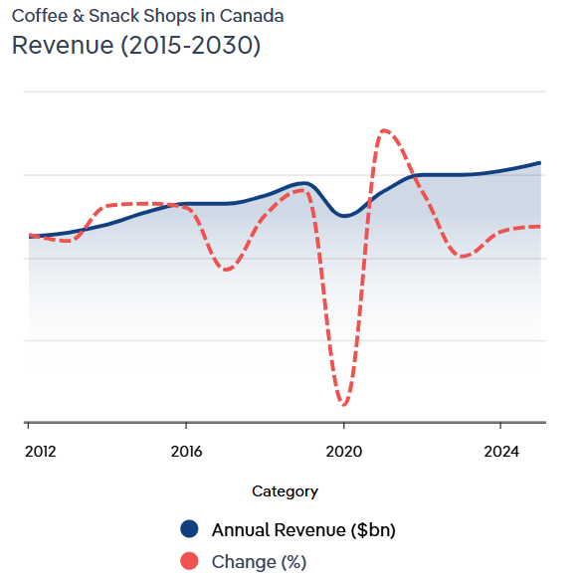
Figure 2: Revenue of Starbucks in Canada
Canada: The Canadian economy is high-income, mature and consumer-based, with a high purchasing power, established cafe culture. Constant inflation, the availability of qualified labour and effective financing systems favour the high pricing approach of Starbucks. Nevertheless, rent, wages, and taxes can push the operating costs up and demand effective control of the costs, thus decreasing the profits.
India: In India, economy is rapidly developing with great big and growing middle-class, which provides long term growth prospects to Starbucks (Team, 2025). The growing urbanisation and increment in disposable income favour the premium food and beverage experiences. Income inequality and price sensitivity however demand price competition and product localisation.
Favorable and Unfavourable: The prices of coffee in Canada have been skyrocketing for months, and this is occurring due to supply issues from major suppliers of Brazil and Vietnam. This has also caused Canadians to pay 27.9% more for their coffee than last year (Canada, 2025). For example, Starbucks has ensured the development of its full commitment in the Indian market. There are no such factors, as both regions have diverse yet positive economic conditions and have been representing accelerated growth. The financial earnings are more effective in Canada than in India within the coffee industry.
S-Social
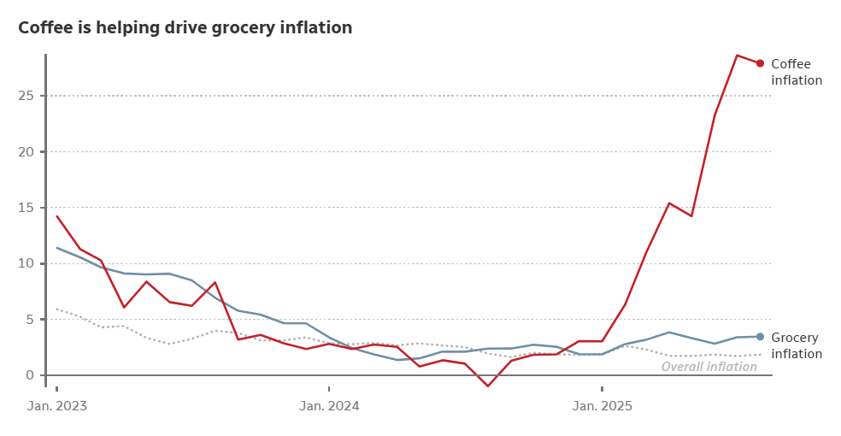
Figure 3: Grocery Inflation from Coffee
Canada: Coffee drinking in Canada is a part of life, and Starbucks fits perfectly well with the habits of consumers. The customers appreciate convenience, quality, ethical sourcing and sustainability. The social values of diversity and inclusivity have a role to play in supporting the brand positioning of Starbucks as well as its workforce practices. Nevertheless, the large level of health awareness can decrease the demand of sugary drinks.
India: The social trend is changing into the café culture of the urban youth and professionals in India. Starbucks can be considered one of the luxury lifestyle brands, which appeal to the aspirational customers. Nevertheless, tea will be the most favored drink and cultural tastes will have to be accommodated in the menu, such as local tastes and vegetarian dishes. Diversity in the social life of different regions requires specific marketing.
Favorable and Unfavourable: Socially, sustainable and ethical sourcing has increased among Canadian consumers, and they are looking for organisations that practice fair trade, trade along with direct trade and also consider the affordability concerns of consumers. The overall consumption rate of coffee in India also has increased from 84,000 MT to 91,000 MT in 2023 (Coffeeboard.gov.in, 2024). This has also expanded as a niche urban beverage in India, especially among Gen Z consumers. This also has become an integral part of their lifestyle (Timesofindia.indiatimes.com, 2025).
No unfavorable conditions as the growing affordability of coffee, this has become one of the key lifestyle beverages for the consumer bases in Canada and India. Expansion of sustainability and ethical sourcing is more effective in Canada, where there is a lack of it in the Indian market.

3.1.1 Cultural Factors Based on Hofstede’s Six Dimensions
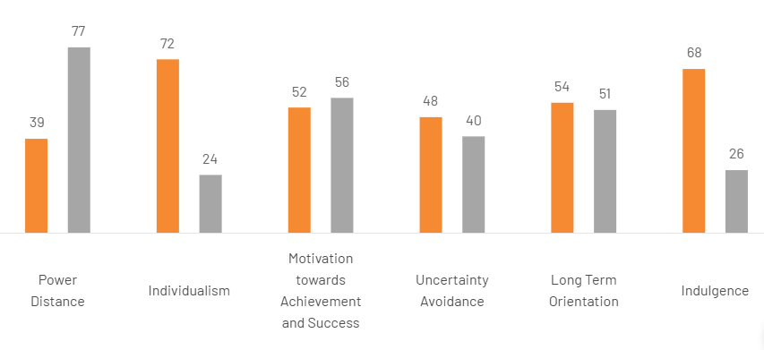

Figure 6: Hofstede’s Cultural Dimension of Canada and India
Cultural comparison can also be performed with the application of Hofstede's Cultural Dimension Model here. Evidence-based knowledge indicates that with the exploration of region and organisational culture, an organisation determines its value proposition and competitive positioning (Hooley et al., 2008).

3.1.2 Advantages and Disadvantages of Hofstede Model
Canada is a country with low power distance, where openness in communication, equality, and participative decision making are promoted in organisations. India, on the other hand has a high power distance that reflects the tolerance of hierarchical forms of power, authority, and centralised decision-making in the workplaces and in the society.
Canada is high on individualism, which is more concerned with personal achievement, independence, and self-expression. However, India belongs to the collectivist group, and people are more important to family, social groups, and long-term relationships than being more focused on personal objectives (Theculturefactor.com, 2020).
Canada and India have similar degrees of masculinity, which means that they are characterized by a lack of competitiveness and quality of life. India is a little more masculine, whereby it gives more emphasis to success, ambition, and performance, whereas Canada respects cooperation as well as achievement. The uncertainty avoidance is relatively high in Canada, which means that it prefers strict rules, structure, and risk management. India has moderate uncertainty avoidance, which gives it the freedom to tolerate ambiguity and flexible solutions to problems.
Canada is more long-term oriented as it emphasizes planning, future rewards, and sustainability. India has a moderate long-term orientation, which is characterized by respect towards tradition with flexibility towards changing market conditions. Canada is very indulgent, which is a condition of culture that delights in leisure, fun, and work-life balance. India is more reserved, in contrast, as social norms refer to self-control and suppression of individuals' desires. The advantages that can be derived from the analysis indicate that India has a strong long-term orientation and is also focused on aspirational consumption, while Canada has the advantages of strong ethical awareness and high indulgence (Theculturefactor.com, 2020). However, the disadvantages state that as there is a high power distance in India, it reduces inclusivity and high individualism in Canada reduces strong community bonding.
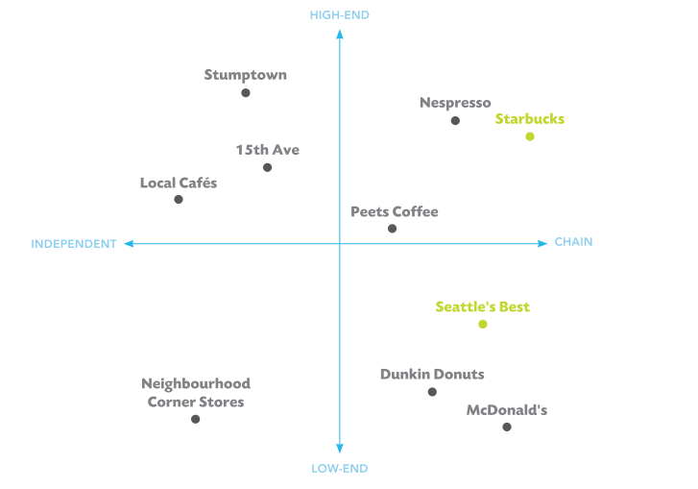
Figure 7: Positioning Map of Starbucks

3.1.3 Similarities and Differences of Hofested Model
A critical assessment of the similarity and differences here states that the condition of Canada represents a low power-distance, along with high indulgence, high individualism and eventually long-term orientation. There is also a presence of high uncertainty avoidance. The country also ensures the promotion of ethical awareness, and at the same time, prefers pleasure-seeking behaviour with personal autonomy. The similarity of it with India also suggests that there is a presence of high power distance in India, along with collectivism and masculinity, which is moderate, and uncertainty avoidance as well (Theculturefactor.com, 2020). The long-term orientation is also moderate, and the indulgence level is low. India ensures the encouragement of a hierarchical structure and has greater aspirational consumption with a community focus. In this way, the assessment of the similarity indicates that there is a presence of a moderate masculinity in both the regions, but the differences are presented in power distribution, collectivism vs. individualism, level of indulgence and also within its long-term orientation (Hooley et al., 2008). Here, the assessment of the cultural contrast is essentially addressing inclusivity in organisation and greater ethical consideration with community bonding and eventually consumption patterns that have ensured the development of the competitive position of Starbucks in both regions regarding its strategic decision-making.
A comparison with India shows that the social and cultural attributes of this country are unfavourable towards considering coffee as a lifestyle beverage, the development of urban cafe culture, etc. However, the unfavourable condition indicates limited penetration of Starbucks in rural areas of India and limited ethical sourcing awareness as compared to Canada. The differences here are justifying that Canada prefers ethics and sustainability, while India prefers lifestyle and aspirations.

T-Technological
Canada: The digital infrastructure in Canada ensures mobile ordering, digital payments, and loyalty programs, which improve customer experience and operational efficiency. The internet penetration and data analytics make it possible to do personalised marketing and supply chain management. Nevertheless, the expenses of operational costs are raised by technological improvements and compliance with cybersecurity.
India: Digital payments and application-based services are facilitated in India by the high pace of digitalisation and the use of mobile devices. Digital payments are supported by the government-based app like UPI, which enables cash-less transactions. Nevertheless, the availability of digital infrastructure, cybersecurity, and reduced digital adoption in smaller cities inhibit uniform service delivery.
Favorable and Unfavourable: Technological advancement has ensured the expansion of robotic-infused cafes, automated kiosks and at the same time super-automatic machinery for brewing coffees and also offering the same to consumers. This is, in turn, expanding the supply chain capability as well (Kittichotsatsawat et al., 2021). Technological innovation, which is emerging in the coffee industry of India, indicates the adaptation of smart farming techniques along with optimised water usage for managing yield quality.
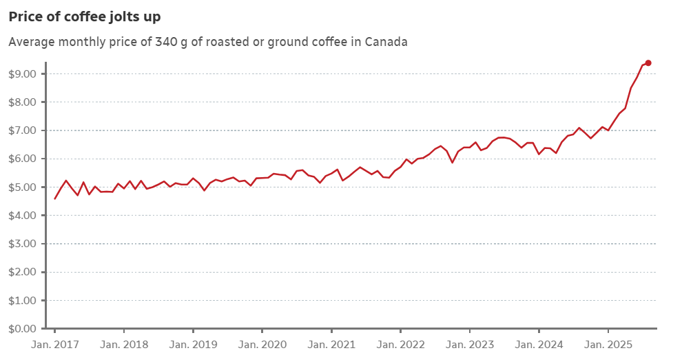
Figure 4: Increasing Price of Coffee
An AI-based sorting system is also enhancing consistency in coffee production and reducing errors (Timesofindia.indiatimes.com, 2024). Technological expansion is prominent in both regions, with greater AI and automation advancement. The advancement is more prominent in the Indian region than in Canada.
L-Legal
Canada: In Canada, there are powerful legal systems in the protection of intellectual property, food safety, employment rights, and consumer protection. Clear guideline and effective dispute resolution minimizes business risk. The high minimum wages, severe labour laws and environment regulations however make compliance costs higher.
India: Legal reform in India has enhanced the ease of doing business, such as an easier tax structure and electronic compliance. The protection of intellectual property has been enhanced and this is good to global brands. Nonetheless, protracted legal disputes, complications on labour regulations and various state state regulatory disparities can slow down expansion and create a legal grey zone.
Favorable and Unfavourable: With the occurrences of trade wars, this is essentially causing an impact on the overall operation of North America (Teixeira, 2025). Industry is also fearing potential tariffs on South American Coffee Imports. The current legal condition in India related to coffee is essentially suggesting the replacement of the Coffee Act of 1942 with a new development of a Bill. With the new regulation of EUDR for exporters in offering proof that coffee is deforestation-free, this is also causing challenges for coffee growers in India in dealing with the compliance (TNN, 2025). Legal complexity has been reducing the potential growth of the coffee industry in both regions. Legal issues are more challenging in Canada than in India, with trade wars.
E-Environmental
Canada: The high level of environmental consciousness and rigorous sustainability policies in Canada are helpful to Starbucks in its ethical sourcing and wastage mitigation practices. The consumers demand responsible practices in the environment. Climate-related risks and compliance expenses however contribute to additional operational problems.
India: Environmental sustainability is becoming a topical issue in India, and the issues of renewable energy are becoming more and more popular, as well as waste minimization. Nevertheless, pollution, water shortage, and climate change have a significant adverse impact on supply chains and operating conditions, which become more long-term risk factors to the environment.
Favorable and Unfavourable: Coffee growers in Canada are facing a threat from climate change, and this is also threatening coffee plants with a risk of total disappearance by 2050 (CBC, 2020). Environmental issues are also prominent with the growing carbon footprint, and this is causing coffee businesses in Canada to pay more money to obtain the best beans for keeping the growers afloat. The current environment for coffee production in India is under shaded conditions, and these kinds of cultivation measures are helping the coffee production more effectively through shielding it from climate change (Yemen, 2024). The threat of climate change is prominent in India and Canada, which is impacting coffee agriculture. The challenge is more prominent in Canada than in India, as diverse measures have been adopted in India for the sustainable growth of coffee plants.
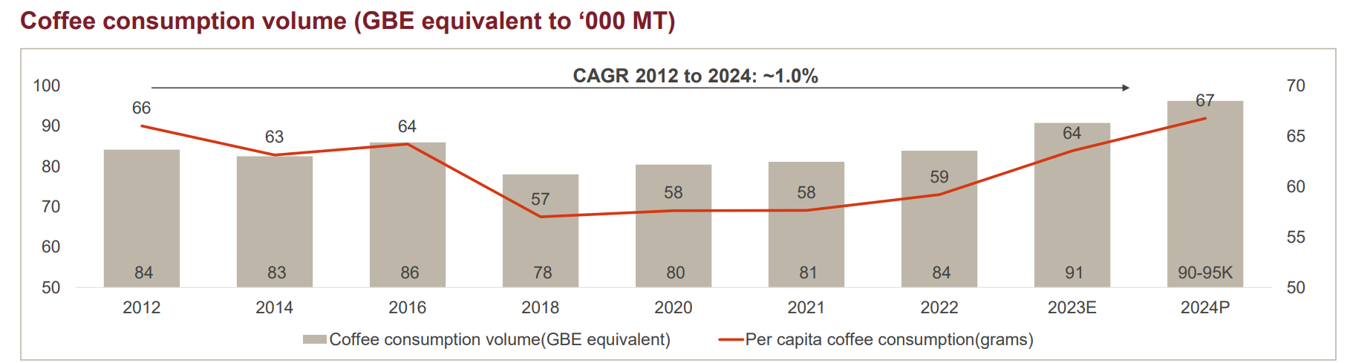
Figure 5: Volume of Coffee Consumption
Similarity and Differences which can be derived from PESTLE analysis indicates that both countries are known for facing the threat from climate change, and both of them use technology for innovation while depending on premium positioning. However, the differences indicate the condition of Canada in suffering from tariffs along with affordability, where India essentially focuses on local adoption and growth of lifestyle.

3.2 Comparison of similarities and differences of PESTEL
PESTEL analysis of the business development of Starbucks in Canada and India highlights the similarities and significant differences that are determined by the economic maturity of the country, regulation, and consumer surrounding. Both the countries have fairly stable governments politically and are willing to invest in foreign direct investment that facilitates the presence and growth of Starbucks in the market. Nevertheless, the policy environment in Canada is predictable and transparent, but in India, there is more variability between states, and Starbucks must change its strategies in the regional levels.
Economically, both markets have growth potentials though at varying levels. Canada is a mature, high-income market that has a high purchasing power and thus Starbucks can invest in premiumisation and customer loyalty. Conversely, India is an emerging economy that is developing at a fast rate and has a large middle-income group with long-term growth prospects but more price elasticity and income inequality, which affect the pricing and localisation of products to the market by Starbucks.
Regarding social factors, there is increasing demand toward the coffee culture and high-end coffee experiences in both countries, especially among urban customers. Nevertheless, the consumption of coffee is intrinsically linked to the Canadian way of life whereas in India, tea is still the main product and Starbucks has to focus on the localisation, experience based branding and tailored products to achieve acceptance.

Both Canada and India are technologically advantaged with increased use of digital which promotes the mobile ordering, digital payment and loyalty of Starbucks. Canada is better equipped and more stable in digital infrastructure whereas India experiences high digital development rates but regional imbalance that influence service homogeneity.
Existing similarities in the environment are rising regulatory and consumer demands on sustainability. The ethical sourcing and waste management programs of Starbucks are also in line with each other in both nations. Nevertheless, the environmental policies in Canada are stricter, whereas India experiences more serious environmental problems, which add to the risk of supply chain and compliance. Intellectual property rights and food safety are safeguarded by both countries in legal terms, although Canada provides a quicker dispute resolution and fewer regulatory barriers, where India has a slow and complicated legal framework, potentially slowing down expansion. Altogether, to develop a business sustainably, Starbucks will have to strike a balance between standardisation and localisation and flexibility in Canada and India respectively.

4. Comparison of Brand’s STP strategies in Canada and India
Segmentation, targeting and positioning are highly essential for the development and improvement of strategic marketing within an organisation (Amira and Fitriasari, 2021).

4.1 Segmentation
Segmentation in Canada:
Demographic Segmentation

Starbucks mostly focuses on young adults and working professionals in Canada that are 18 to 45 years old with a medium to high level of disposable income. The brand is highly attractive to students, urban and corporate employees capable of spending on high priced drinks. The gender division is quite equal, and the level of education also has its influence, with Starbucks being preferred by the educated population that is inclined to appreciate international brands and products of good quality.

Behavioural Segmentation

Canadian customers are also behavioural consumers of coffee as they take cafes as part of their daily life. There is strong demand on services that are convenient like mobile ordering, drive-throughs, and loyalty programs. There is a high level of brand loyalty and customers have been very receptive to rewards, seasonal products and good quality services. There is also an increase in sustainability-related behaviour, which consists of using reusable cups.

Psychographic Segmentation

Starbucks is psychographically targeting consumers that appreciate high-quality experiences, ethical purchasing, and lifestyle branding. Productivity, comfort, and social interaction are the aspects that Canadian customers tend to connect with Starbucks. Especially significant are health-conscience and environmentally-conscious segments, which will affect the demand of plant-based milk, low sugar products, and sustainability sourcing (Chitalia et al., 2022).

Geographic Segmentation

Starbucks is geographically focused in major cities (Toronto, Vancouver, Montreal, and Calgary) and suburbs. Busy places around offices, universities, transport centres and shopping places are preferred. Strong demand of hot beverages all the year round is also supported in cold climate regions.
Segmentation in India:
Demographic Segmentation

Starbucks targets urban consumers between the age of 20 and 40 in India especially the young professionals, college students, entrepreneurs, and those with upper-middle-income. The brand aims at customers who are more affluent and have high disposable incomes with a taste of luxury lifestyle. The segmentation of the gender is even and the education and occupation have a significant impact on the type of consumption.

Behavioural Segmentation

Indian customers go to Starbucks as socialising, meeting, and experience consuming activities instead of everyday consumption of caffeine. Brand aspiration and newness are influential. Customers are receptive to personalisation, online payments, and seasonal/localised menu items. Visiting frequency is usually less in comparison with Canada because of price sensitivity.

Psychographic Segmentation

Starbucks is psychographically oriented towards aspirational, brand-conscious and status-oriented consumers. The brand is linked to modernity, international appearance, and social identity. Young consumers appreciate the atmosphere, Instagramable places, and custom drinks. Tastes towards the vegetarian alternatives and local tastes are also shaped by the cultural values.

Geographic Segmentation

Geographically, Starbucks has operations within Tier 1 and few Tier 2 cities of Mumbai, Delhi NCR, Bengaluru, Chennai, Hyderabad and Pune. The shopping centres are clustered in high end neighbourhoods, airports, business areas, and high quality shopping malls. Growing to smaller cities is still a restricted venture because of the infrastructure and demand limitations.

4.2 Targeting
The targeting attribute of Starbucks in Canada indicates the approach of the firm in using loyalty programmes in rewarding customers for their patronage based on free products, discounts and also with exclusive offers (Jin, 2024). Moreover, by using data analytics, the firm ensures an understanding of the preferences of customers along with their purchase behaviour for offering tailored or customised promotions and rewards. This enables the consumers to become loyal advocates.
The firm is known for targeting urban professionals, coffee enthusiasts and professionals who ensure the sharing of the brand attitude of community and refinement (Gairola, 2024). Other than this, in India, Starbucks ensures the following four brand values: connection with transparency, presence, respect and dignity. Thus, by developing "Starbucks Experience", the firm ensures maintaining consumer loyalty through the offering of quality beverages (Chitalia et al., 2022).

4.3 Positioning
While ensuring heavy engagement in digital presence, Starbucks has positioned itself on social platforms (Jin, 2024). Through Twitter, it has managed to gain 7 million followers, and the forward-thinking approach through digital capability has enabled the business to achieve greater consumer loyalty and satisfaction. This also justifies the position of Starbucks in the high-end, high-quality segment.
Consumers in India ensure purchasing expensive and high-quality tangible products of Starbucks, and at the same time, acquiring a personalised and tailored in-store experience. The firm also ensures the maintenance of its premium brand status by offering in-store seating, Wi-Fi and a welcoming and cosy atmosphere. This essentially justifies the position of the brand in the high-end segment with its exclusive pricing strategy.
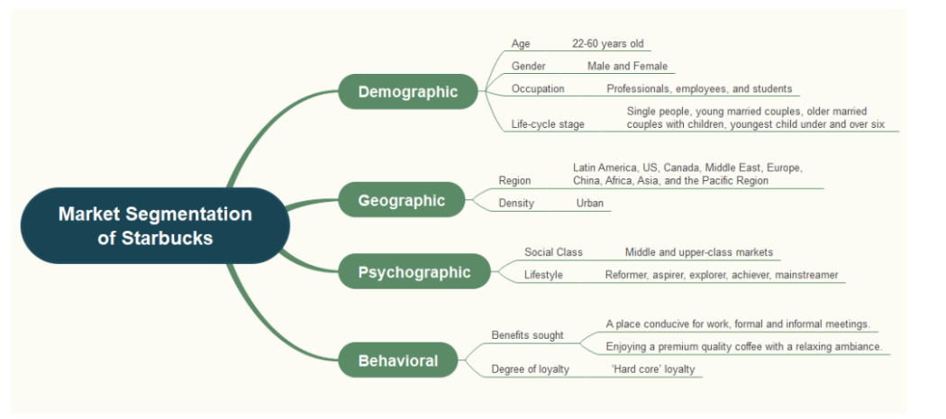
Figure 8: STP of Starbucks

4.4 Similarities and Differences of STP
Similarities
Evidence-based knowledge is addressing that in the current competitive environment, it has become essential for organisations to implement very important call-outs to customers with the application of different marketing strategies (Krom, 2022). Regarding the comparison of the similarity of the STP of Starbucks both in India and Canada, this indicates the approach of targeting Middle and upper-income-based consumers who belong to the age group of 18-44.

Figure 9: Promotion of Starbucks in Canada
In Canada, Starbucks uses differentiated targeting and targets various high-end groups of consumers via loyalty programmes, digital personalisation, and data analytics (Zhou, 2024). The brand focuses on the urban professionals, students, and frequent coffee users by providing them with personalised rewards, personalised promotions, and interaction via the apps, reinforcing the customer retention and returning to purchase (Pine and Dubois, 2024). This strategy suits the individualistic culture of Canada where consumers appreciate individual experiences.

Figure 10: Promotion of Starbucks in India
Differences
Conversely, Starbucks deploys concentrated targeting in India with the major target segment being of high urban professionals, aspirational youth who identify the brand as lifestyle, status, and international identity. It depends less on the development of the Starbucks Experience by respect, transparency, and in-store atmosphere and more on the large-scale loyalty schemes that are prevalent in most targeting efforts in India (Chitalia et al., 2022). In neither of the countries, undifferentiated targeting is employed since mass marketing would water down the brand image of Starbucks as the high-quality positioning (Pine and Dubois, 2024).
Starbucks is a quality-focused, sustainable, and personalised brand of coffee in Canada with a focus on positioning as a high-end and ethical coffee producer. The brand is high-end and aspirational in India, with a global coffee culture and localised experiences and social status (Musonera, 2021). Perceptually, Starbucks is placed at a high price-high quality in both markets, and it is set apart by the competitors in the mass markets by being better in terms of experience and brand symbolism. One of the main similarities in the two markets is that Starbucks concentrates on middle- and high-income, urban age groups between 18-44, such as professionals, students, and lifestyle-oriented people who appreciate high-quality coffee and the atmosphere (Gairola, 2024). The psychographic similarities are also characterized by a preference for high-quality products and a social cafe atmosphere. The first distinction is that it is focused on execution and value focus. Canada depends on differentiated and data-driven loyalty targeting, whereas India pursues a focus on concentrated targeting based on aspirational consumption and cultural values. Canada puts more emphasis on ethics and personalisation, where India focuses on lifestyle aspiration and high-end social experience (Chitalia et al., 2022).

5. Comparison of Marketing Mix Strategies in Canada and India
Evidence-based knowledge indicates that the assessment of 7P Marketing Mix represents the environment in which an organisation ensures the offering of its product and service through effective performance and communication, and also with the maintenance of the quality of the product and service (Jain et al., 2022).

5.1 Marketing Mix comparison
Product
Starbucks has a very broad product line in both nations in terms of coffee and tea, food, and branded merchandise. There is product depth in the different flavours, sizes and customisation. In Canada, emphasis is laid on standardised products worldwide whereas in India, Starbucks has customised its menu with local taste like masala chai, creamier milk and beverages flavoured with mangoes to meet local taste preferences. Branding approaches are the same, with an accent made on high quality and the Starbucks Experience.
Price
Starbucks practices a high pricing in Canada and India. Its high quality positioning, ethical sourcing and high in-store experience are backed by premium pricing. The strategy strengthens brand exclusivity and restricts the accessibility of consumers who are price sensitive.
Place
Starbucks uses the direct channels such as retail stores owned by the company, mobile applications, and delivery services that are the most intensive and tightly regulated distribution channels. Indirect channels are third-party delivery services like DoorDash in Canada and the same in India. Most of the stores are in busy city centers, airports, malls and business centers.
Market Entry Method (India)
Starbucks entered India through a joint venture with Tata
Consumer Products, allowing access to local market knowledge, supply chains, and regulatory expertise (Tata Consumer Products, 2024).
Advantage: Reduced market risk and strong local credibility.
Disadvantage: Shared control may slow strategic decision-making.
Promotion
Starbucks employs Integrated Marketing Communication (IMC) strategy that involves digital marketing, social media, in-store promotions, public relations, and sales promotions. Indian campaigns, like Take a Blonde Turn, emphasize the customisation of products and the use of lifestyle as a selling point (Instagram, 2017).

Figure 9: Promotion of Starbucks in Canada

Figure 10: Promotion of Starbucks in India

People
Starbucks has thousands of employees in both nations also known as partners. Benefits, recognition and career development opportunities provide employees with structured training, skill development and motivation. Tata Starbucks focuses on wellbeing, inclusion, and belonging in the workplace in India (About Starbucks, 2025).
Process
Customer requests are addressed in a systematic manner by involving the in-store reporting, mobile application feedback, customer support, and follow-up resolution to recover and satisfy the customers with the service.
Physical Evidence
The Starbucks locations in the two countries are characterised by warm interior design, uniform branding, e-menus, and uniform employees. The variations come in ambience, where Canada is more comfortable, whereas India is more aspirational in designing a cafe.

5.2 Similarities and Differences
Similarities
The similarity and differences which can be derived from Starbucks' operations in both India and Canada indicates that both countries follow the global menu of premium coffee beverages and also a premium pricing strategy. Stores in both countries are located in high-traffic urban areas, and both countries heavily depend on digital marketing and social media marketing for promotion (About Starbucks, 2025). It also focuses on employee development and offering customer-centric service, but also prefers efficient service delivery. However, the application of Standardisation Vs. The adaptation debate is effective here. Standardisation means that an organisation is applying the same marketing mix to all markets. Evidence-based knowledge suggests that a growing trend towards global standardisation is prominent worldwide among organisations in meeting the global standard of efficiency and productivity (Doole and Lowe, 2012). This is also prominent in the case of Canada, as the Starbucks operating in this region ensures global offerings, where India follows an adaptation strategy in terms of integrating local preferences, taste and quality in the coffee beverages it offers to Indian consumers. The differences also indicate the approach of Canada in highly focusing on loyalty programs along with digital engagement, but India prefers running culturally driven campaigns such as "Take a Blonde Turn" (Instagram, 2017). Canada prefers the offering of training and development opportunities to the partners of Starbucks, where Indian Starbucks maintains the belonging and well-being of its employees through the Tata company.
Differences
A critical discussion on the 7P marketing mix here states that there is a presence of a strategic balance in both Canada and India regarding its local adaptation, and also with global consistency. When it comes to the assessment of the product width and depth, in Canada, Starbucks is known for the offering of a diverse range of tea, coffee, sandwiches, etc (About Starbucks, 2025). In India, it ensures the offering of localised flavoured coffee such as mago frappuccino, masala chai latte, in order to meet the demand of the regional taste. As both countries are known for the application of a premium pricing strategy, this has ensured positioning the company at the high-end level, and the challenge of affordability is also present. For India, being a price-sensitive market, the planning strategy is diverse in both regions. As Canada ensures the usage of suburban and urban locations based on mobile app ordering, India essentially focuses on maintaining its position in urban centres with high traffic (Doole and Lowe, 2012). The condition of the business in having a joint venture with Tata is known for maintaining the entry of the business in the market effectively and credibly. However, the decision-making is slow, and control is also shared.
On the other hand, promotional activity in Canada is also focused on digital campaigning and loyalty programs. The complaint process for customers in Canada is streamlined digitally, whereas in India, the firm offers personalised in-store service and resolution (Al-Sulaiti and Al-Sulaiti, 2023). In this way, the critical exploration of the similarity and differences of both the regions here suggests that though there is a similarity based on its urban focus service and premium positioning, the differences are prominent with cultural adaptation and also according to its style of operation.

6. Evaluation of the Performance of Marketing Strategies
The evidence-based knowledge indicates that international organisations are becoming more competitive as they leverage their competitive advantage by employing effective marketing strategies as the volume of business activity increases globally (Czinkota et al., 2007). According to this view, the effectiveness of marketing strategies of Starbucks in Canada and India is assessed below.

6.1 Canada’s Performance
Starbucks has a good performance in Canada as indicated by a large revenue and market coverage, which justifies its success in premium positioning strategy (Statista, 2024). Although premium pricing aspects allow sustainable profit margins, they also pose affordability issues especially in regard to other low-priced local rivals like Tim Hortons. This is where the country-of-origin effect comes in whereby the premium brand image of Starbucks, the American one, affects the perceptions of price (Al-Sulaiti and Al-Sulaiti, 2023).
Starbucks Canada is highly active on social media, which is backed up by loyalty programmes and online products, including DoorDash. The company has acquired a large number of Twitter followers, which have strengthened its differentiated targeting approach by providing personalised offers and data analytics, which is relevant to the individualistic culture of Canada (Theculturefactor.com, 2020).
In Canada, customer reviews are mostly positive reviews on ethical sourcing, quality of service and comfortable surroundings in the store. But often there is a backlash against high pricing, which influences apprehensiveness of value among price-sensitive consumers (Areiza-Padilla et al., 2021).

6.2 India’s Performance
Starbucks has experienced a stable sales growth in India which suggests that premium effective coffee culture is being embraced by consumers in the urban population (Malviya, 2025). But the price and rural inaccessibility also hamper penetration of the market, which confirms the debate between standardisation and affordability.
Starbucks India concentrates on the aspirational branding by using culturally oriented campaigns like the Take a Blonde Turn on Instagram. These marketing efforts focus on group and lifestyle consumption, which is consistent with the collectivism culture of India (Keegan and Green, 2013).
Starbucks enjoys Indian consumers who appreciate its high quality environment, international brand image, and localised tastes including spices-infused and mango-flavoured drinks. However, the affordability and inaccessibility to areas outside large urban centres are regularly raised as the primary concern in the reviews, which makes proper segmentation especially significant (Wind and Douglas, 1972).

6.3 Similarities and Dissimilarity
One of the main similarities between the two markets is that Starbucks has a high brand equity and a premium segmentation, which appeals to middle- and high-income urban consumers (Malviya, 2025). The role of social media involvement is quite important in both countries, but media and messages vary. The primary distinction is in the maturity of the market and the expectations of the consumers. Canada offers better profitability but it has a high price competition whereby India offers growth potential due to aspirational consumption but limited due to affordability and accessibility. The cultural orientation also further distinguishes performance whereby Canada prefer individualised loyalty and India prefer lifestyle-based engagement (Theculturefactor.com, 2020).

7. Evaluation of marketing ethics practice

7.1 Ethical issues in adaptation, pricing, advertising
Assessment of the presence of ethical issues related to Starbucks marketing in Canada can be performed with the application of ethical relativism vs absolutism, justice approach and marketing ethics framework altogether. In Canada, Starbucks ensures ethically sourced coffee beans and also has fair trade certification with sustainable packaging. Thus, by considering the perspective of ethical absolutism, such practices of the firm represent the universal value of fairness along with environmental responsibility. It is something that cross-cultural companies must uphold (Arnold, 2009). However, according to ethical relativism, this kind of approach is not favourable in some markets, as the approach of sustainable packaging and fair trading increases the overall cost and product price for Canadian Starbucks.
Premium pricing justifies ethical commitments, and based on the justice approach, distributive justice essentially focuses on the fairness of outcomes. Thus, when the firm ensures fair compensation for the coffee suppliers and farmers, the cost becomes a burden on the consumers. This is known for generating greater ethical dilemmas (Kaynak and Delener, 2019). As deceptive pricing is not a challenge here, it increases the rate of competition from competitors like Tim Hortons. The location of the store, mainly in the urban and suburban areas, justifies the selective distribution strategy of the business in Canada, and it also aligns with the ethical marketing attribute that ensures accessibility in the community. However, it is also ethically challenging because it is not accessible to marginalised rural communities and low-income groups. This is essentially generating the concern of procedural justice here regarding the fair distribution of accessibility (Kaynak and Delener, 2019).
Assessment of its promotional attribute indicates the following sustainable measures: community engagement and inclusivity, and the approach of Starbucks in Canada in conducting ethical sourcing through green marketing advertisement. However, the issue of greenwashing still exists here, which essentially asks for the integration of ethical vigilance to ensure that it is not misleading any consumer. As Starbucks in Canada prefers calling its employees partners and also ensures the offering of training and development opportunities, this mainly aligns with the Project GLOBE model altogether, which ensures the offering of rewards based on dignity and fairness management. However, the level of wage being offered to the employees is not fully fair, and this is essentially raising the concern regarding distributive justice (Murphy et al., 2017).
Assessment of the ethical attribute on process indicates an effective delivery service and a digital loyalty program, which enhances customer satisfaction. Though there are fewer ethical issues, the inability of consumers to be tech savvy to obtain digital customer service might be an ethical complexity here, as it is generating the concern of inclusivity. With the growing issue of affordability in Canada, the offering of a cosy and warm in-store environment is known for excluding consumers from the lower-income group (Staff, 2024).

7.2. Overall ethical judgement:-
Evaluation of the favourable attribute here indicates that, based on ethical sourcing in Canada, the firm has enhanced trust and loyalty and also has increased the value among consumers. This has also enhanced its brand equity along with sustainability (Staff, 2024). However, the unfavourable outcome is stating that with its high cost and reduced affordability, this has also increased the concern of distributive justice for not being available and affordable to the rural and low-income consumer base. Ethical issues regarding pricing, adaptation, advertising and eventually the treatment of local employees indicate the condition where in Canada, Starbucks ensures maintaining the reputation of its brand along with the trust of consumers. Some of the primary ethical measures the firm follows include performing ethical sourcing through C.A.F.E., or also through Fairtrade activity and initiative.
This eventually determines that the farmers are essentially achieving fair wages and at the same time working under safe and secure conditions (Murphy et al., 2017). The company is also known for engaging in the activity of offering community donations and performing diverse, inclusive campaign activities. This essentially provides greater support to the local community and, at the same time, promotes environmental sustainability. The diversity of the initiatives being followed by the organisation also determines that the firm is highly sensitive towards society and to its effective management. The condition of conducting ethical advertising is also effective for managing accuracy, transparency and eventually the avoidance of any kind of misleading measures (Kaynak and Delener, 2019). The approach of the business in treating its employees effectively while following necessary labour laws and with the promotion of diversity, fairness and workplace safety, is also effective for the business operating in Canada.
However, the emerging unethical concerns indicate the condition of premium pricing that eventually excludes consumers with low income, and the limited access to the service also generates concern regarding the fairness of the pricing measure (Staff, 2024). Thus, the overall ethical judgement here suggests that, as the Canadian Starbucks has a strong commitment towards community engagement, ethical sourcing and employee welfare and benefits, there is a greater necessity for the improvement of its pricing measures and supply chain transparency.

8. Recommendation & Conclusion

8.1 Recommnedation
Assessment of the business of Starbucks, both in Canada and India, has ensured the implementation of the following recommendations here.
Recommendations for Canada
- At first, as the justice approach has addressed the issue of distributive fairness in Canada, to enhance affordability and ethical sourcing, the firm requires the application of the Contingency Approach pricing strategy in Canada.
- Based on this, the integration of tiered options in managing premium offerings and alternatives will be possible.
- Other than this, as there is also a necessity for the expansion of digital loyalty programs according to differentiated targeting, the improvement of consumer advocacy is possible with personalised rewards and also with the management of price barriers.
Recommendations for India
- Moreover, in India, according to the standardisation and adaptation concern, there is a necessity for Starbucks in India to expand its horizon in rural areas as well, with the integration of the distribution intensity measure.
- The integration of mid-tier pricing is also relevant here, which will allow the adaptation of consumers from diverse income levels.
- Other than this, improvement of its sustainable and ethical sourcing measures is also necessary in India through the integration of these measures in promotional campaigns. This will extend trust and loyalty and the shared value of the consumer base.

8.2 Conlcusion
In conclusion, Starbucks needs to conduct premium positioning of the business while extending local adaptation. As Canada prefers ethical sourcing and sustainability, India prefers lifestyle aspiration. This also suggests the improvement of its pricing strategy and the development of an ethical awareness campaign for moving forward with the firm's international marketing strategy. As a conclusion, it might be said that the success of Starbucks depends on the possibility to adjust global brand positioning to the local cultural and market reality. Nevertheless, the report examines PESTEL, STP, and 7psanalysis, which reveals that a solid and effective cross-market strategy is based on digital innovation, adapting products based on the cultural context, flexible pricing, and well-developed employee engagement. By modifying the course, Starbucks will be able to build leadership in the Canada and re-establish competitive power in India as well. Another aspect that Starbucks ought to incorporate is the global brand and local knowledge of the region in terms of pricing, local productisation and local employee reaction.

9. Reference List
About Starbucks. (2025). People & Impact - About Starbucks. [online] Available at: https://about.starbucks.com/stories/category/people-impact/.
Al-Sulaiti, K.I. and Al-Sulaiti, I.K., 2023. Country of origin effects on service evaluation.
Amira, H. and Fitriasari, N., 2021. Are Segmenting, Targeting, and Positioning Necessary for Strategic Marketing?. Jurnal Kedokteran Brawijaya.
Areiza-Padilla, J.A. and Manzi Puertas, M.A., 2021. Conspicuous consumption in emerging markets: the case of Starbucks in Colombia as a global and sustainable brand. Frontiers in Psychology, 12, p.662950.
Arnold, C., 2009. Ethical marketing and the new consumer. John Wiley & Sons.
Canada (2025). It’s costing you a latte more for that cup of coffee lately, and here’s why - Statistics Canada. [online] Statcan.gc.ca. Available at: https://www.statcan.gc.ca/o1/en/plus/8518-its-costing-you-latte-more-cup-coffee-lately-and-heres-why.
CBC. (2020). How Canadians, coffee and climate change are connected. [online] Available at: https://www.cbc.ca/news/canada/edmonton/specialty-coffee-climate-change-1.5787376.
Chitalia, H., Agrawal, K., Valani, K., Khandwala, N., Shah, N. and Agarwal, V. (2022). STARBUCKS MARKETING STRATEGY. ijsdr.org International Journal of Scientific Development and Research, [online] 7, p.1103. Available at: https://www.ijsdr.org/papers/IJSDR2211166.pdf.
Coffee consumption trends in India, 2023. (2024). Available at: https://coffeeboard.gov.in/Publications/Coffee_Consumption_2023.pdf.
Czinkota, M.R., Ronkainen, I.A. and Cui, P., 2007. International marketing. Mason: Thomson/South-Western.
Desk, T.L. (2024). 5 future trends expected in the coffee industry. [online] The Times of India. Available at: https://timesofindia.indiatimes.com/life-style/food-news/5-future-trends-expected-in-the-coffee-industry/articleshow/114622739.cms.
Desk, T.L. (2025). Understanding the rise of coffee culture in the Indian beverage industry. [online] The Times of India. Available at: https://timesofindia.indiatimes.com/life-style/food-news/understanding-the-rise-of-coffee-culture-in-the-indian-beverage-industry/articleshow/117601582.cms.
Doole, I. and Lowe, R., 2012. International marketing strategy (Vol. 7). Cengage Learning.
Gairola, S. (2024). Crafting a Coffee Empire: Starbucks' Rise in the Indian Market. Case Study of the Starbucks Phenomenon in India. INTERNATIONAL JOURNAL OF INNOVATIVE RESEARCH IN TECHNOLOGY, 11(3). https://ijirt.org/publishedpaper/IJIRT166954_PAPER.pdf.
Hooley, G.J., Piercy, N. and Nicoulaud, B., 2008. Marketing strategy and competitive positioning. Pearson Education.
Instagram. (2017). Starbucks India on Instagram: ‘Starbucks Blonde Roast. No extra charge, just extra smooth. So, are you taking the Blonde turn? #StarbucksIndia #TakeABlondeTurn’. [online] Available at: https://www.instagram.com/reel/DLXrr_qhFbZ/?hl=en [Accessed 28 Oct. 2025].
Jain, R., Jain, S. and Jain, S., 2022. Analysing and exploring the effectiveness of each element of the 7Ps of marketing mix. International Journal of All Research Education and Scientific Methods (IJARESM), 10(1), pp.2455-6211.
Jin, Z. (2024). Analysis of the Successful Marketing Strategy of Starbucks Based on the 4P Theory. Advances in Economics, Management and Political Sciences, [online] 85(1), pp.18–23. doi:https://doi.org/10.54254/2754-1169/85/20240830.
Kaynak, E. and Delener, N. (2019) Ethical Issues in International Marketing. Routledge.
Keegan, W.J. and Green, M.C. (2013) Global marketing. 7th ed., global ed. Boston, Mass. ; London: Pearson.
Kittichotsatsawat, Y., Jangkrajarng, V. and Tippayawong, K.Y., 2021. Enhancing the coffee supply chain towards sustainable growth with big data and modern agricultural technologies. Sustainability, 13(8), p.4593.
Krom, I. ed., 2022. Handbook of Research on Global Perspectives on International Advertising. IGI Global.
Le, V. (2025). Coffee & Snack Shops in Canada - Market Research Report (2014-2029). [online] Ibisworld.com. Available at: https://www.ibisworld.com/canada/industry/coffee-snack-shops/1973/.
Maharani, A. and Syah, T.Y.R., 2024. Marketing mix analysis regarding customer intention to purchase at the coffee shop premium.
Malviya, S. (2025). Starbucks India losses surge 65% in FY25, sales grow 5%. [online] The Economic Times. Available at: https://economictimes.indiatimes.com/industry/cons-products/food/starbucks-india-losses-surge-65-in-fy25-sales-grow-5/articleshow/121398481.cms?from=mdr.
Mosca, F. and Gallo, R. eds., 2016. Global marketing strategies for the promotion of luxury goods. IGI Global.
Murphy, P. E., Laczniak, E. R., & Harris, F. J. (Fiona J. (2017). Ethics in marketing : international cases and perspectives. (Second edition.). Routledge.
Musonera, E., 2021. Strategic marketing case analysis: Starbucks. Journal of Business and Social Science Review, 2(11), pp.12-22.
Pine II, B.J. and Dubois, L.-É. (2024). How Starbucks Devalued Its Own Brand. [online] Harvard Business Review. Available at: https://hbr.org/2024/06/how-starbucks-devalued-its-own-brand.
PTI (2024). Starbucks is fully committed to the Indian market, says India JV Tata Starbucks. [online] The Economic Times. Available at: https://economictimes.indiatimes.com/industry/cons-products/food/starbucks-fully-committed-to-indian-market-says-india-jv-tata-starbucks/articleshow/116510840.cms?from=mdr.
Staff, C. (2024). Starbucks sales tumble as customers reject high-priced coffee. [online] CTVNews. Available at: https://www.ctvnews.ca/business/article/starbucks-sales-tumble-as-customers-reject-high-priced-coffee/.
Starbucks (2024). Tata Starbucks to Accelerate Growth to 1,000 Stores, Double Employment in India by 2028. [online] About Starbucks. Available at: https://about.starbucks.com/press/2024/tata-starbucks-to-accelerate-growth-to-1000-stores-double-employment-in-india-by-2028/.
Starbucks (2025). Our Company. [online] Starbucks Coffee Company. Available at: https://www.starbucks.com/about-us/.
Starbucks Canada. (2025). Communities - Starbucks Canada. [online] Available at: https://stories.starbucks.ca/communities/.
Starbucks.ca (2024). Starbucks Partner Networks help create a culture of belonging - Starbucks Canada. [online] Starbucks Canada. Available at: https://stories.starbucks.ca/stories/2024/starbucks-partner-networks-help-create-a-culture-of-belonging/.
Statista. (2024). Number of Starbucks in Canada 2024| Statista. [online] Available at: https://www.statista.com/statistics/218392/number-of-starbucks-stores-in-canada/?srsltid=AfmBOop9C2AJSvmO1G0R8K0zdpV_unuJWy-IMorY3r033-v4u2tdPR-e [Accessed 24 Nov. 2025].
Stechyson, N. (2025). Coffee prices are jolting consumers. Could this change our drinking habits? [online] CBC. Available at: https://www.cbc.ca/news/canada/coffee-prices-tim-hortons-1.7651965.
Sudirjo, F., (2023). Marketing strategy for improving product competitiveness in the global market. Journal of Contemporary Administration and Management (ADMAN), 1(2), pp.63-69.
Tata Consumer Products (2024). Tata Starbucks | Tata Consumer Products. [online] www.tataconsumer.com. Available at: https://www.tataconsumer.com/brands/out-of-home-retail/tata-starbucks.
Team, E. (2025). Coffee. [online] Current Affairs | Vision IAS. Available at: https://visionias.in/current-affairs/news-today/2025-10-27/also-in-news [Accessed 28 Oct. 2025].
Teixeira, M. (2025). North America's coffee industry seeks answers amid trade war. Reuters. [online] 12 Mar. Available at: https://www.reuters.com/markets/commodities/north-america-coffee-industry-seeks-answers-amid-trade-war-2025-03-12/.
Theculturefactor.com. (2020). Country comparison tool. [online] Available at: https://www.theculturefactor.com/country-comparison-tool?countries=canada%2Cindia.
TNN (2025). Coffee growers worry as the EU's deforestation rule looms. [online] The Times of India. Available at: https://timesofindia.indiatimes.com/city/bengaluru/coffee-growers-worry-aseus-deforestation-rule-looms/articleshow/123886529.cms [Accessed 28 Oct. 2025].
Wind, Y. and Douglas, S.P. (1972). International market segmentation. European Journal of Marketing, 6(1), pp.17–25. doi:https://doi.org/10.1108/eum0000000005120.
Yemen S (2024). Shaded cultivation shields our coffee from climate change challenges: Expert. [online] The Hindu. Available at: https://www.thehindu.com/news/cities/bangalore/shaded-cultivation-shields-our-coffee-from-climate-change-challenges-expert/article68922751.ece [Accessed 28 Oct. 2025].
Zhou, Q., 2024. The Impact and Investigation of Starbucks’ Profit Generation Strategies. In SHS Web of Conferences (Vol. 185, p. 03020). EDP Sciences.

10. Appendix
Figure 1: PESTLE

Figure 2: Revenue of Starbucks in Canada
Figure 3: Grocery Inflation from Coffee

Figure 4: Increasing Price of Coffee

Figure 5: Volume of Coffee Consumption
Figure 6: Hofstede’s Cultural Dimension of Canada and India
Figure 7: Positioning Map of Starbucks

Figure 8: STP of Starbucks

