

BSc (Hons) Health and Social Care
Psychological Classifications and Provisions
BMHP6029
Student name
Baidar begum
Student number
2318995
Lecture
Neale Haddon

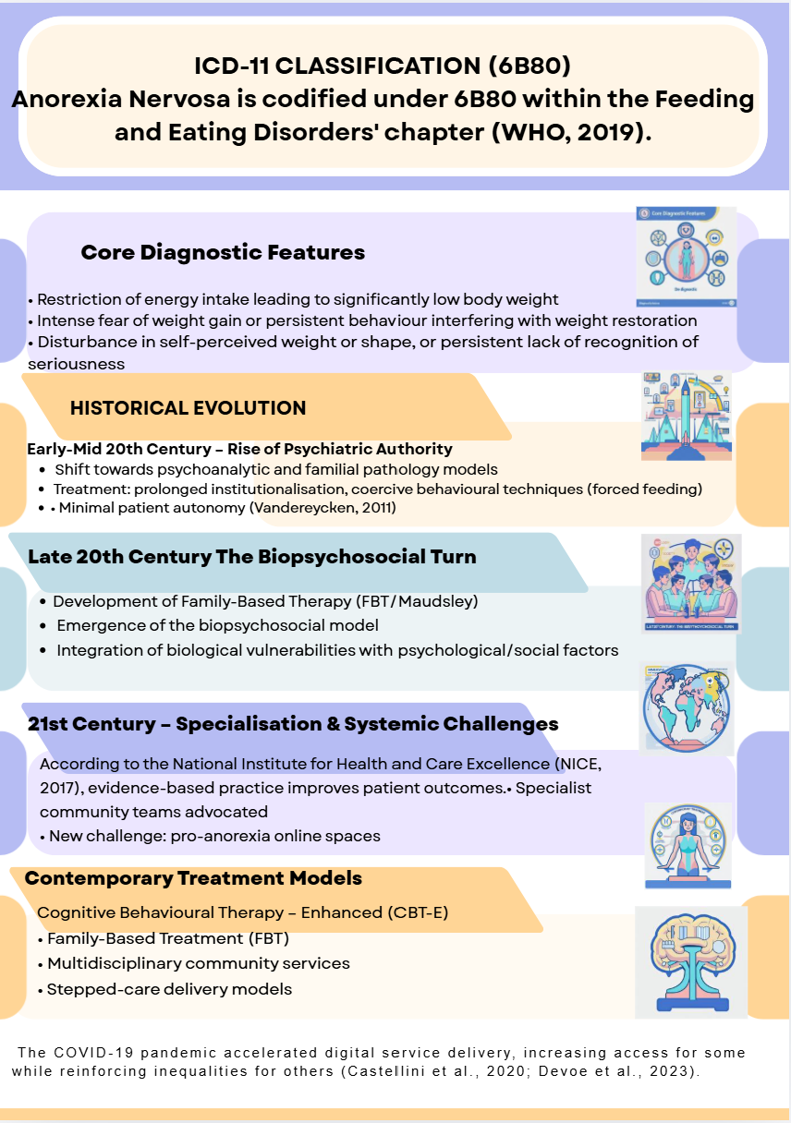
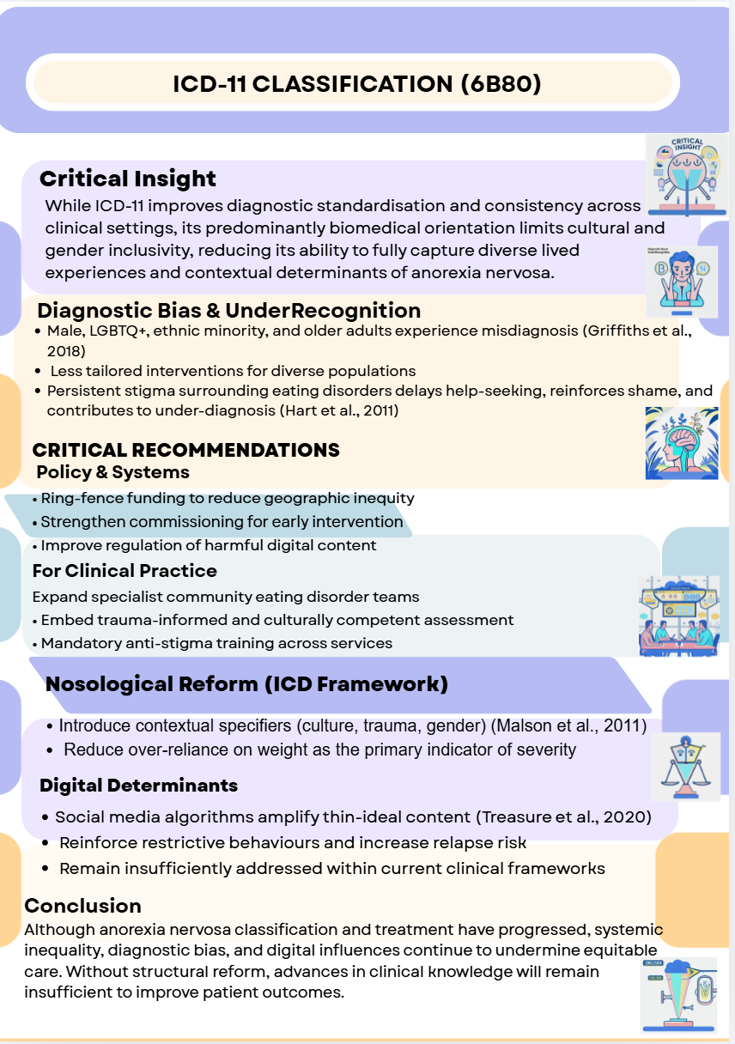
Reference
Agras, W.S. and Robinson, A.H. (eds.) (2017) The Oxford handbook of eating disorders. 2nd edn. Oxford: Oxford University Press.
Brown, M.L. and Levinson, C.A. (2022) ‘Core eating disorder fears: Prevalence and differences across eating disorder diagnoses’, International Journal of Eating Disorders, 55(7), pp. 956–965.
Castellini, G. et al. (2020) ‘The impact of COVID-19 on eating disorders: A longitudinal observation of pre- versus post-psychopathological features’, International Journal of Eating Disorders, 53(11), pp. 1855–1862.
Devoe, D. et al. (2023) ‘The impact of the COVID-19 pandemic on eating disorders: A systematic review’, International Journal of Eating Disorders, 56(1), pp. 5–25.
Fernández-Aranda, F. et al. (2020) ‘COVID-19 and implications for eating disorders’, European Eating Disorders Review, 28(3), pp. 239–245.
Friedlich, C.E. et al. (2023) ‘Updates in the treatment of eating disorders in 2022: A year in review’, Eating Disorders, 31(2), pp. 128–138.
Griffiths, S., Murray, S.B. and Touyz, S. (2018) ‘Extending the masculinity hypothesis: Gender role conformity, body dissatisfaction and disordered eating in young heterosexual men’, Psychology of Men & Masculinity, 19(1), pp. 108–124.
Hart, L.M., Granillo, M.T., Jorm, A.F. and Paxton, S.J. (2011) ‘Unmet need for treatment in eating disorders: A systematic review of treatment seeking among community cases’, Clinical Psychology Review, 31(5), pp. 727–735.
Hay, P. (2020) ‘Current approach to eating disorders: A clinical update’, Internal Medicine Journal, 50(1), pp. 24–29.
Herpertz-Dahlmann, B. and Schmidt, U. (2023) ‘How to deliver developmentally informed treatment for emerging adults with eating disorders’, European Eating Disorders Review, 31(1), pp. 3–8.
Izydorczyk, B. (2022) Body image in eating disorders: Clinical diagnosis and integrative approach to psychological treatment. London: Routledge.
Malson, H. et al. (2011) ‘Un/imaginable future selves: A discourse analysis of in-patients’ talk about recovery from an eating disorder’, European Eating Disorders Review, 19(1), pp. 25–36.
National Institute for Health and Care Excellence (NICE) (2017) Eating disorders: recognition and treatment (NG69). London: NICE.
Nawaz, A. (2022) People of colour with eating disorders face cultural and medical stigmas. PBS NewsHour. Available at: [insert full URL] (Accessed: 3 March 2026).
Quadflieg, N. et al. (2023) ‘Comparing ICD-11 and DSM-5 eating disorder diagnoses’, International Journal of Eating Disorders, 56(9), pp. 1826–1831.
Treasure, J., Duarte, T.A. and Schmidt, U. (2020) ‘Eating disorders’, The Lancet, 395(10227), pp. 899–911.
van Hoeken, D. and Hoek, H.W. (2020) ‘Review of the burden of eating disorders: Mortality, disability and costs’, Current Opinion in Psychiatry, 33(6), pp. 521–527.
Weissman, R.S. and Hay, P. (2022) ‘Lived experience of eating disorders during COVID-19’, International Journal of Eating Disorders, 55(2), pp. 155–160.
World Health Organization (WHO) (2019) International classification of diseases for mortality and morbidity statistics (11th edn.). Geneva: WHO.

