Student: sergiu-viorel chiran
Student id: 2121857
Module: Professional Career Development
Module code: bmsw4005
lecturer: joanna walsh
Professional Career Development Report
2023
Table of Contents
Introduction……………………………………………………………… 2
Current Skills……………………………………………………………. 3
Gap in Skills……………………………………………………………... 4
Skills Acquisition………………………………………………………… 5
Recruitment and Selection…………………………………………….. 5
Conclusion………………………………………………………………..6
References………………………………………………………………. 7
Appendix…………………………………………………………………. 7

Introduction
In this report I will talk about my career development, the career plan that I have in mind and reflect about my weaknesses and strengths in base of this new career path that I intend to follow.
I work in customer service for more than 12 years mostly because I never had a trade that I can exploit and work in. My actual career in Customer Service (Concierge, sales representative, customer service representative etc.) is not something that I chose for myself is more something that chose me because of lack of guidance when I was in my formation years and lack of opportunities. Now I got to a point when I am not enjoying the customer service almost at all and what I want to do is something meaningful and constructive that I can be proud of.
I always thought about web development as a career path that I would like to follow, and recently I find it more and more attractive. Different aspects of this career attract me: financial aspect is one important part because lately I feel that year by year in customer service we earn less and less having in mind all the inflation happening around the globe; the fact that the progression is fast in the web development also is appealing to me. Of course, is fast as long as you are willing to progress and willing to learn new things every day, otherwise is the same as any other job when you don’t put your work, you will never progress. The fact that this job can be done remotely and there is no need to go to the office all the 5 days is really important for me, because I love to be next to the family and help around the house with all day-to-day chores.
I realised that the government in United Kingdom tries to encourage everybody to specialise in something and always offering intense courses called boot camps where you invest a little bit of money but after that you will start a new career path. After finishing a course, they guarantee about 70% that you will get hired. I think is never late to change your job and according to our skills and realistic plans we can fulfil our dreams.
Having all these in mind I will analyse the skills that I have and the skills that I will need to be able to do this career change. I will reflect upon these events using one of the reflective methods that I learned this year and specifically I will use Kolb’s reflective circle which I will describe in the next paragraph.
David Kolb, who is an American educational theorist from Ohio, developed this theory in 1984. He talks about a reflective circle, and he says that the best way to learn is by concrete experience. Once we have the experience of actual doing, we can reflect about the experience and because of the reflection faze, we will be drawing new conclusions and ideas. According to these ideas we will create a new theory that we will put again on practice and reflect again about it and get new ideas who will help use elaborate a new theory and so on.
I consider that this reflective method applies to me because I applied some theories in practice on which I reflected afterword and then I got new ideas and plans.
““Learning is the process whereby knowledge is created through the transformation of experience” (Kolb, 1984, p. 38)
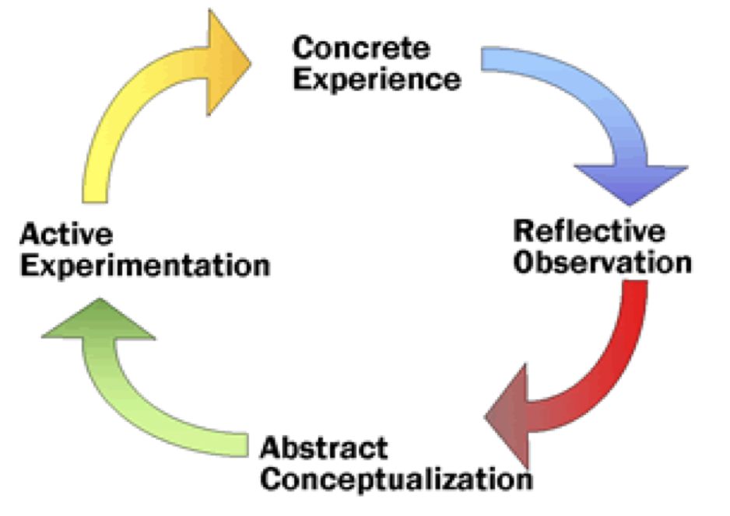

Current Skills
Neugebauer J. and Evans-Brain J. talk about the importance in a workplace of competences. They say that defining the competences at a workplace are beneficial for employer and for the employee. These competences are taking in consideration factors as: teamwork, customer service orientation, problem solving, delivering results, managing with diversity and so on. (Neugebauer J. & Evans-Brain J. , 2016)
I consider myself a good communicator and I think is one of the strengths that I poses because of the prolonged experience in customer service. Throughout my career I had to develop this skill and communicate things to people, not all the time pleasant things, and is important in any career how you say things especially when what you have to communicate is not really enjoyable. Also, communication is essential in between co-workers, and it affects the productivity inside of a team, so knowing how to communicate is an essential skill, sometimes can help you progress faster on your job or if you lack of communication skills will not allow you to go further on.
Problem solving skill is another of my strong strengths that I developed, and I am still developing. Is important in the coding career, maybe one of the most important because every day the developer is confronting himself with problems that take imagination and patience to solve.
I always have been a team player and I think it is essential in web development career to feel that you are part of a team especially when you are participating in a project that is not only depending on you. Throughout my extensive career in Hospitality and Customer Service teamwork was one of the most important value that was presented to us in every aspect of our day-to-day job.
I also believe I have training skills, and because I like to help people, I try my best to train them and show them how I do things and hopefully they will find it useful and helps them at the job.
One of the advantages of being 40+ years old, is that I know how to motivate myself and also how to organise my time and my work in order to be able to be productive. I think these skills are also important giving the fact that in coding you have to be really organised and know when you have to finish your project.

Gap In Skills
I would say that the knowledge of the main coding programs is the main gap in skills. I would need extensive knowledge of HTML, CSS and Java Script in order to start developing projects that I can present in interviews as my portfolio. I also think that not having an actual diploma of a finished course is a major disadvantage.
Work experience is also a big gap because obviously wanting to change career I never worked in this department ever again. This is a big disadvantage because most the companies are looking for employees that have at least one or two years in the domain.
The learning curve is really strong for all these programs but once learned I will be able to fill the gap in skills needed to get a first job in the web development domain.

Skills Acquisition
I started to look for courses online with the scope of gaining knowledge on HTML and CSS. These are the first two programs that I have to start with. I thought first to see how I like them so I entered on Udemy.com which is an website where you can find thousands of courses about a lot of subjects. I chose one and I started working on the first course. I wanted to see how I feel about the information, how dense and understandable is. After 2 weeks of doing this course I can say that the information is not really hard to understand and I just need to practice as much as I can.
Meanwhile I was doing the course I started to check for intense courses that will give me diplomas that will confirm that I have skills in regard to these programs. I haven’t decided yet on which option I will choose and I decided that I will do it starting February 2023 once I will finish my one year course with the University of Wales Trinity Saint David.
I really enjoyed the course because is really interesting and is really enjoyable to do a website and to see how you can progress and learn something useful every day. Also, I realised that it relaxes me to write the code.

Recruitment and Selection
All the time when I am preparing for a job interview, I think about what the employer really wants to hear from me? (Cottrell, S., 2021, p.308) is answering this question by giving us 8 tips of what an employer wants. Some of them are bring a “can-do” attitude, professionalism, a “safe pair of hands” to do the job as the employer requires, “customer service approach and so on. It is a really interesting advice because it showed me what to say during an interview.
We did a job interview simulation in class and at the beginning I was thinking about what questions my colleague will ask me and I was trying to prepare for it according to Stella Cottrell’s advice. The first question was to explain the reason of me changing careers at this age. I was expecting this question and I explained about the way I feel regarding customer service and why I wish to change. I was expecting this question and I had my answer ready.
The second question was if I have any experience in using these programs and I had my answer ready for that too because I said I am preparing and I showed my portfolio of websites that I have done. The third question was about how can I help the team and I said I can help the team with my soft skills gained throughout the years of experience in customer service for example: great communication skills, great team player, customer service orientated.
The fourth question was what I consider will be my biggest challenge on the job. I think it will be to overcome the learning curve for the next 3 to 4 months, but I will do my best and I am sure I will succeed because I am really motivated in doing so.
The last question was about my future career plans for the next five years and I think I did good by showing that I want to learn and stay inside the company and grow my career inside the company.
I will say that I was not that nervous like in a real interview when you know that you can answer something “wrong” and you lose your opportunity. And by “wrong” that means something that the employer doesn’t want to hear. Overall, it was a good experience because you express your thoughts and understand where you can improve your answers for a real interview.

Conclusion
This module was much alike the Employability Skills module, and I enjoyed the lectures because you can always learn something new that will help you in the right moment. This module thought me how to make a career plan and how important is to always have something to look forward to. It also thought me how to plan every move and be conscious in regard to reflecting on each action I take and if is wrong to try to correct it.
The act of reflection on things is not only a lesson that helps us on our academic life or professional life but also on a day-to-day life. I am leaving this University with a lot of good lessons from this first year and I think it was a beneficial course for myself all together because on each of the 6 modules I found something interesting that could help me in the future.

References
- Cottrell, S. (2021) Skills for success: personal development and employability 4th edn. London: Red Globe Press
- Kolb, D. A. (1984). Experiential learning: Experience as the source of learning and development (Vol. 1). Englewood Cliffs, NJ: Prentice-Hall.
- Neugebauer, J. and Evans-Brain, J. (2016) Employability: making the most of your career development London: Sage.

Appendix
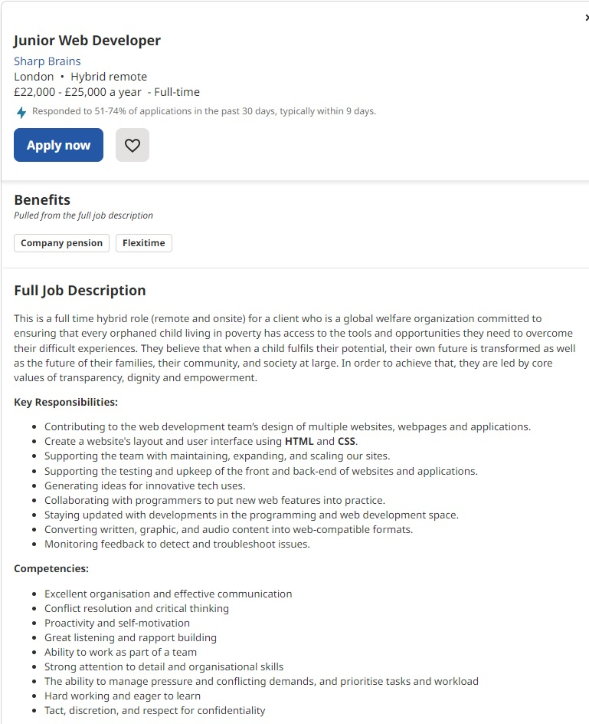

Job application form

Application for – Junior Web Developer

Your details

Name: Sergiu Chiran

Education and training
Please give details:

Highschool C.A. Rosetti Bucarest 1995-1999
CERT HE Skills for the work place 2022-2023 University of Wales Trinity Saint David

Qualifications
Please give details:

Employment history

Your current or most recent employer

Name of employer: Vertus

Job title: Senior Night Concierge

Length of time with employer: 3 years

Reason for leaving: Change of domain
Duties:

Supervision of the night team consisting in concierge and cleaners

Previous employers
Please tell us about other jobs you have done and about the skills you used or learned in those jobs.

Marylebone Hotel as Luggage Porter

Supporting statement
Please tell us why you applied for this job and why you think you are the best person for the job.

I would love to change my line of work, I am self motivated and ready to learn new things.

Right to work in the UK
Do you need a work permit to work in the UK? Yes

References
Andrei Blanaru 07753086555
Milena Stan 0753053987

Declaration
I confirm that to the best of my knowledge the information I have provided on this form is correct and I accept that providing deliberately false information could result in my dismissal.

Name: Sergiu-Viorel Chiran
Signature:
Date:06.01.2023

