

Reflective Report

Student name: Stefan Kolev
Student ID: 2124578
Module name: ACADEMIC AND EMPLOYABILITY SKILLS
Module code: BMSW4001
Lecturer: Dr Lizeta Demetriou

Submitted on:

Table of contents:

- Introduction……………………………………3
- Kolb’s ‘Experiential Learning Cycle’……..3
- Time management………………………………4
- Cover letter…………………………..8
- Writing a cv………………………………9
- Paraphrasing………………………….
- Reflection……………………………………9
- Conclusion ………………………….10
- APPENDIX…………………….11
- Reference list ……………………………..10

- Introduction

Reflection is a writing where you can describe your experience/feelings/practise in order to learn and improve. There are reflective models which are Gibb’s ‘Reflective Cycle’; Kolb’s ‘Experiential Learning Cycle’; Driscoll’s Model. I will reflect on Kolb’s ‘Experiential Learning. Also I will explain about Time management, Writing a CV and Paraphrasing.
I will write about their Description, Feelings, Evaluation, Analysis and Action plan.
I will explain what reflection is and I will finishing off with my conclusion.

2. Kolb’s ‘Experiential Learning Cycle’
Kolb’s ‘Experiential Learning Cycle’ is divide in for concepts which are: Concrete experience, Reflective Observation, Abstract Conceptualisation, Active Experimentation I will give a short brief for every single one. First I going to talk about the concrete experience is a rediscovery of existing experience. Second I will discuss the reflective observation is thinking of what we have experience. The Third is abstract conceptualisation to conceptualize is to make a theory about the meaning of our experiences. Last one is the active experimentation at this stage you have to test the hypotheses.

- Time management
Description: Time management is to allocating your time, using your time more effectively, time management make you more productive, because you are no losing your time. Time management is one of the best skills every person must have, to know how to manage your time is really important because the time is the only thing that we cannot bring I back that’s why we have to be really careful what we are doing with our time.
In class I learn what time management is. The whole class did some activity we answer couple of questions to help us review our use of time and the questions are:
Do I use time efficiently?
How do I waste time?
What or who distracts me from study?
Do I need to plan out my time: for the year? The term? The week? The day? Each piece of work?
Do I waste time getting started?
Do I make the most of spare moments?
Do I find time passes and I don’t know what has happened?
This activity really help us to find out how we are using our time. This activity show us the amount of time we are waiting. After this activity I change a lot of things in my life I start to appreciate my time.
After this activity we did another one we did our
To-do lists-daily and to-do list weekly. Making my To-do list I find out how many things I have to in my day. We learn how to set SMART Goals. The setting of SMART Goals are:
S-SPECIFIC
M-Measurable
A-Achievable
R-Realistic
T-time-related
The SMART Goals are really important.
The third activity we did was to set a goals for next month and after that for next year.
Feelings: I can honestly said that before this class I was wasting my time a lot, but after learning the tools and seeing how important is the time I start using my time properly. This session really change my view about timing.
Evaluation: I learn how to use my time, I learn the smart goals, how to make my to-do list and weekly to-do list.
Analysis: I like this class because of the activity we did what realty help me to organise my days.
Conclusion: In conclusion I can say that the time management is really important for every human who want to achieve something in life.
Action plan: My action plan after learning all this things is to be more organise. To-do my daily and weekly to-do lists and to set a SMART goals in my life. I will start write down what is the most important I need to.

6. Writing a CV:
Description: A CV is a paper which you use to apply for job.IS a document which attribute all your qualifications, skills and experience you have is way you selling yourself to the employees.
In class we did some activity to help us write our CV we write down our knowledge, skills, attributes, and other things with these we can write down our Personal Statement for the CV. In module there is template to write your CV in class we did this as an activity.
Feelings: In this session I learn how to write my CV before this session I was struggling to do my CV good enough. After this class I’m feeling much more confident.
Conclusion: The conclusion I can make is that to write a good CV you have to know the tools and the examples which we learn in this session.
Action plan: After learning all this I am sure that I will write a really good CV.

7. Paraphrasing
Description: Paraphrasing is to write someone idea in your own words. In class we did some practise exercise. We paraphrasing sentences. I learn that you have to change the structure and the words when you are paraphrasing but you have to make sure the meaning is the same. There is some techniques for paraphrasing you have to use synonyms, changing work order and changing word class.
Feelings: Paraphrasing for me was something unfamiliar at all, during the class I start understanding what the meaning of paraphrasing is and how to use it.After the session and the exercise we did I start to use paraphrasing much more.
Evaluation: I learn a lot about the paraphrasing and how to use it.
Analysis: I like this class because I lean something new which I did not know before and I was in need to know this we have to do a lot more reports in future and I have to know how can I paraphrase.
Conclusion: My conclusion is the paraphrasing is really important when you are writing any kind of source. Learning how to use paraphrasing I know will help me to do my reports and presentations in next term.
Action plan: My action plan is to use paraphrasing a lot more than now, because now I know the technique. I will use paraphrasing during my next term reports and presentation.

8. Reflection
In week 3 we had a class on reflection. In this session I understand what is reflection that is activity in which you analyse your experience, skills in order to improve. There is a reflective writing as well which means that is evidence of reflective thinking which involves looking back at something, analysing the event and thinking carefully about what the event means to you.
I learn that there is four models of reflection namely Gibb’s ‘Reflective Cycle, Kolb’s ‘Experiential Learning Cycle’, Driscoll’s Model and this model basically means “what happened? What was the experience of it? Why did it happened? What will I do if it happened again?”
There is reflective writing as well and this is evidence of reflective thinking and the reflective thinking involves: To look back at something could be an idea or event after that you have to analyse the idea and the third action is to think carefully about the event or idea means to you.
There is Reflective report this is a piece of writing which summarise the reflection on a subject.

- Conclusion
I will make my conclusion of what I write in this report for “Academic and employability skills”.
I start with the Kolb’s ‘Experiential Learning Cycle’ is divide in for concepts which are: Concrete experience, Reflective Observation, Abstract Conceptualisation, Active Experimentation. Second one is public speaking and public speaking and giving presentations is giving an oral presentation front of a group of people at university or work. Time management and also I give brief of what is cover letter and how to write cover letter and I write about the CV and what to include in the CV the last thing I write about is Reflection.

APPENDIX
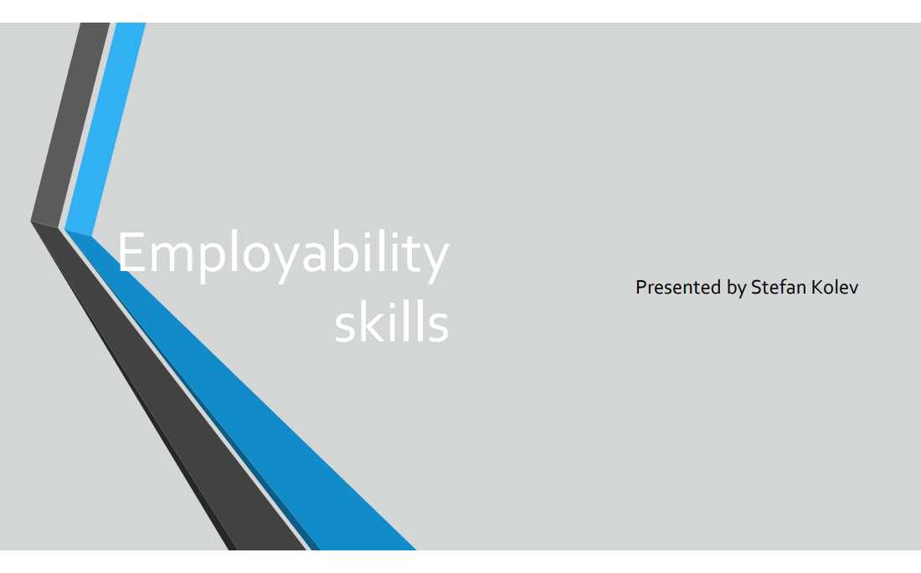
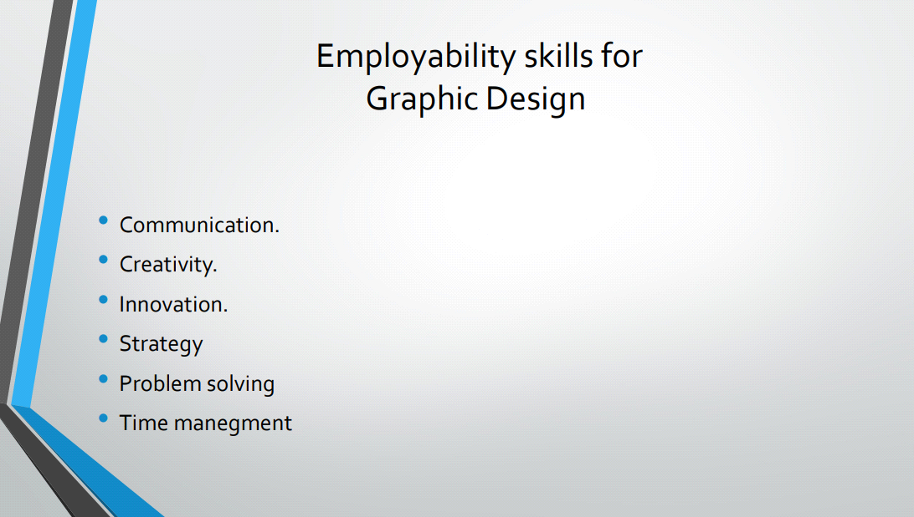
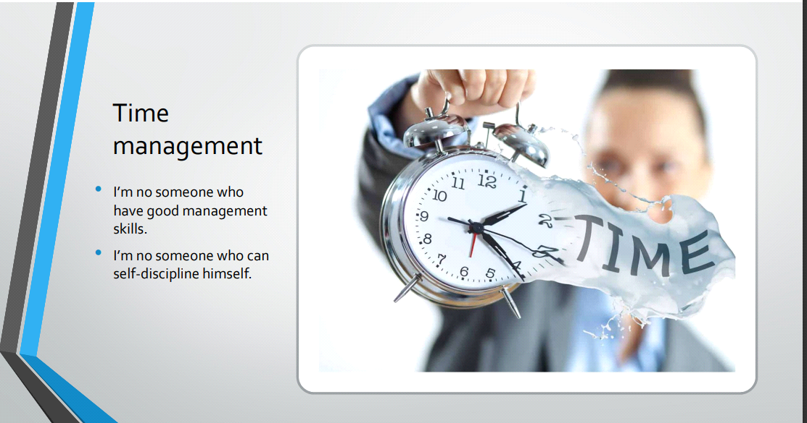

Reference list:
References
Gibbs' Reflective Cycle, 2020. Gibbs' Reflective Cycle. [Online]
Available at: https://www.ed.ac.uk/reflection/reflectors-toolkit/reflecting-on-experience/gibbs-reflective-cycle
[Accessed 02 08 2022].
https://www.mindtools.com/pages/article/newHTE_00.htm#:~:text=Time%20management%20is%20the%20process,manage%20their%20time%20exceptionally%20well.

