Corporate Governance and Social Responsibility
Global CSR – UN goal 1, No Poverty



Total word count: 2472
Module code: M6X00876
Student Number: 1702530
Full Name: Niswat Anjum Aniqa
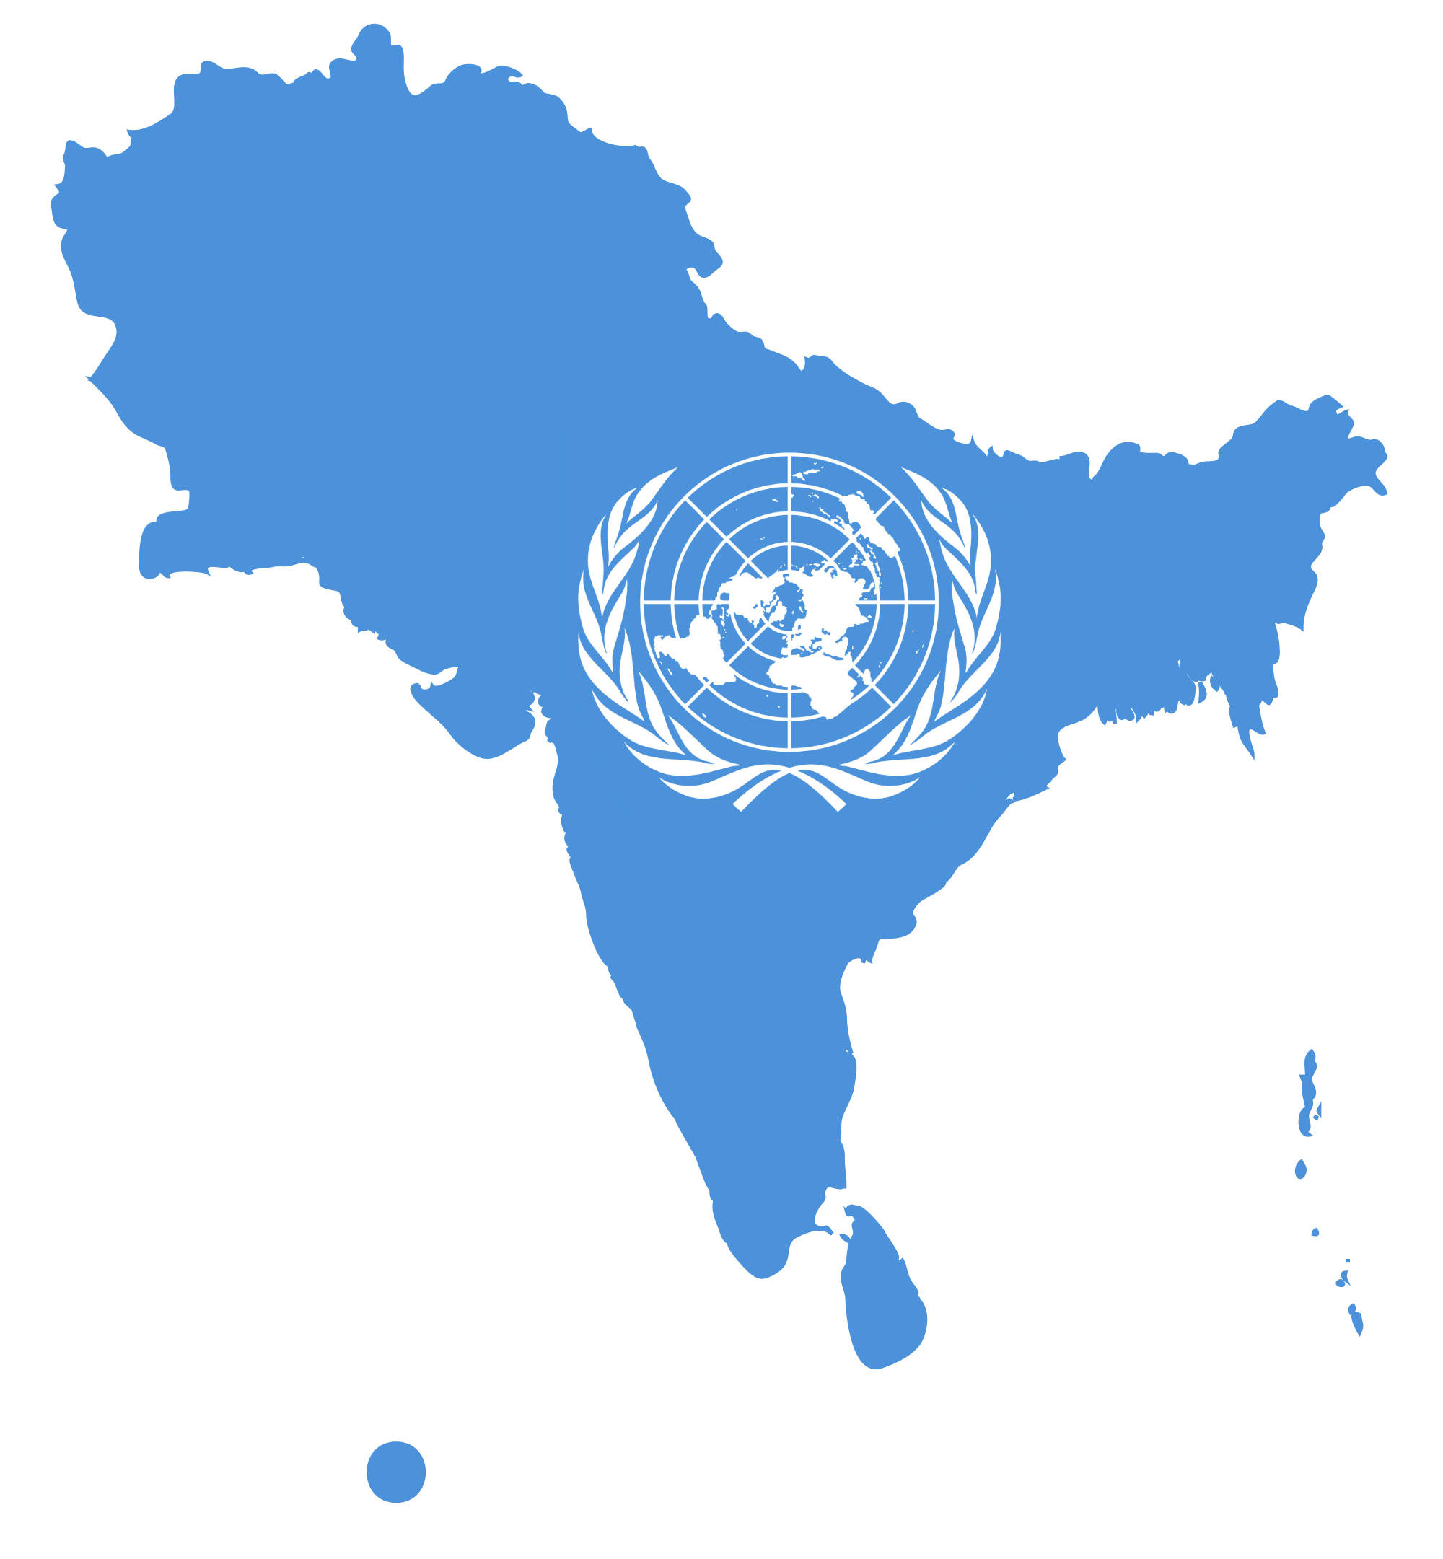

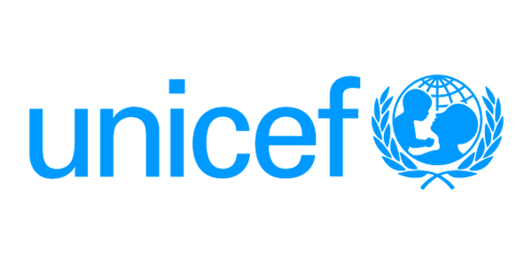

Table of Contents

Executive summary 5
1. Introduction 6
2. Method and Findings 8
2.1 Poverty in South Asia 8
2.2 UNICEF 9
2.2.1 Education 9
2.2.2 Disaster Risk Reduction (DRR) 10
2.2.3 Gender Equality 13
2.2.4 UN Women 15
3. Discussion 16
3.1 UNICEF and CSR 16
4. Conclusion 18
5. Recommendations 20
6. References 21

Table of figures

Figure 1: South Asia Poverty Diagram, causes and solutions……………………………..…19

Executive summary

Poverty is an issue that majority of the countries around the world have faced, however, there are poorer countries than others; some of these countries facing extreme poverty are located in South Asia.

United Nations has initiated 17 Goals that focus on achieving a sustainable future for everyone, intending to complete these by 2030. One of these goals is to eliminate poverty and this report has discussed how the public sector organisations worked together to tackle global development in South Asia.

Things like education and gender equality can combat poverty as they are considered to be big obstacles in the region. Organisations like UNICEF have helped the less developed countries across South Asia as they believe that providing education is the big step needed in getting the countries back on a path to development.

South Asian countries must consider few things such as safety net programs, the state provided free education, improvement of human capital through adult literacy and technical education and health services along with other social protection programs.

Introduction

Over 700 million people of the world are still living on extreme poverty, they struggle daily to fulfil the most basic needs such as education, access to clean water or sanitation (UNDP, 2020; World Vision, 2020). The poverty rate in rural areas is 17.2 per cent which is more than three times higher than in urban areas. It is extremely important to ensure that every children gets protection which potentially helps minimise poverty (World Bank, 2020; Pogge, 2005). Some other forms of poverty are unemployment, diseases which prevent them from being productive (UNDP, 2020; World Bank, 2020; Pogge, 2005)
The United Nations (UN) is an organisation that was established after World War II with the only goal to stop wars in the future and is an intergovernmental organisation that focuses to maintain international peace and security. It is also the largest and most powerful intergovernmental organisation in the world (UNDP, 2020).

The goals were set to ensure that no one is left behind, and the first goal of the UN is aim is to end poverty by 2030 across third world countries (UNDP, 2020). Population growth and poverty are interrelated and as a result, regions experiencing high levels of poverty are often the least developed countries (LDC) of the world (World Vision, 2020).

This report shall discuss the following targets of the sustainable development goal 1:
- Eliminate extreme poverty for everyone, currently measured as people living on less than $1.25 a day (Goal 1 target 1.1).
- To make sure that everyone has equal rights to economic resources, access to basic services, natural resources, and financial services (Goal 1 target 1.4).

This report will introduce the concepts of poverty in southern Asian countries and how the public sector organisations worked together to tackle global development and implement CSR initiatives globally. This shall be followed by a discussion of the interrelations between these concepts, this report shall conclude with a look at poverty and sustainable development.

Method and Findings

2.1 Poverty in South Asia

Population growth leads to a corrupt administration, which fails to offer education to everyone, giving rise to unemployment and food insecurity as well as discrimination (Olinto et al., 2013).
South Asia is the second-fastest-growing region in the world with strong economic growth, contributing to an impressive reduction of poverty (Olinto et al., 2013; Mink, 1993).
Already from the 90s, India, Nepal and Bangladesh lowered their poverty rates by 7.9 and 11 percent points (Devarajan and Nabi, 2006). Overpopulation is another reason why South Asia is struggling to combat poverty; this is due to poor families having more children than affluent ones and thus exponentially grow the number of poor. Most of these families fail to provide decent living conditions for all their children, thus condemn them to lives of deprivation (Mink, 1993).
The unmatched economic growth and poverty reduction elevates the possibility of ending poverty, however, this is quite challenging.

With 400 million people in absolute poverty and violent conflicts in the region, as well as widespread ill-health and illiteracy, combatting poverty can be tough (World Bank, 2020; UNDP, 2020).

2.2 UNICEF

This part of the report shall discuss the first target:
- To eliminate poverty for everyone;
According to various sources, the lack of education is the main cause of poverty (Ringen, 1988; Nolan & Whelan, 1996; Clark et al, 1981).

2.2.1 Education

South Asian countries are prone to yearly flooding, drought and earthquakes and children are a vulnerable group that solely depend on adults for food, protection, care; the frequency of the natural disasters puts a huge number of children at risk daily (Bhalla, 2002).
UNICEF believes that providing education is the first step in getting the countries back on a path to development (Jenkins, 2005). Conflicts have impacts on children and education can offer knowledge and skills to promote a culture of peace and sustain development (Jenkins, 2005).

According to the Global EFA monitoring report (2015) 7 million children and adolescents living in conflict-affected countries are in South Asia. With the rise in environmental degradation and climate change, there is an increase in occurrence disasters, South Asia has accounted 96.5 percent of the total numbers of disasters recorded globally in 2011 (UNESCO, 2015). These disasters have serious implications for South Asia, where a huge number of people are extremely poor, marginalized and at high risk. In South Asia, UNICEF recommends for the mechanism of care, safety for young children; they support their country offices which ensures the continuity of education during and after the emergencies and they also document good practices throughout the region (UNICEF, 2020).

2.2.2 Disaster Risk Reduction (DRR)

Things like Climate change are expected to influence many of these hazards in the region, thus, climate-related risks over South Asia make disaster risk reduction (DRR) key policy goal.
To help vulnerable children with education at high-risk territories, UNICEF through research and capacity-building advances social work on social cohesion in South Asia.

They also ensure that the educational system promotes peace and resilience (UNICEF, 2020). To support such effort about child rights, the South Asian Association for Regional Cooperation (SAARC) and UNICEF have joined hands in early 2014 (SAARC, 2020). During 2014 and 2015, Disaster Risk Reduction (DRR) met UNICEF and SAARC in several occasions to discuss how best to raise the profile of DRR programming for and with children (SAARC, 2020).

The DRR has developed a 3-pillar approach (CWS-Asia, 2020) to reduce the exposure to disasters of communities:
- Community-based activities: working with communities and making sure that risk reduction is sustainable, resulting improvements and strengthening community resilience.
- Education and capacity building activities : integrating DRR education into the school curriculum in close cooperation with local and central governments.
- Advocacy: Improving risks policies at international and local levels (CWS-Asia, 2020).
DRR describes four approaches that help reduce child vulnerabilities which are listed below:
- child-centred risk assessments;
- safeguarding child infrastructure;
- protecting children in emergencies;
- social protection for children (USAID, 2016).
And it also presents four different approaches that enhance child capabilities including:
- participatory action;
- life skills education;
- school safety;
- partnerships (USAID, 2016).
Governments in South Asia are currently investing in DRR to improve the response capacities of their countries from the community to the national level, and The United States Agency for International Development (USAID) has funded and supported these nations to develop DRR and emergency response capacities. In 2016 for example, DRR with the help of USAID has supported Pakistan to improve disaster preparedness and response to flooding by enhancing community infrastructure through cash-for-work. USAID funded $43.5m in 2016 to help South Asia reduce natural disasters (USAID, 2016).

The DRR program has successfully been helping the South Asian region in various ways, they been able to address the water contamination issues in flood-prone geographies (Oxfam India, 2018; World Meteorological Organization, 2007). Through DRR activities in 2017, India was able to reach out to 101544 people during India floods. They also repaired open wells, supply water points were tested, and they have reached to 94603 men, women and children for public health promotion activities and support 16924 families with shelter and livelihood opportunities (Petterson et al., 2019; Dhyani, 2018; Krishnan and Patnaik, 2020).

This section of the report shall now critically analyse the second target:
- To ensure that every person gets equal rights to economic resources.

2.2.3 Gender Equality
The landmark Declaration reaffirms that “All human beings are born free and equal in dignity and rights” (UN, 2020). Adopted by the General Assembly on 10 December 1948.
Suggesting that every human should be entitled to all the rights and freedom however, many countries in the South Asian region do not follow this.
South Asian countries always preferred sons, meaning the girl child struggles twice as hard to survive and fulfil her potential, and social norms in this region prioritise a son receiving higher education which influences the girls and affects their rights as they are disadvantaged as structural inequalities and the low status (Klasen, 2009). The Chinese Government, for example, has introduced ‘One Child per Family Policy’, which started in 1980 to reduce the growth rate of China’s population. (Encyclopedia Britannica, 2020). This policy ended in 2016 however, there was a surge in female infanticide. The Chinese population believed that a girl baby was an economic disaster and having a son is better as of their higher earning potential. Hence, female babies did not survive (Hom, 1991; Arnold et al., 1992; Lee, 1981).

This indicates that many cultures believed a female is less valuable than a male meaning gender inequality was circulating since a very long time. Child marriage is also another burden for young females in South Asia, which again leads to poverty (Bina, 1994; Bhopal, 2019; Klasen, 2009). Bangladesh has the rate of child marriage at 52 percent, followed by India and Nepal at 47 and 37 percent (UNICEF, 2020). This follows young girls becoming pregnant, combined with poor education, as previously discussed, inadequate decision-making power and very poor control over resources. This demonstrates that many young girls are entering pregnancy ill-equipped which will not support healthy foetal growth, as a result, South Asia has the second-highest number of maternal deaths (Graham, 2006; Pasha, 2004; Klasen, 2000).

By the discussions above, it can be concluded that is vital to fuse a gender perspective across all UNICEF programmes to boost the value of women in this region; every person should get equal freedom and rights to economic sources. Thus, UN Women supported gender equality ensuring every female obtains equal rights in the south Asian Region.

2.2.4 UN Women

UN Women came about as part of the UN reform agenda, this brings resources and mandates on gender equality together for greater impact. Un Women works closely in India with its government to set national standards for achieving gender equality (UN Women, 2020). Another priority of the organisation is to end other forms of violence such as trafficking domestic violence etc. In other South Asian countries like Bhutan, Maldives and Sri Lanka, this organisation works in coordination with the United Nations system and civil society which ensures that women become equal partners in development (UN Women, 2020; True, 2016).
In 2017 for example, UN Women has helped the Rohingya women in Bangladesh to recover and earn for a living, they also made sure every female refugee is safe, get basic health consultations and emergency services and psycho-social support (UN Women, 2020).
The organisation has also initiated multiple charities site such as building additional women-only toilet and bathing facilities across the refugee camps, which would offer them greater sanitation and most importantly security (UN Women, 2020; Duffo, 2012)

Discussion

3.1 UNICEF and CSR

UNICEF believes that Corporate social responsibility attributes to production to firmly develop business behaviour and practices as they influence children. This is done in association with a variety of stakeholders, such as civil society, government, children and young people (UNICEF, 2020).
Organisations have massive impacts on children’s rights, these impacts can be either positive or negative. The make important contributes to the health of kids by building jobs and income for families; violations of children rights by businesses can be also a threat the protection or development of children (Business and Human Rights Resource Centre, 2020; UNICEF, 2014).
By adopting CSR with a focus on children’s rights, UNICEF supports companies, civil societies in their efforts to avoid negative impacts of organisations, while increasing the positive impacts on the children’s lives in the workplace as well as the community (UNICEF, 2020). UNICEF does this through three interrelated work areas:

- Policy advocacy and communication
- Strategic corporate partnership
- Programme implementation

The work of UNICEF on CSR is grounded in delivering consequences for the most disadvantaged children. It shows an opportunity to work together with the private sector to address the challenges siding disadvantaged children (Charrière, 2017).
UNICEF believes that CSR can add value to the children’s rights because:
- Organisations impact children’s rights; CSR has often focused on stopping and eliminating child labour. However, products and services, relationship with local national governments also affect children (UNICEF, 2020).
- Through core business activities and public policy engagement, businesses can act as a champion for children's rights. The organisation can work in partnership with peers, suppliers, government and other business relationship as part of aiding children’s rights (UNICEF, 2020).

UNICEF has a massive role in raising awareness of how organisations affect children, and in working with the government to encourage the responsibility to support the rights of children in the workplace and community (UNICEF, 2020). Their CSR work is part of their efforts to keep a collaborative relationship to increase equity, decreasing disparities and growing services for the less fortunate (UNICEF, 2020).

Conclusion

The presence of poverty has been noticed in various LDC’s. These concepts have been acknowledged as irrelevant howbeit, these relationships have also demonstrated to be extremely complex, for this reason addressing these issues have been challenging.
Sustainable development practises with poverty have been poor historically. Efforts to eliminate poverty and environmental degradation are said to require serval disciplines, polices in all sectors. These policies need to be established thoughtfully, also by considering the need to attaining sustainable development if the resourced that are available for future generations are to be conserved.

As seen few factors such as lack of education, gender inequality, overpopulation and natural disasters make South Asia a poorer region (see Figure 1), however, the UNICEF has been helping the countries in South Asia to educate the vulnerable children in areas where natural disasters have occurred. UN Women has also helped females across the region to get equality; gender equality is crucial as everyone should have equal rights, no one should be left behind (Norris, 2003; Sainsbury, 1996; Gatti, 1999).
As the second decade of rapid economic growth enters, South Asia is at a crossroads. South Asian countries risk having inequality problems and weak governance retard poverty reduction. The welfare of every single poor person depends on the patch they choose (Biermann et al., 2017); (Chen, 2010).

UNICEF
Overpopulation

SOUTH ASIA
Lack of education

UN WOMEN

Violence, Natural disasters

Gender inequality
DRR

Figure 1: South Asia Poverty Diagram; causes and solutions.

Recommendations

To reduce poverty, South Asian countries must consider few things such as safety net programs, the state provided free education, improvement of human capital through adult literacy and technical education and health services along with other social protection programs. As previously discussed, the main causes of poverty are related to lack of education, growth of population in some cases also discrimination. The region should also strictly focus on women’s safety as they get discriminated the most, and do not get treated equally. If everyone gets equal rights, these countries could go far and combat poverty. By taking a few actions, setting new laws and helping people understand the consequences, South Asia can eliminate poverty by 2030.

References

- Agarwal, B. and Bina, A., 1994. A field of one's own: Gender and land rights in South Asia (Vol. 58). Cambridge University Press.
- Angelsen, A. and Wunder, S., 2003. Exploring the forest—poverty link. CIFOR occasional paper, 40, pp.1-20.
- Arnold, F. and Zhaoxiang, L., 1992. Sex preference, fertility, and family planning in China. In The Population of Modern China (pp. 491-523). Springer, Boston, MA.
- Bhalla, S.S., 2002. Imagine there's no country: Poverty, inequality, and growth in the era of globalization. Peterson Institute.
- Bhopal, K., 2019. Gender,' race' and patriarchy: a study of South Asian women. Routledge.
- Biermann, F., Kanie, N. and Kim, R.E., 2017. Global governance by goal-setting: the novel approach of the UN Sustainable Development Goals. Current Opinion in Environmental Sustainability, 26, pp.26-31.
- Business and Human Rights Resource centre, 2020. Chief, Corporate Social Responsibility At UNICEF | Business & Human Rights Resource Centre. [online] Business-humanrights.org. Available at: <https://www.business-humanrights.org/en/chief-corporate-social-responsibility-at-unicef> [Accessed 21 April 2020].
- Charrière, F., 2017, January. UNICEF: Engaging Stakeholders on Children’s Rights. In The United Nations Convention on the Rights of the Child (pp. 777-794). Brill Nijhoff.
- Chen, S. and Ravallion, M., 2010. The developing world is poorer than we thought, but no less successful in the fight against poverty. The Quarterly Journal of Economics, 125(4), pp.1577-1625.
- Clark, S., Hemming, R. and Ulph, D., 1981. On indices for the measurement of poverty. The Economic Journal, 91(362), pp.515-526.
- CWS-Asia, 2020. Disaster Risk Reduction | CWS Asia. [online] Cws-asia.org. Available at: <https://cws-asia.org/disaster-risk-reduction/> [Accessed 30 April 2020].
- Devarajan, S. and Nabi, I., 2006. Economic Growth in South Asia: Promising, Unequalising, Sustainable?. Economic and Political Weekly, Vol. 41, No. 33, pp.pp. 3573-3580.
- Dhyani, S., Lahoti, S., Khare, S., Pujari, P. and Verma, P., 2018. Ecosystem based Disaster Risk Reduction approaches (EbDRR) as a prerequisite for inclusive urban transformation of Nagpur City, India. International journal of disaster risk reduction, 32, pp.95-105.
- Dollar, D. and Gatti, R., 1999. Gender inequality, income, and growth: are good times good for women? (Vol. 1). Washington, DC: Development Research Group, The World Bank.
- Duflo, E., 2012. Women empowerment and economic development. Journal of Economic literature, 50(4), pp.1051-79.
- Encyclopedia Britannica, 2020. One-Child Policy | Definition & Facts. [online] Encyclopedia Britannica. Available at: <https://www.britannica.com/topic/one-child-policy> [Accessed 29 April 2020].
- Fikree, F.F. and Pasha, O., 2004. Role of gender in health disparity: the South Asian context. Bmj, 328(7443), pp.823-826.
- Hom, S.K., 1991. Female Infantcide in China: The Human Rights Specter and Thoughts towards (An) Other Vision. Colum. Hum. Rts. L. Rev., 23, p.249.
- Inglehart, R., Norris, P. and Ronald, I., 2003. Rising tide: Gender equality and cultural change around the world. Cambridge University Press.
- Jenkins, R., 2005. Globalization, corporate social responsibility and poverty. International affairs, 81(3), pp.525-540.
- Klasen, S. and Lamanna, F., 2009. The impact of gender inequality in education and employment on economic growth: new evidence for a panel of countries. Feminist economics, 15(3), pp.91-132.
- Klasen, S., 2000. Does gender inequality reduce growth and development? Evidence from cross-country regressions.
- Krishnan, S. and Patnaik, I., 2020. Health and disaster risk management in India. In Public Health and Disasters (pp. 155-184). Springer, Singapore.
- Lee, B.J., 1981. Female infanticide in China. Historical Reflections/Réflexions Historiques, pp.163-177.
- Mink, S.D. and Mundial, B., 1993. Poverty, population, and the environment (Vol. 189). Washington DC: World Bank.
- Nolan, B. and Whelan, C.T., 1996. Resources, deprivation, and poverty. OUP Catalogue.
- Olinto, P., Beegle, K., Sobrado, C. and Uematsu, H., 2013. The state of the poor: Where are the poor, where is extreme poverty harder to end, and what is the current profile of the world’s poor. Economic Premise, 125(2), pp.1-8.
- Oxfam India, 2018. 3 Innovations In Disaster Risk Reduction In India You Should Know About. [online] Oxfamindia.org. Available at: <https://www.oxfamindia.org/blog/3-innovations-disaster-risk-reduction-india-you-should-know-about> [Accessed 30 April 2020].
- Petterson, M., Wangchuk, S. and Konchok, N., 2019. A multiple natural hazard analysis, SECMOL College region, near Leh, Ladakh, North India, with applications for community based DRR. Disaster Prevention and Management: An International Journal.
- Pogge, T., 2005. World poverty and human rights. Ethics & international affairs, 19(1), pp.1-7.
- Ringen, S., 1988. Direct and indirect measures of poverty. Journal of social policy, 17(3), pp.351-365.
- Ronsmans, C., Graham, W.J. and Lancet Maternal Survival Series steering group, 2006. Maternal mortality: who, when, where, and why. The lancet, 368(9542), pp.1189-1200.
- SAARC, 2020. SAARC SECRETARIAT. [online] Saarc-sec.org. Available at: <http://saarc-sec.org/news/detail_front/press-release-saarc-and-unicef-renews-cooperation-agreement> [Accessed 16 April 2020].
- Sainsbury, D., 1996. Gender, equality and welfare states. Cambridge University Press.
- True, J., 2016. Women, peace and security in Asia Pacific: Emerging issues in national action plans for women, peace and security. UN Women. Available at, http://asiapacific. unwomen. org/en/digital-library/publications/2016/12/emerging-issues-innaps-on-wps.
- UN Women, 2020. Support Rohingya Women In Cox’S Bazaar And Others In Need. [online] UN Women | Asia and the Pacific. Available at: <https://asiapacific.unwomen.org/en/get-involved/simply-giving/rohingya-women> [Accessed 18 April 2020]
- UN Women, 2020. UN Women India. [online] UN Women | Asia and the Pacific. Available at: <https://asiapacific.unwomen.org/en/countries/india> [Accessed 18 April 2020].
- UN, 2020. Universal Declaration Of Human Rights. [online] Un.org. Available at: <https://www.un.org/en/universal-declaration-human-rights/> [Accessed 30 April 2020].
- UNESCO, 2015. Overview Of Natural Disasters And Their Impacts In Asia And The Pacific. [online] Unescap.org. Available at: <https://www.unescap.org/sites/default/files/Technical%20paper-Overview%20of%20natural%20hazards%20and%20their%20impacts_final.pdf> [Accessed 16 April 2020].
- UNESCO, 2020. Homepage | Global Education Monitoring Report. [online] En.unesco.org. Available at: <https://en.unesco.org/gem-report/> [Accessed 16 April 2020].
- UNICEF, 2014. ENGAGING STAKEHOLDERS ON CHILDREN’S RIGHTS. [online] Unicef.org. Available at: <https://www.unicef.org/csr/css/Stakeholder_Engagement_on_Childrens_Rights_021014.pdf> [Accessed 21 April 2020].
- UNICEF, 2020. Education for Disaster Risk Reduction, Social Cohesion And Peace-Building. [online] Unicef.org. Available at: <https://www.unicef.org/rosa/what-we-do/education/education-disaster-risk-reduction-social-cohesion-and-peace-building> [Accessed 16 April 2020].
- UNICEF, 2020. UNICEF - Corporate Social Responsibility - Home. [online] Unicef.org. Available at: <https://www.unicef.org/csr/> [Accessed 21 April 2020].
- UNICEF, 2020. UNICEF South Asia. [online] Unicef.org. Available at: <https://www.unicef.org/rosa/> [Accessed 11 April 2020].
- UNICEF, 2020. UNICEF Strategic Plan, 2018–2021: Executive Summary. [online] UNICEF. Available at: <https://www.unicef.org/publications/index_102552.html> [Accessed 21 April 2020].
- United Nations Sustainable Development, 2020. Goal 1: End Poverty in All Its Forms Everywhere - United Nations Sustainable Development. [online] United Nations Sustainable Development. Available at: <https://www.un.org/sustainabledevelopment/poverty/> [Accessed 1 April 2020].
- USAID, 2016. SOUTH ASIA – DISASTER RISK REDUCTION. [online] Scms.usaid.gov. Available at: <https://scms.usaid.gov/sites/default/files/documents/1866/southasia_drr_fs01_09-30-2016.pdf> [Accessed 16 April 2020].
- World Bank, 2020. Overview. [online] World Bank. Available at: <https://www.worldbank.org/en/region/sar/overview> [Accessed 9 April 2020].
- World Bank, 2020. Understanding Poverty. [online] World Bank. Available at: <https://www.worldbank.org/en/understanding-poverty> [Accessed 30 April 2020].
- World Meteorological Organization, 2007. Flood And Drought Management Through Water Resources Development In India. [online] World Meteorological Organization. Available at: <https://public.wmo.int/en/bulletin/flood-and-drought-management-through-water-resources-development-india> [Accessed 30 April 2020].
- World Vision, 2020. Global Poverty: Facts, Faqs, And How To Help | World Vision. [online] World Vision. Available at: <https://www.worldvision.org/sponsorship-news-stories/global-poverty-facts> [Accessed 30 April 2020].

