Tetra pack printing-cut-print-draw

Working from the botanical forms gathered from last week you are asked to work in the continued colour palette below.

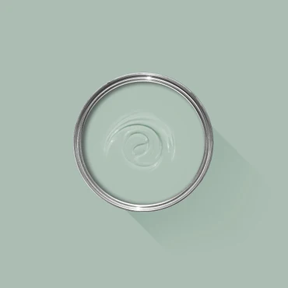

- Using your botanical imagery, cut leafy shapes from tetra packs, you will need at least 3/5 (consider the negative space left behind too).

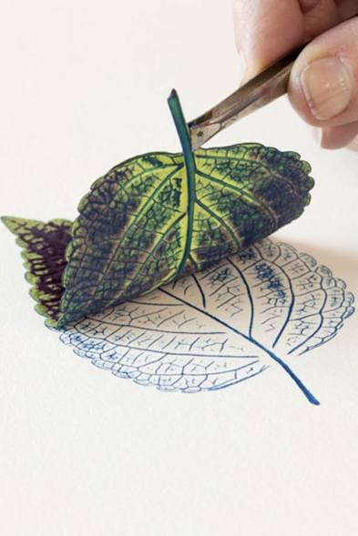
- Ink these tetra shapes up to use for direct printing, using these colours from the Farrow and Ball colour palette and play with layering where possible. Again consider inking up the negative space too

- Clean the tetra plates and draw into them using pattern from your lace, textile, embroidery or weave image making developments. Ink these tetra plates up and print again, you will not be able to print over the 1st set of prints as these will be wet. Play with layering and the negative spaces too.

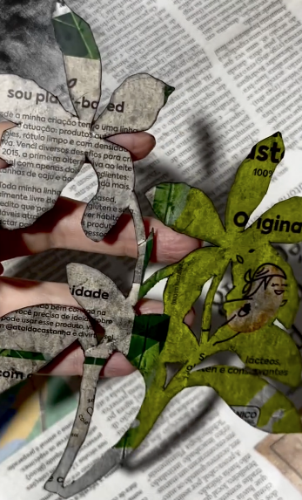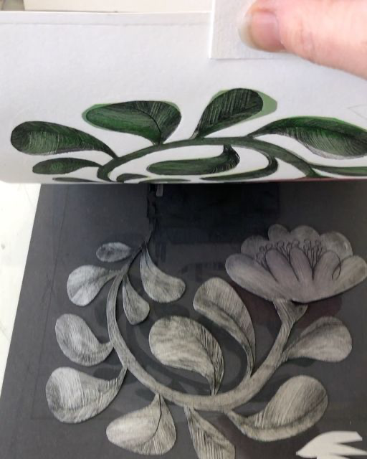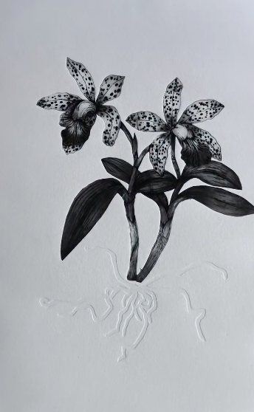

Laiz Carelli Lisa Stubbs Laiz Carelli

Extension task
Work into the dried prints, through your emerging image making ideas and techniques, consider what and how you can add to them to create difference in your prints. The prints will take 24/48hrs to dry…please make sure that you collect them from the print room before the end of the week.

Print makers: inspiration
Kate Heiss
Lisa Stubbs
Martha Armitage
William Morris
Angie Lewin
Huw Dunford Wood
Laura Weston
Cameron Short
Andrea Lauren
Mary Hick
Mark Herald
Claire Florey-Hitchcox

