Analysis of Cylinder Head Design and Efficiency

January, 15 2019
School Of Engineering
Ashleigh Jones (1707088)
Powertrain Design and Efficiency
Lecturer: Pedro Monteiro Feffeira
Motorsport Engineering HND/BSC
Abstract
Investigation on matching a known engine setup with four unknown turbo combinations based identifying the engines flow and pressure requirements and basing the requirements with the supplied turbo manufacture efficiency map. To ensure a correct match validation methods are used to quantify the selection. Intercooler input and output temperatures are estimated and the size of the intercooler required is established.

Table of Contents
1 | List of figures | Page: 4
2 | Introduction and operation of a turbo | Page:5-6
3 | Turbo Dismantling Procedure | Page:6-10
4 | The Flow of Gasses through the Turbo charger | Page:10
5 | Analysis | Page:11-13
6 | Turbo charger selection | Page:14-17
7 | Conclusion | Page:18
8 | Bibliography | Page: 19

1. List of figures
Fig 1 | Turbo removed from engine
Fig 2 | Manifold being split from turbo
Fig 3 | coolant lines being removed
Fig 4 | Oil high pressure lines being removed
Fig 5 | Oil low pressure lines being removed
Fig 6 | Waist gate being removed including the retaining clip.
Fig 7 | Pressure sensor being removed
Fig 8 | recirculation removal
Fig 9 | illustration of the marking line
Fig 10 | Compressor housing being removed.
Fig 11 | V-Band being removed from the exhaust housing to enable housing to be removed
Fig 12 | Compressor centre being dismantled and the turbine on the centre shaft.
Fig 13 | Image illustrating the gas flow through a turbo system.
Fig 14 | Manufacture efficiency maps from indivdual turbos.
Fig 15 | Turbo Efficiency Map On The Chosen Turbo

2. Introduction and operation of a turbo
Due to the higher demands for internal combustion engines to become more fuel efficient and economical. Low-end and part-load performance is mainly targeted to improve and due to the engine mostly being between these points. To increase power in an engine there are three main aspects that can be optimised. First is the cylinder volume. This can cause the engine to use more fuel which means more air can be used increasing power. This comes at a disadvantage of the engine being heavier and larger also being less economical. The second is to increase engine speed. This means to increase the number of power strokes per minute. This has its limitations as well by the mechanical limitations as well as combustion limitations as well as frictional losses. The efficiency of the engine is also dramatically reduced. The final aspect is to increase the air pressure that enters the cylinder. This ensures that the air is pre compressed before it enters the combustion chamber. This increases the volume of air meaning that the air is denser allowing a ensuring that the maximum amount can be utilized. This intern increases the volumetric efficiency of the engine. The pressurised air is achieved buy ether by installing a supercharger which compresses the air by the engines own drive which is achieved via a belt. This has a disadvantage of having a parasitic draw on the engine but had the advance of quicker air compression. A turbo charger is also used which utilises waist gasses to spin an exhaust turbine which is connected to the intake turbine. This has no direct draw on the engine but dose have the limitation of slow spooling times which created turbo lag. (Hillier et al., 2004)
The turbo has an intake turbine and compressor and an exhaust turbine and compressor. The turbine is connected together via a shaft which rotates inside bearing or brass sleeve. These bearing are supported in the centre housing which ensure that the both intake and exhaust housings are mounted securely as well as creating a location for oil lines to be inserts as well as coolant channels if necessary. The exhaust side of the turbo is directly connected to the manifold which allows the redirection of exhaust gasses straight to the turbine. The turbine then spins in a Radial fashion which means the gasses flow in from the outside of the wheel. As the engine speed increases, the more the gasses is created which in turn spins the turbine faster. As the exhaust turbine spins the intake also spins because it is connected by the shaft. The intake is connected to in intake manifold of the engine to allow the compressed air to be contained. If the air is compressed it generally increases in temperature which means the air is less dense. An intercooler is used to cool down the compressed intake air which ensures that the air is as dense as possible when entering the engine. (Bell, 1999)
If the air isn’t controlled, the turbo would create a vast amount of pressure which would be detrimental for the engine due to a large amount of air that enters the engine could cause the engine to lean burn and possibly detonate. A waist gate is a boost pressure operated actuator which is connected to a valve which diverts the exhaust gasses around exhaust turbine. The waist gate composes of the set spring which is chosen to match the desired pressure required. A pipe connected to the compressed side of the intake which ensures an accurate actuation to ensure the reliability of the system. Boost controllers are also used to further control timing of the waist gate to allow the user more freedom when mapping the vehicle. (Hillier et al., 2004)
Turbo selection is vital to ensure that the correct turbo is used for the correct application. This to ensure that the desired power range is matched with the engine as well as reducing the amount of turbo lag. Turbo lag is the delay between pressing the throttle and boost pressure that’s being created. A large turbo had the capability for a larger volume of air to enter the engine but has the disadvantage of having a large amount of rotational mass which create a large amount of turbo lag. A small turbo has a small amount of turbo lag because it small rotational inertia to allow boost pressure to build faster but has disadvantage of lower air volume that enters the engine. These factors can be analysed by the supplied manufacture turbo performance graphs and match the desired size of turbo based on the requirements or the engine power and torque dyne curves.

3. Turbo Dismantling procedure

Fig 1: Turbo removed from engine
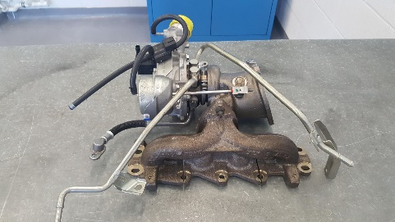
First the turbo needs to be removed from the engine. Remove all necessary hoses, oil lines, vacuum lines and removed from the exhaust manifold to free the turbo (Fig 1).

Fig 2: Manifold being split from turbo
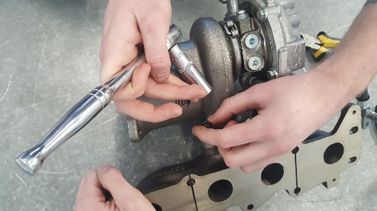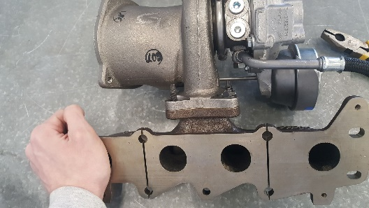
The turbo can be removed from the manifold by removing the three 13mm bolts (Fig 2).

Fig 3: coolant lines being removed
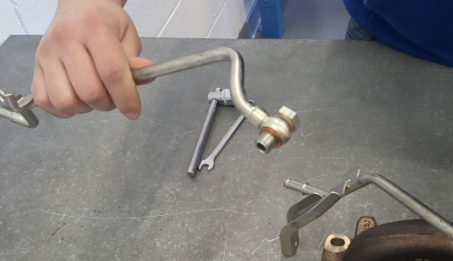
Both coolant lines can be removed by unbolting the two banjo bolts from both lines and removing the coolant lines (Fig 3).

Fig 4: Oil high pressure lines being removed
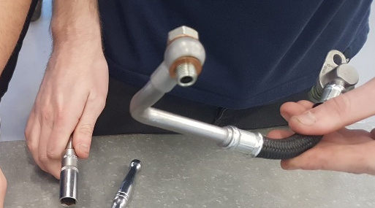
Remove the high pressure oil feed line by removing the banjo bolt from the core using the 17mm socket and removing the pipe (Fig 4).

Fig 5: Oil low pressure lines being removed
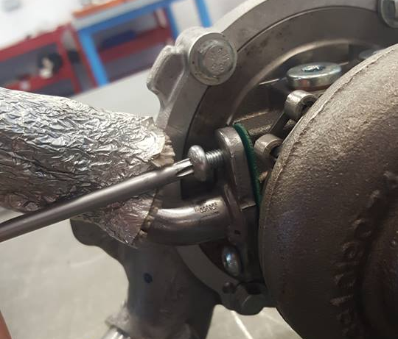
Remove the low pressure oil line by unbolting the flange from the core using a T30 driver (Fig 5).

Fig 6: Waist gate being removed including the retaining clip.
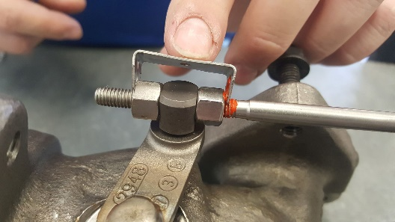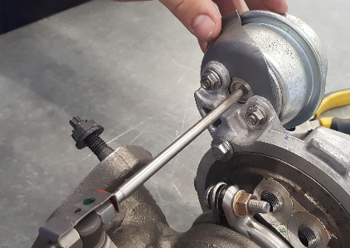
Remove the waist gate by first ensuring the vacuum line is removed and by unbolting the two 10mm mounting bracket bolts on the compressor side of the housing. The connecting rod is removed by unscrewing the 10mm nut from the push rod and the assembly can be freed by sliding it out (Fig 6).

Fig 7: Pressure sensor being removed
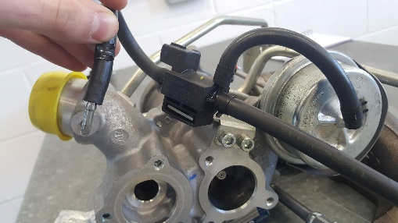
Remove the pressure sensor by removing two 10mm bolts holding it to the compressor housing (Fig 7).

Fig 8: recirculation removal
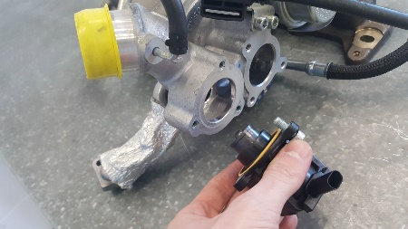
Remove the recirculation valve by locating it and ensuring the vacuum line is removed and then unbolting the three T25 bolts from the valve (Fig 8).

Fig 9: illustration of the marking line
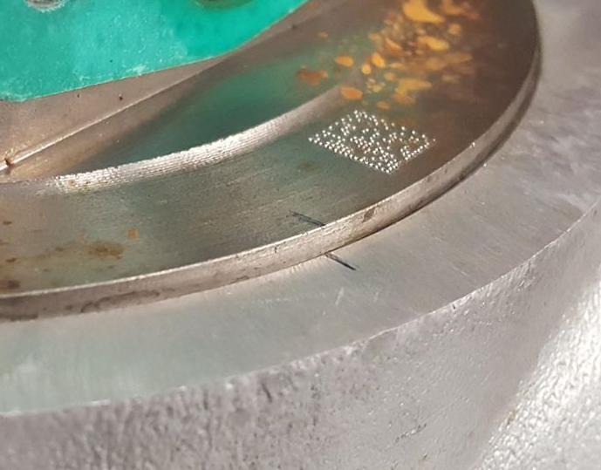
By using a marker pen, create locating marks on the compressor relative to the core and do the same to the exhaust side. This is to ensure correct alignment on reassembly to make sure all of the sections are in the correct locations (Fig 9).

Fig 10: compressor housing being removed.
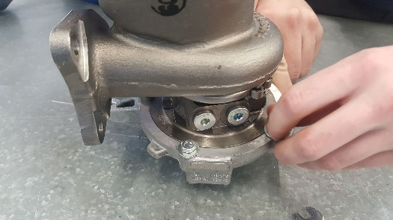
Remove the compressor casting by unbolting the four equidistant 10mm bolts. Once removed tilt the turbo upwards with the compressor wheel to the sky and gently lift the compressor upwards being extra cautious not the damage the blades or the casting (Fig 10).

Fig 11: V-Band being removed from the exhaust housing to enable housing to be removed
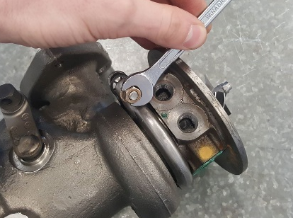
Keeping the turbo in the same position, the V-band ring retainer can the removed on the exhaust casting. Once removed lift the core upwards, again being cautious not to damage the blades or casting (Fig 11).

Fig 12: Compressor centre being dismantled and the turbine on the centre shaft.
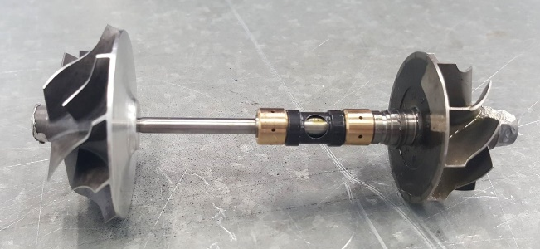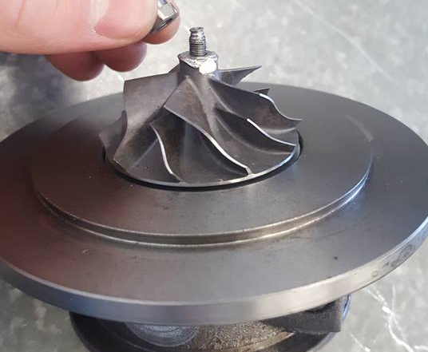
Once the core is removed set down on the soft surface to ensure the blades can’t be damaged. By using an 8mm socket, hold the exhaust turbine and loosen the retaining nut on the intake turbine. Please note this nut is a backward thread which requires a tightening or clockwise action to loosen the nut. The whole shaft assembly can then be removed by pulling on the exhaust turbine being careful not to damage the internal of the core and the bearing sleeves (Fig

4. The Flow of Gasses through the Turbo charger
A turbo has a specific system of pipes to allow the gasses to be directed through the turbo towards the engine and back to the turbo. These pipes ensure that the gasses can be pressurised without losing pressure. This means that the pipes need to be air tight and to be able to handle pressure. On the image below (Fig 1) illustrates the gas path of a turbo system. The gas is sucked through the inlet of the turbo through (1) which is done by the rotation of the inlet turbine. The gas then travels toward the intercooler (2). The air then travels through the intercooler which cools down the pressurised air. Once the air is cooled the pressurised air then travels to the engine through the inlet manifold which directs the air to the different cylinders (4). The combustion process then uses the charged air and exhausts it out through the exhaust valve and to the exhaust manifold (5). The hot exhaust gasses then travels to the exhaust side of the turbo (6). The exhaust waited exhaust gasses are used to spin the turbine rapidly which is connected to the inlet turbine. The gas then goes out to the exhaust pipe and out the tailpipe (7). This system then continues the cycle to ensure a constant flow of pressurised air. (EngineLogics Inc., 2019) (Bell, 1999)
Fig 13: Image illustrating the gas flow through a turbo system.
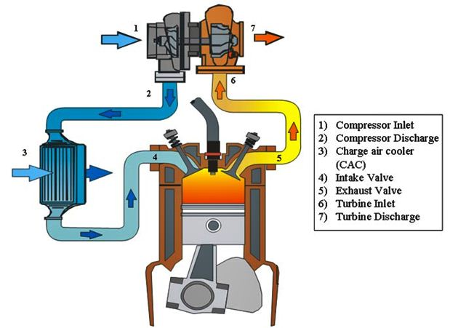
(EngineLogics Inc., 2019)
5. Analysis
To find a correct turbo charger to match the selected engine and requirements, many calculations are made to first find the existing engine output and specification. This to provide a basis to create a comparison between the standard engine and the engine with the addition of the turbo charger. The engine is research in terms of cylinder displacement, rev limit, volumetric efficiency and the desired psi. A list of these specifications is as follows:

V8 spark ignition four stroke engine
-Cylinder bore of 95mm
-Cylinder stroke of 80mm
-Engine rev limit of 9500 rpm
-volumetric efficiency of 85%
-Desired boost pressure: 12psi

Engine Displacement
Engine displacement is a vital calculation to help the following formulas with the calculations. It is especially apparent for engine flow rate calculation. The data is measured when the head is off the block. In this case the V8 engine has a bore of 95mm and a stroke of 80mm. This has to be converted to M to allow the for the correct result in the correct unit. The calculation for one cylinder is a follows:
$$Cylinder Displacement=\frac{π×{Bore}^{2}×Stroke }{4}$$
$$Cylinder Displacement=\frac{π×{0.095m}^{2}×0.080m }{4}$$
$$Cylinder Displacement={0.00057m}^{3}$$
This calculation is for one cylinder so to cater for the eight cylinder engine, the cylinder displacement needs to be multiplied by eight. The correct engine displacement is as follows.
$$Total Engine Displacement=0.57×8$$
$$Total Engine Displacement=0.00458m^{3}$$

Naturally aspirated Engine Flow Rate
The volumetric flow rate can be calculated by multiplying engine displacement, volumetric efficiency and engine speed by 120. This gives the answer in m³/s but is converted to cubic feet per minute (cfm).
$$Volumetric Flow Rate=\frac{v ×η_{v}×N}{2×60}$$
$$V=\frac{0.00458 ×0.85×9500}{2×60}$$
$$V={ 0.31m}^{3}/s$$
$$V=656.85cfm$$

Pressure Ratio
Pressure ratio is calculated by adding atmospheric pressure and boost and dividing by atmospheric pressure.
$$Pressure Ratio=\frac{14.7+Boost}{14.7}$$
$$PR=\frac{14.7+12}{14.7}$$
Pressure Ratio = 1.82

Turbo Charge Engine Flow Rate
This calculation is performed as the normally aspirated engine flow rate but with its all divided by the pressure ratio.
$$Volumetric Flow Rate=PR\frac{v ×η_{v}×N}{2×60}$$
$$V=1.82\frac{0.00458 ×0.85×9500}{2×60}$$
$$V=1.82\frac{0.00458 ×0.85×9500}{2×60}$$
$V=0.56m^{3}/s ×2110cfm$
$$V=1186.57cfm$$

Volumetric flow rate conversion
One the volumetric flow rate is identified for the desired maximum boost pressure of the engine, it needs to be converted to best suit the graph. This conversion converts cubic feet per minute (cfm) to pounds per minute (lb/m). The conversion is as follows:

$V=1186.57cfm ×0.07lb/min$
$$V=82.71lb/min$$

Turbo Charge Engine Flow Rate at diffident efficiency
Once the Volumetric flow rate at 100% efficiency is identified, the efficiency can be identified for 50% and 20%. This is to create a basis to plot on the provided manufacture efficiency graphs of the turbo. This give a better understanding of the turbo and the efficiency. Convictions is as follows
Maximum Flow: 82.71lb/min at PR: 1.82
50% of maximum flow rate: 41.36lb/min at PR: 1.82
20% of maximum flow rate: 16.54lb/min at RR: 1.00

6. Turbo charger selection
When a manufacturer creates a turbo, a compressor map is created for each individual turbo. This is to allows the engineer select to correct turbo for the selected requirements and engine output. The graph is plotted with pressure ratio and air flow. By using the supplied specification, Pressure ratio and air flow can be calculated and used to plot on the compressor map graph.
Below is 4 different compressor maps (Fig 13), by using the graphs the calculated air flow and pressure ratio, points can be added and lines drawn from point to point. This to simulate the expected engine requirements by creating a rough power curve. By looking at the last point which is used to identify where the last point falls in the efficiency zones.

  - Fig 13: Manufacture efficiency maps from indivdual turbos.
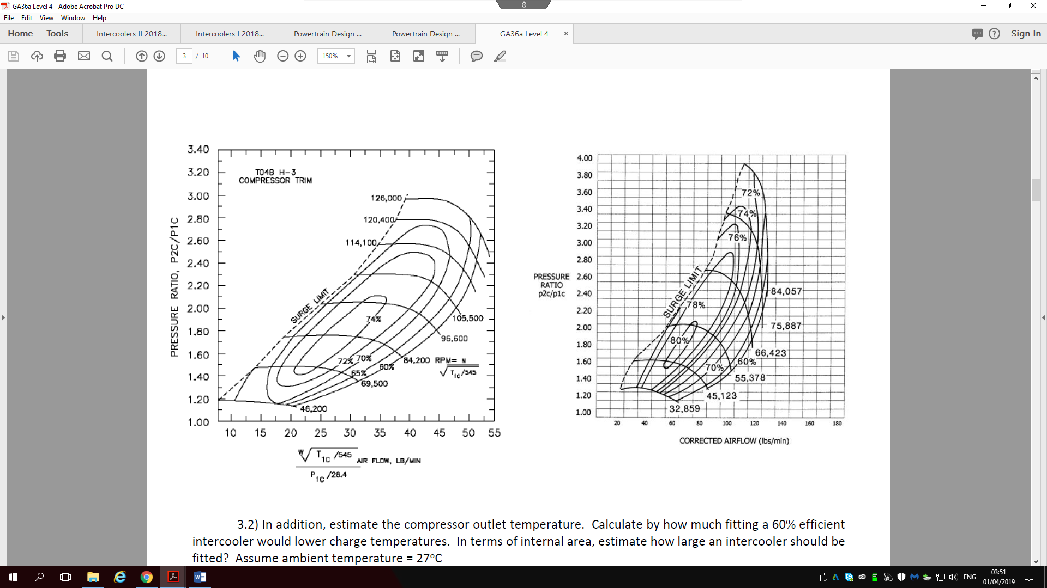
  - 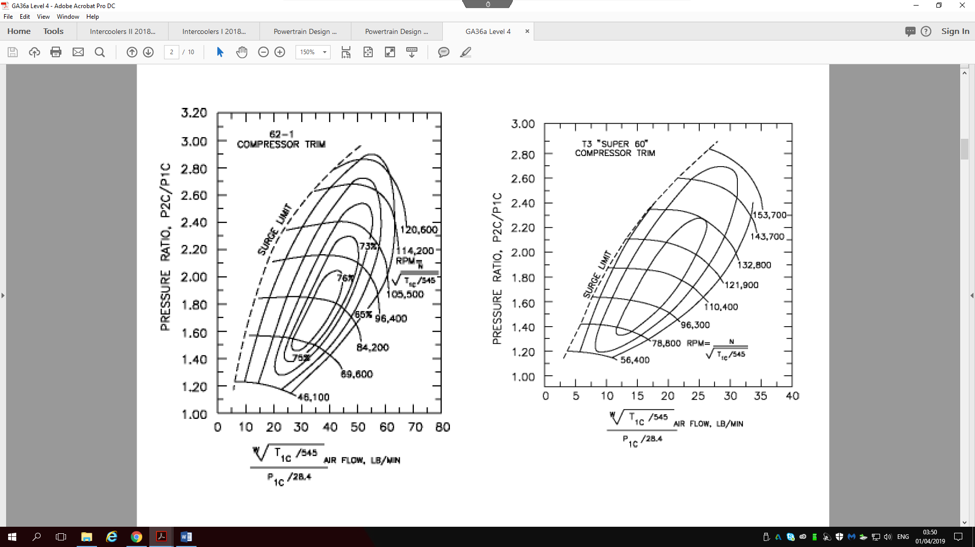
Looking on graphs 1,2 and 3, (fig )shows the plotted marks that exceed the boundaries of the graph. The graph can go on continuisly untill it reaches 0% therietically but isnt included because the maximum efficiency is the main focalpoint. Knowing this, the final point is furthest away from the ideal turbo efficiency meaning it that these turbos are not suited for this engines requiremnts but would be ideal for a engine requireing lower air flow but higher pressure.

The fouth turbo has higher capabilities than the other turbos interms of air flow. This turbo is more efficient by produccing a higher ammount of air flow. This means that it’s a larger turbo than the rest of the turbos. By using the calculated plotting points, lines can be created to identify the efficiency in the map. Using the lines gives us a underdtanding of the efficiency which achives an average of 80% and has a maximum efficiency at maximum load of 72%. This means that this turbo is most efficient when the engine is at its under mid to high load. If the Pressure ratio is increassed by increassing the turbo pressure, the efficiecny of the turbo under high load due to the fact that the point conforms to higher pressure area on the map.
Fig 14: Turbo Efficiency Map On The Chosen Turbo
Shows that the average efficiency is 80% and the Maximum Load efficiency is 76%

Compressor Outlet Temperature
The compressor outlet pressure is calculated so that a comparison can be made beteen the outlet of the charge air and the intercooler outlet. First the ambiant temperature needs to be converted from °c to Kelven. this conversion is a follows:
$$27°c=300Kelven$$
The ourlet temperature can now be calculated using the following:
$$T_{out}={PR}^{0.28}×T_{in}$$
$T_{out}={1.82}^{0.28}×$ 300Kelvin
$T_{out}=354.77$ Kelvin
The compressor output temperature is calculate in kelvin but can be converted which is 81.62°c. This can be converted with the outlet pressure of the intercooler to gain an understanding of the intercooler efficiency.
Intercooler Outlet Temperature
The intercooler outlet temperature can be identified by identifying the intercooler efficiency. This can be identified by using the following formula:
$$η_{i}=\frac{T_{co}-T_{io}}{T_{co}-T_{io}}$$
In this case, the intercooler efficiency is known so can be utilised by finding the efficiency percentage of the output charge temperature.
$$Intercooler output temperature= 60\% of 81.62°c$$
Intercooler output temperature $=48.97°c$

Intercooler Size and Design
The intercooler can be a verity of sizes and thicknesses, this is to ensure the intercooler is fit for purpose without hindering the system in terms of flow weight or cooling. This is why it’s vital that the intercooler is an adequate size to do the job. First a graph is used (Fig 15) to understand the internal flow area based on the air flow demands. The table is as follows:
Using this graph the internal flow area can be identified. Using the engine cfm which is 1186.57 cfm which can be plotted on the graph
Fig 15: Graph illustrating the intercooler floe are over cfm

With the cfm plotted shows the internal flow area of the intercooler which is 68 sq.in. Using the following formula, the face are of the intercooler can be calculated:
$$Intercooler Face Area= \frac{Internal Flow Area}{0.45}$$
$$Intercooler Face Area= \frac{60}{0.45}$$
$$Intercooler Face Area= 133.3sq.in$$

Turbo Installation Considerations
The turbo requires many components compared to a normally aspirated engine. This is due to the added complexity of the setup. The turbo requires many different components to ensure an efficient and reliable setup. The obvious considerations is the turbo. The turbo is large with load of added complexities like added pipework and pipelines which require added space. This space is sometimes difficult to source which means added costs in engineering around components. With the added inlet piping and the exhaust piping means that additional room is required. Turbos require oil circulation so the addition of the oil feel and return line can be hard and some difficult if there added supply on the block of the engine. Some engine require coolant lines which also require the addition of finding a cool water source and return. The intercooler is another factor that is affected by space. This is due to the bummer not having the extra room to fit an intercooler adequate for the function.
With the Addison of the turbo system, a corresponding map is required to ensure maximum efficiency of all components. Some manufacturer have additional limitations of fuel starvation so added injectors and fuel pumps are sometimes used to supply the engine with an adequate amount of fuel.

Note: All of the calculations for the intercoolers involving the temperatures and the areas are all estimations based on the few information soured.

7. Conclusion
In concussion reviewing the supplied specification and the supplied turbo efficiency maps, the turbos 1, 2 and 3 were made redundant due to the fact that the cubic flow per minute and the pressure ratio didn’t fit on the supplied graph rendering the efficiency too high to even be counted. The fourth turbo was within specification and was adequate for the job due to the high average efficiency and the high load efficiency.

8 .Bibliography
EngineLogics Inc. (2019). How to read a turbo compressor map. [online] Available at: https://www.enginelogics.com/read-a-turbo-compressor-map/ [Accessed 24 Mar. 2019].
Bell, C. (1999). Maximum boost. Cambridge, Mass.: Bentley Publ., p.156.
Hillier, V. (2012). Hillier's fundamentals of motor vehicle technology [electronic resour. Cheltenham: Nelson Thornes.
Hillier, V., Coombes, P., Rogers, D., Hillier, V. and Hillier, V. (2004). Hillier's fundamentals of motor vehicle technology. Cheltenham: Nelson Thornes.

Word Count: 3012

