Psychology for Health and Social Care

Task-1

Submitted to Dr. Gulnar Ali

Submitted by:
Sharmin Rahman
ID# 1809328
University of Wales
Trinity Saint David

Concepts and Theoretical perspectives related to lifespan development

Introduction
This report is developed to support my understanding on concepts and theoretical perspectives related to lifespan development. This report discussed the different life stages, my professional interest about one particular stage, two significant psychological theory related to that stage, development pattern and recent studies about those theories.

Different life stage
Across different life stage range of developments take place in human life such as physical form, physical capabilities, cognitive capabilities, moral capabilities, personality, societal exceptions, roles and responsibility awareness (Armstrong, 2009). Each stage should be understood deeply to ensure appropriate biological, memory and skill development of any human being.

Professional interest
In my previous profession, I have worked with age group 6 to 8 which is known as middle childhood. In this age stage, the mind of a child is young and innocent and not aware of other worldly matters. The important aspect of this life stage is it comes just before puberty stage so, it is an important diversion stage. Children completes basic school education by the end of this school. The reason why I chose this stage to present here is the inner sense that subjectifies self-development (Donald, 2011). Children build their sense to understand about outer world from the images they take, and they bring it up to their next life stages from that depths and understandings. This is what amazed me when I read about the human life span developments. The imaginations children build in this stage should be considered as most important because it contributes as a source of creative inspirations in their later life.

Psychological theories
Two psychological theories can help us to explain and to understand how individuals physical and psychological development occurs. From my understanding, middle childhood stage of life can be incorporated with two significant theory such as Erikson’s’ psychological development theory and Piaget’s cognitive theory. Both the theories have been discussed below:

Erikson’s Theory of Psychosocial Development
Erikson described that humans’ personality develops in a predetermined order which includes eight different psychological stages. The stages start from infancy to adulthood and in each stage, people face psychological crisis. These psychological crisis impact on psychological development either positively or negatively. According to Erikson, these crises defines the nature of a person and it is actually the difference between individuals’ need and the need of society (Slater, 2003). The picture below shows which psychological crisis develops which basic virtues in respective ages.
Stage | Psychosocial Crisis | Basic Virtue | Age
1. | Trust vs. Mistrust | Hope | 0 - 1½
2. | Autonomy vs. Shame | Will | 1½ - 3
3. | Initiative vs. Guilt | Purpose | 3 – 5
4. | Industry vs. Inferiority | Competency | 5 – 12
5. | Identity vs. Role Confusion | Fidelity | 12 – 18
6. | Intimacy vs. Isolation | Love | 18 – 40
7. | Generativity vs. Stagnation | Care | 40 – 65
8. | Ego Integrity vs. Despair | Wisdom | 65+

Figure: psychological development by Erikson (McLeod, 2018).

Jean Piaget cognitive theory
In 1896, Jean Piaget one of the most influential researcher in development studies, developed cognitive theory to describe how organism adapts to environment. He told that this adaptation is driven by biological drives. In explaining the theory, he used two terms; assimilation and adaptation. Assimilation is transforming information from the environment to fit it into the per-existing cognitive structure. Accommodation involves the process which helps to change cognitive structures to accept something new from the environment (Powel & Kalena, 2009). Both the process continuously and alternatively occurs throughout the whole human life. According to Piaget, in middle childhood, age from 2 to 6/7 years, people are too young to do any mental operation; using intuitive rather than logical reasoning (Merriam, 2004)
Piaget’s theory impacted globally with validation of number of ideas in the field of development and growth in different cultures and societies. Whereas, advance researches claim that development is a continuous process and children express mental abilities at early ages. Therefore, the theory can very clearly explain the way hoe the child adapts this ever-changing world. Even the youngest child is inquisitive and actively explores this world.
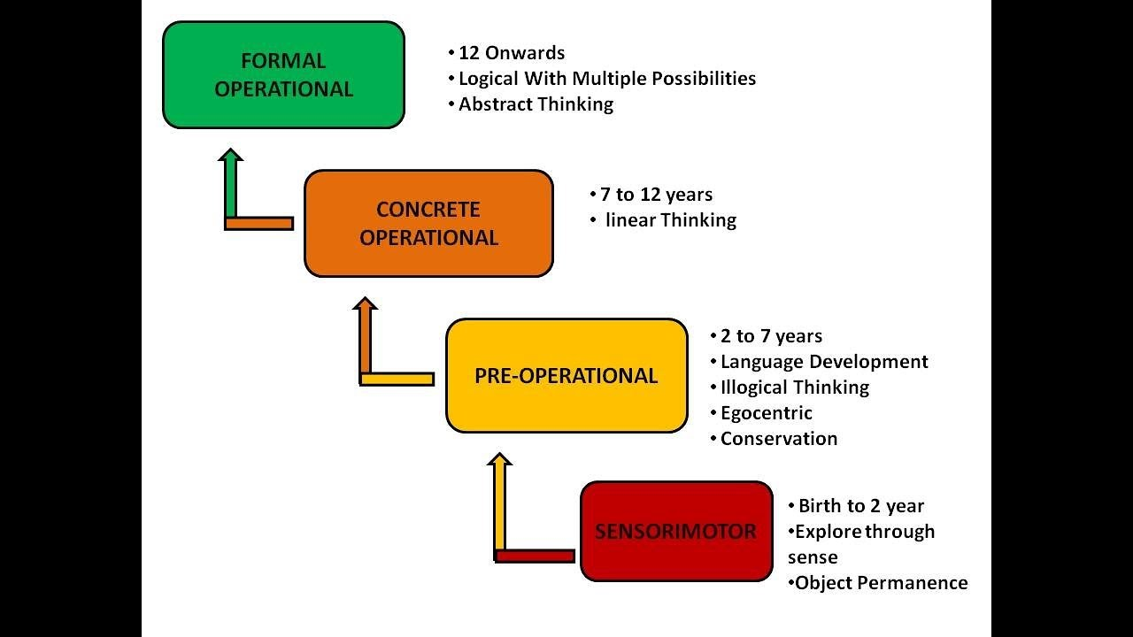
Figure: Piaget’s theory of cognitive development
According to Piaget, age 7to 11 is the concrete operational stage when children is able to carry out operations and develops logical thoughts. In this stage, they involve two actions one is reversibility. Reversibility is the ability to mental picture of an action to be carried out. The other one is known as conservation which refers to the realization that amount remains same until unless something is added or removed.

Human Cognition development
Piaget stated that the thinking process of young children can be characterised by egocentrism which means they tend to think that all other peoples’ thinking, and feelings are just like them. Nevertheless, his invention on child psychology is the central of social cognitive activity by children but range of researches showed that Piaget underestimated children’s perspective -taking ability (Anderson, et al., 2015).

Social & Emotions Development
The ability to understand the feeling of others, controlling own behaviour and getting along with other children and building relationships are the emotional developments of children. Being cooperative, following directions, self-control and attention paying are the skill that are developed at the stage of middle childhood (Fischer & Bullock, 1984).

Behavioural pattern
During this middle childhood, children get the access to new setting and pressure which helps them to deal with development challenges. at this age, children develop new capabilities through new challenges as they are assigned with new roles and responsibilities (DelGiudice, 2017).

Conclusion
Exploring the aspects of the middle childhood stage of life-span development and demonstrating the importance of this stage motivated me to develop this report. Children when are given most support with deep understanding of the process of mental development, we can ensure the care given to blossom to their fullest degree. The sequence of physical, language, thought and emotional behavioural changes need to be nurtured appropriately. Problems in these developments can impact their further development and so as to the development of the society.
………………………………………………..

References
Anderson, D. R. et al., 2015. An Introduction to Management Science: Quantitative Approaches to Decision Making. 1st ed. Boston: Cengage learning.
Armstrong, T., 2009. The 12 Stages of Life. s.l.:Ixia publications.
DelGiudice, M., 2017. Middle Childhood: An Evolutionary-Developmental Synthesis. Handbook of life ocurse Health DEvelopment, pp. 95-107.
Donald, S. E., 2011. A life-span, life-space approach to career development. Journal of vocational behaviour, 16(3), pp. 282-298.
Fischer, K. W. & Bullock, D., 1984. Development During Middle Childhood: The Years From Six to Twelve.. National Research Council (US).
Merriam, S. B., 2004. The Role of Cognitive Development in Mezirow’s Transformational Learning Theory. Adult Education quaterly, 55(1).
Powel, K. C. & Kalena, C. J., 2009. COGNITIVE AND SOCIAL CONSTRUCTIVISM: DEVELOPING TOOLS FOR AN EFFECTIVE CLASSROOM. Education, 130(2), pp. 241-250.
Slater, C. L., 2003. Generativity Versus Stagnation: An Elaboration of Erikson's Adult Stage of Human Development. Journal of Adult DEvelopment, 10(1), pp. 53-65.

………………………………………………..

