Application Development

ACCA5012

Daniel O’Dwyer | 1801164 | 09/12/2019

Table of Contents

Introduction

[Page 1]

Application Development Concepts

[Pages 1 - 7]

Requirements

[Page 7]

Design and Implementation

[Page 8 - 11]

Evaluation

[Pages 12 - 13]

Bibliography

[Page 14]

Introduction
In this report the author will be looking into a question and discussing it. The question is, Loot Boxes, are they gambling? The author will then talk about the game he has made for this module. Using unity and various assets provided by the university the author has made a game he calls, Need for Seed 2: This time it’s berries. He will be talking about the design, implementation and evaluating the games performance with various tests.
Application Development Concepts
Loot Boxes, are they gambling?
There have been many new development trends in the games industry over the years. As the industry continues to evolve and innovate so do the trends. One of these trends has taken the games industry by storm. This trend has been a staple feature in many of the popular games enjoyed and loved by todays people. This trend is known as “Loot Boxes” or “Micro Transactions”. They sound the same but Micro Transactions is a broader, umbrella term for any items that can be purchased in a shop, usually hosted in-game. For this discussion the author will be focusing more on Loot Boxes.
So, what are loot boxes? According to the BBC, “Loot boxes allow players to spend real money to unlock special characters, equipment or skins in a game.”. [1] This definition offers a concise insight into the nature of loot boxes. Loot boxes can vary greatly in the type of items they offer. A consensus is that most loot boxes will offer items called “Skins”. This term can mean anything from a custom paintjob for a player’s weapon, to a new look for a player’s character. Loot boxes can usually be accessed and purchased from an in-game shop. The prices can vary depending on the contents and how rare or desirable they are. Loot boxes are made and controlled directly by the company who publishes the game. They can dictate the prices, desirability and rarity of the items they are selling through their loot boxes. Loot boxes are considered a form of monetization, which means to generate money from a product.
The earliest examples of loot boxes are difficult to define. However, PCgamer testifies that, [2] “Industry researchers identify Chinese free-to-play MMO ZT Online from 2006 as the pioneer. The book Red Wired: China's Internet Revolution cites ZT Online's innovations: "virtual treasure boxes, which may contain in-game items worth more than the cost of the box itself" and "allowing players to hire in-game 'substitute players' which let them raise their characters' experience levels without actually playing.'" Many games since then have implemented loot boxes as an additional feature. Three prominent games that have featured loot boxes are the FIFA franchise, Overwatch and Counter Strike Global Offensive (CS: GO). However, these games offer different items in each of their loot boxes. According to the BBC [3] “In Fifa, players can be bought in packs, but their content is only revealed after payment.” In Overwatch the loot boxes contain purely cosmetic items, such as character skins, voice lines and emotes. CS: GO’s loot boxes only contain weapon skins, each with varying degrees of detail and rarity. While it seems like these loot boxes are identical, they differ greatly from each other. FIFA offers clear benefits to those who decide to purchase their loot boxes, a chance to claim rare and powerful player characters. The rarer the character, the greater the power. Its logical to assume that the more loot boxes you buy, the better your chances are at acquiring better characters. This form of loot boxes is considered the most devious in nature, and it shows. Fifa has come under a lot of fire recently for its aggressive form of loot boxes, which pressure people into buying them in order to acquire the “perfect team”. Wired exclaims, [4] “In order to compete, players feel like they need to buy hundreds, if not thousands, of £s worth of packs in order to get the best players,” said one gamer interviewed for the DCMS report. “Children are especially vulnerable because they lack the maturity to understand that these purchases are manipulative, and their parents may not understand that these purchases are entirely unnecessary.” The Telegraph also says, [5] “Loot boxes feature in popular games such as FIFA Ultimate Team, where gamers buy packs of football players in the hope of getting the biggest stars for their online team. During the hearings, Electronic Arts, which makes FIFA, denied the feature constituted gambling, describing it instead as a “surprise mechanic” However, the committee heard from a gamer who said they spent “almost £800 to £1000 a year annually on FIFA” loot boxes trying to improve their team.” It’s clear from these statements that FIFA’s form of loot boxes is not held in high regard, and that’s putting it lightly. Overwatch has a much less aggressive form of loot boxes. Their loot boxes contain only cosmetic items of varying rarities. However, the player can earn these loot boxes by simply levelling up in game. They can still buy them, but there are plenty of opportunities to earn them. CS: GO is an interesting case, while their loot boxes are earnable by playing the game, they require a key to be opened. This key costs around £2.50, the player also has the option to buy loot boxes from the games market. Where CS: GO is different is that each item in the loot box has real world monetary value. Some of these items can fetch a price of £1000 and more. By using the value of its loot box skins, CS: GO has created its own economy. Committed players buy and trade daily to break even or make a profit. Recently CS: GO has come under harsh criticism from many countries for its loot boxes. Eurogamer tells us that, [6] “It seems the Netherlands' threat to prosecute video game companies over loot boxes has claimed its first victim: Valve. Players of CS: GO and Dota 2 in the Netherlands were today greeted with a message from Valve saying the company had pulled item trading and Steam Marketplace transfers for both games.” The article goes on to say, [6] “Valve's note to Dutch Steam users reveals the company received two letters from the Dutch Gaming Authority, stating both CS: GO and Dota 2 contain loot boxes that violate the Dutch Betting and Gaming Act.” Despite loot boxes being a mainstream form of monetization in games, there has been many outcries by people and critics to regulate them or remove them entirely.
The main problem with loot boxes seems to be the risk. What risk? The risk of spending money and getting nothing “rare” or “valuable” out of it. For example, if FIFA allowed player to buy the character they wanted, then they could just spend the money and be done with it. This eliminates the need to potentially buy more loot boxes if they didn’t get the character they wanted. Of course, this one-time purchase is referred to as a “micro transaction” and while it was met with the same criticism and negativity as loot boxes, its far less random and expensive. This risk is why people are starting to link loot boxes to gambling. Gambling has been around since the dawn of man, and it has over the years become more widely accepted and studied. As stated by Mikal J. Aasved, [7] “The last several decades have witnessed a definite shift in attitude and approach, and a profusion of empirically-based scholarly publications on gambling which demonstrate that it is entirely normal and sometimes even a culturally mandated behaviour.” Now people have never minded gambling’s enticement on adults, in their eyes it’s their own choice. What people are starting to have a problem with is gambling’s grasp on children. The Independent states that, [8] “According to the Gambling Commission, an estimated 55,000 children in the UK are now classed as having a gambling problem.” They also proclaim, [8] “As a result of growing concern that child gambling is being fuelled by online gaming sites and targeted adverts, NHS England has announced plans to launch The National Problem Gambling Clinic in London which will offer specialist help for children and young people aged 13 to 25.” Now loot boxes in most people’s eyes are gambling or a gateway to it. The definition of gambling is, to take a risky action in hope of a desired result. This statement can be applied to loot boxes, with the risk being the money and the desired result being an item of high value or rarity. Granted, this statement can be applied to a lot of games, however Eurogamer reports, [9] “Like real-life gambling, loot boxes appeal to our deep psychological need for reward. Psychologist and behaviourist B.F. Skinner researched something called the variable ratio schedule, a reward system typically used by casinos, which sees a person rewarded at varying times. So, if someone does a positive behaviour, such as buying a loot box and opening it, they could be rewarded the first time. They're then not rewarded again until the sixth box they buy, then the third after that, then the 10th and so on.” So, we can see that there may be a link between loot boxes and gambling, but does the fact that the stakes aren’t nearly as high or that its part of a game hide it? It seems more people are answering no to that question, these past years more than ever.
In a peer reviewed study Matthew McCaffrey discusses, “The macro problem of microtransactions: The self-regulatory challenges of video game loot boxes.” [10]. The study explores how loot boxes began as scarcely employed monetization features, to a core element of most games today. The study explores how loot boxes have come under recent criticism, with developers and publishers being slammed for relying on loot boxes to generate revenue. According to the study, this controversy stemmed from consumers who use social media platforms to express their frustration, mostly directed at the publisher Electronic Arts (EA). [10]. Loot boxes refer to a virtual consumable item which can be redeemed to receive a randomized selection of further virtual items, says the study. [10]. Matthew then states that, regulators have focused on two issues, gambling and consumer exploitation. [10]. If loot boxes are legally equivalent to gambling, then it will be regulated so. [10]. He also brings up the questions about consumer welfare. Including whether loot boxes encourage addictive behaviour, are marketed deceptively or if they take advantage of children using false advertising and addiction. [10]. He then gives a list of different countries and their regulations and rulings on loot boxes, the most notable being Belgium and the Netherlands. These two countries were mentioned earlier and have ruled that loot boxes can be gambling; in both cases they recommend banning them entirely. [10]. The attention then turns to the industry and developers, unsurprisingly most developers don’t consider loot boxes a form of gambling. [10]. The Entertainment Software Rating Board (ESRB) rule that loot boxes aren’t gambling since losing is impossible in absolute terms. [10]. ESRB has stated that they will put a special label on games with loot boxes, to make parents aware. [10]. Matthew makes the point that it is vital that developers are prepared to meet the challenges of regulation, further stating the same can be said for any business selling a controversial product. [10]. As far as response strategies go Matthew points out six key strategies. [10]. Firstly, he states that publishers are rethinking their international game development and distribution strategies considering the evolving views of regulators. [10]. Secondly, firms that offer products as controversial as loot boxes can only avoid external regulation by seizing the initiative to self-regulate. [10]. Thirdly, developers and publishers must take account of the complex relationships between customer and regulatory complaints. [10]. Fourth, direct involvement in supporting customer communities is increasingly important throughout the industry. [10]. Fifth, strategic partners in the industry can be a major help. He says that Apples decision to require the publication of draw rates helped all parties. [10]. Sixth, trade associations and individual developers have already been working to repair customer relationships directly. [10]. Matthew concludes with, Microtransactions are a kind of ongoing experiment, and although it is inevitable that there should be uncertainty and even controversy over them, the costs to the industry will be significant if developers cannot resolve their problems, and soon. [10].
The author feels that loot boxes are unnecessary in most cases. He feels that if loot boxes are in a game, they should offer purely cosmetic items and nothing more. The author agrees with the point ESRB brings up in the peer review study, “The Entertainment Software Rating Board (ESRB) rule that loot boxes aren’t gambling since losing is impossible in absolute terms. [10]. However, he would argue that you might feel at a loss if you don’t get the high rarity or valuable item you want. Loot boxes are so commonplace now that the author has gotten used to seeing them in game, despite his views against them. The author agrees strongly with a reference made earlier. [9] “Like real-life gambling, loot boxes appeal to our deep psychological need for reward. Psychologist and behaviourist B.F. Skinner researched something called the variable ratio schedule, a reward system typically used by casinos, which sees a person rewarded at varying times. So, if someone does a positive behaviour, such as buying a loot box and opening it, they could be rewarded the first time. They're then not rewarded again until the sixth box they buy, then the third after that, then the 10th and so on.” The author feels this statement rings true in the case of loot boxes; he also feels children are at particular risk. Children have little concept of limitations and boundaries and loot boxes in many cases go against those. The author hopes that in the future more regulations will be imposed on games that choose to accommodate loot boxes. While they are still the topic of controversy, with proper regulation the author feels that loot boxes can avoid scrutiny in the future.
Requirements
The game is quite simple in design, the controls are:
- Left Arrow Key = Move left
- Right Arrow Key = Move right
- Up Arrow Key = Fly
The game revolves around the player taking control of a small bird. The aim of the game is to collect fifteen berries per level. The berries are randomly spawned, they can fall anywhere in the level. The challenge in these levels are the hidden spikes that appear more frequently as the levels progress. If the player touches on of these spikes, he loses a life, the player starts with two lives. Once the player has collected fifteen berries, the level changes and the berry counter is set to zero and the player must collect fifteen berries again. If the player dies during the level, he must start again from the beginning of the level he dies on.
The game features many functions to make sure that it runs correctly. The main camera is set to follow the player, which is necessary so that the player can see what they are doing. There is a user interface to keep track of how many lives the player has and how many berries they have collected. If the player loses all their lives a game over screen displays and freezes the play character, forcing them to restart the level. The game checks to see how many berries the player has collected, if its exactly fifteen the player can progress to the next level. The berries spawn between two co-ordinates in each level, these co-ordinates range from the start of each level to the end. There is a ceiling hitbox to stop the player flying out of the level, as well as two walls to stop the player walking off each edge of the map. The spikes have trigger hitboxes to check if the player has collided with them, the berries also have these, but they disappear after collision to simulate picking them up. These functions are the core mechanics that keep the game running intended.

Design and Implementation
Main Camera Scene
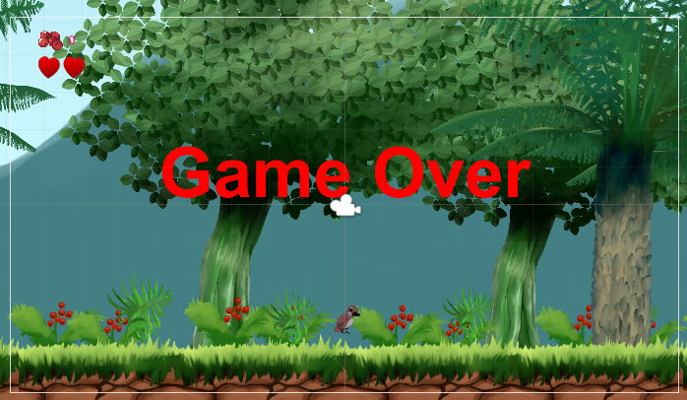

Level 1 Game Screen
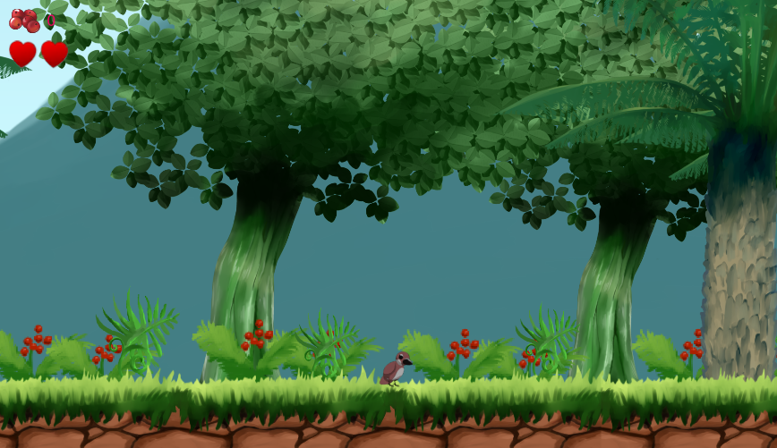


Main Assets

Level 1 Hierarchy
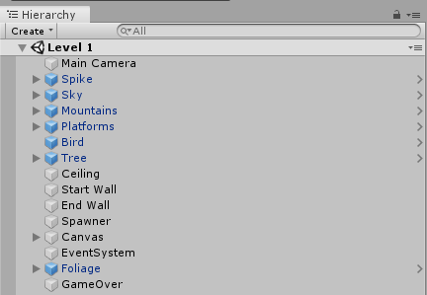

Animation Window

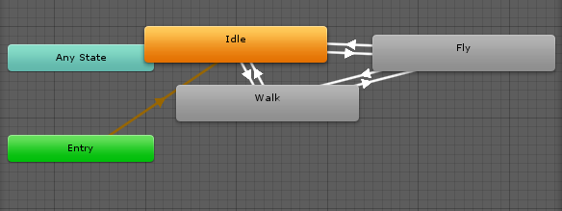

Level 2 Game Screen
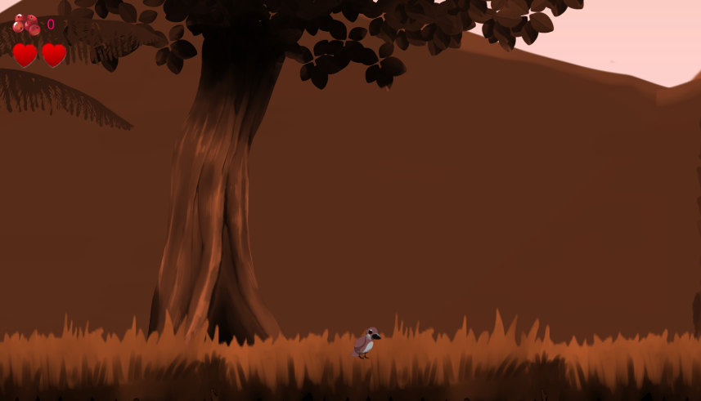

Level 3 Game Screen
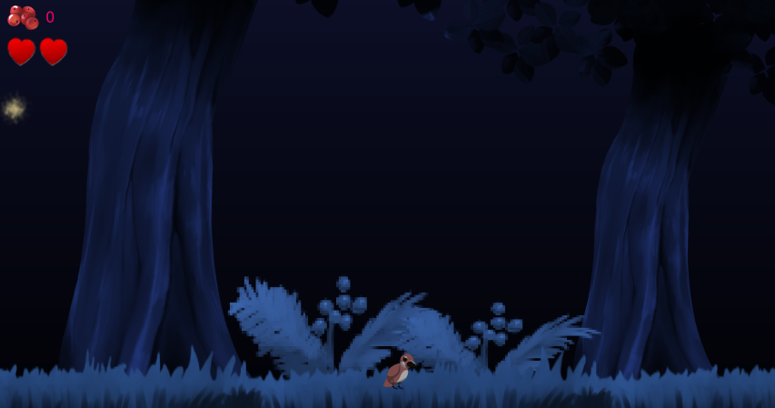

Victory Screen
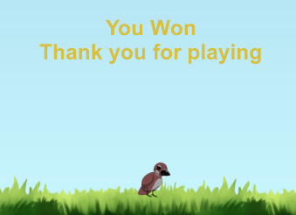

These game uses a total of five scripts. The main script is the “Move” script which has the character movement code in it as well as void function to flip the character sprite if it changes direction. It also contains two if statements, one for the player colliding with a berry hitbox and the other for a spike hitbox. If the berry hitbox collision is detected the code tells the game to add +1 to the user interface berry score counter, it also tells the game to destroy the berry sprite the player just collided with. If a spike hitbox is collided with the code tells the game to deduct -1 hearts from the lives counter. Tags are used to differentiate between the two collisions. The move script links to two other scripts, death and berry text. The berry text script updates the counter each time a berry is collided with or “collected” it also allows the player to advance to the next level by checking if the total collected berries is equal to fifteen. If it is then the level changes, the script uses the build index to identify the different levels and progress through them, it also resets the berry counter to zero at the start of a new level. The death script is responsible for the characters life counter. It checks the total hearts the player has each frame using a bool variable, the operation itself is a combination of an if and a switch statement. The script uses the command Time.timeScale = 0; to freeze the player if all the lives are lost, it also displays a game over screen. The camera control script was created so that the main camera always follows the player sprite, this is essential as for the game to function properly the player needs to see what the character is doing. Finally, there is the spawn script which spawns the berry sprite in random locations between two co-ordinates. The co-ordinates are set between the start and end of each level, it will keep spawning berries until the player dies or collects fifteen.

Evaluation
Test 1
Description
This test will see what happens if the player loses two lives. If the test is a success, then the game over screen will display and the character sprite will be frozen. If it fails, then nothing will happen, and the game will continue as normal.
Steps
- Walk up to a spike
- Take damage
- Walk up to a different spike
- Take damage again
- Game over
Expected Result
The expected result that the player will die and the game over screen will appear.
Actual Result
The actual result was that the player died and the game over screen was displayed.
Status
Pass.
Test 2
Description
This test will see what happens if the player collects fifteen berries. The level should change, and the berry counter should reset if this works. If it doesn’t work, then the level won’t change.
Steps
- Collect berries
- Reach 15 total berries
- Change to next level
Expected Result
The expected result that the level will change once the player has reached 15 berries.

Actual Result
The actual result was that the level changed when the player collected 15 berries.
Status
Pass.
Test 3
Description
This test will see what happens if the player loses two lives but at the same time manages to collect fifteen berries. This can be done because the berries fall on the spikes and can still be collected. The expected result would be that the level changes because the character collides with the berry first.
Steps
- Reach 14 collected berries
- Lose one life
- Find a spike with a berry on it
- Collect the berry and collide with the spike
- Level changes
Expected Result
The expected result that the level will change.
Actual Result
The actual result was that the level changed.
Status
Pass.

Bibliography
[1] https://www.bbc.co.uk/news/newsbeat-49674333
[2] https://www.pcgamer.com/uk/the-evolution-of-loot-boxes/
[3] https://www.bbc.co.uk/news/technology-49074003
[4] https://www.wired.co.uk/article/fifa-20-ultimate-team-loot-box
[5] https://www.telegraph.co.uk/news/2019/09/11/gambling-like-video-game-loot-boxes-should-banned-children-mps/
[6] https://www.eurogamer.net/articles/2018-06-20-dutch-loot-box-threat-forces-valve-to-pull-cs-go-and-dota-2-item-trading-in-the-netherlands
[7] Mikal J. Aasved, The Sociology of Gambling, Charles C Thomas Publisher LTD, Springfield, Illinois, USA, 2003
[8] https://www.independent.co.uk/life-style/nhs-gambling-addiction-children-uk-clinic-gaming-adverts-a8971686.html
[9] https://www.eurogamer.net/articles/2017-10-11-are-loot-boxes-gambling
[10] https://www.sciencedirect.com/science/article/pii/S0007681319300345

